🔹 1. Microservices Basics & Design
Q What are microservices? How do they differ from monolithic architecture?
Microservices are an architectural style where an application is broken into small, independent services, each responsible for a specific business capability. Unlike monolithic architecture, where the whole application is a single unit with one codebase and database, microservices are loosely coupled, can be deployed independently, scaled individually, and often have their own databases. This makes them more flexible, fault-tolerant, and better suited for large, evolving applications
Q Advantages and disadvantages of microservices ?
🔹 Advantages of Microservices
- Independent Deployment
  - Each service can be deployed without redeploying the whole system.
  - Faster release cycles and CI/CD friendly.
- Scalability
  - Scale only the services that need more resources (e.g., Payment Service under high load).
  - Cost-efficient compared to scaling the entire monolith.
- Technology Flexibility
  - Different services can use different languages, frameworks, or databases depending on requirements.
- Fault Isolation / Resilience
  - Failure in one service (e.g., Notification Service) doesn’t crash the entire system.
  - Easier to implement resiliency patterns like circuit breakers.
- Organizational Agility
  - Teams can own and manage independent services.
  - Easier parallel development (teams don’t block each other).
- Improved Maintainability
  - Codebase is smaller per service → easier to understand, test, and maintain.
- Better Alignment with Business Capabilities
  - Services often align with bounded contexts from Domain-Driven Design.

🔹 Disadvantages of Microservices
- Increased Complexity
  - Managing many services is harder than a single monolith.
  - Need service discovery, API gateways, container orchestration (e.g., Kubernetes).
- Data Management Challenges
  - No single database; distributed data consistency is tricky.
  - Requires patterns like Saga, CQRS, or eventual consistency.
- Network Latency & Reliability Issues
  - Inter-service calls over the network add latency and possible failures.
  - Need retries, timeouts, and monitoring.
- Deployment & DevOps Overhead
  - More moving parts → need containerization, CI/CD pipelines, monitoring, logging, tracing.
- Testing is Harder
  - Integration and end-to-end testing are complex (many services, many dependencies).
- Operational Cost
  - More infrastructure, more resources.
  - Higher cloud costs compared to running one monolith.
- Team Skill Requirement
  - Developers need to understand distributed systems concepts (async messaging, consistency, observability).

Q How do you decide the boundary of a microservice? (Domain-Driven Design, bounded context).
To decide microservice boundaries, start with Domain-Driven Design and identify bounded contexts in the business domain. Each microservice should represent a single business capability, own its data, and have high cohesion with low coupling. For example, in e-commerce, Orders, Payments, and Inventory are separate bounded contexts, so they become independent services. This ensures each service can evolve independently without becoming tightly coupled
Q Difference between SOA (Service-Oriented Architecture) and Microservices.
SOA (Service-Oriented Architecture)
- Architectural style where applications are built by composing services.
- Services are usually larger, enterprise-wide components (e.g., "Customer Service" for the entire organization).
- Often communicate via ESB (Enterprise Service Bus).
- Services may share a database.
- Heavy use in large enterprises (banks, government systems).
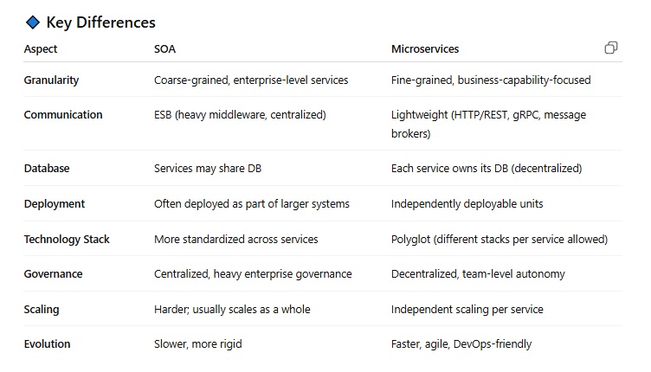
In Practice
- SOA is best suited for large enterprises where different departments or applications need to interoperate, share data, and re-use services across the organization. Centralization and integration are key, but can introduce complexity and potential bottlenecks (e.g., ESB as a single point of failure).
- Microservices excel in organizations prioritizing agility, continuous delivery, fault isolation, and rapid scaling of independent features. Each microservice is built and deployed separately, often by autonomous teams, with a strong preference for decentralization and flexibility.

Q What is API Gateway and why do we need it?
An API Gateway is a server or software layer that acts as a centralized entry point between client applications and backend services. It functions as a reverse proxy that receives incoming requests from clients, routes them to appropriate microservices or backend systems, aggregates responses, and returns them to the client.
Core Functions of an API Gateway
Request Routing: The gateway analyzes incoming requests and determines which backend service should handle them based on URL paths, HTTP methods, headers, or other criteria.
Protocol Translation: It can convert between different communication protocols, such as translating HTTP requests to gRPC calls for backend services.
Request Aggregation: A single client request can trigger multiple backend service calls, with the gateway combining all responses into a unified response.
Authentication and Authorization, Rate Limiting and Throttling, Load Balancing ,Caching
Why Do We Need an API Gateway?
Service Discovery Complexity: In a microservices environment, clients would otherwise need to know the specific endpoints of dozens or hundreds of services, which becomes unmanageable as services scale and change.
Prevents Direct Client-Service Coupling: Without a gateway, clients become tightly coupled to individual microservices, making it difficult to refactor, update, or relocate services without impacting all consuming applications.
Eliminates Cross-Cutting Concerns Duplication: Instead of implementing authentication, logging, rate limiting, and other common functionality in every microservice, these concerns are centralized at the gateway level.

Q How do you handle inter-service communication (sync vs async, REST vs gRPC vs messaging)?

- 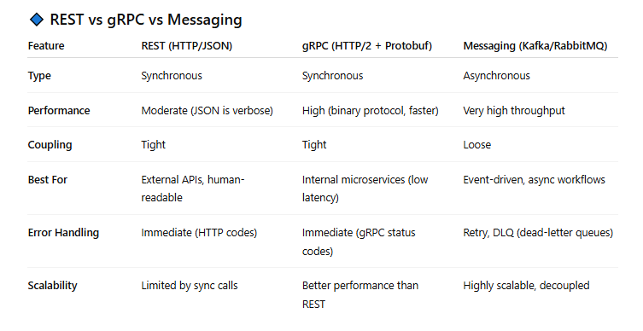
For request/response scenarios, we use REST (easy, human-readable) or gRPC (faster, strongly typed, good for internal services).
- For decoupling and high scalability, we prefer asynchronous messaging with Kafka or RabbitMQ, where services publish events and others consume them.
Typically, a well-architected system uses a hybrid approach: synchronous for critical requests, and asynchronous for workflows or notifications.

🔹 2. Data Management
Q How do microservices handle databases? One DB per service vs shared DB?
1. Database per Service (Preferred Approach ✅)
- Each microservice owns its database.
- Service is responsible for its schema, tables, queries, and migrations.
- No other service can directly access it.
Example:
- Order Service → Orders DB
- Payment Service → Payments DB
- Inventory Service → Inventory DB
Pros
- Loose coupling → services evolve independently.
- Each service can choose the database type best suited (SQL, NoSQL, Graph, etc.).
- Better data ownership and autonomy.
Cons
- Harder to handle cross-service queries (e.g., reporting, joins across services).
- Data consistency issues (requires Saga pattern or eventual consistency).

2. Shared Database (Discouraged ❌)
- All microservices use the same database schema.
Example:
- Orders, Payments, and Inventory tables all in one DB.
Pros
- Simple to implement.
- Easy for reporting (joins possible).
Cons
- Tight coupling → schema change by one service may break others.
- Harder to scale specific services independently.
- Violates the principle of service autonomy.

How to Handle Cross-Service Data?
Since each service has its own DB, you can’t just do a SQL join. Instead:
- API Composition – One service queries others via APIs and aggregates results.
  - Example: Order Service calls Payment Service and Inventory Service for order details.
- CQRS + Event Sourcing – Services publish events when data changes; a read model (projection) builds aggregated views.

Q What is the Saga pattern? How do you implement distributed transactions?
In monolithic apps, we use ACID transactions (commit/rollback) to ensure consistency.
👉 In microservices, each service has its own database, so we can’t use a single DB transaction across services.
Example:
- Order Service → create order
- Payment Service → process payment
- Inventory Service → reserve stock
If one step fails, how do we keep data consistent?
Saga is a design pattern for handling distributed transactions in microservices using a sequence of local transactions with compensating actions.
- Each service performs its local transaction.
- If one step fails, previous steps are compensated (rolled back logically) using compensating actions.
Example (E-commerce Order):
- Order Service → Create order (status: Pending).
- Payment Service → Deduct payment.
- Inventory Service → Reserve stock.
👉 If step 3 fails → Payment Service refunds, Order Service cancels order.
This ensures eventual consistency across services without relying on a distributed 2-phase commit.

🔹 Two Ways to Implement Saga
1. Choreography (Event-Driven)
- Services communicate via events.
- No central coordinator.
- Each service listens to events and performs its action, then publishes the next event.
Flow:
- Order Service → OrderCreated event
- Payment Service consumes OrderCreated, processes payment → publishes PaymentCompleted
- Inventory Service consumes PaymentCompleted, reserves stock → publishes StockReserved
- If failure: services publish compensating events (PaymentRefunded, OrderCancelled).
✅ Pros: Simple, no single point of failure
❌ Cons: Hard to manage with many services, complex event choreography

2. Orchestration (Central Coordinator)
- A Saga orchestrator service manages the workflow.
- Orchestrator tells each service what to do, and handles compensations.
Flow:
- Orchestrator calls Order Service → create order
- Then calls Payment Service → deduct payment
- Then calls Inventory Service → reserve stock
- If something fails → Orchestrator triggers compensations.
✅ Pros: Centralized, easier to manage complex workflows
❌ Cons: Orchestrator can become a bottleneck / single point of failure

Q How do you maintain data consistency across services?

How to Maintain Consistency

1. Eventual Consistency (Most Common)
- Accept that services won’t always be in sync immediately.
- Use asynchronous events (Kafka, RabbitMQ, Service Bus).
- Services update themselves based on events.

2. Saga Pattern
- Break distributed transactions into a series of local transactions with compensating actions.
- Two styles: Choreography (event-driven) or Orchestration (central coordinator).

3. CQRS (Command Query Responsibility Segregation)
- Separate write model (commands update data per service) from read model (denormalized, combined data for queries).
- Read model is built asynchronously using events.
- Helps maintain eventual consistency for queries.

4. Idempotency & Retry
- Make operations idempotent so retries don’t corrupt data.
- Example: Deducting payment twice should not double-charge.

5. Outbox Pattern
- Avoids losing events due to DB/Message broker mismatch.
- Service writes both local transaction + outgoing event in the same DB transaction.
- A background process (outbox poller) reliably publishes the event.

Q what is Outbox Pattern in microservices
The Problem It Solves
In distributed systems, services often need to perform two operations atomically:
- Update their local database
- Publish an event/message to notify other services
Without proper handling, you can end up with inconsistent states where the database is updated but the message fails to send, or vice versa. This violates the principle of atomicity and can lead to data inconsistencies across your microservices.

How the Outbox Pattern Works
The pattern works by treating message publishing as part of the same database transaction:
- Single Transaction: Instead of directly publishing messages, the service writes both its business data and outgoing messages to the database in a single transaction
- Outbox Table: Messages are stored in a special "outbox" table within the same database
- Message Publisher: A separate component (message relay/publisher) reads from the outbox table and publishes messages to the message broker
- Cleanup: Once messages are successfully published, they're marked as processed or deleted from the outbox
Benefits
- Guaranteed Message Delivery: Messages will eventually be published since they're persisted in the database
- Data Consistency: Ensures business data and message publishing happen atomically
- Resilience: System can recover from failures and continue processing pending messages
- Ordering: Can maintain message ordering if needed
Trade-offs
- Complexity: Adds additional infrastructure and logic
- Latency: Messages aren't published immediately
- Storage: Requires additional database storage for the outbox table
- Duplicate Messages: Consumers need to handle potential duplicates (idempotency)

Q Explain CQRS and when to use it.
CQRS (Command Query Responsibility Segregation) is an architectural pattern that separates the responsibility for handling commands (writes) from queries (reads) by using different models, and often different data stores, for each operation.
Core Concept
CQRS is based on the principle that the requirements for reading data are fundamentally different from writing data:
- Commands: Change state, perform business logic, validate rules, but don't return data
- Queries: Return data but never modify state
Instead of using a single model for both operations, CQRS uses:
- Write Model: Optimized for commands, enforces business rules
- Read Model: Optimized for queries, denormalized for fast retrieval
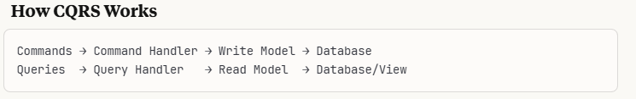
Simple CQRS: Same database, different models/handlers
Advanced CQRS: Separate databases, with eventual consistency between them
When to Use CQRS
- Complex Domain Logic: When business rules for writes are significantly different from read requirements
- Performance Requirements: Read and write workloads have very different performance characteristics
- Scalability Needs: Read and write operations need independent scaling
- Different Teams: Separate teams handling read vs write functionality

Q How would you design reporting when data is spread across multiple services?

Primary Design Patterns

1. Data Lake/Warehouse Approach
Extract data from all services into a centralized analytical store:
Implementation:
- Use ETL/ELT pipelines to extract data from service databases
- Transform and load into a data warehouse (Snowflake, BigQuery, Redshift)

2. Event-Driven Reporting (Event Sourcing)
Services publish events that feed into reporting systems:
Implementation:
- Services emit domain events to message streams
- Reporting service consumes events to build materialized views
- Reports query these pre-built views

🔹 3. Communication & Messaging
- Difference between synchronous (HTTP/gRPC) and asynchronous (Kafka/RabbitMQ) communication.
- What is event-driven architecture and how does it help microservices?
- How do you handle message retries, duplicates, and ordering issues in message brokers?

🔹 4. Deployment & DevOps
- How do you deploy microservices? Docker, Kubernetes experience?
- What is a service discovery mechanism and how is it implemented (e.g., Consul, Eureka, Kubernetes DNS)?
- How do you perform blue-green or canary deployments in microservices?

🔹 5. Scalability & Reliability
- How do you scale microservices horizontally?
- How do you ensure fault tolerance? (circuit breaker pattern, retries, fallbacks).
- What’s the difference between load balancing and service discovery?
- How do you handle service failures gracefully?

🔹 6. Observability
- How do you monitor microservices (logs, metrics, distributed tracing)?
- What tools have you used (Prometheus, Grafana, ELK, Azure Application Insights, Jaeger, Zipkin)?
- How do you trace a single request across multiple services?

🔹 7. Security
- How do you secure microservices communication? (OAuth2, JWT, mTLS).
- What is the role of API Gateway in security?
- How do you handle authentication and authorization across microservices?

🔹 8. Real-World Challenges
Expect scenario-based questions like:
- You have multiple services dependent on each other. One service is down — how will you prevent cascading failures?
- How would you migrate a monolithic application to microservices?
- How do you test microservices (unit, integration, contract testing)?
- How do you handle versioning of APIs?

🔹 Sample Interview Questions (based on 4 years exp)
- Can you walk me through a project where you implemented microservices?
- How did you decide on service boundaries?
- What communication patterns did you use and why?
- Did you face data consistency issues? How did you solve them?
- What tools did you use for deployment and monitoring?
- How did you handle security between services?
- If two services need to update data atomically, how do you ensure consistency?
- Explain circuit breaker and retry logic in microservices.

