Problem Statement 1
- API Data Retrieval and Storage: You are tasked with fetching data from an external REST API, storing it in a local SQLite database, and displaying the retrieved data. The API provides a list of books in JSON format with attributes like title, author, and publication year.
https://github.com/samadhanmane/AccuKnox/blob/main/ps1.py

- Data Processing and Visualization: Given a dataset containing information about students' test scores, fetch the data from an API, calculate the average score, and create a bar chart to visualize the data.

https://colab.research.google.com/drive/1LKmGkaWUWGhdeOZZPvMeY1yHLugpVDOW?usp=sharing

- CSV Data Import to a Database: Write a Python script that reads data from a CSV file containing user information (e.g., name, email) and inserts it into an SQLite database.
https://github.com/samadhanmane/AccuKnox/blob/main/ps3.py

- Send a link to the most complex Python code you have written
Entire codebase written by me except app.py and health_check.py
https://github.com/samadhanmane/MOM-ai

https://github.com/samadhanmane/MOM-ai/blob/main/core/transcriber.py

- Send a link to the most complex database code you have written
https://github.com/samadhanmane/FinExplain/blob/main/backend/app/db/repositories/user_repo.py
1. Self-Rating
Area | Rating
LLM | B
Deep Learning | B
AI | B
ML | B
2. High-Level Architecture of an LLM-Based Chatbot
A basic LLM chatbot can be designed as:
User → Frontend → Backend/API → Guardrails & Validation → Token/Prompt/Context Management → LLM → Output Validation → Response
Key Components
1. Frontend
Provides the chat interface where the user sends messages and receives responses.
2. Backend / API
Receives the user's request and manages communication between the frontend, LLM, database, and other services.
3. Authentication & Session Management
Handles user authentication and maintains the user's conversation/session.
4. Input Validation & Guardrails
Checks the user's input before sending it to the LLM. Guardrails can help block harmful, malicious, irrelevant, or out-of-scope queries.
5. Conversation Memory
Maintains relevant previous messages so the chatbot can understand the context of the ongoing conversation.
6. Token/Prompt & Context Management
The backend prepares the input given to the LLM, including system instructions, the user query, and relevant conversation context. To reduce unnecessary token usage, it can limit conversation history, summarize or truncate long inputs, set a token budget, remove unnecessary context, use smaller or cheaper models for simple queries, and cache repeated responses or context where appropriate. This helps control token usage, cost, and latency while keeping the required context for generating a useful response.
7. LLM
Processes the user's query and available context and generates the response.
8. Output Validation & Guardrails
The generated response can be checked for unsafe, structured output or inappropriate content before it is shown to the user.
9. Monitoring & Logging
Tracks errors, latency, token usage, and other metrics to monitor the chatbot's performance and reliability.
High-Level Flow
User
↓
Frontend
↓
Backend / API
↓
Authentication + Input Validation + Guardrails
↓
Conversation Memory + Token/Prompt/Context Management
↓
LLM
↓
Output Validation + Guardrails
↓
Response
Question is specific about only chatbot. For more advanced use cases, components such as RAG, vector databases, external APIs, or agentic tool calling can be added depending on the application's requirements.

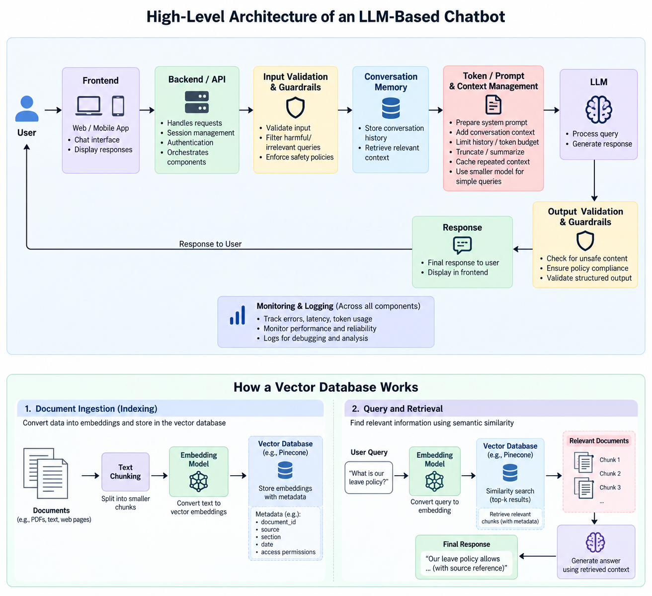

3. Vector Databases

A vector database is used to store and search vector embeddings, which are numerical representations of data such as text or documents.
Unlike traditional keyword search, vector databases can find information based on semantic similarity.
For example:
Text → Embedding → Vector Database
A user query is also converted into an embedding, and the system searches for vectors that are most similar to it.
Hypothetical Problem
Suppose I need to build a production level internal company chatbot for a large organization. The chatbot needs to answer questions from thousands of company documents that are continuously updated. It may need to support a large number of concurrent users and provide fast semantic search over the document collection.
I would choose Pinecone as the vector database.
Why Pinecone?
I would choose Pinecone because it is a managed vector database designed for production scale AI applications. It can handle large numbers of vectors, provides similarity search with metadata filtering, and reduces the need to manage the underlying database infrastructure.
For this use case, scalability, low latency retrieval, and easier production management are more important than keeping the architecture minimal.

Resume:
https://drive.google.com/file/d/1dEMVfkCUYY4PEtAwmn-XJwAK8Yo_xc1B/view?usp=drive_link

