# Page 1

GitHub Home page

https://github.com/

## Non-text content Level A

Score: 4

Findings: Fully compliant. No errors.

Tool: Used wave and manual inspection

## 1.2.1. Audio-only and Video-only Level A

Score: 4 (1)

Finding: Not present.

Tool: Firefox.

## 1.2.2. Captions (Pre-recorded audio) Level A

Score: 4 (1)

Finding: Not present.

Tool: Firefox.

## 1.2.3. Audio Description or Media Alternative (Pre-recorded) Level A

Score: 4 (1)

Finding: Not present.

Tool: Firefox.

## 1.2.4. Captions (Live) Level AA

Score: 4 (1)

Finding: Not present.

Tool: Firefox.

## 1.2.5. Audio Description (Pre-recorded) Level AA

Score: 4 (1)

Finding: Not present.

Tool: Firefox.

## 1.3.1. Info and Relationships Level A

Score: 4

Finding: Used Firefox Web developer toolbar for removing styles and Wave for checking html markup is used correctly for elements such as tables, headings, and lists.

Tool: Firefox Web developer toolbar and Wave.

## 1.3.2. Meaningful Sequence Level A

Score: 4

Finding: Fully compliant.

Tool: Checked manually.

## 1.3.3. Sensory Characteristics Level A

Score: 4

Finding: Fully compliant.

Tool: Checked manually.

## 1.3.4 Orientation Level AA

Score: 4

Finding: fully complaint.

Tool: Used responsive design mode in manual inspection Firefox for testing orientation.

## 1.3.5 Identify Input Purpose Level AA

Score: 4

Finding: Fully compliant.

Tool: Checked manually.

## 1.4.1 Use of Color Level A

Score: 4

Finding: Fully compliant. Checked whole pages and forms.

Tool: Checked manually.

## 1.4.2 Audio Control Level A

Score: 4 (1)

Finding: Not present.

Tool: Firefox.

## 1.4.3 Contrast (Minimum) Level AA

Score: 2

Finding: 32 contrast error. One example shown below.

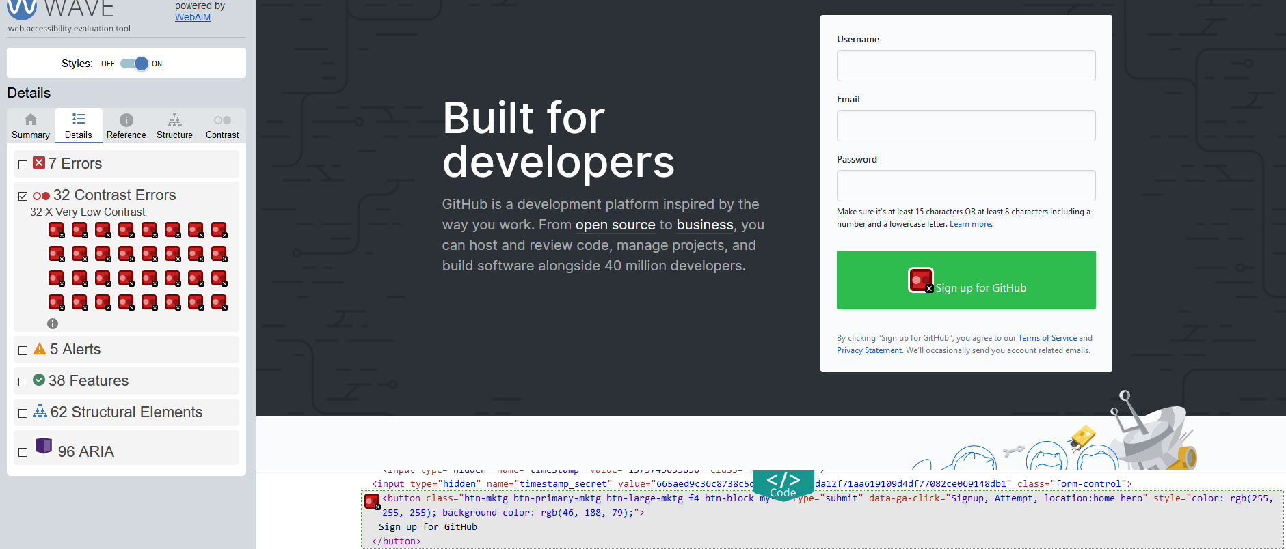

Tool: Used wave.

## 1.4.4 Resize text Level AA

Score: 4

Finding: Fully complaint.

Tool: Firefox Zooming tool.

## 1.4.5 Images of Text Level AA

Score: 4

Finding: Fully complaint. No image of text available.

Tool: Checked manually.

## 1.4.10 Reflow Level AA

Score: 4

Finding: No loss of information or functionality and without scrolling in both directions (horizontal, vertical). Fully compliant.



Tool: Used Firefox and zoomed page for testing.

## 1.4.11 Non-Text Contrast Level AA

Score: 2

Findings: More UI components with low contrast than Graphical objects.

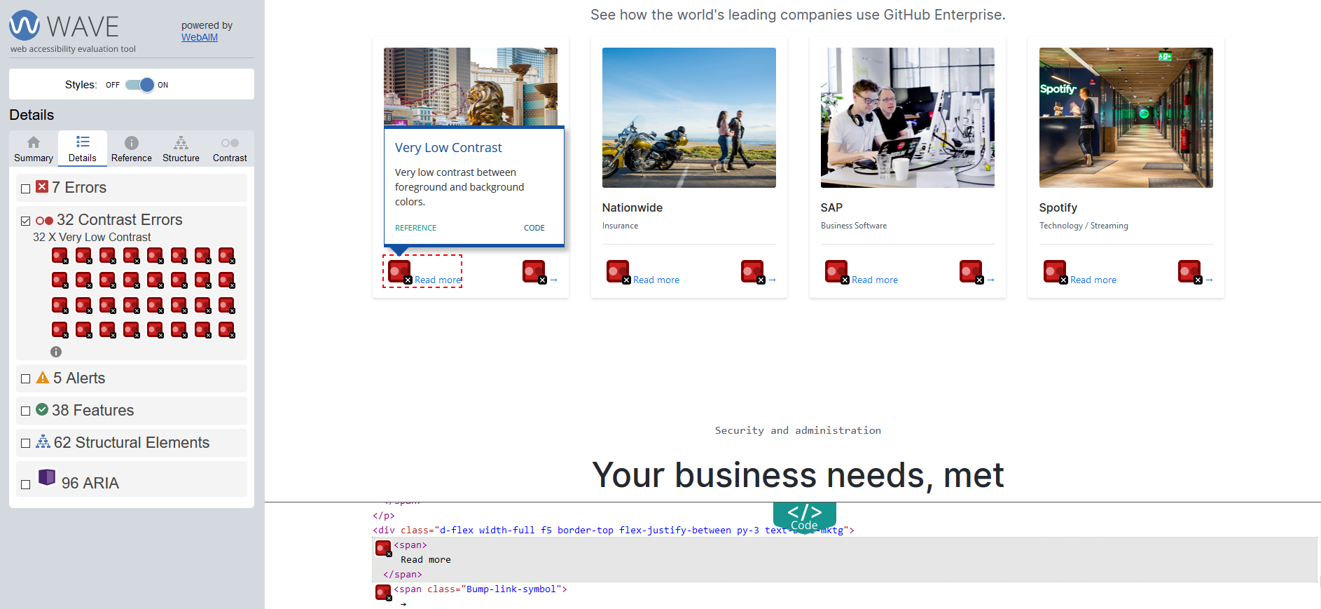

Tool: Used Paciello Group Colour Contrast Analyser or WebAim Contrast Checker for graphical objects and Wave for UI components. Installed for pc and do manual checking for checking not-text contrast.

## 1.4.12 Text Spacing Level AA

Score: 4

Finding: Styling changes made didn’t make content unreadable or cut-off.

Tools: Inserted below code in head-tagg. Used manuall inspection

<style>

* {

line-height: 1.5 !important;

letter-spacing: 0.12em !important;

word-spacing: 0.16em !important;

}

</style>

## 1.4.13 Content on Hover or Focus Level AA

Score: 4

Finding: Content of hover or focus is dismissable, hoverable, and persistent.

Tools: Checked it manually.

## 2.1.1. Keyboard Level A

Score: 4

Finding: Full complaint.

Tools: Checked it manually.

## 2.1.2. No Keyboard Trap Level A

Score: 4

Finding: Full complaint.

Tools: Checked it manually.

## 2.1.4. Character Key Shortcuts Level A

Score: 4 (1)

Finding: Not present.

Tools: Checked it manually.

## 2.2.1 Timing Adjustable Level A

Score: 4 (1)

Finding: No present.

Tool: Checked manually.

## 2.2.2 Pause, Stop, Hide Level A

Score: 4 (1)

Finding: No present.

Tool: Checked manually.

## 2.3.1 Three Flashes or Below Threshold Level A

Score: 4 (1)

Finding: Not present.

Tool: Checked manually.

## 2.4.1 Bypass Blocks Level A

Score: 4

Finding: Skip to main content available.

Tool: Wave or Firefox developer toolbar.

## 2.4.2 Page Titled Level A

Score: 4

Finding: Title tag available.

Tool: Checked manually by seeing the page tab on browser.

## 2.4.3 Focus Order Level A

Score: 4

Finding: compliant.

Tool: Used keyboard tabbing for navigate sequentially through a web page.

## 2.4.4 Link Purpose (In Context) Level A

Score: 2

Finding: Not all link purpose is easily understood from the text link or context. Some links need label/title to understand its purpose. See example below.

<a **href="/pricing"** class="d-block no-underline Bump-link" data-ga-click="Home Enterprise, click, text:Compares plans">**Compare plans** <span class="Bump-link-symbol">→</span></a>

Tool: Firefox and inspection tool.

## 2.4.5 Multiple Ways Level AA

Score: 4

Finding: Full complaint.

Tools: Checked it manually.

## 2.4.6 Headings and Labels Level AA

Score: 3 (Almost 4).

Finding: Two missing labels for input tag which is hidden by css code. Maybe this can be ignored since hidden.

Test: Used Wave for finding out all the headings and labels. Checked manually if headings and labels are clear and easily describes its purpose.

## 2.4.7 Focus Visible Level AA

Score: 4

Finding: Fully compliant.

Test: Checked manually.

## 2.5.1 Pointer Gestures Level A

Score: 4

Finding: Fully compliant. All operations can be performed by a single click.

Test: Checked manually.

## 2.5.2 Pointer Cancellation Level A

Score: 4

Finding: Compliant. Function not available to do pointer cancellation.

Test: Checked manually.

## 2.5.3 Label in Name Level A

Score: 4.

Finding: Fully complaint.

Tool: Used Wave and check manually.

## 2.5.4 Motion Actuation Level A

Score: 4 (1)

Finding: Not present.

Tool: Checked manually.

## 3.1.1 Language of Page Level A

Score: 4

Findings: No errors. Full compliant.

Tool: Used manual inspection.

## 3.1.2 Language of Parts Level AA

Score: 4 (1)

Findings: Not present.

Tool: Viewed and checked content of the page. English language is used for entire page.

## 3.2.1 On Focus Level A

Score: 4

Finding: Fully complaint.

Tool: Checked manually in Firefox.

## 3.2.2 On Input Level A

Score: 4

Finding: Fully complaint.

Tool: Checked manually in Firefox.

## 3.2.3 Consistent Navigation Level AA

Score: 4

Finding: Fully complaint.

Tool: Checked manually in Firefox.

## 3.2.4 Consistent Identification Level AA

Score: 4

Finding: Fully complaint. UI components fully consistent.

Tool: Checked manually in Firefox.

## 3.3.1 Error Identification Level A

Score: 4

Finding: fully complaint. Input error are easily identified and described for correcting.

Tool: Checked manually in Firefox.

## 3.3.2 Labels or Instructions Level A

Score: 4

Finding: Fully complaint.

Tool: Used AChecker to check for form elements that are not (properly) labeled. Checked manually that each form element is clearly labeled.

## 3.3.3 Error Suggestion Level AA

Score: 4

Finding: fully complaint. Show error.

Tool: Checked manually in Firefox.

## 3.3.4 Error Prevention (Legal, Financial, Data) Level AA

Score: 4

Finding: fully complaint.

Tool: Checked manually in Firefox.

## 4.1.1 Parsing Level A

Score: 2

Findings: 37 errors using html validator. No duplicate id found.

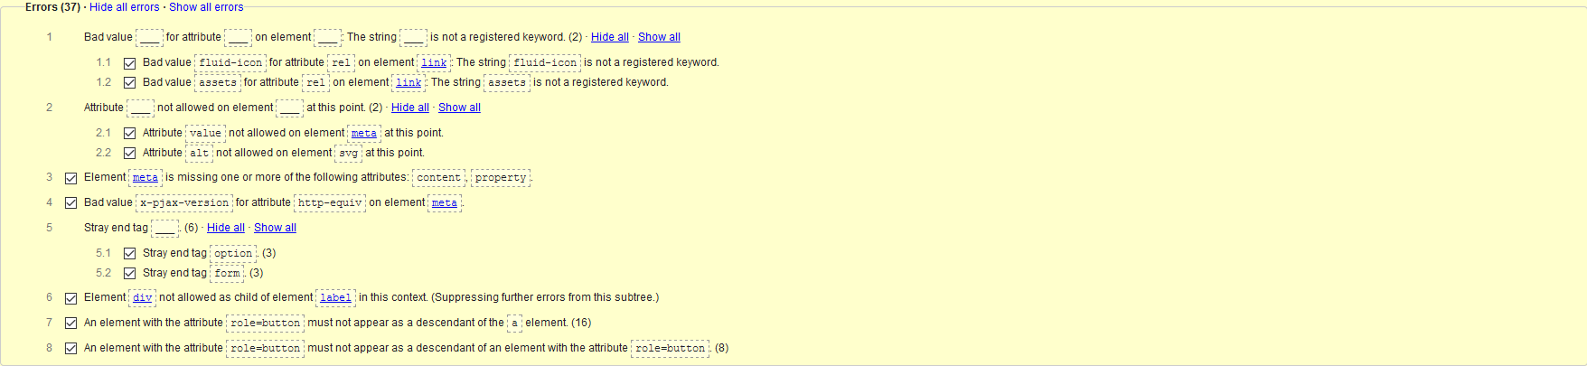

Tool: html validator, axe and Wave.

## 4.1.2 Name, Role, Value Level A

Score: 4

Findings: No error for <div>s and <span>s. No non-standard controls are used.

Tool: Used Axe tool.

## 4.1.3 Status Messages Level AA

Score: 0

Finding: Not compliant. NVDA software cannot read the status messages.

Tool: Used NVDA software and manually checked.

# Page 2

Sign up page

<https://github.com/join>

## Non-text content Level A

Score: 4

Findings: Fully compliant. No errors. Alternative form of CAPTCHA provided for people with visual disabilities.

Tool: Used wave and manual inspection

## 1.2.1. Audio-only and Video-only Level A

Score: 4 (1)

Finding: Not present.

Tool: Firefox.

## 1.2.2. Captions (Pre-recorded audio) Level A

Score: 4 (1)

Finding: Not present.

Tool: Firefox.

## 1.2.3. Audio Description or Media Alternative (Pre-recorded) Level A

Score: 4 (1)

Finding: Not present.

Tool: Firefox.

## 1.2.4. Captions (Live) Level AA

Score: 4 (1)

Finding: Not present.

Tool: Firefox.

## 1.2.5. Audio Description (Pre-recorded) Level AA

Score: 4 (1)

Finding: Not present.

Tool: Firefox.

## 1.3.1. Info and Relationships Level A

Score: 4

Finding: Used Firefox Web developer toolbar for removing styles and Wave for checking html markup is used correctly for elements such as tables, headings, and lists.

Tool: Firefox Web developer toolbar and Wave.

## 1.3.2. Meaningful Sequence Level A

Score: 0

Finding: Sequence in in order but tabbing gets stuck CAPTCHA.

Tool: Checked manually.

## 1.3.3. Sensory Characteristics Level A

Score: 4

Finding: Fully compliant.

Tool: Checked manually.

## 1.3.4 Orientation Level AA

Score: 4

Finding: fully complaint.

Tool: Used responsive design mode in manual inspection Firefox for testing orientation.

## 1.3.5 Identify Input Purpose Level AA

Score: 4

Finding: Fully compliant.

Tool: Checked manually.

## 1.4.1 Use of Color Level A

Score: 4

Finding: Fully compliant. Checked whole pages and forms.

Tool: Checked manually.

## 1.4.2 Audio Control Level A

Score: 4 (1)

Finding: Not present.

Tool: Firefox.

## 1.4.3 Contrast (Minimum) Level AA

Score: 4

Finding: No contrast error.

Tool: Used wave.

## 1.4.4 Resize text Level AA

Score: 4

Finding: Fully complaint.

Tool: Firefox Zooming tool.

## 1.4.5 Images of Text Level AA

Score: 4

Finding: Fully complaint. No image of text available.

Tool: Checked manually.

## 1.4.10 Reflow Level AA

Score: 4

Finding: No loss of information or functionality and without scrolling in both directions (horizontal, vertical). Fully compliant.

Tool: Used Firefox and zoomed page for testing.

## 1.4.11 Non-Text Contrast Level AA

Score: 4

Findings: Fully complaint.

Tool: Used Paciello Group Colour Contrast Analyser or WebAim Contrast Checker for graphical objects and Wave for UI components. Installed for pc and do manual checking for checking not-text contrast.

## 1.4.12 Text Spacing Level AA

Score: 4

Finding: Styling changes made didn’t make content unreadable or cut-off.

Tools: Inserted below code in head-tagg. Used manuall inspection

<style>

* {

line-height: 1.5 !important;

letter-spacing: 0.12em !important;

word-spacing: 0.16em !important;

}

</style>

## 1.4.13 Content on Hover or Focus Level AA

Score: 4

Finding: Content of hover or focus is dismissable, hoverable, and persistent.

Tools: Checked it manually.

## 2.1.1. Keyboard Level A

Score: 0

Finding: Not complaint. Cannot go further with the keyboard after CAPTCHA.

Tools: Checked it manually.

## 2.1.2. No Keyboard Trap Level A

Score: 0

Finding: Not complaint. Cannot go further with the keyboard after CAPTCHA.

Tools: Checked it manually.

## 2.1.4. Character Key Shortcuts Level A

Score: 4 (1)

Finding: Not present.

Tools: Checked it manually.

## 2.2.1 Timing Adjustable Level A

Score: 4 (1)

Finding: No present.

Tool: Checked manually.

## 2.2.2 Pause, Stop, Hide Level A

Score: 4 (1)

Finding: No present.

Tool: Checked manually.

## 2.3.1 Three Flashes or Below Threshold Level A

Score: 4 (1)

Finding: Not present.

Tool: Checked manually.

## 2.4.1 Bypass Blocks Level A

Score: 4

Finding: Skip to main content available.

Tool: Wave or Firefox developer toolbar.

## 2.4.2 Page Titled Level A

Score: 4

Finding: Title tag available.

Tool: Checked manually by seeing the page tab on browser.

## 2.4.3 Focus Order Level A

Score: 0

Finding: Focus of keyboard gets stuck on CAPTCHA.

Tool: Used keyboard tabbing for navigate sequentially through a web page.

## 2.4.4 Link Purpose (In Context) Level A

Score: 3

Finding: Only few link purposes is easily understood from the text link or context. Some links need label/title to understand its purpose. See example below.

<a **href="/pricing"** class="d-block no-underline Bump-link" data-ga-click="Home Enterprise, click, text:Compares plans">**Compare plans** <span class="Bump-link-symbol">→</span></a>

Tool: Firefox and inspection tool.

## 2.4.5 Multiple Ways Level AA

Score: 4

Finding: Full complaint.

Tools: Checked it manually.

## 2.4.6 Headings and Labels Level AA

Score: 3 (Almost 4).

Finding: One missing label for input tag which is hidden by css code. Maybe this can be ignored since hidden.

<input type="text" name="required_field_14d2" id="required_field_14d2" class="form-control" hidden="hidden">

Test: Used Wave for finding out all the headings and labels. Checked manually if headings and labels are clear and easily describes its purpose.

## 2.4.7 Focus Visible Level AA

Score: 4

Finding: Fully compliant.

Test: Checked manually.

## 2.5.1 Pointer Gestures Level A

Score: 4

Finding: Fully compliant. All operations can be performed by a single click.

Test: Checked manually.

## 2.5.2 Pointer Cancellation Level A

Score: 4

Finding: Compliant. Function not available to do pointer cancellation.

Test: Checked manually.

## 2.5.3 Label in Name Level A

Score: 4.

Finding: Fully complaint.

Tool: Used Wave and check manually.

## 2.5.4 Motion Actuation Level A

Score: 4 (1)

Finding: Not present.

Tool: Checked manually.

## 3.1.1 Language of Page Level A

Score: 4

Findings: No errors. Full compliant.

Tool: Used manual inspection.

## 3.1.2 Language of Parts Level AA

Score: 4 (1)

Findings: Not present.

Tool: Viewed and checked content of the page. English language is used for entire page.

## 3.2.1 On Focus Level A

Score: 4

Finding: Fully complaint.

Tool: Checked manually in Firefox.

## 3.2.2 On Input Level A

Score: 4

Finding: Fully complaint.

Tool: Checked manually in Firefox.

## 3.2.3 Consistent Navigation Level AA

Score: 4

Finding: Fully complaint.

Tool: Checked manually in Firefox.

## 3.2.4 Consistent Identification Level AA

Score: 4

Finding: Fully complaint. UI components fully consistent.

Tool: Checked manually in Firefox.

## 3.3.1 Error Identification Level A

Score: 4

Finding: fully complaint. Input error are easily identified and described for correcting.

Tool: Checked manually in Firefox.

## 3.3.2 Labels or Instructions Level A

Score: 4

Finding: Fully complaint.

Tool: Used AChecker to check for form elements that are not (properly) labeled. Checked manually that each form element is clearly labeled.

## 3.3.3 Error Suggestion Level AA

Score: 4

Finding: fully complaint. Show error.

Tool: Checked manually in Firefox.

## 3.3.4 Error Prevention (Legal, Financial, Data) Level AA

Score: 4

Finding: fully complaint.

Tool: Checked manually in Firefox.

## 4.1.1 Parsing Level A

Score: 3

Findings: 8 errors using html validator. No duplicate id found.

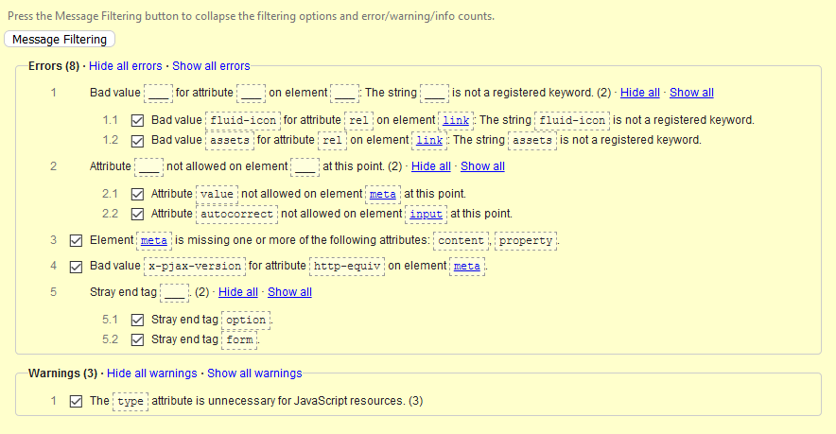

Tool: html validator, axe and Wave.

## 4.1.2 Name, Role, Value Level A

Score: 4

Findings: No error for <div>s and <span>s. No non-standard controls are used.

Tool: Used Axe tool.

## 4.1.3 Status Messages Level AA

Score: 4

Finding: Fully compliant.

Tool: Used NVDA software and manually checked.

# Page 3

Login page

<https://github.com/login>

## Non-text content Level A

Score: 4

Findings: Fully compliant. No errors. Alternative form of CAPTCHA provided for people with visual disabilities.

Tool: Used wave and manual inspection

## 1.2.1. Audio-only and Video-only Level A

Score: 4 (1)

Finding: Not present.

Tool: Firefox.

## 1.2.2. Captions (Pre-recorded audio) Level A

Score: 4 (1)

Finding: Not present.

Tool: Firefox.

## 1.2.3. Audio Description or Media Alternative (Pre-recorded) Level A

Score: 4 (1)

Finding: Not present.

Tool: Firefox.

## 1.2.4. Captions (Live) Level AA

Score: 4 (1)

Finding: Not present.

Tool: Firefox.

## 1.2.5. Audio Description (Pre-recorded) Level AA

Score: 4 (1)

Finding: Not present.

Tool: Firefox.

## 1.3.1. Info and Relationships Level A

Score: 4

Finding: Used Firefox Web developer toolbar for removing styles and Wave for checking html markup is used correctly for elements such as tables, headings, and lists.

Tool: Firefox Web developer toolbar and Wave.

## 1.3.2. Meaningful Sequence Level A

Score: 4

Finding: Fully compliant. Used Firefox Web developer toolbar.

Tool: Checked manually.

## 1.3.3. Sensory Characteristics Level A

Score: 4

Finding: Fully compliant.

Tool: Checked manually.

## 1.3.4 Orientation Level AA

Score: 4

Finding: fully complaint.

Tool: Used responsive design mode in manual inspection Firefox for testing orientation.

## 1.3.5 Identify Input Purpose Level AA

Score: 4

Finding: Fully compliant.

Tool: Checked manually.

## 1.4.1 Use of Color Level A

Score: 4

Finding: Fully compliant. Checked whole pages and forms.

Tool: Checked manually.

## 1.4.2 Audio Control Level A

Score: 4 (1)

Finding: Not present.

Tool: Firefox.

## 1.4.3 Contrast (Minimum) Level AA

Score: 4

Finding: No contrast error.

Tool: Used wave.

## 1.4.4 Resize text Level AA

Score: 4

Finding: Fully complaint.

Tool: Firefox Zooming tool.

## 1.4.5 Images of Text Level AA

Score: 4

Finding: Fully complaint. No image of text available.

Tool: Checked manually

## 1.4.10 Reflow Level AA

Score: 4

Finding: No loss of information or functionality and without scrolling in both directions (horizontal, vertical). Fully compliant.

Tool: Used Firefox and zoomed page for testing.

## 1.4.11 Non-Text Contrast Level AA

Score: 4

Findings: Fully complaint.

Tool: Used Paciello Group Colour Contrast Analyser or WebAim Contrast Checker for graphical objects and Wave for UI components. Installed for pc and do manual checking for checking not-text contrast.

## 1.4.12 Text Spacing Level AA

Score: 4

Finding: Styling changes made didn’t make content unreadable or cut-off.

Tools: Inserted below code in head-tagg. Used manuall inspection

<style>

* {

line-height: 1.5 !important;

letter-spacing: 0.12em !important;

word-spacing: 0.16em !important;

}

</style>

## 1.4.13 Content on Hover or Focus Level AA

Score: 4

Finding: Content of hover or focus is dismissable, hoverable, and persistent.

Tools: Checked it manually.

## 2.1.1. Keyboard Level A

Score: 4

Finding: Full complaint.

Tools: Checked it manually.

## 2.1.2. No Keyboard Trap Level A

Score: 4

Finding: Full complaint.

Tools: Checked it manually.

## 2.1.4. Character Key Shortcuts Level A

Score: 4 (1)

Finding: Not present.

Tools: Checked it manually.

## 2.2.1 Timing Adjustable Level A

Score: 4 (1)

Finding: No present.

Tool: Checked manually.

## 2.2.2 Pause, Stop, Hide Level A

Score: 4 (1)

Finding: No present.

Tool: Checked manually.

## 2.3.1 Three Flashes or Below Threshold Level A

Score: 4 (1)

Finding: Not present.

Tool: Checked manually.

## 2.4.1 Bypass Blocks Level A

Score: 4

Finding: Skip to main content available.

Tool: Wave or Firefox developer toolbar.

## 2.4.2 Page Titled Level A

Score: 4

Finding: Title tag available.

Tool: Checked manually by seeing the page tab on browser.

## 2.4.3 Focus Order Level A

Score: 4

Finding: compliant.

Tool: Used keyboard tabbing for navigate sequentially through a web page.

## 2.4.4 Link Purpose (In Context) Level A

Score: 4

Finding: Full complaint.

Tool: Firefox and inspection tool.

## 2.4.5 Multiple Ways Level AA

Score: 4

Finding: Full complaint.

Tools: Checked it manually.

## 2.4.6 Headings and Labels Level AA

Score: 3 (Almost 4).

Finding: One missing label for input tag which is hidden by css code. Maybe this can be ignored since hidden.

<input type="text" name="required_field_1a57" id="required_field_1a57" class="form-control" hidden="hidden">

Test: Used Wave for finding out all the headings and labels. Checked manually if headings and labels are clear and easily describes its purpose.

## 2.4.7 Focus Visible Level AA

Score: 4

Finding: Fully compliant.

Test: Checked manually.

## 2.5.1 Pointer Gestures Level A

Score: 4

Finding: Fully compliant. All operations can be performed by a single click.

Test: Checked manually.

## 2.5.2 Pointer Cancellation Level A

Score: 4

Finding: Compliant. Function not available to do pointer cancellation.

Test: Checked manually.

## 2.5.3 Label in Name Level A

Score: 4.

Finding: Fully complaint.

Tool: Used Wave and check manually.

## 2.5.4 Motion Actuation Level A

Score: 4 (1)

Finding: Not present.

Tool: Checked manually.

## 3.1.1 Language of Page Level A

Score: 4

Findings: No errors. Full compliant.

Tool: Used manual inspection.

## 3.1.2 Language of Parts Level AA

Score: 4 (1)

Findings: Not present.

Tool: Viewed and checked content of the page. English language is used for entire page.

## 3.2.1 On Focus Level A

Score: 4

Finding: Fully complaint.

Tool: Checked manually in Firefox.

## 3.2.2 On Input Level A

Score: 4

Finding: Fully complaint.

Tool: Checked manually in Firefox.

## 3.2.3 Consistent Navigation Level AA

Score: 4

Finding: Fully complaint.

Tool: Checked manually in Firefox.

## 3.2.4 Consistent Identification Level AA

Score: 4

Finding: Fully complaint. UI components fully consistent.

Tool: Checked manually in Firefox.

## 3.3.1 Error Identification Level A

Score: 4

Finding: fully complaint. Input error are easily identified and described for correcting.

Tool: Checked manually in Firefox.

## 3.3.2 Labels or Instructions Level A

Score: 4

Finding: Fully complaint.

Tool: Used AChecker to check for form elements that are not (properly) labeled. Checked manually that each form element is clearly labeled.

## 3.3.3 Error Suggestion Level AA

Score: 4

Finding: fully complaint. Show error.

Tool: Checked manually in Firefox.

## 3.3.4 Error Prevention (Legal, Financial, Data) Level AA

Score: 4

Finding: fully complaint.

Tool: Checked manually in Firefox.

## 4.1.1 Parsing Level A

Score: 2

Findings: 8 errors using html validator. No duplicate id found.



Tool: html validator, axe and Wave.

## 4.1.2 Name, Role, Value Level A

Score: 4

Findings: No error for <div>s and <span>s. No non-standard controls are used.

Tool: Used Axe tool.

## 4.1.3 Status Messages Level AA

Score: 0

Finding: Not compliant. NVDA software cannot read the status messages.

Tool: Used NVDA software and manually checked.

# Page 4

GitHub after login in. Test different functionality as creating new repository.

<https://github.com/>

## Non-text content Level A

Score: 4

Findings: Fully compliant. No errors.

Tool: Used wave and manual inspection

## 1.2.1. Audio-only and Video-only Level A

Score: 4 (1)

Finding: Not present.

Tool: Firefox.

## 1.2.2. Captions (Pre-recorded audio) Level A

Score: 4 (1)

Finding: Not present.

Tool: Firefox.

## 1.2.3. Audio Description or Media Alternative (Pre-recorded) Level A

Score: 4 (1)

Finding: Not present.

Tool: Firefox.

## 1.2.4. Captions (Live) Level AA

Score: 4 (1)

Finding: Not present.

Tool: Firefox.

## 1.2.5. Audio Description (Pre-recorded) Level AA

Score: 4 (1)

Finding: Not present.

Tool: Firefox.

## 1.3.1. Info and Relationships Level A

Score: 0

Finding: Text overlap and hard to read for after using Firefox Web developer toolbar for removing styles. Used Wave for checking html markup. is used correctly for elements such as tables, headings, and lists.

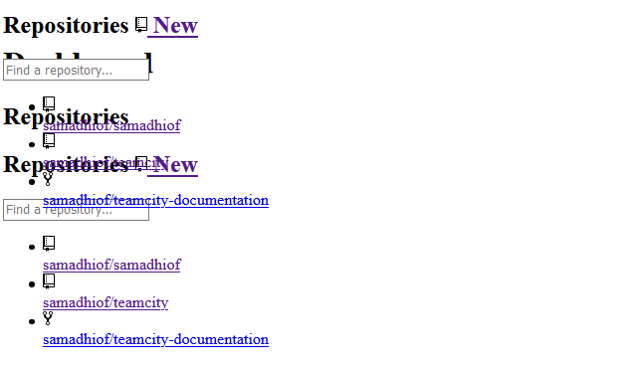

Tool: Firefox Web developer toolbar and Wave.

## 1.3.2. Meaningful Sequence Level A

Score: 0

Finding: Content overlap and hard to read, tabbing order is correct.

Tool: Checked manually.

## 1.3.3. Sensory Characteristics Level A

Score: 4

Finding: Fully compliant.

Tool: Checked manually.

## 1.3.4 Orientation Level AA

Score: 4

Finding: fully complaint.

Tool: Used responsive design mode in manual inspection Firefox for testing orientation.

## 1.3.5 Identify Input Purpose Level AA

Score: 4

Finding: Fully compliant.

Tool: Checked manually.

## 1.4.1 Use of Color Level A

Score: 4

Finding: Fully compliant. Checked whole pages and forms.

Tool: Checked manually.

## 1.4.2 Audio Control Level A

Score: 4 (1)

Finding: Not present.

Tool: Firefox.

## 1.4.3 Contrast (Minimum) Level AA

Score: 3

Finding: one Low Contrast error.

Tool: Used wave.

## 1.4.4 Resize text Level AA

Score: 4

Finding: Fully complaint.

Tool: Firefox Zooming tool.

## 1.4.5 Images of Text Level AA

Score: 4

Finding: Fully complaint. No image of text available.

Tool: Checked manually

## 1.4.10 Reflow Level AA

Score: 0

Finding: Not compliant. No loss of information or functionality but have to scroll in both directions.

Tool: Used Firefox and zoomed page for testing.

## 1.4.11 Non-Text Contrast Level AA

Score: 2

Findings: Not fully compliant. UI components with low contrast.

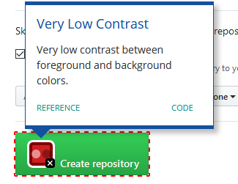

Tool: Used Paciello Group Colour Contrast Analyser or WebAim Contrast Checker for graphical objects and Wave for UI components. Installed for pc and do manual checking for checking not-text contrast.

## 1.4.12 Text Spacing Level AA

Score: 4

Finding: Styling changes made didn’t make content unreadable or cut-off.

Tools: Inserted below code in head-tag. Used manual inspection

<style>

* {

line-height: 1.5 !important;

letter-spacing: 0.12em !important;

word-spacing: 0.16em !important;

}

</style>

## 1.4.13 Content on Hover or Focus Level AA

Score: 4

Finding: Content of hover or focus is dismissable, hoverable, and persistent.

Tools: Checked it manually.

## 2.1.1. Keyboard Level A

Score: 4

Finding: Full complaint.

Tools: Checked it manually.

## 2.1.2. No Keyboard Trap Level A

Score: 4

Finding: Full complaint.

Tools: Checked it manually.

## 2.1.4. Character Key Shortcuts Level A

Score: 4 (1)

Finding: Not present.

Tools: Checked it manually.

## 2.2.1 Timing Adjustable Level A

Score: 4 (1)

Finding: No present.

Tool: Checked manually.

## 2.2.2 Pause, Stop, Hide Level A

Score: 4 (1)

Finding: No present.

Tool: Checked manually.

## 2.3.1 Three Flashes or Below Threshold Level A

Score: 4 (1)

Finding: Not present.

Tool: Checked manually.

## 2.4.1 Bypass Blocks Level A

Score: 4

Finding: Skip to main content available.

Tool: Wave or Firefox developer toolbar.

## 2.4.2 Page Titled Level A

Score: 4

Finding: Title tag available.

Tool: Checked manually by seeing the page tab on browser.

## 2.4.3 Focus Order Level A

Score: 4

Finding: compliant.

Tool: Used keyboard tabbing for navigate sequentially through a web page.

## 2.4.4 Link Purpose (In Context) Level A

Score: 4

Finding: Full complaint.

Tool: Firefox and inspection tool.

## 2.4.5 Multiple Ways Level AA

Score: 4

Finding: Full complaint.

Tools: Checked it manually.

## 2.4.6 Headings and Labels Level AA

Score: 4

Finding: Fully compliant.

Test: Used Wave for finding out all the headings and labels. Checked manually if headings and labels are clear and easily describes its purpose.

## 2.4.7 Focus Visible Level AA

Score: 4

Finding: Fully compliant.

Test: Checked manually.

## 2.5.1 Pointer Gestures Level A

Score: 4

Finding: Fully compliant. All operations can be performed by a single click.

Test: Checked manually.

## 2.5.2 Pointer Cancellation Level A

Score: 4

Finding: Compliant. Function not available to do pointer cancellation.

Test: Checked manually.

## 2.5.3 Label in Name Level A

Score: 4.

Finding: Fully complaint.

Tool: Used Wave and check manually.

## 2.5.4 Motion Actuation Level A

Score: 4 (1)

Finding: Not present.

Tool: Checked manually.

## 3.1.1 Language of Page Level A

Score: 4

Findings: No errors. Full compliant.

Tool: Used manual inspection.

## 3.1.2 Language of Parts Level AA

Score: 4 (1)

Findings: Not present.

Tool: Viewed and checked content of the page. English language is used for entire page.

## 3.2.1 On Focus Level A

Score: 4

Finding: Fully complaint.

Tool: Checked manually in Firefox.

## 3.2.2 On Input Level A

Score: 4

Finding: Fully complaint.

Tool: Checked manually in Firefox.

## 3.2.3 Consistent Navigation Level AA

Score: 4

Finding: Fully complaint.

Tool: Checked manually in Firefox.

## 3.2.4 Consistent Identification Level AA

Score: 4

Finding: Fully complaint. UI components fully consistent.

Tool: Checked manually in Firefox.

## 3.3.1 Error Identification Level A

Score: 4

Finding: fully complaint. Input error are easily identified and described for correcting.

Tool: Checked manually in Firefox.

## 3.3.2 Labels or Instructions Level A

Score: 4

Finding: Fully complaint.

Tool: Used AChecker to check for form elements that are not (properly) labeled. Checked manually that each form element is clearly labeled.

## 3.3.3 Error Suggestion Level AA

Score: 4

Finding: fully complaint. Show error.

Tool: Checked manually in Firefox.

## 3.3.4 Error Prevention (Legal, Financial, Data) Level AA

Score: 4

Finding: fully complaint.

Tool: Checked manually in Firefox.

## 4.1.1 Parsing Level A

Score: 4

Findings: No Errors html validator. No duplicate id found.

Tool: html validator, axe and Wave.

## 4.1.2 Name, Role, Value Level A

Score: 4

Findings: No error for <div>s and <span>s. No non-standard controls are used.

Tool: Used Axe tool.

## 4.1.3 Status Messages Level AA

Score: 4 (1)

Finding: Not present.

Tool: Used NVDA software and manually checked.

# Page 5

GitHub after login in. Getting inside the created repository and testing different section inside the repository such as code, issues, pull requests, actions, projects, security, insights, settings.

<https://github.com/samadhiof/samadhiof> and <https://github.com/samadhiof>

## Non-text content Level A

Score: 3

Findings: Fully compliant. One image missing alternative text

Tool: Used wave and manual inspection

## 1.2.1. Audio-only and Video-only Level A

Score: 4 (1)

Finding: Not present.

Tool: Firefox.

## 1.2.2. Captions (Pre-recorded audio) Level A

Score: 4 (1)

Finding: Not present.

Tool: Firefox.

## 1.2.3. Audio Description or Media Alternative (Pre-recorded) Level A

Score: 4 (1)

Finding: Not present.

Tool: Firefox.

## 1.2.4. Captions (Live) Level AA

Score: 4 (1)

Finding: Not present.

Tool: Firefox.

## 1.2.5. Audio Description (Pre-recorded) Level AA

Score: 4 (1)

Finding: Not present.

Tool: Firefox.

## 1.3.1. Info and Relationships Level A

Score: 4

Finding: Fully compliant.

Tool: Firefox Web developer toolbar and Wave.

## 1.3.2. Meaningful Sequence Level A

Score: 4

Finding: Fully compliant. Used Firefox Web developer toolbar.

Tool: Checked manually.

## 1.3.3. Sensory Characteristics Level A

Score: 4

Finding: Fully compliant.

Tool: Checked manually.

## 1.3.4 Orientation Level AA

Score: 4

Finding: fully complaint.

Tool: Used responsive design mode in manual inspection Firefox for testing orientation.

## 1.3.5 Identify Input Purpose Level AA

Score: 4

Finding: Fully compliant.

Tool: Checked manually.

## 1.4.1 Use of Color Level A

Score: 4

Finding: Fully compliant. Checked whole pages and forms.

Tool: Checked manually.

## 1.4.2 Audio Control Level A

Score: 4 (1)

Finding: Not present.

Tool: Firefox.

## 1.4.3 Contrast (Minimum) Level AA

Score: 2

Finding: More than few contrast issues.

Tool: Used wave.

## 1.4.4 Resize text Level AA

Score: 4

Finding: Fully complaint.

Tool: Firefox Zooming tool.

## 1.4.5 Images of Text Level AA

Score: 4

Finding: Fully complaint. No image of text available.

Tool: Checked manually

## 1.4.10 Reflow Level AA

Score: 0

Finding: Not compliant. No loss of information or functionality but have to scroll in both directions.

Tool: Used Firefox and zoomed page for testing.

## 1.4.11 Non-Text Contrast Level AA

Score: 1

Findings: Not fully compliant. UI components with low contrast.

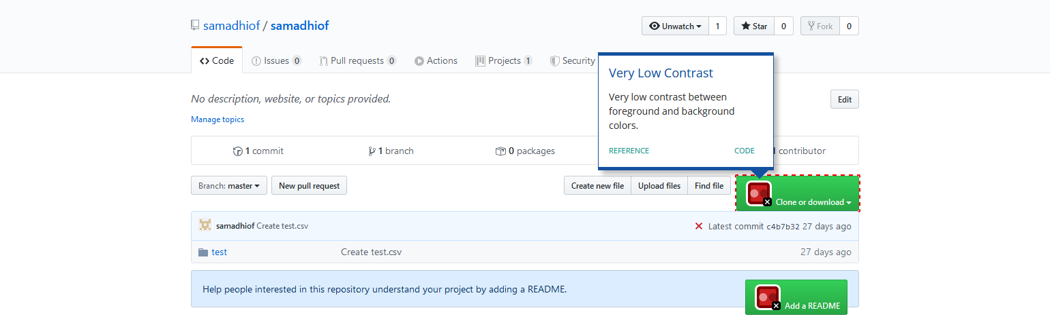

Tool: Used Paciello Group Colour Contrast Analyser or WebAim Contrast Checker for graphical objects and Wave for UI components. Installed for pc and do manual checking for checking not-text contrast.

## 1.4.12 Text Spacing Level AA

Score: 4

Finding: Styling changes made didn’t make content unreadable or cut-off.

Tools: Inserted below code in head-tag. Used manual inspection

<style>

* {

line-height: 1.5 !important;

letter-spacing: 0.12em !important;

word-spacing: 0.16em !important;

}

</style>

## 1.4.13 Content on Hover or Focus Level AA

Score: 4

Finding: Content of hover or focus is dismissable, hoverable, and persistent.

Tools: Checked it manually.

## 2.1.1. Keyboard Level A

Score: 4

Finding: Full complaint.

Tools: Checked it manually.

## 2.1.2. No Keyboard Trap Level A

Score: 4

Finding: Full complaint.

Tools: Checked it manually.

## 2.1.4. Character Key Shortcuts Level A

Score: 4 (1)

Finding: Not present.

Tools: Checked it manually.

## 2.2.1 Timing Adjustable Level A

Score: 4 (1)

Finding: No present.

Tool: Checked manually.

## 2.2.2 Pause, Stop, Hide Level A

Score: 4 (1)

Finding: No present.

Tool: Checked manually.

## 2.3.1 Three Flashes or Below Threshold Level A

Score: 4 (1)

Finding: Not present.

Tool: Checked manually.

## 2.4.1 Bypass Blocks Level A

Score: 4

Finding: Skip to main content available.

Tool: Wave or Firefox developer toolbar.

## 2.4.2 Page Titled Level A

Score: 4

Finding: Title tag available.

Tool: Checked manually by seeing the page tab on browser.

## 2.4.3 Focus Order Level A

Score: 4

Finding: compliant.

Tool: Used keyboard tabbing for navigate sequentially through a web page.

## 2.4.4 Link Purpose (In Context) Level A

Score: 4

Finding: Full complaint.

Tool: Firefox and inspection tool.

## 2.4.5 Multiple Ways Level AA

Score: 4

Finding: Full complaint.

Tools: Checked it manually.

## 2.4.6 Headings and Labels Level AA

Score: 3 (Almost 4).

Finding: One missing label for input tag which is hidden by css code. Maybe this can be ignored since hidden.

<input type="text" name="required_field_c85b" id="required_field_c85b" class="form-control" hidden="hidden">

Test: Used Wave for finding out all the headings and labels. Checked manually if headings and labels are clear and easily describes its purpose.

## 2.4.7 Focus Visible Level AA

Score: 4

Finding: Fully compliant.

Test: Checked manually.

## 2.5.1 Pointer Gestures Level A

Score: 4

Finding: Fully compliant. All operations can be performed by a single click.

Test: Checked manually.

## 2.5.2 Pointer Cancellation Level A

Score: 4

Finding: Compliant. Function not available to do pointer cancellation.

Test: Checked manually.

## 2.5.3 Label in Name Level A

Score: 4.

Finding: Fully complaint.

Tool: Used Wave and check manually.

## 2.5.4 Motion Actuation Level A

Score: 4 (1)

Finding: Not present.

Tool: Checked manually.

## 3.1.1 Language of Page Level A

Score: 4

Findings: No errors. Full compliant.

Tool: Used manual inspection.

## 3.1.2 Language of Parts Level AA

Score: 4 (1)

Findings: Not present.

Tool: Viewed and checked content of the page. English language is used for entire page.

## 3.2.1 On Focus Level A

Score: 4

Finding: Fully complaint.

Tool: Checked manually in Firefox.

## 3.2.2 On Input Level A

Score: 4

Finding: Fully complaint.

Tool: Checked manually in Firefox.

## 3.2.3 Consistent Navigation Level AA

Score: 4

Finding: Fully complaint.

Tool: Checked manually in Firefox.

## 3.2.4 Consistent Identification Level AA

Score: 4

Finding: Fully complaint. UI components fully consistent.

Tool: Checked manually in Firefox.

## 3.3.1 Error Identification Level A

Score: 4

Finding: fully complaint. Input error are easily identified and described for correcting.

Tool: Checked manually in Firefox.

## 3.3.2 Labels or Instructions Level A

Score: 4

Finding: Fully complaint.

Tool: Used AChecker to check for form elements that are not (properly) labeled. Checked manually that each form element is clearly labeled.

## 3.3.3 Error Suggestion Level AA

Score: 4

Finding: fully complaint. Show error.

Tool: Checked manually in Firefox.

## 3.3.4 Error Prevention (Legal, Financial, Data) Level AA

Score: 4

Finding: fully complaint.

Tool: Checked manually in Firefox.

## 4.1.1 Parsing Level A

Score: 2

Findings: No Errors html validator. No duplicate id found.

Tool: html validator, axe and Wave.

## 4.1.2 Name, Role, Value Level A

Score: 4

Findings: No error for <div>s and <span>s. No non-standard controls are used.

Tool: Used Axe tool.

## 4.1.3 Status Messages Level AA

Score: 4 (1)

Finding: Not present.

Tool: Used NVDA software and manually checked.