
FPT- aptech computer education
User Guide
Auto Ancillaries Limited
Group 5
Group Member | Dam Quang Hieu - B00385 - 6222 (Leader)  Nguyen Quy Trong - B00838 - 0068  Nguyen Quy bao - B00839 – 0126
Instructor | Nguyen Ngoc Tu
Batch | C0910G – S4
Semester | 4

- Hanoi, 05/2012 -

Login page
1.1.Login page:
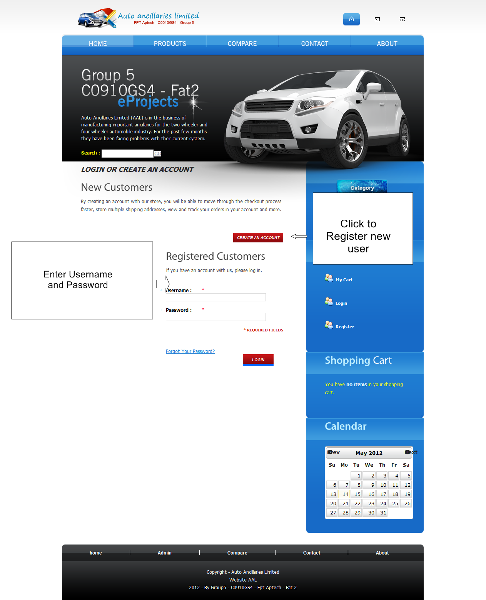

1.2.register page:
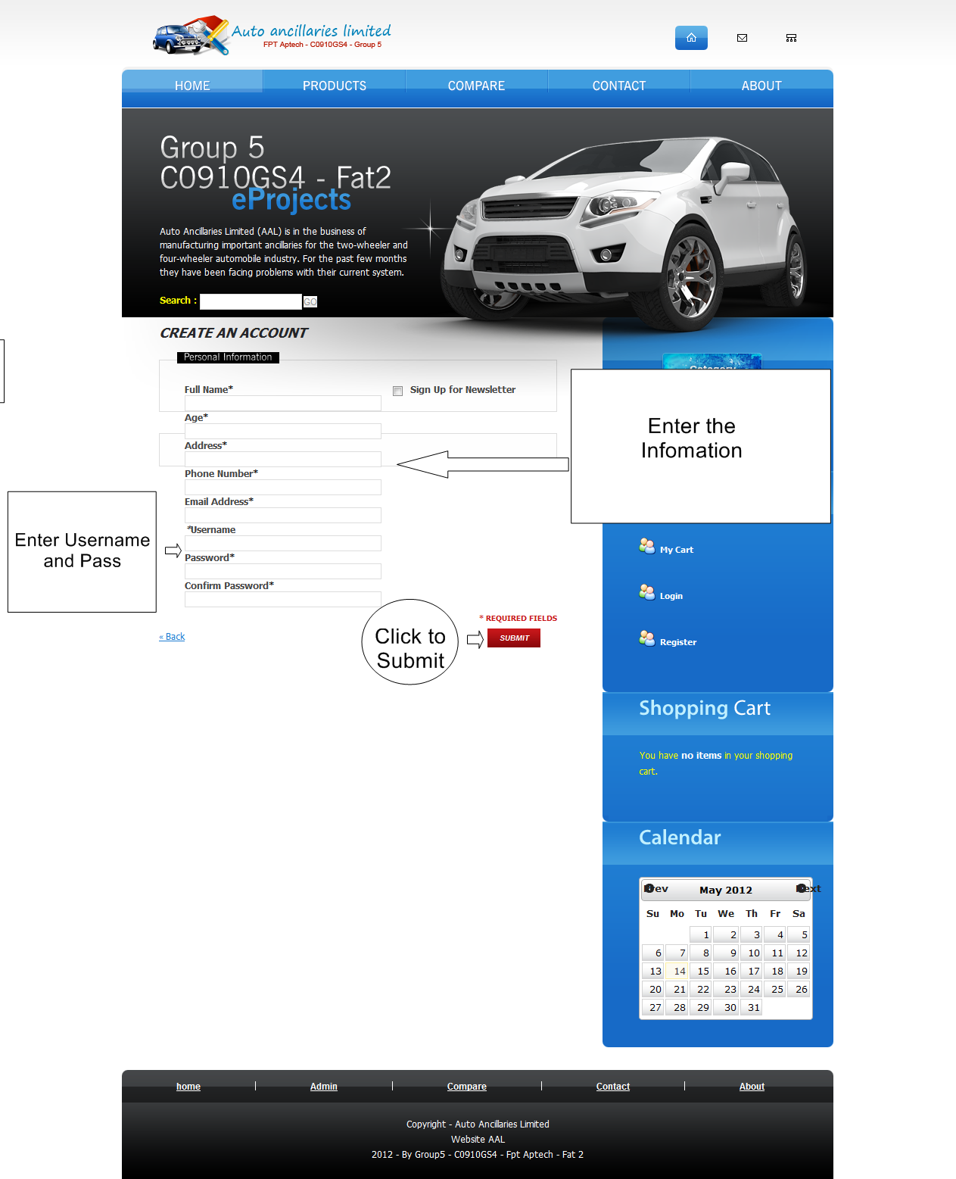

Run Admin page
2.1.View page:
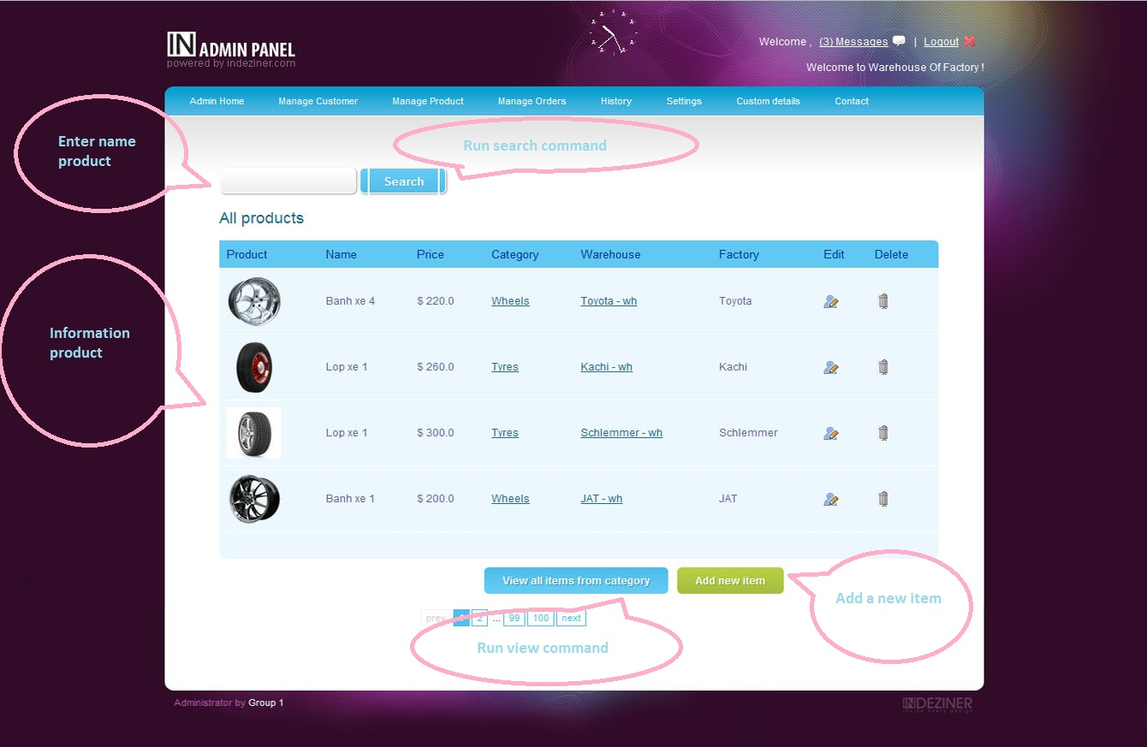

2.2.Add page:
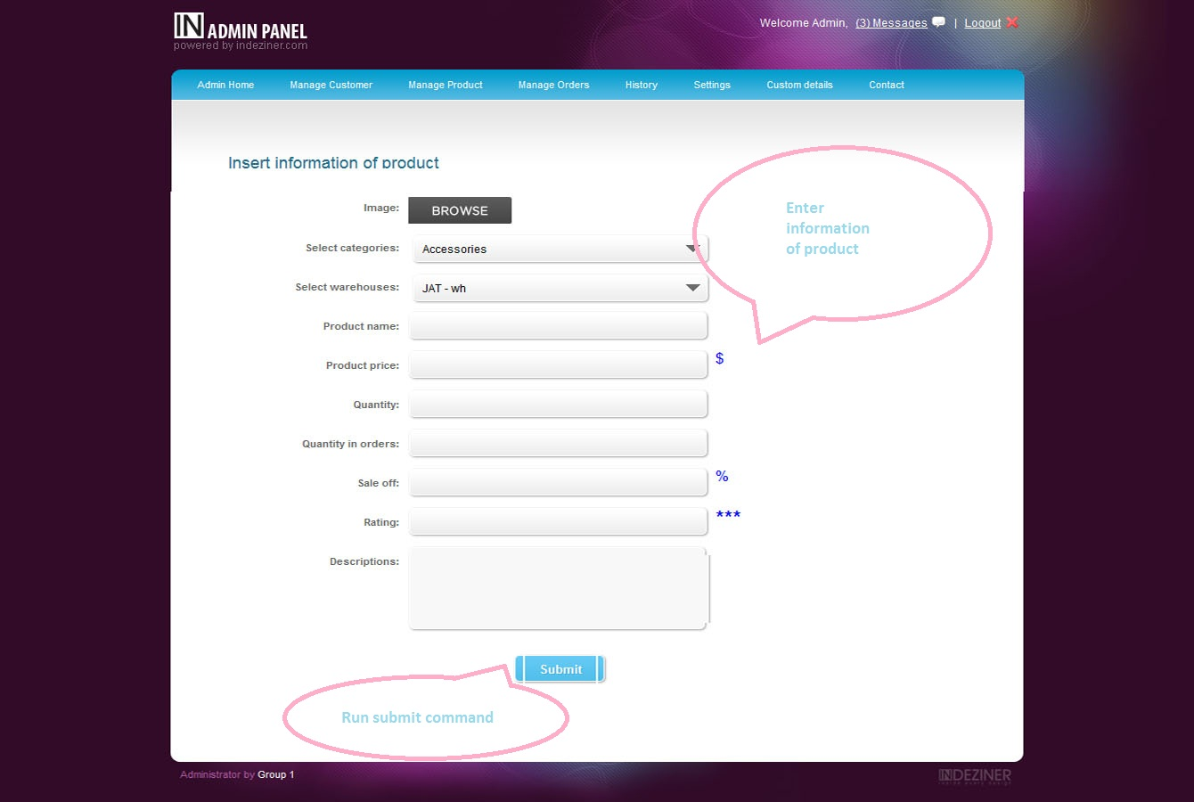

2.3.Edit page:
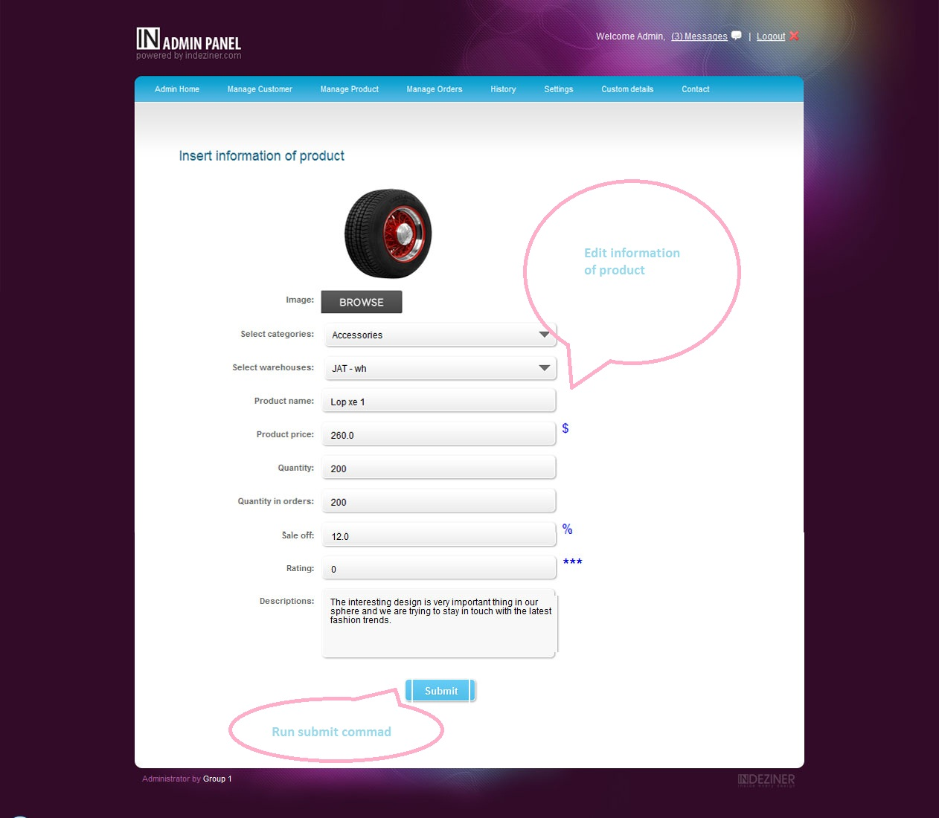

2.4.History page:
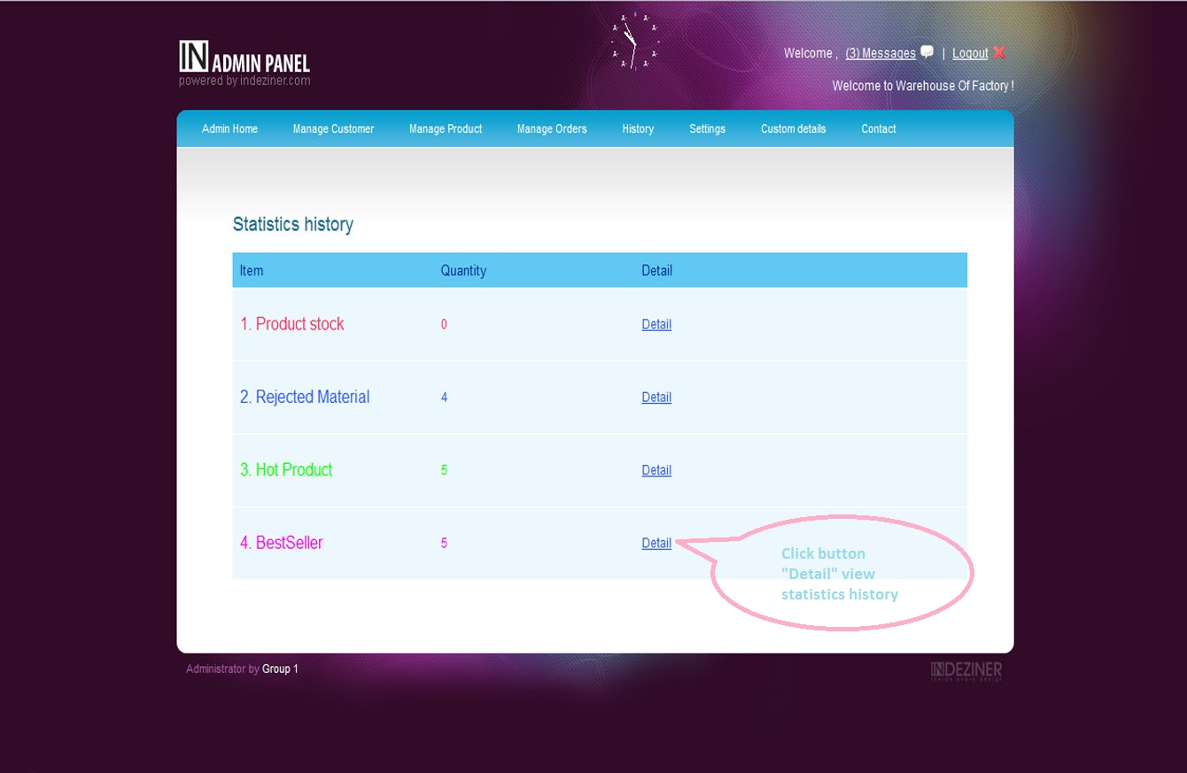

Run Customer page
3.1.Home page:
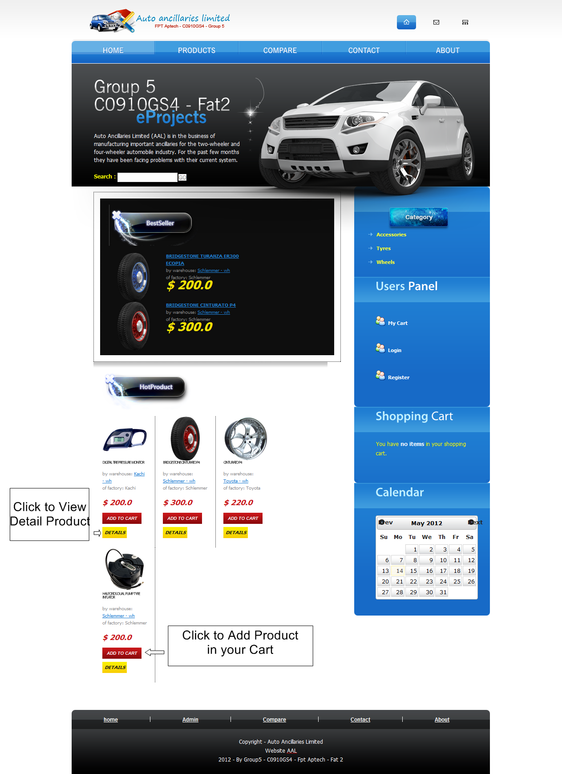

3.2.Product page:
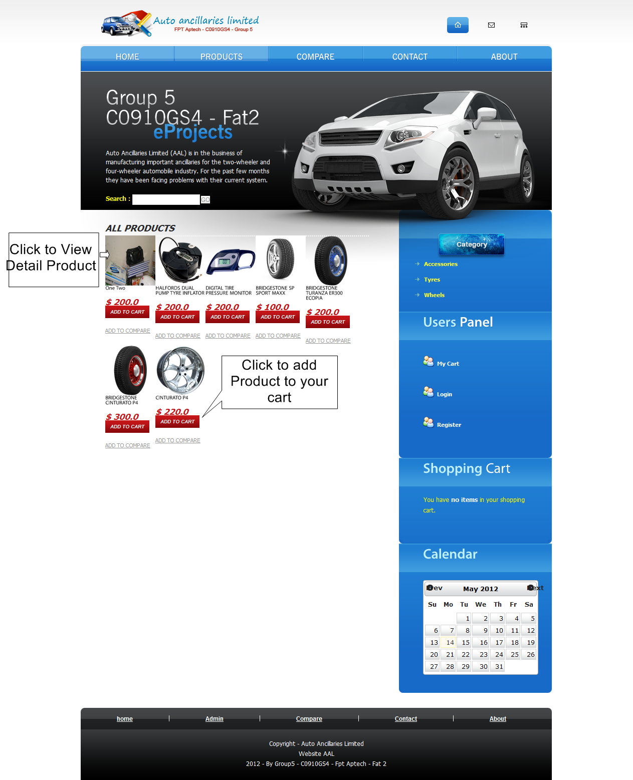

3.3.Details of product page:
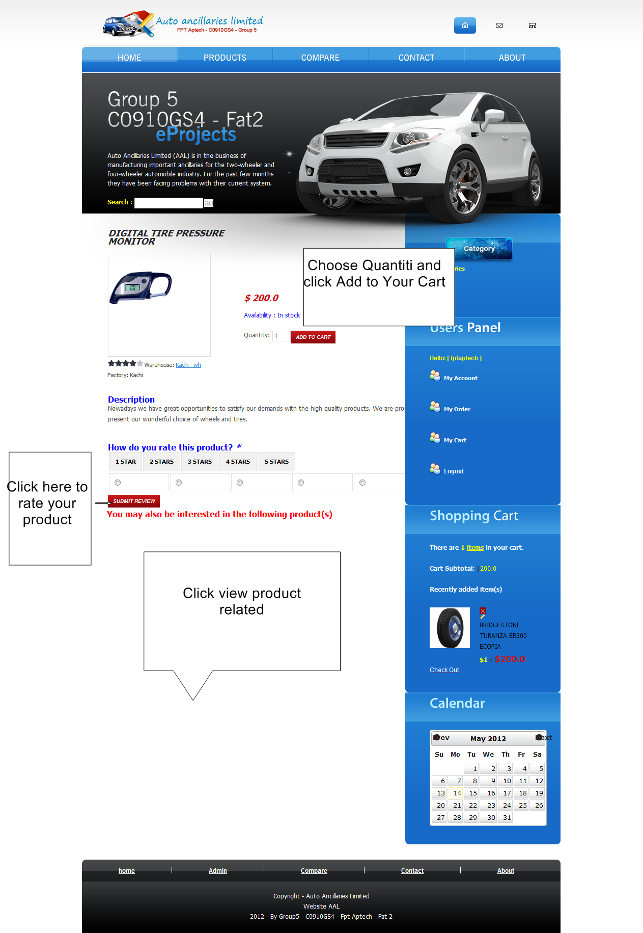

3.4.Compare page:
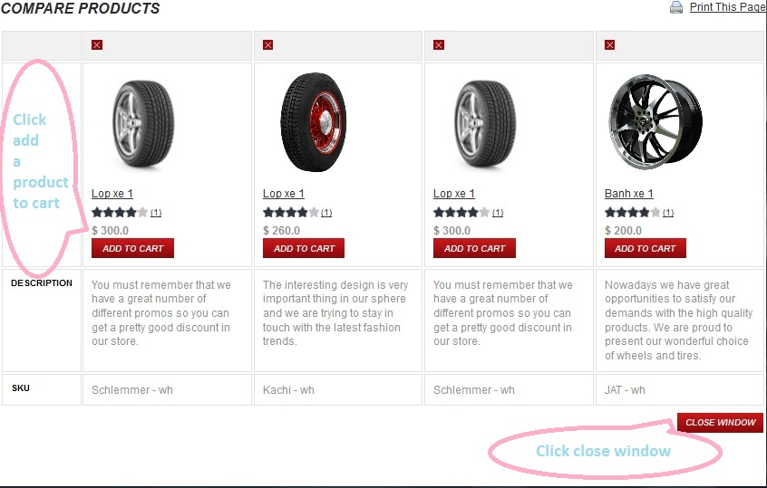

3.5.Cart page:
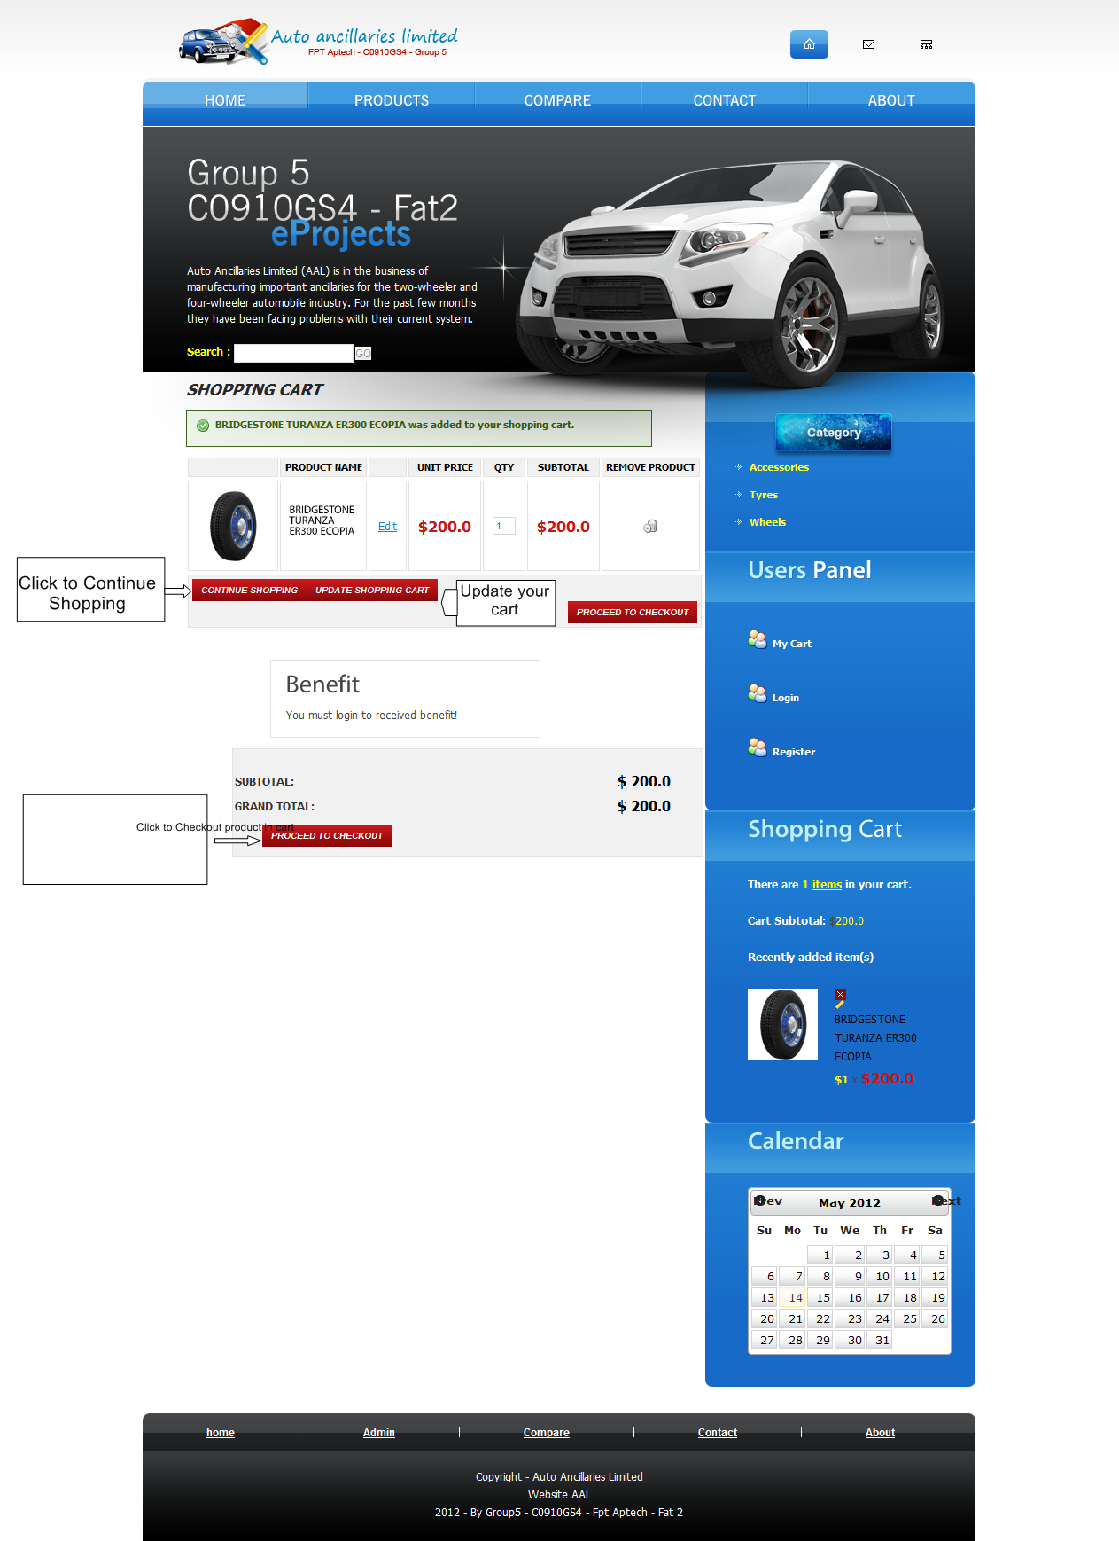

3.6.Checkout page:
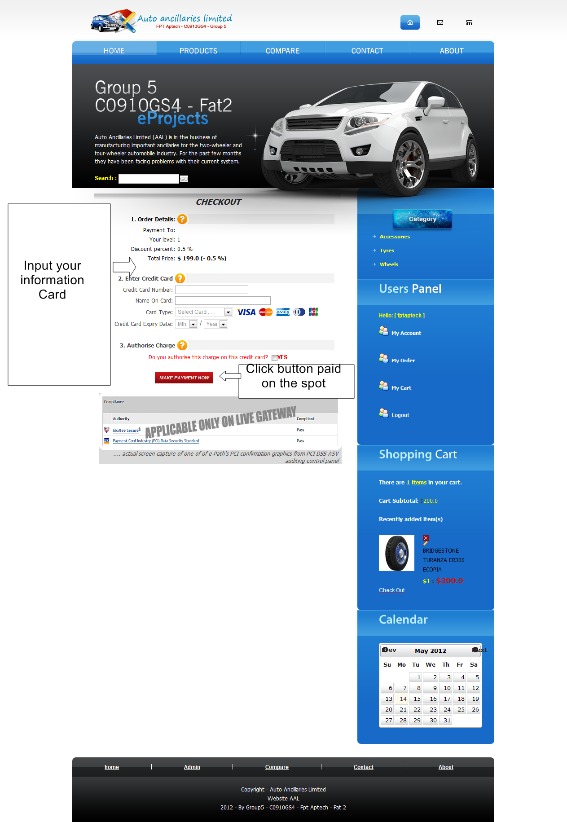

3.7.Order page:
