
FPT- aptech computer education
Install Guide
Auto Ancillaries Limited
Group 5
Group Member | Dam Quang Hieu - B00385 - 6222 (Leader)  Nguyen Quy Trong - B00838 - 0068  Nguyen Quy bao - B00839 – 0126
Instructor | Nguyen Ngoc Tu
Batch | C0910G – S4
Semester | 4

- Hanoi, 05/2012 -

System Requirement:
  - Hardware: Pentium 200 or higher with 200MB of RAM.
  - Software: NetBeans, MS SQL Server 2008 or higher.

Launch:

Open SQL Server 2008 and attach database GROUP5_AAL.mdf.
- Install and Open SQL Server Management Studio.
- Right click Databases choose Attach …

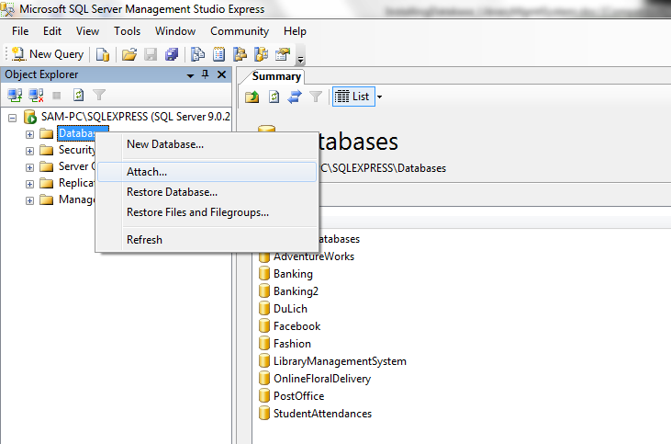

- Browse to the project directory and select GROUP5_AAL.mdf.

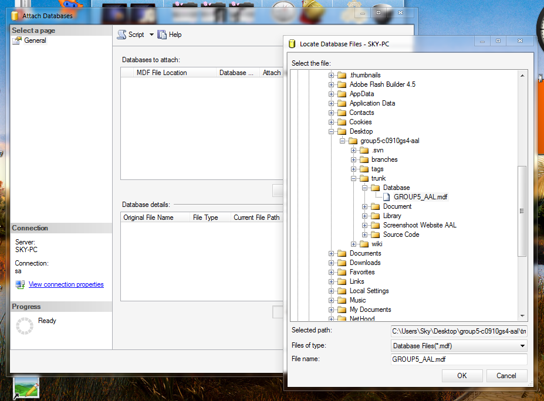

- Click “Ok” button! Installation Database ‘s completed.

- Another way to installation Database, See below:
- Install SQL Server Management Studio.
- Choose “File” -> “Open” -> “File”.

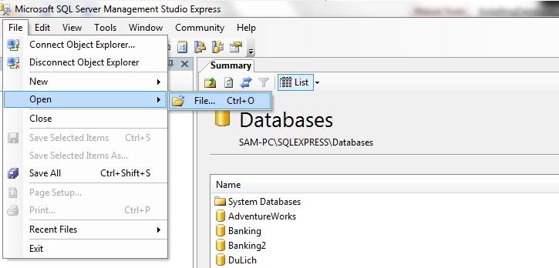

- Browse to the project directory and select “Group5_AAL_CreateDB.sql ” -> “Open”.
- Connect to server.

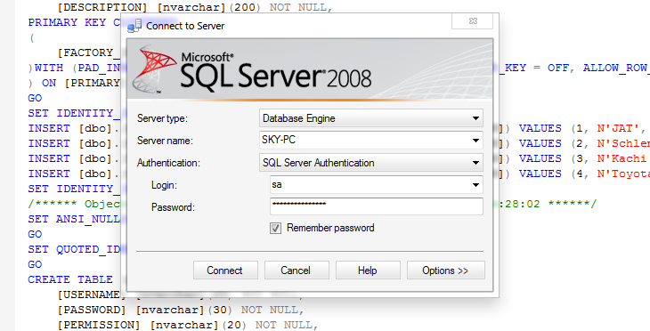

- Execute all query in file ” Group5_AAL_CreateDB.sql ”.

Run Program
- Open NetBeans and choose services -> servers -> GlassFish Server 3.
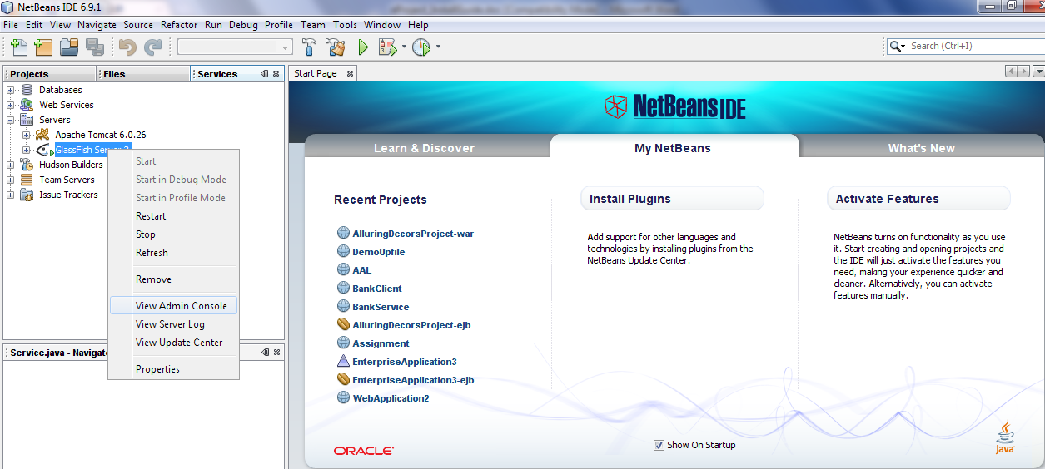

- Click “View Admin Console” -> Applications.
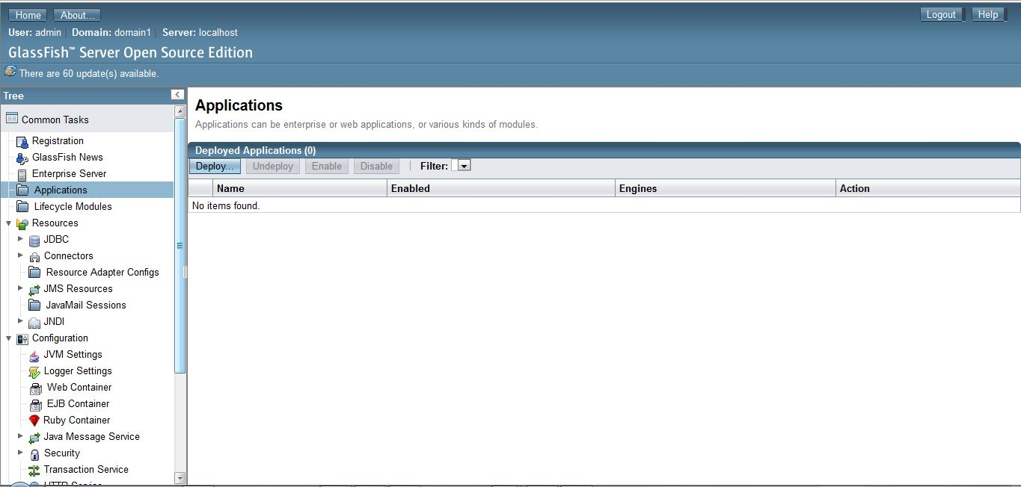
- Browse file “war” in project\dist.
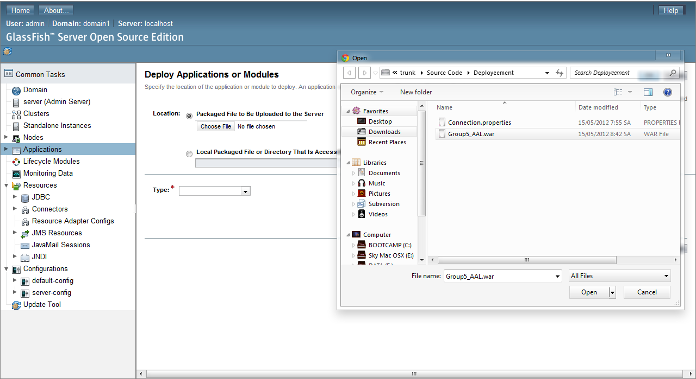
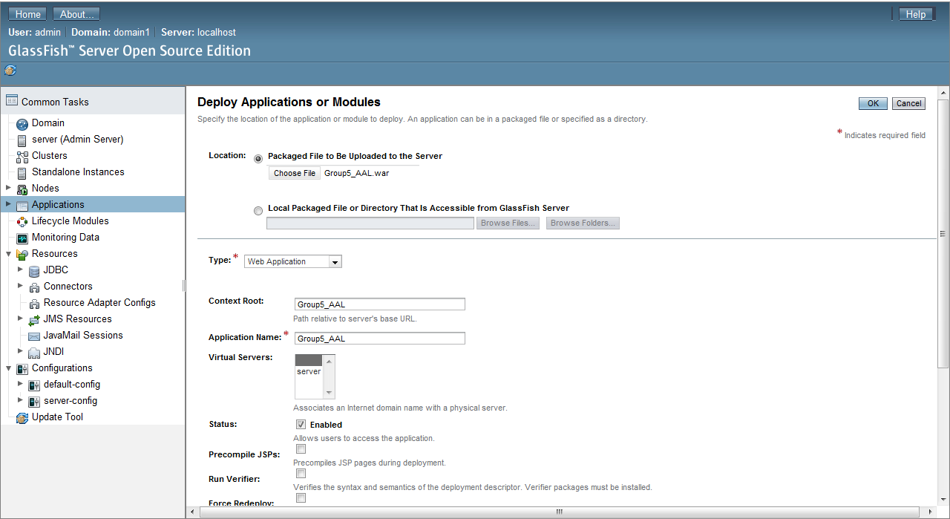

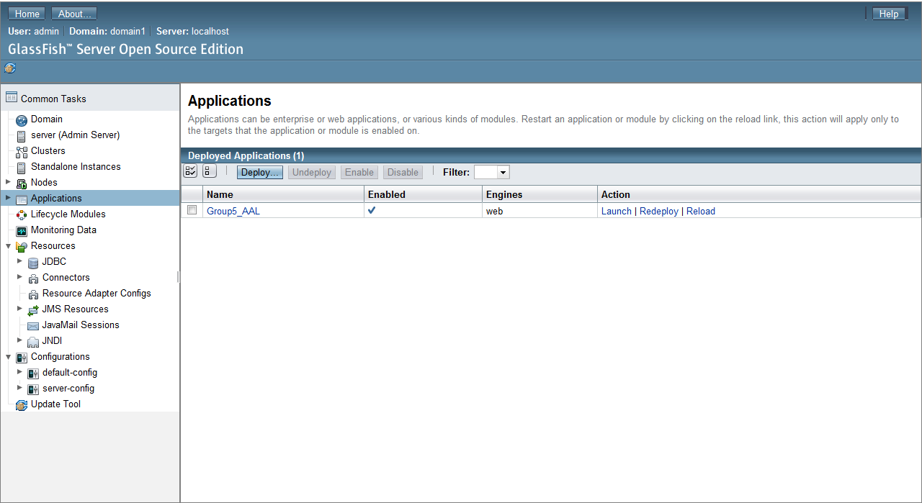
- Then edit connection file Connection.properties in disk C, deployee and run program.(or Click Launch to view page in browser)

