L1 vs L2 Distance

For things with fixed categories - where you would like sparseness in the data, prefer L1 distance - eg: age, income… [1,1,0,0]] preferred over [0.75,0.75,0.75,0.75] in a KNN classifier. Some differences may be big, others can be small
For uniform but smaller magnitude distances - l2 is preferred. Remember - L2 norm is independent of rotation. This should be important
It is interesting to consider differences between the two metrics. In particular, the L2 distance is much more unforgiving than the L1 distance when it comes to differences between two vectors. That is, the L2 distance prefers many medium disagreements to one big one. L1 and L2 distances (or equivalently the L1/L2 norms of the differences between a pair of images) are the most commonly used special cases of a p-norm.

Why does Regularisation work??
Prevents overfitting.
The most appealing property is that penalizing large weights tends to improve generalization, because it means that no input dimension can have a very large influence on the scores all by itself.
max margin property in SVMs

Setting Delta. - SVM. Does not actually matter. Scaling of weights & reg parameter
KNN Classifier - Takes a lot of memory & time to execute
If you wish to apply kNN in practice (hopefully not on images, or perhaps as only a baseline) proceed as follows:

- Preprocess your data: Normalize the features in your data (e.g. one pixel in images) to have zero mean and unit variance. We will cover this in more detail in later sections, and chose not to cover data normalization in this section because pixels in images are usually homogeneous and do not exhibit widely different distributions, alleviating the need for data normalization.
- If your data is very high-dimensional, consider using a dimensionality reduction technique such as PCA (wiki ref, CS229ref, blog ref), NCA (wiki ref, blog ref), or even Random Projections.
- Split your training data randomly into train/val splits. As a rule of thumb, between 70-90% of your data usually goes to the train split. This setting depends on how many hyperparameters you have and how much of an influence you expect them to have. If there are many hyperparameters to estimate, you should err on the side of having larger validation set to estimate them effectively. If you are concerned about the size of your validation data, it is best to split the training data into folds and perform cross-validation. If you can afford the computational budget it is always safer to go with cross-validation (the more folds the better, but more expensive).
- Train and evaluate the kNN classifier on the validation data (for all folds, if doing cross-validation) for many choices of k (e.g. the more the better) and across different distance types (L1 and L2 are good candidates)
- If your kNN classifier is running too long, consider using an Approximate Nearest Neighbor library (e.g. FLANN) to accelerate the retrieval (at cost of some accuracy).
- Take note of the hyperparameters that gave the best results. There is a question of whether you should use the full training set with the best hyperparameters, since the optimal hyperparameters might change if you were to fold the validation data into your training set (since the size of the data would be larger). In practice it is cleaner to not use the validation data in the final classifier and consider it to be burned on estimating the hyperparameters. Evaluate the best model on the test set. Report the test set accuracy and declare the result to be the performance of the kNN classifier on your data.
Linear Classifier
SVM loss gradient - not that easy to code
Whatever features we are using, if the features are not like this:
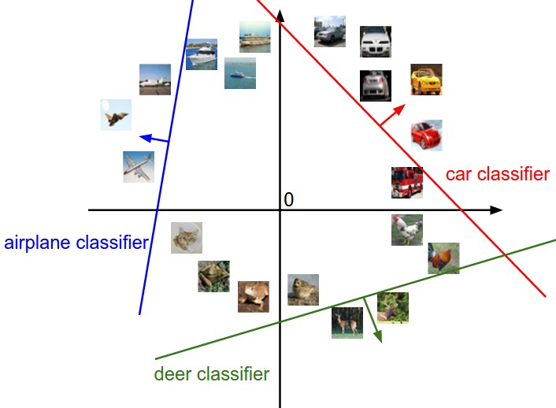
Can be separated by hyperplanes in higher dimensions, Linear classifier will fail

Interpretation of linear classifiers as template matching.
Another interpretation for the weights W is that each row of W corresponds to a template (or sometimes also called a prototype) for one of the classes. The score of each class for an image is then obtained by comparing each template with the image using an inner product (or dot product) one by one to find the one that “fits” best.
Bias trick.

Image data preprocessing. As a quick note, in the examples above we used the raw pixel values (which range from [0…255]). In Machine Learning, it is a very common practice to always perform normalization of your input features (in the case of images, every pixel is thought of as a feature). In particular, it is important to center your data by subtracting the mean from every feature. In the case of images, this corresponds to computing a mean image across the training images and subtracting it from every image to get images where the pixels range from approximately [-127 … 127]. Further common preprocessing is to scale each input feature so that its values range from [-1, 1]. Of these, zero mean centering is arguably more important but we will have to wait for its justification until we understand the dynamics of gradient descent.
Softmax
Same as MLE - maximising. Remember probabilities analogy
Numeric stability. When you’re writing code for computing the Softmax function in practice, the intermediate terms exp(f_{yi}) and ∑_{j} exp(f_{j}) may be very large due to the exponentials. Dividing large numbers can be numerically unstable, so it is important to use a normalization trick. Notice that if we multiply the top and bottom of the fraction by a constant C and push it into the sum, we get the following (mathematically equivalent) expression:

