Automis AI Platform – UX Redesign Brief & Current UI Screens
This document is for the UX/UI designer working on the Automis AI Platform. It explains what we are trying to achieve with the redesign and provides the current product screenshots grouped by main sections of the app.

1. Project Overview
Automis is an AI-powered voice agent platform. Each client gets their own dashboard to manage AI call agents, monitor performance, and control call minutes. The current product is a basic MVP; the main goal of this project is to redesign the experience to be more modern, aligned with the marketing website, and future-proof for richer analytics and self-service features.
Key flows today:
- Log in / register into the platform.
- See call statistics and minute usage.
- Manage AI agents (create, edit, test, delete).
- View call logs and export them.
- Manage account settings and phone number assignments.

2. What We Are Trying to Achieve
The client describes the current UI as "pretty basic" and wants the application to feel more in line with their website style, with a more modern and futuristic look. Functionally, the platform should evolve into a control center where clients can see analytics, demographics, and detailed data for their AI agents, and take actions such as editing agents, listening to calls, and purchasing extra minutes, all from within the app.
High-level objectives:
1. Give users clear visibility and control over their AI agents.
2. Provide rich analytics (call performance, trends, demographics) in a clean, modern UI.
3. Make it easy to scale: more agent configuration options, recordings, billing and quota management.
4. Visually communicate that this is an advanced, AI-driven, future-oriented platform.

3. Desired Design Direction
Visual Style:
- Modern SaaS look, aligned with the Automis marketing website (colors, typography, tone).
- Futuristic but professional: think subtle gradients, clean cards, strong hierarchy, and micro-interactions.
- Clear use of white space and consistent components (cards, tables, charts, filters).
Experience & UX Goals:
- A "mission control"-style dashboard with top-level KPIs, call volume charts, and demographics.
- Easy drill-down from global metrics → agent-level analytics → individual call recordings.
- Obvious minute quota and billing status with an in-platform purchase flow for extra minutes.
- Space for future features such as more advanced agent settings, sentiment analysis, and richer demographics.
Future Dashboard Concept (for inspiration):
- KPI row with cards: Calls Today/This Week/This Month, Success Rate, Active Agents, Minutes Remaining.
- Charts for call volume over time, outcome breakdown, and usage per agent.
- Demographics visuals: map or charts for caller location, language, and time-of-day/weekday patterns.
- Recent calls widget with inline audio player and quick filters.
- Clear Plan & Minutes card with a prominent "Buy more minutes" action.

4. Login Screen
This is the entry point to the platform. Users can toggle between Login and Register, enter email and password, and choose the interface language from the dropdown in the top-right. In the redesigned version, this screen should visually match the website style while clearly communicating the product value and brand.
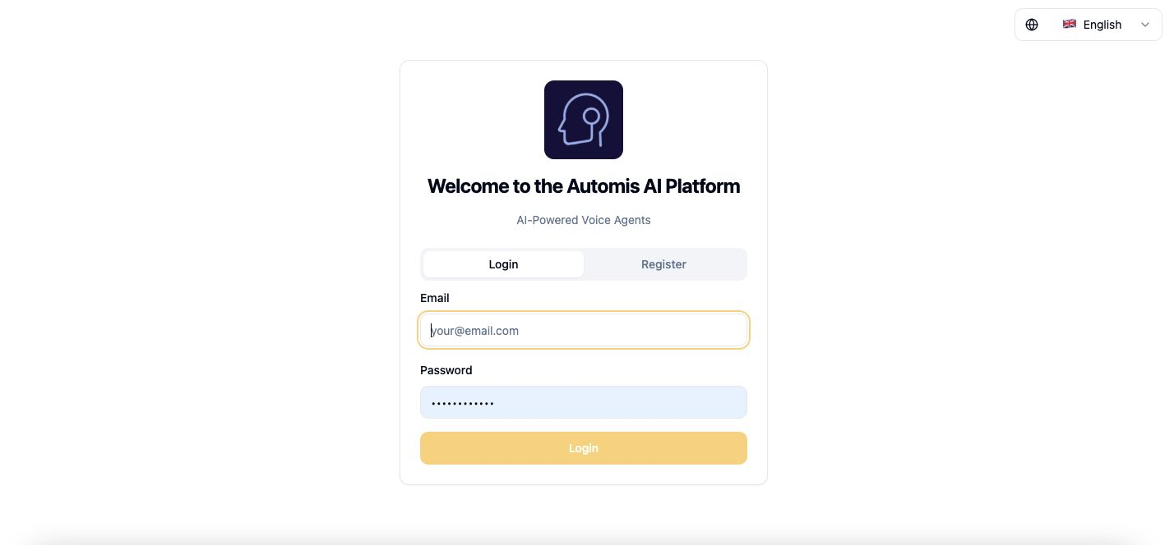

5. Call Dashboard (Current)
This is the current Call Dashboard view. It shows high-level metrics like Calls Today, This Week, This Month, and Total, as well as Call Statistics and Minute Quota. The language selector is in the top-right. In the future design, this should evolve into a richer, futuristic analytics dashboard with demographics, trends, and quick access to key actions.
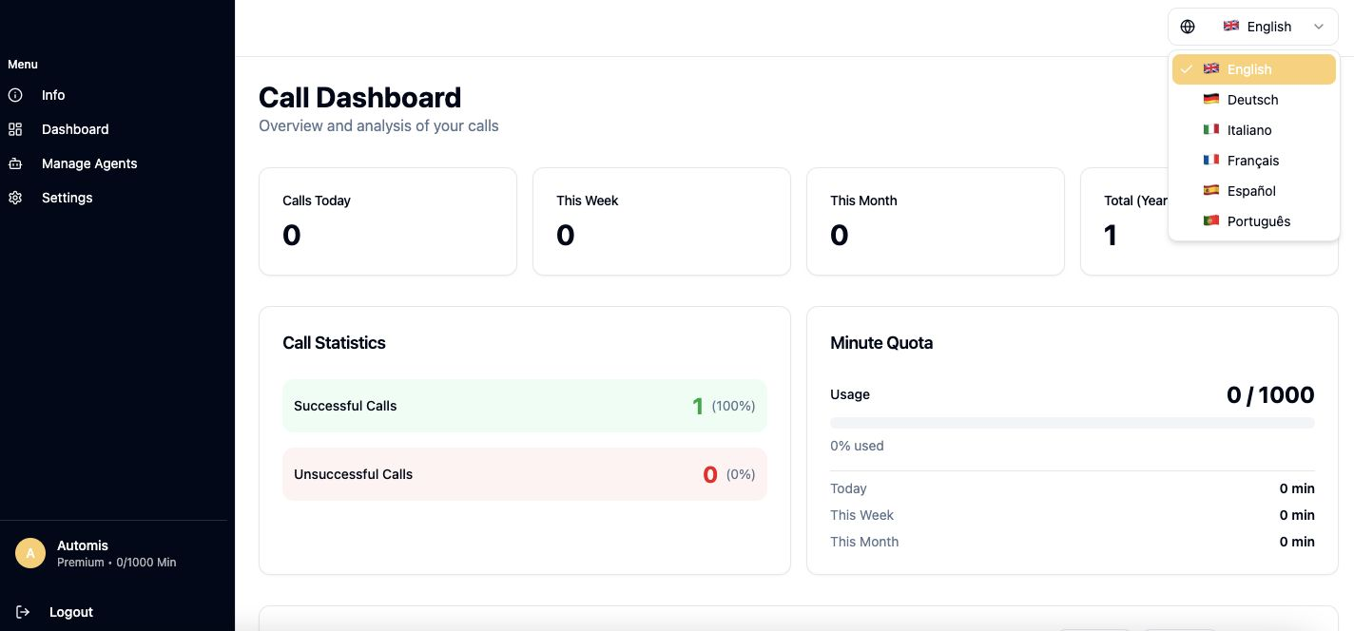

6. Info / Platform Overview
This screen summarizes platform usage with cards for Active Agents, Phone Numbers, and Subscriptions, and includes a Phone Number Assignments section. In the redesign, this could either be merged into the main dashboard or refined as an "Account Overview" with more contextual insights.
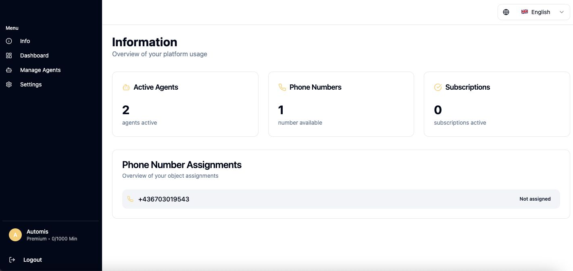

7. Call Logs & Usage Details
This view focuses on more detailed call information. It contains call statistics, usage data, filters for agents and phone numbers, export options (PDF/TXT), and a Call Logs table. In the new design, this section should integrate with the analytics and recording player, with stronger filtering and clearer visual separation of data.
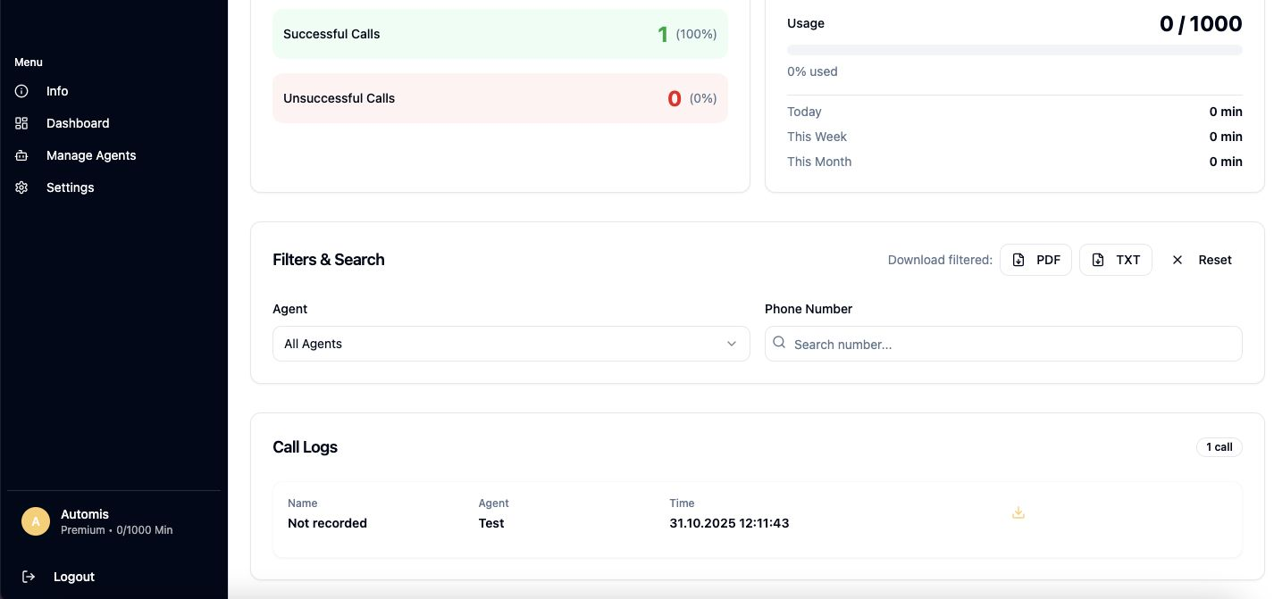

8. Manage Agents
The Manage Agents screen lists each AI agent as a card with name, voice, status (Active/Inactive), and actions such as Edit, Test, and Delete. This is a core area for users. The redesign should make it easy to see agent performance at a glance and to navigate into a detailed Agent view for configuration and analytics.
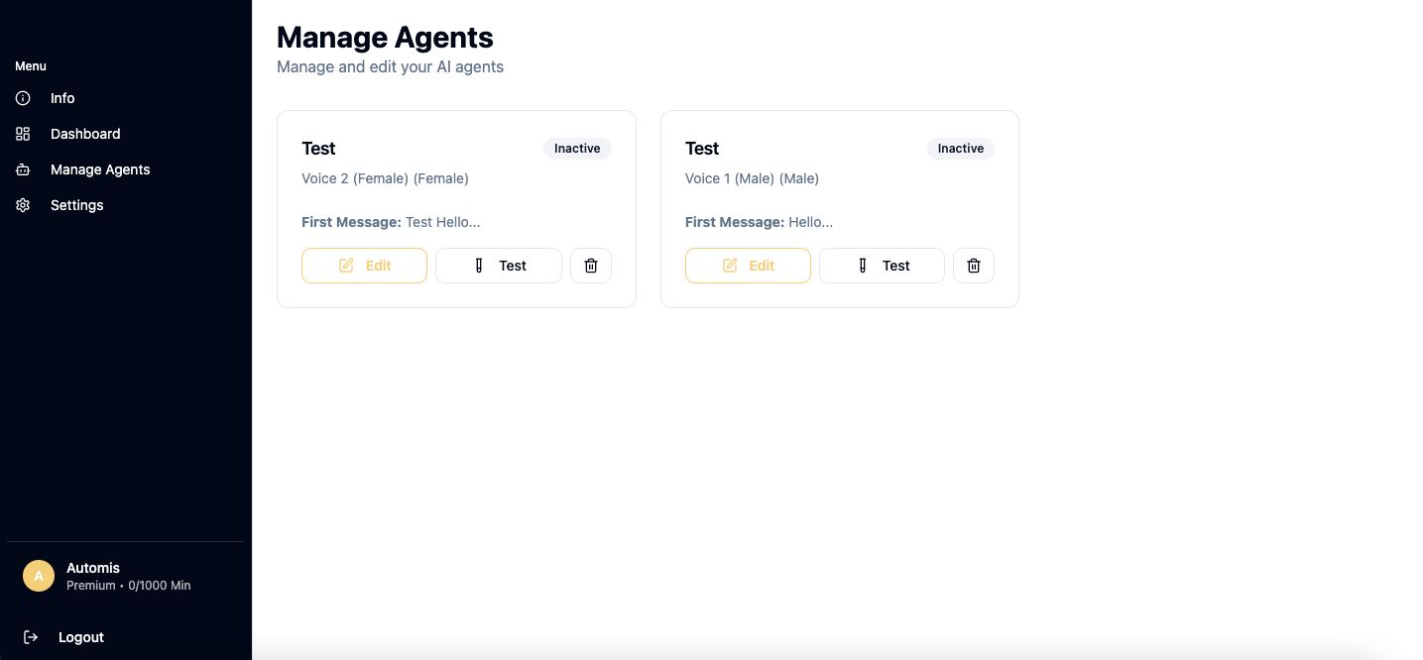

9. Settings & Profile
The Settings page allows users to update profile information (username, company name) and manage phone number assignments. In future iterations, this section will likely hold account, billing, notification, and localization settings, so it should be designed with scalability in mind.
