DOCUMENTATION OF LIQUINET PROGRAM

Basic Concepts

The Program is based on paper “Application of Finite Element computer Program to Water Distribution System Analysis” by Anthony G. Collins. In this program, we have used Darcy Weisbach Equation. Attempts have been made to take into account the effects of Partial closure of Valves and effects of Booster/Pumps on a Pipe Network.

Use of Units in Program

Use of units in the program need to be consistent throughout. That means if m/s² is used as units for acceleration, and kg/m³ is used as units for density, then N s/m² must be used for dynamic viscosity. A table is provided below as a guide as to what units may be used for which kind of values.

Type of Unit | Gravitational  Acceleration | Dynamic  Viscosity | Flow Rate | Internal  Diameter | Roughness | Length | Booster  Head | Opening Percentage of Valve | Head at Node
SI units | m/s² | Ns/m² | m³/s | m | m | m | m | % | m
Recomme-nded value if Any | 9.81 | 1.002 x 10⁻³ (20º C, water) | -- | -- | -- | -- | -- | -- | --
Imperial units | ft/s² | lb_{f} s/ft² | ft³/s | ft | ft | ft | ft | % | ft
Recomme-nded value if Any | 32.174 | 2.035 x 10⁻⁵ (70º F, water) | -- | -- | -- | -- | -- | -- | --

Formulae Used:

For Pipe Segments

Here, h=Head Loss,
f=friction factor,
L=Length,
q=Flow Rate,
g=Gravitational Acceleration,
d=Diameter,
A=Area of Pipe calculated by,
k=Total k factor of Pipe taking into account bend, reducers, valves, etc.

For Boosters

Here, h=Static Head Difference,
H_{d}=Total Head created by the Booster,
q=Flow Rate,
g=Gravitational Acceleration,
A=Area of Pipe calculated by,

For Flow Control Valves

Here, h=Head Loss,
k=Total k factor of Pipe taking into account bend, reducers, etc.,
g=Gravitational Acceleration,
d=Diameter,
A=Area of Pipe calculated by,
o=opening percentage,
n=non-linearity factor.

Background of using Flow Control Valve Formula

For Valves, it is not necessary that flow within the valve be directly proportional to the opening percentage. It may be linear or non-linear (including quick opening and equal percentage).
Solving for in the formula provided for flow control valve we have,

At 100 percent opening we have,

Hence the flow percentage is,

Using the above formula, by initializing ‘n’ as .5, 1, 2 each time, we plot a graph to find the following characteristics for different opening percentages.
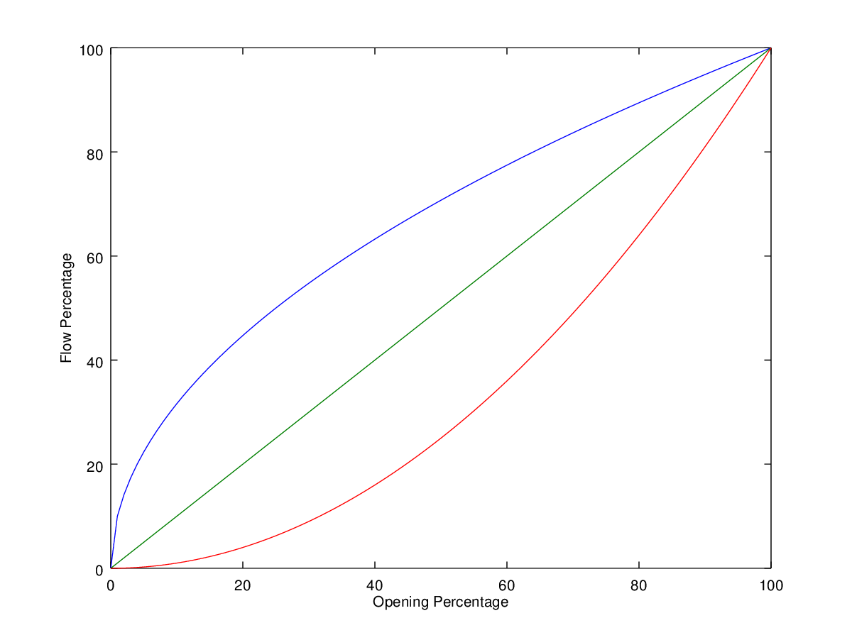
Here, the blue line represents n=.5, green line represents n=1, and red line represents n=2.

An Octave/Matlab program “valve_characteristic.m” used to plot this has been provided in the source files, in the Documentation folder. In the program Diameter, Head Loss, k-factor and gravitational acceleration has been considered as 1 meter, 10 meters, 10 and 9.81 m²/s respectively. Hence, a reasonable approximation of flow characteristics of the valve may be represented if adequate data is available.

Working Principle

The program tries to approximate the solution by linearising the equation similar to the Matrix formas Hereis the Total amount of flow in or out of a particular node.is the head at a certain node.

Method of Calculation for Each Element

In local form, similar to the formhas been considered whereis the flow through the particular element andis the head loss.
We know from Darcy Weisbach equation thatFor sake of better understanding, lets consider the previous equation as
Now consider thatis known andis to be found by using

Refer to the graph above. We start of with an approximated value ofIn the program, this accomplished by asking the user for an approximate value of Reynold’s number from whereis calculated.
- Step 1.
  - Is calculated byand slope
- Step 2
  - Using the slope ofwe calculateas
- Step 3
  - And slope
- Step 4
  - Ifis within approximation range, we stop calculating. Else, we find new slopeand continue to Step 5.
- Step 5
  - We go back to Step 1 and continue the later Steps.Is calculated by replacingIs replaced byandis replaced by

These steps are repeated for every element in each iteration. The instance of the iteration runs till for all elements are within the allowed approximation range.

Formation of Global Matrix

To demonstrate how the global matrix is formed we consider a simple problem given below.

Circles with numbers indicate nodes. Flowsare going into the nodes 1, 2, and 3. Squares with numbers represent elements. In the program for flow going into the node (going into to the pipe network), the values ofshall be positive. For flow coming out of the node (coming out of the pipe network), the values ofshall be negative.
Flows within the pipe are represented byFlow towards a particular node is taken as positive. Flow away from a node is negative.
It is to be noted that head loss within an element or static head difference across any element(as in case of Boosters) is the difference of the Heads of the two nodes at the end of the particular element. Hence, we may write the following as per the flow direction of the liquid.

…..(a)

…..(b)

…..(c)

Whereare the Heads at nodes 1, 2, 3 respectively.
As mentioned under heading “Method of calculation for each element”, we take the following form of consideration for each element.

whereis the head loss/static head difference
&is the booster head contribution or equal to zero (0), if element is otherwise.

Hence, we may form the following equations for each element.

…..(1)

…..(2)

…..(3)

Above, are equal to zero(0).
We have the following equations at each node. Are considered positive below, for the sake of explanation.

…..(4)

…..(5)

…..(6)

Substituting Equations (1), (2) & (3) in (4), (5) & (6) as appropriate, we have the following.

…..(7)

…..(8)

…..(9)

From equations (7), (8) & (9) we can form the following matrix.

Next, values are found out as per equations (1), (2), & (3). Values of are found out as per equations (a), (b) & (c). Next, as stated under heading “Method of calculation for each element”, we check for values for all of. This continues till all of are with the allowed approximation range.

