Atomic Project

**Birthday**

**Birthday**

**Step-1: User Story**

* As a user I want to add birthdates of my employees so that this will show on the list. (C)
* As a user I want to edit birthdates of my employees so that I can correct any mistakes. (U)
* As a user I want to view the birthdates of my employees individually. (RS)
* As a user I want to view the list of birthdates of all my employees that I can wish them on their birthday. (RM)
* As a user I want to delete birthdates of my Ex-employees from the list. (D)

**Step2: Use Case**

**Add birthdays:**

|  |  |  |
| --- | --- | --- |
| **Requirements** | **Key Features** | **Acceptance Criteria** |
| As a user I want to add birthdates of my employees so that this will show on the list.  . | To make a user friendly, Data should be saved without refreshing page. (Ajax) | 1.    Only user can add birthdates of employees without any problem.(Core features)  2.    User should see the success/failure message. (Message)  3.    Birthday must be in date format. **DD-MMM-YYYY** format must be used for validate the field. (Format Validation)  4.    No empty value is accepted.(Empty Validation)  5.    Input should be Sanitized to secure the application  (Sanitization)  6.   In case of invalid input JavaScript message should be displayed. (Usability/User Friendly Interface)  7. Use relevant picture to use as a submit button.(Look)  8. User to reset form content anytime. |

**Edit birthdays:**

|  |  |  |
| --- | --- | --- |
| **Requirements** | **Key Features** | **Acceptance Criteria** |
| As a user I want to edit birthdates of my employees so that I can correct any mistakes. | To make a user friendly, Data should be saved without refreshing page. (Ajax) | 1.   User can edit the birthdates of employees without any problem.(Core features)  2.    User should see the success/failure message. (Message)  3.     Birthday must be in date format. **DD-MMM-YYYY** format must be used for validate the field. (Format Validation)  4.     No empty value is accepted.(Empty Validation)  5.     Input should be Sanitized to secure the application  (Sanitization)  6.     In case of invalid input JavaScript message should be displayed. (Usability/User Friendly Interface) |

**View birthdays(individually):**

|  |  |  |
| --- | --- | --- |
| **Requirements** | **Key Features** | **Acceptance Criteria** |
| As a user I want to view the birthdates of my employees individually. |  |  |

**View birthdays of all employees (list view):**

|  |  |  |
| --- | --- | --- |
| **Requirements** | **Key Features** | **Acceptance Criteria** |
| As a user I want to view the list of birthdates of all my employees so that I can wish them on their birthday. |  | 1.      Birthdates should be in  list format.  2.      Birthdates should be  listed in monthly order.  3. Last entered birthdates  should load first.  4. List should be paginated.  5. User can choose  Number of items to be  shown per page from a  dropdown list. |
| As a user I want to download the birthday list as XLS file. |  |  |
| As a user I want to download the birthday list as PDF file. |  |  |
| As a user I want to wish my employees on their birthdates via email. |  |  |
|  |  |  |

**Delete birthdays of ex-employees:**

|  |  |  |
| --- | --- | --- |
| **Requirements** | **Key Features** | **Acceptance Criteria** |
| As a user I want to delete birthdates of my Ex-employees from the list. |  | 1.    Confirmation message should be displayed.  2.    After successfully deletion a message should be displayed. |

**User Friendly Navigation:**

|  |  |  |
| --- | --- | --- |
| **Requirements** | **Key Features** | **Acceptance Criteria** |
| As a user I want to have user friendly navigation so that I can browse the site easily. |  | 1.    There should be two button at the bottom of add form. (1. Add, 2. Save & add)  **1. A)** User should see the list of birthdates if clicked on “Add” button.  **1. B)** User should stay on the adding form if clicked on “Save & Add” button.  2.    User should see the list of birthdates after edit/update info.  3.     User should stay on the list of birthdates after deleted any employee’s birthday.  4.    User can back to list page using back button, from edit, details page. |

**Step 3: Robustness Diagram**

**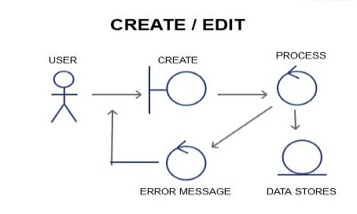**

**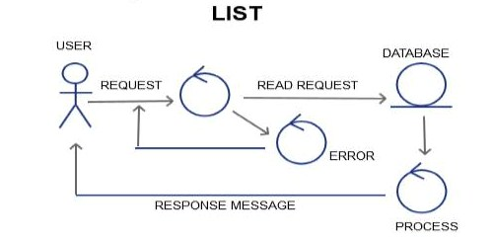**

**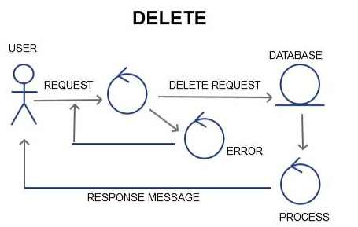**

**Class Diagram:**

**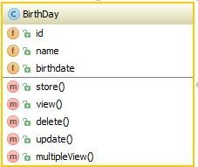**

#### Sequence Diagram:

#### Create/add /edit

#### C:\Users\Rumpa\Desktop\Untitled.png

DATABASE

PROCESS

USER/GUI

Storing Data to DB

Sanitization

Empty Validation

Format Validation

Validation Failure

Response Message

Add Request

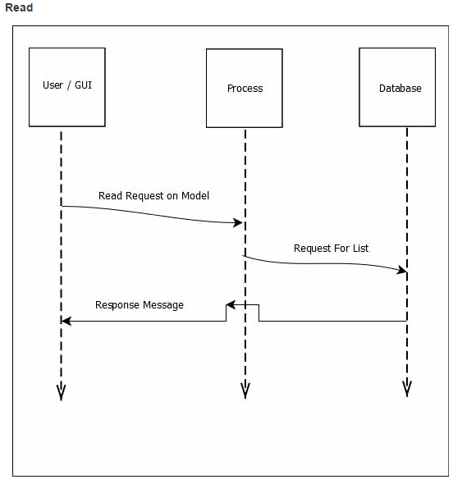

**Delete:**

**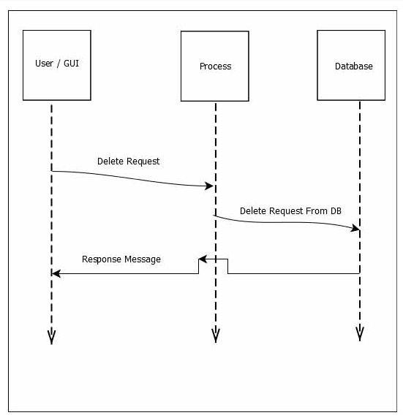**

#### Schema Diagram:

#### F:\xampp\htdocs\atomic_project_rumpa_136509_b34\Atomic project b34\Schema diagram\birthday.JPG

#### Mockup :

#### Add:

#### 

#### Edit:

#### 

#### View:

#### 