Atomic Project

**City**

**City**

**Step-1: User Story**

* As a user I want to add city names of Bangladesh so that this will show on the list. (C)
* As a user I want to edit city names of Bangladesh so that I can correct any mistakes. (U)
* As a user I want to view the list of city names of Bangladesh so that I can travel any city what I like. (RM)
* As a user I want to delete any city name from the list. (D)

**Step2: Use Case**

**Add city name:**

|  |  |  |
| --- | --- | --- |
| **Requirements** | **Key Features** | **Acceptance Criteria** |
| As a user I want to add city names of Bangladesh so that this will show on the list. | To make a user friendly, Data should be saved without refreshing page. (Ajax) | 1.    User can add city name without any problem.(Core features)  2.    User should see the success/failure message. (Message)  3.    User can enter only letter. (Format Validation)  4.    No empty value is accepted.(Empty Validation)  5.    No city name can be entered repeatedly.( Unique validation)  6.    Input should be Sanitized to secure the application  (Sanitization)  7.   In case of invalid input JavaScript message should be displayed. (Usability/User Friendly Interface) |

**Edit city name:**

|  |  |  |
| --- | --- | --- |
| **Requirements** | **Key Features** | **Acceptance Criteria** |
| As a user I want to edit city names of Bangladesh so that I can correct any mistakes. | To make a user friendly, Data should be saved without refreshing page. (Ajax) | 1.     Anyone can edit the city name without any problem.(Core features)  2.     User should see the success/failure message. (Message)  3.     User can enter only letter. (Format Validation)  4.     No empty value is accepted.(Empty Validation)  5.     No city name can be entered repeatedly.( Unique validation)  6.     Input should be Sanitized to secure the application  (Sanitization)  7.     In case of invalid input JavaScript message should be displayed. (Usability/User Friendly Interface) |

**View cityname(list view):**

|  |  |  |
| --- | --- | --- |
| **Requirements** | **Key Features** | **Acceptance Criteria** |
| As a user I want to view the list of city names of Bangladesh so that I can select any city for travelling what I like. |  | 1.      Citynames should be in  list format.  2.      City name should be  listed in Alphabetic order.  3. Last entered city name  should load first.  4. List should be paginated.  5. User can choose number  of items to be shown per  page from a dropdown  list. |
| As a user I want to download the list of city name as XLS file. |  |  |
| As a user I want to download the list of city name as PDF file. |  |  |

**Delete city name:**

|  |  |  |
| --- | --- | --- |
| **Requirements** | **Key Features** | **Acceptance Criteria** |
| As a user I want to delete any city name from the list. |  | 1.    Confirmation message should be displayed.  2.    After successfully deletion a message should be displayed. |

**User Friendly Navigation:**

|  |  |  |
| --- | --- | --- |
| **Requirements** | **Key Features** | **Acceptance Criteria** |
| As a user I want to have user friendly navigation so that I can browse the site easily. |  | 1.    There should be two button at the bottom of add form. (1. Add, 2. Save & add)  **1. A)** User should see the list of city names if clicked on “Add” button.  **1. B)** User should stay on the adding form if clicked on “Save & Add” button.  2.    User should see the list of city names after edit/update info.  3.     User should stay on the list of city names after deleted any city. |

**Step 3: Robustness Diagram**

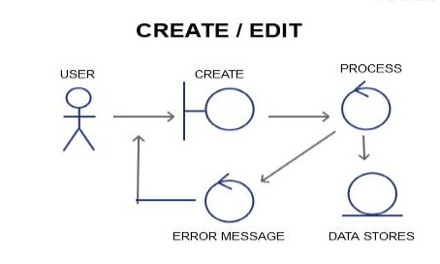

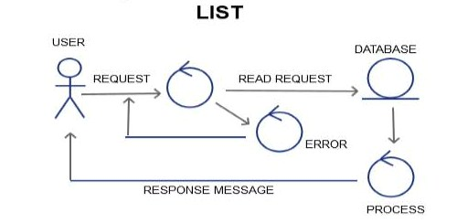

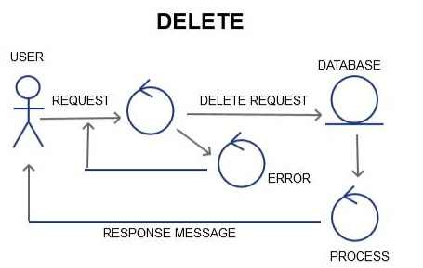

**Class Diagram:**

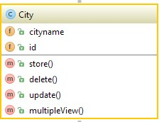

**Sequence Diagram:**

**Create/Add/Edit**

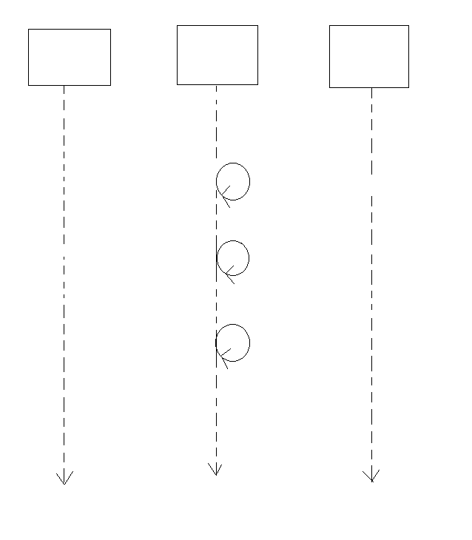

Add Request

Response Message

Storing Data to DB

Sanitization

Unique Validation

Format Validation

DATABASE

USER/GUI

Validation failure

Empty Validation

PROCESS

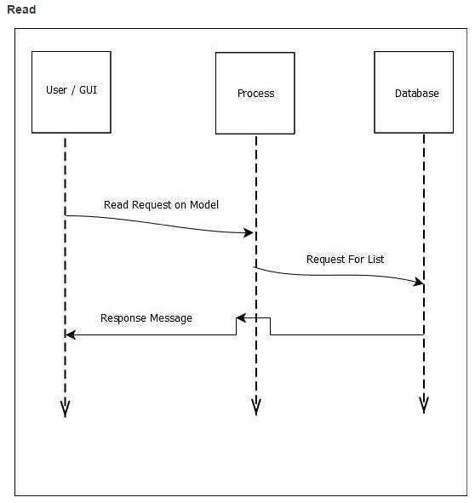

**Delete**

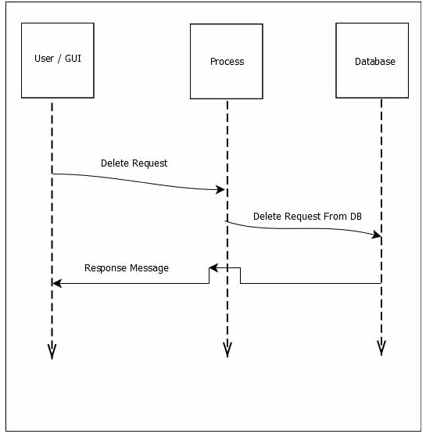

**Schema Diagram:**

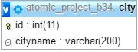

**Mockup:**

**Add:**

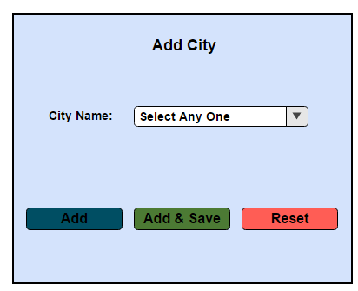

**Edit:**

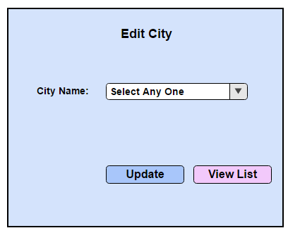

**View:**

