Atomic Project

**Email**

**Email**

**Step-1: User Story**

* As a user I want to add email of all my customers so that this will show on the list. (C)
* As a user I want to edit email of any customer so that I can correct any mistakes. (U)
* As a user I want to viewemail of my customers individually. (RS)
* As a user I want to view the list of email of all my customers. (RM)
* As a user I want to soft-delete email of any of my customersfrom the list so that I can recover it.
* As a user I want to recover my soft-deleted emails from trash list.
* As a user I want to delete any email of my customers from the list. (D)

**Step2: Use Case**

**Add email:**

|  |  |  |
| --- | --- | --- |
| **Requirements** | **Key Features** | **Acceptance Criteria** |
| As a user I want to add email of all my customers so that this will show on the list. | To make a user friendly, Data should be saved without refreshing page. (Ajax) | 1.    User can add email without any problem.(Core features)  2.    User should see the success/failure message. (Message)  3.    User can enter only letter, number and @(Format Validation)  4.    No empty value is accepted.(Empty Validation)  5.    No email address can be entered repeatedly.( Unique validation)  6.    Input should be Sanitized to secure the application  (Sanitization)  7.   In case of invalid input JavaScript message should be displayed. (Usability/User Friendly Interface)  8. Use relevant picture to use as a submit button.(Look)  9. User wants to reset form content anytime. |

**Edit email:**

|  |  |  |
| --- | --- | --- |
| **Requirements** | **Key Features** | **Acceptance Criteria** |
| As a user I want to edit email of any customer so that I can correct any mistakes. | To make a user friendly, Data should be saved without refreshing page. (Ajax) | 1.    User can edit the email of customers without any problem.(Core features)  2.     User should see the success/failure message. (Message)  3.     User can enter only letter, number and @(Format Validation)  4.     No empty value is accepted.(Empty Validation)  5.     No email address can be entered repeatedly.( Unique validation)  6.     Input should be Sanitized to secure the application  (Sanitization)  7.     In case of invalid input JavaScript message should be displayed. (Usability/User Friendly Interface) |

**View email (individually):**

|  |  |  |
| --- | --- | --- |
| **Requirements** | **Key Features** | **Acceptance Criteria** |
| As a user I want to view email of my customers individually. |  |  |

**View email (list view):**

|  |  |  |
| --- | --- | --- |
| **Requirements** | **Key Features** | **Acceptance Criteria** |
| As a user I want to view the list of email of all my customers. |  | 1.      Email address should be  in list format.  2.      Email should be in  serial number.  3. Last entered email  should load first.  4. List should be paginated.  5. User can choose  number of items to be  shown per page from a  dropdown list. |
| As a user I want to download the email list as XLS file. |  |  |
| As a user I want to download the email list as PDF file. |  |  |

**Soft-Delete emails:**

|  |  |  |
| --- | --- | --- |
| **Requirements** | **Key Features** | **Acceptance Criteria** |
| As a user I want to soft-delete email of any of my customersfrom the list so that I can recover it. |  | 1.    Confirmation message should be displayed.  2.    After successfully soft-delete a message should be displayed. |

**Restore emails from trash list:**

|  |  |  |
| --- | --- | --- |
| **Requirements** | **Key Features** | **Acceptance Criteria** |
| As a user I want to recover my soft-deleted emails from trash list. |  | 1.    Confirmation message should be displayed.  2.    After successfully recover a message should be displayed. |

**Delete email:**

|  |  |  |
| --- | --- | --- |
| **Requirements** | **Key Features** | **Acceptance Criteria** |
| 1. As a user I want to delete any email of my customers from the list. 2. As a user I want temporary deleted emails which are 10 days old are removed automatically. |  | 1.    Confirmation message should be displayed.  2.    After successfully deletion a message should be displayed. |

**User Friendly Navigation:**

|  |  |  |
| --- | --- | --- |
| **Requirements** | **Key Features** | **Acceptance Criteria** |
| As a user I want to have user friendly navigation so that I can browse the site easily. |  | 1.    There should be two button at the bottom of add form. (1. Add, 2. Save & add)  **1. A)** User should see the list of emails if clicked on “Add” button.  **1. B)** User should stay on the adding form if clicked on “Save & Add” button.  2.    User should see the list of emails after edit/update info.  3.     User should stay on the list of emails after deleted any email address.  4.    User can back to list page using back button, from edit, details page. |

**Step 3: Robustness Diagram**

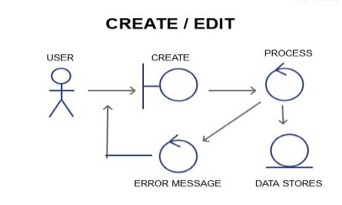

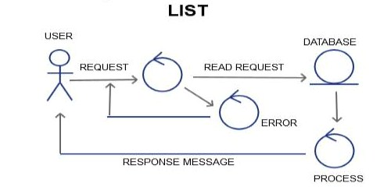

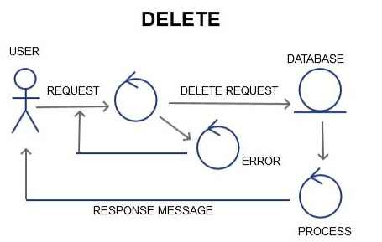

**Class Diagram:**

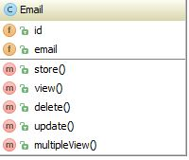

**Sequence Diagram:**

**Create/Add/Edit**

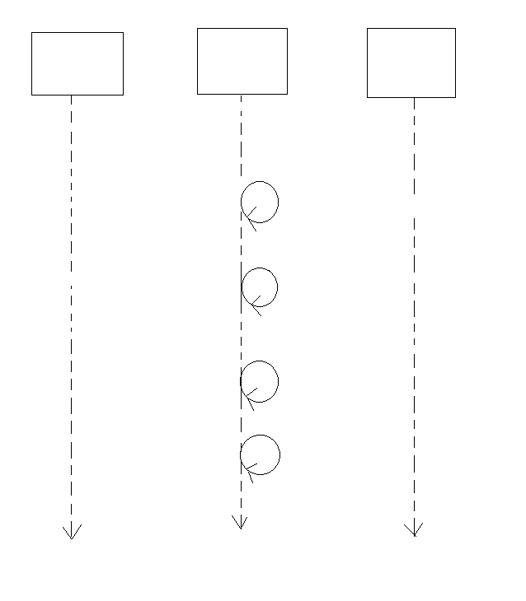

Response Message

Sanitization

Storing Data to DB

Validation failure

Add Request

Unique Validation

Empty Validation

DATABASE

USER/GUI

PROCESS

Format Validation

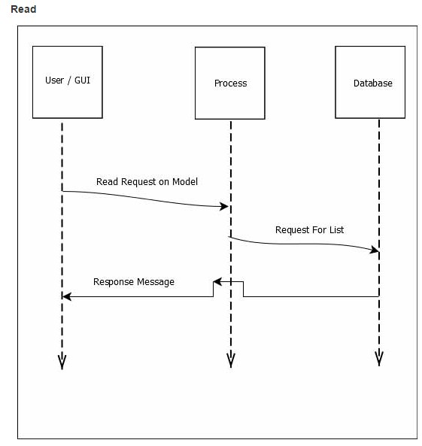

**Delete:**

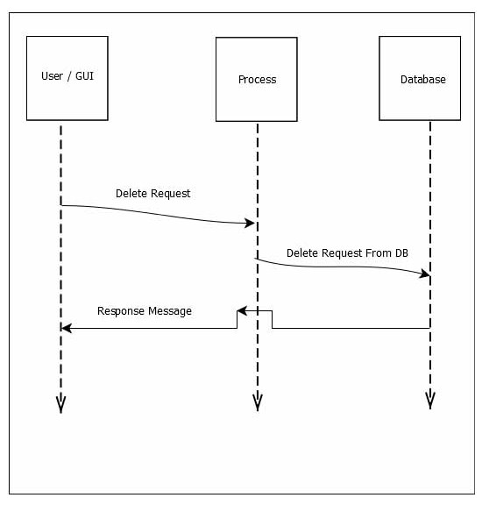

**Schema Diagram:**

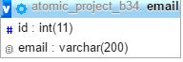

#### Mockup :

#### Add:

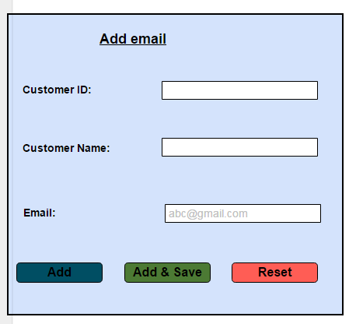

**Edit:**

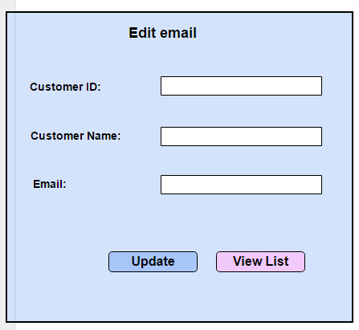

**View:**

