Atomic Project

**Gender**

**Gender**

**Step-1: User Story**

* As a user I want to add gender of all applicants so that this will show on the list. (C)
* As a userI want to edit gender of any applicants so that I can correct any mistakes. (U)
* As a user I want to viewgender of all applicants individually. (RS)
* As a userI want to delete gender of any applicants with his/her record from the list. (D)

**Step2: Use Case**

**Add gender of applicant:**

|  |  |  |
| --- | --- | --- |
| **Requirements** | **Key Features** | **Acceptance Criteria** |
| As a user I want to add gender of all applicants so that this will show on the list. | To make a user friendly, Data should be saved without refreshing page. (Ajax) | 1.    Usercan add gender name without any problem.(Core features)  2 . Usershould see the success/failure message.(Message)  3.    Usercan choose radio button for input.  4.    No empty value is accepted.(Empty Validation)  5.   In case of empty input JavaScript message should be displayed. (Usability/User Friendly Interface) |

**Edit gender:**

|  |  |  |
| --- | --- | --- |
| **Requirements** | **Key Features** | **Acceptance Criteria** |
| As a user I want to edit gender of any applicants so that I can correct any mistakes. | To make a user friendly, Data should be saved without refreshing page. (Ajax) | 1.     Usercan edit the gender name without any problem.(Core features)  2.     Course Usershould see the success/failure message. (Message)  3.     Usercan choose radio button for input.  4.     No empty value is accepted.(Empty Validation)  5.  In case of empty input JavaScript message should be displayed. (Usability/User Friendly Interface) |

**View gender name (individually):**

|  |  |  |
| --- | --- | --- |
| **Requirements** | **Key Features** | **Acceptance Criteria** |
| As a user I want to view gender of all applicants individually. |  |  |

**Delete gender name:**

|  |  |  |
| --- | --- | --- |
| **Requirements** | **Key Features** | **Acceptance Criteria** |
| As a user I want to delete gender of any applicants with his/her record from the list. |  | 1.    Confirmation message should be displayed.  2.    After successfully deletion a message should be displayed. |

**User Friendly Navigation:**

|  |  |  |
| --- | --- | --- |
| **Requirements** | **Key Features** | **Acceptance Criteria** |
| As a userI want to have user friendly navigation so that I can browse the site easily. |  | 1.    There should be two button at the bottom of add form. (1. Add, 2. Save & add)  **1. A)** User should see the list of gender names if clicked on “Add” button.  **1. B)** User should stay on the adding form if clicked on “Save & Add” button.  2.    User should see the list of gender names after edit/update info.  3.     User should stay on the list of gender names after deleted gender of any applicant.  4.    User can back to list page using back button, from edit, details page. |

**Step 3: Robustness Diagram**

**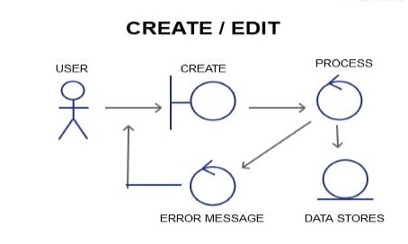**

**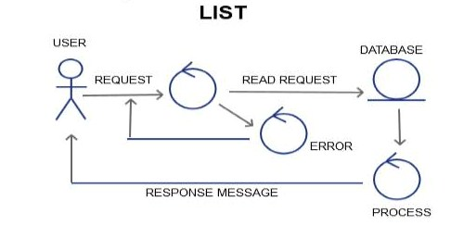**

**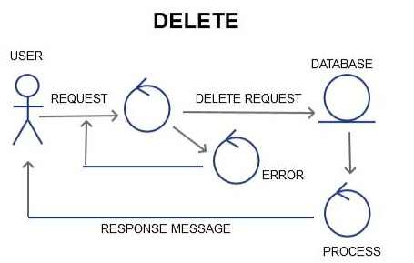**

**Class Diagram:**

**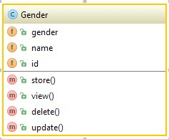**

**Sequence Diagram:**

**Create/Add/Edit**

**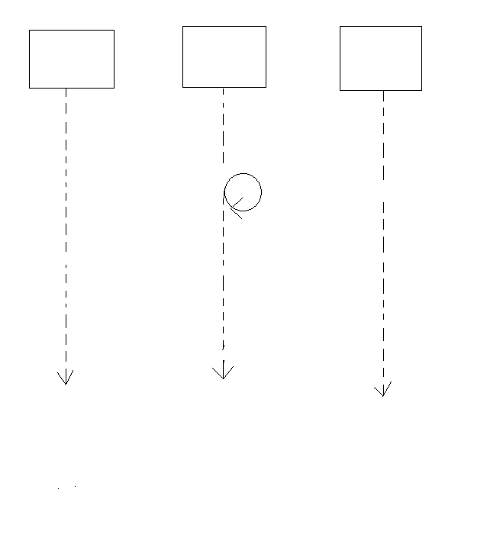**

Response Message

Empty Validation

Storing Data to DB

Validation failure

Add Request

DATABASE

PROCESS

USER/GUI

**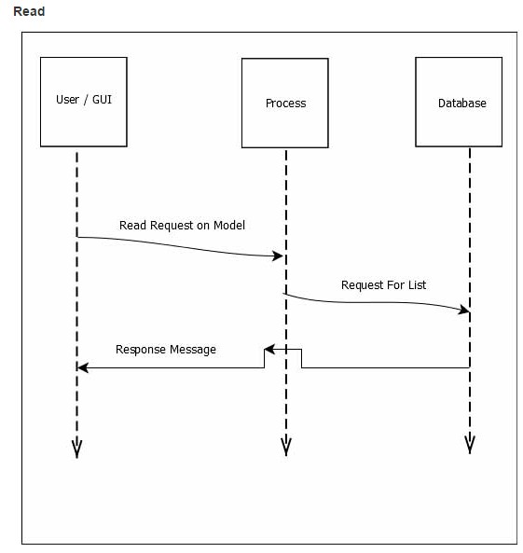**

**Delete**

**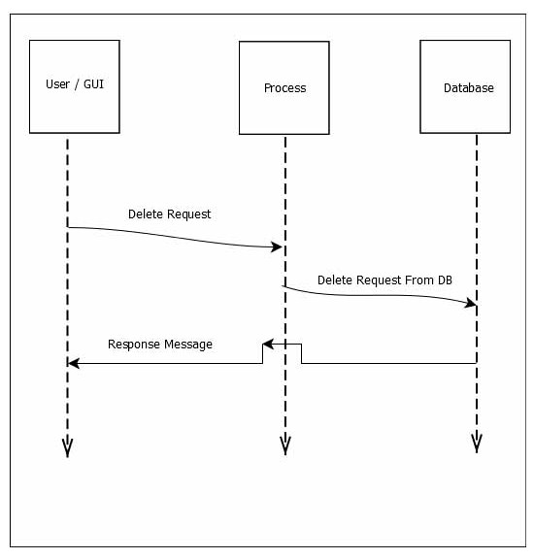**

#### Schema Diagram:

#### F:\xampp\htdocs\atomic_project_rumpa_136509_b34\Atomic project b34\Schema diagram\gender.JPG

#### Mockup :

#### Add:

#### 

**Edit:**

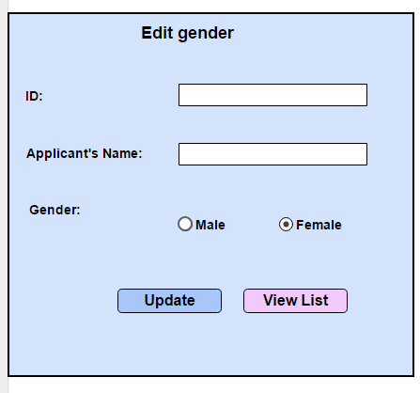:

**View:**

**