Atomic Project

**Hobbies**

**Hobbies**

**Step-1: User Story**

* As a user I want to add student’s hobbies so that this will show on the list. (C)
* As a user I want to edit any hobbies of any student so that I can correct any mistakes. (U)
* As a user I want to view hobbies by their names individually. (RS)
* As a user I want to soft-delete any hobbies from the list so that I can recover it.
* As a user I want to recover my soft-deleted hobbies from trash list.
* As a user I want to delete any hobbies from the list. (D)

**Step2: Use Case**

**Add hobbies:**

|  |  |  |
| --- | --- | --- |
| **Requirements** | **Key Features** | **Acceptance Criteria** |
| As a user I want to add people’s hobbies so that this will show on the list. | To make a user friendly, Data should be saved without refreshing page. (Ajax) | 1.    User can add their hobbies without any problem.(Core features)  2.    User should see the success/failure message. (Message)  3.    User can enter only letter. (Format Validation)  4.    No empty value is accepted.(Empty Validation)  5.    Input should be Sanitized to secure the application  (Sanitization)  6.   In case of invalid input JavaScript message should be displayed. (Usability/User Friendly Interface) |

**Edit hobbies:**

|  |  |  |
| --- | --- | --- |
| **Requirements** | **Key Features** | **Acceptance Criteria** |
| As a user I want to edit any hobbies of any person so that I can correct any mistakes. | To make a user friendly, Data should be saved without refreshing page. (Ajax) | 1.    User can edit his/her hobbies without any problem.(Core features)  2.     User should see the success/failure message. (Message)  3.     User can enter only letter. (Format Validation)  4.     No empty value is accepted.(Empty Validation)  5.    Input should be Sanitized to secure the application  (Sanitization)  6.     In case of invalid input JavaScript message should be displayed. (Usability/User Friendly Interface) |

**View hobbies (individually):**

|  |  |  |
| --- | --- | --- |
| **Requirements** | **Key Features** | **Acceptance Criteria** |
| As a user I want to view hobbies by their names individually. |  |  |

**Soft-Delete hobbies:**

|  |  |  |
| --- | --- | --- |
| **Requirements** | **Key Features** | **Acceptance Criteria** |
| As a user I want to soft-delete any hobbiesfrom the list so that I can recover it. |  | 1.    Confirmation message should be displayed.  2.    After successfully soft-delete a message should be displayed. |

**Restore hobbies from trash list:**

|  |  |  |
| --- | --- | --- |
| **Requirements** | **Key Features** | **Acceptance Criteria** |
| As a user I want to recover my soft-deleted hobbies from trash list. |  | 1.    Confirmation message should be displayed.  2.    After successfully recover a message should be displayed. |

**Delete hobbies:**

|  |  |  |
| --- | --- | --- |
| **Requirements** | **Key Features** | **Acceptance Criteria** |
| As a user I want to delete any hobbies from the list. |  | 1.    Confirmation message should be displayed.  2.    After successfully deletion a message should be displayed. |

**User Friendly Navigation:**

|  |  |  |
| --- | --- | --- |
| **Requirements** | **Key Features** | **Acceptance Criteria** |
| As a user I want to have user friendly navigation so that I can browse the site easily. |  | 1.    There should be two button at the bottom of add form. (1. Add, 2. Save & add)  **1. A)** User should see the list of hobbies if clicked on “Add” button.  **1. B)** User should stay on the adding form if clicked on “Save & Add” button.  2.    User should see the list of hobbies by their name after edit/update info.  3.     User should stay on the list of hobbies after deleted any hobby of a person. |

**Step 3: Robustness Diagram**

**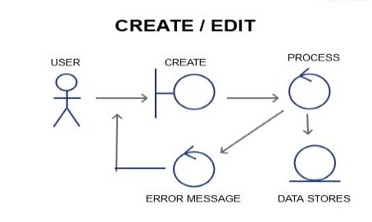**

**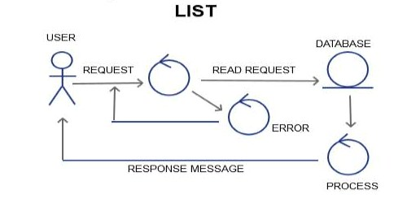**

**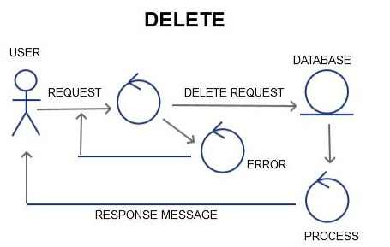**

**Class Diagram:**

**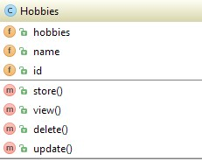**

**Sequence Diagram:**

**Create/Add/Edit**

**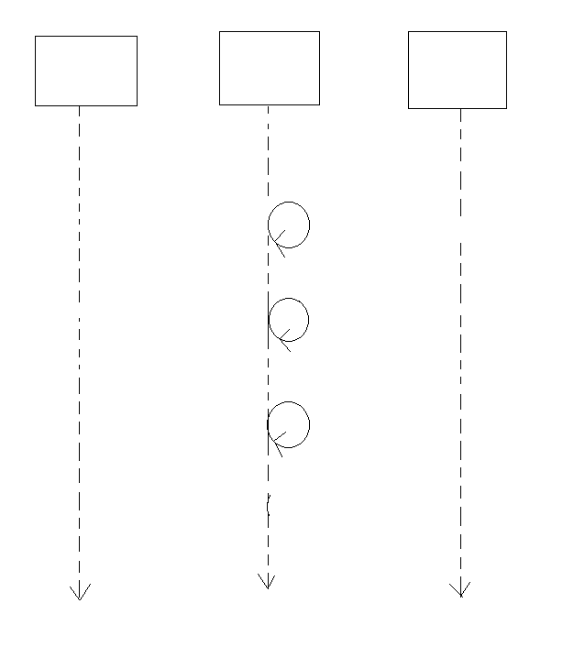**

Response Message

Validation failure

Sanitization

Storing Data to DB

Format Validation

Add Request

Empty Validation

DATABASE

PROCESS

USER/GUI

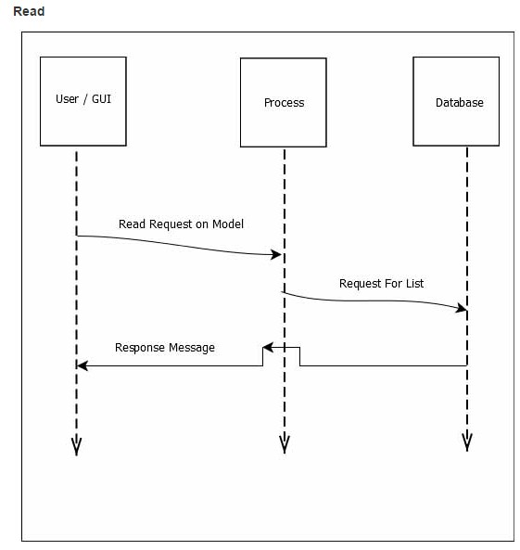

Delete

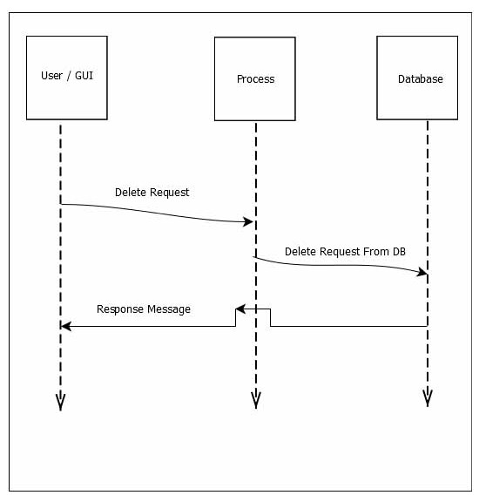

#### Schema Diagram:

#### F:\xampp\htdocs\atomic_project_rumpa_136509_b34\Atomic project b34\Schema diagram\hobbies.JPG

#### Mockup:

#### Add:

#### 

#### Edit:

#### 

#### View:

#### 