CS/CE 457/464 - Homework Assignment 5: NoSQL

Syeda Samah Daniyal, 07838

[sd07838@st.habib.edu.pk](mailto:sd07838@st.habib.edu.pk)

1. the count of total number of records in the collection:

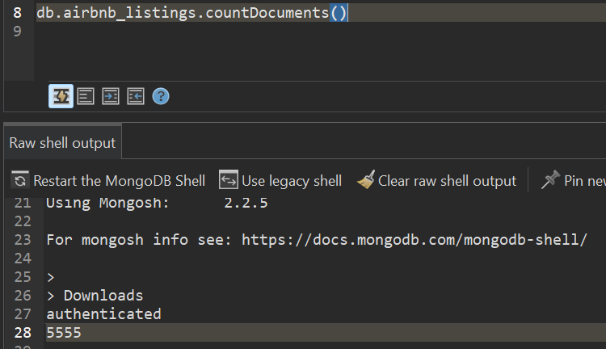

This tells us that we have the information of 5555 airbnbs in our database.

1. the count of records for property_type “House”:





The amount of airbnb’s using House as their property is 606.

1. counts for each property_type in descending order of count (use group).

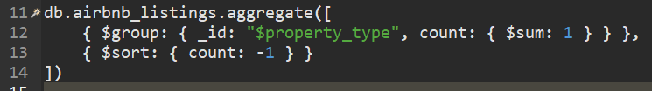

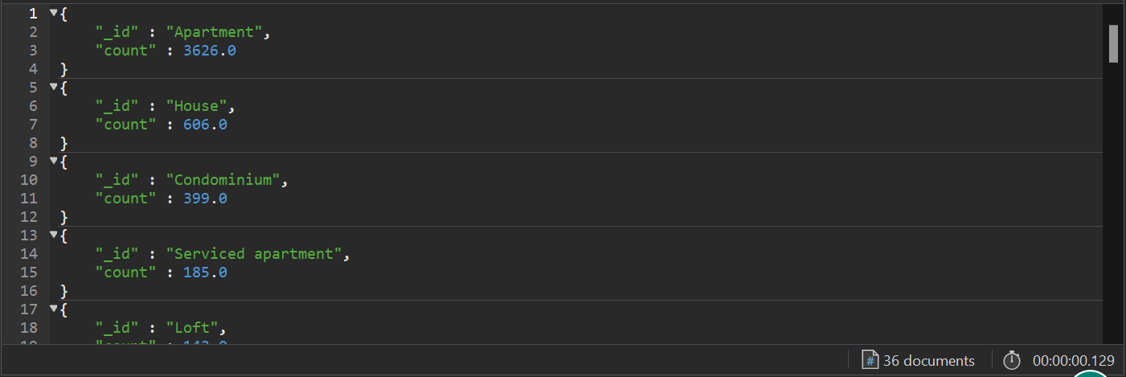

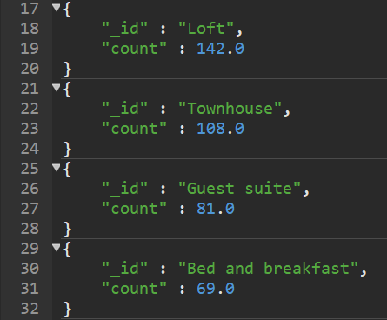 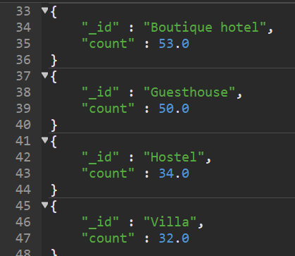

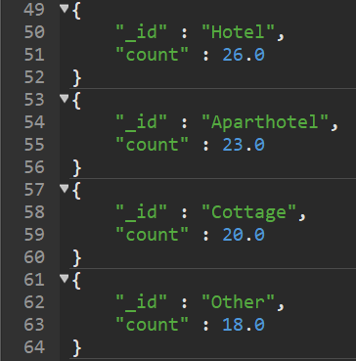 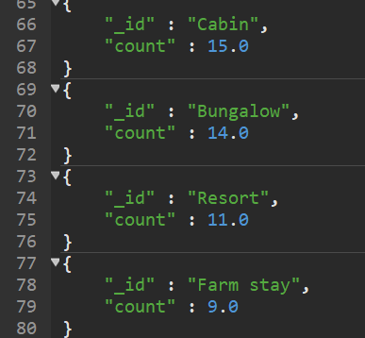

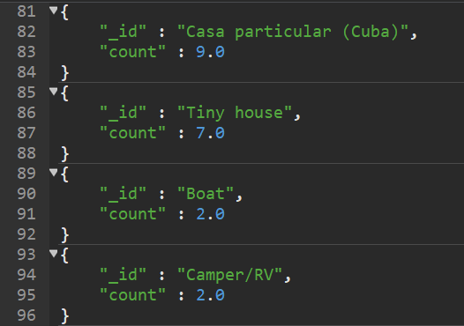 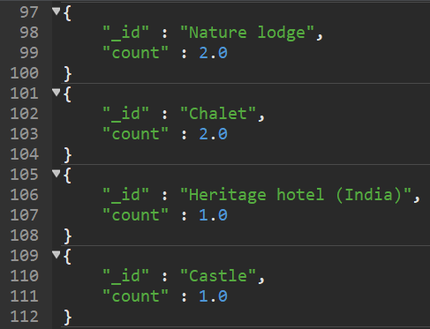

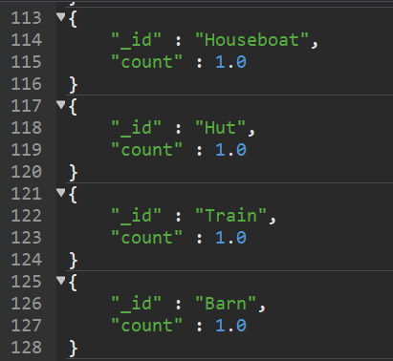 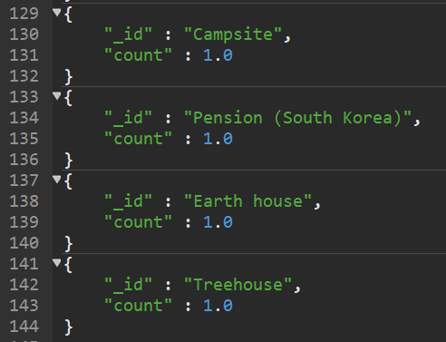

In total, there are 36 different types of properties people have used to build airbnbs. The results above show how many of each property type exist in our database.

1. the count of records for review_scores_cleanliness less than 5.





There are only 38 out of 5555 airbnbs whose cleanliness score is less than 5.

1. the count of records for each room_type, cancellation_policy. Order the output by count in ascending order.



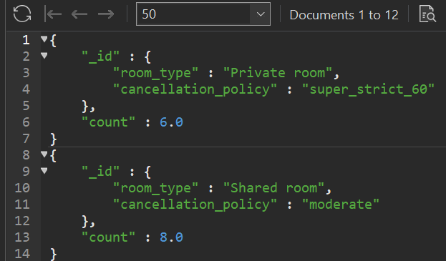 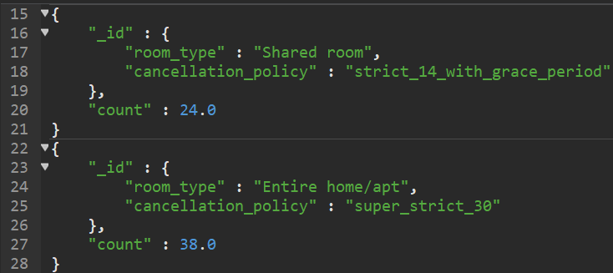

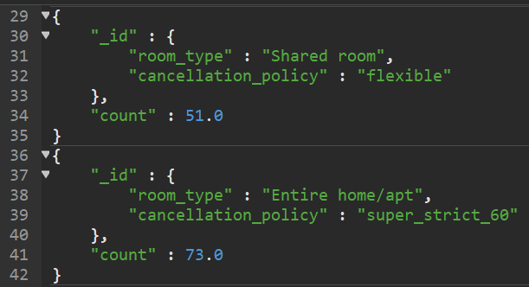

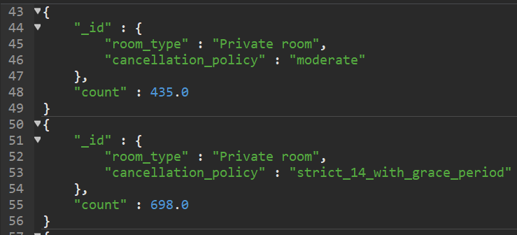

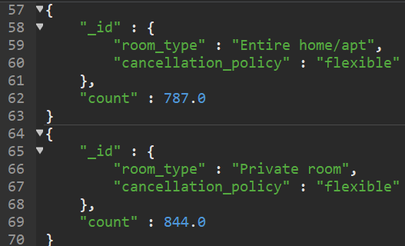 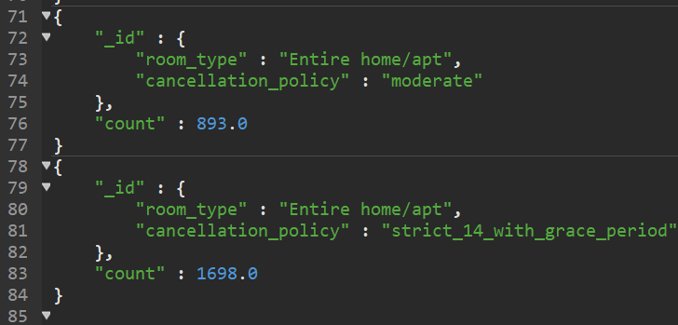

This tells us the amount of the combination of different types of rooms and their cancellation policy in all these airbnbs. With the most being entire home or apartment with strict 14 days cancellation policy with grace period.

1. Similar to question 5, the count of records for each room_type, cancellation_policy when property_type is “Apartment”. Order the output by cancellation_policy in ascending order.



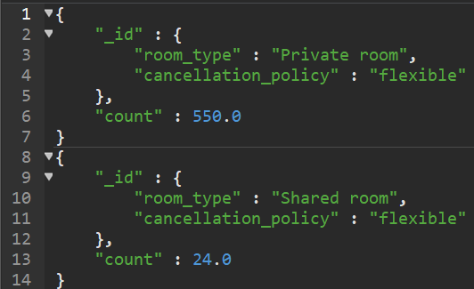 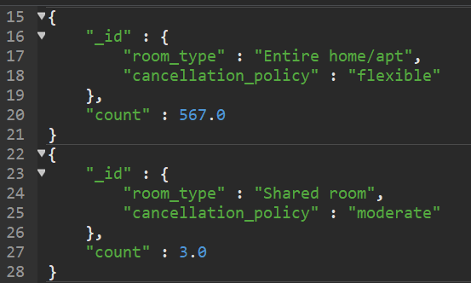

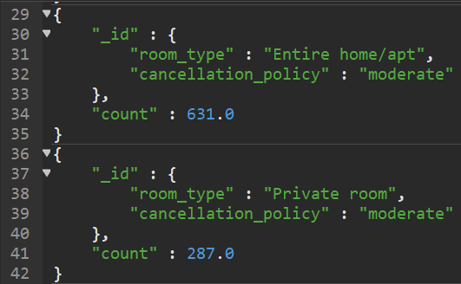

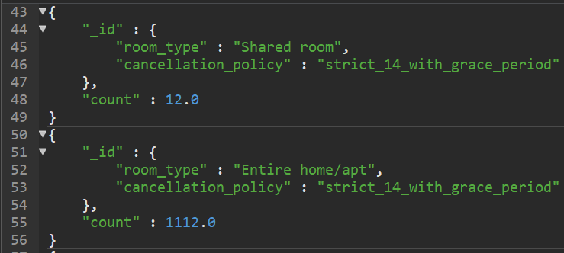

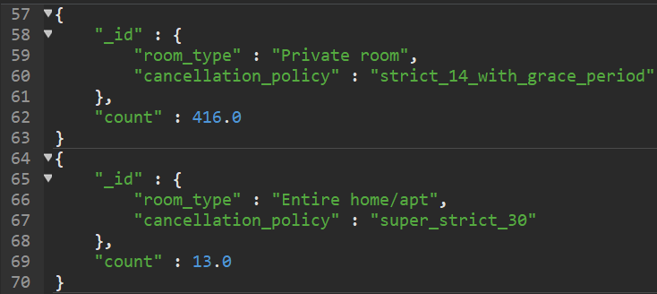

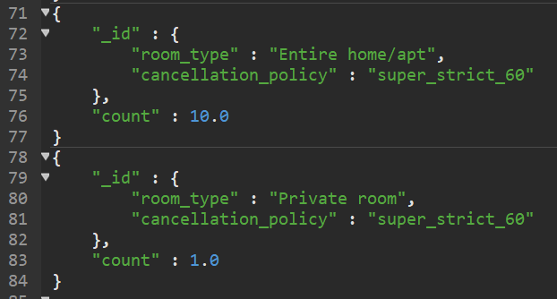

This only shows the combination of different types of rooms and their cancellation policy of airbnbs that are built in Apartments.

1. Find all the records where address.market is “New York” and monthly_price is greater than 5000. Display only id and monthly_price and sort the output by monthly_price in descending order.



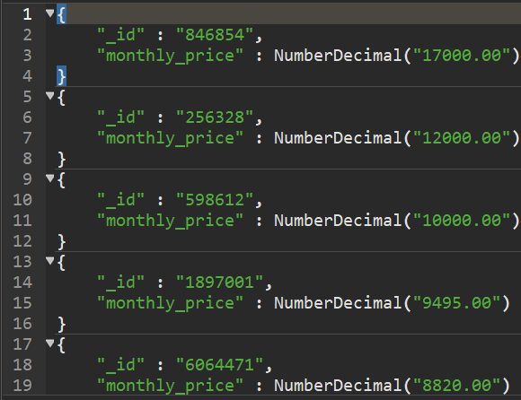 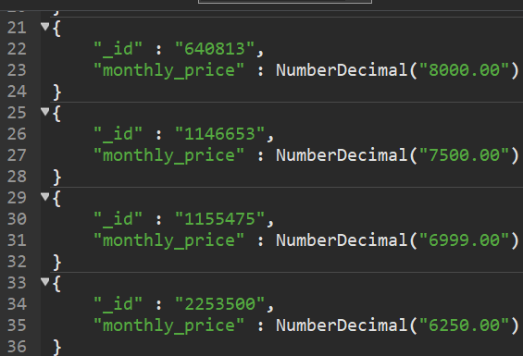

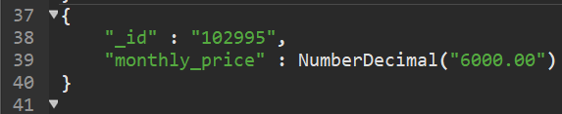

This shows us the Airbnbs and their prices in New York that cost more than $5000 per month.

1. Display the records with cleaning_fee in descending order. Display name, property_type and cleaning_fee. Limit records to 10 (easy)



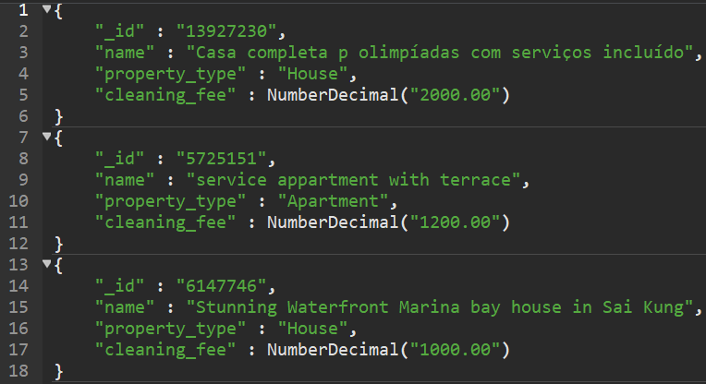

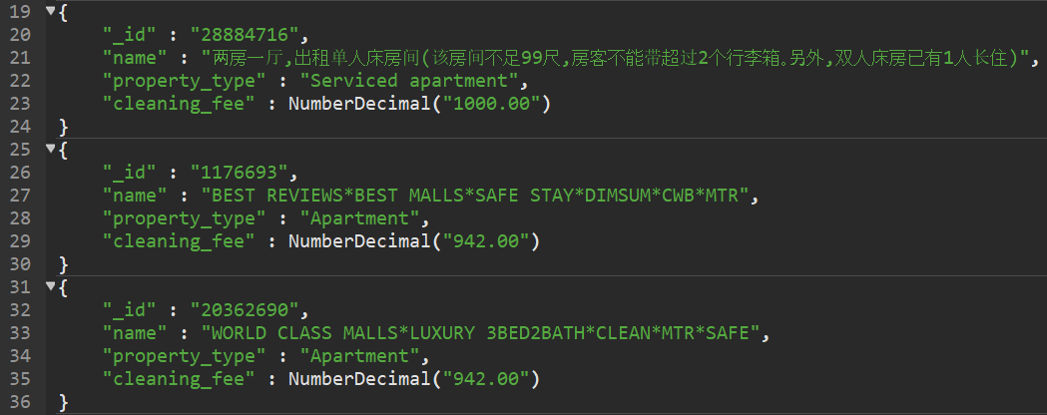

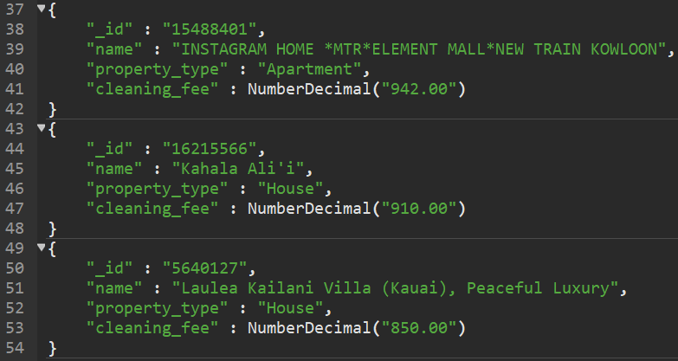

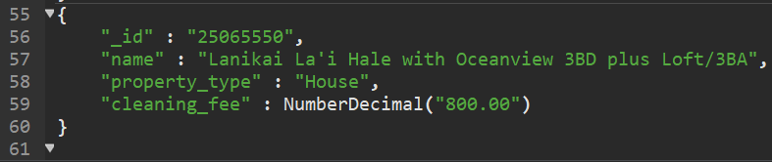

This shows us the name and property type of the top 10 most expensive Airbnbs in terms of cleaning fee.

1. Come up with your own query to show any interesting insight. Use atleast two fields for match and two fields for group.

The following shows the count of Airbnbs in our database grouped by property_type and bed_type where accommodates > 4 and price > 100:



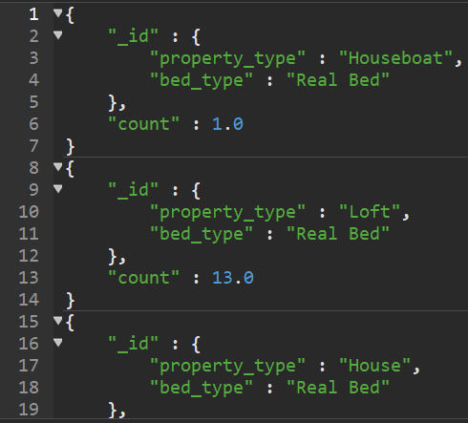 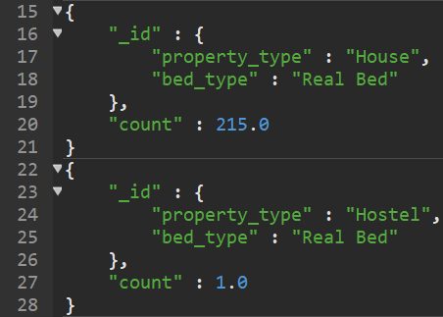

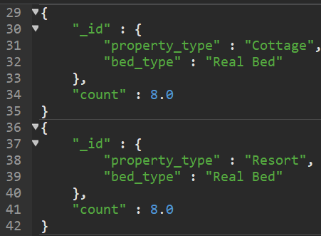 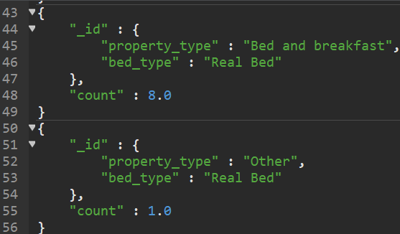

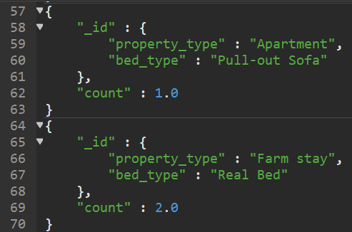

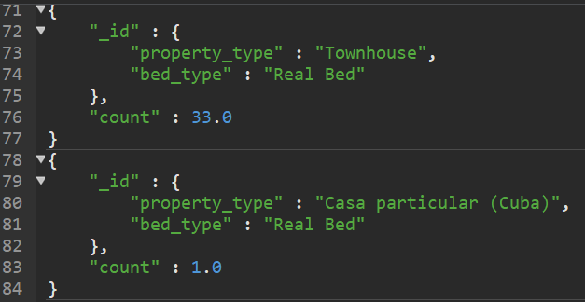

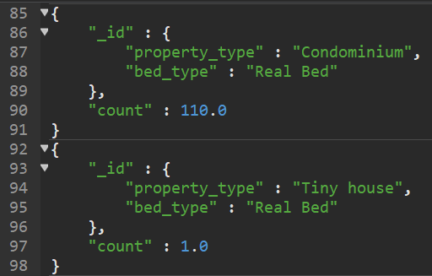

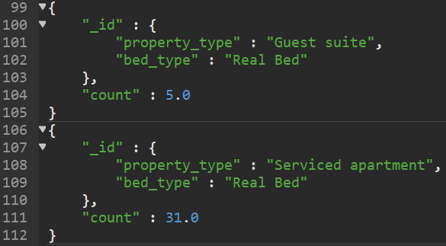

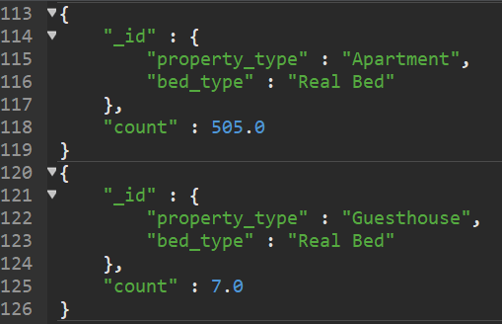

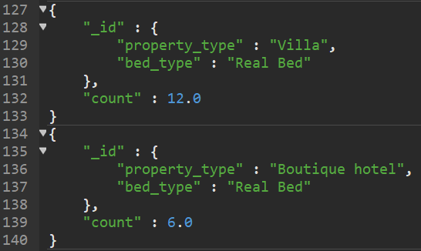

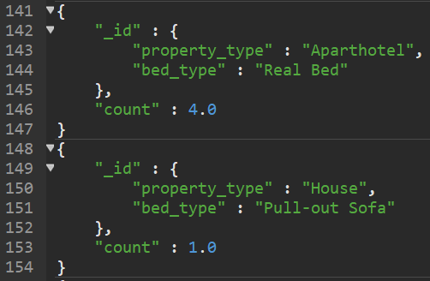

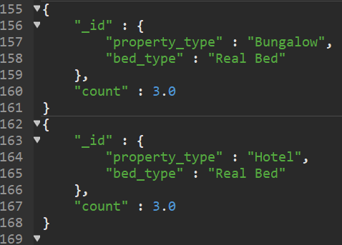

1. Come up with your own query to show any interesting insight. Use atleast two fields for group.

The following shows the average price of the Airbnbs in our database by room_type and cancellation_policy and is sorted in descending order of price:

