**Van Arsdel Ltd**

Van Arsdel is a company that manufactures and sells sporting goods. The company has offices in the United States and several other countries. Its sales are comprised of US sales and international sales. VanArsdel’s sales come from its own manufactured products, as well as other manufacturers’ products.

**Query Editor (ETL)**

Imported multiple files from a folder, and used DAX tool to transform XLSX into CSV format.

Created a custom column as follows to retrieve all 6 tables stored under the content column:

Excel Custom = Excel.Workbook([Content])

CSV Custom = Csv.Document([Content])

Deleted the Content column, expanded the custom column to retrieve all datasets, changed data type as needed, and parsed data as follows to prepare data for analysis:

Fact table:

Sales 5 columns, 4198755 rows, format Zip as Text to keep leading zero

*InternationalSales* 6 columns, 3036737 rows, append to Sales > right click > Disable Load, View > Query Dependencies

Dimension tables:

Product (what) split column, fill down, replace value,

Manufacturer (whom) remove top/bottom rows, transpose, promote header

Geography (where) remove top rows, promote header

Date (when)

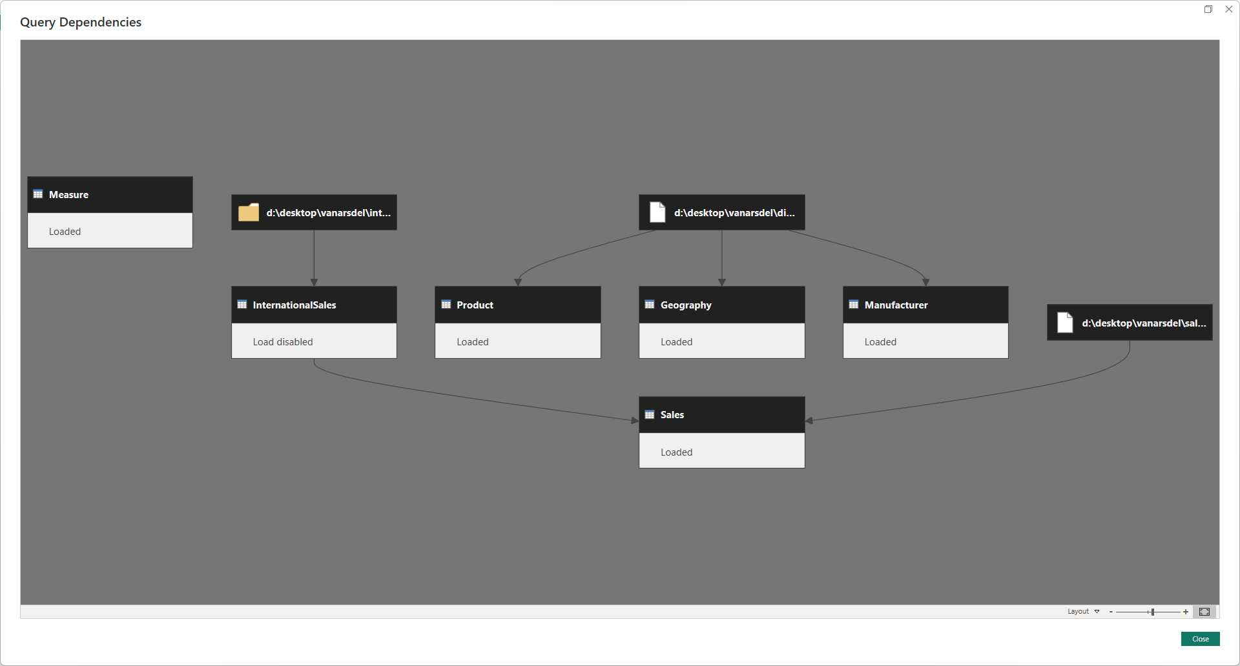

**schema**

|  |  |  |
| --- | --- | --- |
| table | column | # distinct values |
| Sales  (KPI) | *ProductID*  *Zip*  *Country*  *Date*  **Units**  **Revenue** | 1265  32706  7  2757  US > Australia > Japan |
| Product  (what) | **ProductID**  **Product**  **Segment**  **Category**  *ManufacturerID*  Price | 2412 (1 x 1986 + 2 x 132 + 3 x 54)  2172 (1986 + 132 + 54)  8 (All Season, Convenience, Extreme, Moderation, Productivity, Regular, Select, Youth)  4 (Mix, Rural, Urban, Youth)  14 |
| Manufacturer  (whom) | **ManufacturerID**  **Manufacturer**  Logo | 14  14 (Abbas, Aliqui, Barba, Currus, Fama, Leo, Natura, Palma, Pirum, Pomum, Quibus, Salvus, VanArsdel, Victoria)  14 |
| Geography  (where) | **Zip**  City  **District**  **State**  Region  **Country** | 159918  90398  5138  186  17  7 (Australia, Canada, Germany, Japan, Mexico, Nigeria, USA) |
| date  (when) | **Date**  **Month**  **Quarter**  **Year** | 3287  108  36  9 (2014-2022) |

columns = **dimensions** + **measures** + **primary keys** + *foreign keys*

**Data Model**

Added a new column(ZipCountry) to the Geography & Sales tables to connect the tables.

Product Product Hierarchy: Category > Segment > Product

Geography Country Hierarchy: Country > State > District

Geography primary key: ZipCountry = Geography[Zip] & "," & Geography[Country]

Manufacturer Manufacturer (groups): Grouped by top Competitors, VanArsdel, Other

Date Date = CALENDAR ( DATE ( 2014, 1, 1 ), DATE ( 2021, 12, 31 ) )

Sales foreign key: ZipCountry = Sales[Zip] & "," & Sales[Country]

Fit to page, hide all primary/foreign keys, except Date in Date table

Creating measures using ([DAX Formatter](https://www.daxformatter.com/)):

Revenue CY = SUM ( Sales[Revenue] )

Revenue PY = CALCULATE ( [Revenue CY], SAMEPERIODLASTYEAR ( 'Date'[Date] ) )

Revenue Y/Y = DIVIDE ( [Revenue CY] - [Revenue PY], [Revenue PY] )

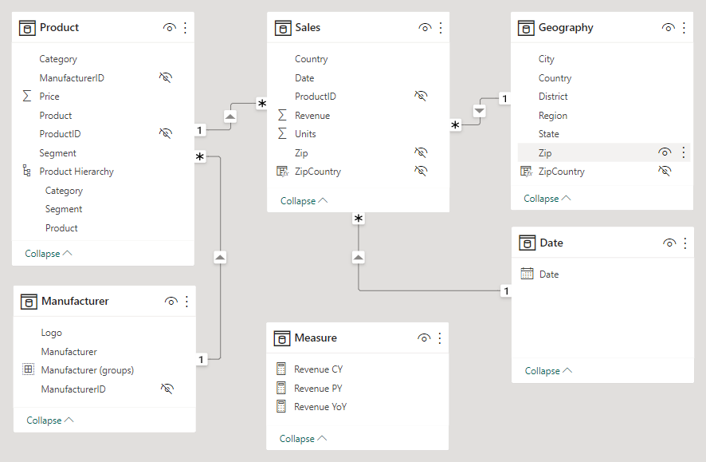

**Dashboard design**

1. Theme (15 colors): Imported the theme JSON file to add a new theme to the themes collection.
2. Background: Imported using the browse option under the canvas background.
3. Logo: Used the insert/image option under Power BI to insert the Vanarsdel logo, and adjusted the position on the background canvas.
4. text box: Inserted a text box as a title for the dashboard.
5. Slicer: Used this visual to load manufacturers’ logos URLs into Power BI, then adjusted its position on the background canvas.
6. Gauge visual: Used to compare revenues this year vs. last year.
7. Column chart: For revenue by country, with up & down arrows to drill up/down, double down arrow to go to the next level hierarchy, and split arrow to expand all down one level in the hierarchy.
8. Matrix: Used it to compare categories revenues for the current year, percentage of total, previous year, and year over year.
9. Play axis (custom visual): Imported this custom visual to display each country’s revenue when clicking the play button at a speed of 5000ms, also edited the interaction with visuals to highlight the year it’s displaying.
10. Bookmark navigator: Created to bookmark initial revenue state, USA, and Australia’s revenues.
11. Smart Narrative: Used to auto-highlight revenue performance based on other visuals on the page.
12. Column + Line chart: Used to compare current and year-over-year revenues by year.
13. **Second sheet:**
    1. Parameters: Used parameters to create cross-filtering for dimensions and measures.
    2. Table: Added a table to compare revenue by Country/Year using the slicers created above.
    3. Scattered Chart: Used to display top 10 products by revenue and sold units for each.

**Bookmarks(design steps)**

1. View > Bookmarks > Add: Initial State
2. "Revenue by Country" column chart > select USA column > ... > Spotlight > Bookmarks > Add: USA Revenue
3. "Revenue by Country" column chart > select Australia column > ... > Spotlight > Bookmarks > Add: Australia Revenue
4. Bookmarks > View > Use arrows to navigate bookmarks and tell a story

**Cross-Filtering/Cross-Highlighting(design steps)**

Format > Edit interactions (cross filtering/highlighting)

1. "Revenue by Country" > Select Filter
2. "Revenue and % Growth by Year" > select Highlight

**Project**

[Sales and Marketing](https://learn.microsoft.com/en-us/power-bi/create-reports/sample-sales-and-marketing)

The CMO asks you to build a dashboard to analyze Van Arsdel’s sales performance vs. top competitors and answer the following questions:

1. What is VanArsdel's share of sales worldwide and highlight the US, and Australia?
2. What is VanArsdel's share of sales in the Urban category?
3. What is the revenue by country since 2014?
4. What are the top 10 products by total revenue?