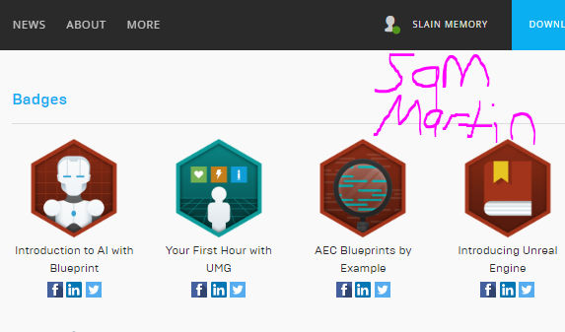

**Function: FoodSource (blueprint class)**

**When a foodSource is spawned, set int CasheValue to a number between 3-5 and set food source’s scale based on CasheValue from an array of vectors.**

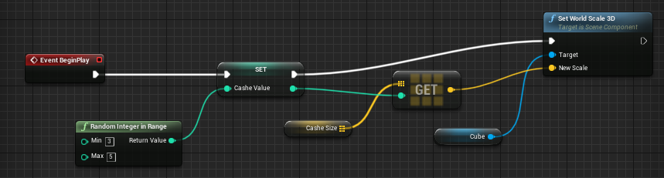

**As the agent walks away from touching the food source, add one to int CasheCount.**

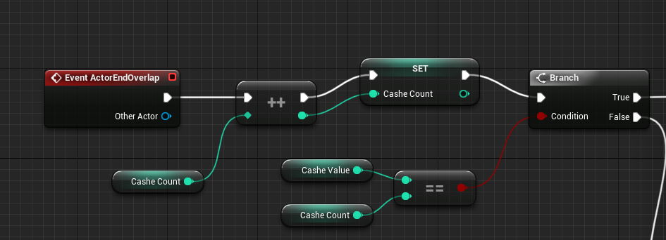

**If CasheCount does not equal CasheValue then the food source’s scale is reduced by 0.75.**

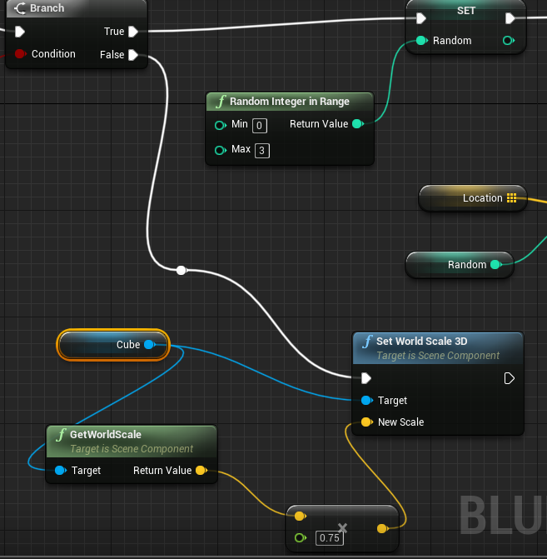

**If CasheCount does equal CasheValue, spawn a new food source at one of four locations and destroy the old food source.**

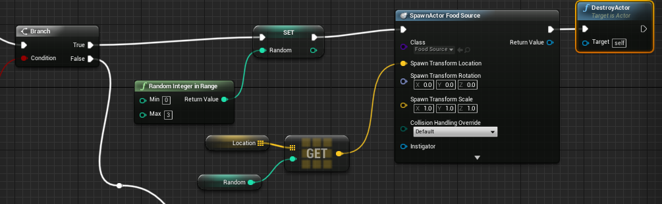

**Function: BT_EnemyAI (Behavior tree)**

First Sequence in the tree has the agent check all known locations until a food source is targeted.

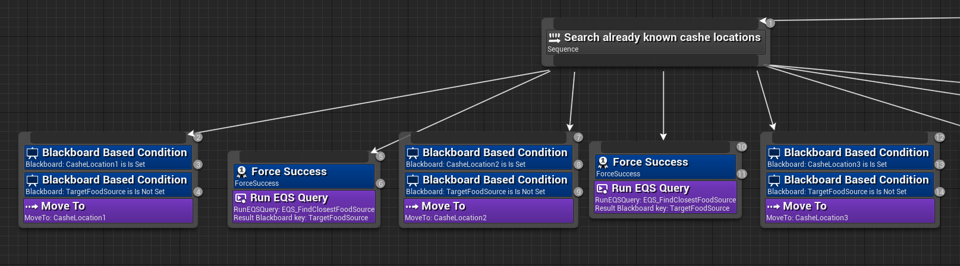

Second Sequence in the tree is to collect the closest food source and save its location if the location has not been set. New locations must check if the agent is currently at any previous known locations before setting the new location.

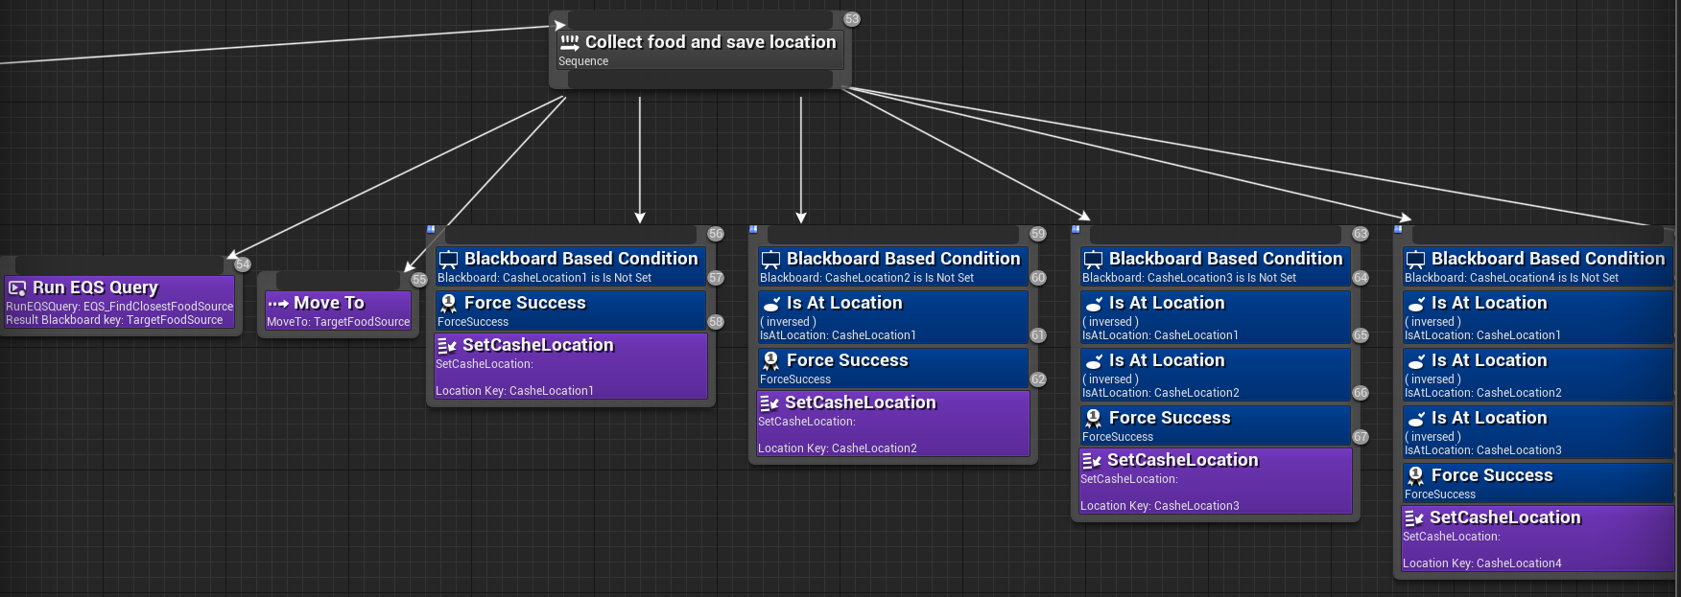

Once the location has been set, the agent continuously moves between the food source and home until the food source is depleted and destroyed, causing TargetFoodSource to not be set, breaking the loop.

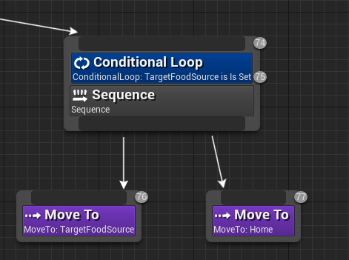

When the agent has finished collecting from a food source the tree returns to the first sequence of checking known locations.

If a food source is not found, the agent wanders until a food source is found.