BLUETOOTH

CIRCUIT DIAGRAM :

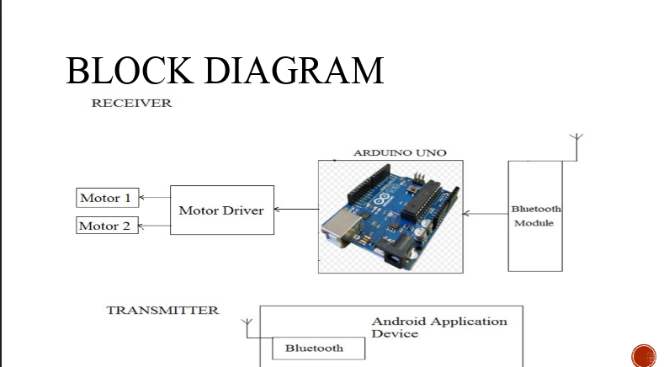

THEORY

CONCEPT USED:

Here we use the concept of Bluetooth which can be used to transmit or receive the signals from Bluetooth and arduino respectively.

LEARNING AND OBSERVATION:

1. Here we learned to set the data rate in bits per second for serial data transmission.
2. We learned to use different types of Bluetooth applications.
3. We observed that when we press ON button on the mobile application the LED turns ON.

PROBLEMS AND TROUBLESHOOTING:

1. Bluetooth was not able to connect to phone.
2. Connections were not done properly.

PRECAUTIONS:

1. Circuit should be made properly.
2. Hand should not be wet.
3. Connection should be tight.

LEARNING OUTCOMES:

1. We learn how to communicate between mobile and microcontroller Bluetooth module.
2. We learn how to communicate using Bluetooth device.