CIRCUIT DIAGRAM :

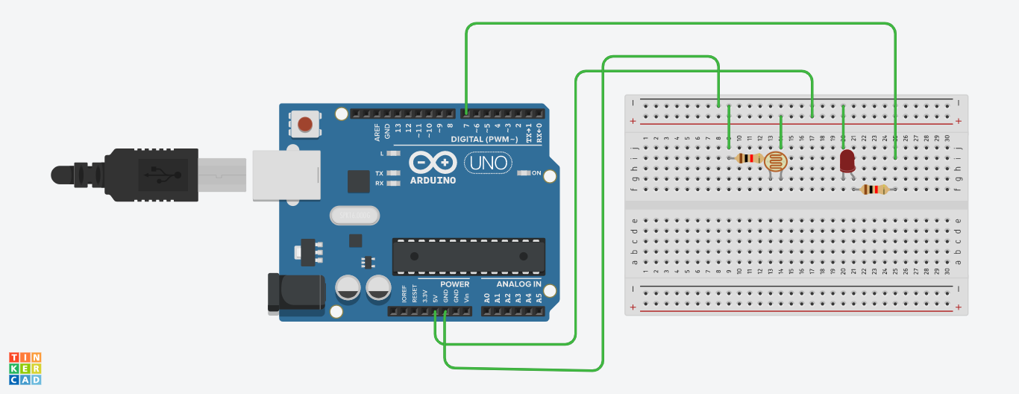

THEORY

CONCEPT USED :

Here we use the concept of light dependent resistor which is used to sense light and is easy to use with microcontroller or even with normal digital or analog IC we also use LED ,two resistors,Arduino .

LEARNING AND OBSERVATION:

1. We learned that how to use an LDR along with LED as an obstacle detector.
2. It reads LDR value and prints them on serial monitor. Once we upload the code to the Arduino board open serial monitor and observe the values changing with the change of light intensity.
3. The attached LED glows in analog mode according to LDR values.

PROBLEMS AND TROUBLESHOOTING:

1. The code of LDR was written wrong due to whichthe LDR was not detective light.
2. LED was not working properly so it needs to be replaced.
3. The connections went wrong so we had to change the connections.

PRECAUTIONS:

1. Double check the circuit to make sure all the components on the right place.
2. Hand should not be wetwhile working with circuit to prevent shock
3. The circuit must be closed and neat.

LEARNING OUTCOMES:

1. I learn the working of LDR with LED
2. We learned how to make circuit using different hardwares and controlling functions done by the circuit with the program.