**DIGITAL DATA DISPLAY SYSTEM**

**CIRCUIT DIAGRAM:-**

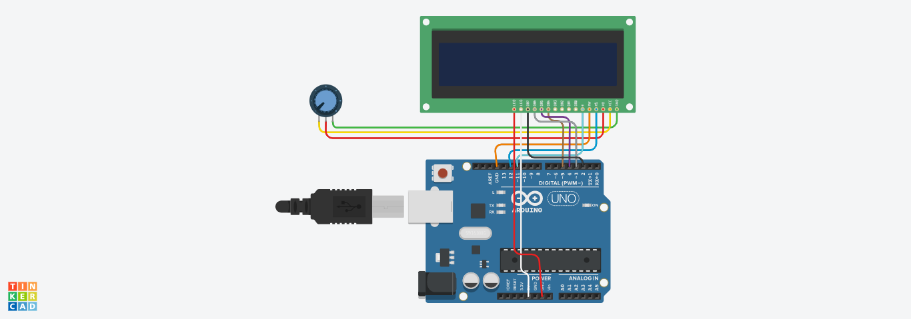

**THEORY**

**CONCEPT USED:-**

Here we will use the concept of liquid crystal display or LCD i.e. a digital data display on which we can display characters and numbers. In this we also learned that how to write a code of displaying characters on LCD.

**LEARNING AND OBSERVATION:-**

1. We learned about various connections done to make the LCD work and display the desired content.
2. LCD displays have the advantage of consuming very less current and they are idle for arduino projects.
3. We observed the breakdown of the pin functions of the digital data system:-

**GND** – This is the Ground pin.  On some modules it is labeled VSS.

**5 VDC** – This is the 5 volt power connection. On some modules it is labeled VDD.

**Brightness** – This is the input for the brightness control voltage, which varies between 0 and 5 volts to control the display brightness. On some modules this pin is labeled V0.

**RS** – This is the Register Select pin. It controls whether the input data is meant to be displayed on the LCD or used as control characters.

**RW** – Puts the LCD in either Read or Write mode. In most cases you’ll be using Read mode so this pin can be tied permanently to ground.

**EN** – The Enable pin. When High it reads the data applied to the data pins. When low it executes the commands or displays the data.

**D0** – Data input 0.

**D1** – Data input 1.

**D2** – Data input 2.

**D3** – Data input 3.

**D4** – Data input 4.

**D5** – Data input 5.

**D6** – Data input 6.

**D7** – Data input 7.

**A** – The Anode (positive voltage) connection to the backlight LED.

**K** – The Cathode (ground or negative voltage) connection to the backlight LCD.

**PROBLEMS AND TROUBLESHOOTING:-**

The problem faced while performing the tasks were:-

1. Code of LCD was written wrong due to which our circuit was not working.
2. The connections went wrong so I had to change the connections and that’s why LCD was not blinking.

**PRECAUTIONS:-**

1. Double check the circuit and breadboard diagram to make sure all the components in the right place.
2. Hands should not be wet while working with the circuits to prevent shock.
3. The circuit must be closed and neat.

**LEARNING OUTCOMES:-**

1. I learned that how we work with LCD display and how to change the content and intensity of the display.
2. I learned making circuits using different hardwares and controlling the functions done by circuit with the program.
3. I learned to make codes for the simulation of arduino UNO.