Accenture

Hello, my name is Samala Ritesh dhyan, and I'm thrilled to have the opportunity to introduce myself today. I am from Godavarikhani Telangana. I have completed my 10th standard in shantiniketan Vidyalaya CBSE with 80% and I have completed my intermediate in Sri Chaitanya educational institutions with an aggregate of 95.5 and I am currently pursuing my BTech in MLRIT in the stream of Computer science and engineering with a specialization of data science with my current CGPA of 8.36. Although I might be new to the professional world, I am eagerly waiting to apply the knowledge and skills I acquired during my education.

I am a keen learner and volunteer in my college academics. This ability made me learn some of the most popular programming languages i.e python and Java. In addition to that I have also learnt SQL and Web development as well. Furthermore, I have also pursued relevant certifications for Java and python from Un school and SQL from Coursera in order to strengthen my knowledge and stay up to date. As I have already mentioned, I am also a video editor volunteer of SQUAD club which is the official data science club of MLRIT. During my academic journey, I proactively tried my best for opportunities to enhance my skills and gain practical experience. I successfully completed a remote internship at Code Clause as a web development intern, where I had developed a unit converter and portfolio web application.

During my academics, I had an opportunity to develop a project on chatbot for Arundathi Hospital as a team where I have gained a good knowledge about NLP on which the whole project backend depends.

On the other hand, my interest towards Data Analytics has grown immensely so I thought to do a hands on project in order to better understand the Data Analytics Tools. So, I have successfully developed an interactive dashboard on call center data. The dataset consists of various filters such as date, channel and city by which you can visualize the filtered data.

Coming to my extra curricular activities, I am interested in playing badminton and I enjoy a lot playing it. I love travelling and exploring new places with my family or friends. At last, I am excited about this opportunity to start my career with Conduent.

Thank you

HR questions

1. what do you know about Accenture?

Accenture is a global professional services company that provides a wide range of services and solutions in strategy, consulting, digital, technology, and operations. The company helps organizations to improve their performance and create sustainable value for their stakeholders.

* + Accenture has offices in more than 200 cities across 50 countries
  + Julie Sweet is Accenture’s Chief Executive Officer
  + Accenture's headquarters are in Dublin, Ireland, at 1 Grand Canal Square, Dublin, Ireland.
  + Accenture has 10 Innovation Hubs
  + Accenture has more than 7000 clients
  + Accenture employs more than 710,000 people
  + 38% of Accenture employees are women and 62% of Accenture employees are men.

1. what do you know about data science?
   * Data science is a multidisciplinary field that extracts valuable insights from data to inform decision-making and solve complex problems.
   * Data scientists employ programming languages like Python and R, alongside tools like SQL and data visualization softwares such as PowerBI, Tableau etc to uncover patterns and trends within vast datasets.
   * These insights can be applied in diverse industries, such as healthcare, finance, and marketing, to optimize processes, predict future outcomes, and drive innovation.

Data science has a wide range of applications across various industries and fields. Here are some common applications:

|  |  |  |  |  |  |  |  |  |
| --- | --- | --- | --- | --- | --- | --- | --- | --- |
|  | 1. | **Business and Marketing** | | | | | | : |
|  | | |  | * Customer segmentation and targeting for personalized marketing. * Market basket analysis to optimize product recommendations. * Pricing optimization based on demand and competition. | | | | |
|  | 2. | **Healthcare** | | | | : | | |
|  | | |  | * Disease prediction and early diagnosis using patient data. * Drug discovery and development. * Healthcare resource allocation and optimization. | | | | |
|  | 3. | **Finance** | | | : | | | |
|  | | |  | * Fraud detection and prevention in banking and credit card transactions. * Risk assessment and portfolio management. * Algorithmic trading for financial markets. | | | | |
|  | 4. | **E-commerce** | | | | | : | |
|  | | |  | * Recommender systems for product recommendations. * Inventory management and demand forecasting. * Customer sentiment analysis for product reviews. | | | | |

1. what is your favourite subject in your academics? PPS and Data Structures
2. least subject?

DECO – digital electronics and computer organization POC : principles of communication

1. where do you see yourself in the next five years?

In the next five years I would see myself as a high skilled professional who has gained an immense experience in IT industry and also deliver various successful projects for my company and I also expect to reach to higher positions in the company and help my junior colleagues with their career advancement.

1. different job roles in datascience?

Data Analyst : An individual who uses various visualization tools in order to gain insights from large amount of data and help the organizations or businesses in decision making.

Data Engineer : An individual who actually creates and manages the data created from various sources and organizes the data in a proper manner which could be used by the data analysts and data scientists to work with that data.

Data Scientist : An individual who applies various machine learning algorithms

On the large amount of data and help in predicting the future of the organization ups and downs in prior which would help the businesses a lot.

1. difference beween AI and ML

AI, or Artificial Intelligence, is like giving a computer or a machine the ability to think and learn on its own, similar to how humans do. It's about making computers smart so they can understand things, make decisions, and solve problems without being explicitly programmed for every single task. AI uses algorithms and data to improve its performance over time, just like we learn from our experiences to become better at different tasks. In simple words, AI makes machines act smart and capable, even though they don't have human brains.

Machine Learning (ML) is a part of Artificial Intelligence (AI) that focuses on teaching computers to learn from data and improve their performance without being explicitly programmed. It's like training a computer to recognize patterns, make predictions, or solve problems by showing it lots of examples.

In simple words, ML allows machines to get better at tasks by learning from experience, much like how we humans learn from our experiences and mistakes. Instead of telling the computer exactly what to do step by step, we feed it data and let it figure out the patterns and rules on its own. This makes ML a powerful tool for tasks like image recognition, language translation, and even predicting future events based on past data.

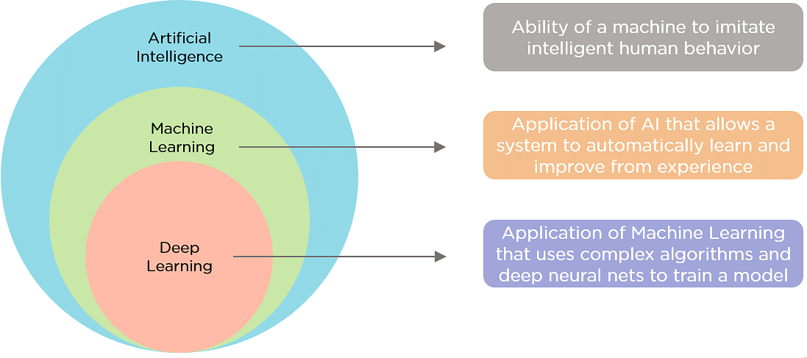

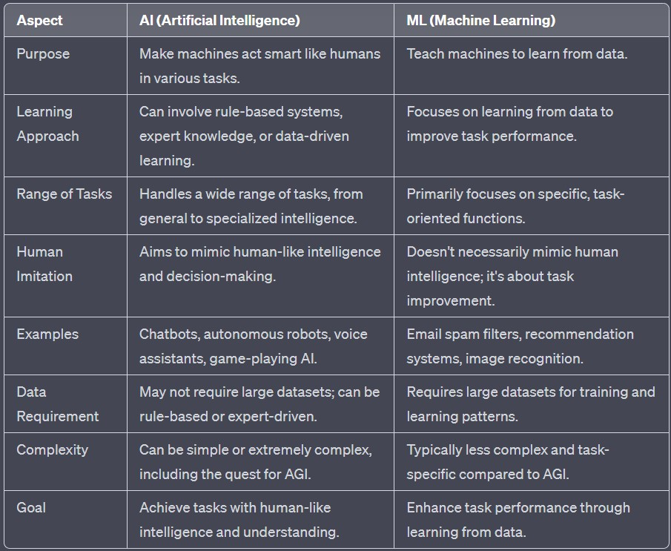

1. why did you choose this role?

I chose this role because it perfectly aligns with my skills and career aspirations. In my previous experiences as an intern, I've had the opportunity to work on several projects that involve development and problem-solving, which I find incredibly fulfilling. When I read the job description for this role, I was excited to see that it involves working as an associate software engineer. I see this position as a great opportunity to further develop my skills and make a meaningful impact in my professional career.

1. what do you know about the role which you are going to do? Responsibilities of an ASE :

# Software Development:

* + Writing, testing, and maintaining code for software applications or systems.
  + Collaborating with senior engineers and developers to design and implement software solutions.
  + Debugging and troubleshooting code to identify and fix issues.

# Coding and Programming:

* + Using programming languages and development tools (e.g., Java, Python, C++, etc.) to build software applications.
  + Following coding standards and best practices to ensure high-quality code.

# Documentation:

* + Creating and maintaining technical documentation for software development, including code comments, user manuals, and system architecture documentation.

# Testing:

* + Writing unit tests and conducting software testing to identify and address bugs and defects.
  + Participating in code reviews to ensure code quality and adherence to coding standards.

# Collaboration:

* + Collaborating with cross-functional teams, including other developers, quality assurance (QA) testers, and product managers, to deliver software projects on time.

# Problem Solving:

* + Analyzing and solving technical problems and challenges that arise during the development process.
  + Identifying and implementing solutions to optimize software performance.

# Are you a team player or a team leader explain?

"Depending on the situation and the needs of the team, I believe I am both a team leader and a team player." As a team player, I enjoy collaboration and believe that good teamwork is often critical to the success of any project. I actively listen to my colleagues, contribute ideas, and collaborate to reach mutual objectives. I am versatile and eager to assist others when necessary.

On the other side, I've also held leadership positions where I was responsible for directing and coordinating team efforts, setting objectives, and ensuring that everyone is on the same page with the project's vision. I set a good example for my team members, motivate them, and provide clear direction when necessary**.**

# Why Accenture?

For various reasons, I'm pleased about the opportunity to work with Accenture. First and foremost, I've been impressed by Accenture's commitment to innovation and its global reputation for providing best solutions to clients. The company's

culture of continual learning and development is well aligned with my career aspirations.

Accenture's diverse and inclusive work atmosphere also appeals to me, as I feel it stimulates creativity and brings out the best in employees. I also found it appealing for the opportunity to work together with talented experts from various backgrounds and fields.

Overall, I see Accenture as a place where I can continue to grow professionally, work on exciting and meaningful projects, and be part of a dynamic team dedicated to making a difference. I am genuinely enthusiastic about the prospect of being a part of the Accenture family.

# Problems in Test

Given a binary array arr[], the task is to find the length of the longest sub-array of the given array such that if the sub-array is divided into two equal-sized sub- arrays then both the sub-arrays either contain all 0s or all 1s. For example, the two sub-arrays must be of the form {0, 0, 0, 0} and {1, 1, 1, 1} or {1, 1,

1} and {0, 0, 0} and not {0, 0, 0} and {0, 0, 0}

***Input:*** *arr[]={1,1,1,0,0,1,1}*

## Output: 4

*{1, 1, 0, 0} and {0, 0, 1, 1} are the maximum length valid sub-arrays.*

***Input:*** *arr[]={1,1,0,0,0,1,1,1,1}*

## Output: 6

*{0, 0, 0, 1, 1, 1} is the only valid sub-array with maximum length.*

For every two consecutive elements of the array say **arr[i]** and **arr[j]** where **j = i**

**+ 1**, treat them as the middle two elements of the required sub-array. In order for this sub-array to be a valid sub-array **arr[i]** must not be equal to **arr[j]**. If it can

be a valid sub-array then its size is **2**. Now, try to extend this sub-array to a bigger size by decrementing **i** and incrementing **j** at the same time and all the elements **before index i** and **after index j** must be equal to **arr[i]** and **arr[j]** respectively. Print the size of the longest such sub-array found so far.

Code :

package JavaImportantPrograms; import java.util.*;

public abstract class MaximumSubArrayLength {

public static int findMaxLength(int[] arr,int n)

{

int i=0; int j=i+1;

int maxlen=0; while(j<n)

{

if(arr[i]!=arr[j]) {

maxlen = Math.*max*(maxlen, 2);

int l = i-1; int r = j+1;

while(l>=0 && r<n && arr[i] == arr[l] && arr[j] == arr[r])

{

l--; r++;

}

maxlen = Math.*max*(maxlen, 2*(r-j));

} i++;

j=i+1;

}

return maxlen;

}

public static void main(String[] args) {

// **TODO** Auto-generated method stub Scanner s = new Scanner(System.***in***); int n = s.nextInt();

int[] arr = new int[n]; for(int i=0;i<n;i++)

arr[i] = s.nextInt();

int result = *findMaxLength*(arr,n); System.***out***.println(result);

}

}

2.Write a program to print the following output Input : SaveTheWorld

Output : sAVE

tHE wORLD

Code :

package JavaImportantPrograms; import java.util.Scanner; public class StringToggleCase {

public static void toggleCase(String str)

{

for(int i=0;i<str.length();i++)

{

if(Character.*isUpperCase*(str.charAt(i)) ==

true)

{

if(i!=0)

{

System.***out***.println();

}

System.***out***.print(Character.*toLowerCase*(str.charAt(i))

);

}

else

{

System.***out***.print(Character.*toUpperCase*(str.charAt(i))

);

}

}

}

public static void main(String[] args) {

// **TODO** Auto-generated method stub Scanner s = new Scanner(System.***in***); String str = s.next(); *toggleCase*(str);

}

}

# Strengths

1. Hardworking
2. Good communicator
3. Time management

# Weakness

1. Take time to habituate with new people or new place
2. Nervous at public speaking

# What are the issues you found in the project?

1. library version issues(tensor flow, nltk, tkinter, json) 2.inaccurate output(because less feeding of data)
2. requirement of data(collection of data from hospital)

# Internship 1 – OasisInfobyte

In this internship, I worked as a data science intern for one month, where I was provided by several data sets. These datasets were structured i.e it was in the form of table with rows and columns. I was asked to complete three tasks.

1. Email Spam Detection
2. Iris Flower Species Detection
3. Sales Prediction model

# Iris Flower Species Detection

1.I have used pandas, numpy, sklearn library in this project.

1. In this dataset, consist of four columns i.e Sepal length, Sepal width, Petal length, petal width and at last species. The Species were Setosa[0], Versicolor[1], Virginica[2].
2. First I have divided the data set into two types i.e. training data, testing data.
3. I have also divided the columns into two types i.e. independent variables and dependent variables.
4. The next step is to create a model and train the model in order to make it predict the output i.e. species when input is given i.e. sepal length, sepal width, petal length, petal width.
5. I have used Logistic Regression model in order to predict the output.

**Logistic Regression** is a statistical and machine learning technique used for binary classification. It models the relationship between a binary dependent variable (an outcome that can take only two values, typically 0 and 1) and one or more independent variables (features or predictors) by estimating the probability of the dependent variable belonging to the positive class (1).

In simple terms, logistic regression helps you predict whether something will happen (1) or not happen (0) based on input features. It uses a logistic function (sigmoid curve) to transform a linear combination of these features into a probability score. If the probability is greater than a chosen threshold (usually 0.5), the model predicts the positive class; otherwise, it predicts the negative class.

1. Then I trained the model with the training data. Once the training is done we need to test it whether the model is making accurate predictions or not. So, we test the model with the testing data and the model accuracy came out to be 96.6% which is a good one.
2. In this way I have completed the first project.

# Sales Price Prediction Model

1. I have used pandas, numpy, sklearn library in this project.
2. In this dataset, consist of four columns i.e TV, Radio, NewPapers and at last Sales.
3. First I have divided the data set into two types i.e. training data, testing data.
4. I have also divided the columns into two types i.e. independent variables and dependent variables.
5. The next step is to create a model and train the model in order to make it predict the output i.e. sales when input is given i.e. TV, Radio, Newspapers.
6. I have used Linear Regression model in order to predict the output.
7. Linear regression is a statistical method used to model the relationship between a dependent variable (the outcome you want to predict) and one or more independent variables (features or predictors) by fitting a linear equation to the observed data. In simpler terms, it's a technique for understanding and predicting how one variable changes as another variable(s) changes.
8. Then I trained the model with the training data. Once the training is done we need to test it whether the model is making accurate predictions or not. So, we test the model with the testing data and the model accuracy came out to be 89.8% which is a good one.
9. In this way I have completed the second project.

# Difference between Logistic Regression and Linear Regression

* + **Linear Regression:** It is used for predicting a continuous numerical output. In linear regression, the dependent variable (the variable you are trying to predict) is a continuous quantity, and the model's goal is to find a linear relationship between the independent variables and the continuous output.
  + **Logistic Regression:** It is used for predicting a binary categorical output. In logistic regression, the dependent variable is categorical with two possible outcomes (usually coded as 0 and 1), and the model predicts the probability of an observation belonging to the positive class (1).

# Email Spam Detection

1. This project’s main aim it to predict whether the mail is spam or not spam.
2. The dataset consists of two columns i.e. spam/notspam, content of email.
3. First, I have added another column to the dataset which is named as length, to find out the length of the content in the mail.
4. Then I have replaced the strings spam with 1 and not spam with 0 inorder to better understand the data.
5. Here, I removed all the punctuation marks in the sentence in order to remove the unwanted content in the sentence.
6. Next, I have tokenized the sentence i.e. we break down the sentences in to individual words each word is considered as token.
7. In order to create a model I have used multinomailNB to train and test it.
8. **MultinomialNB** stands for Multinomial Naive Bayes, which is a popular machine learning algorithm used for classification tasks, especially in natural

language processing (NLP) and text analysis. It's an extension of the Naive Bayes algorithm, which is based on Bayes' theorem of probability.

1. Then I trained the model with the training data. Once the training is done we need to test it whether the model is making accurate predictions or not. So, we test the model with the testing data and the model accuracy came out to be 98.5% which is a good one.
2. In this way I have completed third project.

Chatbot For Arundathi Hospital

Chat bot[2] is an automated way of communication with the users in human understandable language.Chat bots[2] are programs built to automatically engage with received messages. Chat bots[2] can be programmed to respond the same way each time, to respond differently to messages containing certain keywords and even to use machine learning[7] to adapt their responses to fit the situation. The chat bot which we are building is a task oriented[2] chatbot

There are two main types of chat bots:

* + Task-oriented (declarative) chat bots are single-purpose programs that focus on performing one function. Using rules, NLP, and very little ML, they generate automated but conversational responses to user inquiries. Though they do use NLP so end users can experience them in a conversational way, their capabilities are fairly basic. These are currently the most commonly used chat bots.
  + Data-driven and predictive (conversational) chat bots are often referred to as virtual assistants or digital assistance and they are much more sophisticated,

interactive, and personalized than task-oriented chat bots. They apply predictive intelligence and analytics to enable personalization based on user profiles and past user behavior. Digital assistants can learn a user’s preferences over time, provide recommendations. In addition to monitoring data and intent, they can initiate conversations. Examples like apple’s Siri and Amazon’s Alexa. The chatbot which we are creating is a task oriented type.

Natural Language Processing

We use Natural Language Processing to pre process the data before we tarin it to the machine. The essence of Natural Language Processing lies in making computers understand the natural language. That’s not an easy task though. Computers can understand the structured form of data like spreadsheets and the tables in the database, but human languages, texts, and voices form an unstructured category of data, and it gets difficult for the computer to understand it, and there arises the need for Natural Language Processing. There’s a lot of natural language data out there in various forms and it would get very easy if computers can understand and process that data. We can train the models in accordance with expected output in different ways

Steps involved :

1.Sentence Segementation : Breaking down a para into sentences. 2.Tokenization : Breaking down the sentence into words.

1. Predicting parts of speech of each word : Predicting whether the word is a noun, verb, adjective, adverb, pronoun, etc. This will help to understand what the sentence is talking about.
2. Lemmatization : The goal of lemmatization is to transform different inflected

or derived forms of a word into a common base form, making it easier to analyze and compare words.

In English, words can appear in various forms due to tense, plurality, conjugation, and other grammatical factors. For example, the verb "run" can have different forms like "running," "ran," and "runs." Lemmatization helps standardize these variations by reducing them to the base form, which in this case is "run."

1. identifying stop words : There are various words in the English language that are used very frequently like ‘a’, ‘and’, ‘the’ etc. These words make a lot of noise while doing statistical analysis. We can take these words out 6.Dependency Parsing : This means finding out the relationship between the words in the sentence and how they are related to each other

7.Finding Noun Phrases : We can group the words that represent the same idea.We can use the output of dependency parsing to combine such words

* 1. Working of the chatbot

Step1 : The user enters some text.

Step2 : The input is analyzed by Natural Language Tool Kit(Natural Language Processing) which helps in assessing the intents and entities of the text entered by the user and create response based on the contextual analysis of the text.

Step 3 :Now it’s time to really get into the nitty-gritty of how AI chat bots work. There are five major steps involved — tokenizing, normalizing, recognizing

entities, dependency parsing, and generation — for the chatbot to read, interpret, understand, and formulate and send a response. Let’s take a closer look.

* + - Tokenizing: The chatbot starts by chopping up text into pieces (also called ‘tokens’) and removing punctuation
    - Normalizing: Next, the bot removes details that aren't relevant and converts words to their "normal" version, for example by making everything lowercase
    - Recognizing Entities: Now that the words are all normalized, the chatbot

seeks to identify which type of thing is being referred to. For example, it would identify North America as a location, 67% as a percentage, and Google as an organization

* + - Dependency Parsing: For the next step, the bot identifies the role each word plays in the sentence, such as noun, verb, adjective, or object CHATBOT FOR ARUNDATHI HOSPITAL 11
    - Generation: Finally, the chatbot generates a number of responses using the information determined in all the other steps and selects the most appropriate response to send to the user.