NIP Project — Submission Template
Pega Platform project · This document is your complete submission
Read this before you start:
1. Fill in Section 1 completely. The Pega application name must follow the format NIP-[Project]-[YourName].
2. Create a new Operator in Pega with your full name and log in as that operator before taking any screenshot.
3. When you create your test case, enter YOUR FULL NAME in the Issue Description (Vehicle) or Movie Name (Movie) field.
4. Complete only the section for your chosen project. Delete the other project section.
5. Paste one screenshot per user story (10 total). Follow the screenshot rules in your selected project section.
6. Answer every question in Sections 3 and 4 in your own words.
7. Save the file using this format: ProjectName_FirstName_LastName.docx. Use VehicleService or MovieTicket as the ProjectName. Examples: VehicleService_Ravi_Kumar.docx or MovieTicket_Ravi_Kumar.docx.

Section 1 — Your Details
Full Name | Samala Vennela
Email ID (registered on NIP) | samalavennela2006@gmail.com
Phone Number | 7382286409
College Name | ACE Engineering College
Course (e.g. IT, CS) | CSE
State | Telangana
Project Chosen (Vehicle Service OR Movie Ticket Booking) | Vehicle Service Management Application
Pega Application Name (e.g. NIP-VehicleService-YourName) | NIP-VehicleService-SamalaVennela
Case Type Name (exact) | Vehicle Service Request
Pega Instance URL | https://smwd5fgj.pegaacademy.net/prweb/app/vehicle-service-management/hvcpWh0V8YbA69BvBHjDen0zVd1a7Ecx*/!STANDARD?pzPostData=1002035004
Operator Name (created in Pega with your full name) | Samala Vennela

Section 2A — Vehicle Service Management Application
Complete this section only if you selected this project. Delete the other project section before submitting.

Screenshot rules — IMPORTANT before you start:
1. Name your Pega application as: NIP-VehicleService-YourName OR NIP-MovieTicket-YourName
2. Create a new Operator in Pega with your full name (Security → Operators) and log in as that operator.
3. When you create your test case, enter YOUR FULL NAME in the Issue Description (Vehicle) or Movie Name (Movie) field.
4. The logged-in operator name must be visible in every screenshot wherever the Pega interface displays it.
5. The student's full name must be visible in all running-case screenshots.
6. Configuration screenshots must clearly show the relevant application or rule name.
Screenshots that do not show these will not be accepted.

US-001 — Submit Vehicle Service Request
What is expected:
Case created, customer submits Vehicle ID, Vehicle Model, Issue Description. Validation applied.
Screenshot — paste your screenshot below this line:
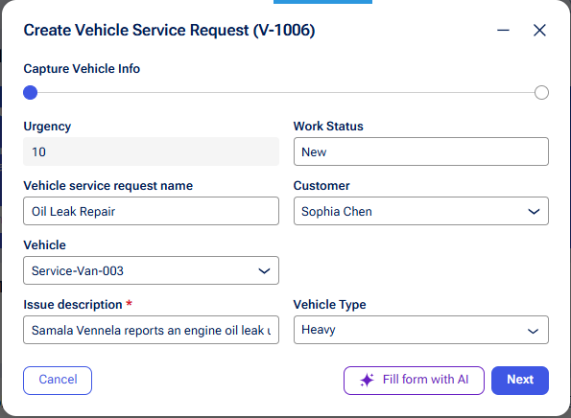

What I built for this (1–2 lines in your own words):
I created the Vehicle Service Request case type with an initial Request Intake stage where the Customer persona enters Vehicle, Vehicle Type, and Issue Description. Required fields are validated before the case can be submitted

US-002 — Perform Vehicle Inspection
What is expected:
Inspection stage with Service Advisor step. Inspection Notes and Condition Rating captured.
Screenshot — paste your screenshot below this line:
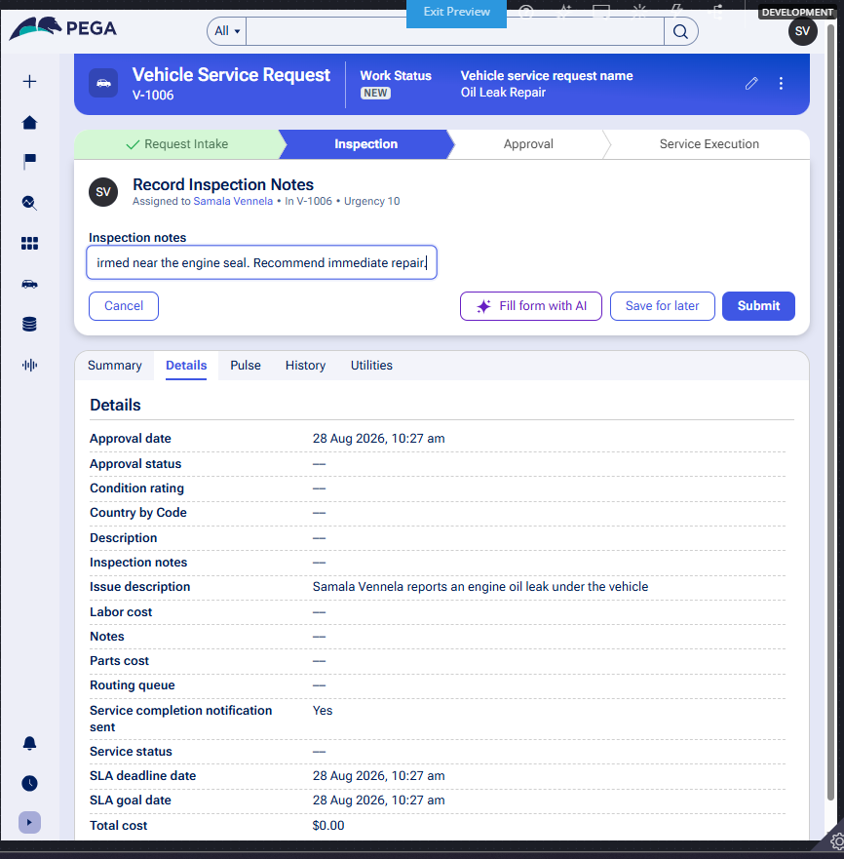

What I built for this (1–2 lines in your own words):
I added an Inspection stage with a Record Inspection Notes step for the Service Advisor persona to capture Inspection Notes and a Rate Condition step to capture Condition Rating. This must be completed before moving to Estimate Generation

US-003 — Generate Service Estimate
What is expected:
Labor Cost and Parts Cost captured. Total Cost calculated automatically by declare expression.
Screenshot — paste your screenshot below this line:
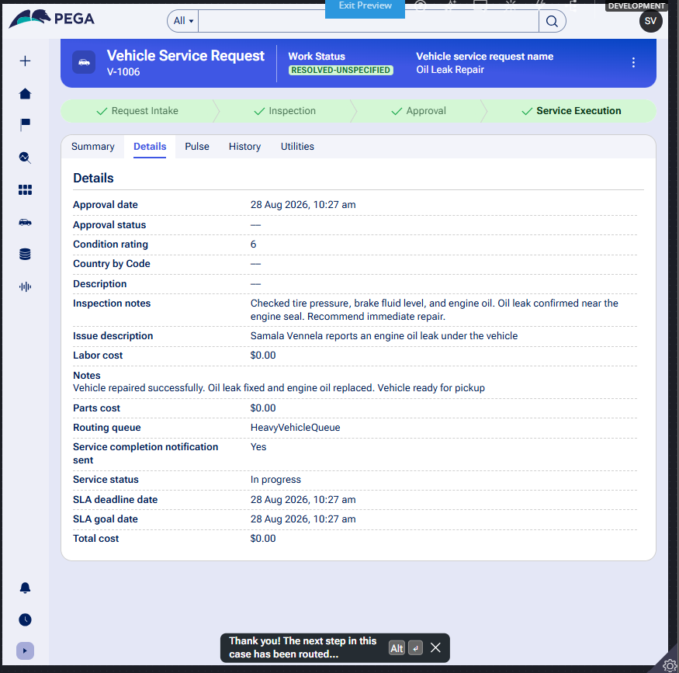

What I built for this (1–2 lines in your own words):
I added an Estimate Generation step within the Inspection stage where the Service Advisor enters Labor Cost and Parts Cost. A Total Cost calculation was configured using a Data Transform to add these two values automatically

US-004 — Approve Service Estimate
What is expected:
Approval stage assigned to Customer. Approval Status captured. Flow branches on approve/reject.
Screenshot — paste your screenshot below this line:
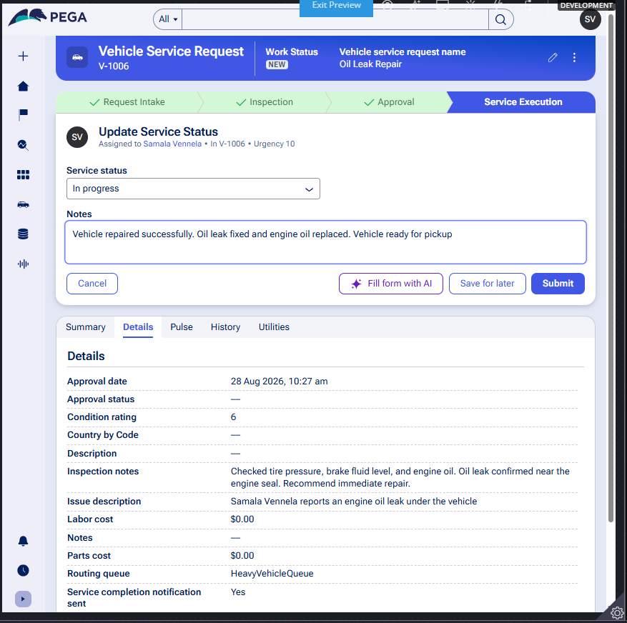

What I built for this (1–2 lines in your own words):
I added an Approval stage with an approval step assigned to the Customer persona. The customer's decision is captured in Approval Status, and approved requests move forward to Service Execution while rejected ones follow a separate Rejection Path

US-005 — Maintain Vehicle Data
What is expected:
Reusable Vehicle data object created with Vehicle ID, Model, Type — linked to case.
Screenshot — paste your screenshot below this line:

What I built for this (1–2 lines in your own words):
I created a reusable Vehicle data object separate from the case type, with properties for Vehicle ID, Model, and Type. It is linked to the Vehicle Service Request case, allowing the same vehicle data to be reused across multiple service requests and enabling service history tracking

US-006 — Review Service Estimate
What is expected:
Approval screen shows Labor Cost, Parts Cost and Total Cost clearly to the Customer persona.
Screenshot — paste your screenshot below this line:

What I built for this (1–2 lines in your own words):
I configured the Approval step's Customer Review screen to clearly display Labor Cost, Parts Cost, and the calculated Total Cost together, giving the customer full visibility into the estimate before they approve or reject the service

US-007 — Auto Assign Technician
What is expected:
Service Execution stage with routing to HeavyVehicleQueue or LightVehicleQueue. Assigned Technician and Service Status properties maintained.
Screenshot — paste your screenshot below this line:

What I built for this (1–2 lines in your own words):
I added a Service Execution stage with an Assignment Routing group containing Route by Vehicle Type and Assign Technician steps. The case is automatically routed to HeavyVehicleQueue or LightVehicleQueue, and Assigned Technician and Service Status properties are maintained to track progress

US-008 — Notify Service Completion
What is expected:
Correspondence rule created and triggered on case resolution. Email includes case and vehicle details.
Screenshot — paste your screenshot below this line:

What I built for this (1–2 lines in your own words):
I created a Correspondence rule named ServiceCompletionNotification (Email type) that is triggered by a Send email step when the case reaches Resolved-Completed. The email includes the Vehicle ID, Vehicle Model, Service Summary, and Total Cost to keep the customer informed

US-009 — Define Service SLA
What is expected:
SLA configured on the case type. Goal: 2 days. Deadline: 3 days. Priority increases on breach.
Screenshot — paste your screenshot below this line:

What I built for this (1–2 lines in your own words):
I configured a Service Level Agreement on the Vehicle Service Request case type with a Goal of 2 days and a Deadline of 3 days from case creation. Urgency is automatically increased if the deadline is missed, without needing complex escalation paths

US-010 — Route by Vehicle Type
What is expected:
Routing rule or Decision Table routes to HeavyVehicleQueue or LightVehicleQueue based on Vehicle Type property.
Screenshot — paste your screenshot below this line:

What I built for this (1–2 lines in your own words):
I created a Data Transform (RouteByVehicleType) that checks the Vehicle Type property and automatically routes the case to HeavyVehicleQueue for heavy vehicles or LightVehicleQueue for all other types, with no manual selection required.

Section 3 — About Your Application
These answers are checked against your screenshots. Write exactly what is in your application.

Q1. List your stages in the order they appear in your case lifecycle.
Stage names in order, separated by commas.
Request Intake, Inspection, Approval, Service Execution

Q2. Name the data object(s) you created and the properties inside them.
Data object name and its properties.
Vehicle data object with properties: Vehicle ID, Model, Type. This is linked to the Vehicle Service Request case to enable reuse across multiple service requests.

Q3. What is the exact name and type of the rule you used to calculate Total Cost?
Provide:
• Rule Name
• Rule Type
• Properties used in the calculation
• Formula used
Rule Name: CalculateTotalCost Rule Type: Data Transform Properties used: .LaborCost and .PartsCost Formula used: .TotalCost = .LaborCost + .PartsCost (Set action, target .TotalCost, source .LaborCost + .PartsCost)

Section 4 — Your Understanding
Short, honest and specific answers score well.

Q4. What did Blueprint generate for you, and what did you add or change yourself afterwards?
Be specific about what was already there and what you built or modified on top.
Blueprint generated the initial case type structure with the four stages (Request Intake, Inspection, Approval, Service Execution) and basic steps based on the scenario description. After generation, I added the Vehicle data object with its properties, configured the Total Cost calculation, set up the SLA (Goal/Deadline), created the routing logic to HeavyVehicleQueue/LightVehicleQueue, and built the correspondence rule for service completion notifications.

Q5. Was there anything Blueprint created that you had to correct or configure further? Describe one example.
A real example from your own work.
Yes — the Send email step generated by Blueprint referenced the correspondence rule by its display name with spaces ("Service Completion Notification"), but the actual rule's internal identifier had no spaces ("ServiceCompletionNotification"). This mismatch caused a "Failed to find instance" error at runtime. I had to open the step configuration and correct the reference to match the rule's exact identifier.

Q6. Explain your case flow from creation to resolution, in order.
What happens first, who does what, when the case closes.
The Customer creates a Vehicle Service Request by entering Vehicle, Vehicle Type, and Issue Description (Request Intake). The Service Advisor then inspects the vehicle, records Inspection Notes and Condition Rating, and generates a cost estimate using Labor Cost and Parts Cost (Inspection stage). The Customer reviews the estimate and either approves or rejects it (Approval stage). If approved, the case automatically routes to a technician work queue based on Vehicle Type, the technician updates the Service Status, and once complete, an email notification is sent to the customer and the case reaches Resolved-Completed (Service Execution).

Q7. Pick two design choices you made in your application and explain why you made them.
For each design choice, provide:
• What you implemented
• Why you chose that approach
• What benefit it provides to the application
1) I used a Data Transform (CalculateTotalCost) called from a dedicated "Calculate Total Cost" step, rather than a Declare Expression, because it gave explicit control over exactly when the calculation runs (right after Labor Cost and Parts Cost are entered), matching how Blueprint had structured the Estimate Generation step. 2) I used a Data Transform (RouteByVehicleType) to route cases to HeavyVehicleQueue or LightVehicleQueue automatically, instead of manual queue selection, so that heavy vehicle requests are guaranteed to reach the right team without relying on the service advisor to pick the correct queue every time.

Q8. What was the hardest part, and how exactly did you fix it?
Specific and honest. A real challenge scores much better than a generic answer.
The hardest part was a "Failed to find instance" error when the case tried to send the completion email. I traced it down step by step: opened the Send email step's configuration in Dev Studio, found that it referenced the correspondence rule by its display name with spaces ("Service Completion Notification") while the actual rule's identifier had no spaces ("ServiceCompletionNotification"). I corrected the reference to match exactly, then discovered a second layer of the same problem — the fix had been saved to a development branch that my new test operator's access group could not see. I resolved this by merging the branch into the main VehicleS ruleset so the fix applied to all operators.

Q9. If the approval step was only needed when Total Cost is above a certain amount, what would you change in your application?
Explain what you would change and where. You do not need to build this.
I would add an entry condition (a When rule) on the Approval stage that checks whether .TotalCost is greater than the threshold amount. If Total Cost is at or below the threshold, the case would skip the Approval stage entirely and move directly into Service Execution, since no customer sign-off would be required for low-cost repairs.

Q10. List three exact rule names from your application that you personally created or modified.
Include the rule name and rule type for each one (for example: CalculateTotalCost - Declare Expression).
1) CalculateTotalCost – Data Transform
2) ServiceCompletionNotification – Correspondence (Email)
3) RouteByVehicleType – Data Transform

Q11. List all personas used in your application.
List the persona names exactly as they appear in your application.
Customer, Work Portal (the Work Portal persona covers internal staff roles such as Service Advisor and Technician who process the case).

Q12. List all work queues used in your application and explain when each one is used.
For each work queue, provide its exact name and the condition or type of work routed to it.
HeavyVehicleQueue – used when Vehicle Type is "Heavy"; the case is routed here automatically during Service Execution for heavy vehicle servicing. LightVehicleQueue – used for all other (non-heavy) vehicle types; the case is routed here automatically during Service Execution.

Before You Submit — Check These
Read through once before uploading.
1. Section 1 filled in. Application named as NIP-[Project]-[YourName]. Names match the actual application.
2. New Operator created in Pega with my full name. I logged in as that operator for all screenshots.
3. Only my chosen project section remains — the other project section is deleted.
4. All 10 user story screenshots are pasted and follow the operator, running-case, application, and rule-name evidence requirements.
5. Every question in Sections 3 and 4, including Q10, Q11, and Q12, is answered in my own words.
6. This file is named using the required format: ProjectName_FirstName_LastName.docx (for example, VehicleService_Ravi_Kumar.docx or MovieTicket_Ravi_Kumar.docx) and uploaded as required.

