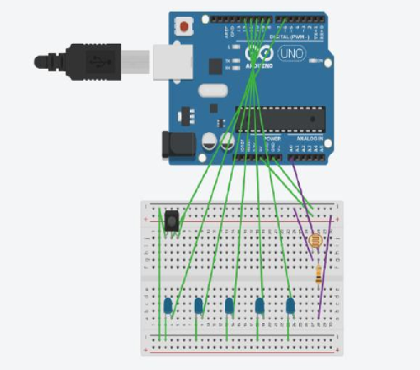

Theory

Light dependent resistor (LDR) or a photo resistor is a device whose resistivity is a function of the incident electromagnetic radiation. Hence, they are light sensitive devices. They are also called as photo conductors, photo conductive cells or simply photocells.

Learning & observations:

This project is used for decoration . It can be used on Diwali and other festivals. different patterns produce different effects and mesmerize people

Different patterns can be imbued with a slight change in the program.Using arduino we can give patterns and ldr helps it activate automatically at night.

#### Problems & troubleshooting

Problems faced during this project:-

Load short-circuiting

Incorrect wiring

### Precautions

Do not short-circuit the load doing so may cause explosion or burning.

Do not reverse the power supply polarity or otherwise wire incorrectly. Doing so may cause explosion or burning.

#### Learning outcomes :

In this when the darkness is detected then the LEDS will blink automatically and pattern can be changed using switch , otherwise the lights will remain off.

We need to be careful with the wiring and power supply so as not to damage the circuit due to overload and short circuiting.

#### Experimenting:-

#### We placed the lights in different connection and finally reached the concluding circuit.