 |  | ITER, SIKSHA ‘O’ ANUSANDHAN (Deemed to be  University) |  |  |  |  | Assignment
Branch |  | Computer Science and Engineering, |  | Programme |  |  | B.Tech
Course Name |  | Practical Robotics Projects with Arduino |  | Semester |  |  | 7th
Course Code |  | CSE-4571 |  | Academic Year |  |  | 2025/Odd
Assignment-1 |  | Topic- WiFi-Communication
Learning Level (LL) |  | L1: Remembering | L3: Applying |  | L5: Evaluating
 |  | L2: Understanding | L4: Analyzing |  | L6: Creating
To interface an ESP01 Wi-Fi module with an Arduino Uno to establish wireless communication for transmitting real-time sensor data to a remote server or monitoring system. This involves utilizing serial communication between Arduino and ESP01, configuring Wi-Fi connectivity using AT commands, and implementing TCP/IP protocols to enable accurate and reliable wireless data transmission for IoT-based applications.

Q’s | Questions |  |  |  |  | COs |  | LL
1 | What is the primary purpose of the ESP8266 ESP-01 module when interfaced with an Arduino UNO? |  |  |  |  | CO1 |  | L1 &L2
2 | Why does the ESP-01 module operate at 3.3V instead of 5V, and what could happen if connected directly to 5V? |  |  |  |  | CO1 |  | L1 &L2
3 | List all 8 pins of the ESP-01 module and briefly describe the function of each. |  |  |  |  | CO1 |  | L1 &L2
4 | What is the default baud rate of the ESP-01 module, and why is it important to match it with the Arduino serial communication settings? |  |  |  |  | CO1 |  | L1 &L2
5 | Differentiate between Station (STA) and Access Point (AP) Wi-Fi modes, as well as both (STA+AP) Wi-Fi modes, supported by the ESP-01. |  |  |  |  | CO2 |  | L2 & L3
6 | Explain the function of the AT commands AT, AT+RST, and AT+CWJAP. |  |  |  |  | CO2 |  | L2 & L3

7 | Explain the role of the ESP01 Wi-Fi module in an IoT-based Arduino system. | CO2 | L2 & L3
8 | Describe how serial communication occurs between the Arduino UNO and the ESP01 module. | CO2 | L2 & L3
9. | Why is a voltage divider circuit or logic level converter required when connecting Arduino TX (5V) to ESP-01 RX (3.3V)? | CO2 | L2 & L3
10 | What is the purpose of using the AT+CWJAP="SSID","PASSWORD" command during ESP01 configuration. | CO2 | L2 & L3
11. | Using the ESP8266 ESP-01 Wi-Fi module and Arduino UNO, demonstrate how to configure the module in Station (STA) mode to connect to an existing Wi-Fi network.  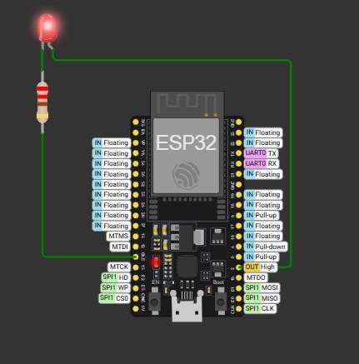  - Draw the circuit diagram showing the connection between Arduino UNO and ESP-01 module for Station mode configuration.  - Perform a Simulation-based Configuration to connect ESP-01 to a Wi-Fi network and record your observations.  - Perform Hardware-based Configuration to connect ESP-01 to a Wi-Fi network and capture the serial monitor output. | CO3 | L3 & L4
12 | 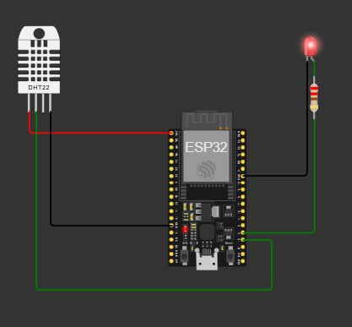  Using the ESP8266 ESP-01 Wi-Fi module and Arduino Uno, demonstrate how to wirelessly transmit sensor data from Arduino to a remote server or monitor through both simulation and hardware implementation.  - Draw the circuit diagram showing the connection between Arduino UNO, ESP-01 module, and a sensor for wireless data transmission.  - Write a short Arduino code snippet to send temperature or humidity data from a DHT11/LM35 sensor through ESP-01 to a remote server.  - Perform Simulation-based implementation to wirelessly transmit sensor data and record your observations.  - Perform Hardware-based implementation to demonstrate actual data transmission and capture the serial monitor output or server response.  - Conclude your observations by discussing how reliable data transmission can be achieved using ESP-01 in IoT applications. | CO4 | L4 & L5
13 | Using the ESP8266 ESP-01 Wi-Fi module and Arduino UNO, demonstrate how to implement TCP/IP protocols for client-server communication through hardware-based development  - How can you configure the ESP-01 module as a TCP client to connect with a remote server?  - Write the AT commands sequence for establishing a TCP connection and transmitting data.  - Draw the circuit diagram showing the setup for client-server communication between Arduino UNO and ESP-01.  - Perform Hardware-based development to implement TCP/IP communication and record the serial monitor output. | CO5 | L4 & L5
14 | Explain how ESP-01 Wi-Fi communication contributes to the development of smart IoT systems with an example | CO6 | L5 & L6

Assignment 1 | Topic: WiFi-Communication | Date of Assignment1: 22.11.2025 | Date of Submission: 26.11.2025

Note:
- Assignment carries a weightage of 20 marks out of 100
- Course outcome CO1 to CO2 was covered.

Course Outcomes | CO1 | Understand the fundamentals of Arduino hardware and software.
Course Outcomes | CO2 | Interface various sensors and actuators with Arduino.
Course Outcomes | CO3 | Apply programming logic to control robotic systems.
Course Outcomes | CO4 | Design and build basic to intermediate level robotics projects.
Course Outcomes | CO5 | CO5 Demonstrate problem-solving and debugging skills in robotics.
Course Outcomes | CO6 | Collaborate in teams to plan, execute, and present robotics projects

