Group No. | Group Members (Regd. No.) | Project Title
12 | 2241019269 | David Putra -  Gesture Controlled Robot Car Using Arduino
12 | 2241014005 | David Putra -  Gesture Controlled Robot Car Using Arduino
12 | 2241019128 | David Putra -  Gesture Controlled Robot Car Using Arduino
12 | 2241019415 | David Putra -  Gesture Controlled Robot Car Using Arduino
12 | 2241013070 | David Putra -  Gesture Controlled Robot Car Using Arduino
12 | 2241019022 | David Putra -  Gesture Controlled Robot Car Using Arduino
Fill up the following Topics and submit the colour printed Hardcopy to the corresponding Faculties.
- Introduction: (Details about the Topic, industry, products, need of study and some history about the same etc.)
This project entails the construction of a 4WD robotic car that integrates embedded systems and modern wireless communication to achieve intelligent mobile robotics behavior. With the growing demand for autonomous and remotely controlled systems, such robotic platforms are increasingly relevant in applications such as autonomous vehicles, logistics, military operations, and research. This project focuses on the integration of mobile robotic systems at the control level of a robotic vehicle, demonstrating the vehicle’s responsive behavior and user interactivity.

The robotic car uses an Arduino Uno microcontroller as its central control unit. The microcontroller performs control functions for the car’s hardware, including motor control through a TB6612FNG motor driver and autonomous obstacle detection using an HC-SR04 ultrasonic sensor. The robotic car also features a NeoPixel LED strip to provide visual feedback and an NRF24L01 wireless module to enable wireless communication.

A key feature of this project is the gesture control system, which allows the user to control the robotic car through hand gestures. These gestures are captured and translated into control commands such as “move forward,” “turn left,” or “stop.” The commands are transmitted wirelessly to the microcontroller, which then executes the corresponding actions, enabling real-time remote control and intuitive interaction with the robotic vehicle.

The research initiated to fulfill the demand for intelligent, autonomous, and human-interactive systems in robotics.

- Problem identification and Problem Formulation: (Core area of problems or other related problems and their brief solutions)
Conventional robotic vehicles can either be driven manually or have their actions determined through preset logic, resulting in limited flexibility and reduced human interaction. Since these systems lack intuitive control mechanisms, they are less effective in dynamic and real-time environments. The principal challenge lies in achieving responsive and user-friendly control of embedded robotic systems. This project addresses the challenge using an Arduino-based control system combined with a gesture-controlled wireless interface, allowing the user to command the robotic vehicle to move, avoid obstacles, and respond effectively in real time. This approach enhances human–robot interaction while maintaining reliable and efficient embedded control.

- Objective of the Project: (Objectives should be mentioned pointwise. Students can also divide the broader and narrow areas of the objectives. These objectives must be near to the situation of the problems)
- To design and build a 4WD robotic car using Arduino and essential hardware components.
- To implement autonomous obstacle detection using the HC-SR04 sensor.
- To add AI control through an Android app that understands voice/text commands.
- To enable wireless communication using the NRF24L01 module.
- To control the car's movement using the TB6612FNG motor driver.
- To provide visual feedback using a NeoPixel LED strip.
- To develop a user-interactive robotic system that responds to natural commands.

- Block Diagram of the Project: (Diagram of a system in which the principal parts or functions are represented by blocks connected by lines that show the relationships of the blocks)
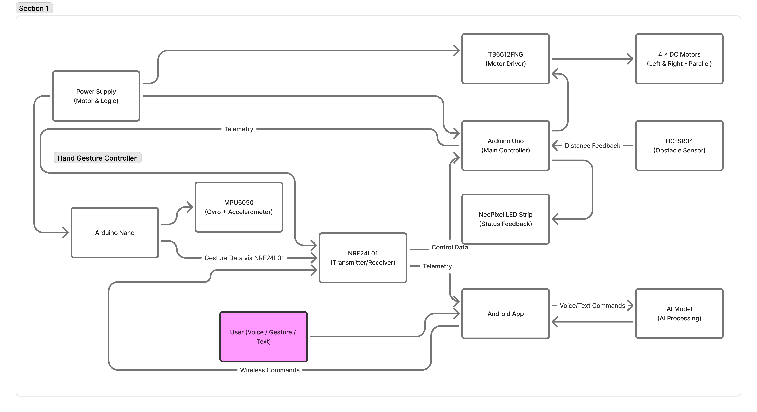

- Circuit Diagram of the project:
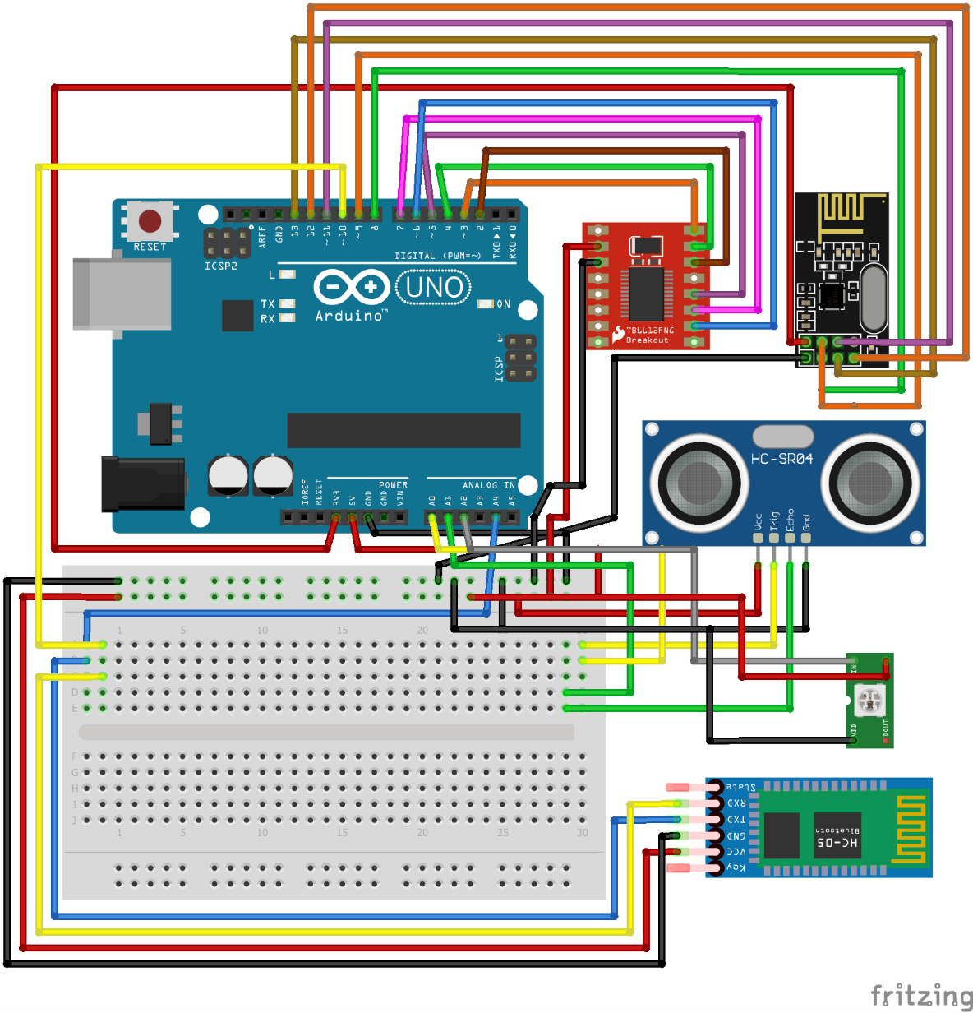
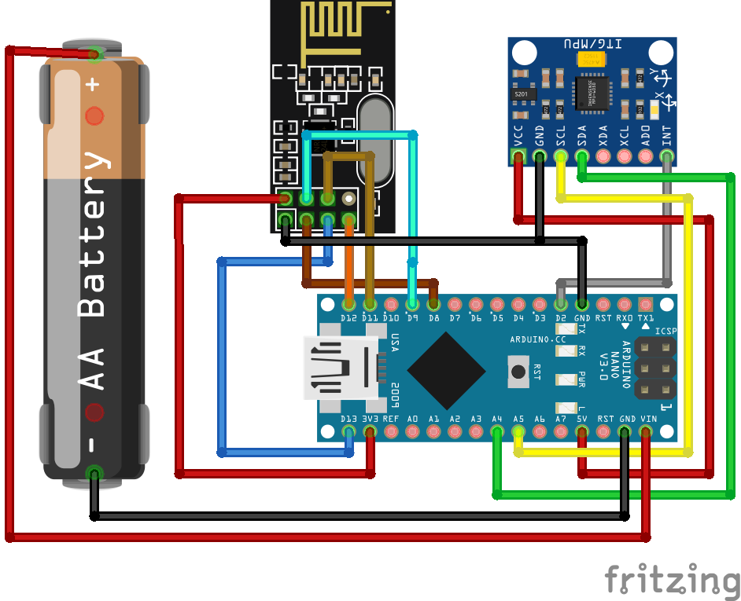

- Components/Items Required:
Sl. No. | Name of the Components | Specification | Quantity
1 | Arduino UNO | ATmega328P, 16 MHz | 1
2 | TB6612FNG Motor Driver | Motor Driver Carrier | 1
3 | DC BO Gear Motor | 500 RPM Straight | 4
4 | Wheels | 65mm | 4
5 | Battery | Lipo – 2200mAh-18650 | 3
6 | Battery Holder with Switch | On/Off switch | 2
7 | MPU6050 | Accelerometer + Gyro | 1
8 | Bluetooth Module | HC-05 Module | 1
9 | Arduino Nano | ATmega328P, 16 MHz | 1
10 | Ultrasonic Sensors | HC-SR04 | 2
11 | WiFi Transceiver | NRF24L01 | 2
12 | NeoPixel Lights | WS2812 | 16
13 | Jumper Wires and Accessories | Connecting | -

The project synopsis should be verified by the corresponding faculties within 7 days.

Signature of Corresponding Faculty
Full Signature of Group members:
1.
2.
3.
4.
5.
6.

