

Name: Samama Iqbal
Roll no : 2024-CET-16
TASK:05
Topic :linklist
Subject: DSA

TASK:05
#include <iostream>
using namespace std;

struct Node {
int id;
Node* next;
};

Node* head = NULL;

// Insert at the end using loop
void insertEnd(int x) {
Node* n = new Node();
n->id = x;
n->next = NULL;

// If list empty → new node becomes head
if (head == NULL) {
head = n;
return;
}

// Loop to reach last node
Node* temp = head;
while (temp->next != NULL) {
temp = temp->next;
}

temp->next = n;
}

// Insert at beginning
void insertBeginning(int x) {
Node* n = new Node();
n->id = x;

n->next = head; // new node points to old head
head = n; // new node becomes head
}

// Display all patients using loop
void display() {
if (head == NULL) {
cout << "No patients in the list.\n";
return;
}

Node* temp = head;

cout << "Patient IDs: ";
while (temp != NULL) {
cout << temp->id << " ";
temp = temp->next;
}
cout << "\n";
}

int main() {
int choice, value;

while (true) {
cout << "\n----- Patient Linked List Menu -----\n";
cout << "1. Insert patient at END\n";
cout << "2. Insert patient at BEGINNING\n";
cout << "3. Display all patients\n";
cout << "4. Exit\n";
cout << "Enter choice: ";
cin >> choice;

if (choice == 1) {
cout << "Enter Patient ID: ";
cin >> value;
insertEnd(value);
cout << "Patient added at end.\n";
}
else if (choice == 2) {
cout << "Enter Patient ID: ";
cin >> value;
insertBeginning(value);
cout << "Patient added at beginning.\n";
}
else if (choice == 3) {
display();
}
else if (choice == 4) {
cout << "Exiting...\n";
break;
}
else {
cout << "Invalid choice.\n";
}
}

return 0;
}

OUTPUT
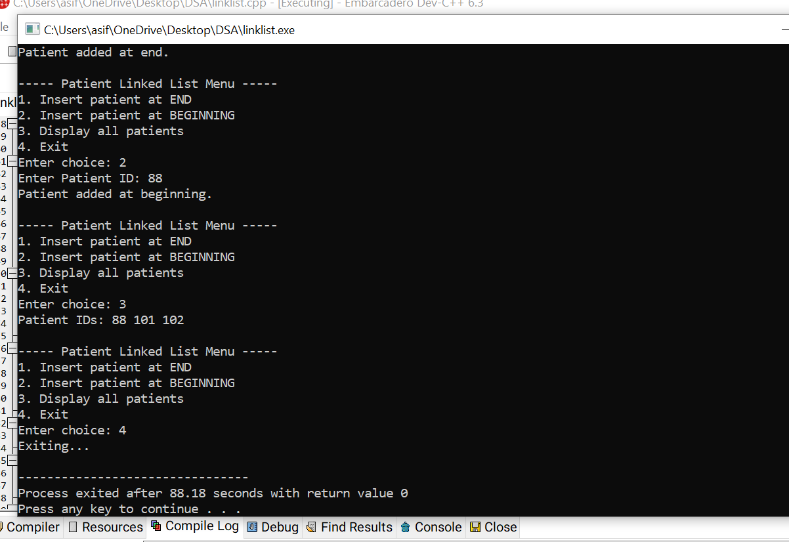

REPORT
This report explains the working, structure, and purpose of a Singly Linked List program written in C++.
A linked list is a dynamic data structure in which elements (called nodes) are connected using pointers.
Each node stores:

Data (Patient ID)

A pointer to the next node

This program is designed to store and manage patient IDs using basic linked list operations.

