
s
DataBase System


LAB TASK-04

CS-2204

Name: Samama iqbal
Roll No: 2024-cet-16
Department: CET
Course Name: Database Systems
Instructor: Engr. Asma javed

LAB REPORT
Lab Task – 04: SQL Server – DDL Commands

Task 01:
“Creating a Database and Table Using SQL DDL Commands”
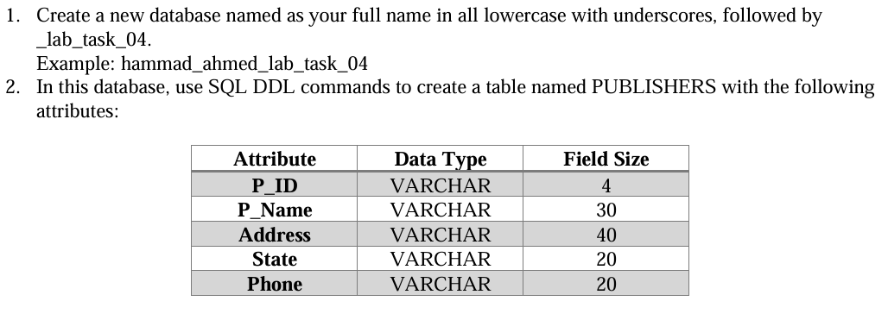
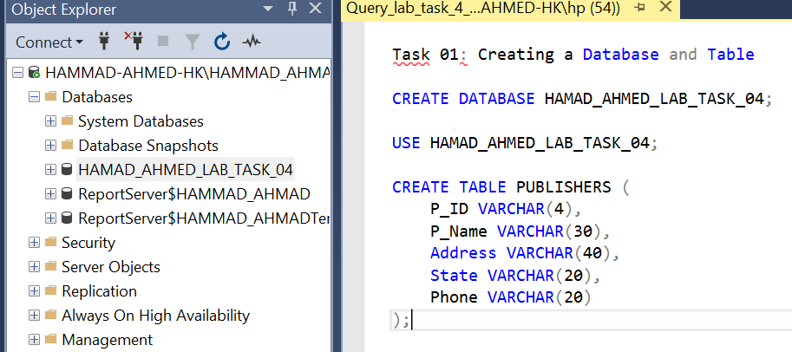
(Database created)

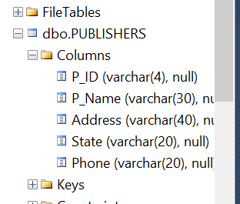
(Table created with attributes)

Task 02:
“Modifying Table Structure Using SQL DDL Commands”
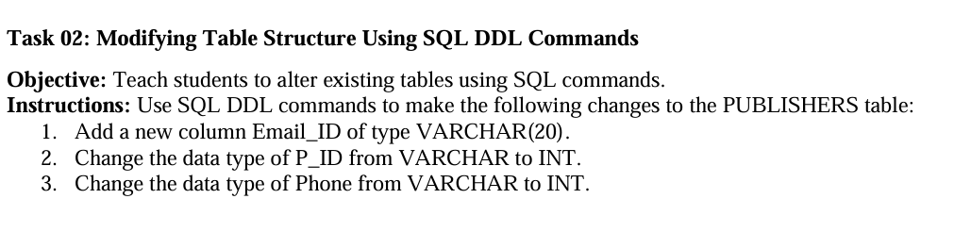
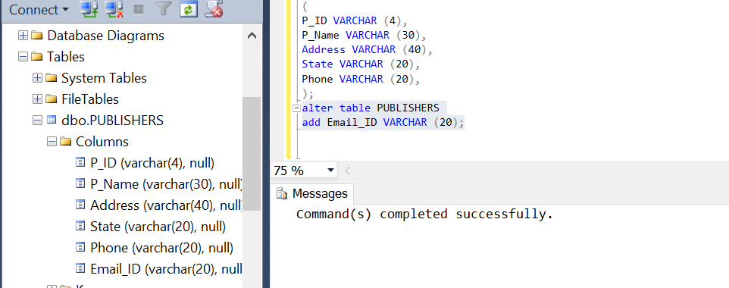
(Column of Email_ID added)
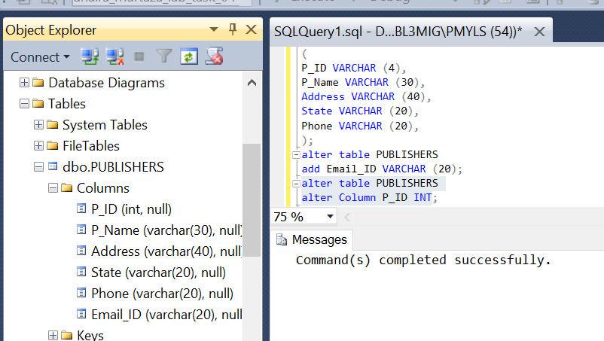
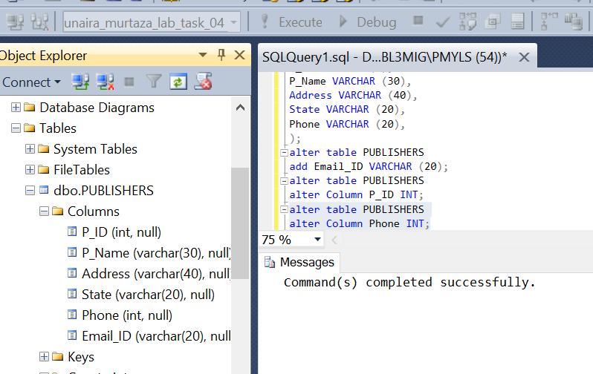

Task 03:
“Renaming and Deleting Table Using SQL DDL Commands”
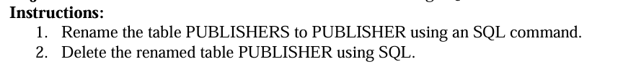
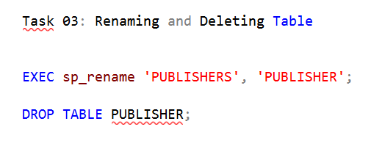
(Publishers renamed as publisher)

Task 04:
“Creating and Modifying Another Table Using SQL DDL Commands”
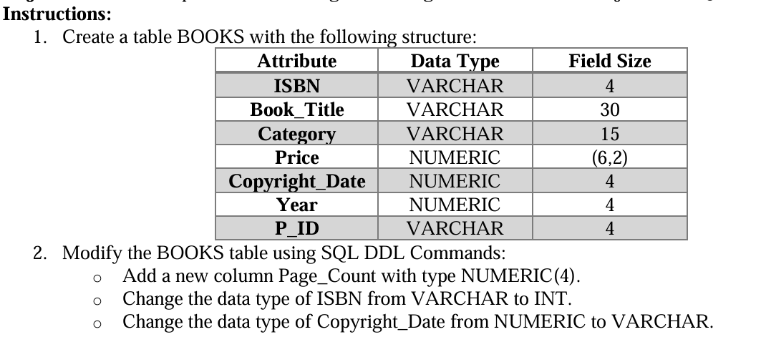

(Table named as BOOKS created)

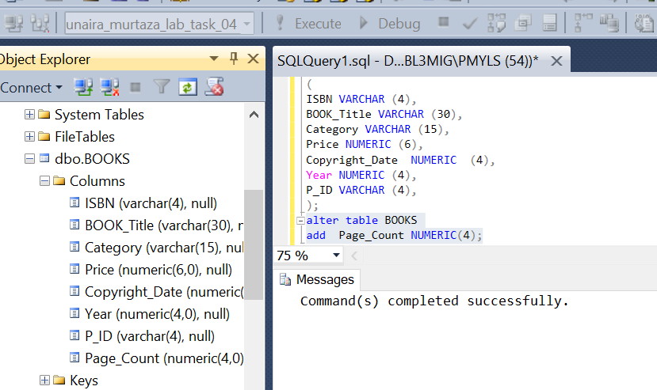
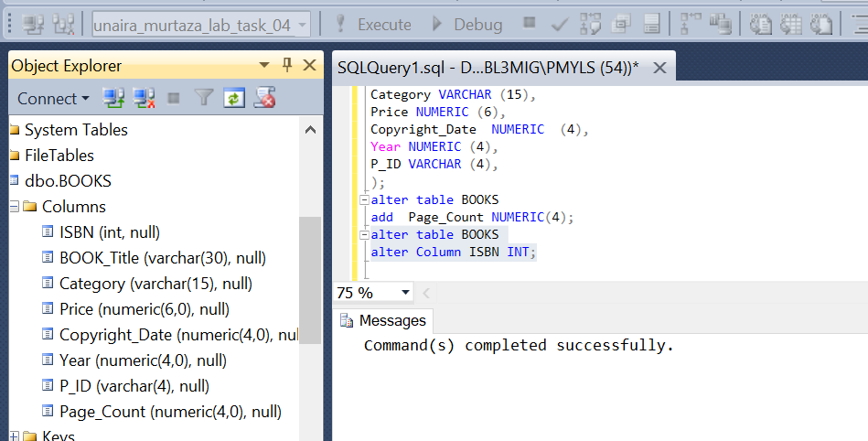

Task 05:
“Deleting Tables and Database”
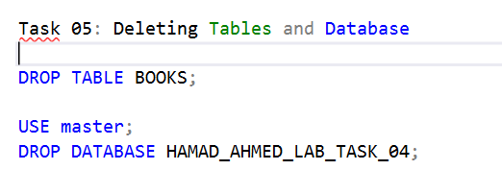
__The End__

