
s
DataBase System


LAB TASK-05

CS-2204

Name: samama iqbal
Roll No: 2024-cet-16
Department: Software Engineering
Course Name: Database Systems
Instructor: Engr.Asma javed

Lab Task – 05: SQL Server – Keys and Constraints

Objective:
In this lab, students will work on SQL Server to understand and apply different types of keys and constraints. The focus will be on creating tables with constraints during definition and modifying tables afterward using ALTER commands. Students will also learn how to manage dependencies when deleting tables.

Task 01: Creating Database and Tables with Initial Constraints
Objective: Enable students to create a database and define tables with primary key, NOT NULL, and default constraints.
Instructions:
- 1. Create a new database named as your full name in all lowercase with underscores, followed by _lab_task_05.
- 2. Inside this database, create a table named PUBLISHERS with the following structure:
• P_ID INT
• P_Name VARCHAR(30)
• Address VARCHAR(50)
• State VARCHAR(12)
• Phone VARCHAR(18)
• Email_ID VARCHAR(20)
• Set P_ID as the Primary Key.
• Make sure P_Name and Phone are NOT NULL.
• Set a DEFAULT value of 'Unknown' for State.
Screenshot of Task 01:
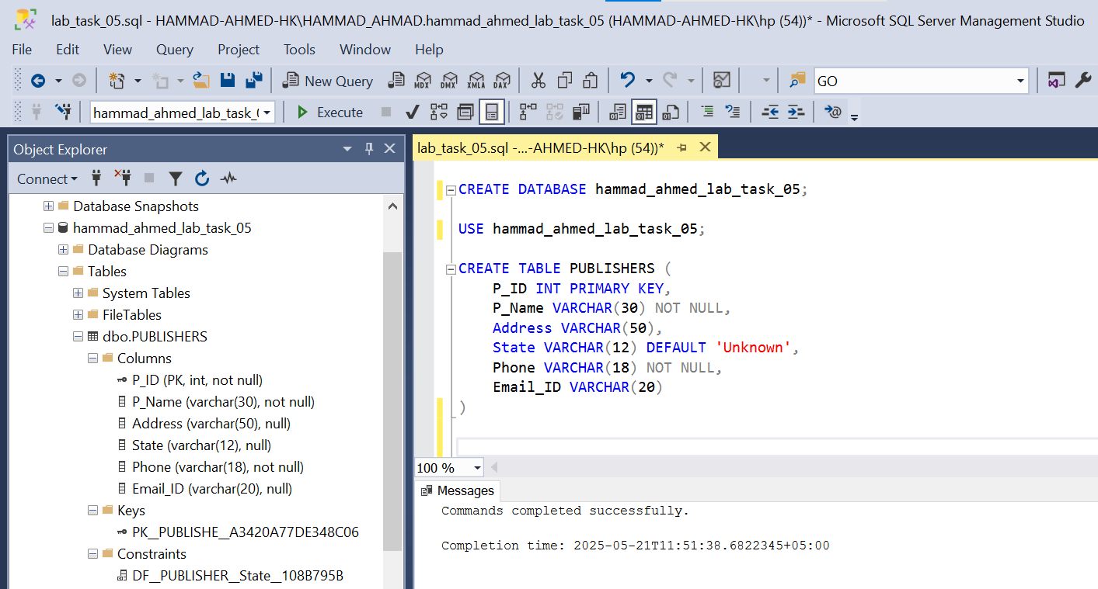

Task 02: Applying More Constraints Using ALTER TABLE
Objective: Enable students to modify table structure by adding additional constraints using ALTER TABLE.
Instructions:
- 1. Create a table named BOOKS with the following structure:
• ISBN INT
• Book_Title VARCHAR(50)
• Category VARCHAR(20)
• Price NUMERIC(6,2)
• Copyright_Date VARCHAR(4)
• Year NUMERIC(4)
• Page_Count NUMERIC(4)
• P_ID INT
• Set ISBN as the Primary Key.
• Set Book_Title and P_ID as NOT NULL fields.
- 2. After creating the BOOKS table:
• Add a Foreign Key on P_ID referencing PUBLISHERS(P_ID).
• Add a CHECK Constraint to ensure Price > 20.
• Add a UNIQUE Constraint on Book_Title.
Screenshot of Task 02
: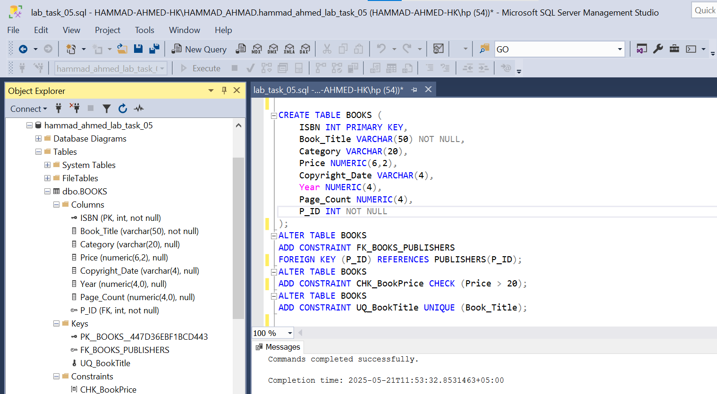

Task 03: Viewing and Describing Table Constraints
Objective: Teach students how to view existing constraints and understand their structure.
Instructions:
- 1. Use the SQL Server system views to list the constraints applied to both PUBLISHERS and BOOKS tables.
- 2. Specifically, query:
• INFORMATION_SCHEMA.TABLE_CONSTRAINTS
• INFORMATION_SCHEMA.CONSTRAINT_COLUMN_USAGE
- 3. Write queries that:
• Display the names of all constraints on each table.
• Display which columns are associated with which constraints.
Screenshot of Task 03:
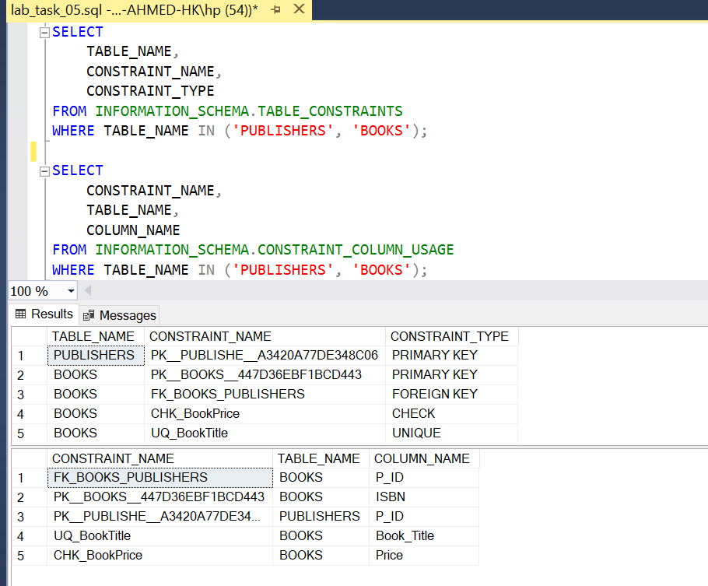

Task 04: Dropping Specific Constraints
Objective: Teach students how to remove specific constraints without deleting the whole table.
Instructions:
- 1. Drop the DEFAULT constraint on the State column from the PUBLISHERS table.
- 2. Drop the CHECK constraint applied to the Price column from the BOOKS table.
- 3. Ensure only the constraints are dropped, and the tables/data remain intact.
Screenshot of Task 04:
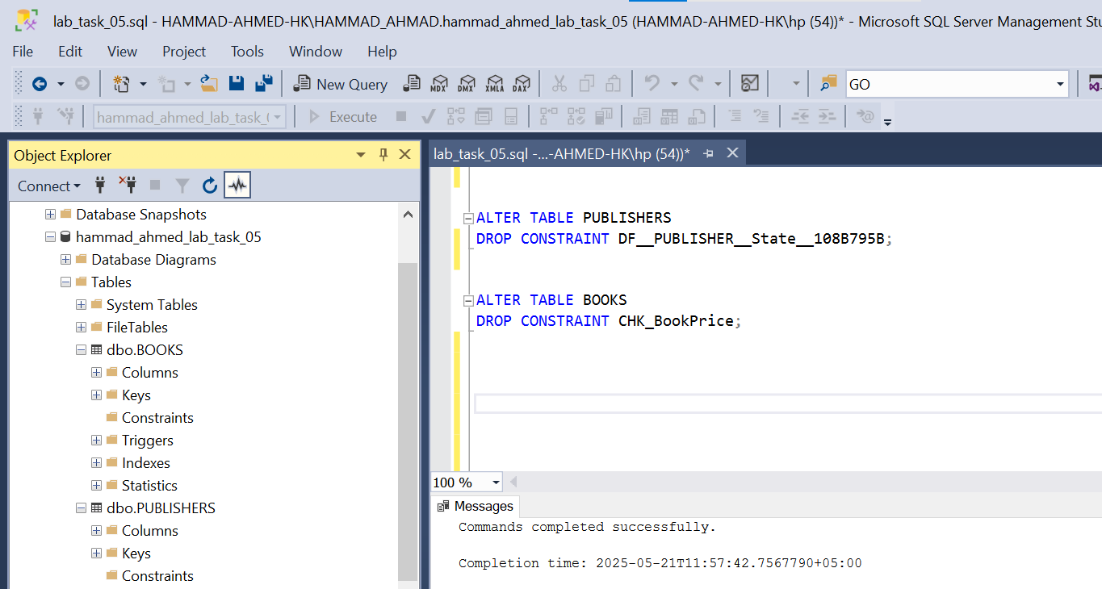

Task 05: Managing Foreign Key Dependencies for Table Deletion
Objective: Teach students about foreign key dependencies and safe deletion practices.
Instructions:
- 1. Attempt to delete the PUBLISHERS table using DROP TABLE.
- 2. Observe the error message related to the foreign key dependency.
- 3. Use ALTER TABLE to drop the foreign key constraint from the BOOKS table.
- 4. After removing the foreign key, successfully delete the PUBLISHERS table.
Screenshot of Task 05(a):
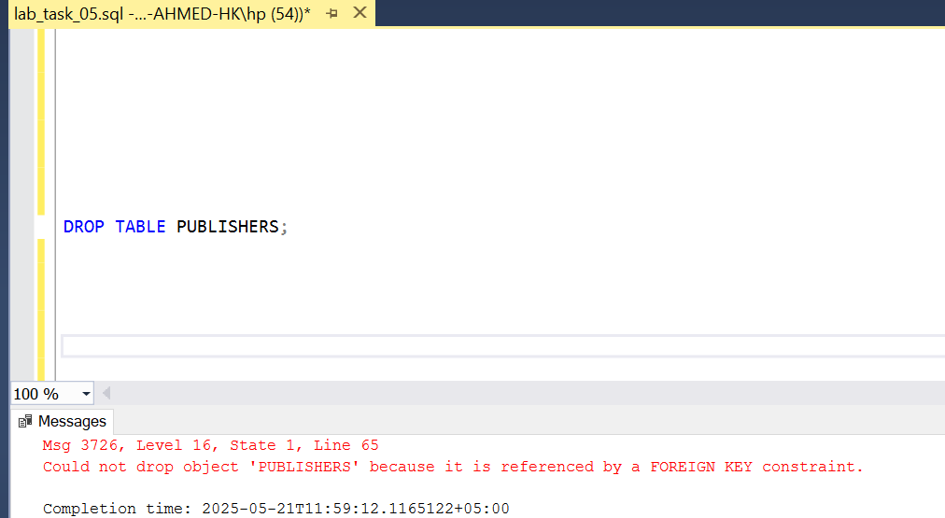

Screenshot of Task 05(b):

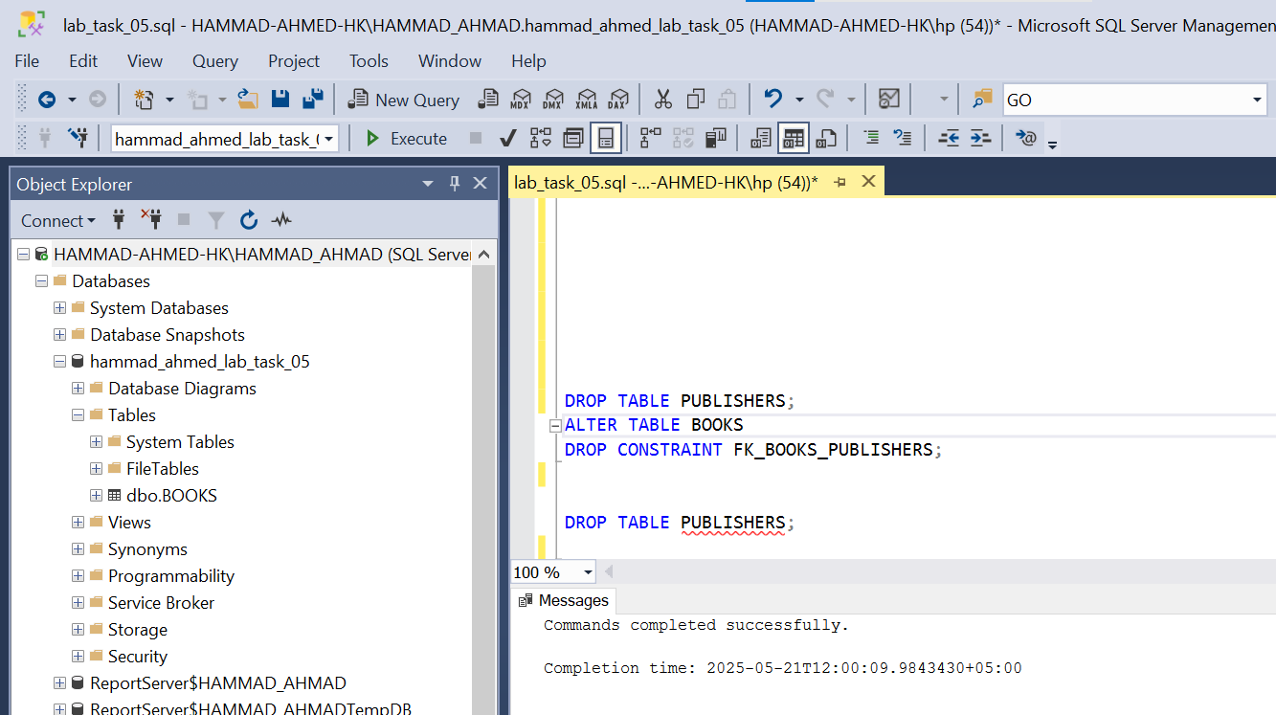
Conclusion
In this lab, we successfully explored the fundamental concepts of keys and constraints in SQL Server. By performing a series of structured tasks, we gained hands-on experience with:
Creating databases and tables with primary keys, NOT NULL, and DEFAULT constraints to enforce data integrity at the schema level.
Using the ALTER TABLE command to enhance table definitions by adding foreign keys, CHECK constraints, and UNIQUE constraints after table creation.
Querying INFORMATION_SCHEMA views to inspect the constraints applied to tables, which is essential for understanding the structure and dependencies within the database.
Learning how to safely drop constraints without affecting the underlying table structure or data.
Managing foreign key dependencies by recognizing how relational integrity prevents deletion of referenced data and how to properly drop these constraints to proceed with table deletion.
Overall, this lab provided a practical understanding of how constraints ensure consistency, accuracy, and reliability in relational databases. The knowledge gained here is foundational for building well-structured, secure, and maintainable database systems.

