**DS 501: STATISTICAL AND MATHEMATICAL METHODS FOR DATA SCIENCE**

REPORT FOR ASSIGNMENT 03

ROLL No.:18L-1882

**CASE 1:** Diagonal covariance matrix Σ1 = Σ2 = I

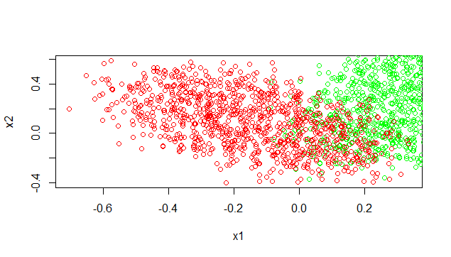 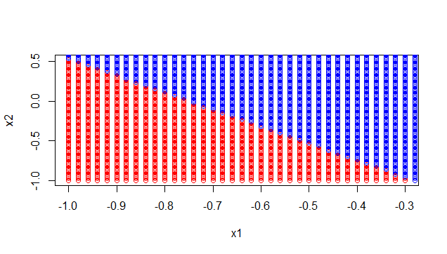

Figure 1(a): Plot of training data, for class 1 Figure 1(b): Plot of decision boundary

and class 2 and the mistakes

Here the table shows the MAP probabilities and predicted labels for the first 3 test points

|  |  |  |  |
| --- | --- | --- | --- |
| **No.** | **MAP probability:**  P(C=0|**x**) | **MAP probability**  P(C=1|**x**) | **Predicted label** |
| 1 | 0.385604 | 0.614396 | 1 |
| 2 | 0.8086006 | 0.1913994 | 0 |
| 3 | 0.5325342 | 0.4674658 | 0 |

Table 1: MAP probabilities for case 1

**CASE 2:** Common covariance matrixΣ1 = Σ2 = Σ

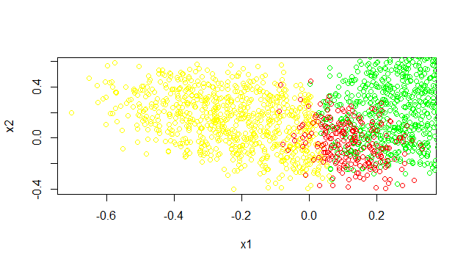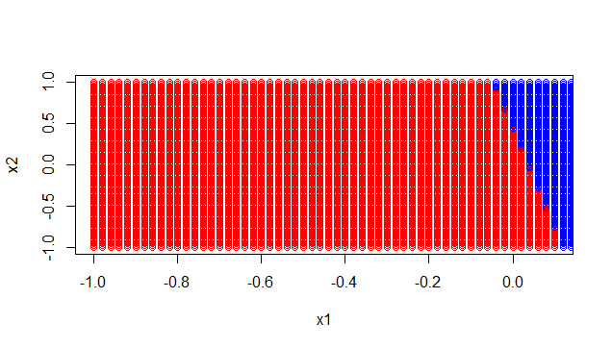

Figure 2(a): Plot of training data, for class 1 Figure 2(b): Plot of decision boundary

and class 2 and the mistakes

The table shows the MAP probabilities and predicted labels for the first 5 test points for case 2

|  |  |  |  |
| --- | --- | --- | --- |
| **No.** | **MAP probability:**  P(C=0|**x**) | **MAP probability**  P(C=1|**x**) | **Predicted label** |
| 1 | 0.008802201 | 0.991197799 | 1 |
| 2 | 0.9881458 | 0.01185418 | 0 |
| 3 | 0.05099577 | 0.9490042 | 1 |
| 4 | 0.8129269 | 0.1870731 | 0 |
| 5 | 0.788086 | 0.211914 | 0 |

Table 2: MAP probabilities for case 2

**CASE 3:** Full covariance matrix for both classes

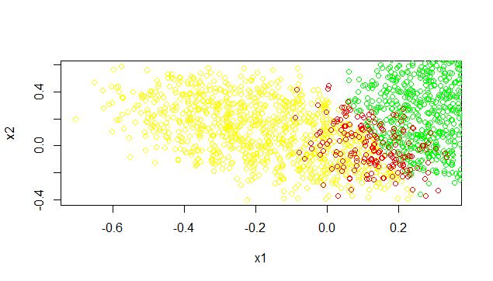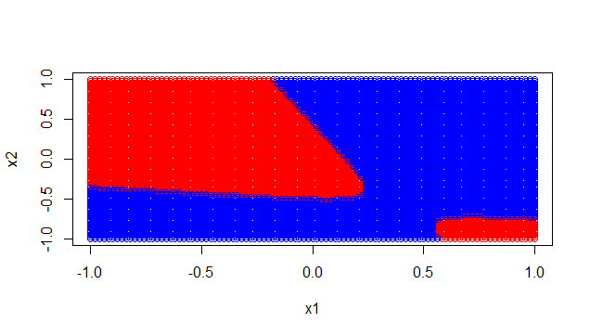

Figure 3(a): Plot of training data, for class 1 Figure 3(b): Plot of decision boundary

and class 2 and the mistakes

Here the table shows the MAP probabilities and predicted labels for the first 4 test points

|  |  |  |  |
| --- | --- | --- | --- |
| **No.** | **MAP probability:**  P(C=0|**x**) | **MAP probability**  P(C=1|**x**) | **Predicted label** |
| 1 | 1.000000e+00 | 5.861444e-10 | 0 |
| 2 | 1 | 8.687032e-20 | 0 |
| 3 | 1.426095e-05 | 0.9999857 | 1 |
| 4 | 0.570659 | 0.429341 | 0 |

Table 3: MAP probabilities for case 3

**Discussion/comparison of results for all cases**

**For Case 1:**

Identity Matrix is used as a covariance matrix.

**Training Set**

We observed that it has predicted all the data wrong with class label one.

**Test Set**

We observed a diagonal line which separates the classes in the data.

**For Case 2:**

We used covariance of the whole training set.

**Training Set**

Model failed to predict the class when the probability of both classes are closer.

**Test Set**

It has grouped most of the dataset in class 1.

**For Case 3:**

Used separate covariance for separate classes.

**Training Set**

It has predicted the training set much better than the previous cases.

**Test Set**

It has predicted the test set much better than the previous cases.