1. **Two-stage stochastic programming with recourse and substitution:**

One way to think about how to write this problem as a two-stage stochastic programming problem. In this method, we separate "production" from "sales". The first stage problem decides what products to produce where , and the second stage problem decides given that much production, how to substitute them to make the most profit. To show this, we distinguish between “costs” due to production (using COGS) and "profit" due to selling products (using the concept of Margin). Notice that production of product describes total production including the surplus, therefore the first stage problem, therefore, can be written as:

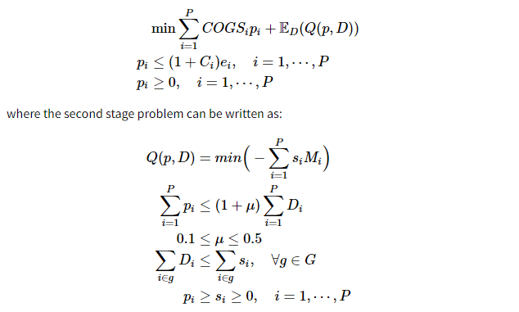

where is the amount of item sold. In this formulation, the goal is to choose the decision variables in a way that we minimize the cost. Estimated amount of demand is shown with and is used in the first stage. In the first stage, we decide how much of each product to produce (includes surplus).

This costs us for product . The only constraint at this stage is that the production, , which includes surplus values, should not exceed the capacity of producing surplus for that product.

In the second stage, we assume that the decision is made to produce for product with index . Then we need to decide what to sell in a way that we make the most profit. We are bounded to produce less that a total percentage of the total demand.

The other bound for this problem is that the amount we sell should be as much as the demand, but since we have degree of freedom to substitute the demand with other products in the same group, rather than writing , we write for all groups in the set of Groups, .

1. **Writing the problem as a robust optimization and solve it deterministically using Pulp or Pyomo:**

|  |  |
| --- | --- |
|  |  |
| s.t. |  | |

Where is the index for products, is net profit per unit of product , is the surplus quantity added to demand forecast for product , is the maximum surplus quantity allowed for product , is the adjustable macro target percentage, is the estimated demand for product , is minimum total surplus quantity required for substitutability group G.

1. **Writing the problem as a two stage stochastic programming problem**

|  |  |
| --- | --- |
|  |  |
| s.t. |  |

Where is actual sales of product under scenario .