## What's on the board?

There are many varieties of Arduino boards that can be used for different purposes. Some boards look a bit different from the one below, but most Arduinos have the majority of these components in common:

[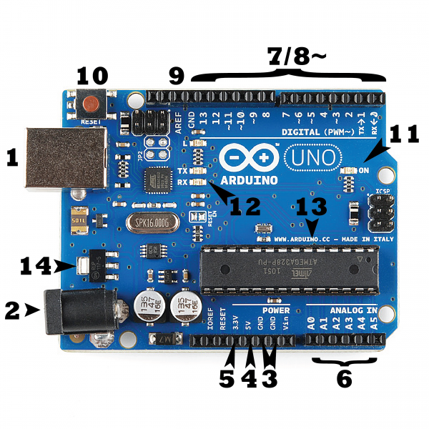](https://cdn.sparkfun.com/assets/b/f/e/9/c/513824face395f6d3d000000.png)

### Power (USB / Barrel Jack)

Every Arduino board needs a way to be connected to a power source. The Arduino UNO can be powered from a USB cable coming from your computer or a wall power supply that is terminated in a barrel jack. In the picture above the USB connection is labeled **(1)** and the barrel jack is labeled **(2)**.

**NOTE:** Do NOT use a power supply greater than 20 Volts as you will overpower (and thereby destroy) your Arduino. The recommended voltage for most Arduino models is between 6 and 12 Volts.

### Pins (5V, 3.3V, GND, Analog, Digital, PWM, AREF)

The pins on your Arduino are the places where you connect wires to construct a circuit (probably in conjunction with a [breadboard](https://learn.sparkfun.com/tutorials/how-to-use-a-breadboard/) and some [wire](https://learn.sparkfun.com/tutorials/working-with-wire). They usually have black plastic ‘headers’ that allow you to just plug a wire right into the board. The Arduino has several different kinds of pins, each of which is labeled on the board and used for different functions.

* **GND (3)**: Short for ‘Ground’. There are several GND pins on the Arduino, any of which can be used to ground your circuit.
* **5V (4) & 3.3V (5)**: As you might guess, the 5V pin supplies 5 volts of power, and the 3.3V pin supplies 3.3 volts of power. Most of the simple components used with the Arduino run happily off of 5 or 3.3 volts.
* **Analog (6)**: The area of pins under the ‘Analog In’ label (A0 through A5 on the UNO) are Analog In pins. These pins can read the signal from an analog sensor (like a [temperature sensor](https://www.sparkfun.com/products/10988)) and convert it into a digital value that we can read.
* **Digital (7)**: Across from the analog pins are the digital pins (0 through 13 on the UNO). These pins can be used for both digital input (like telling if a button is pushed) and digital output (like powering an LED).
* **PWM (8)**: You may have noticed the tilde (~) next to some of the digital pins (3, 5, 6, 9, 10, and 11 on the UNO). These pins act as normal digital pins, but can also be used for something called Pulse-Width Modulation (PWM). these pins as being able to simulate analog output (like fading an LED in and out).
* **AREF (9)**: Stands for Analog Reference. Most of the time you can leave this pin alone. It is sometimes used to set an external reference voltage (between 0 and 5 Volts) as the upper limit for the analog input pins.

### Reset Button

Just like the original Nintendo, the Arduino has a reset button **(10)**. Pushing it will temporarily connect the reset pin to ground and restart any code that is loaded on the Arduino. This can be very useful if your code doesn’t repeat, but you want to test it multiple times. Unlike the original Nintendo however, blowing on the Arduino doesn’t usually fix any problems.

### Power LED Indicator

Just beneath and to the right of the word “UNO” on your circuit board, there’s a tiny LED next to the word ‘ON’ **(11)**. This LED should light up whenever you plug your Arduino into a power source. If this light doesn’t turn on, there’s a good chance something is wrong. Time to re-check your circuit!

### TX RX LEDs

TX is short for transmit, RX is short for receive. These markings appear quite a bit in electronics to indicate the pins responsible for [serial communication](https://learn.sparkfun.com/tutorials/serial-communication). In our case, there are two places on the Arduino UNO where TX and RX appear – once by digital pins 0 and 1, and a second time next to the TX and RX indicator LEDs **(12)**. These LEDs will give us some nice visual indications whenever our Arduino is receiving or transmitting data (like when we’re loading a new program onto the board).

### Main IC

The black thing with all the metal legs is an IC, or Integrated Circuit **(13)**. Think of it as the brains of our Arduino. The main IC on the Arduino is slightly different from board type to board type, but is usually from the ATmega line of IC’s from the ATMEL company. This can be important, as you may need to know the IC type (along with your board type) before loading up a new program from the Arduino software. This information can usually be found in writing on the top side of the IC. If you want to know more about the difference between various IC’s, reading the datasheets is often a good idea.

### Voltage Regulator

The voltage regulator **(14)** is not actually something you can (or should) interact with on the Arduino. But it is potentially useful to know that it is there and what it’s for. The voltage regulator does exactly what it says – it controls the amount of voltage that is let into the Arduino board. Think of it as a kind of gatekeeper; it will turn away an extra voltage that might harm the circuit. Of course, it has its limits, so don’t hook up your Arduino to anything greater than 20 volts.

### [Arduino Leonardo](https://www.sparkfun.com/products/11286)

The Leonardo is Arduino’s first development board to use one microcontroller with built-in USB. This means that it can be cheaper and simpler. Also, because the board is handling USB directly, code libraries are available which allow the board to emulate a computer keyboard, mouse, and more!

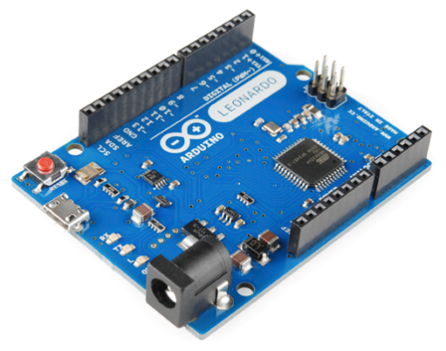

# LCD5110 (Nokia 5110 LCD)

These displays were used in old Nokia 5110/3310 cell phones. It is a 84×48 pixel monochrome LCD display. These displays are small, but very readable and come with backlight. This display is made of 84×48 individual pixels, so you can use it for graphics, text or bitmaps. These displays are inexpensive, easy to use, require only a few digital I/O pins and are fairly low power as well

To drive the display, you will need 5 digital output pins. Another pin can be used to control (via on/off or PWM) the backlight, but the library has no support for this function.

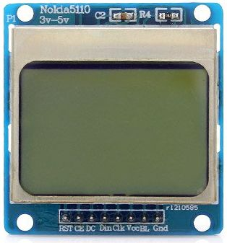

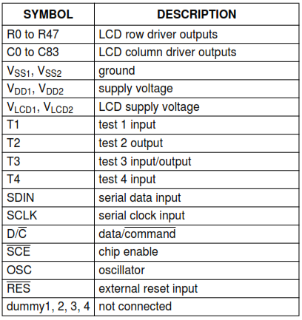

Braille Keyboard

Connect an Arduino with 7 buttons. They are representing one braille letter. A letter will be entered by pressing on the right set of buttons at the same time. Send the corresponding letter over the serial console. For example, according to figure …to show letter “A” we should press button number1 and for letter “B” press button number 1 and 2 and so on. Also for representing space we assign a button, so 6 buttons for letters and number and one button for space to recognize words.

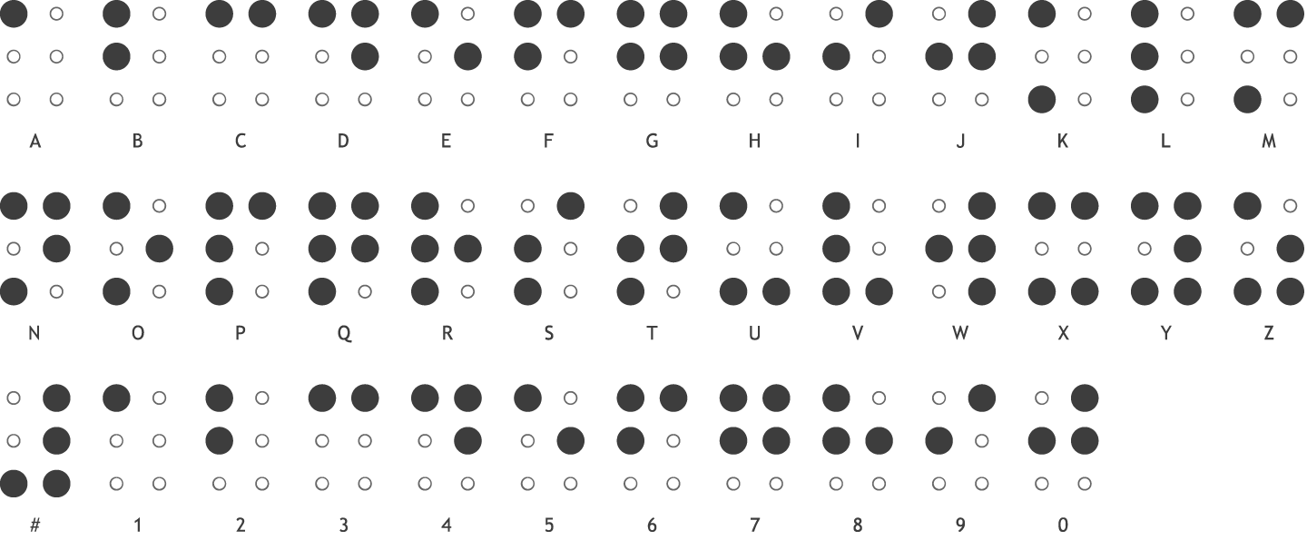

**Pushbuttons / Interrupts**

The microcontroller utilizes interrupts to detect when a button is pushed. The

microcontroller is set to read in the voltages from the pins connected to the push buttons.

The buttons feed in a LOW signal when idle and change to HIGH when pushed. The

microcontroller recognizes the state change and calls an interrupt method that sends data

to the program.

When a button is pushed, the microcontroller sends serial data for the program to receive.

Each button sends different data to the program. The program then determines what was

sent from the microcontroller and does the necessary action. A delay is placed after the

data is sent to prevent the microcontroller from accidentally repeating itself.