Problem 1:

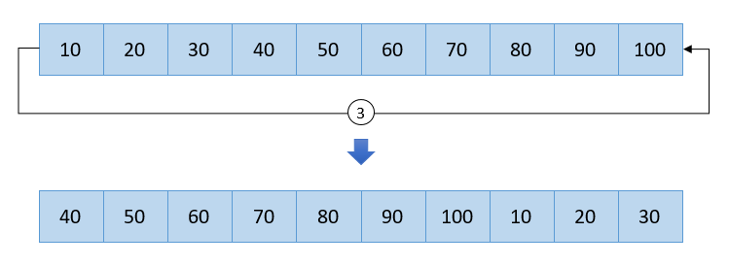

**Example**

**Input**

Input 10 elements in array: 1 2 3 4 5 6 7 8 9 10

Input number of times to rotate: 3

**Output**

Array after left rotation 3 times: 4 5 6 7 8 9 10 1 2 3

Problem 2:

C program count total duplicate elements in array

Write a C program to input elements in array from user and count duplicate elements in array. C program to find all duplicate elements in an unsorted array. How to count duplicate elements in array using loop in C programming.

**Example**

**Input**

Input array elements: 1, 10, 20, 1, 25, 1, 10, 30, 25, 1

**Output**

Total number of duplicate elements = 5

Problem 3:

C program to count frequency of each element in an array

Write a C program to input elements in array and find frequency of each element in array. How to count occurrence of each element in array in C programming using loop. Logic to count frequency of each element in array in C program.

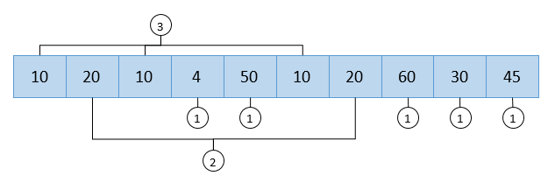

**Example**

**Input**

Input array elements: 5 10 2 5 50 5 10 1 2 2

**Output**

Frequency of 5 = 3

Frequency of 10 = 2

Frequency of 2 = 3

Frequency of 50 = 1

Frequency of 1 = 1