## **Created By: Samandar Toyirov 1. Refined Research Questions**

To enhance clarity and analytical depth, consider the following precise research questions:

1. **GDP Growth**: How has Uzbekistan's real GDP evolved annually from 1990 to 2024, and what are the key factors influencing its growth trajectory?​

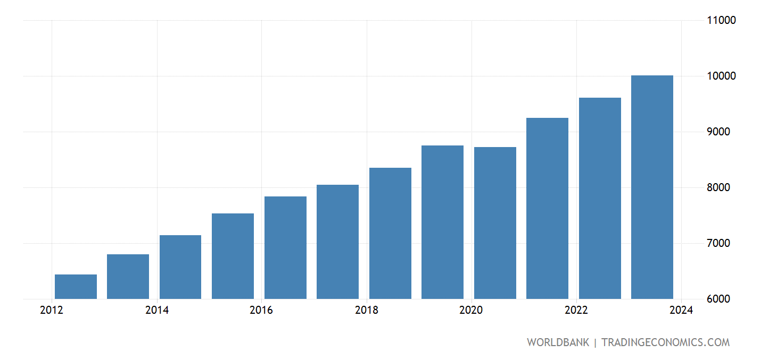

1. **GDP per Capita**: What trends are observable in Uzbekistan's GDP per capita over this period, and how do they reflect changes in individual economic well-being?​
2. **Employment and Unemployment**: How have employment and unemployment rates fluctuated, and what do these trends indicate about labor market dynamics?​
3. **Price Levels (Inflation)**: What patterns emerge in consumer price inflation, and how have they impacted purchasing power and economic stability?​
4. **Interest Rates**: How have central bank interest rates changed, and what monetary policies have influenced these shifts?​
5. **Balance of Payments**: How has Uzbekistan's balance of payments, including current and capital accounts, evolved, and what does this reveal about external economic relations?​

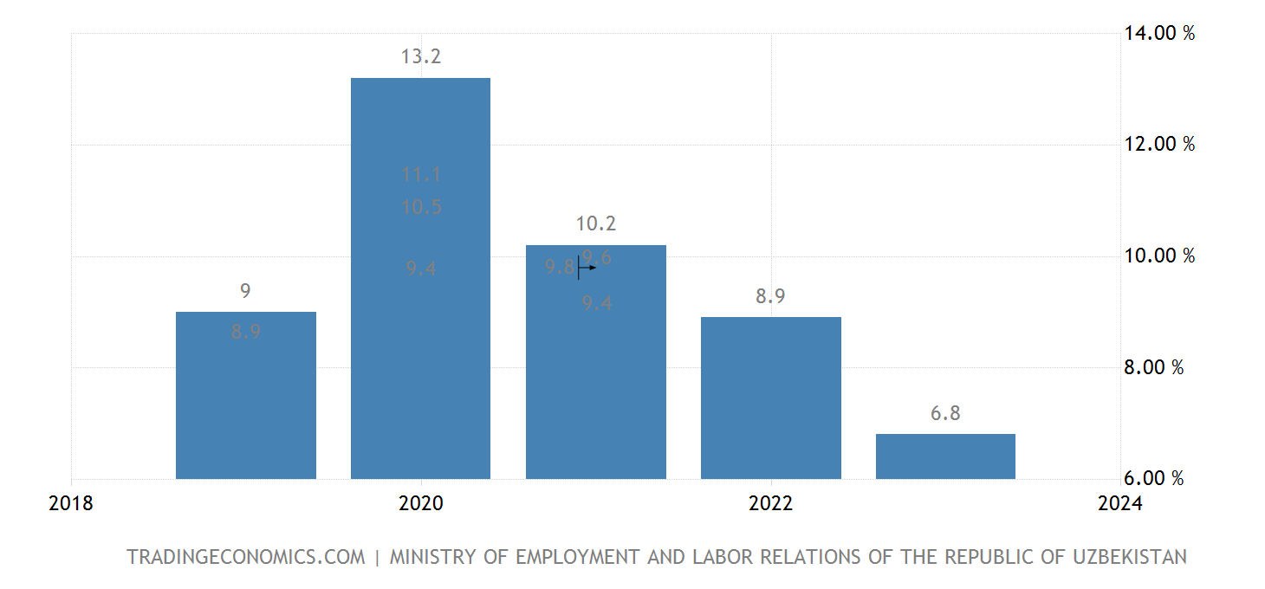

## **2. Data Collection and Preparation**

**Data Sources**:

* **World Bank Open Data**: Provides comprehensive macroeconomic indicators.​
* 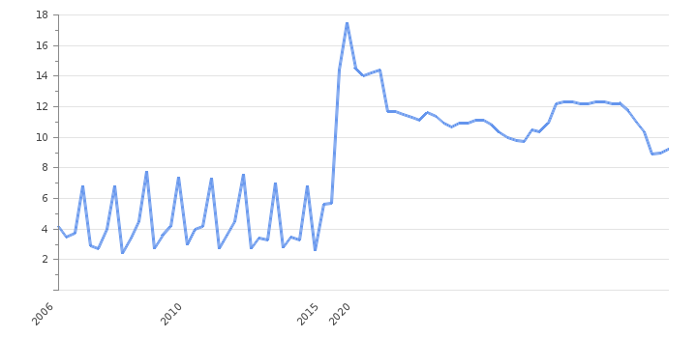

Uzbekistan Inflation rate

* **IMF Data Portal**: Offers detailed financial statistics and reports.​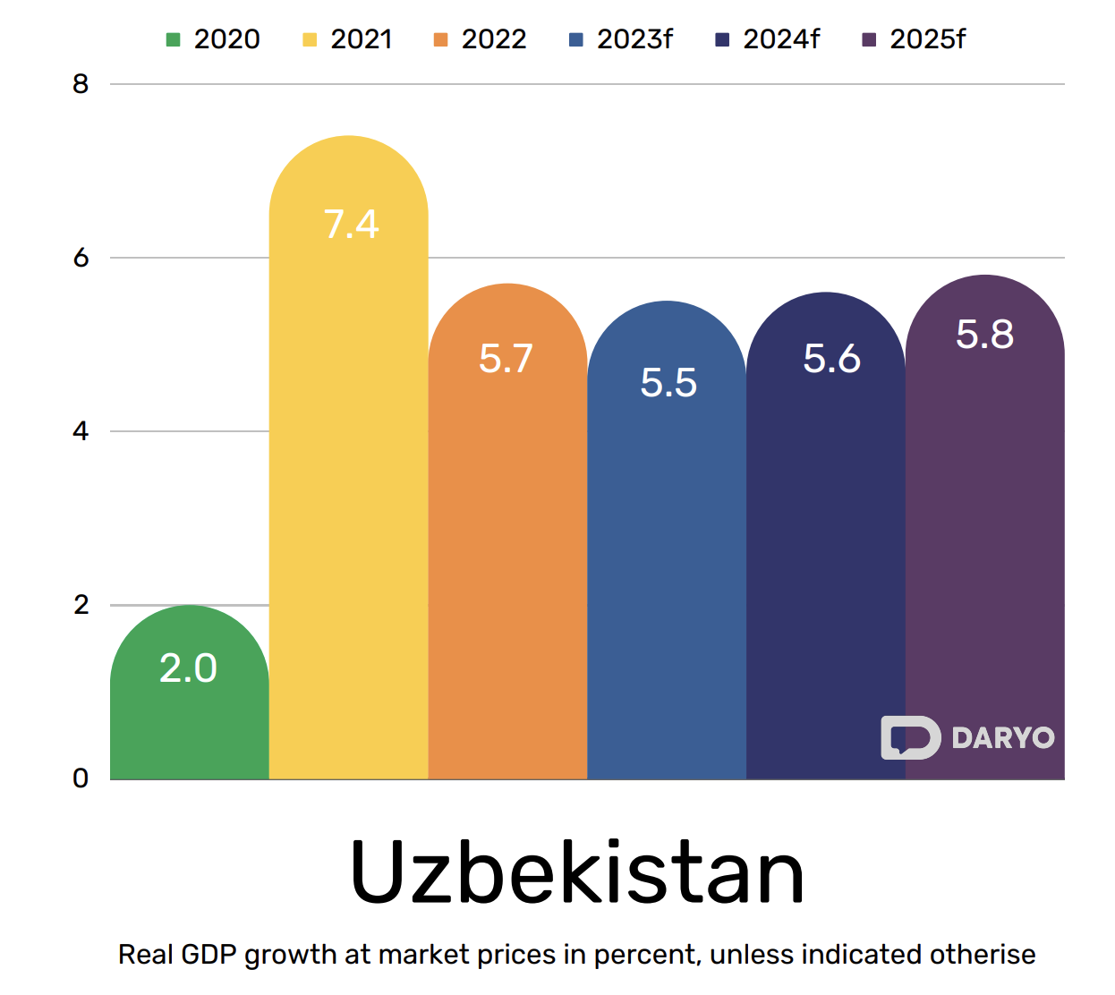

**Steps**:

1. **Download Data**: Access the World Bank and IMF databases to download time series data for the specified indicators from 1990 to 2024.​
2. **Excel Preparation**: Organize the data into an Excel spreadsheet with clear labels for each variable and year. Ensure consistency in units and adjust for inflation where necessary.​
3. **Data Cleaning**: Check for missing values or anomalies and address them appropriately to maintain data integrity.​

**3. Data Visualization**

Using statistical software such as R or Python (with libraries like pandas, matplotlib, and seaborn), create the following visualizations:

1. **GDP and GDP per Capita**: Line graphs showing annual changes, highlighting periods of significant growth or decline.​
2. **Employment and Unemployment Rates**: Bar charts or line graphs illustrating labor market trends.​
3. **Inflation Rates**: Line graphs depicting annual consumer price inflation.​
4. **Interest Rates**: Line graphs showing changes in central bank policy rates.​
5. **Balance of Payments**: Stacked area charts displaying current and capital account balances over time.​

## **4. Historical Contextualization**

Integrate major political, economic, and social events to provide context for the observed macroeconomic trends:

* **1991**: Independence from the Soviet Union, leading to significant economic restructuring.​
* **1992**: Adoption of a new constitution, establishing the framework for economic reforms.​
* **2005**: Andijan unrest, resulting in political instability and potential economic repercussions.​
* **2016**: Death of President Islam Karimov; Shavkat Mirziyoyev assumes presidency, initiating reforms
* **2022**: Protests in Karakalpakstan over constitutional amendments, leading to social unrest.​

These events can be annotated on the visualizations to illustrate their impact on economic indicators.

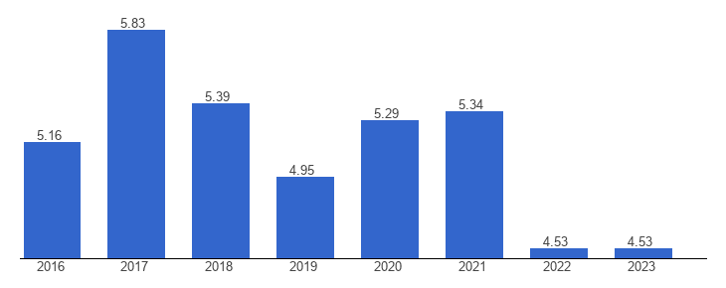

## **5. Theoretical Explanations for Volatility**

Provide economic theories to explain the volatility in each macroeconomic variable:

* **GDP and GDP per Capita**: Structural transformation theory explains shifts from agriculture to industry and services, affecting GDP growth.​
* **Employment and Unemployment**: Okun's Law relates changes in unemployment to GDP growth, highlighting cyclical unemployment during economic downturns.​
* **Inflation**: Monetarist theory attributes inflation to excessive growth in money supply, while cost-push inflation explains price rises due to increased production costs.​
* **Interest Rates**: The Taylor Rule provides a guideline for setting interest rates based on inflation and output gaps.​
* **Balance of Payments**: The Mundell-Fleming model illustrates how exchange rates and capital mobility affect the balance of payments under different exchange rate regimes.​