CPU Scheduler Implementation Using Heterogeneous Earliest Finish Time Heuristic

Project By: Samanjate Sood
Ryan Joshua D’silva
Under: Prof. Mike Shah

Abstract: Process scheduling has a critical area of study in high-performance computing for a while now, especially in environments with distributed resources that would support parallelism. Application scheduling in general has been demonstrated to be an NP-complete problem, corroborated through considerable general examples, and select restricted scenarios as well. However, most study and literature concerning this problem focuses on its implementation with homogeneous processors. The same algorithms that are proven to be performant on homogeneous systems may not be as efficient on systems with heterogeneous processors, or may actually even degrade performance by virtue of ignoring scheduling costs for switching between different processors. To this end, the HEFT (Heterogeneous Earliest Finish Time) algorithm was developed to meet the demand of high throughput and low scheduling time in such systems. HEFT is derived from list scheduling algorithms and is selected as a practical and robust heuristic for the scheduling problem on heterogeneous systems.

Brief Introduction:
A heterogeneous computing system is one with myriad resource sets interconnected by a low latency, high speed network, primarily designed for parallel and distributed computation. Heterogeneous systems should be designed with both run-time and compile-time efficiency in mind. One of the major considerations in designing a heterogeneous computing system is how to eke maximum performance from it through efficient scheduling of resource utilization by running processes.

An outline of the task scheduling problem, that is, the assigning of the tasks of an application to suitable processors and the task execution order among them, is generally illustrated with a static model. This would represent the task execution times and the dependencies of data between tasks and intercommunication costs. The form of representation of this model is a directed acyclic graph, wherein nodes denote the distributed tasks, and the edges and their direction indicate the dependency of data between them, labeled with their communication costs.

By definition, a scheduling system model targets a computing environment with rigorously defined performance constraints to schedule within. To this end of achieving maximum parellelism and throughout on the processor’s end, we wish to implement a scheduling algorithm for a bounded number of heterogeneous processors completely connected to each other: the Heterogeneous Earliest Finish time (HEFT) algorithm. The objective of HEFT, as of any good scheduling algorithm, is to minimize application scheduling time by choosing the best possible assignment of tasks among various heterogeneous processors.
One of the primary concerns of optimal scheduling is to deliver a schedule for optimal distribution in low scheduling time, that is, the cot of schedule generation itself should be minimal.

System Representation And Implementation:
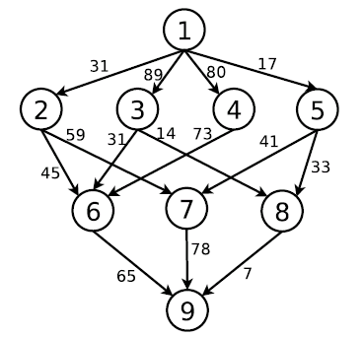
Representation of a Directed Acyclic Graph, as used in
problem, where nodes represent tasks, and edge weights represent communication cost.

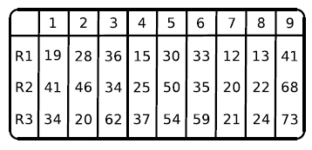
Computational cost matrix for each task; R1-R3 are three processors used, columns 1 through 9 represent the tasks.

The general representation of an application in the scheduling system is in the form of a directed acyclic graph, G = (V, E), V being the cumulative task set and E being the cumulative set of intertask edges. An edge E(i,j) marks the precedence constraint before a task , indicating that task should completely execute before task starts. A communication matrix of dimension v x v holds the values of intertask communication data costs, where data[i,k] is the volume of data that task sends to task .

A graph outlining this system should contain at least one entry task, without any parent, an an exit task, without any child. The target system is assumed to consist of a set Q of q homogeneous processors performing in a completely interconnected topology with zero interprocess contention, non-preemptive tasks within an application and simultaneous communication and computation capability. A computation cost matrix of dimension v x q holds the computation costs of tasks on processors, where denotes the computation cost of a task i on a processor j. Tasks are usually assigned a average execution cost prior to scheduling and execution, defined as

Another matrix B holds the data transfer rates in a size of q x q, and the processor start up costs are defined in a q-dimensional vector, L. The edge communication cost is represented as

The EST (Earliest Start Time) and EFT (Earliest Finish Time) need to be derived from a partial schedule before defining the final objective function.
EST (, ) and EFT (, ) denote the earliest start time and earliest finish time of a task on a processor , respectively. The entry task’s EST is given by

A task’s EFT can only be calculated once all of its predecessors EFTs have been calculated. These EFTs and ESTs are calculated from the entry task in recursion.

avail[j] is the earliest possible time at which a processor might be available for execution for a task , for which pred() is a set of all completed predecessor tasks. The inner max section of the EST equation returns the earliest ready time by which processor acquires all the data required by task . The actual start time, AST() and actual finish time,
AFT() of task give the EST and EFT of task after it is scheduled to the processor .
Finally, the complete schedule duration, also called the makespan, is defined as

Implementation:
HEFT is an application scheduling heuristic for a bounded number of heterogeneous processors, primarily encompassed in two phases: a task prioritizing phase and a processor selection phase. The task prioritization phase computes task priorities and the processor selection phase subsequently selects each task on the basis of computed priority and schedules them on the best available processor to achieve the earliest possible finish time for the task.

Task Prioritization Phase: Here, each task’s priority is updated with the upward rank value, which is calculated from the mean computation and communication costs for that task. Sorting the tasks in descending order of these upward ranks gives the resultant task list. Ties and priority conflicts could resolved by alternative policies, like selection the task whose immediate successor(s) have higher upward ranks, but since solutions like these would increase the time complexity, a random selection policy is adopted instead. This resultant list of tasks in decreasing order of upward ranks produces a topological, linear order that adhere to precedence constraints.

Input: Task computation and communication costs
Output: Non-increasingly ordered list of tasks, by upward rank
Upward rank of task: Mean of computation costs on all processors + successor task () with the greatest (mean communication cost + upward rank of )
Upward rank of exit task: Mean of computation costs on all processors.

Processor Selection Phase: In most other scheduling heuristics, the earliest possible available time of a processor is the time at which it completes execution of its last defined task. However, the HEFT heuristic adopts an insertion-based approach, wherein the earliest idle time window on a processor between two processes is considered for insertion of a task to be scheduled. This window is given by the difference between the execution start time and execution finish time of a succeeding and preceding process, scheduled in succession on a processor. It should at least accommodate the computation cost of the task that the HEFT heuristic attempts to insert and schedule, while still preserving precedence constraints.
HEFT searches for an appropriate idle time slot on a processor for a task from the point of ready time for , that is the point at which all input data required by that was produced by ’s predecessor tasks are available at processor . This step repeats until an idle time window capable of accommodating the computation cost of is found.
Complexity: The time complexity for HEFT is in the order of O() for e edges and q processors. For a particularly dense graph with a number of edges proportional to O (), v being the task count, the time complexity is in the order of O ().

Data Flow Diagrams:

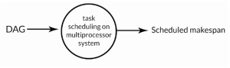

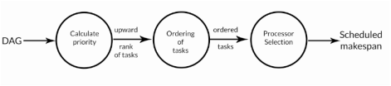
Algorithm Outline:
The basic algorithm for HEFT can be outlined in the following steps:

1. Acquire and assign the computation costs for tasks, and communication costs with mean values to the edges.

2. Compute upward rank () for all tasks by traversing through the graph bottom-to-top, starting from the exit task.

3. Sort the tasks in descending order of values into a scheduling list.

4. while tasks are unscheduled in the list; do
a. Select first task, , from the scheduling list.
b. for each processor in the heterogeneous processor set Q; do
Compute the EST(, ) and EFT(, ) at current processor using the insertion-based policy.
c. Assign task to processor where EFT(, ) < the EFT on all other processors.

5. end while

RESULTS:

To provide a comparative evaluation of the HEFT heuristic versus others, we use the following metrics:

> Schedule Length Ratio: The primary performance measure of a scheduling algorithm is its makespan. Normalizing the schedule length to a lower bound is essential, considering the large set of tasks, this is called the Schedule Length Ratio (SLR). The SLR of an algorithm defined on a graph is given by

[IMAGE OF SLR]

The denominator is the sum of minimum computation costs of all task lying along the critical path of an unscheduled directed acyclic graph. The SLR value cannot be less than 1 since the denominator is the lower bound. An ideal task scheduling algorithm gives the lowest SLR for a given graph.

> Speedup: The speedup factor of a graph is given by dividing the sequential exectuion time, that is, the sum of computation costs of all tasks in the graph, by the parallel execution time, that is, the makespan produced by the algorithm. Sequential execution time is given by assigning all tasks to a sequential processor with minimum cumulative computation cost.

[IMAGE OF SPEEDUP]

Using a cumulative of higher computation costs produces a better speedup value, but still provides a same ranking for comparison with other algorithms.

> Number of better scheduling occurrences: This is the number of times that each algorithm produces better, worse and average quality of schedules compared to other algorithms.

> Running time of the algorithms: This is essentially the execution time of the algorithm required to produce an output schedule. This metric provides the average cost of each algorithm. Here, a minimum time is desirable.

Performance Results:

We will compare HEFT’s performance against that of established and prevalent scheduling algorithms like Dynamic Loop Scheduling (DLS), Mapping Heuristic (MH) and Levelized Min Time (LMT).

