IEEE Std 1588a™-2023
(Amendment to IEEE Std 1588™-2019
as amended by IEEE Std 1588b™-2022 and
IEEE Std 1588g™-2022)
IEEE Standard for a Precision
Clock Synchronization Protocol for Networked Measurement and Control Systems
Amendment 3: Precision Time Protocol (PTP) Enhancements for Best Master Clock Algorithm (BMCA) Mechanisms
Developed by the
varCommittee
of the
IEEE Instrumentation and Measurement Society
Approved 21 September 2023
IEEE SA Standards Board

Abstract: Updates to information and messages for the Enhanced Accuracy TLV are provided in this amendment to IEEE 1588-2019. This amendment also clarifies the operation of the best master clock algorithm (BMCA), provides a new annex about the default BMCA, corrects errors in the text, and clarifies unclear passages.

Keywords: Best Master Clock, BMCA, Enhanced Accuracy, IEEE 1588a™, TLV
•Important Notices and Disclaimers Concerning IEEE Standards Documents
IEEE Standards documents are made available for use subject to important notices and legal disclaimers. These notices and disclaimers, or a reference to this page (https://standards.ieee.org/ipr/disclaimers.html), appear in all standards and may be found under the heading “Important Notices and Disclaimers Concerning IEEE Standards Documents.”

Notice and Disclaimer of Liability Concerning the Use of IEEE Standards Documents
IEEE Standards documents are developed within IEEE Societies and subcommittees of IEEE Standards Association (IEEE SA) Board of Governors. IEEE develops its standards through an accredited consensus development process, which brings together volunteers representing varied viewpoints and interests to achieve the final product. IEEE standards are documents developed by volunteers with scientific, academic, and industry-based expertise in technical working groups. Volunteers are not necessarily members of IEEE or IEEE SA and participate without compensation from IEEE. While IEEE administers the process and establishes rules to promote fairness in the consensus development process, IEEE does not independently evaluate, test, or verify the accuracy of any of the information or the soundness of any judgments contained in its standards.
IEEE makes no warranties or representations concerning its standards, and expressly disclaims all warranties, express or implied, concerning this standard, including but not limited to the warranties of merchantability, fitness for a particular purpose and non-infringement IEEE Standards documents do not guarantee safety, security, health, or environmental protection, or guarantee against interference with or from other devices or networks. In addition, IEEE does not warrant or represent that the use of the material contained in its standards is free from patent infringement. IEEE Standards documents are supplied “AS IS” and “WITH ALL FAULTS.”
Use of an IEEE standard is wholly voluntary. The existence of an IEEE standard does not imply that there are no other ways to produce, test, measure, purchase, market, or provide other goods and services related to the scope of the IEEE standard. Furthermore, the viewpoint expressed at the time a standard is approved and issued is subject to change brought about through developments in the state of the art and comments received from users of the standard.
In publishing and making its standards available, IEEE is not suggesting or rendering professional or other services for, or on behalf of, any person or entity, nor is IEEE undertaking to perform any duty owed by any other person or entity to another. Any person utilizing any IEEE Standards document, should rely upon their own independent judgment in the exercise of reasonable care in any given circumstances or, as appropriate, seek the advice of a competent professional in determining the appropriateness of a given IEEE standard.
IN NO EVENT SHALL IEEE BE LIABLE FOR ANY DIRECT, INDIRECT, INCIDENTAL, SPECIAL, EXEMPLARY, OR CONSEQUENTIAL DAMAGES (INCLUDING, BUT NOT LIMITED TO: THE NEED TO PROCURE SUBSTITUTE GOODS OR SERVICES; LOSS OF USE, DATA, OR PROFITS; OR BUSINESS INTERRUPTION) HOWEVER CAUSED AND ON ANY THEORY OF LIABILITY, WHETHER IN CONTRACT, STRICT LIABILITY, OR TORT (INCLUDING NEGLIGENCE OR OTHERWISE) ARISING IN ANY WAY OUT OF THE PUBLICATION, USE OF, OR RELIANCE UPON ANY STANDARD, EVEN IF ADVISED OF THE POSSIBILITY OF SUCH DAMAGE AND REGARDLESS OF WHETHER SUCH DAMAGE WAS FORESEEABLE.

Translations
The IEEE consensus balloting process involves the review of documents in English only. In the event that an IEEE standard is translated, only the English version published by IEEE is the approved IEEE standard.

Official statements
A statement, written or oral, that is not processed in accordance with the IEEE SA Standards Board Operations Manual shall not be considered or inferred to be the official position of IEEE or any of its committees and shall not be considered to be, nor be relied upon as, a formal position of IEEE. At lectures, symposia, seminars, or educational courses, an individual presenting information on IEEE standards shall make it clear that the presenter’s views should be considered the personal views of that individual rather than the formal position of IEEE, IEEE SA, the Standards Committee, or the Working Group. Statements made by volunteers may not represent the formal position of their employer(s) or affiliation(s).

Comments on standards
Comments for revision of IEEE Standards documents are welcome from any interested party, regardless of membership affiliation with IEEE or IEEE SA. However, IEEE does not provide interpretations, consulting information, or advice pertaining to IEEE Standards documents.
Suggestions for changes in documents should be in the form of a proposed change of text, together with appropriate supporting comments. Since IEEE standards represent a consensus of concerned interests, it is important that any responses to comments and questions also receive the concurrence of a balance of interests. For this reason, IEEE and the members of its Societies and subcommittees of the IEEE SA Board of Governors are not able to provide an instant response to comments, or questions except in those cases where the matter has previously been addressed. For the same reason, IEEE does not respond to interpretation requests. Any person who would like to participate in evaluating comments or in revisions to an IEEE standard is welcome to join the relevant IEEE working group. You can indicate interest in a working group using the Interests tab in the Manage Profile & Interests area of the IEEE SA myProject system. An IEEE Account is needed to access the application.
Comments on standards should be submitted using the Contact Us form.

Laws and regulations
Users of IEEE Standards documents should consult all applicable laws and regulations. Compliance with the provisions of any IEEE Standards document does not constitute compliance to any applicable regulatory requirements. Implementers of the standard are responsible for observing or referring to the applicable regulatory requirements. IEEE does not, by the publication of its standards, intend to urge action that is not in compliance with applicable laws, and these documents may not be construed as doing so.

Data privacy
Users of IEEE Standards documents should evaluate the standards for considerations of data privacy and data ownership in the context of assessing and using the standards in compliance with applicable laws and regulations.

Copyrights
IEEE draft and approved standards are copyrighted by IEEE under U.S. and international copyright laws. They are made available by IEEE and are adopted for a wide variety of both public and private uses. These include both use, by reference, in laws and regulations, and use in private self-regulation, standardization, and the promotion of engineering practices and methods. By making these documents available for use and adoption by public authorities and private users, neither IEEE nor its licensors waive any rights in copyright to the documents.

Photocopies
Subject to payment of the appropriate licensing fees, IEEE will grant users a limited, non-exclusive license to photocopy portions of any individual standard for company or organizational internal use or individual, non-commercial use only. To arrange for payment of licensing fees, please contact Copyright Clearance Center, Customer Service, 222 Rosewood Drive, Danvers, MA 01923 USA; +1 978 750 8400; https://www.copyright.com/. Permission to photocopy portions of any individual standard for educational classroom use can also be obtained through the Copyright Clearance Center.

Updating of IEEE Standards documents
Users of IEEE Standards documents should be aware that these documents may be superseded at any time by the issuance of new editions or may be amended from time to time through the issuance of amendments, corrigenda, or errata. An official IEEE document at any point in time consists of the current edition of the document together with any amendments, corrigenda, or errata then in effect.
Every IEEE standard is subjected to review at least every 10 years. When a document is more than 10 years old and has not undergone a revision process, it is reasonable to conclude that its contents, although still of some value, do not wholly reflect the present state of the art. Users are cautioned to check to determine that they have the latest edition of any IEEE standard.
In order to determine whether a given document is the current edition and whether it has been amended through the issuance of amendments, corrigenda, or errata, visit IEEE Xplore or contact IEEE. For more information about the IEEE SA or IEEE’s standards development process, visit the IEEE SA Website.

Errata
Errata, if any, for all IEEE standards can be accessed on the IEEE SA Website. Search for standard number and year of approval to access the web page of the published standard. Errata links are located under the Additional Resources Details section. Errata are also available in IEEE Xplore. Users are encouraged to periodically check for errata.

Patents
IEEE standards are developed in compliance with the IEEE SA Patent Policy.
Attention is called to the possibility that implementation of this standard may require use of subject matter covered by patent rights. By publication of this standard, no position is taken by the IEEE with respect to the existence or validity of any patent rights in connection therewith. If a patent holder or patent applicant has filed a statement of assurance via an Accepted Letter of Assurance, then the statement is listed on the IEEE SA Website at https://standards.ieee.org/about/sasb/patcom/patents.html. Letters of Assurance may indicate whether the Submitter is willing or unwilling to grant licenses under patent rights without compensation or under reasonable rates, with reasonable terms and conditions that are demonstrably free of any unfair discrimination to applicants desiring to obtain such licenses.
Essential Patent Claims may exist for which a Letter of Assurance has not been received. The IEEE is not responsible for identifying Essential Patent Claims for which a license may be required, for conducting inquiries into the legal validity or scope of Patents Claims, or determining whether any licensing terms or conditions provided in connection with submission of a Letter of Assurance, if any, or in any licensing agreements are reasonable or non-discriminatory. Users of this standard are expressly advised that determination of the validity of any patent rights, and the risk of infringement of such rights, is entirely their own responsibility. Further information may be obtained from the IEEE Standards Association.

IMPORTANT NOTICE
Technologies, application of technologies, and recommended procedures in various industries evolve over time. The IEEE standards development process allows participants to review developments in industries, technologies, and practices, and to determine what, if any, updates should be made to the IEEE standard. During this evolution, the technologies and recommendations in IEEE standards may be implemented in ways not foreseen during the standard’s development. IEEE standards development activities consider research and information presented to the standards development group in developing any safety recommendations. Other information about safety practices, changes in technology or technology implementation, or impact by peripheral systems also may be pertinent to safety considerations during implementation of the standard. Implementers and users of IEEE Standards documents are responsible for determining and complying with all appropriate safety, security, environmental, health, and interference protection practices and all applicable laws and regulations.
Participants

At the time thistxtTrialUsetxtGorRPorSTD was submitted to the IEEE SA Standards Board for approval, the varWorkingGroup Working Group had the following membership:
varWkGrpChair, Chair
varWkGrpViceChair, Vice Chair
Silvana Rodrigues, Secretary
John MacKay, Editor

Greg Armstrong
Stephan Bedrosian
Robert Coulter
John Fletcher
Geoffrey M. Garner
Stephen Guendert
Ken Harris
Mikael S. Johansson
Terry Jones
Clay Kaiser
Maciej Lipinski
Jingfei Lv
Peter Meyer
Karen O’Donoghue
Karol Poczęsny

Denis Reilly
Opher Ronen
Stefano Ruffini
Sam Sambasivan
Kristof Teichel
Richard Tse
Hans Weibel
Leigh Whitcomb

The following members of the individual balloting committee voted on thistxtTrialUsetxtGorRPorSTD. Balloters may have voted for approval, disapproval, or abstention.

Jay Anderson
Greg Armstrong
Douglas Arnold
Steven Bezner
Reid Bowen
Riccardo Brama
Gustavo Brunello
Paul Cardinal
Pin Chang
Zhiman Chen
Diego Chiozzi
Kurniawan Diharja
Michael Dood
Neal Dowling
Lee Eccles
Carl Fredericks
Avraham Freedman
Kamal Garg
Shubhanker Garg
Geoffrey M. Garner
Jalal Gohari
Roman Graf
Stephen Guendert
Marco Hernandez
Werner Hoelzl

Philip Hopkinson
Woojung Huh
C. Huntley
Richard Jackson
Mikael S. Johansson
Anthony Johnson
Clay Kaiser
Piotr Karocki
Stuart Kerry
Yongbum Kim
Jacob Kulangara
Takashi Kuramochi
Gavin Lai
Ya-Shian Li-Baboud
Maciej Lipinski
Haiying Lu
Christophe Mangin
Jonathon McLendon
Sven Meier
Daleep C. Mohla
Ronald Murias
Rajesh Murthy
Bruce Muschlitz
N. Kishor Narang
James O’Brien
Karen O’Donoghue
Lorraine Padden
Bansi Patel
Howard Penrose
Karol Poczęsny
Venkatesha Prasad
Dieter Proell
Alon Regev
Denis Reilly
Maximilian Riegel
Silvana Rodrigues
Charles Rogers
Stefano Ruffini
Steven Sano
Peter Saunderson
Veselin Skendzic
Richard Tse
James Van De Ligt
John Vergis
Quintin Verzosa
Lisa Ward
Stephen Webb
Karl Weber
Scott Willy
Jeffrey Wischkaemper
Oren Yuen

When the IEEE SA Standards Board approved this standard on 21 September 2023, it had the following membership:
David J. Law, Chair
Ted Burse, Vice Chair
Gary Hoffman, Past Chair
Konstantinos Karachalios, Secretary

Sara R. Biyabani
Doug Edwards
Ramy Ahmed Fathy
Guido R. Hiertz
Yousef Kimiagar
Joseph L. Koepfinger*
Thomas Koshy
John D. Kulick
Joseph S. Levy
Howard Li
Johnny Daozhuang Lin
Gui Lin
Xiaohui Liu
Kevin W. Lu
Daleep C. Mohla
Andrew Myles
Paul Nikolich
Annette D. Reilly
Robby Robson
Lei Wang
F. Keith Waters
Karl Weber
Philip B. Winston
Don Wright

*Member Emeritus
Introduction
This introduction is not part of IEEE Std 1588a-2023, IEEE Standard for a Precision Clock Synchronization Protocol for Networked Measurement and Control Systems—Amendment 3: Precision Time Protocol (PTP) Enhancements for Best Master Clock Algorithm (BMCA) Mechanisms.
IEEE Std 1588-2019 defines the Precision Time Protocol and mappings for several network transport media technologies, for example Ethernet. IEEE Std 1588a updates the operation of the Enhanced Accuracy TLV.
Contents
3. Definitions, acronyms, and abbreviations 12
3.2 Acronyms and abbreviations 12
7. Characterization of PTP characterization 12
7.7 PTP timing characterization 12
8. PTP data sets 13
8.1 General specifications for data set members 13
8.2 Data sets for PTP instances 14
9. PTP for Ordinary Clocks and Boundary Clocks 15
9.2 State protocol 15
9.3 Best master clock algorithms 16
13. PTP message formats 18
13.2 Header 18
16. General optional features 19
16.4 Holdover upgrade (optional) 19
16.12 Enhanced synchronization accuracy metrics (optional) 19
17. State configuration options 28
17.8 Computation of <announceReceiptTimeoutInterval> and FOREIGN_MASTER_TIME_WINDOW interval using the received logAnnounceInterval (optional) 28
19. Compatibility of this edition with earlier and future editions 31
19.5 Compatibility of IEEE Std 1588-2019 31
Annex P1 (informative) BMCA basic introduction 32
Annex P2 (informative) Theoretical example of an alternate BMCA incorporating the enhanced synchronization accuracy metrics TLV 45
Annex Q (informative) Bibliography 52

IEEE Standard for a Precision
Clock Synchronization Protocol for Networked Measurement and Control Systems
Amendment 3: Precision Time Protocol (PTP) Enhancements for Best Master Clock Algorithm (BMCA) Mechanisms

NOTE—The editing instructions contained in this amendment define how to merge the material contained therein into the existing base standard and its amendments to form the comprehensive standard.
The editing instructions are shown in bold italic. Four editing instructions are used: change, delete, insert, and replace. Change is used to make corrections in existing text or tables. The editing instruction specifies the location of the change and describes what is being changed by using strikethrough (to remove old material) and underscore (to add new material). Delete removes existing material. Insert adds new material without disturbing the existing material. Insertions may require renumbering. If so, renumbering instructions are given in the editing instruction. Replace is used to make changes in figures or equations by removing the existing figure or equation and replacing it with a new one. Editing instructions, change markings, and this NOTE will not be carried over into future editions because the changes will be incorporated into the base standard.

- Definitions, acronyms, and abbreviations
  - Acronyms and abbreviations
Insert the following acronym into 3.2, maintaining alphabetical order:
GM Grandmaster PTP Instance
- Characterization of PTP characterization
  - PTP timing characterization
    - PTP message transmission intervals
      - Announce message transmission interval
Change 7.7.2.2 (the second paragraph) and NOTE 2 as follows:
The portDS.logAnnounceInterval shall specify the mean time interval between successive Announce messages, that is, the announceInterval (see 9.5.8).
The portDS.logAnnounceInterval should be uniform throughout a domain, unless the optional feature of 17.8 is used. The behavior of domains in which this is not so is outside the scope of this standard, unless the optional feature of 17.8 is used.
- The value of portDS.logAnnounceInterval is a compromise between the desired responsiveness to changes in the PTP Network in determining the master–slave hierarchy in a domain and the communication and computation load imposed by transmission of these messages.
- It might be desirable for the portDS.logAnnounceInterval to be different in regions of different communication technologies, for example, wired and wireless technologies. Unless the optional feature of 17.8 is used, Ssystems where the portDS.logAnnounceInterval varies from region to region need to adjust the value of the portDS.announceReceiptTimeout on all PTP Ports to ensure that timeouts do not occur as a result of the differences in the announceIntervals. Even with this precaution, reconfiguration of the entire PTP Network will usually take longer than with comparable uniform intervals.
    - PTP timeouts
      - Port DS.announceReceiptTimeout
Change 7.7.3.1 (third paragraph) and add two new paragraphs as follows:
The value of portDS.announceReceiptTimeout shall specify the number of announceIntervals that must pass without receipt of an Announce message before the occurrence of the event ANNOUNCE_RECEIPT_TIMEOUT_EXPIRES (see 9.2.6.12). The range shall be 2 to 255 subject to further restrictions of the applicable PTP Profile. Although 2 is permissible, normally the value should be at least 3.
- A value of 2 is permitted but is not recommended except in carefully controlled environments where more rapid reaction to missed Announce messages is needed and the number of missed messages is very low.
The product (portDS.announceReceiptTimeout) × 2^{portDS.logAnnounceInterval} should be uniform throughout a domain. The behavior of domains for which this is not the case is outside the scope of this standard.The product (portDS.announceReceiptTimeout) × announceInterval should be uniform throughout a domain when the optional feature of 17.8 is not used; in this case the value of announceInterval is 2^{portDS.logAnnounceInterval} (see 7.7.2.2 and 8.2.15.4.1).
If the optional feature of 17.8 is used, the value of announceInterval is derived from the logMessageInterval field of the most recently received qualified Announce message, unless the Announce message is unicast and unicast negotiation is used, in which case the announceInterval is derived from the logInterMessagePeriod field of the GRANT_UNICAST_TRANSMISSION TLV that granted this unicast session.
The behavior of domains for which the product (portDS.announceReceiptTimeout) × announceInterval is not uniform throughout the domain is outside the scope of this standard unless the optional feature of 17.8 is used.
- PTP data sets
  - General specifications for data set members
    - Use of data sets for managements
      - Organization within a PTP Node
Change the list in 8.1.4.2, and renumber subsequent list items as follows:
The following hierarchy summarizes the managed data sets within a PTP Node:
a) instanceList []
1) defaultDS
2) currentDS
3) parentDS
4) timePropertiesDS
5) descriptionDS
6) faultLogDS
7) nonVolatileStorageDS
8) pathTraceDS
9) alternateTimescaleOffsetsDS
10) holdoverUpgradeDS
11) grandmasterClusterDS
12) acceptableMasterTableDS
13) performanceMonitoringDS
14) enhancedSynchronizationAccuracyMetricsDS
14)15) adaptiveReceiptTimeoutDS
15)16) portList []
i) portDS
ii) timestampCorrectionPortDS
iii) asymmetryCorrectionPortDS
iv) descriptionPortDS
v) unicastNegotiationPortDS
vi) alternateMasterPortDS
vii) unicastDiscoveryPortDS
viii) acceptableMasterPortDS
ix) L1SyncBasicPortDS
x) L1SyncOptParamsPortDS
xi) communicationCapabilitiesPortDS
xii) performanceMonitoringPortDS
xiii) commonServicesPortDS
xiii) slaveMonitoringPortDS
xiv) externalPortConfigurationPortDS
xiv) commonServicesPortDS
xv) slaveMonitoringPortDS
xvi) adaptiveReceiptTimeoutPortDS
b) transparentClockDefaultDS
c) transparentClockPortList[]
1) transparentClockPortDS
d) commonServices
1) commonMeanLinkDelayService
i) cmldsDefaultDS
ii) cmldsLinkPortList[]
i A) cmldsLinkPortDS
ii B) cmldsTimestampCorrectionLinkPortDS
iii C) cmldsAsymmetryCorrectionLinkPortDS
iv D) cmldsPerformanceMonitoringLinkPortDS

  - Data sets for PTP instances
Insert the following new subclause 8.2.15, and renumber subsequent subclauses as necessary:
    - adaptiveReceiptTimeoutDS
This data set provides management access to the adaptiveReceiptTimeoutDS of the optional feature for computation of <announceReceiptTimeoutInterval> and FOREIGN_MASTER_TIME_WINDOW using the received logAnnounceInterval (see 17.8). The adaptiveReceiptTimeoutDS is specified in 17.8.7.
Insert the following new subclause 8.2.31, and renumber subsequent subclauses as necessary:
This data set provides management access to the adaptiveReceiptTimeoutPortDS of the optional feature for computation of <announceReceiptTimeoutInterval> and FOREIGN_MASTER_TIME_WINDOW using the received logAnnounceInterval (see 17.8). The adaptiveReceiptTimeoutPortDS is specified in 17.8.8.
- PTP for Ordinary Clocks and Boundary Clocks
  - State protocol
    - Events initiating PTP state transitions
      - ANNOUNCE_RECEIPT_TIMEOUT_EXPIRES
Change 9.2.6.12 as follows:
Each protocol engine shall support a timeout mechanism defining the <announceReceiptTimeoutInterval>. The value of <announceReceiptTimeoutInterval> shall be with athe value of portDS.announceReceiptTimeout multiplied by the announceInterval (see 7.7.3.1), unless the optional feature of 17.8 is used.
If the optional feature of 17.8 is not used, tThe ANNOUNCE_RECEIPT_TIMEOUT_EXPIRES event occurs at the expiration of this timeout plus a random number uniformly distributed in the range (0,1) announceIntervals.
This timeout mechanism for a PTP Port shall start or be restarted when any of the following apply:
- For a PTP Port in the UNCALIBRATED or SLAVE states, when an Announce message is received from the Parent PTP Instance as indicated by the parentDS.parentPortIdentity;
- At the expiration of the current <announceReceiptTimeoutInterval> unless otherwise specified in Clause 9;
- When entering the LISTENING, UNCALIBRATED, SLAVE, or PASSIVE state;
- For a PTP Port in the PASSIVE state when an Announce message is received from the PTP Instance that transmitted the Announce message that caused the PTP Port to be in the PASSIVE state, as indicated by a comparison of the sourcePortIdentity fields of the respective messages.
This timeout mechanism for a PTP Port shall be stopped and not restarted when entering the INITIALIZING, PRE_MASTER, FAULTY, DISABLED, or MASTER states.
In addition to the state changes of Figure 30 and Figure 31, PTP Ports in the LISTENING, PASSIVE, UNCALIBRATED, or SLAVE states when the ANNOUNCE_RECEIPT_TIMEOUT_EXPIRES event occurs shall update data sets prior to entering the MASTER state as follows:
- For an Ordinary Clock, update the PTP Port’s data sets to the MASTER state configuration
(see 9.3.5), as specified for decision M1M2.
- For a Boundary Clock with no other PTP Port in the SLAVE state, update the PTP Port’s data sets to the MASTER state configuration (see 9.3.5), as specified for decision M1.
- For a Boundary Clock with a different PTP Port in the SLAVE state, update the PTP Port’s data sets to the MASTER state configuration (see 9.3.5) as specified for decision M3.
  - Best master clock algorithms
    - Best master clock algorithm
      - Computation of E_{rbest}
Change 9.3.2.3, item b and add 2 notes as follows:
b) Include at least two qualified Announce messages at port “r” from each considered a foreign master if such messages exist. In this case, “r” shall delete all such records that were considered from its implementation-specific <foreignMasterList> (see 9.3.2.4) all such records that were considered, but not selected, as E_{rbest}.
NOTE 1—It is important that item b) above be observed to ensure that all foreign masters communicating with port “r” will eventually be considered in the computation of E_{rbest}, regardless of the implementation-specific size of the <foreignMasterList>.
NOTE 2—If all qualified Announce messages received on PTP Port “r” during the Announce interval were considered, then only the Announce message selected as E_{rbest} will be saved in the <foreignMasterList>. After the computation of E_{rbest}, if n qualified Announce messages received on PTP Port “r” were not considered, and the capacity of foreign master records is sufficient, then n+1 Announce messages will be saved in the <foreignMasterList>
NOTE 3—If the option of 17.7 specifies that the foreign master function is not to be used, then there will never be Announce messages designated as a foreign master.
      - <foreignMasterList> specifications
9.3.2.4.5 FOREIGN_MASTER_TIME_WINDOW and FOREIGN_MASTER_THRESHOLD
Change the list in 9.3.2.4.5 as follows:
The values of these two attributes determine the criteria for accepting an Announce message from a previously silent PTP Instance for consideration in the operation of the best master clock algorithm. The values of these attributes shall be:
- FOREIGN_MASTER_TIME_WINDOW: 4 announceIntervals, where announceInterval is 2^{portDS.logAnnounceInterval} if the optional feature of 17.8 is not used (see 7.7.2.2 and 7.7.3.1)
- FOREIGN_MASTER_THRESHOLD: 2 Announce messages received within the FOREIGN_MASTER_TIME_WINDOW
NOTE—The option of 17.7 permits not using the <foreignMasterList>. Implementations can accomplish this by either not implementing the functions of 9.3.2.4 or by setting the value of the FOREIGN_MASTER_THRESHOLD to 0.
9.3.2.4.6 Size of <foreignMasterList>
Change 9.3.2.4.6 as follows:
The implementation-specific <foreignMasterList> shall have a minimum capacity of five foreign master records in the list to allow different foreign masters to be considered for E_{rbest} selection of port “r”.

9.3.2.5 Qualification of Announce messages
Change 9.3.2.5 as follows:
An Announce message S received by a PTP Port “r” shall be qualified for consideration by the best master clock algorithm as follows:
- If S was sent from PTP Port “r” or from any other PTP Port on the PTP Instance containing PTP Port “r” (see 9.5.2), S shall not be qualified.
- If S is not the Announce message most recently received on PTP Port “r” from a given PTP Instance, S shall not be qualified.
- Unless otherwise specified by the options of 17.7 or 17.8, if the sender of S is a foreign master F, and fewer than FOREIGN_MASTER_THRESHOLD distinct Announce messages, including S, from F have been received within the most recent FOREIGN_MASTER_TIME_WINDOW interval, S shall not be qualified. Distinct Announce messages are those that have different sequenceIds, subject to the constraints of the rollover of the UInteger16 data type used for the sequenceId field.
NOTE 1—For example, if an Announce message from a foreign master is received, and if FOREIGN_MASTER_TIME_WINDOW = 4, the Announce message is qualified if at least FOREIGN_MASTER_THRESHOLD Announce messages, including the received Announce message, have been received during the most recent 4 × 2 ^{portDS.logAnnounceInterval} seconds.
NOTE 1 — NOTE 2—If the option of 17.7 has determined that the foreign master feature is not to be used and this is implemented by setting the FOREIGN_MASTER_THRESHOLD to 0, then the operation of this specification, that is, in this provision “c”, would not result in the PTP message being disqualified. If the implementation simply does not implement the foreign master function, then specification “c” is nonoperative.
NOTE 2 — NOTE 3—The purpose of this window and threshold is to qualify only stable potential masters and prevent spurious transitions between Master PTP Instances.
d) If the stepsRemoved field of S is 255 or greater, S shall not be qualified.
NOTE 3 — NOTE 4 — This provision ensures that rogue Announce messages are extinguished. This is a mandatory backup to the use of the PATH_TRACE option for this purpose (see 16.2). This stepsRemoved-based mechanism can cause the failure of PTP if the size of the PTP Network is such that there are paths through the PTP Network involving
255 Boundary Clocks. This is extremely unlikely in practical applications.
e) This specification “e” is optional. If the option is used, then if the stepsRemoved field of S is greater than or equal to the value of defaultDS.maxStepsRemoved, S shall not be qualified. The value of defaultDS.maxStepsRemoved may be set by a PTP Profile or network designers to help decrease the delay in eliminating rogue Announce messages. The value need not be the same for each PTP Instance in the domain. Care should be taken to ensure that selected values are set high enough to enable qualification of PTP messages arriving along the longest allowed path between any PTP Instance and its possible Grandmaster PTP Instances. See Annex N for a discussion of suppression of rogue Announce messages and the selection of appropriate values for defaultDS.maxStepsRemoved.
NOTE 4 — NOTE 5—This provision “e” allows configuration to ensure that rogue Announce messages are extinguished sooner than would be the case with the 255 limit of the previous item. Performance can be improved by setting the values of defaultDS.maxStepsRemoved to values appropriate to the actual PTP Network topology.
NOTE 5 — NOTE 6—9.3.2.5 is part of the definition of the best master clock algorithm. Profiles specifying alternate BMCAs under the provisions of 9.3.1 that also want to include the protection against rogue Announce messages enabled by the option of item “e” or the specification of item “d” of 9.3.2.5 need to include these specifications in the profile-defined alternate BMCA.
f) Otherwise, S shall be qualified.
9.3.3 State decision algorithm
Change 9.3.3 paragraph 3 as follows:
Comparisons of D₀ with E_{best} or E_{rbest} shall be made using the data set comparison algorithm. For the decision block in Figure 33, “E_{best} better by topology than E_{rbest},” comparisons of E_{best} with E_{rbest} shall be made using the data set comparison algorithm. The “Yes” branch out of this block is taken if E_{best} is better by topology than E_{rbest}; otherwise, the “No” branch is taken, as E_{best} is better than E_{rbest}, rather than better by topology.
9.5 PTP message processing semantics
9.5.3 Receipt of an Announce message from another PTP Instance
Change 9.5.3 paragraph 8 as follows:
When an Announce message from PTP Port F is received by PTP Port N from the PTP Communication Path associated with N, PTP Port F is designated as a foreign master clock if any of the following is true:
- PTP message formats
  - Header
    - Header Specifications
13.3.2.14 logMessageInterval (Integer8)
Change Table 42 as follows:
Table 42—Values of logMessageInterval field
PTP message type | Value of logMessageInterval
Announce | The value of portDS.logAnnounceInterval in a multicast message. In a unicast PTP message, if the optional feature of 17.8 is not used the value is specified as follows: the value should be 7F₁₆; however, it shall be either 7F₁₆ or the value of portDS.logAnnounceInterval.  NOTE—The choice for unicast is to allow existing implementations to conform. However, the actual value is not used in unicast operation.
Sync, Follow_Up | The value of portDS.logSyncInterval in a multicast message, and 7F₁₆ in a unicast PTP message.
Delay_Resp | The value of portDS.logMinDelayReqInterval in a multicast message, or a unicast message according to 16.9, and 7F₁₆ in a unicast PTP message negotiated according to 16.1.
Delay_Req | 7F₁₆
Signaling | 7F₁₆
PTP management | 7F₁₆
Pdelay_Req | The value shall be either 7F₁₆ or a value specified by the applicable PTP Profile.
Pdelay_Resp, | 7F₁₆
Pdelay_Resp_Follow_Up | 7F₁₆

Remove the full stop at the end of 16.4.3 heading and change NOTE 1 in 16.4.3 as follows:
- General optional features
  - Holdover upgrade (optional)
    - Behavior of a holdover-upgradable PTP Instance when in the enabled state.
Change NOTE 1 in 16.4.3 as follows:
NOTE 1—For example, an upgrade configuration policy might require the following:
- The most recent value of stepsRemoved from a Grandmaster PTP Instance with a clockClass value of 6 be less than 5
- The minimum holdover time of the holdover-upgradable PTP Instance be at least 50 ms
- It is The holdover-upgradable PTP Instance be within its holdover specification
- The clockClass not change until at least 5 ms after Sync messages from the former Grandmaster PTP Instance cease or the clockClass of the former Grandmaster Clock degrades to 187, and
- The holdover-upgradable PTP Instance’s upgraded value can only be 187

  - Enhanced synchronization accuracy metrics (optional)
16.12.1 General
Change 16.12.1 as follows:

When this option is implemented (see 6.1), then the option shall operate as specified in this subclause.
This subclause specifies a mechanism, using the ENHANCED_ACCURACY_METRICS a TLV, for propagating estimates of various inaccuracy components affecting the overall expected PTP Instance Time accuracy. The propagation of this TLV shall be initiated only by a Grandmaster PTP Instance. The metrics will beare updated and available for utilization at the various points along the PTP timing chain: from the Grandmaster PTP Instance, up to a leaf PTP Instance in the synchronization tree. Each implementing node along the timing path updates the relevant metrics based on its contribution to the expected degradation in PTP Instance Time accuracy due to various induced timing error components.
The mandatory parts of this standard include, within the clockQuality, basic metrics depicting the accuracy of time distributed by the GM. When Boundary Clocks are part of the timing chain, the number of those traversed at various points in the chain is depicted by the stepsRemoved metric within the Announce message. However, tThe latter however does not convey any effects of Transparent Clocks in the path and does not provide the ability to effectively generate a quantitative metric for PTP Instance Time accuracy downstream from the Grandmaster PTP Instance in a generic manner (especially when the PTP Network includes both Boundary Clocks and Transparent Clocks).
Various applications need, or can benefit from, more precise quantitative information regarding the current estimated PTP Instance Time accuracy available within the various PTP Instances in the network. These can be used, for example, to verify that timing performance is adequate for the applications needs or, possibly, to adapt application behavior to the accuracy currently available (e.g., by adaptation of operational margins).
In assessing the expected accuracy, the use of such a metrics can be valuable in determining the values to be advertised when a Slave PTP Instance serves as a timing source to a different PTP Network (see O.4.3).
The metrics included in the ENHANCED_ACCURACY_METRICS TLV might also be used within PTP Profiles to specify the establishment of the PTP network topology. Such a PTP Profile might, for example, include an alternate BMCA that uses these metrics to create a topology more optimized for the performance requirements of its applications. Such a PTP Profile must would need to mandate support for this option by all relevant PTP Instances.
To support the varying needs within these aforementioned applications and other possible ones, this option supports dividing the various components affecting the achieved accuracy into several contributing component categories. The sum of the contribution of components from these categories supplies an overall estimate for the expected accuracy. The categories are as follows:
- Grandmaster Clock inaccuracy
- Transient path inaccuracy
- Dynamic path inaccuracy
- Static path inaccuracy (separated into contribution within a PTP Instance and on the preceding medium where relevant)
The categories providing information on the timing degradation in the timing transfer from the Grandmaster PTP Instance (i.e., Transient, Dynamic and Static) along the PTP Instance chain, are termed “distribution components” in this subclause. The distribution components can be updated along the chain. The component that provides the timing performance of the Grandmaster Clock is termed “GM component” and shall not be updated along the chain.
In some cases, the worst-case performance under normal operating conditions is of interest, whereas in others, a metric indicating the typical range of these error components is of interest. The TLV contains two types of metrics for each of these components: maximum and variance.
NOTE 1—The metrics are typically determined offline as part of a device specification.
Grandmaster Clocks, Boundary Clocks, and Transparent Clocks each update their contribution into the appropriate members of the ENHANCED_ACCURACY_METRICS TLV as specified below. This TLV is an optional mechanism that should be supported by all PTP Instances participating within the domain as only then will all contributions (present in the TLV) be accounted for at the leaf PTP Instances of the topology.
If enhancedSynchronizationAccuracyMetricsDS.enable is configured TRUE within a Grandmaster PTP Instance supporting this option, the ENHANCED_ACCURACY_METRICS TLV shall be appended to all outgoing Announce messages transmitted by such a PTP Instance. A Grandmaster PTP Instance shall provide in the relevant Grandmaster metrics defined below (maxGmInaccuracy varGmInaccuracy) estimates regarding the accuracy of the component of the timing it is distributing. It shall initialize all the distribution components, the bcHopCount and the tcHopCount, to zero in the transmitted TLV.
The TLV shall be a propagating TLV (see 14.2.2.2), and thus will be propagated down the topology by all Boundary Clocks receiving it (regardless of whether they support this option). See 16.12.3 for details on interworking with the earlier revision of this TLV based on IEEE Std 1588™-2019.
If enhancedSynchronizationAccuracyMetricsDS.enable is configured TRUE within a Boundary Clock supporting this option, it shall update its contributions to all the appropriate metrics in the propagated ENHANCED_ACCURACY_METRICS TLV attached to an incoming Announce message, prior to propagating it, that is, add its own contribution to the distribution components. It shall also increment the received value of bcHopCount by one, and use this incremented value in the propagated TLV. A Boundary Clock shall not update any other fields within the ENHANCED_ACCURACY_METRICS TLV.
Even if enhancedSynchronizationAccuracyMetricsDS.enable is configured TRUE within a Boundary Clock supporting this option, if that Boundary Clock is not the Grandmaster PTP Instance, it does not initiate the ENHANCED_ACCURACY_METRICS TLVIf enhancedSynchronizationAccuracyMetricsDS.enable is configured TRUE within a Boundary Clock supporting this option and the Boundary Clock is not the Grandmaster PTP Instance, the Boundary Clock does not initiate the ENHANCED_ACCURACY_METRICS TLV.
If enhancedSynchronizationAccuracyMetricsDS.enable is configured TRUE within a Transparent Clock supporting this option, it shall update its contributions to all the appropriate metrics in the retransmitted ENHANCED_ACCURACY_METRICS TLV attached to an incoming Announce message, prior to retransmitting it, that is, add its own contribution to the distribution components. It shall also increment the received value of tcHopCount by one, and use this incremented value in the retransmitted TLV. A Transparent Clock shall not update any other fields within the ENHANCED_ACCURACY_METRICS TLV.
Even if enhancedSynchronizationAccuracyMetricsDS.enable is configured TRUE within a Transparent Clock supporting this option, the Transparent Clock does not initiate the ENHANCED_ACCURACY_METRICS TLVIf enhancedSynchronizationAccuracyMetricsDS.enable is configured TRUE within a Transparent Clock supporting this option, the Transparent Clock does not initiate the ENHANCED_ACCURACY_METRICS TLV.
Both these types of redistributing PTP Instances (i.e., Boundary Clocks and Transparent Clocks) shall update the path metrics, based upon both their own internal contributions and the contributions introduced along the timing link from the preceding PTP Instance #83 (see Figure 46).
If the enhancedSynchronizationAccuracyMetricsDS.enable is configured FALSE (either within a Boundary clock or a Transparent Clock), an ENHANCED_ACCURACY_METRICS TLV attached to an incoming Announce message should be propagated/retransmitted without being updated.
NOTE 21—The bcHopCount field can be used to determine whether all BC’s along the announce message path update the TLV by comparing it to the stepsRemoved field of the Announce message.
NOTE 32—Transparent Clocks supporting this option will update the metrics and increase the tcHopCount field. Transparent Clocks not supporting this option will retransmit the entire message to which the ENHANCED_ACCURACY_METRICS TLV is appended, including the appended ENHANCED_ACCURACY_METRICS TLV, as done for all messages. There is no protocol mechanism enabling the determination of whether all Transparent Clocks along the path support this option. A PTP Pprofile could require Transparent Clock support for this option.
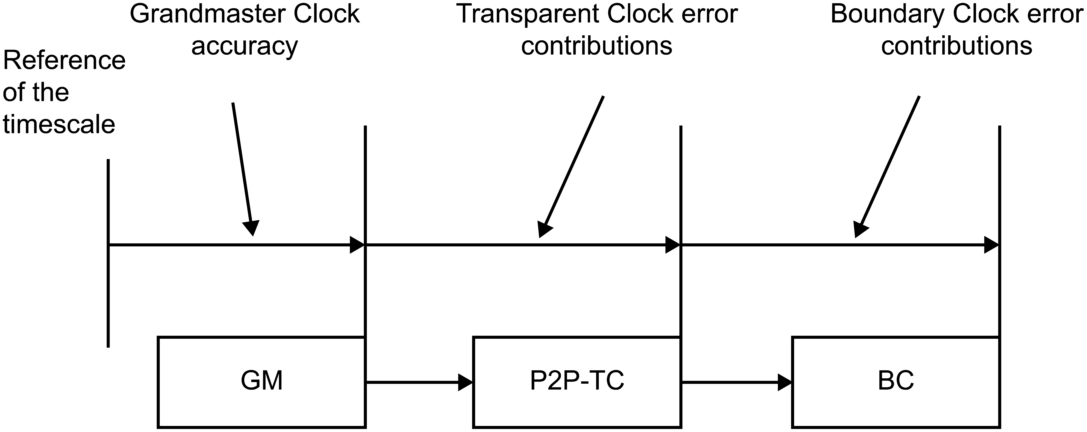
Figure 46—Contribution of the various PTP Instances to metrics in the TLV
The TLV includes the following two groups of components:
- GM component: A component depicting the timing performance supplied by the Grandmaster PTP Instance (as compared with the timescale being distributed by it). (The component will be quantified using the metrics defined below.)
- Distribution components: Components depicting the reduction in accuracy expected along the timing path during the normal operation of the PTP Network, including transitionary contributors that can occur during network transitions (e.g., caused by a change in the topology, or during the initial start-up of the network). (These component will bes are quantified using the metrics defined below, and accumulated in the manner defined below).
The different types of distribution components are illustrated by Figure 47, depicting which depicts various possible contributors to the PTP Instance Time erroraccuracy.
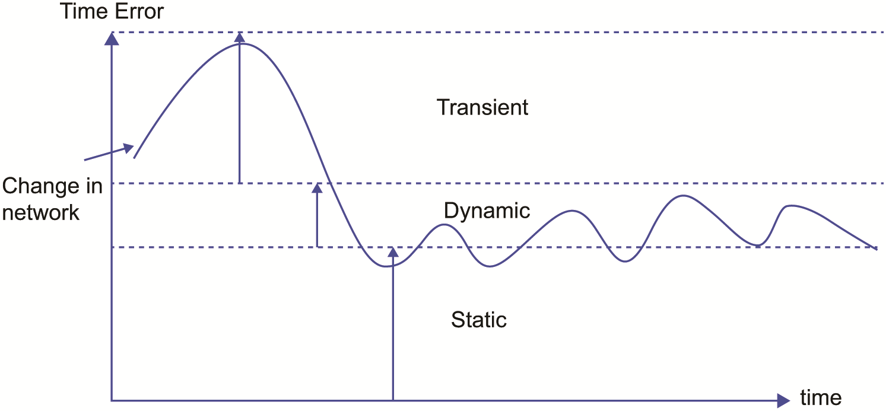
Figure 47—Contributions to degradation in time distribution
For the distribution components, the metrics shall be based on all knowledge the PTP Instance has regarding the current deviations it (and the link connecting it to the upstream instance) might be adding to the timescale being distributed by the upstream PTP instanceInstance. Since the different components might have different significance in context of the application (e.g., the dynamic component could possibly be filtered and could be considered of a different significance compared to the static component), the metrics enable the quantification of the division between among the defined components. The sum of all contributors shall quantify all possible contributors. If an error contributor is not known to be a transient or dynamic component (per their definitions below), its contribution should be accounted for within the static component.
The distribution components are divided into the following two subgroups:
- Transient component: It quantifies an additional time error currently estimated to be induced (beyond that expected in steady state) due to transitory convergence effects (e.g., due to a reaction to a PTP network rearrangement) dependent on the mechanisms by which the PTP Instance maintains its Local PTP Clock or Local Clock as appropriate. The absolute size of this component must decays to zero over time during steady state operation, because any contribution that does not decay to zero is, by definition, part of the steady-state response.
NOTE 43—Providing the metrics for the transient component in a Boundary Clock will, in general, involve estimation of the current deviation of currentDS.offsetFromMaster measurements from such measurement in steady state operation.
- Steady state components: These components quantify the remaining contributors affecting PTP Instance Time accuracy after all transient contributors (e.g., due to PTP network rearrangement) have become negligible in their effect. These are as follows:
  - Static component: It quantifies the mean of the steady state time error under the current operating conditions of the PTP Instance.
  - Dynamic component: It quantifies the temporal deviations of time error from its mean. The value for the dynamic component shall either include all the effects of relevant contributors or be an estimate accounting for the possible reduction in the high-frequency portion of this component as specified in the applicable PTP Profile (e.g., due to filtering in the PTP Iinstance).
NOTE 54—The values to be supplied for the metrics for the steady state components will, in general, involve taking into account various aspects in the design of the implementation (e.g., variations expected due to possible variations in delay of components in use, and possible variations in the performance of the Local Clock utilized within the PTP Instance). It is likely that, while direct measurements can be used to verify the validity of the supplied estimates, they will not be a practical approach to ascertain the required values (e.g., as the estimates cover the expected variations among identically implemented PTP Instances over the expected ensemble of all relevant variations, e.g., those due to variations within production and the various deployment conditions).
The static component is further divided into the following two subcomponents that accumulate into its overall contribution:
- staticInstance: It quantifies the mean of the steady state time error under the current operating conditions of the PTP Instance, contributed by errors internal to the PTP Instance.
- staticMedium: It quantifies the mean of the steady state time error under the current operating conditions, contributed by the medium connecting the PTP Instance to the upstream PTP Instance.
NOTE 6—The mean is measured over the observation window of interest for the application.
The minimal observation window to be used to verify, based on an empirical time error measurement that the PTP Instance is providing conservative estimates of the dynamic component (i.e., overestimating the error) should be supplied as part of the PTP Instance specifications.
For each component, the following two metrics shall be supplied:
- Var: A conservative (over-)estimate of the variance of the error contribution of the component.
- Max: A conservative (over-)estimate of the maximum of the absolute value of the error contribution of the component.
As an example, an estimate of the variance of a staticInstance could be derived from an ensemble of measurements.
The current PTP Instance’s own contributions (labeled “local(X)” in the following equation) shall be accumulated with values of the metrics within the received ENHANCED_ACCURACY_METRICS TLV (labeled “received (X)” in the following equation), to generate the values to be included within the ENHANCED_ACCURACY_METRICS TLV transmitted by the PTP Instance (labeled “transmitted (X)” in the following equation). The accumulation shall be via addition of the PTP Instance’s own contribution to the received values:
transmitted(X) = received(X) + local(X)
where X is any of the metrics: maxTransientInaccuracy, varTransientInaccuracy, maxDynamicInaccuracy, varDynamicInaccuracy, maxStaticInstanceInaccuracy, varStaticInstanceInaccuracy, maxStaticMediumInaccuracy, varStaticMediumInaccuracy.
The max metrics shall be represented using the TimeInterval data type.
The var metrics shall be represented using the Float64 data type (see 5.2) in units of seconds squared (s²). For example, if the expected value for the square root of the variance is 1 ns, then the value of the var estimate is represented as 10^{–18} (i.e., 10^{–9} × 10^{–9}) using the Float64 data type.
NOTE 57—Although the data types enable negative values, the definitions of the metrics generate only non-negative values.
The accumulation is propagated independently for each metric. This allows, for instance, the linear accumulation of maxStaticInstanceInaccuracy and varDynamicInaccuracy; the latter contains squared standard deviation values. The PTP Instance that makes use of the maxStaticInstanceInaccuracy and varDynamicInaccuracy accumulated values can perform appropriate calculations in order to combine these two values (e.g., taking the square root of the accumulated varDynamicInaccuracy).
NOTE 8—The metrics defined in this option can be associated by an applicable PTP Profile to the metrics defined and used by the related industry. As an example, maxStaticInstanceInaccuracy and varDynamicInaccuracy can be used to accumulate the values of constant time error and the squared value of dynamic time error, respectively, as specified by ITU-T G.8260 [B3]. As another example, if an applicable PTP Profile specifies that only the low frequency error components are to be accounted for in the dynamic time error, the maxDynamicInaccuracy or varDynamicInaccuracy components of the ENHANCED_ACCURACY_METRICS TLV can be used to represent the low-passed dynamic time error of the PTP network.
    - EHNANCED_ACCURACY_METRIC TLV
Change 16.12.2 as follows:
The ENHANCED_ACCURACY_METRICS TLV format shall be as specified in Table 130.

- —ENHANCED_ACCURACY_METRICS TLV format
Bits |  |  |  |  |  |  |  | Octets | TLV offset
7 | 6 | 5 | 4 | 3 | 2 | 1 | 0 | Octets | TLV offset
tlvType |  |  |  |  |  |  |  | 2 | 0
lengthField |  |  |  |  |  |  |  | 2 | 2
bcHopCount |  |  |  |  |  |  |  | 1 | 4
tcHopCount |  |  |  |  |  |  |  | 1 | 5
exclusionFlags Reserved |  |  |  |  |  |  |  | 2 | 6
maxGmInaccuracy |  |  |  |  |  |  |  | 8 | 8
varGmInaccuracy |  |  |  |  |  |  |  | 8 | 16 ª
maxTransientInaccuracy |  |  |  |  |  |  |  | 8 | 24 ª
varTransientInaccuracy |  |  |  |  |  |  |  | 8 | 32 ª
maxDynamicInaccuracy |  |  |  |  |  |  |  | 8 | 40 ª
varDynamicInaccuracy |  |  |  |  |  |  |  | 8 | 48 ª
maxStaticInstanceInaccuracy |  |  |  |  |  |  |  | 8 | 56 ª
varStaticInstanceInaccuracy |  |  |  |  |  |  |  | 8 | 64 ª
maxStaticMediumInaccuracy |  |  |  |  |  |  |  | 8 | 72 ª
varStaticMediumInaccuracy |  |  |  |  |  |  |  | 8 | 80 ª
ª This is the TLV offset in case all components are carried. In case not all components are carried, as indicated by the exclusionFlags field, (see 16.12.2.2), this value shall be reduced by k times 8, where k is the number of previous components that are not carried. As an example, if maxTransientInaccuracy, varTransientInaccuracy and varStaticInstanceInaccuracy are not carried, the following applies:
- k=0 for varGmInaccuracy,;
- k=2 for maxDynamicInaccuracy, varDynamicInaccuracy, and maxStaticInstanceInaccuracy;
- k=3 for maxStaticMediumInaccuracy and varStaticMediumInaccuracy.
Therefore, in this example, the TLV offset has to be reduced by 16 for maxDynamicInaccuracy, varDynamicInaccuracy, and maxStaticInstanceInaccuracy (e.g., the TLV offset for the maxDynamicInaccuracy is 40-16=24), while for maxStaticMediumInaccuracy and varStaticMediumInaccuracy, the TLV offset has to be reduced by 24 (e.g., the TLV offset for the varStaticMediumInaccuracy is 80-24 =56). Concerning the TLV offset applicable to maxGMInaccuracy, there is no need for adjustments, because if this is carried, it is always the first component in the TLV, i.e., TLV Offset=8.
16.12.2.2 lengthField
Change 16.12.2.2 as follows:
The value of the lengthField depends on the value of the exclusionFlags field and is between 12 (when only one component is carried) and 84 (when all components are carried).
Insert new subclause (16.12.2.5) after 16.12.2.4 as follows and renumber the following subclauses accordingly:
16.12.2.5 exclusionFlags (Boolean[16])
The value of the exclusionFlags field indicates which of the components are carried by the TLV as shown in Table 130b. The values of the fields are defined in 16.12.2.5.1 through 16.12.2.5.10.
An applicable PTP Profile should specify if a specific set of components is carried by specifying the value of the exclusion flag bits. Unless the value of the exclusionFlags field is specified by an applicable PTP Profile, all exclusion flag bits shall be set to FALSE, indicating that all components are carried.
Reserved bits shall be set to zero and ignored at reception (see 4.2.7).
- Exclusion flags allow for optimized implementations (e.g., reducing the need for implementing and testing components that are not used by a PTP Profile).
Table 130b—exclusionFlags
Bits |  |  |  |  |  |  |  | Octets
7 | 6 | 5 | 4 | 3 | 2 | 1 | 0 | Octets
EVSII | EMSII | EVDI | EMDI | EVTI | EMTI | EVGI | EMGI | 0
Reserved |  |  |  |  |  | EVSMI | EMSMI | 1

As an example, if the exclusionFlags bits are 10011110 00000011 (where bit 0 of each octet is on the right and bit 7 of each octet on the left; octet 0 is most significant and is on the left, and octet 1 is least significant and is on the right), this indicates that the following 3 components are carried at consecutive TLV offsets (octets 8, 16 and 24 respectively): maxGmInaccuracy, varDynamicInaccuracy and maxStaticInstanceInaccuracy. In this case, the value of lengthField is equal to 28.
- The original specification of this TLV in IEEE Std 1588 TM-2019 listed the exclusionFlags field as reserved (all zeroes), and all ten components were carried. This allows interworking between an implementation of the TLV based on this edition of the standard with an implementation based on IEEE Std 1588 TM-2019.
16.12.2.5.1 EMGI (Boolean)
The value of EMGI shall be FALSE if the component maxGmInaccuracy is carried, TRUE if it is not carried.
16.12.2.5.2 EVGI (Boolean)
The value of EVGI shall be FALSE if the component varGmInaccuracy is carried, TRUE if it is not carried.
16.12.2.5.3 EMTI (Boolean)
The value of EMTI shall be FALSE if the component maxTransientInaccuracy is carried, TRUE if it is not carried.
16.12.2.5.4 EVTI (Boolean)
The value of EVTI shall be FALSE if the component varTransientInaccuracy is carried, TRUE if it is not carried.
16.12.2.5.5 EMDI (Boolean)
The value of EMDI shall be FALSE if the component maxDynamicInaccuracy is carried, TRUE if it is not carried.
16.12.2.5.6 EVDI (Boolean)
The value of EVDI shall be FALSE if the component varDynamicInaccuracy is carried, TRUE if it is not carried.
16.12.2.5.7 EMSII (Boolean)
The value of EMSII shall be FALSE if the component maxStaticInstanceInaccuracy is carried, TRUE if it is not carried.
16.12.2.5.8 EVSII (Boolean)
The value of EVSII shall be FALSE if the component varStaticInstanceInaccuracy is carried, TRUE if it is not carried.
16.12.2.5.9 EMSMI (Boolean)
The value of EMSMI shall be FALSE if the component maxStaticMediumInaccuracy is carried, TRUE if it is not carried.
16.12.2.5.10 EVSMI (Boolean)
The value of EVSMI shall be FALSE if the component varStaticMediumInaccuracy is carried, TRUE if it is not carried.
Insert the following subclause (16.12.3) after 16.12.2 as follows:
    - Interworking with earlier revisions of this TLV based on
IEEE Std 1588™-2019
In a network where some of the PTP Instances support only the ENHANCED_ACCURACY_METRICS TLV conformant with IEEE Std 1588-2019, it is recommended that the ENHANCED_ACCURACY_METRICS TLV generated by a Grandmaster PTP Instance that supports the TLV defined in the present edition of the standard carry all the fields (i.e., the value of lengthField equal to 84) in order to allow for proper interworking.
If a TLV with the value of lengthField different from 84 is desired, the value of enhancedSynchronizationAccuracyMetricsDS.enable should be set to FALSE for PTP Instances in the network that only support TLVs conformant to IEEE Std 1588-2019. In this way, the TLV would be propagated by these PTP Instances. If the value of enhancedSynchronizationAccuracyMetricsDS.enable were set to TRUE, the behavior of these PTP Instances when receiving a flexible length TLV is unknown, and may lead to undesired results (e.g., the TLV may be discarded or propagated by these PTP Instances).
Figure 47B shows three typical cases that can happen when mixing implementations that support the Enhanced synchronization accuracy metrics with fixed length (conformant with IEEE Std 1588-2019) and with flexible length (i.e., conformant with this IEEE Std 1588-2019 as amended by IEEE Std 1588a-2023).
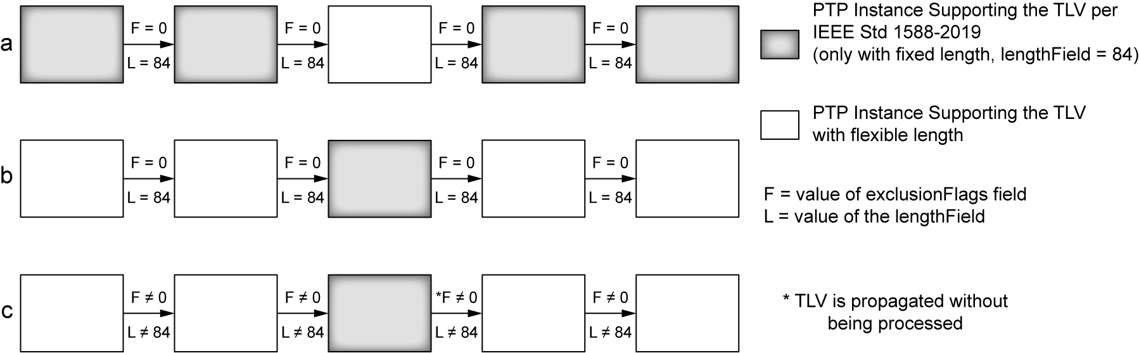
Figure 47B—Interworking between different versions of the TLV

In all cases it is assumed that the enhancedSynchronizationAccuracyMetricsDS.enable is configured TRUE in all PTP Instances, with the exception of case c) where enhancedSynchronizationAccuracyMetricsDS.enable is configured FALSE in the PTP Instance that only supports the ENHANCED_ACCURACY_METRICS TLV conformant with IEEE Std 1588TM-2019 edition of this standard (i.e., non-conformant with this edition as amended by IEEE Std 1588a).
For the first case (a) of Figure 47B, a Grandmaster PTP Instance conformant with IEEE Std 1588-2019 generates a TLV with the value of lengthField = 84 (and zero as the value of the two octets at TLV offset 6, which are defined as Reserved in IEEE Std 1588-2019). The intermediate PTP Instance conformant with this edition of the standard and able to support flexible length would just process it correctly and propagate the TLV (the “Reserved” octets are now interpreted as the exclusionFlags field, indicating that all components are carried).
For the second case (b) of Figure 47B, a Grandmaster PTP Instance supporting this version of the TLV (i.e., able to handle flexible length) generates a TLV with the value of lengthField = 84 and with the flags set to zero as specified in Table 130b. In this way it can be processed by an intermediate PTP Instance even if it does not support the option to handle TLVs with flexible length.
In the last example (c) of Figure 47B, the Grandmaster PTP Instance conformant with this edition of the standard, generates a TLV with the value of lengthField less than 84. An intermediate PTP Instance that is not able to process a flexible length TLV is recommended to be configured with enhancedSynchronizationAccuracyMetricsDS.enable equal to FALSE. This PTP Instance therefore would propagate the TLV without processing it.
- State configuration options
Insert new subclause 17.8 as follows:
  - Computation of <announceReceiptTimeoutInterval> and FOREIGN_MASTER_TIME_WINDOW interval using the received logAnnounceInterval (optional)
    - General
This subclause defines an optional mechanism for computation of <announceReceiptTimeoutInterval> and FOREIGN_MASTER_TIME_WINDOW interval using the received logAnnounceInterval. The received logAnnounceInterval can better reflect the actual interval between successive Announce messages sent by the adjacent PTP Instance, and help to prevent the premature occurrence or the failure to occur of an ANNOUNCE_RECEIPT_TIMEOUT_EXPIRES event and foreign master qualification.

When this option is both implemented (see 6.1) and enabled (see 2.1.7.2), then the option shall operate as specified in this subclause.
    - <announceReceiptTimeoutInterval> and ANNOUNCE_RECEIPT_TIMEOUT_EXPIRES

The specifications of 9.2.6.12 shall apply, except that:
- For multicast communication, the value of <announceReceiptTimeoutInterval> shall be the value of portDS.announceReceiptTimeout multiplied by 2^{logMessageInterval}, where logMessageInterval is the value of the logMessageInterval field of the most recently qualified Announce message (see 13.3.2.14, 9.3.2.5 and 2.1.4).
- For unicast communication, the value of <announceReceiptTimeoutInterval> shall be the value of portDS.announceReceiptTimeout multiplied by either:
  - If unicast negotiation is not used, 2^{logMessageInterval}, where logMessageInterval is the value of the logMessageInterval field of the most recently qualified Announce message (see 13.3.2.14, 9.3.2.5 and 2.1.4), or
  - If unicast negotiation is used, 2^{logInterMessagePeriod}, where logInterMessagePeriod is the value of the logInterMessagePeriod field of the GRANT_UNICAST_TRANSMISSION TLV (see 16.1.4.2) that granted this unicast session.
- The ANNOUNCE_RECEIPT_TIMEOUT_EXPIRES event shall occur at the expiration of the timeout as specified by a) or b), plus either:
  - A random number uniformly distributed in the range (0,1) announceIntervals, or
  - 0, if specified by the applicable PTP Profile.
    - FOREIGN_MASTER_TIME_WINDOW and FOREIGN_MASTER_THRESHOLD

The specifications of 9.3.2.4.5 shall apply, except that the value of FOREIGN_MASTER_TIME_WINDOW shall be equal to either:
- For multicast communication, or unicast communication if unicast negotiation is not used:
- 4×2^{logMessageInterval}, where logMessageInterval is the value of the logMessageInterval field of the most recently qualified Announce message (see 13.3.2.14, 9.3.2.5 and 2.1.4), or
- 4×2^{portDS.logAnnounceInterval}, if no Announce messages have been qualified yet.
- For unicast communication if unicast negotiation is used, 4×2^{logInterMessagePeriod}, where logInterMessagePeriod is the value of the logInterMessagePeriod field of the GRANT_UNICAST_TRANSMISSION TLV (see 16.1.4.2) that granted this unicast session.
    - Qualification of Announce Messages

The specifications of 9.3.2.5 shall apply, except that FOREIGN_MASTER_TIME_WINDOW shall be computed as specified in 2.1.3.

In addition, in computing the value of the expression 4 × 2^{portDS.logAnnounceInterval} in NOTE 1 of 9.3.2.5, the quantity X is used instead of portDS.logAnnounceInterval, where X is equal to:
  - For multicast communication or unicast communication without unicast negotiation, logMessageInterval, where logMessageInterval is the value of the logMessageInterval field of the most recently qualified Announce message, unless no Announce messages have been qualified yet in which case portDS.logAnnounceInterval is not replaced.
  - For unicast communication with unicast negotiation, logInterMessagePeriod, where logInterMessagePeriod is the value of the logInterMessagePeriod field of the GRANT_UNICAST_TRANSMISSION TLV that granted this unicast session.
    - logMessageInterval field of an Announce message

If the Announce message is multicast, the provisions of Table 42 apply. If the Announce message is unicast, the value of the logMessageInterval field shall be:

- The value of portDS.logAnnounceInterval if unicast negotiation is not used;
- Either 7F₁₆ or the value of portDS.logAnnounceInterval if unicast negotiation is used.

In case b) above, it is recommended that the value of the logMessageInterval field should
be 7F₁₆.

    - Change in the value of announceInterval at a PTP Port in the MASTER state
If the value of announceInterval (see 7.7.2.2) at a PTP Port in the MASTER state increases, i.e., the mean Announce message rate decreases, the PTP Port shall use the old, i.e., smaller, Announce mean time interval in the N consecutive Announce messages transmitted after the value of the relevant data set member has changed. However, the PTP Port places the new, i.e., larger, value of portDS.logAnnounceInterval in the logMessageInterval field of the transmitted Announce messages as soon as this data set member is updated, i.e., announceInterval changes. The value of N shall be the larger of the new value of portDS.announceReceiptTimeout and 4.

- The value 4 above reflects the number of announceIntervals used in computing FOREIGN_MASTER_TIME_WINDOW (see 9.3.2.4.5).
- If the announceInterval increases, i.e., the desired Announce rate decreases, the loss of one or more Announce messages can cause a delay in the receiving PTP Port finding out that the rate has decreased. In this case, the receiving PTP Port will still expect to receive Announce messages at the old, i.e., faster rate, which might cause a premature ANNOUNCE_RECEIPT_TIMEOUT_EXPIRES event or delay in qualifying a foreign master. By continuing to send up to N Announce messages at the old, i.e., faster rate, there could be a loss of up to N Announce messages without causing announce receipt timeout to occur too soon or foreign master qualification to occur too late. If more than N messages are lost, announce receipt timeout or failure to qualify a foreign master would have occurred even if the Announce rate had not changed.
- If portDS.announceReceiptTimeout is larger at the receiver than at the sender, premature announce receipt timeout can still occur.
    - adaptiveReceiptTimeoutDS
      - General
The name and operational conformance, as defined in 8.1.6, of each adaptiveReceiptTimeoutDS member is summarized in Table 138a.

Table 138a—adaptiveReceiptTimeoutDS operational conformance

Name | OC | BC | E2E TC | P2P TC
announceAndForeignMasterEnabled | optional | optional | N/A | N/A

This data set provides management access to the adaptiveReceiptTimeoutDS of the optional feature for computation of <announceReceiptTimeoutInterval> and FOREIGN_MASTER_TIME_WINDOW using the received logAnnounceInterval.

      - adaptiveReceiptTimeoutDS.announceAndForeignMasterEnabled
The data type shall be Boolean. The classification is configurable. The initialization value (see 8.1.3.4) shall be FALSE.

If the optional feature for computation of <announceReceiptTimeoutInterval> and FOREIGN_MASTER_TIME_WINDOW using the received logAnnounceInterval is implemented, the value TRUE shall indicate that the option is enabled on all PTP Ports of the PTP Instance, and the value FALSE shall indicate that the option is disabled on all PTP Ports of the PTP Instance.
    - adaptiveReceiptTimeoutPortDS
      - General
The name and operational conformance, as defined in 8.1.6, of each adaptiveReceiptTimeoutPortDS member is summarized in Table 138b.

Table 138b—adaptiveReceiptTimeoutPortDS operational conformance

Name | OC | BC | E2E TC | P2P TC
rxLogAnnounceInterval | optional | optional | N/A | N/A

This data set provides management access to the adaptiveReceiptTimeoutPortDS of the optional feature for computation of <announceReceiptTimeoutInterval> and FOREIGN_MASTER_TIME_WINDOW using the received logAnnounceInterval.
17.8.8.2 adaptiveReceiptTimeoutPortDS.rxLogAnnounceInterval
The data type shall be Integer8. The classification is dynamic.

The value of adaptiveReceiptTimeoutPortDS.rxLogAnnounceInterval shall be the value of the logMessageInterval field of the most recently qualified Announce message.

This data set member is optional.

The initialization value (see 8.1.3.4) shall be implementation specific.
- Compatibility of this edition with earlier and future editions
Insert the following new subclause 19.5 after 19.4.14:
  - Compatibility of IEEE Std 1588-2019
For details on the compatibility of EEE Std 1588-2019 as amended by IEEE Std 1588a with IEEE Std 1588-2019 related to the use of the Enhanced Accuracy TLV, refer to 1.1.2.
Insert two new Annexes (Annex P1 and Annex P2) after Annex P and adjust the next Annex letters accordingly.

Annex P1
(informative)
BMCA basic introduction
P1.1 Introduction
This annex is intended to help to understand the default Best Master Clock Algorithm (BMCA) as specified in 3.2.1. Only the typical cases are described; corner cases are not described.
The purpose of the BMCA is to form a hierarchy among the PTP Instances (i.e., Boundary Clocks and Ordinary Clocks) in a single PTP domain (3.1.9). The BMCA, which determines the state of each PTP Port, is executed by every Boundary Clock (3.1.3) and Ordinary Clock (3.1.40). As such, it determines whether the Local PTP Clock (see 3.1.28) receives timing from its Master Clock (see 3.1.31) and is therefore traceable (see 3.1.82) to the Grandmaster Clock (see 3.1.17), or is itself the source of time in the PTP domain (i.e., is the Grandmaster Clock). A PTP Instance is not aware of the full PTP Network (3.1.59) hierarchy, but only receives information from its neighbor PTP Instances. As such, the BMCA is a distance vector algorithm, similar in operation to other such algorithms, e.g., the Rapid Spanning Tree Protocol in IEEE Std 802.1Q™-2018 [B2].
Information that the BMCA uses for its decisions is distributed to PTP Instances (Boundary Clocks and Ordinary Clocks) in the Announce message. This information includes characteristics of the currently selected Grandmaster PTP Instance and the path to it. Announce messages can be directly received from the currently selected Grandmaster PTP Instance, or from a PTP Instance connected through a chain of PTP Instances to the currently selected Grandmaster PTP Instance. Announce messages are sent periodically on all PTP Ports in the MASTER state. This means that a PTP Instance receives Announce messages from one or more PTP Ports of its neighbor PTP Instances (either from its Parent PTP Instance’s PTP Port to which it is currently synchronizing to, see 3.1.41, or from foreign masters, see 3.1.14). The BMCA then compares these received characteristics with its own PTP Instance characteristics and decides which one is the best. Based on the above decision, the state of each PTP Port is determined.
The scope of this annex is to give an overview of the typical use cases of the default BMCA operation to help the reader understand the algorithm. More advanced use cases and “corner cases” can be found in Eidson, John [B1].
P1.2 BMCA Overview
The BMCA is run for all qualified Announce messages that are received on PTP Ports of a PTP Instance that are connected to other PTP Ports in the MASTER state. Only Announce messages for the PTP domain of interest to the BMCA are considered for qualification. The same Announce message can be received on multiple PTP Ports, depending on the transport network topology.
The BMCA includes the data set comparison algorithm and state decision algorithm, defined in 9.3.4 and illustrated in Figure 34, Figure 35, and Figure 33. These figures are replicated with additional information for this annex in Figure P1.1, Figure P1.2, and Figure P1.3, respectively. Figure 32 provides an overview of how the default BMCA, and the two algorithms are executed in a PTP Instance. This figure is replicated with additional information for this annex in Figure P1.4.
The data set comparison algorithm is used to compare information received in Announce messages, as well as information (D₀), describing the PTP Instance on which the BMCA is performed. The first part of the algorithm, depicted in Figure P1.1, is used in the case when the compared information describes distinct “candidate” Grandmaster PTP Instances (i.e., having different grandmasterIdentities). Out of the two “candidates”, it identifies which one is better suited to serve as a Grandmaster Clock.
The second part of the algorithm, depicted in Figure P1.2, is used in the case when the compared information describes the same “candidate” Grandmaster PTP Instance (i.e., having the same grandmasterIdentity), but where the information typically traversed different paths to the PTP Port(s) where the comparison is being made (e.g., via different chains of Boundary Clocks). Out of the two different paths, the shorter is considered better. If the paths are of the same length, clock identities and port numbers are used as a tiebreaker to choose one path as being better.
Figure P1.3 illustrates the “state decision algorithm,” which is performed for each PTP Port of a Boundary Clock or Ordinary Clock. It recommends the PTP state to which the PTP Port should transition to (or remain in). It uses the ‘data set comparison algorithm’ illustrated in Figure P1.1 and Figure P1.2 to compare the following information (see Table 29 for details):
- D₀ – the information describing the PTP Instance on which the BMCA is performed, which is contained in the defaultDS.
- E_{best} & E_{rbest}– the information received in certain qualified Announce messages
- E_{rbest} – the information in Announce messages received from the parent PTP Instance’s PTP Port to which it is currently synchronizing to or the best foreign master, on the PTP Port “r”. If Announce messages from more than one PTP Instance is received on PTP Port “r”, the ‘data set comparison algorithm’ is used to choose the best one.
- E_{best} – the information in Announce messages received from the parent PTP Instance’s PTP Port to which it is currently synchronizing to or from the best foreign master, on all the PTP Ports of the PTP Instance on which the BMCA is performed. If Announce messages are received on multiple PTP Ports, the ‘data set comparison algorithm’ is used to choose the best master for the PTP Instance, taking Erbest of each PTP Port as input. In other words, E_{best} is the best of the E_{rbest} sets, taken over all PTP Ports “r”.
Below is a step by step walk through of the data set comparison algorithm and the state decision algorithm.
Figure P1.1 depicts the first portion of the “data set comparison algorithm.” It compares information characterizing distinct “candidate” Grandmaster PTP Instances. This information is referred to as dataset A and dataset B, respectively.
- Step 1-1: The algorithm compares the values of the clockIdentity attribute (7.6.2.2) of the two "candidate" Grandmaster PTP Instances, and verifies whether the compared information identifies a single or two distinct “candidate” Grandmaster PTP Instances. If the information identifies a single “candidate” Grandmaster PTP Instances, the second part of the ‘data set comparison algorithm’, depicted in Figure P1.2, is used. Otherwise, the algorithm continues to step 1-2.
- Step 1-2: The algorithm compares the values of the priority1 attributes (7.6.2.3) of the two “candidate” Grandmaster PTP Instances. The value of this attribute can be modified for each “candidate” Grandmaster PTP Instance (e.g., by the network administrator) by configuring the defaultDS.priority1 (8.2.1.4.1) data set member; thus, the desired outcome of the BMCA can be achieved. If the priority1 values are equal the algorithm continues to step 1-3. Otherwise, the candidate with the lower priority1 value will be considered “better”.
- Step 1-3: The algorithm compares the values of the clockClass attributes (7.6.2.5) of the two “candidate” Grandmaster PTP Instances. The value of this attribute denotes the traceability and synchronization of the time or frequency distributed by a “candidate” Grandmaster PTP Instance. If the clockClass values are equal the algorithm continues to step 1-4. Otherwise, the candidate with the lower clockClass value will be considered “better”.
- Step 1-4: The algorithm compares the values of the clockAccuracy attributes (7.6.2.6) of the two “candidate” Grandmaster PTP Instances. The value of this attribute indicates the expected accuracy of the source of time of “candidate” Grandmaster PTP Instances; typically it depends on the source of time used. If the clockAccuracy values are equal, the algorithm continues to step 1-5. Otherwise, the candidate with the lower clockAccuracy value will be considered “better”.
- Step 1-5: The algorithm compares the value of the GM offsetScaledLogVariance attribute (7.6.2.7) of the two “candidate” Grandmaster PTP Instances. The value of this attribute indicates the expected variance (7.6.3) of the source of time of “candidate” Grandmaster PTP Instances. If the offsetScaledLogVariance values are equal, the algorithm continues to step 1-6. Otherwise, the candidate with the lower offsetScaledLogVariance value will be considered “better”.
- Step 1-6: The algorithm compares the value of the priority2 attribute (7.6.2.4) of the two “candidate” Grandmaster PTP Instances. The value of this attribute can be modified for each “candidate” Grandmaster PTP Instance (e.g., by the network administrator) by configuring the defaultDS.priority2 (8.2.1.4.2) data set member, and lower values of this attribute take precedence. If the priority2 values are equal, the algorithm continues to step 1-6. Otherwise, the candidate with the lower priority2 value will be considered “better”.
- Step 1-7: The algorithm compares the value of the clockIdentity attribute (7.6.2.2) of the two “candidate” Grandmaster PTP Instances. The value of this attribute identifies a PTP Instance (7.5.5) and is used as a tiebreaker. A lower value of this attribute takes precedence. The candidate with the lower clockIdentity value will be considered “better”, the situation in which the clockIdentity values are equal, is covered in step 1-1.
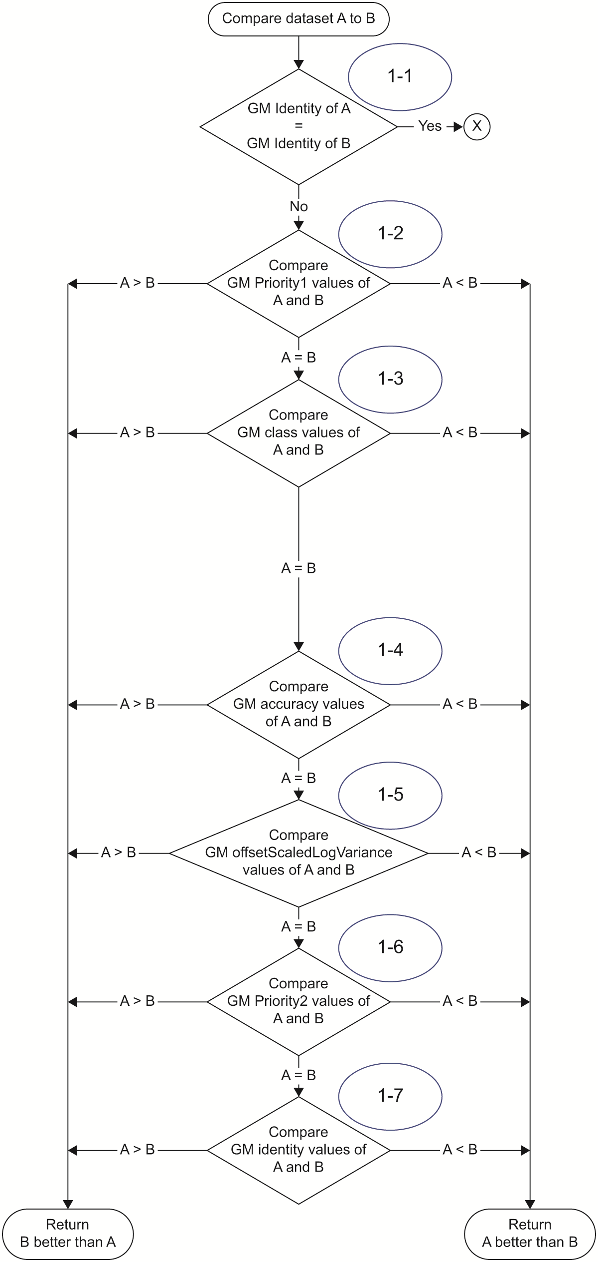

Figure P1.1—First part of the ‘data set comparison algorithm’

Figure P1.2 depicts second portion of the “data set comparison algorithm.” It compares information characterizing the “candidate” paths to a single Grandmaster PTP Instance; this information is referred to as dataset A and dataset B, respectively.
- Step 2-1: The algorithm compares the values of the stepsRemoved received in the Announce messages, which characterize each “candidate” path to the Grandmaster PTP Instance. This value indicates the number of PTP Communication Paths (3.1.52) between the PTP Instance that performs the BMCA and the Grandmaster PTP Instance; each Boundary Clock increments the value of stepsRemoved by 1. If the difference between the stepsRemoved values of the two “candidate” paths is zero or 1, the next step is 2-2 – in this case special precaution is required to detect the presence of a loop between PTP Ports of the same PTP Instance. Otherwise, the algorithm completes and the “candidate” path with the smaller value of stepsRemoved is considered “better” (label #Z or #Y in Figure P1.2).
- Step 2-2: The algorithm again compares the values of stepsRemoved received in the Announce messages, which characterize each “candidate” path to the Grandmaster PTP Instance, and then proceeds to detection of a network loop. If the stepsRemoved values are equal, the next step is 2-5; otherwise the algorithm proceeds to the step 2-3 or 2-4, depending on the outcome of comparing the stepsRemoved values.
- Steps 2-3 and 2-4: In this case (i.e., where the difference between the stepsRemoved values is 1) a potential loop could be created via a neighbor network element (e.g., Ethernet switch), and the algorithm compares the portIdentity (see 7.5.2.4) attributes of the PTP Ports that sent and received the Announce messages. If the portIdentities are the same, the algorithm completes with an error condition (label #E in Figure P1.2) indicating that that one of the PTP messages was transmitted and received on the same PTP Port. Otherwise, the Announce message with lower value of stepsRemoved is selected. In this case, the portIdentity of the sender and of the receiver is used as a tiebreaker for decision on whether the selected reference is considered “better” (label #Z or #Y) or “better by topology” (label #Q or #X). This will be used by the state decision algorithm (see Figure P1.3) in the recommendation of the PTP Port state (either PASSIVE, MASTER, or SLAVE).
- Step 2-5: The algorithm compares the values of the portIdentities of the sending PTP Ports. If the values are the same (i.e., the Announce messages reflecting the same “candidate” Grandmaster PTP Instance are sent by the same PTP Port), the next step is 2-6, otherwise the values of the portIdenties are used as a tiebreaker for selecting the “candidate” path; the algorithm completes and the “candidate” path via the PTP Port with lower value of portIdentity is considered “better by topology” (label #Q or #X in Figure P1.2).
- Step 2-6 The algorithm compares the values of the portNumbers of the PTP Ports on which the Announce messages have been received. Entering step 2-6 is due to the fact that the Announce messages have been sent by the same PTP Port. If they have also been received by the same PTP Port, the algorithm completes with an error condition (label #F in Figure P1.2, in fact, this means that either PTP messages are duplicates or they are an earlier and later PTP message from the same Grandmaster PTP Instance). Otherwise, the algorithm completes and the “candidate” path via the reception PTP Port with lower value of portNumber (used as tiebreaker) is considered “better by topology” (label #Q or #X in Figure P1.2).

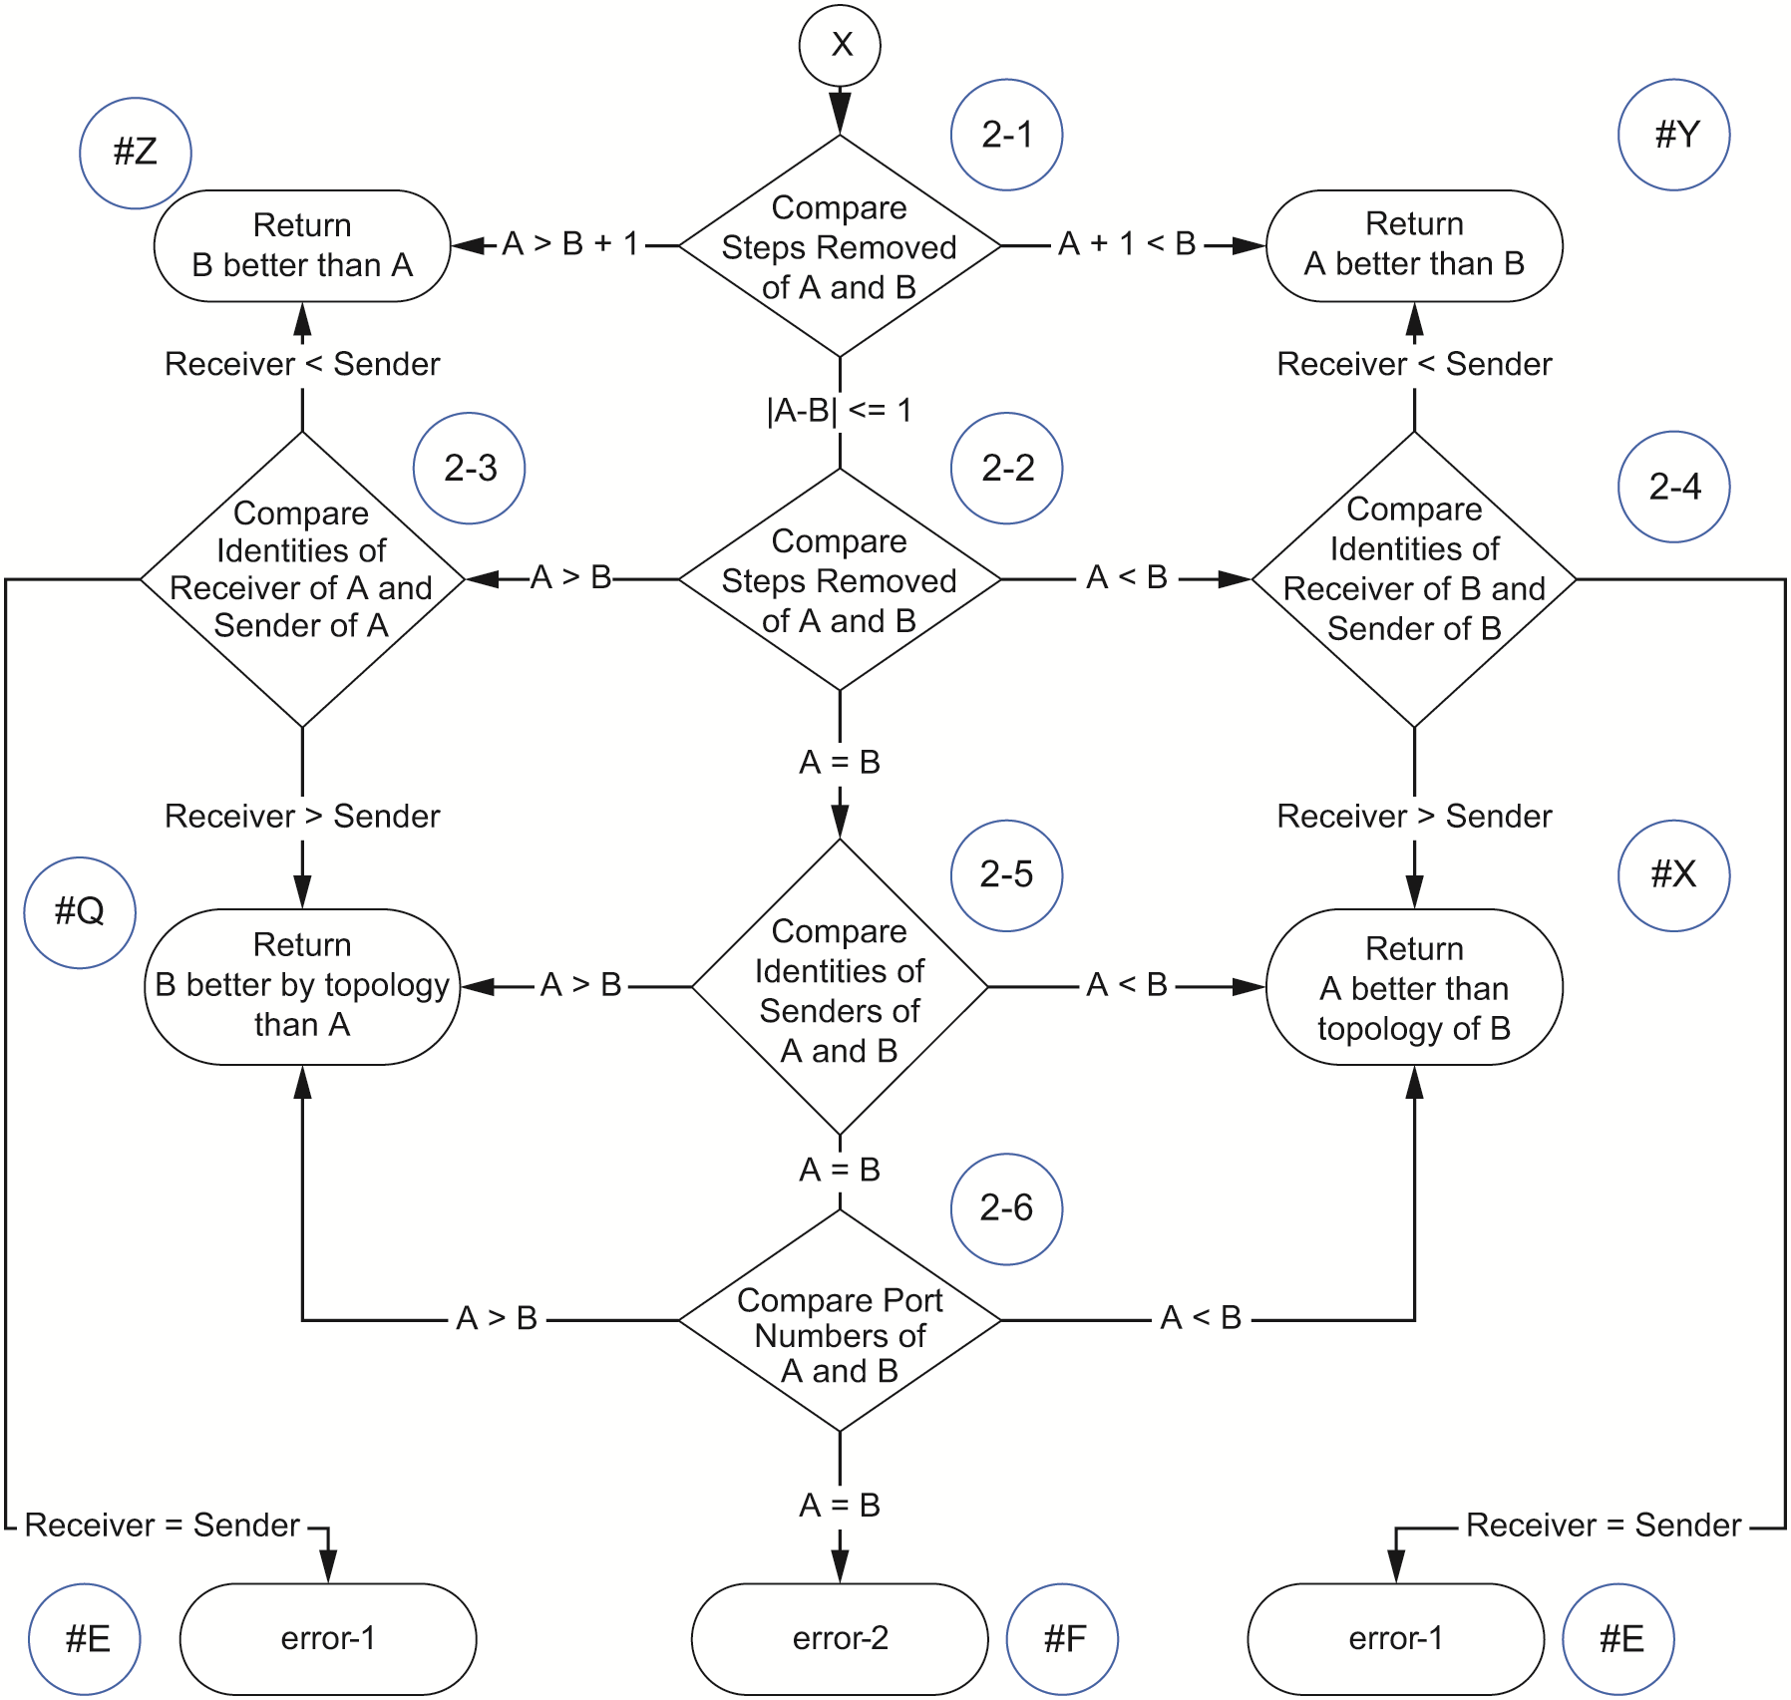

Figure P1.2—Second part of the ‘data set comparison algorithm’
Figure P1.3 illustrates the ‘state decision algorithm’, which is performed for each PTP Port “r” of a Boundary Clock or Ordinary Clock. It compares information characterizing the “candidate” Grandmaster PTP Instances and paths to them. This information is referred to as D₀, E_{rbest}, and E_{best}.
- Step 3-1: The algorithm verifies whether there are any Announce messages received either from the Parent PTP Instance’s PTP Port to which it is currently synchronizing, see 3.1.41, or from foreign masters. In particular, if no qualified Announce message has been received at any of the PTP Ports of the PTP Instance (thus no foreign master has been identified and so E_{best} is empty) and the PTP Port on which BMCA is performed has been recently initialized (i.e., it is in LISTENING state), the PTP Port remains in the LISTENING state. Otherwise, the algorithm continues to step 3-2.
- Step 3-2: The algorithm verifies whether the clockClass of the PTP Instance on which the BMCA is performed prohibits it from having PTP Ports in the SLAVE state (i.e. clockClass in the range 1 through 127) – such PTP Instances are meant to be Grandmaster PTP Instances. However, a PTP Instance with clockClass greater than 127 can also become a Grandmaster PTP Instance, provided there is no other PTP Instance in the same domain with clockClass in the range 1 through 127. Depending on the value of clockClass, the algorithm continues with step 3-3 or step 3-4.
- Step 3-3: The algorithm (on the PTP Instance that cannot have PTP Ports in the SLAVE state) compares, using the ‘data set comparison algorithm’:
- D₀ – the characteristics of the PTP Instance on which the BMCA is performed, and
- E_{rbest} – the characteristics received in the qualified Announce messages from the best foreign master connected to the PTP Port “r” on which the BMCA is performed.
If the PTP Instance on which the BMCA is performed is considered “better” or “better by topology” than E_{rbest}, the PTP Port is recommended to be placed in the MASTER state; otherwise, the PASSIVE state is recommended.
- Step 3-4: The algorithm (on the PTP Instance that can have a PTP Port in the SLAVE state) compares, using ‘data set comparison algorithm’:
- D₀ – the characteristics of the PTP Instance on which the BMCA is performed, and
- E_{best} – the characteristics received in the qualified PTP Announce messages from the best foreign master connected to the PTP Instance (among all PTP Ports) on which the BMCA is performed.
If the PTP Instance on which the BMCA is performed is considered “better” or “better by topology” than E_{best}, the PTP Port is recommended to be placed in the MASTER state; otherwise, the next step is 3-5.
- Step 3-5: The algorithm verifies whether the Announce messages from the best foreign master on the PTP Instance (characterized by E_{best}) are received on the PTP Port on which the BMCA is performed. If yes, this PTP Port is recommended to be placed in the SLAVE state, as it is connected to the Grandmaster PTP Instance through the optimal path. Otherwise, the next step is 3-6.
- Step 3-6: The algorithm compares characteristics of the best foreign master for the PTP Port “r” on which the BMCA is performed (E_{rbest}) and the best foreign master for the entire PTP Instance (among all PTP Ports, E_{best}). If the ‘data set comparison algorithm’ determines that E_{best} is “better by topology” than E_{rbest}, it means that the PTP Port on which the BMCA is performed provides a path to the same Grandmaster PTP Instance as the PTP Port on which E_{best} is received. Thus, this PTP Port provides a valid backup path and the PTP Port is recommended to be placed in the PASSIVE state. Otherwise, if the ‘data set comparison algorithm’ determines that E_{best} is "better” than E_{rbest}, the PTP Port is recommended to be placed in the MASTER state.
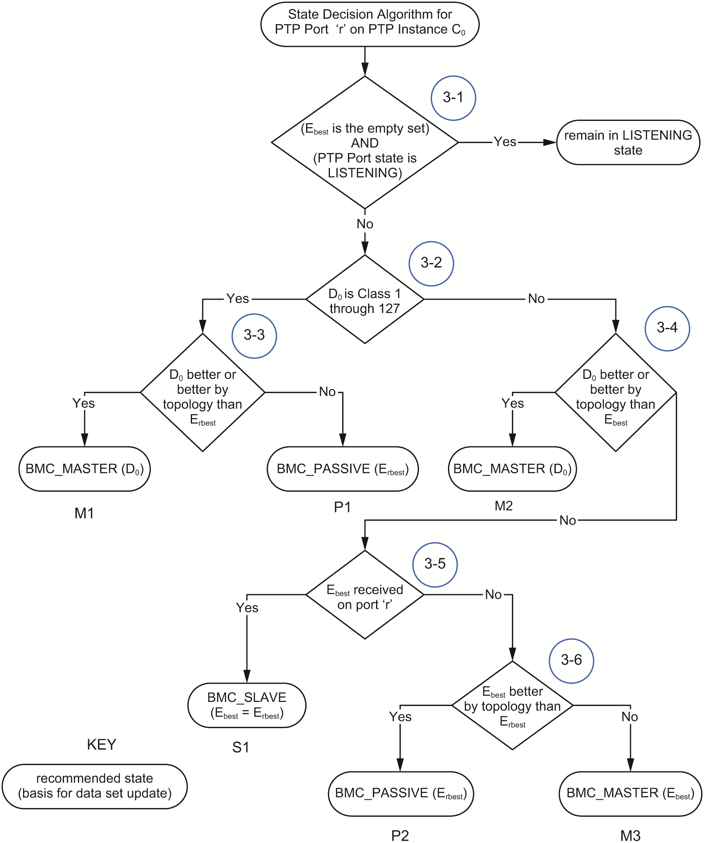
Figure P1.3—State decision algorithm
Figure P1.4 illustrates the execution of the default BMCA in a PTP Instance:
- Step 4-1: The BMCA is triggered for all PTP Ports of a Boundary Clock or an Ordinary Clock simultaneously;
- Step 4-2: The best candidate Grandmaster PTP Instance for each PTP Port (E_{rbest}) is computed using the ‘data set comparison algorithm’ based on the information received in qualified Announce messages;
- Step 4-3: The best candidate Grandmaster PTP Instance for the entire PTP Instance (E_{best}) is computed using the ‘data set comparison algorithm’ based on the outputs of Step 4-2;
- Step 4-4: The ‘state decision algorithm’ is performed for all the PTP Ports (except for PTP Ports in the DISABLED or FAULTY states) based on the outputs of Step 4-2 and Step 4-3;
- Step 4-5: The output of the BMCA is used to update the states of all PTP Ports and the appropriate data sets (see 9.3.5).

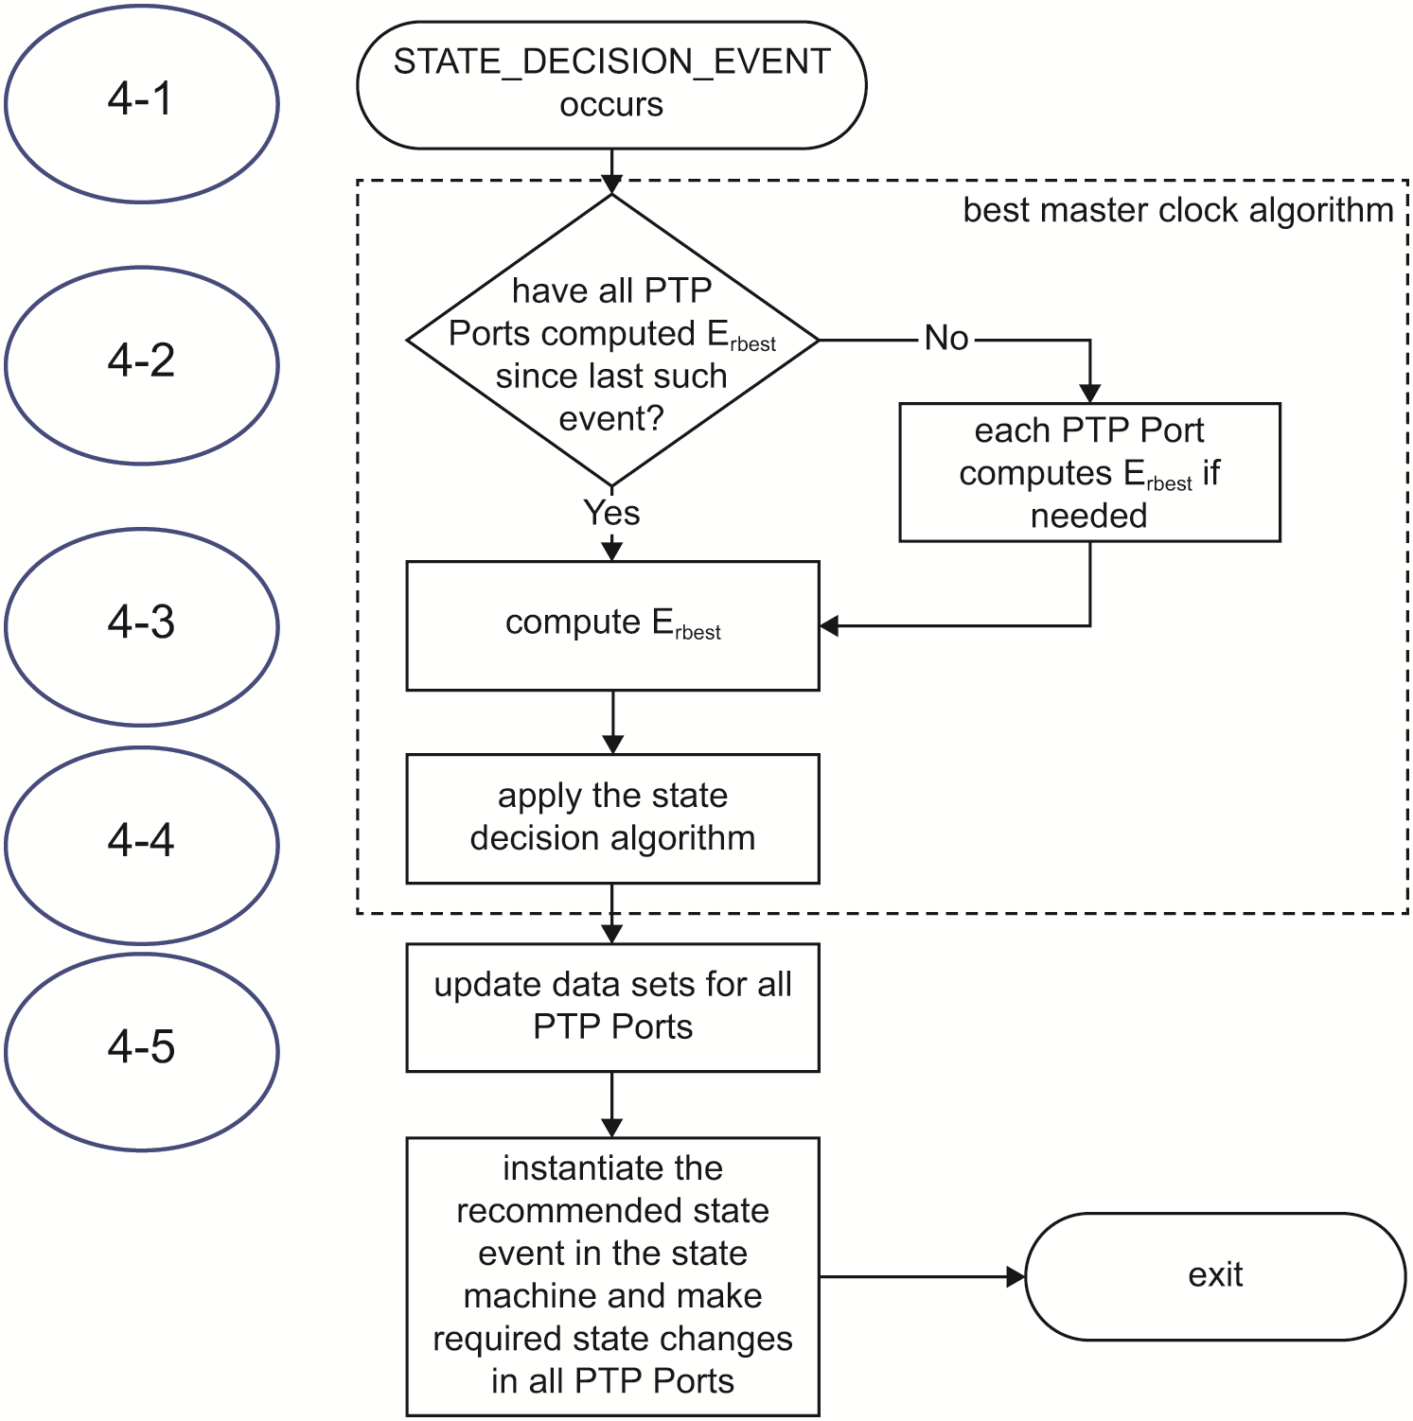
Figure P1.4—Default Best Master Clock Algorithm

P1.3 BMCA Example
This clause illustrates a practical example of BMCA operation in a PTP Network consisting of 4 PTP Instances, illustrated in Figure P1.5. The example explains how the synchronization hierarchy is maintained by the default BMCA (see 3.2.1). Figure P1.6 focuses on the PTP Grandmaster Instance. For the Boundary Clocks BC1, and BC3 the decision logic is depicted in Figure P1.7, and for BC2 in Figure P1.8.
Only a subset of the data set members and fields in the Announce messages are depicted in the figures for readability. The (yellow) rectangle labeled “Transmitted Announce PTP message” or “Received Announce PTP message” depicts relevant fields of the Announce message transmitted or received by the depicted PTP Instance. The rectangles labeled with data set names depict values of their members relevant for the BMCA decision as stored in a steady state in the data sets. With reference to values shown in the figures in this example, while some members of defaultDS can be configured by the user (see 8.2.1), the values of the other data set members, the values in the Announce message fields, and the PTP Port state recommendation result from the operation of the PTP Protocol. These protocol operations are defined in the figures, tables and subclauses referenced in Figure P1.6, Figure P1.7, and Figure P1.8.
Importantly, the value of the clockClass attribute in the PTP Instances in this example is as follows. GM1 has a value of the clockClass equal to 6, and BC1, BC2 and BC3 have a value of the clockClass equal to 248. As a result of their clockClass values, BC1, BC2 and BC3 will not be selected by the default BMCA as Grandmaster PTP Instances, see 7.6.2.5, in this network topology as long as GM1 is visible.
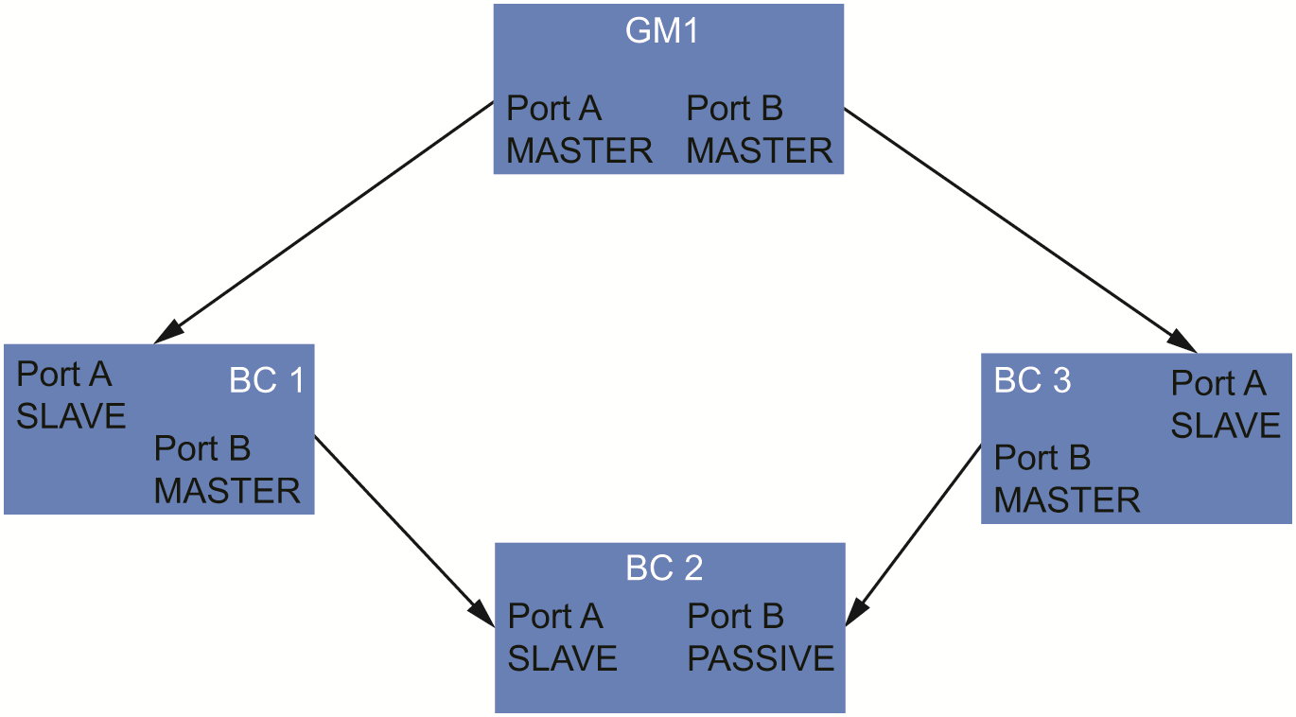
Figure P1.5—Example of a PTP Network with 4 PTP Instances
In Figure P1.6, GM1 transmits Announce messages on PTP Ports A and B. The adjacent PTP Ports at BC1 and BC3 are in the SLAVE state and do not transmit any Announce messages (E_{rbest} for each PTP Port of GM1 is the empty set). Hence GM1’s PTP Ports A and B will remain in the MASTER state as per step 3-3 in Figure P1.3 due to the fact that any non-empty set is always deemed better than an empty one by the ‘data set comparison algorithm’, see 9.3.4. As the Grandmaster PTP Instance, GM1 copies its own characteristics to the ParentDS, per 9.3.5.

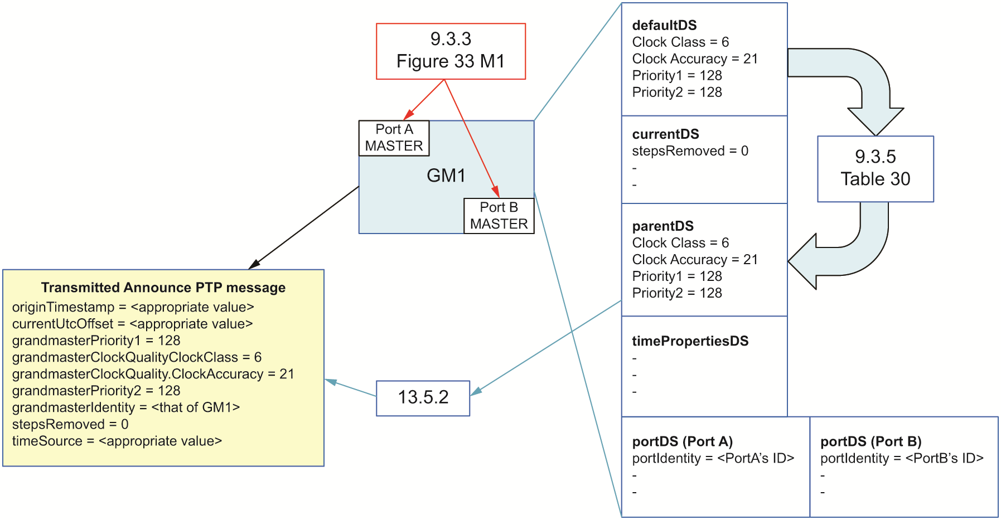
Figure P1.6—PTP Grandmaster (GM1)
In Figure P1.7, BC1 and BC3 each receive Announce messages from GM1 on the respective PTP Port A with the depicted field values. Per Table 29, the values of D₀ are taken from the defautltDS. As D₀ of BC1 and D₀ of BC3 each have a clockClass value greater than 127, the ‘state decision algorithm’ in step 3-2 of clause P1.2 takes the path towards step 3-4. In step 3-4, E_{best} is compared with the D₀ by the ‘data set comparison algorithm’. Since E_{best} represents a Grandmaster PTP Instance with the clockClass value (i.e., 6) lower than that of BC1 and BC3 (i.e., 248), D₀ is neither "better" nor "better by topology" than E_{best}, therefore the algorithm takes step 3-5.
When the BMCA is executed for the PTP Port A of BC1 and PTP Port A of BC3, it is the port on which E_{best} Announce messages are received; therefore, the state decision algorithm recommends the state to be SLAVE via step 3-5. The information from the Announce message is copied to the parentDS per Table 33 (see 9.3.5). This data set is used to populate the fields of the Announce message transmitted on PTP Port B of BC1 and PTP Port B of BC3.
When the BMCA is executed for PTP Port B of BC1(3) connected to adjacent PTP Port in the SLAVE or PASSIVE state (Port A or B of BC2), it is not the port on which E_{best} is received and the algorithm continues to step 3-6. Since PTP Port A of BC2 is in the SLAVE state once steady state is reached, no Announce messages are received on PTP Port B of BC1. Similarly, since PTP Port B of BC2 is in the PASSIVE state once steady state is reached, no Announce messages are received on PTP Port B of BC3. This means that on PTP Port B of BC1(3), E_{rbest} is empty and “E_{best} is better than E_{rbest}” (rather than “better by topology”). As E_{best} is not “better by topology”, the algorithm recommends the MASTER state for PTP Port B, and the MASTER state is maintained for PTP Port B of BC1(3).

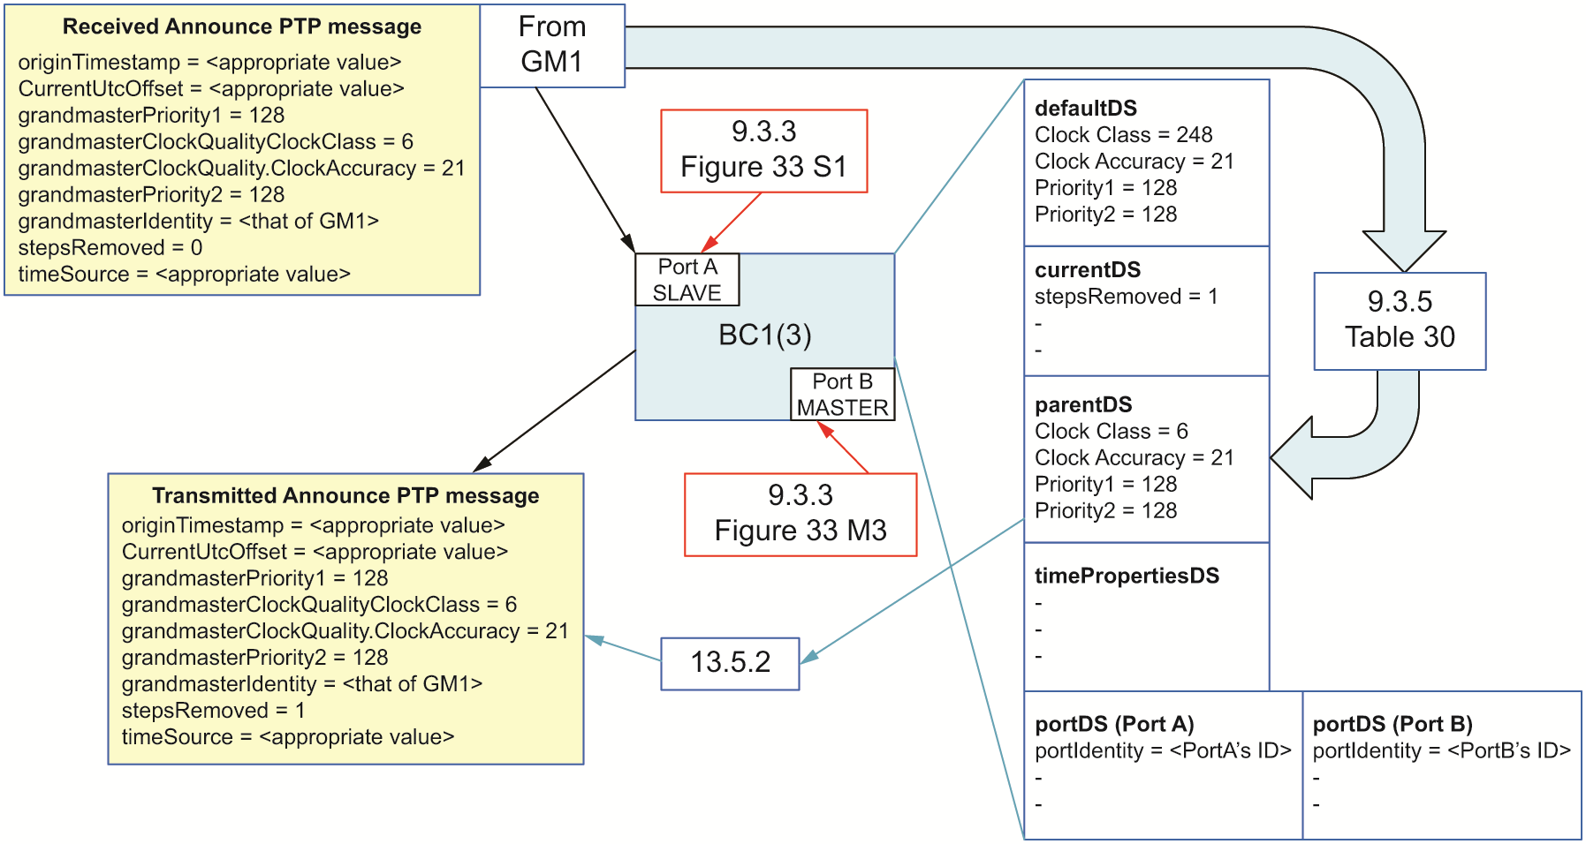
Figure P1.7—PTP Boundary clock (BC1 and BC3)
In Figure P1.8, BC2 receives Announce messages from BC1 and BC3 on PTP Port A and PTP Port B, respectively, with the depicted fields values. E_{rbest} on each port is given by the information contained in the Announce messages received on each port. From these E_{rbest} sets, the E_{rbest} information received on PTP Port A is selected as the E_{best}. As D₀ has a clockClass greater than 127, the ‘state decision algorithm’ in step 3-2 takes the path towards step 3-4. In step 3-4, E_{best} is compared with D₀ by the ‘data set comparison algorithm’. Since E_{best} represents a Grandmaster PTP Instance with the clockClass value (i.e., 6) lower than that of BC2 (i.e. 248), D₀ is neither "better" nor "better by topology" than E_{best}, therefore the algorithm takes step 3-5.
When the BMCA is executed for the PTP Port A, it is the port on which E_{best} information is received (this is because of the tiebreaker between portIdentities in step 2-5), therefore the ‘state decision algorithm’ recommends the SLAVE state for PTP Port A via step 3-5. The information from the Announce messages received on PTP Port A is copied to the parentDS per Table 33 (see 9.3.5).
When BMCA is executed for the PTP Port B, it is not the port on which E_{best} information is received and the algorithm continues to step 3-6. The ‘data set comparison algorithm’ compares the E_{best} (received on PTP Port A) with the E_{rbest} (received on PTP Port B) and considers “E_{best} better by topology than E_{rbest}” – label #Q or #X via step 2-5 (tiebreaker using PortIdentities) in Figure P1.2. As such, the ‘state decision algorithm’ recommends the PASSIVE state for PTP Port B.

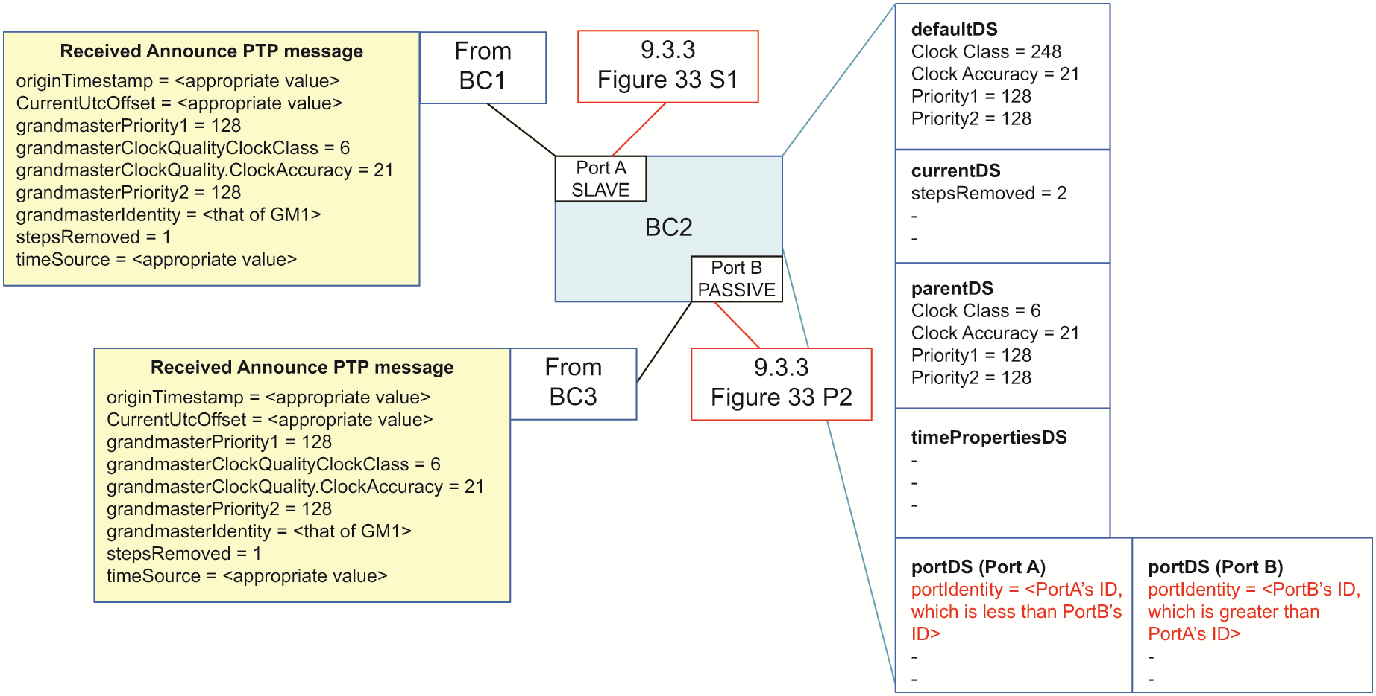
Figure P1.8—PTP Boundary clock (BC2)

Annex P2
(informative)
Theoretical example of an alternate BMCA incorporating the enhanced synchronization accuracy metrics TLV
P2.1 General
This annex outlines how a theoretical alternate BMCA could use information from the optional enhanced synchronization accuracy metrics TLV (38083.1) in its decision process.
P2.2 Generic introduction to using the ENHANCED_ACCURACY_METRICS TLV in alternate BMCA
A PTP Profile is allowed to define an alternate BMCA within the limits specified in 9.3.1. One difference between the default BMCA and an alternate BMCA could be the use of information gathered using the ENHANCED_ACCURACY_METRICS TLV (16.12). The default BMCA decides which PTP Port of a Boundary Clock to set to the SLAVE state when multiple ports receive Announce messages that reflect the same Grandmaster Clock. In the default BMCA, the relative timing errors introduced in the different PTP Network paths are quantified by the value contained in the stepsRemoved field of the Announce message. This field is an incomplete representation of the relative time error in different PTP Network paths in two ways:
- It ignores Transparent Clocks
- It treats all Boundary Clocks as equivalent with respect to error contributions

The former problem is shown in Figure P2.1, and the latter problem is shown in Figure P2.2.
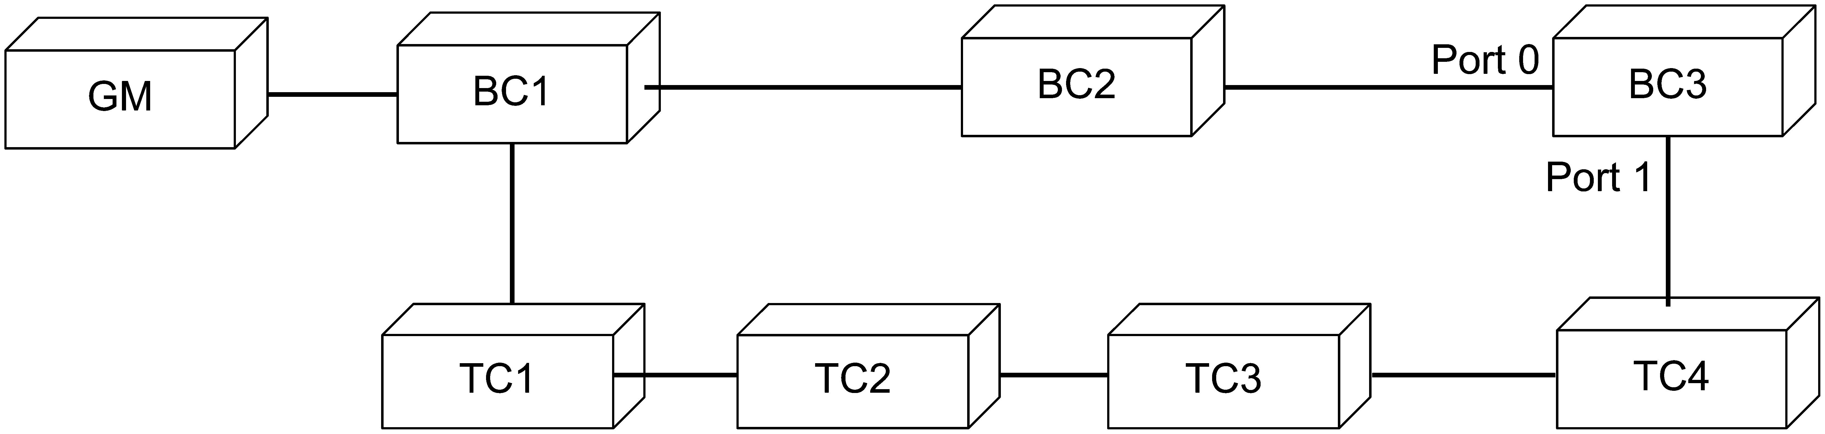

Figure P2.1—Behavior of the default BMCA in a network with a chain of TCs
In the network illustrated in Figure P2.1, using the default BMCA BC3 sets the state of PTP Port 1 to SLAVE, even though that port has a path to the Grandmaster PTP Instance through a larger number of network elements (e.g., Ethernet switches) acting as Transparent Clocks.
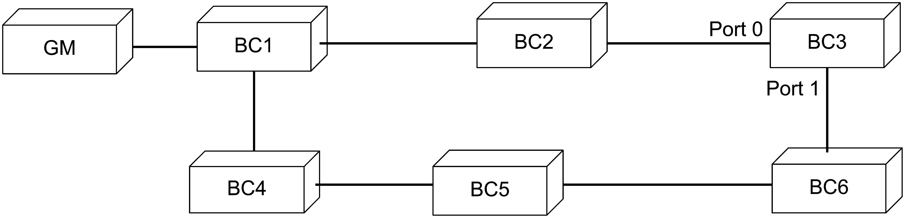

Figure P2.2—Behavior of the default BMCA in a network with chains of BCs providing different synchronization performance.
In the network illustrated in Figure P2.2, BC4, BC5 and BC6 provide better performance compared to BC2, because they introduce less error than BC2. Using the default BMCA, BC3 sets the state of port 0 to SLAVE, even though that port has a path to the Grandmaster PTP Instance that has a larger accumulated timing error.
Both of these deficiencies can be mitigated using the ENHANCED_ACCURACY_METRICS TLV, which is updated during propagation by both Transparent Clocks and Boundary Clocks that support this TLV and includes several cumulative time error metrics. With reference to the examples in Figures P2.1 and P2.2, an alternate BMCA that uses the ENHANCED_ACCURACY_METRICS TLV can specify rules for selecting which PTP Port in BC3 is set to the SLAVE state when two or more PTP Ports receive Announce messages with information from the same Grandmaster PTP Instance. Here are some examples of possible new rules for recommending the SLAVE state on a PTP Port. These rules could take the place of the default approach that only compares stepsRemoved:
- Compare stepsRemoved + tcHopCount, or
- Compare maxStaticInstanceInaccuracy, or
- Involk some comparison function of the metrics in the two
ENHANCED_ACCURACY_METRICS TLV.
An applicable PTP Profile will need to specify that the ENHANCED_ACCURACY_METRICS TLV is used and that all the fields used by the alternate BMCA are included. Improvements in path selection will be more reliable if Boundary Clocks and Transparent Clocks are required to support the TLV. An alternate BMCA might compare bcHopCount with stepsRemoved to detect the presence of Boundary Clocks that do not process the TLV. If they are not equal, then the alternate BMCA specifications could specify a different rule for comparing the attributes received on different PTP Ports.
Which metrics transported in the ENHANCED_ACCURACY_METRICS TLV to use in an alternate BMCA will depend on what is important to the application that the PTP Profile is intended to support. The metrics are described in 16.12.1. Alternate BMCAs that support applications that are most concerned with timing variation could make use of variance metrics, such as varStaticInstanceInaccuracy. Metrics that start with “var” are variances, so if the deviation is needed for an alternate BMCA, then depending on the implementation the square root of the metric would need to be calculated. Alternate BMCAs that support applications that are most concerned with the worst-case timing performance will want to make use of metrics related to maxima, such as maxStaticInstanceInaccuracy. If the behavior during transients is important, then maxTransientInaccuracy or varTransientInaccuracy could be useful. If steady state performance is more important, then the fields with transient inaccuracy metrics could be ignored. The metrics related to dynamic inaccuracy might be important for a PTP Profile where Boundary Clocks do not include a lowpass filter as part of the clock steering algorithm, but might be less important for a profile where the low pass filters are present. However, even in the case where a lowpass filter is implemented in the Boundary Clocks, the dynamic inaccuracy metrics might still be relevant if its filtered inaccuracy metrics (with a low pass filtered of similar bandwidth of the Boundary Clock filter) is carried by the TLV. Whenever the alternate BMCA rules make use of metrics that summarize dynamic behavior, there could be a greater possibility of an excessive number of PTP Network spanning tree rearrangements. This tendency might be mitigated by including some hysteresis in comparisons of attributes received on PTP Ports. The inclusion of hysteresis would require saving the most recent value(s) of the respective metrics being compared.
In addition to being used by a Boundary Clock to select the best PTP Network path from the Grandmaster PTP Instance, the ENHANCED_ACCURACY_METRICS TLV could be also used by a Grandmaster PTP Instance to set its port state to MASTER or PASSIVE. Similarly, it could be used to compare the attributes received from different PTP Instances acting as Grandmaster PTP Instances, on different ports of Boundary Clocks. Using the information received in the ENHANCED_ACCURACY_METRICS TLV in this way might result in a network breaking up into timing islands with multiple Grandmaster PTP Instances. Depending on the application, such a behavior might be acceptable or desirable. Guidelines for creating stable timing spanning trees in this scenario are out of the scope of this standard.
In addition, when comparing the GM accuracy values of candidate Grandmasters in the data set comparison algorithm, the information carried in the maxGmInaccuracy field, could be used for a more precise comparison instead of using the grandmasterClockQuality.clockAccuracy value carried in the Announce messages.
P2.3 Theoretical example of an alternate BMCA that incorporates the enhanced synchronization accuracy metrics TLV
P2.3.1 Introduction
The ENHANCED_ACCURACY_METRICS TLV carries information about the Grandmaster Clock’s characteristics as well as the characteristics of the path from the Grandmaster PTP Instance. As described in P2.2, this can be of interest for use in an alternate BMCA when determining the PTP Port state and choosing the Grandmaster PTP Instance. In this example, it is assumed that all PTP Instances in the PTP domain support and have enabled the ENHANCED_ACCURACY_METRICS TLV and the alternate BMCA. Other cases, which allow a mix of PTP Instances supporting and not supporting the TLV, are not covered in this Annex.
P2.3.2 Alternate BMCA Details
The purpose of the alternate BMCA described in this annex is to use information from the network path to impact the choice of synchronization spanning tree and selection of GM by taking advantage of information in the optional ENHANCED_ACCURACY_METRICS TLV. No changes are needed for the state decision algorithm (Figure P2.5) compared to the default BMCA. However, the data set comparison algorithm from 9.3.4 (see Figure 34 and Figure 35) is changed (see Figure P2.3 and Figure P2.4) so the alternate BMCA could change the synchronization hierarchy and the selected GM. For the data set comparison algorithm illustrated in Figure P2.3 and Figure P2.4 (comparing information from different and the same Grandmaster PTP Instances, respectively) additions to include information from the enhanced accuracy TLV are marked P and Q:
- In Figure P2.3, with the decision block indicated by P, the comparison of the GM clock accuracy (received in the PTP Announce message) is replaced by the comparison of the maxGmInaccuracy received in the enhanced accuracy TLV.
- In Figure P2.4, with the addition of the block indicated by Q, the inaccuracy values received in ENHANCED_ACCURACY_METRICS TLVs from the same Grandmaster PTP Instance, are compared before the comparison of stepsRemoved. The comparison function of the metrics can be based on only one metric (e.g., maxStaticInstanceInaccuracy) or more than one metric carried by the ENHANCED_ACCURACY_METRICS TLV (see 16.12.2). However, not all of them are necessarily needed or useful. As an example, the maxTransientInaccuracy might fluctuate and cause rapid change of Grandmaster (or Grandmaster path) and, as such, would not be useful.

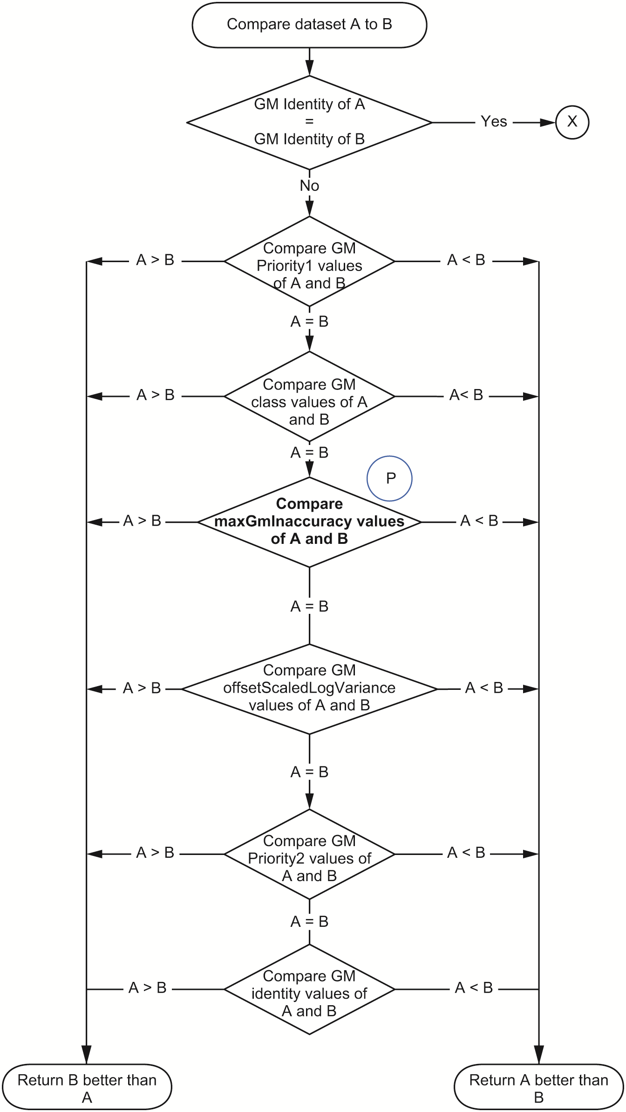
Figure P2.3—Alternate data set comparison algorithm, part 1, modified to consider the optional enhanced accuracy TLV

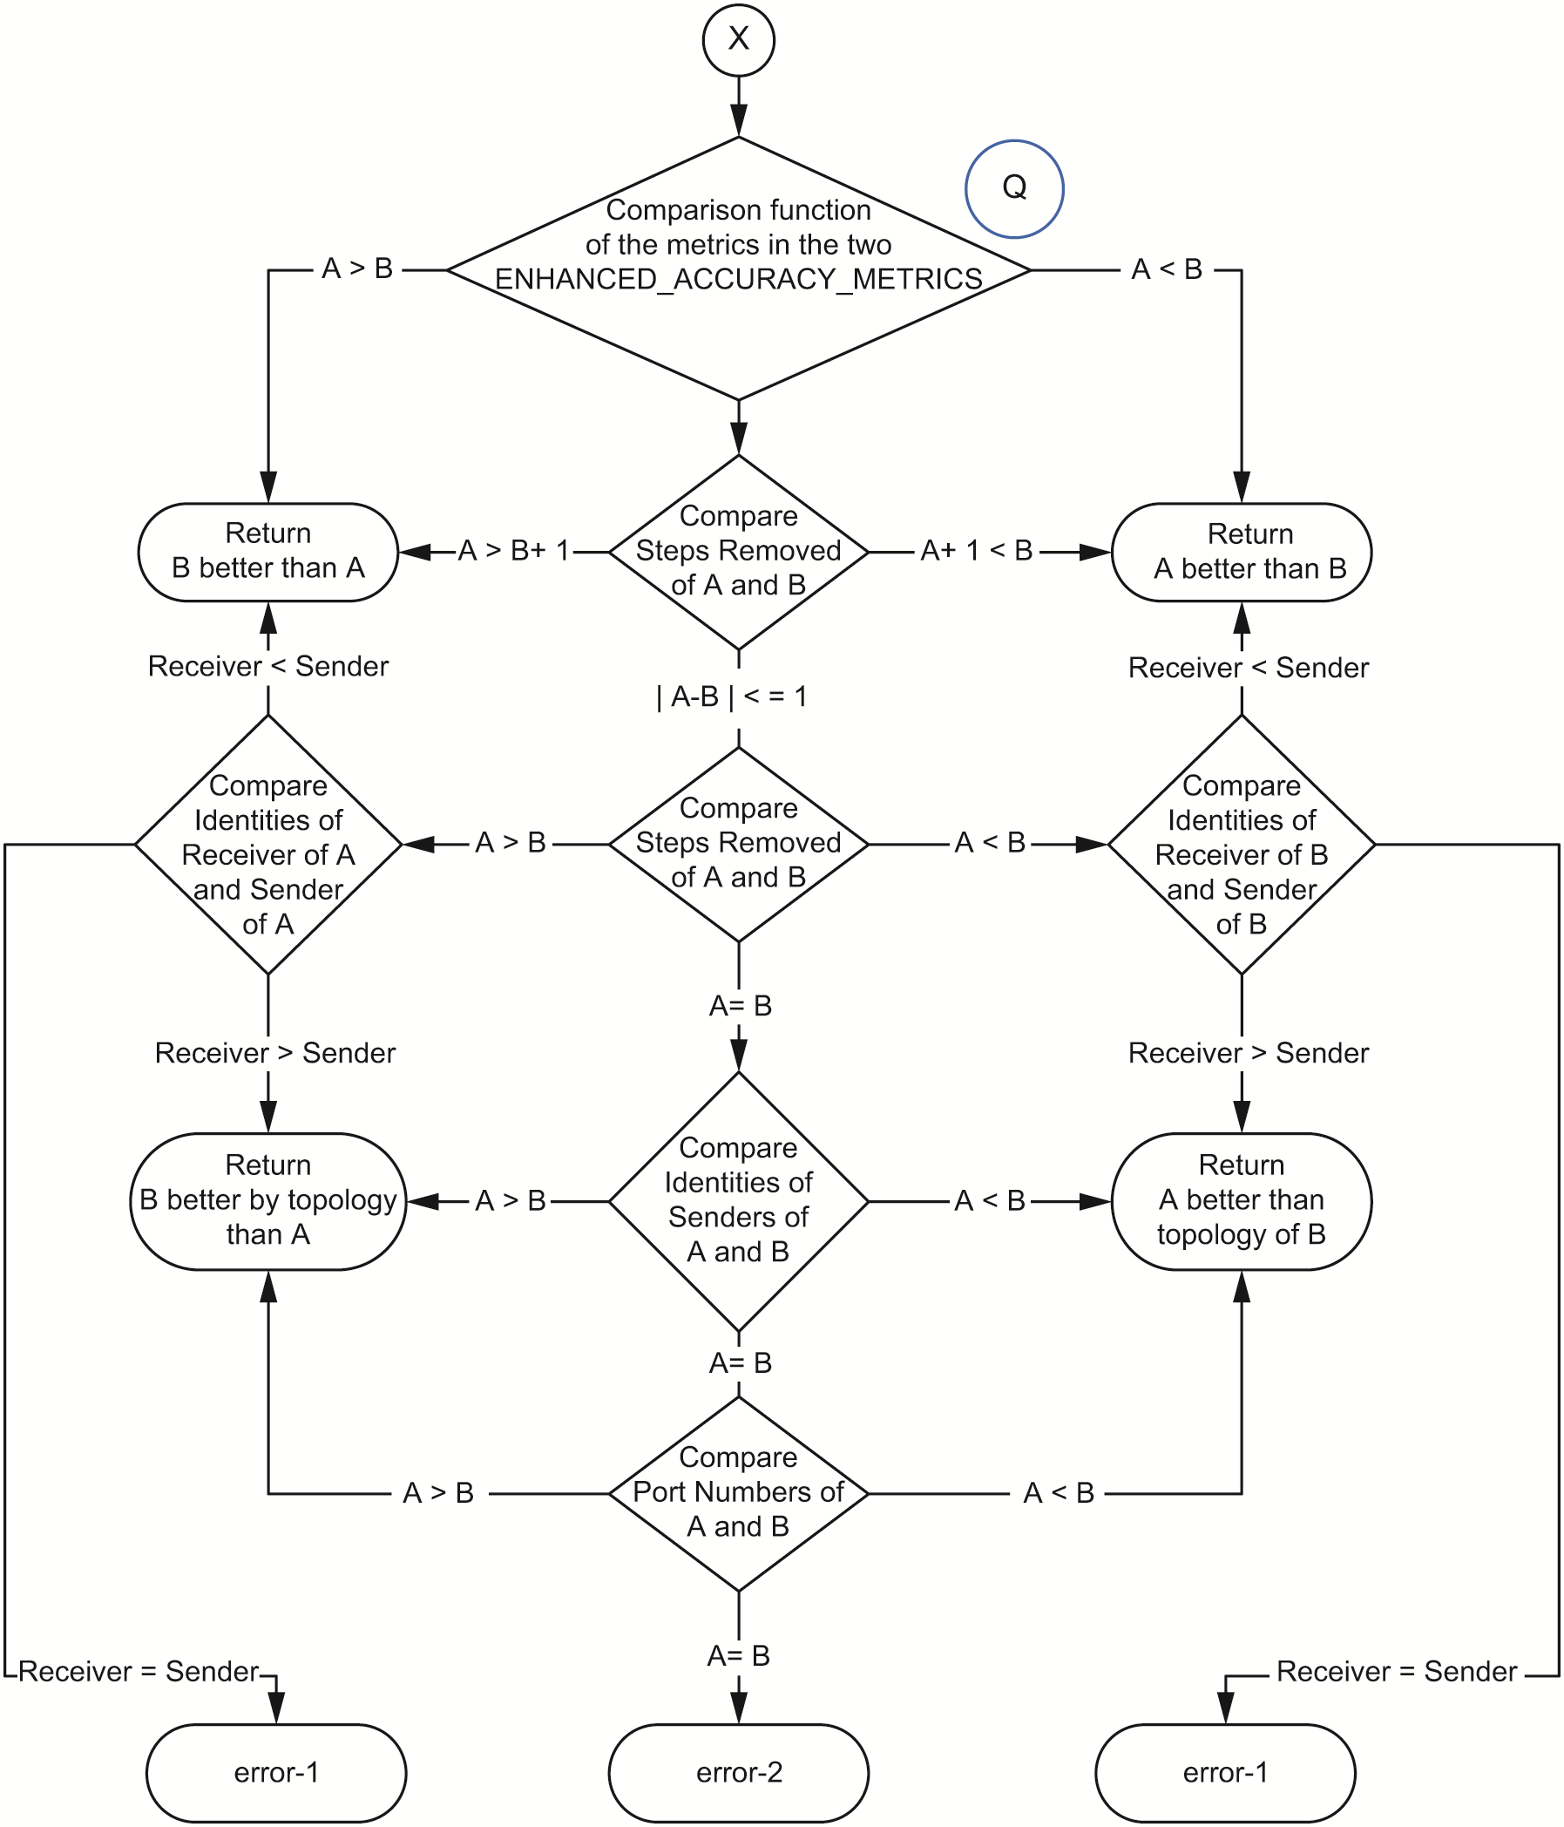
Figure P2.4—Alternate data set comparison algorithm, part 2, modified to consider the optional enhanced accuracy TLV

Figure P2.5—Alternate state decision algorithm (no change compared to standard BMCA)

(informative)
Bibliography
Bibliographical references are resources that provide additional or helpful material but do not need to be understood or used to implement this standard. Reference to these resources is made for informational use only.
Insert the following items into Annex P alpha-numeric order and renumber the other entries accordingly.
- Eidson, John, Measurement, Control, and Communication Using IEEE 1588. London Springer-Verlag, 2006.
- IEEE Std 802.1Q™-2018, IEEE Standard for Local and Metropolitan Area Networks–Bridges and Bridged Networks.
- ITU-T G.8260 (2020), Definitions and terminology for synchronization in packet networks.

•The Institute of Electrical and Electronics Engineers, Inc. 3 Park Avenue, New York, NY 10016-5997, USA Copyright © 2023 by The Institute of Electrical and Electronics Engineers, Inc. All rights reserved. Published 6 December 2023. Printed in the United States of America. IEEE is a registered trademark in the U.S. Patent & Trademark Office, owned by The Institute of Electrical and Electronics Engineers, Incorporated. PDF: ISBN 979-8-8557-0288-0 STD26598 Print: ISBN 979-8-8557-0289-7 STDPD26598 IEEE prohibits discrimination, harassment and bullying. For more information, visit https://www.ieee.org/about/corporate/governance/p9-26.html. No part of this publication may be reproduced in any form, in an electronic retrieval system or otherwise, without the prior written permission of the publisher.
Available at: https://development.standards.ieee.org/myproject-web/public/view.html#landing.
Available at: https://standards.ieee.org/content/ieee-standards/en/about/contact/index.html.
Available at: https://ieeexplore.ieee.org/browse/standards/collection/ieee.
Available at: https://standards.ieee.org/standard/index.html.
Available at: https://standards.ieee.org/about/sasb/patcom/materials.html.
Notes in text, tables, and figures of a standard are given for information only and do not contain requirements needed to implement this standard.

