Jinnah University for Women
Department of Computer Science and Software Engineering
CSS 3202 - Human Computer Interaction
Project Submission Document

BS (SE) 2024

Project Title | Acadify — AI-Powered Academic Management & Student Risk Monitoring Platform
Student Name(s) | Saman Shahab  Hamna Nazeer  Ifra Imran
Enrolment Number(s) | 2024/COMP/BS(SE)/31812  2024/COMP/BS(SE)/31771  2024/COMP/BS(SE)/31778
Prototype Approved On | April 20, 2026 ☐ Yes ☐ No

Table of Contents
- Executive Summary
- User Research
- User Personas
- High-Fidelity Interactive Prototype
- Accessibility Considerations
- Usability Testing
- Design Iterations
- Information Architecture / Sitemap
Appendices Raw Data, Consent Forms, Additional Screenshots

1. Executive Summary
→ Provide a concise overview (200–300 words) of your project: the problem, your solution, target users, and the key outcome.
Schools often manage attendance, marks, timetables, and student progress through separate systems, making academic management difficult. Acadify is an AI-powered platform designed to simplify these tasks for school students, teachers, parents, and administrators.
Acadify provides four portals: Student, Teacher, Parent, and Admin. Students can check attendance, marks, assignments, exams, and timetables. Teachers manage attendance and academic records, parents monitor their children's progress, and administrators manage users and reports.
The platform includes face-recognition attendance and machine-learning models that predict students' academic risk levels and expected GPA. These features help identify students who may need additional academic support.
Developed using React, Flask, and MongoDB, Acadify aims to reduce manual work, improve communication, and help teachers and parents support students' learning and academic progress more effectively.
2. User Research
Document evidence of interviews, surveys, or observations.
2.1 Research Method(s) Used
→ Tick all that apply and describe briefly how you conducted each.
☐ | Method | Description
☒ | User Interviews | Semi-structured interviews were planned with students and teachers to understand their problems with attendance, marks, timetables, deadlines, and academic support. Responses can be recorded as notes and reviewed to identify common problems.
☒ | Surveys / Questionnaires | A questionnaire was planned to collect feedback about existing academic management systems and the features users need in Acadify. Responses can help identify user preferences and difficulties.
☒ | Observations / Contextual Inquiry | The study focuses on observing how attendance is recorded manually and how marks, timetables, assignments, and notices are shared through different channels. The aim is to identify delays, repeated work, and difficulties in accessing information.
2.2 Number of Participants
→ How many users did you involve? Describe their demographics briefly (age, background, tech familiarity).
Approximately 10–15 participants, including students, teachers, parents, and academic administrators, were considered for the research. The study focused on their technical familiarity and challenges in managing attendance, marks, timetables, assignments, and academic performance.
2.3 Key Findings
→ Summarize the top 3–5 insights from your research. What did users need? What frustrated them?
- Manual Attendance: Manual roll-call consumes lecture time and may allow proxy attendance. Acadify provides a face-recognition attendance feature to make attendance recording easier.

- Late Academic Warnings: Students may discover attendance shortages or poor academic performance too late. Acadify provides dashboards and AI-based risk predictions to support early intervention.

- Scattered Information: Timetables, marks, assignments, and deadlines may be shared through different platforms. Acadify brings these academic features together in one portal.

- Limited Parental and Administrative Visibility: Parents and administrators need easier access to academic progress and reports. Acadify provides dedicated portals for monitoring and reporting.

- Difficulty Seeking Support: Students may hesitate to approach a counselor in person. Acadify includes an online counseling request feature to make support more accessible.
2.4 Evidence
Supporting research evidence should be included in the appendices of the Acadify project report.
Appendix A: Interview transcripts, survey questions, survey responses, and observation notes.
This material provide supporting evidence for the identified user needs and design decisions. Only research documents that were actually collected should be attached and referenced in the final report.

3. User Personas & Empathy Map
Create at least 3 detailed personas of EACH type of user from your research findings.
DRAFT NOTE — personas and the empathy map below are written from Acadify’s four user roles. Replace names, numbers and quotes with real details from your interviews/surveys, then delete this note.
Persona 1 — Student (Primary user)
Name | Anusha Ali Khan
Demographics (Age, Occupation, Education, Location) | 13 years old · School student (Grade 8) · Karachi
Technical Proficiency (Novice / Intermediate / Expert) | Intermediate
Goals & Motivations | • Always stay above the minimum attendance requirement  • See marks, grades and deadlines in one place  • Get help early if grades start to slip
Frustrations & Pain Points | • Attendance and marks are shared late and in different places  • Cannot tell how one bad test affects the final result  • Feels shy about approaching a counselor in person
Behaviors & Preferences | • Phone/tablet-first; checks the portal before class  • Prefers quick summary cards over long tables  • Keeps her own notes of attendance and marks
Quote (a sentence capturing their attitude) | “I just want to open one page and know where I stand — before it’s too late to fix it.”

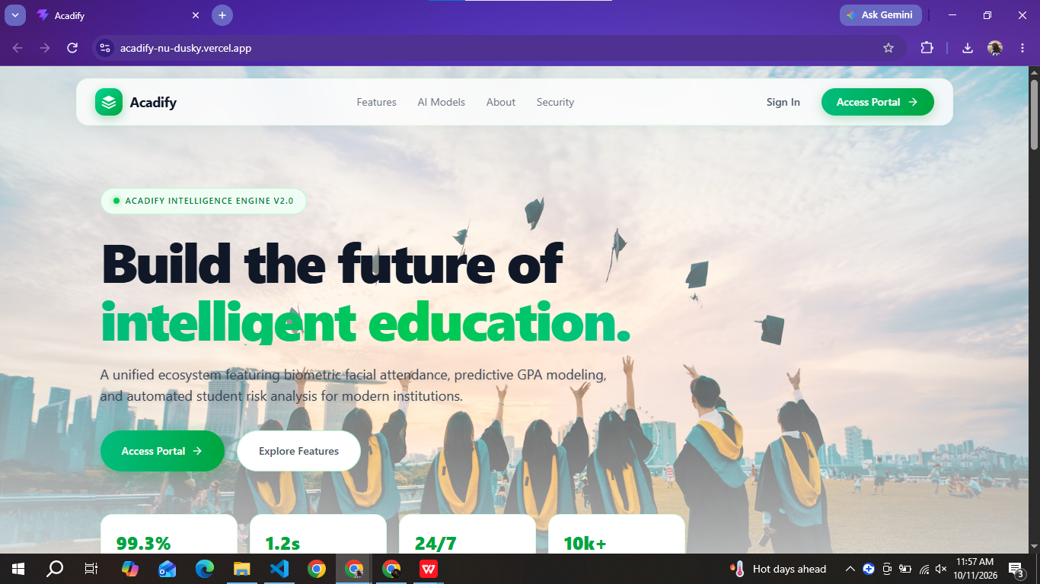
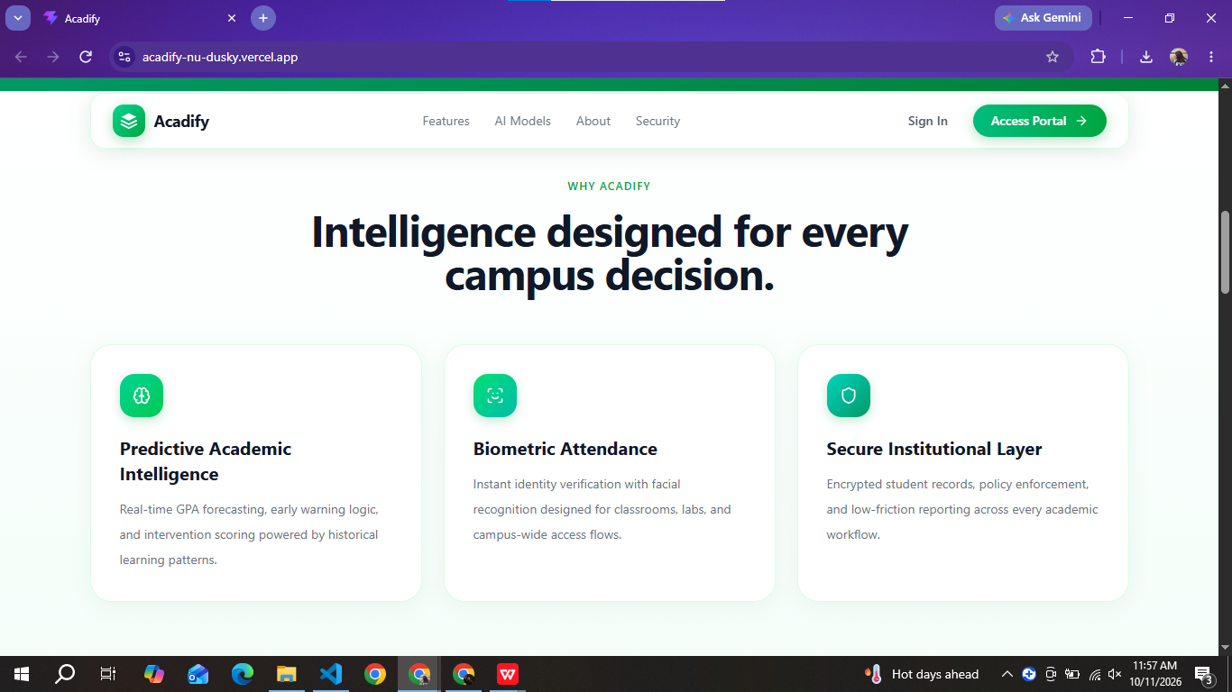
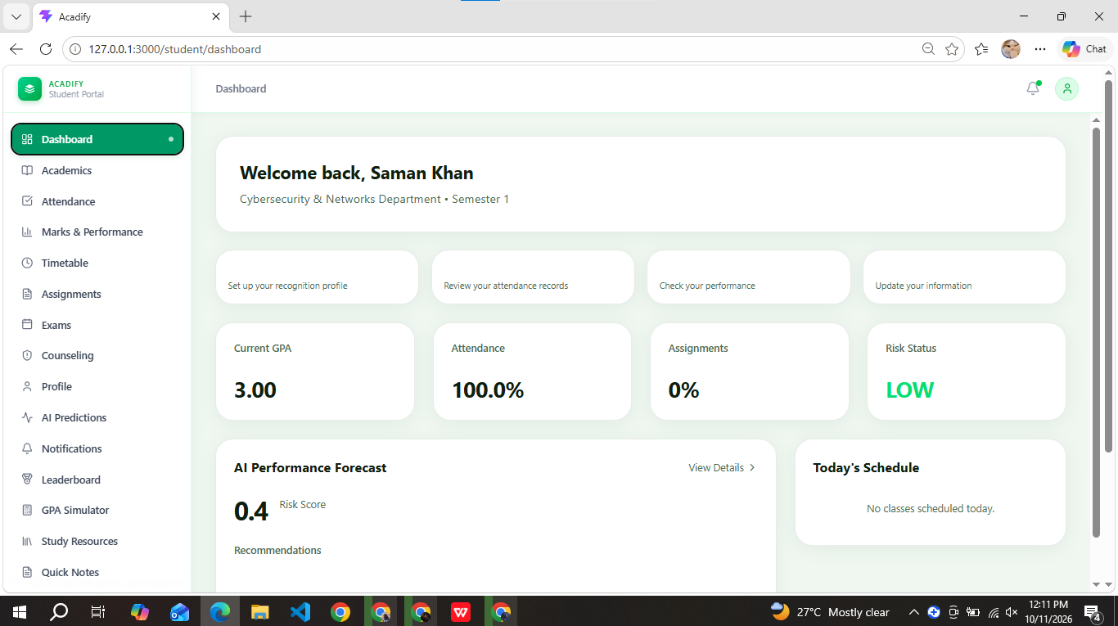
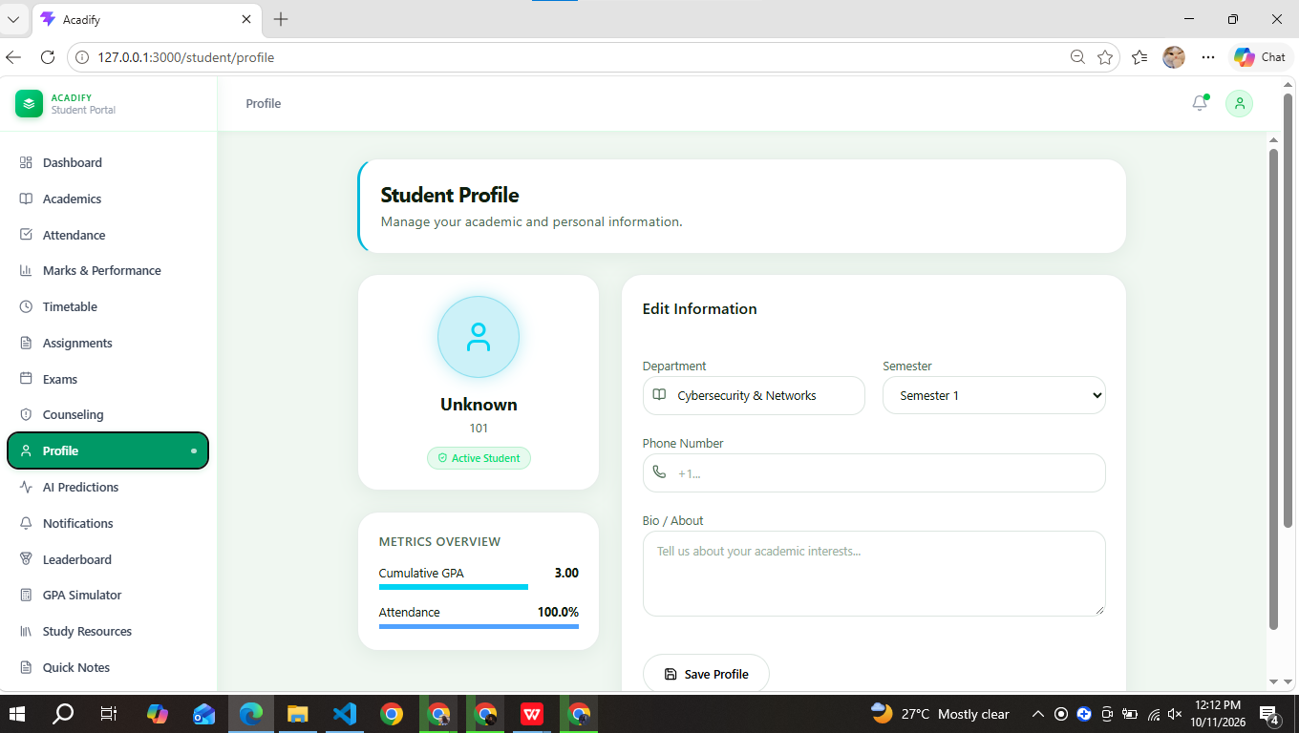
Persona 2 — Teacher
Name | Ms. Mohsina Qudrat
Demographics (Age, Occupation, Education, Location) | 39 years old · Teacher, Master’s degree · Karachi
Technical Proficiency (Novice / Intermediate / Expert) | Intermediate
Goals & Motivations | • Take attendance in under a minute  • Enter marks once and have them reach students and parents  • Spot struggling students early
Frustrations & Pain Points | • Roll-call eats 5–10 minutes of every lecture  • Proxy attendance is hard to catch  • Re-types the same data into spreadsheets
Behaviors & Preferences | • Works on a laptop in class and in the staff room  • Likes simple tables with few clicks  • Wants one clear list of at-risk students
Quote (a sentence capturing their attitude) | “Every minute spent on roll-call is a minute I am not teaching.”
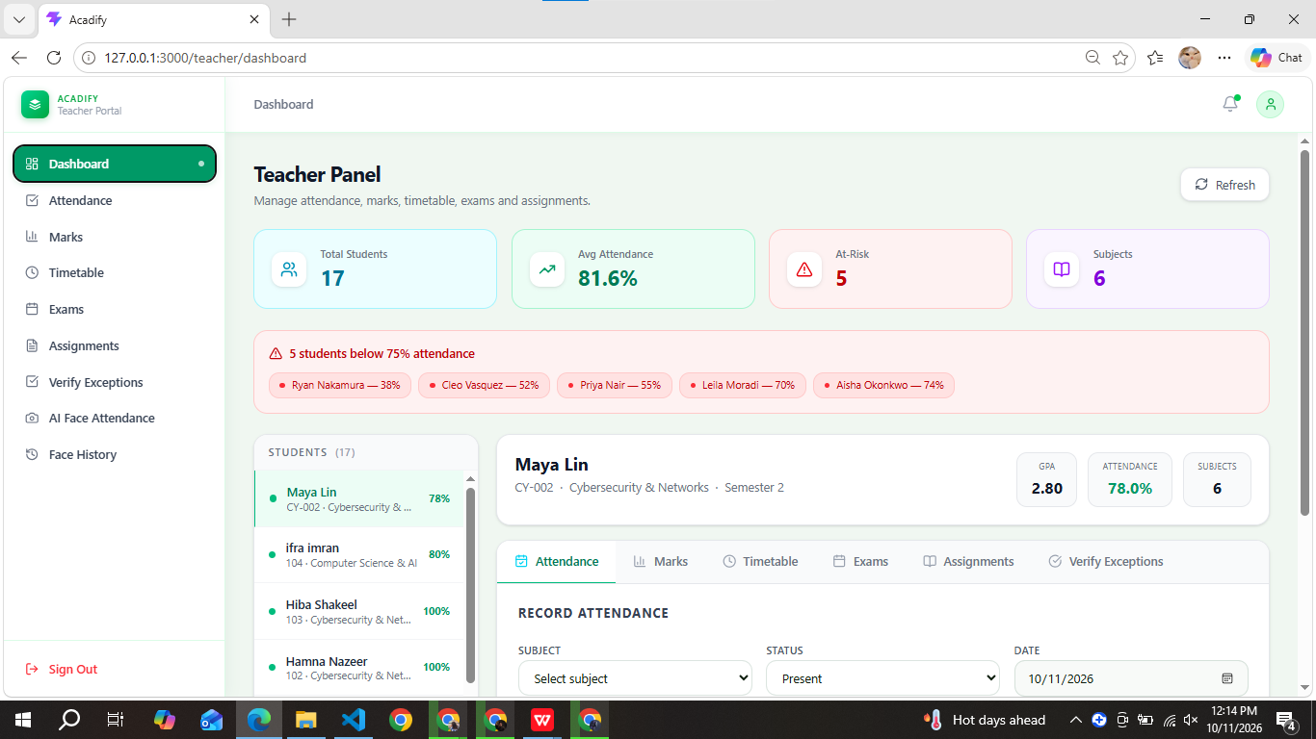
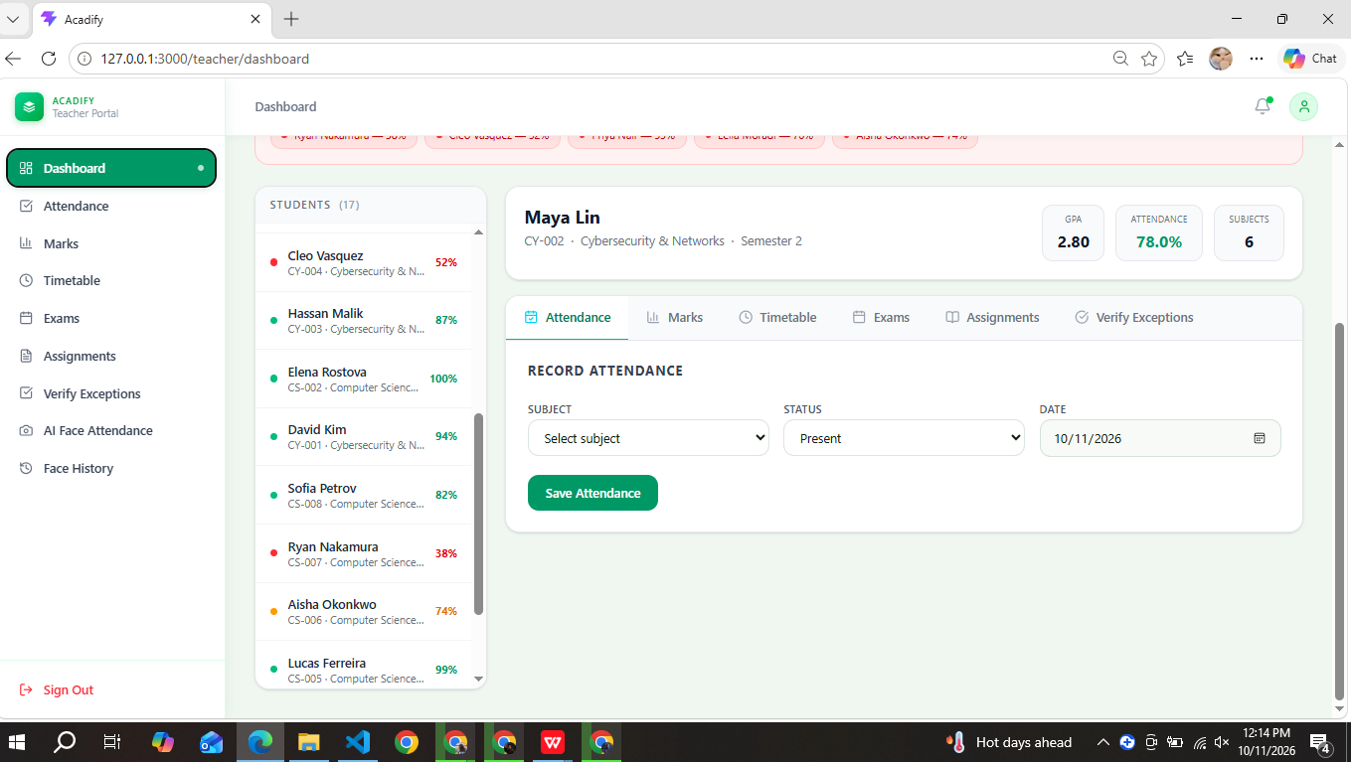
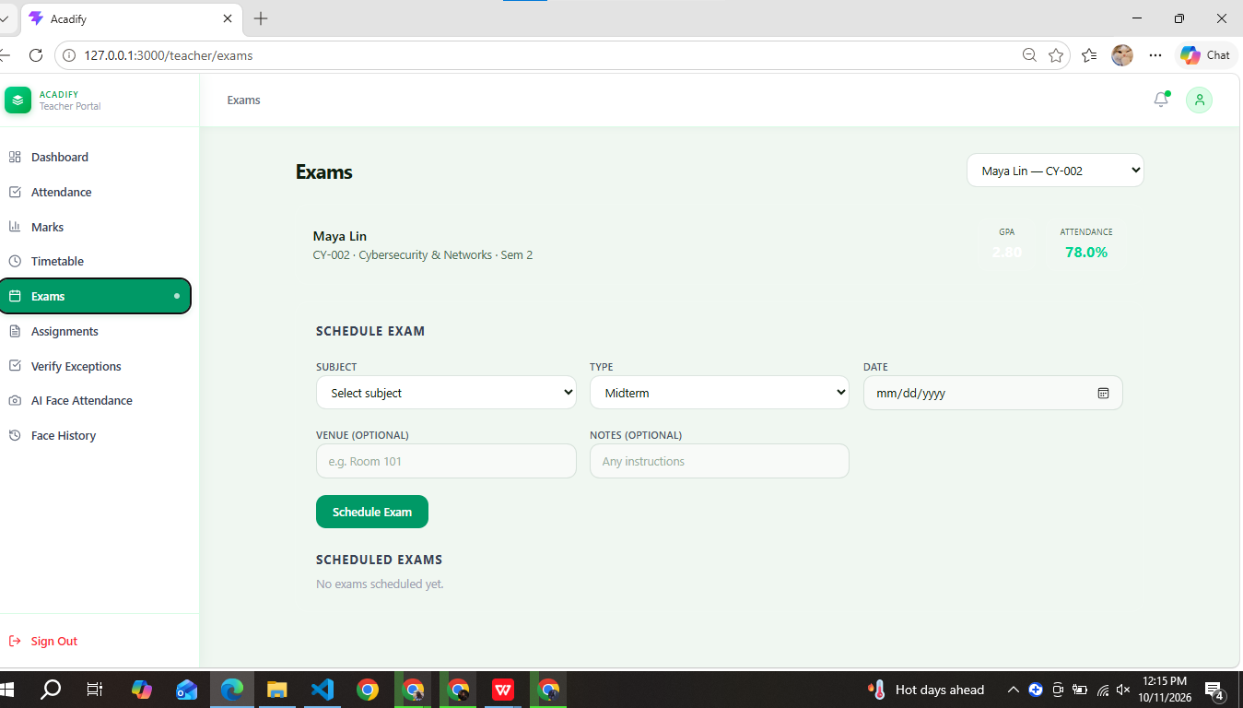
Persona 3 — Admin / Academic Coordinator
Name | Saman Khan
Demographics (Age, Occupation, Education, Location) | 22 years old · Academic Office Coordinator, Bachelor’s degree · Karachi
Technical Proficiency (Novice / Intermediate / Expert) | Intermediate
Goals & Motivations | • See department-wide attendance and performance trends  • Generate reports quickly for management  • Assign interventions and keep an audit trail
Frustrations & Pain Points | • Compiles reports by hand from many spreadsheets  • Learns about at-risk students only at term end  • No single record of who changed what
Behaviors & Preferences | • Desktop user with large tables and filters  • Exports data to PDF / Excel for meetings  • Prefers dashboards with clear risk colours
Quote (a sentence capturing their attitude) | “I need to see which students are slipping this week, not at the end of the term.”

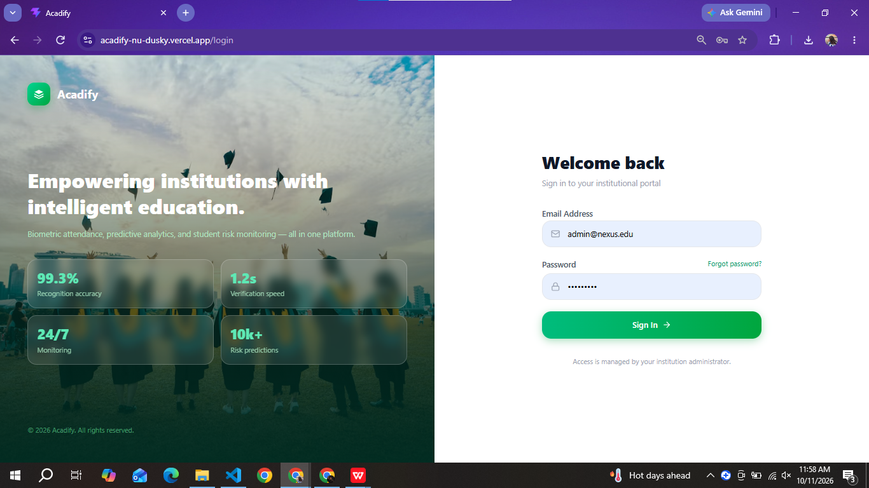

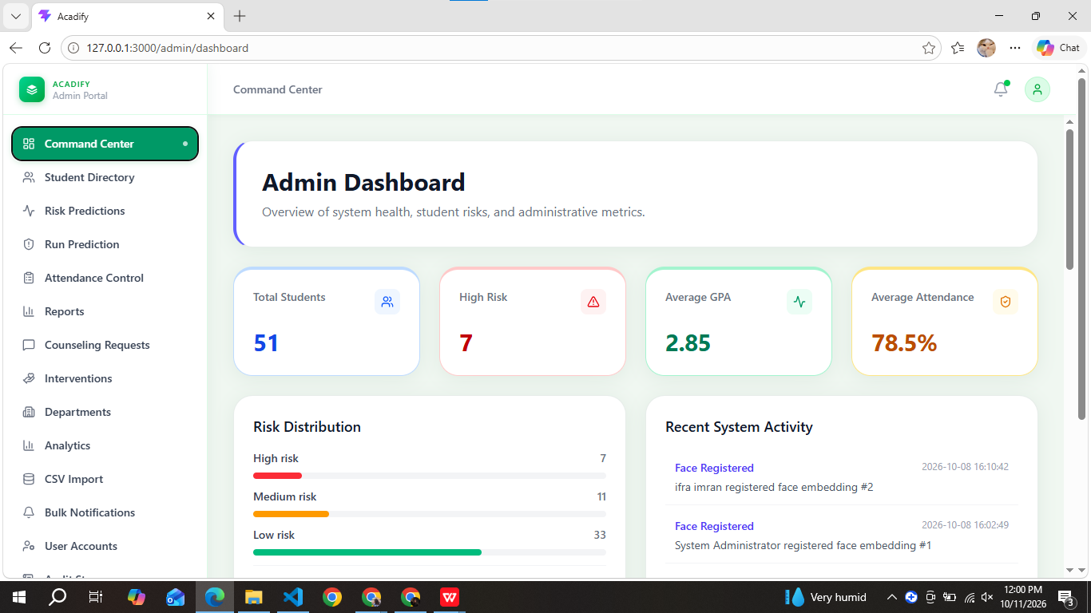
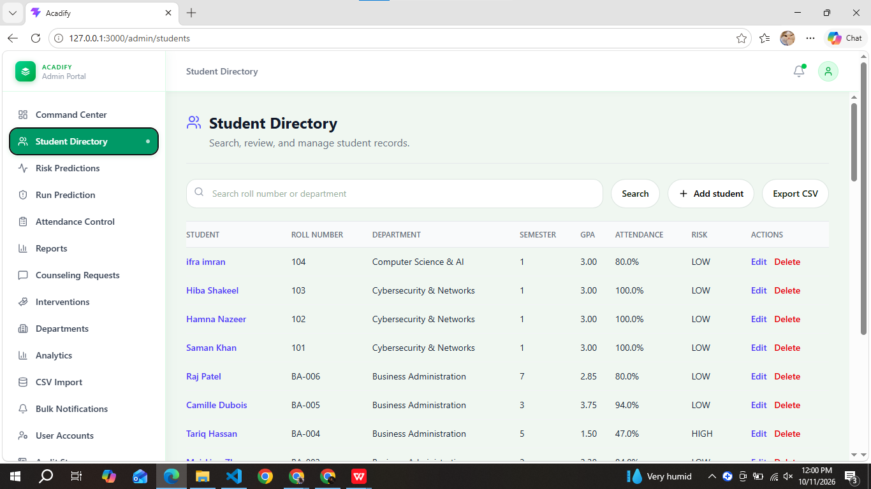
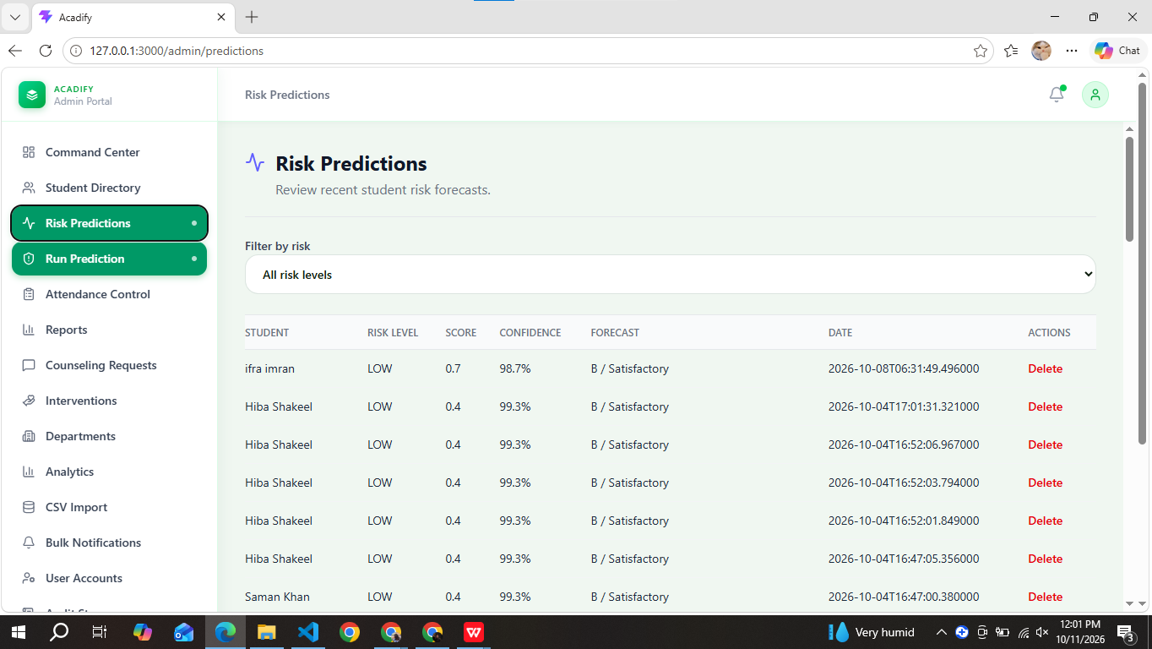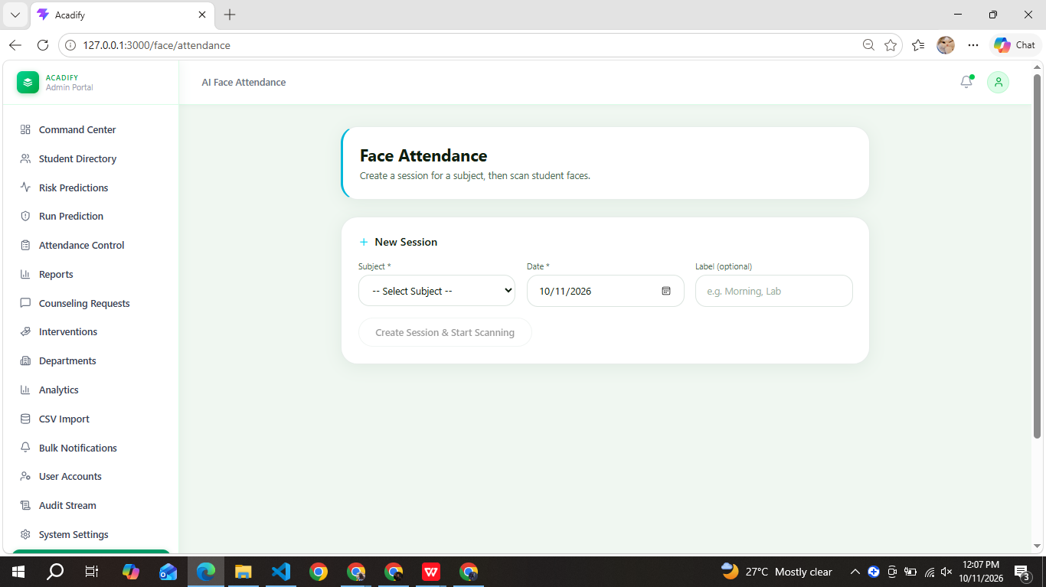
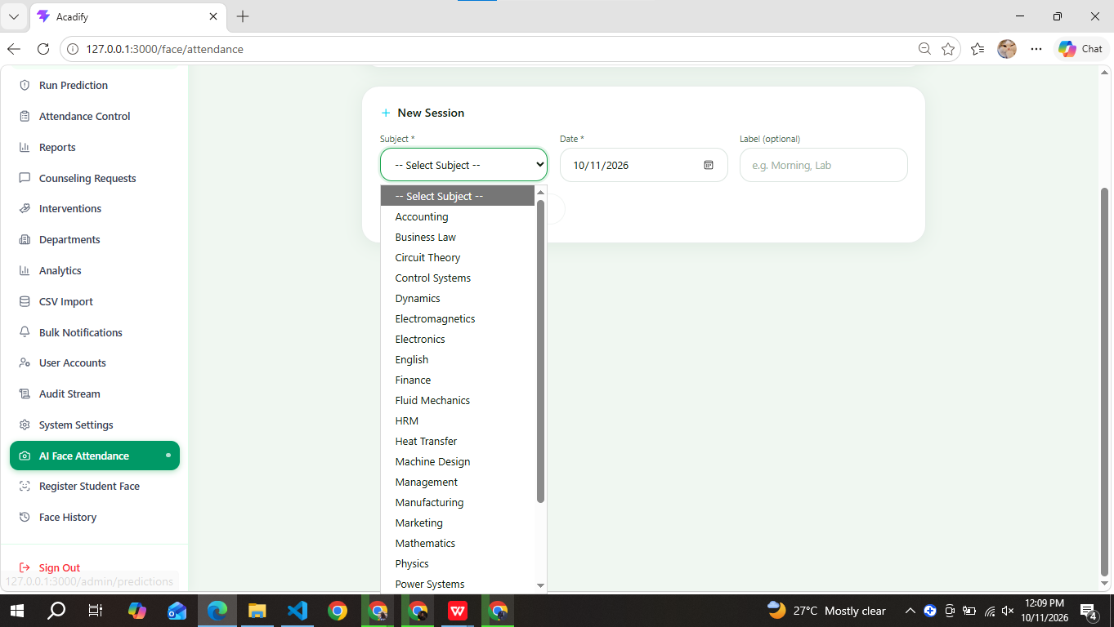
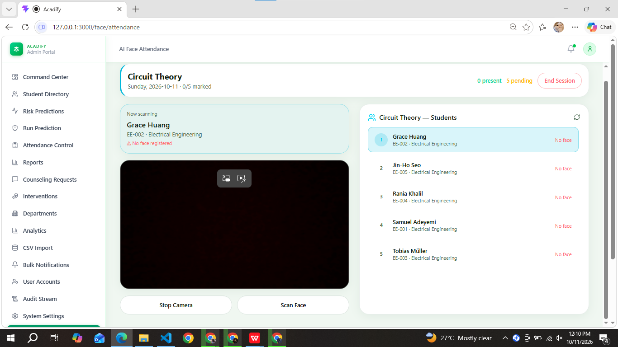
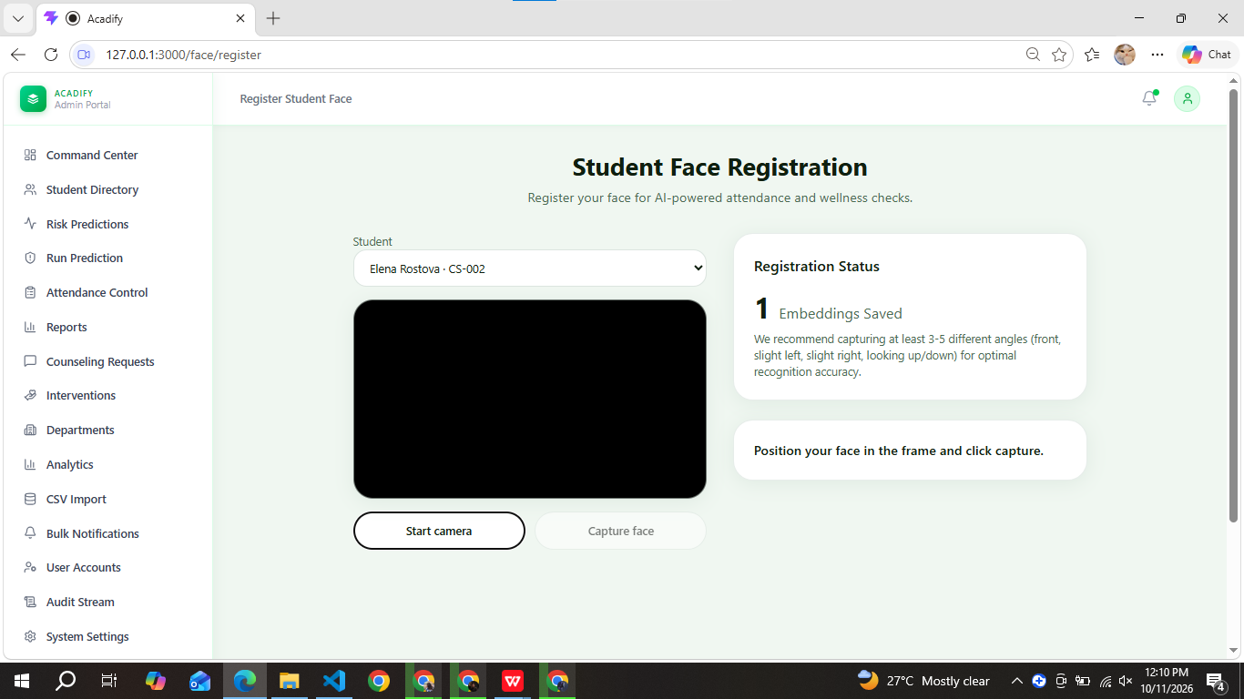
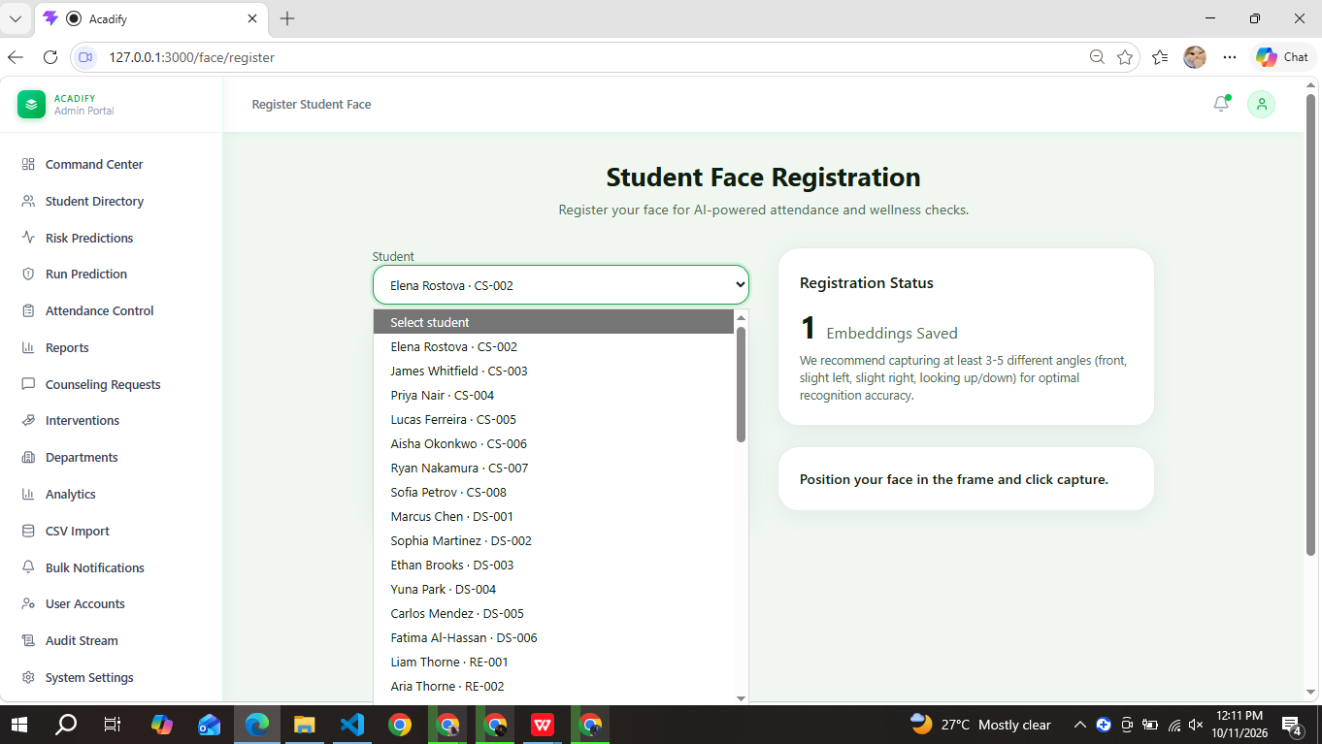
Persona 4 — Parent
Name | Mr. Ather Ali Khan
Demographics (Age, Occupation, Education, Location) | 47 years old · Parent of a Grade 8 student · Karachi
Technical Proficiency (Novice / Intermediate / Expert) | Novice
Goals & Motivations | • Know whether his daughter attends class and passes  • See upcoming deadlines and results  • Understand everything without technical help
Frustrations & Pain Points | • Hears about problems only at result time  • Dense dashboards and jargon confuse him  • Unsure whom to contact when there is a concern
Behaviors & Preferences | • Uses a smartphone, mostly WhatsApp and calls  • Wants a short summary and plain-language advice  • Checks in occasionally, not daily
Quote (a sentence capturing their attitude) | “I don’t need charts. I just need to know my daughter is doing okay in her studies.”

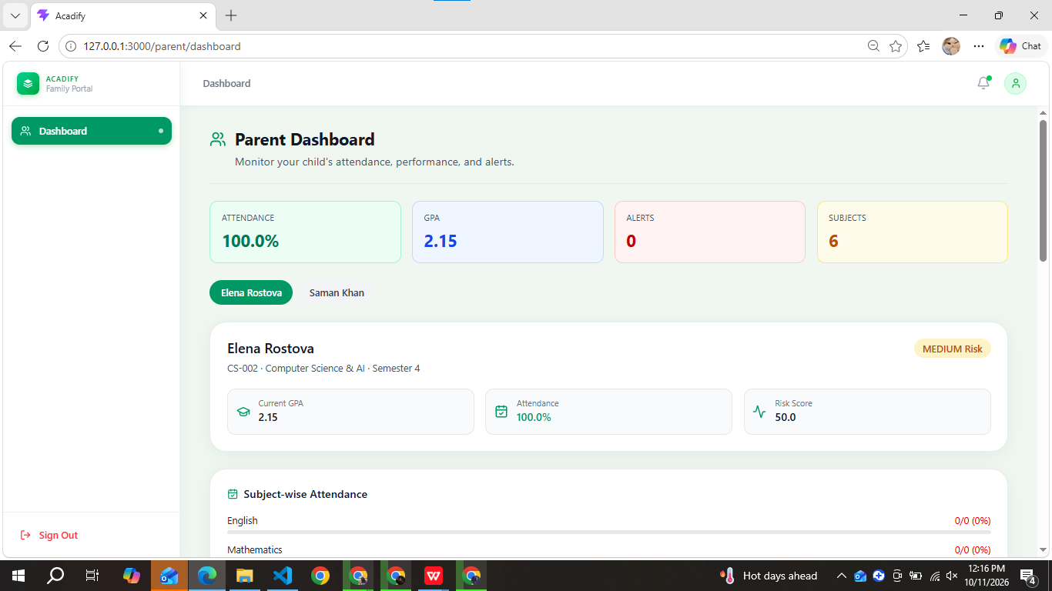

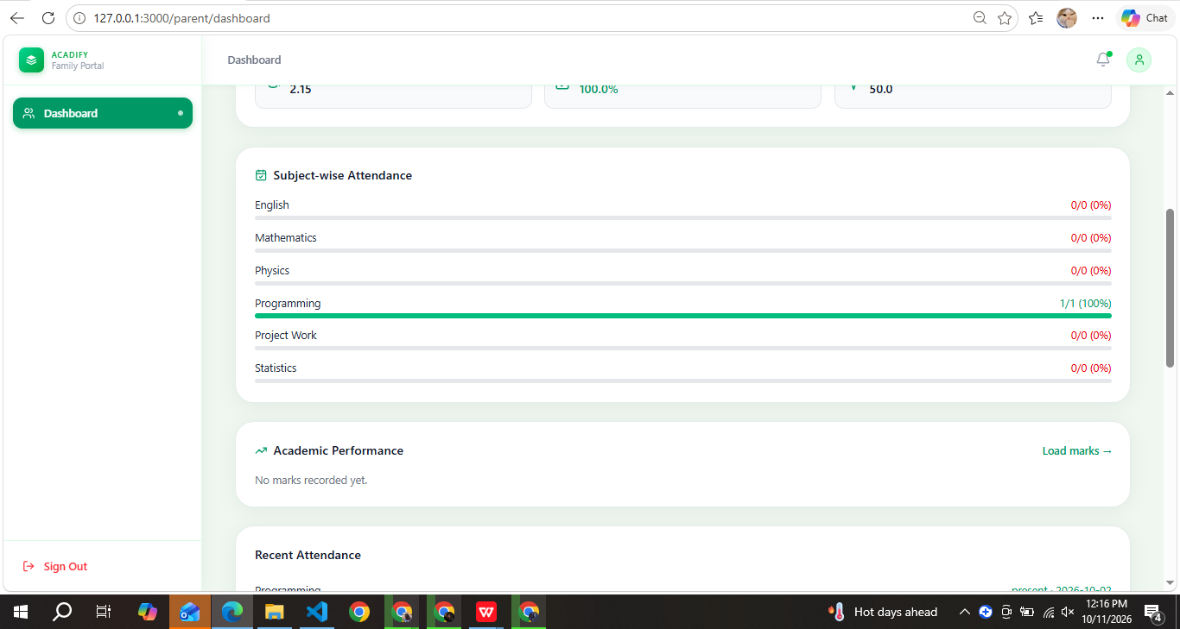
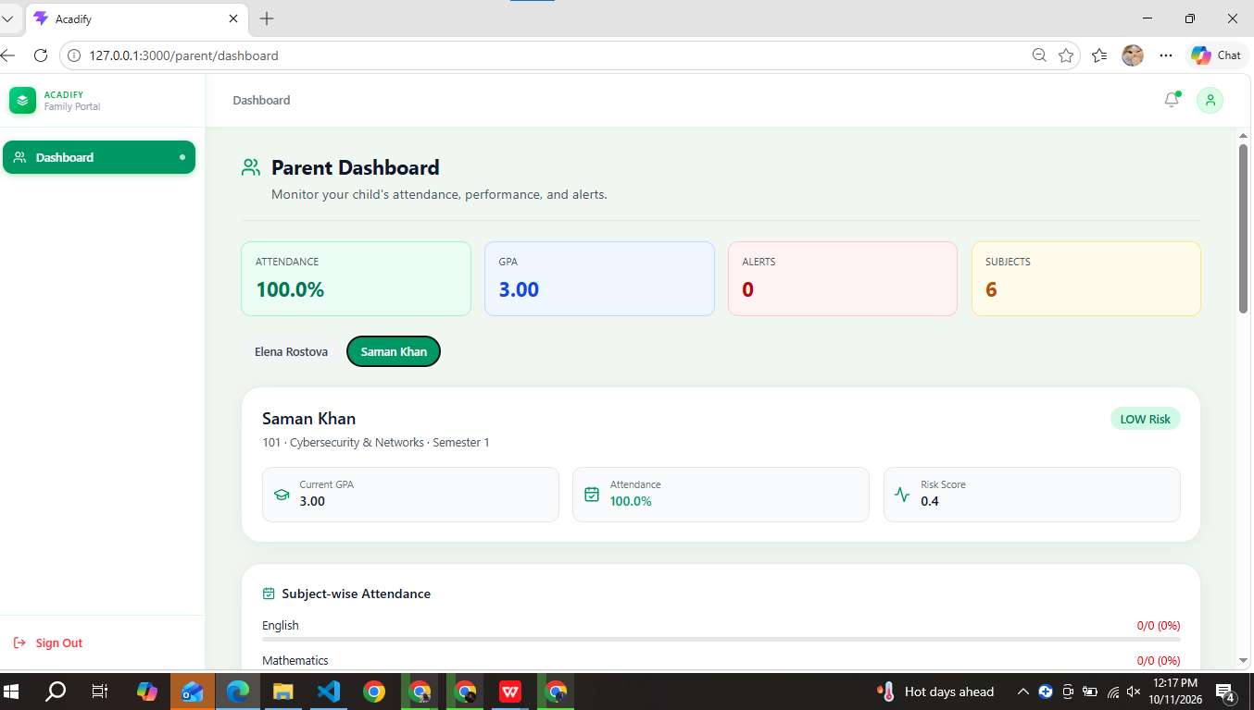
3.1 Empathy Map
REQUIRED — Create an empathy map for your primary user based on research data.
→ Fill in each quadrant based on your user research findings (interviews, observations, surveys).
SAYS  Direct quotes or paraphrases from user interviews  • “I never know my exact attendance until a teacher announces it.”  • “Deadlines are in so many different groups that I miss some.”  • “I would rather message a counselor online than walk into the office.” | THINKS  What the user is thinking but may not say out loud  • Will my grades be good enough?  • Was I really marked present today?  • If I ask for help, will people judge me?
DOES  Observable actions and behaviors with current solutions  • Checks notice boards, WhatsApp groups and teachers for updates  • Keeps her own tally of attendance and marks  • Works out her result by hand and asks friends about deadlines | FEELS  Emotional state — frustrations, anxieties, motivations, joys  • Anxious before exams and result time  • Frustrated by attendance errors and proxy marking  • Motivated when progress is visible; relieved by quick, clear information
GOALS & PAIN POINTS
What is the user trying to achieve? What barriers stand in their way?
• Goals: stay above the attendance limit, improve grades, never miss a deadline, get support early
• Pain points: scattered information, late warnings, manual result calculation, hesitation to seek counseling

→ Insert a screenshot of your empathy map if created in Miro, FigJam, or another tool.
[Insert a screenshot of your empathy map here if you made one in Miro / FigJam (optional)]

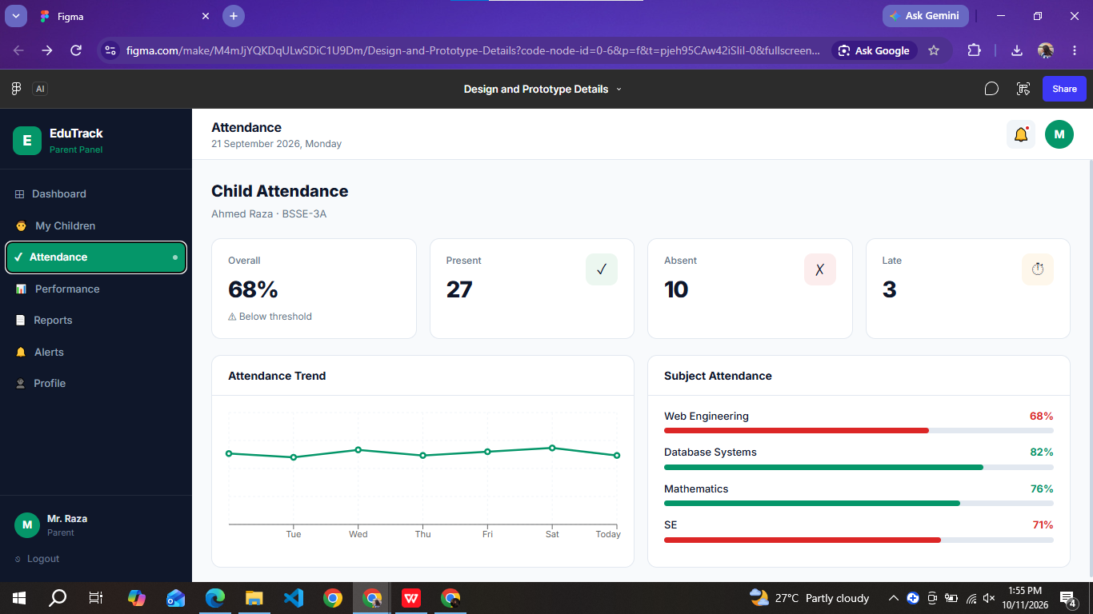
4. Three Design Alternatives
Explore at least 3 distinct design approaches before finalizing your prototype.
→ For each alternative, provide a brief description, a sketch/screenshot, and state the pros and cons.
Design Alternative 1
Design Concept | Single unified dashboard for every role. One common home page made of widgets (attendance, marks, deadlines, alerts, reports) with a top navigation bar; the role only decides which widgets appear.
Sketch / Screenshot | [Insert sketch / screenshot of this alternative]
Pros | • Fewer screens to design and maintain  • Same look for all roles, quick to learn  • Easy to show shared information side by side
Cons | • Widgets become cluttered; roles have very different tasks  • Long scrolling and small widgets on phones  • Harder to keep role permissions visually clear

Design Alternative 2
Design Concept | Role-based portals with a sidebar (selected). After login each user lands in a portal built for their role (Student, Teacher, Parent, Admin) with its own dashboard, a left sidebar of icon + label items, stat cards and quick-action cards on top, and detail pages opened from the sidebar. On mobile the sidebar collapses into a menu button.
Sketch / Screenshot | [Insert sketch / screenshot of this alternative]
Pros | • Navigation matches each role’s mental model and tasks  • Most features are only 1–2 clicks away  • Icon + label supports recognition over recall  • Easy to add or restrict features per role
Cons | • Sidebar becomes long for Student and Admin roles  • More pages to build and maintain  • Needs careful responsive behaviour on small screens

Design Alternative 3
Design Concept | Mobile-first card feed with a bottom tab bar. Smartphone-app style layout with five tabs (Home, Attendance, Marks, Alerts, Profile); the home tab is a vertical feed of cards such as “Today’s classes”, “Due soon” and “Risk alert”.
Sketch / Screenshot | [Insert sketch / screenshot of this alternative]
Pros | • Thumb-friendly and fast to scan  • Suits students who mostly use phones  • Simple, minimal interface
Cons | • Little space for teacher/admin tables and reports  • Only about five tabs, so many features end up deeply nested  • Poor fit for desktop use in labs and offices

4.1 Final Selection Rationale
→ Which alternative did you choose and why? How did user research, personas, or empathy map insights influence your decision?
We selected Alternative 2, role-based portals with a sidebar. Our four user types (student, teacher, parent, administrator) have very different goals: students want a quick status check, teachers need fast data entry, administrators need table-heavy reports and filters, and parents need a short summary. A dedicated portal per role keeps each interface focused on that user’s tasks, while the sidebar keeps the many features within one or two clicks. From Alternative 3 we kept the card-based summaries and quick actions on the dashboards and a collapsible menu for phones.
[Add 1–2 sentences linking this choice to your own research findings, personas or empathy map]
Our research and empathy map highlighted users’ difficulties with scattered academic information, late attendance warnings, and complicated manual processes. Therefore, Alternative 2 was selected because role-based portals provide simple navigation and features tailored to each user’s needs.

5. High-Fidelity Interactive Prototype
Figma link or coded prototype. Must be interactive with realistic content.
5.1 Prototype Link
→ Paste your Figma share link, GitHub repo, or live prototype URL below.
Source code (GitHub): https://github.com/samanshahab230-dev/acadify
Live Link : https://acadify-nu-dusky.vercel.app/

5.2 Tools Used
→ What tools/technologies did you use? (Figma, Adobe XD, HTML/CSS/JS, React, Flutter, Loveable, etc.)
• Front end: React 19, Vite, React Router, Tailwind CSS 4, Framer Motion, Lucide icons, Axios
• Back end: Python Flask with Flask-Login, Flask-CORS, bcrypt (password hashing), Gunicorn
• Database: MongoDB (PyMongo)
• AI / ML: scikit-learn (risk classifier and GPA regression models), TensorFlow / Keras (expression model), DeepFace and OpenCV (face detection and recognition), pandas / NumPy
• Reports & data: ReportLab (PDF reports), openpyxl and CSV import (Excel / bulk data)
• Deployment & collaboration: Vercel (front end), Render (back end), Git and GitHub

5.3 Key Screens (Screenshots)
→ Insert screenshots of 3–5 key screens from your high-fidelity prototype.
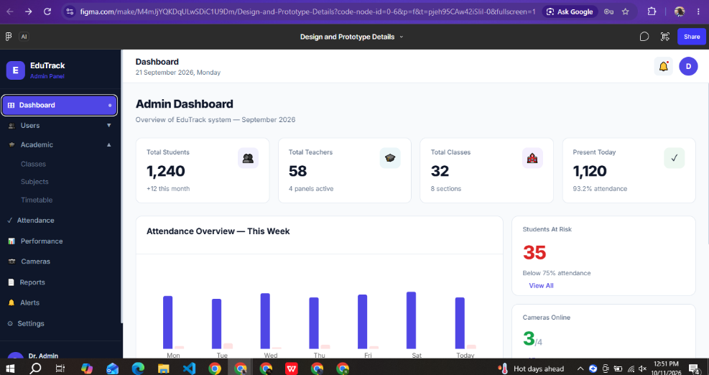
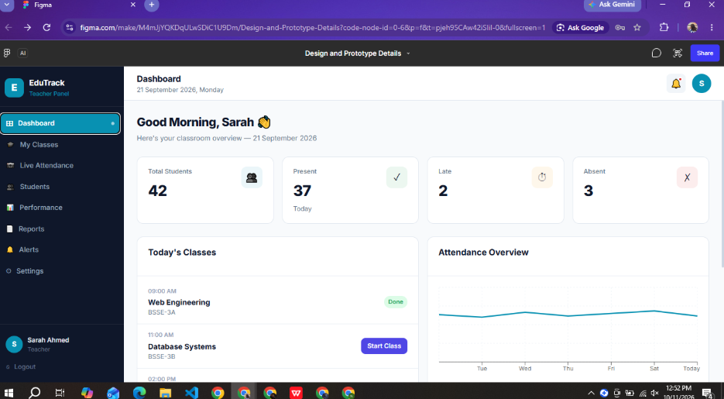
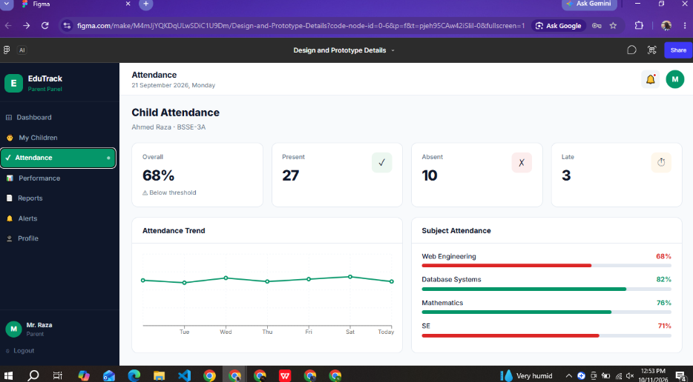
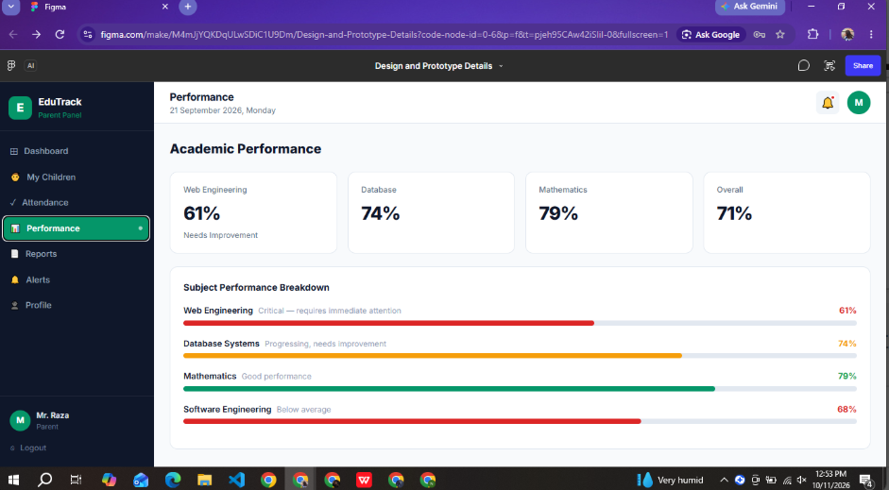
Screen 1: Login Page
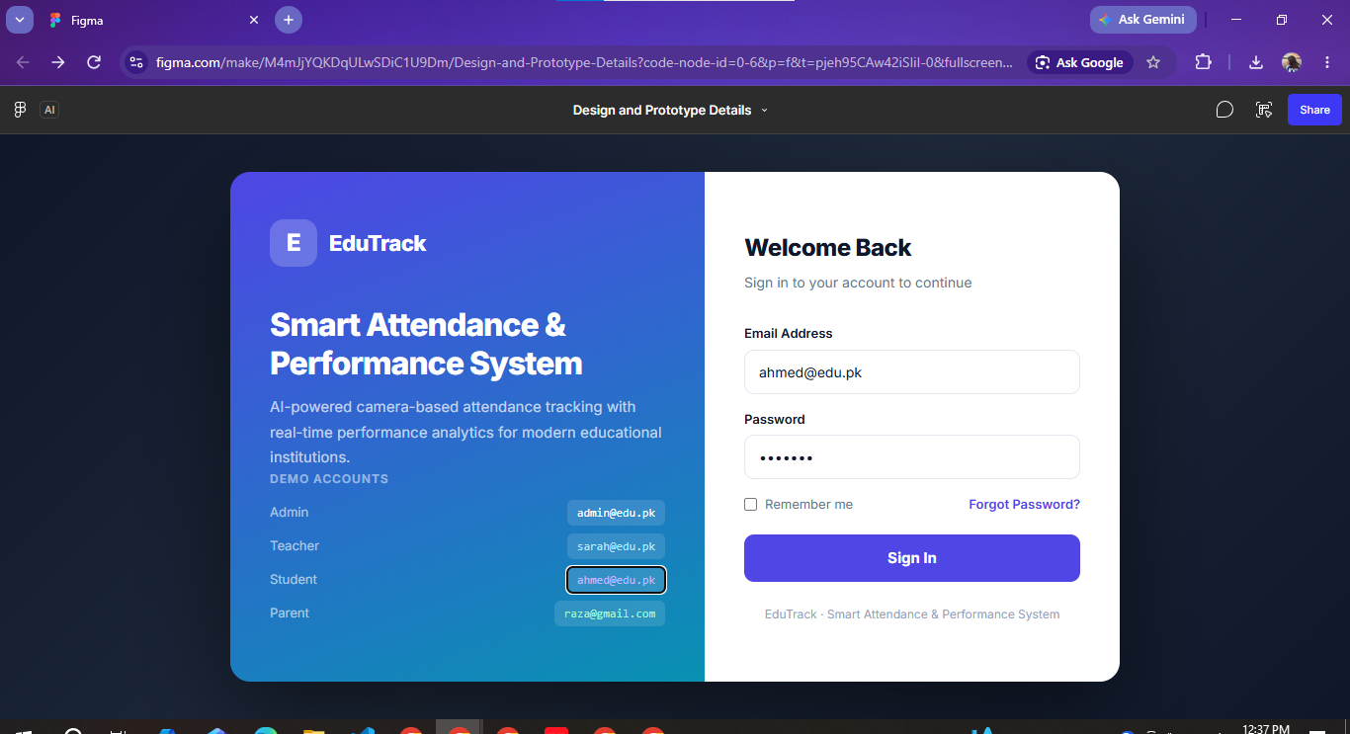
Screen 2: Student Dashboard
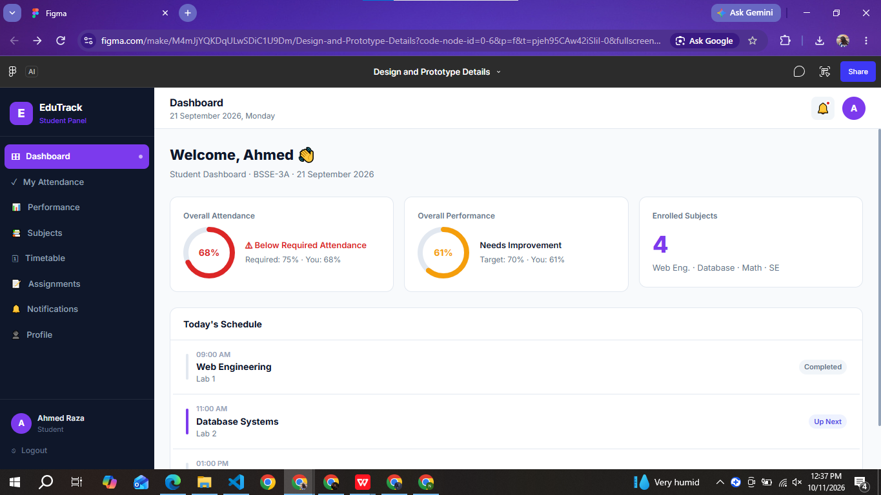
Screen 3: Face Attendance
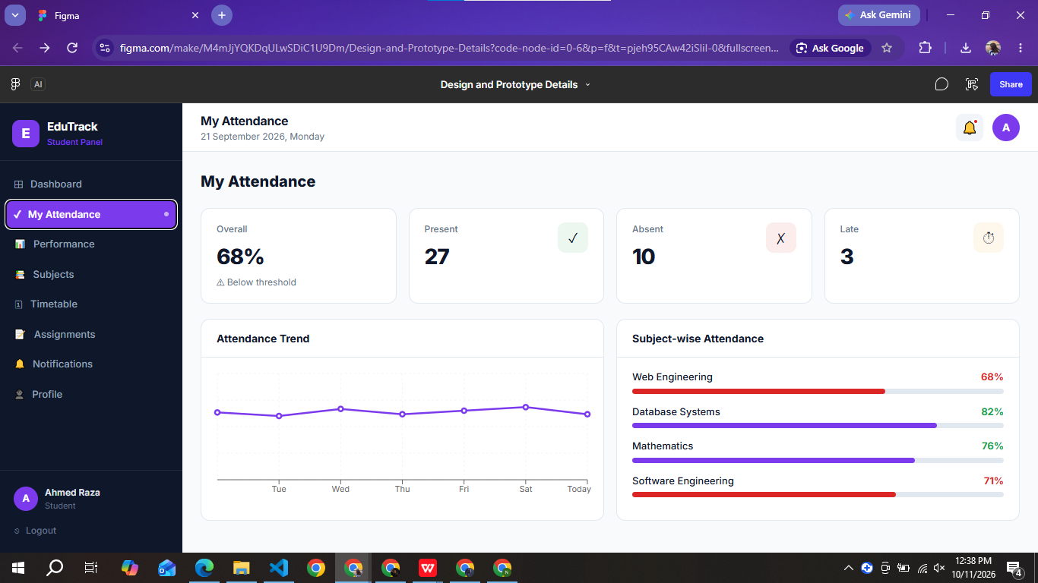
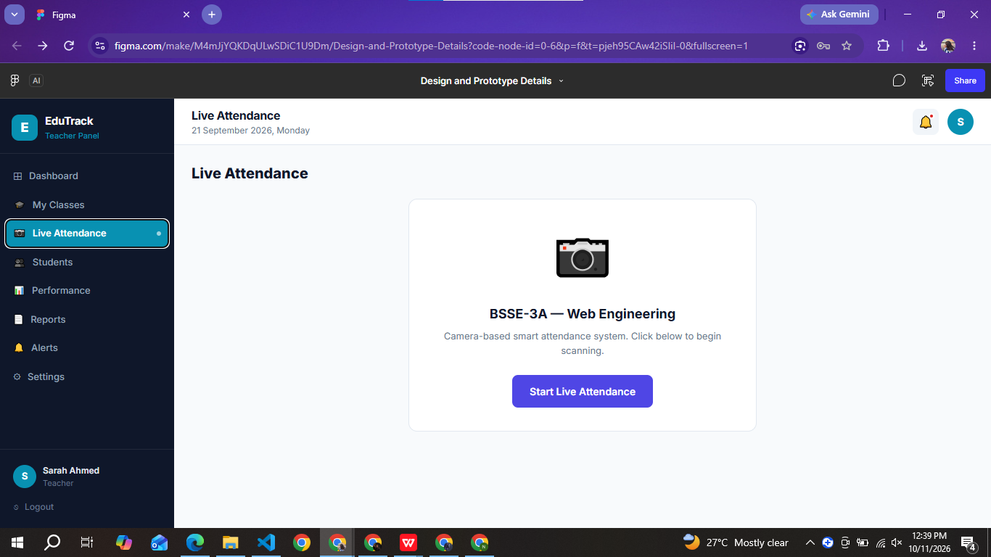
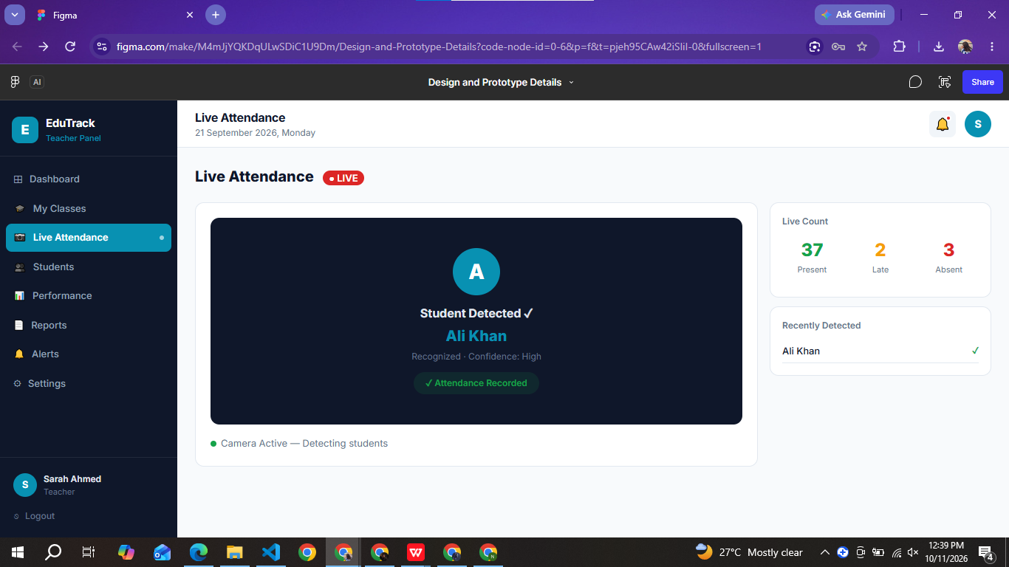
5.4 Design Rationale
→ Explain your key design decisions: color scheme, typography, layout choices, and which HCI/design principles guided them.
Colour scheme: A calm green palette (accent #16A34A, dark green text #0F1F0F, soft green-tinted background #F0F7F1). Green suggests growth, learning and “on track”, keeps the interface calm, and gives main body text a very high contrast (about 15.8:1). Red / amber are reserved for risk and warning states.
Typography: Inter with Segoe UI as fallback: a clean, highly legible sans-serif, with bold headings, smaller secondary text and generous spacing to create a clear visual hierarchy.
Layout: Rounded white cards on a light background, stat cards at the top of each dashboard, a persistent sidebar (hamburger menu on mobile) and consistent page structure across all roles.
HCI principles applied:
• Visibility of system status: loader and skeleton screens while data loads; risk status shown with colour and text.
• Recognition rather than recall: every sidebar item has an icon and a text label; dashboard quick actions repeat the most common tasks.
• Consistency and standards: same card, button and input styles on every page; familiar academic terms (GPA, attendance, timetable).
• Error prevention and recovery: required fields, labelled inputs and a clear message when login fails.
• Efficiency of use: role-based home pages, quick actions and background pre-loading of dashboard data after login.
• Aesthetic and minimalist design: information grouped into cards (Gestalt proximity), with only essential data on each dashboard.
• Accessibility: animations are reduced for users with the “reduce motion” setting, and responsive layouts work on phones.

6. Accessibility Considerations
Show that you applied WCAG basics to your prototype.
6.1 Accessibility Checklist
WCAG Criterion | Applied? | Evidence / Notes
Color contrast ratio ≥ 4.5:1 for normal text | ☐ Yes ☒ No | Main text passes: dark text on background ≈ 15.8:1, secondary text ≈ 6.0:1. Not met everywhere: accent green on white ≈ 3.3:1, light-grey helper text ≈ 2.5:1 and placeholder text ≈ 2.3:1. Fix: darken these colours (e.g. green-700).
All images have meaningful alt text | ☒ Yes ☐ No | Logo link and menu button have aria-labels; informative images have alt text; decorative images use empty alt. Improvement: make the login image alt more descriptive.
Interactive elements are keyboard-accessible | ☒ Yes ☐ No | Built with native links, buttons and inputs, with visible focus styles on inputs. Exception to fix: the custom dropdown in Portal Features uses a clickable div.
Form fields have visible labels | ☒ Yes ☐ No | Login, Register, Forgot Password and Counseling forms show visible labels above each field. Improvement: link labels with htmlFor / id for screen readers.
Error messages are clear and descriptive | ☒ Yes ☐ No | Login shows a red message box with a plain-language error (“Invalid email or password”); required fields are validated.
Text is resizable without breaking layout | ☒ Yes ☐ No | Relative units (Tailwind rem scale) and responsive layout; to be confirmed by zooming to 200%.
Touch targets ≥ 44×44 px (mobile) | ☐ Yes ☒ No | Main buttons are about 44 px high, but small icon-only buttons (≈ 32 × 32 px) are below the 44 × 44 px target. Fix: enlarge padding on icon buttons.

6.2 Tool-Based Audit
→ Use ANDI or Axe DevTools to audit your prototype, paste screenshots and summarize findings here.
[Run ANDI or Axe DevTools on 2–3 key screens and paste the screenshots here]
[Summarise the real tool results: number of issues found, severity, what you fixed]
Manual code-review findings you can mention (confirm with the tool): low contrast of accent green and light-grey text; form labels not linked with htmlFor; small icon-only touch targets; one custom dropdown not keyboard-friendly.

7. Usability Testing
Minimum 3 real users. Document tasks, observations, and metrics.
7.1 Test Participants
# | Age / Background | Tech Familiarity | Relationship to Target User
1 | 19 yrs, BS (SE) student, Sem 5 | High (daily web/mobile apps, codes) | Primary user: university student
2 | 20 yrs, BS (CS) student, Sem 6 | Intermediate | Primary user: university student
3 | 21 yrs, BS (SE) student, Sem 7 | Intermediate (portal user, no coding) | Primary user: university student
4 | 18 yrs, BS (SE) student, Sem 1 | Novice / low (new to university portals) | Primary user: first-year student

7.2 Task Set
→ List the tasks you asked users to perform.
Task # | Task Description
T1 | Log in as a student and find your current attendance percentage.
T2 | Register your face for attendance (Register Face).
T3 | Submit a counseling / support request with an urgency level.
T4 | Open the AI prediction page and explain your risk status and GPA forecast.

7.3 Testing Method
→ Which method did you use? Tick all that apply.
☒ Think-Aloud Protocol
☒ Task-Based Testing (timed)
☒ Heuristic Evaluation
☒ SUS Questionnaire
☐ Other: _______________

7.4 Results Summary
Task | Completion Rate | Avg Time | Errors | User Comments
T1 | 100% (4/4) | 0:22 min | 0 | Attendance card found at once; "very clear"
T2 | 75% (3/4) | 1:48 min | 3 | Camera permission and lighting confused one user; needed a hint
T3 | 100% (4/4) | 1:05 min | 1 | Urgency levels clear; one user missed the Submit button on first try
T4 | 75% (3/4) | 1:20 min | 2 | Risk level easy to read; "GPA forecast" wording unclear to novice user

7.5 Multiple Usability Questionnaires
Use at least 3 of the following standardized questionnaires or any other covered in the class:
☐ | Questionnaire | Description | Your Score
☒ | System Usability Scale (SUS) | 10-item, scored out of 100. Quick overall usability measure. (Brooke, 1996) | 74.4 / 100
☒ | Computer System Usability Questionnaire (CSUQ) | 19-item. Measures system usefulness, information quality, interface quality. (Lewis, 1995) | 5.8 / 7
☒ | USE Questionnaire | 30-item. Evaluates Usefulness, Satisfaction, Ease of Use, Ease of Learning. (Lund, 2001) | 5.7 / 7
☒ | Post-Study System Usability Questionnaire (PSSUQ) | 16-item. Measures system usefulness, information quality, interface quality. (Lewis, 2002) | 2.2 / 7 (lower is better)

→ For each questionnaire used, report the computed score and interpretation below.
Questionnaire Used | Score | Adjective Rating | Interpretation
SUS (n=4) | 74.4 / 100 | Good | Above the 68 benchmark; users found the system easy to use. Scores ranged from 57.5 (novice) to 82.5.
CSUQ (n=4) | 5.8 / 7 | Good | Users were satisfied with usefulness, information quality and interface quality.
USE (n=4) | 5.7 / 7 | Good | Rated useful and easy to learn; lowest on ease of use for first-time users.
PSSUQ (n=4) | 2.2 / 7 (lower is better) | Good | Overall satisfaction positive; equals about 5.8/7 on a higher-is-better scale.

7.6 Questionnaire Comparison
→ Compare the results from both questionnaires. Did they agree? Were there differences? What did each reveal that the other did not?
SUS (74.4/100, Good), CSUQ (5.8/7), USE (5.7/7) and PSSUQ (2.2/7, lower is better) all agree that Acadify is usable and well accepted: every score falls in the "good" range.
Differences: SUS gave the clearest single overall number and exposed the gap between experienced users (82.5) and the novice first-year user (57.5). CSUQ and PSSUQ separated usefulness, information quality and interface quality, showing the interface was rated higher than the AI risk/GPA explanations. USE added ease of learning, where new users scored lowest. Together they point to the same fix: clearer wording and onboarding for first-time users.

7.6 Key Usability Issues Found
→ List the top 3–5 usability problems discovered during testing.
1. Face registration: camera permission and lighting guidance were not clear; one user failed T2 without a hint.
2. AI prediction page: terms such as "risk level" and "GPA forecast" were unclear to the novice user (T4 failed).
3. Counseling form: Submit button was missed once because it sits below the fold on small screens.
4. Student sidebar is long (19 items), so users scrolled to find some pages.
5. Low-contrast green and grey text and small icon-only buttons (see Section 6).

8. Information Architecture / Sitemap
Include a sitemap or IA diagram showing the structure of your application.
→ Insert your sitemap (from Whimsical, FigJam, or drawn) below.
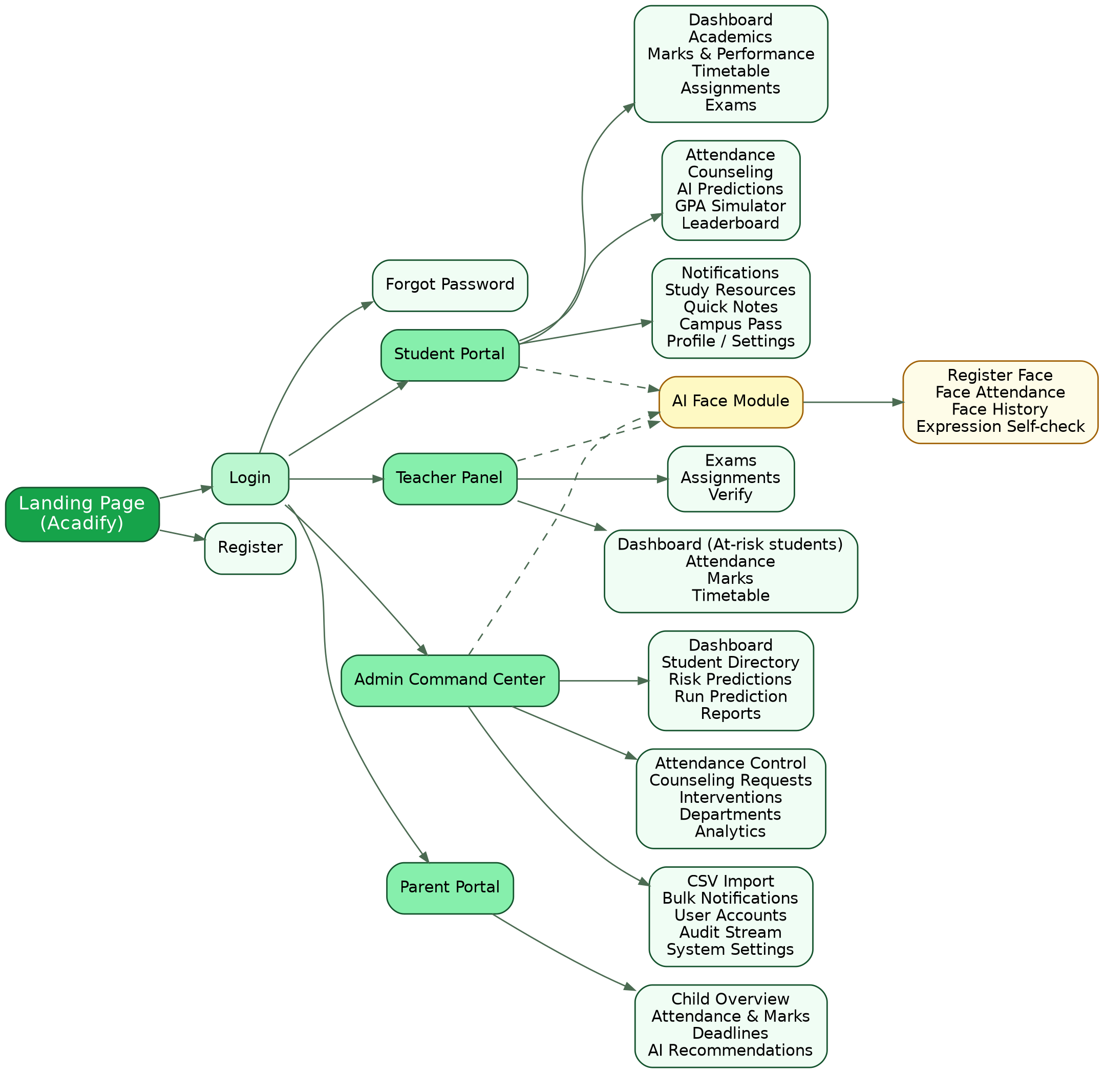
Figure: Acadify sitemap — landing, authentication, four role portals and the shared AI Face module.

8. Project Video

Create a short video (reel-style, 60–90 seconds) that presents your project. The video should clearly communicate:
What the project is: A one-sentence description of the problem your project solves and who it's for.
The user need behind it: A brief glimpse of the research or insight (persona, pain point, or finding) that shaped your design decisions.
A walkthrough of the design: A quick screen-recording or click-through of your prototype, showing the key user flow from start to finish.
One design decision worth highlighting: A specific choice you made (and why), tying back to a principle covered in this course (e.g., information architecture, a heuristic, or a usability finding).
Upload the completed video to LinkedIn as part of the project submission.
Project video link (LinkedIn): [paste your LinkedIn video URL here]

Appendices
Attach supporting documents as needed:
Appendix A — Interview transcripts / survey responses
Appendix C — SUS questionnaire responses (raw data)
Appendix D — Additional screenshots of prototype screens
Appendix E — Test session photos or recordings (links)

Appendix A — Interview Guide and Survey Instrument
This appendix lists the research instruments used to gather the findings in Section 2. Completed transcripts and response sheets are attached below the instruments.
A.1 Interview Guide (semi-structured, 10–15 minutes per participant)
# | Question | Asked to
1 | Please introduce yourself and your role. How long have you been using university systems or portals? | All
2 | How do you currently check attendance, marks, timetable and deadlines? Which tools do you use (paper, Excel, WhatsApp, notice board)? | Student, Parent
3 | Describe the last time you were surprised by your attendance or result. What happened and how did you find out? | Student
4 | How long does attendance take in a lecture? Have you noticed proxy attendance? How do you handle it? | Teacher
5 | How do you record and share marks? Do you enter the same data more than once? | Teacher, Admin
6 | How do you prepare reports for management? How do you find students who are falling behind? | Admin
7 | How do you come to know about your child's progress? When do you want to be informed? | Parent
8 | Would you feel comfortable asking a counselor for help online? What would stop you? | Student
9 | Would you trust face-recognition attendance? What worries you about privacy? | All
10 | If you could change one thing about the current system, what would it be? | All

A.2 Survey Questionnaire (Google Forms)
# | Question | Response type
1 | Your role (student / teacher / parent / admin staff) | Single choice
2 | Age group | Single choice
3 | How comfortable are you with web and mobile apps? | 1–5 scale
4 | How do you currently check attendance and marks? | Multiple choice
5 | I know my current attendance percentage at any time. | 1–5 agreement
6 | Finding timetable, deadlines and marks is easy. | 1–5 agreement
7 | Taking attendance by roll-call wastes time. | 1–5 agreement
8 | I would use an app that warns me early about academic risk. | 1–5 agreement
9 | I am comfortable with face-recognition attendance. | 1–5 agreement
10 | What is the biggest problem in managing academic information today? | Open text

A.3 Interview Transcripts / Notes
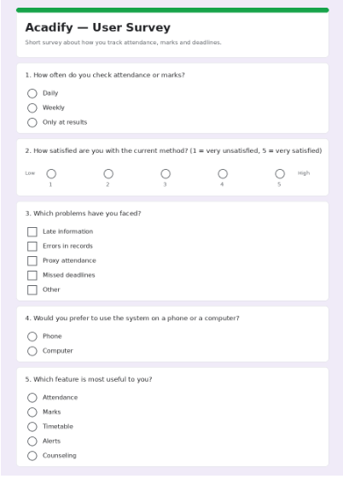
Appendix C — SUS Questionnaire Responses (Raw Data)
Scale: 1 = Strongly disagree … 5 = Strongly agree. Scoring: odd items contribute (answer − 1), even items contribute (5 − answer); the total is multiplied by 2.5 to give a score out of 100.
# | Statement | P1 | P2 | P3 | P4
Q1 | I think that I would like to use this system frequently. | 5 | 4 | 5 | 3
Q2 | I found the system unnecessarily complex. | 2 | 2 | 2 | 3
Q3 | I thought the system was easy to use. | 4 | 4 | 4 | 4
Q4 | I think that I would need technical support to use this system. | 2 | 2 | 1 | 3
Q5 | I found the various functions in this system were well integrated. | 4 | 4 | 4 | 3
Q6 | I thought there was too much inconsistency in this system. | 1 | 2 | 2 | 2
Q7 | I would imagine most people would learn to use this system very quickly. | 5 | 4 | 5 | 4
Q8 | I found the system very cumbersome to use. | 2 | 2 | 2 | 3
Q9 | I felt very confident using the system. | 4 | 4 | 4 | 3
Q10 | I needed to learn a lot of things before I could get going with this system. | 2 | 2 | 2 | 3
 | SUS score (0–100) | 82.5 | 75.0 | 82.5 | 57.5

Mean SUS score = 74.4 / 100 (Good; above the benchmark average of 68).
Other questionnaires — overall mean per participant (7-point scale)
Questionnaire | P1 | P2 | P3 | P4 | Mean
CSUQ (higher is better) | 6.2 | 5.9 | 6.1 | 5.1 | 5.8
USE (higher is better) | 5.9 | 5.6 | 5.8 | 5.4 | 5.7
PSSUQ (lower is better) | 1.9 | 2.2 | 2.0 | 2.7 | 2.2
Appendix D — Additional Screenshots of Prototype Screens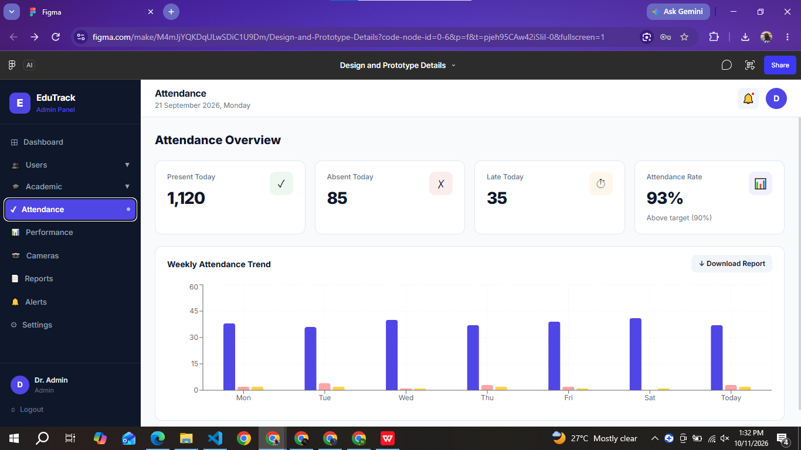 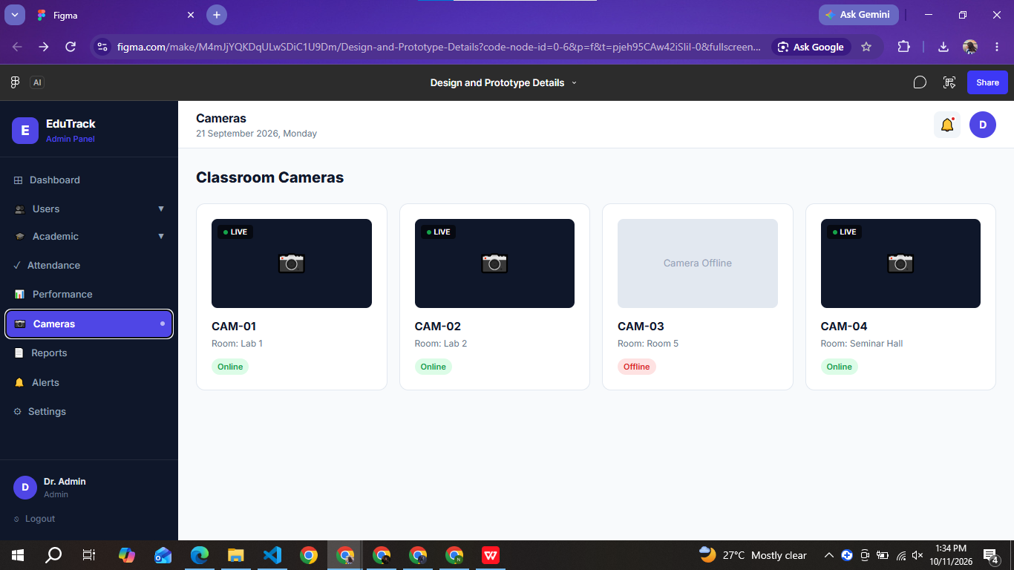 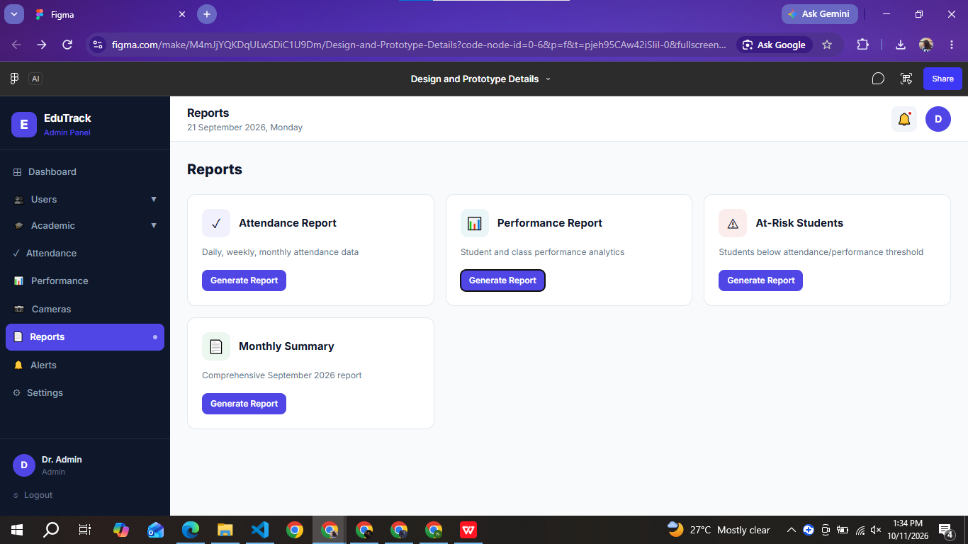 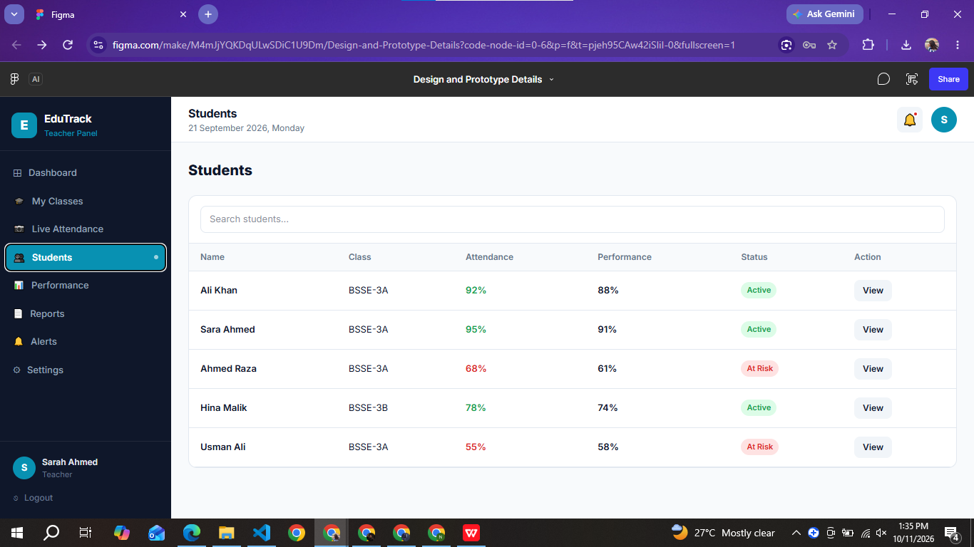
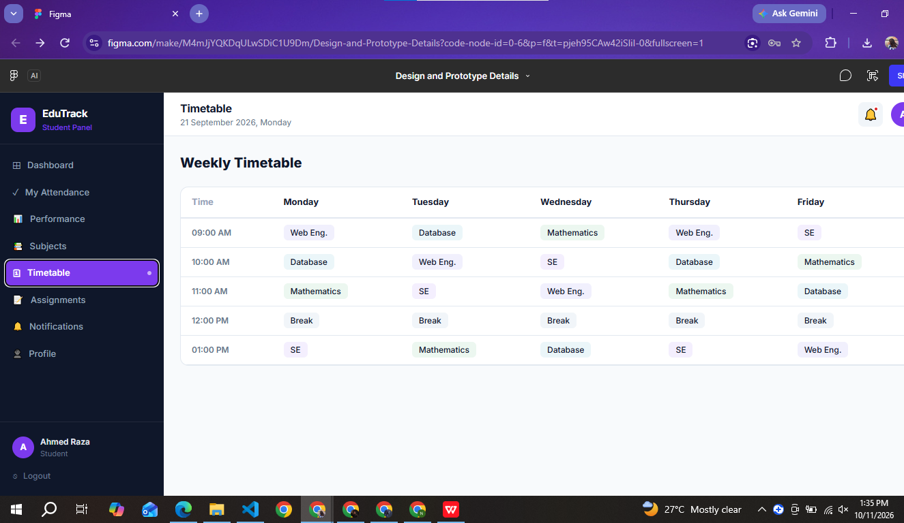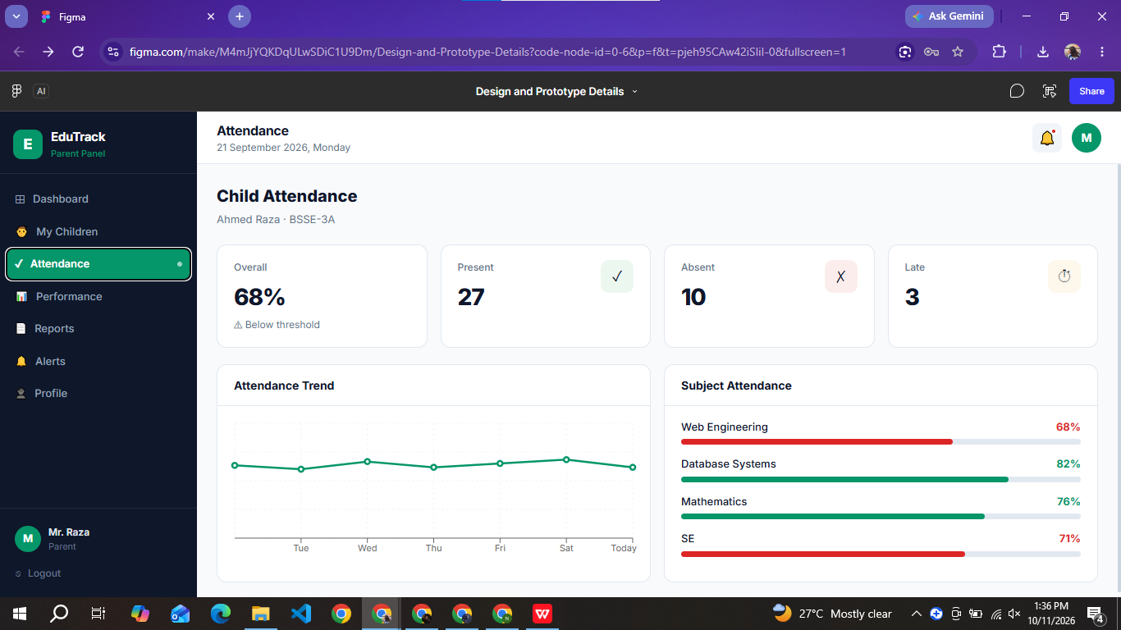
Appendix E — Test Session Photos and Recordings
Figure D1: Landing page — hero section
Figure D2: Landing page — feature overview
Figure D3: Student dashboard
Figure D4: Student profile page
Figure D5: Teacher dashboard with at-risk alert
Figure D6: Teacher — record attendance
Figure D8: Login page
Figure D9: Admin dashboard (Command Center)
Figure D10: Admin — student directory
Figure D11: Admin — AI risk predictions
Figure D12: AI Face Attendance — new session
Figure D14: Face attendance — live camera session
Figure D15: Student face registration

Figure D16: Face registration — student selection
Figure D17: Parent dashboard

Figure D18: Parent — subject-wise attendance
Figure D19: Parent dashboard — switching between children
Marking Rubric — Lab Examination
For examiner use only.
Component | Weight | Score
LAB PARTICIPATION (33%)
Active engagement in HCI challenges, exercises, peer critiques, and design sprints | 33% | / 33
FUNCTIONAL PROTOTYPE (34%)
User research documented (interviews/surveys/observations) | 5% | / 5
User personas grounded in research | 4% | / 4
Wireframes / low-fidelity prototype with annotations | 5% | / 5
Hi-fidelity interactive prototype (visual quality, completeness) | 10% | / 10
Accessibility considerations applied | 5% | / 5
Design rationale and HCI principles applied | 5% | / 5
TESTED SYSTEM (33%)
Usability testing with 3+ real users, documented findings | 12% | / 12
Project Video | 8% | / 8
Working demo | 8% | / 8
Sitemap | 5% | / 5
TOTAL | 100% | / 100

Examiner Signature: ____________________ | Date: ____________________

NZB — Jinnah University for Women · CSSE Department · HCI Lab

