**FitBit Sleep Data Cleaning**

All Data:

Distribution of asleep hours by start hour of the sleep period

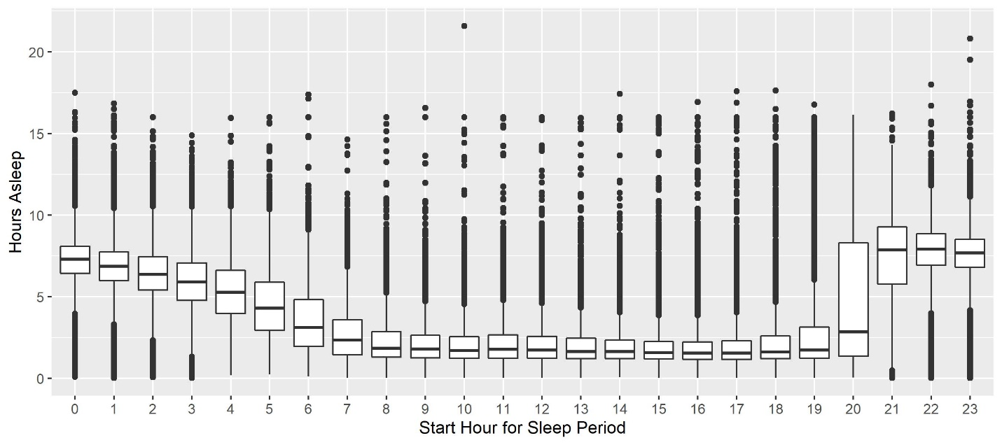

Distribution of asleep hours by end hour of the sleep period (because date is associated with end of sleep period)

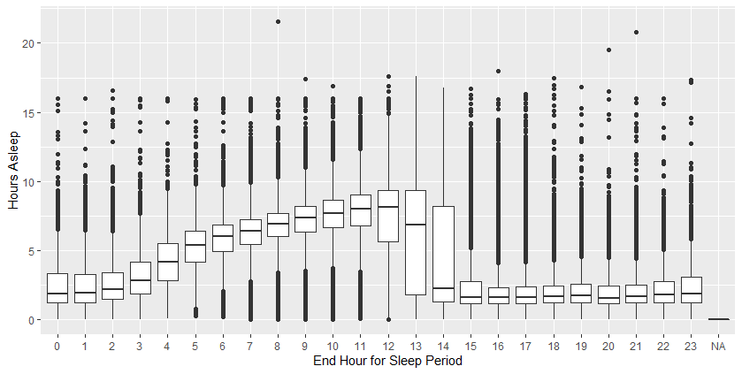

Nonsensical Data??

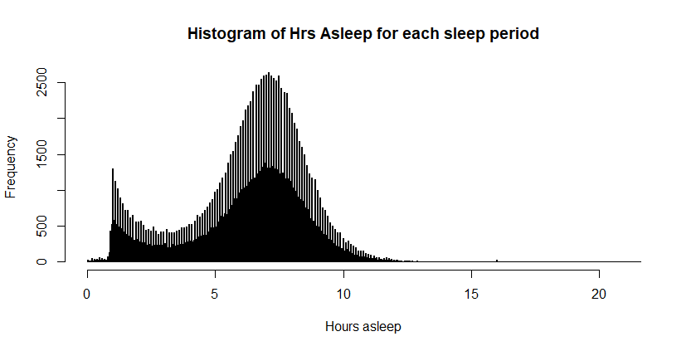

Min. 1st Qu. Median Mean 3rd Qu. Max. SD

0.01667 5.20000 6.71667 6.27920 7.81667 21.58333 2.33

*There might be some kind of rounding that the Fitbit is doing leading to the odd spikes in the histogram.*

**NOTE:** The sleep date in the sleep period file is the date the sleep period ENDED (<http://sites.nd.edu/nethealth/fitbit-data/>).

Creating the date for matching the sleep periods to step data (pa.matchdate)

* Any sleep period that ends at or after 8 pm, has the date variable incremented by 1 so that it is matched with the next days step data.
  + Example:

|  |  |  |  |  |
| --- | --- | --- | --- | --- |
| Egoid | Sleep Date in File | pa.matchdate | start of sleep period | end of sleep period |
| 98766 | 2016-04-16 | 2016-04-17 | 17:23:30 | 20:17:30 |
| 98766 | 2016-04-28 | 2016-04-29 | 21:01:00 | 23:25:00 |

After aggregating the sleep times over a pa.match date, there were 21 sleep day with sleep times of at least 20 hours. Please look at the “Sleep_Time_Issues.xlsx” file to review the full data for these days. I’ve included comments on any day with >= 24 hours of sleep. – Question should I remove all/some of these days?

Data Cleaning Table

|  |  |  |
| --- | --- | --- |
|  | Days | N |
| Raw Data | 333708 | 622 |
| Aggregate asleep minutes by pa.matchdate | 297483 | 622 |
| Remove days without a pa.matchdate (no original date) | 297481 | 622 |
| Remove days with >= 1440 mins asleep | 297475 | 622 |
| Removed days outside the 1st Academic Year (e.g. days earlier than 08/2015) | 297152 | 622 |
| Matched to FitBit Step Counts for all valid days | 240041 | 470 |
| Matched to FitBit Step Counts for 1 Academic Year with most # of days | 107151 | 470 |

Match of Fitbit Step and Sleep data Across all Academic Years

|  |  |  |  |  |  |
| --- | --- | --- | --- | --- | --- |
|  |  | FitBit Sleep days | |  |  |
|  |  | No | Yes | Total | % of row |
| Fitbit Step days | No | 0 | 39762 | 39762 |  |
| Yes | 17283 | 257396 | 274679 | 93.7 |
|  | Total | 17283 | 297158 | 314441 |  |

Match of Fitbit Step and Sleep data Across 1 Academic Year per subject (with most days with step data)

|  |  |  |  |  |  |
| --- | --- | --- | --- | --- | --- |
|  |  | FitBit Sleep days | |  |  |
|  |  | No | Yes | Total | % of row |
| Fitbit Step days | No | 0 | 190350 | 190350 |  |
| Yes | 5655 | 106808 | 112463 | 95% |
|  | Total | 5655 | 297158 | 302813 |  |