# Data Cleaning Summary – REVISED 4/30/2021

**Question: What counts as a nonsensical step count?**

*All Days:*

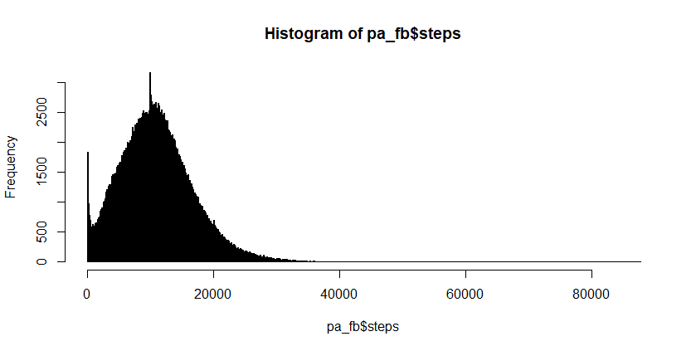

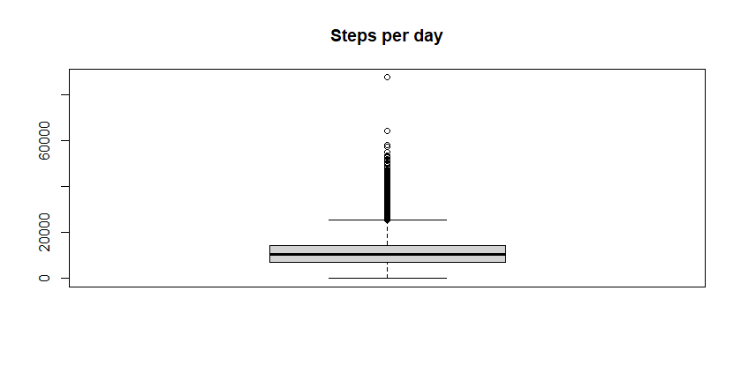

Summary:

Min. 1st Qu. Median Mean 3rd Qu. Max. NA's SD

4 6961 10599 11053 14455 87677 1072 5864.1

Min. 1st Qu. Median Mean 3rd Qu. Max. sd

6.000 8002.000 11332.000 11905.723 15061.000 64226.000 5582.008

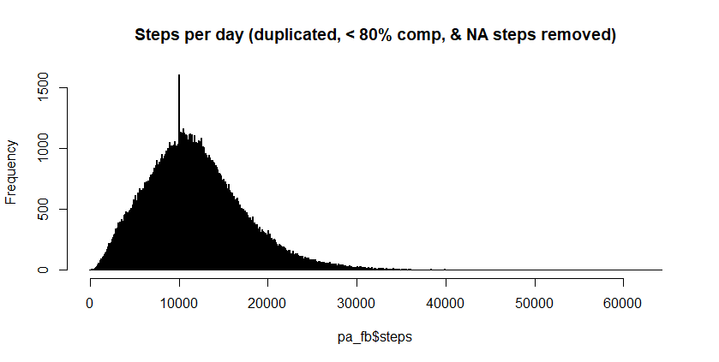

3 days with < 100 steps

464 days with > 35,000 steps

|  |  |  |  |
| --- | --- | --- | --- |
|  | Days | % decrease | N |
| Raw Data | 357827 | 100% | 623 |
| Remove duplicate days (2163 days) | 355664 | 99.4% | 623 |
| Removed days with *NA* steps (*Nonsensical Data*) | 354592 | 99.1% | 623 |
| Removed Days with < 1000 or > 35000 steps (*Nonsensical Data*) | 345484 | 96.6% | 622 |
| Remove Days ≤ 80% compliance | 273708 | 76.5% | 618 |
| Remove Days before the 1st Academic Year (starts: 8/1/2015)  *(earliest day before 1st Academic Year: 7/25/2015)* | 273446 | 76.4% | 618 |
| Remove years with < 100 days of data | 252954 | 70.7% | 470 |
| Reduce to one Academic Year per subject using year with max days | 112463 | 31.4% | 470 |