Doubles

Bools

Printing strings to terminal



Converting string to ints, doubles, longs

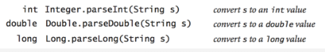

Math functions

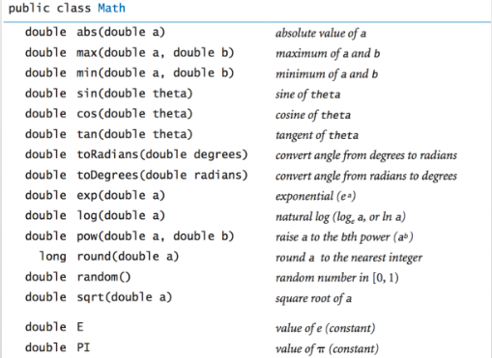

Common method call examples

Type conversion

Some if statement examples that may be helpful

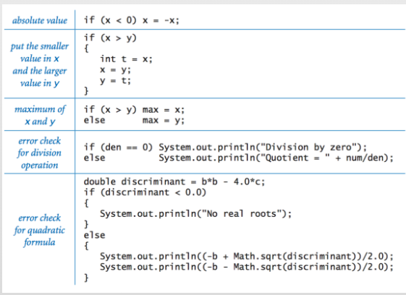

While loop

For loop

Loop examples ( largest power of 2, compute a finite sum or product, print a table of function values, compute ruler function 1.2.1)

