Results of NSF funding within the past 5 years.
NSF DEB-0519223 AK Brody (PI) COI: Interactions among keystone species: effects of termites and ungulates on biodiversity in East African savannas. TM Palmer and DF Doak CO-PIs. 9/05–8/11.
Intellectual Merit: The importance of ecological engineers is widely asserted in many ecological communities but their effects are rarely experimentally quantified. We asked how termites, through their mound-building activities, support diverse plant and animal communities in East African savannas. We: 1) tested the effects of termites on plant and animal biodiversity through their modification of soil properties, 2) examined the indirect effects of termites mediated through vertebrate herbivores, 3) quantified the effects of termites on belowground mycorrhizal communities. We found: 1) proximity to enriched mound soils is a key driver of reproduction for the monodominant tree, Acacia drepanolobium, 2) nutrient enhancement from termites creates strong spatial patterning in plant, invertebrate, and vertebrate communities.
Broader Impacts: We supported one US and 5 Kenyan RAs, 2 Post-docs (one Kenyan), 3
Master’s students (one Kenyan), 2 undergraduate Honor’s students, 2 technicians, and provided wages for 3 US PhD and 2 Master’s students. We participated in workshops with ranchers providing information about sustainable grazing practices. We established a long-term collaboration with the International Center for Insect Physiology and Ecology. We gave talks at professional meetings and our work was featured in the scientific and popular press.
Publications to date: Botany (1), Current Biology (1), Ecology (4), Ecology Letters (1), PLOS Biology (1), International J Tropical Insect Science (1).

Response to Reviewers. The 2016 panel expressed enthusiasm about our ideas and described the work as “both timely and relevant.” However, several concerns were expressed. These are italicized with our response following in regular font.
A central hypothesis is needed. Our overarching hypothesis is that viruses spread to bumble bees from honey bees, and that viral acquisition is a function of numerous interacting spatial and temporal factors, including apiary proximity, honey bee viral load, floral resource distribution, and host species identity. From this we predict that: A) areas where wild bumble bees co-occur with managed honey bee apiaries are ‘hotspots’ of viral transmission; B) transmission occurs via shared use of floral resources, and is positively correlated with floral density; C) there are temporal and spatial dynamics to bee disease transmission that can be modeled to allow better prediction of risk factors, such as land use and apiary management patterns.
It is unclear if the field and laboratory studies [will] provide the appropriate level of data to validate the proposed models. We changed the field studies and the modeling. Here, we will examine the probability of virus transmission on shared flowers (the “patch”) in a controlled setting and couple our results with those of an already in-hand field survey to build realistic models. We will then test how well what we see in “patches” scales up to that observed in communities and across broader spatial and temporal scales (Aims 2 & 3). In addition, we will use the predictions of the models to produce landscape scale risk maps for infection of managed and wild bees with viruses and other diseases.
The investigators have the expertise to carry out the proposed study, but there are general concerns that they may lack the expertise to carry out such a large interdisciplinary study.
Our team combines expertise and leadership of junior and senior scientists. We have each engaged in successful collaborations and several of us have lead large, interdisciplinary projects. Lead PI, Ogbunugafor (Ogbunu) is a New Investigator but recent collaborations and publications demonstrate his ability to expertly lead this project. Brody led a 6-year, COI, multidisciplinary study that was highly productive and led to several (NSF funded) “spin-off” projects by others on her team. Per the suggestion of Reviewer 2, we added an applied mathematician (Co-PI Samuel Scarpino) whose expertise was instrumental in the re-wiring of our entire approach.
The use of multiple modeling frameworks with different levels of complexity was a key strength of this proposal. However, the panel felt there was insufficient detail to determine if the models were feasible or appropriate. Here, we will capitalize on data gathered over the past year (see preliminary data, Aim 1) that provide superior parameterization of models relative to the prior proposal. Our new modeling approach is better designed with the biological specifics of the problem and our approach to scaling up from the patch to the landscape is more elegant. We provide more details that link the experiments to the modeling (also questioned by reviewers) and demonstrate that the models are both feasible and appropriate (see Figs. 4 and 6).
The proposal lacks details in regards to the generalization of the results to other systems.
Our new theoretical framework of “sit and wait” transmission dynamics is a stronger conceptual approach to the problem of viral transmission in bees and a more natural analogy for other infectious diseases. Also called “indirectly transmitted diseases” (Joh et al., 2009), the dynamics of “sit and wait” diseases have been under-examined but are highly relevant to many diseases. We provide details of the links between our work and other systems throughout the proposal.
How [will] the results of the proposed research enhance teaching or student mentoring?
We firmly believe in the teacher-scholar model championed by the University of Vermont. Our scholarship enhances our teaching directly by actively involving undergraduates in research and indirectly through generating knowledge, ideas and innovations that we discuss in the classroom.
How [will] the investigators increase enrollment and retention of underrepresented minorities? PI C. Brandon Ogbunu was recruited to UVM through the George Washington Henderson Fellowship Program, an initiative to help diversify the faculty. Ogbunu is dedicated to diversity in STEM, serving as a role model and actively recruiting underrepresented minorities into the sciences. He has mentored many underrepresented minority students, including those who later pursued graduate and professional school training. His B.S. degree was at Howard University, an historically Black College/University (HBCU). Since coming to UVM, Ogbunu has been actively engaged with the Department of Chemistry (his former home department) and the College of Arts and Sciences Honors Program to recruit students for summer research internships and graduate work at UVM (He had successfully done so in his prior institutional affiliations). Ogbunu is a former Ford Foundation Fellow, a prestigious fellowship dedicated to helping to diversify the professoriate. He maintains close ties with the Ford Fellows, and will use this as an avenue to recruit students and faculty colleagues. (For example, he recently assisted the Vermont Complex Systems Center with recruiting for a tenure-track line through his connections with the Ford Foundation Fellows.)
The investigators [assert they will] provide training for middle and high school students, [but] there are no activities listed and the budget does not list any funding for these activities.
In 2016, Richardson mentored two high school students in developing a testable hypothesis about the effects of bees’ exposure to insecticides and fungicides. He provided technical assistance, live bees, and equipment that allowed the students to test their question. We will continue to provide such students with hands-on experience that dovetails with our research program. We ask for nominal funds to cover supplies and educational materials.

CONCEPTUAL FRAMEWORK AND BACKGROUND
The Community Ecology of Infectious Disease: A Call to Action
Emerging infectious diseases (EIDs) pose a substantial threat to global biodiversity, ecosystem function, food security, and human health. Complex interactions between host species, pathogens, and the environment undermine simplistic, overly-reductionist perspectives on infectious diseases. Approaches enriched and driven by principles in community ecology hold promise for making significant advances in our understanding of—and ability to prevent or contain—epidemics. Emphasis on the interaction between agents of disease and the environment, can foster a rich picture of infectious disease dynamics at multiple scales (Johnson et al., 2015; Heesterbeek et al., 2015). This perspective is consistent with the general efflorescence of ecological and evolutionary research in the field of infectious disease over the past 25 years (Ewald, 1993; Bergstrom et al., 2004). No longer is disease defined exclusively by descriptive symptomatology and the narrative experience of illness, but rather, by a mechanistic understanding of its environmental determinants (Nesse and Stearns, 2008; Gluckman and Bergstrom, 2011). Community ecology perspectives are especially relevant because they can inform network and complex systems approaches in determining the importance of multiple actors, feedbacks, and interactions (a disease with multiple hosts is much like a food web). These are essential for resolving debates in infectious disease, such as the “hot spot vs. dilution” debate (Randolph and Dobson, 2012).

Underexplored Routes to Transmission: Environmental Transmission
Technological breakthroughs in various fields have provided better details of the molecular phylogeny of infections (Pybus and Rambaut, 2009), novel applications of computer science to simulate evolution in infectious disease (Ogbunugafor et al., 2016), and other computationally-intensive means of revealing patterns in large data sets (Neafsey, 2013). Although these methods carry great promise, the infectious disease community remains naïve about the relative importance of different routes of transmission in dictating the dynamics of epidemics at different scales. It is here that community ecology perspectives are invaluable, as they allow one to consider how these details interact. And in doing so, they allow us to consider under-explored aspects of disease transmission, for example, the dynamics of infectious diseases that utilize multiple routes of transmission.
Conceptualizations of the process of disease transmission have historically assumed direct-transmission of pathogens between susceptible hosts, and have dominated foundational mathematical studies in the evolution of infectious disease (Otto and Day, 2007). This approach has been essential for building the modern field of mathematical epidemiology, but it underestimates the complex natural history of infectious disease. For example, epidemiologists now acknowledge that the direct transmission route is one of many, and that hosts can be infected through indirect (biotic or abiotic) scaffolds or intermediaries, as in the case of water borne illnesses where pathogens contact hosts through an infected water supply (Jensen et al., 2002). Moreover, many diseases propagate through multiple host taxa whose varying competence as hosts affects transmission dynamics (Schmidt and Ostfeld, 2001).

Contribution to Understanding the Evolution and Ecology of Infectious Disease
These “indirectly transmitted” pathogens can be thought of as utilizing a “sit and wait” infection strategy (Ogbunugafor et al., 2013), as pathogens get from host to host via “sitting” around (in the environment) and “waiting” to encounter a susceptible host (Joh et al., 2009). This route has been historically underappreciated in the evolution of infectious disease literature, but can be used to describe the mechanism of transmission for several notable human pathogens, including cholera (where water is the intermediary (Andrews and Basu, 2011), rotavirus (Estes et al., 1983), and Hepatitis C virus (HCV; where the contents of drug mixtures is the intermediary) (Razali et al., 2009). Insect diseases including the nucleopolyhedrovirus of gypsy moth and protozoan parasites of monarch butterflies are also transmitted indirectly, and feature disease dynamics that depend on seasonality and environmental factors such as host plant quality and identity (Myers and Cory, 2016). Advances in our understanding of how the “sit and wait” mechanism of transmission impacts larger-scales of epidemics could influence the way we study and address epidemics in natural settings (public health, agriculture).

Here, we propose an interdisciplinary approach to studying the transmission dynamics of RNA viruses that infect social bees. Our study system—composed of honey bees, bumble bees, pathogens, and floral resources—is ideal for examining the “sit and wait” dynamics of environmentally transmitted diseases. Here, flowers may function as an environmental scaffold for the virus, upon which bees forage for nectar and/or pollen. Alternatively, direct contact between hosts may be required as in sexually-transmitted diseases or in person-to-person transmission of influenza between individuals (Scarpino, 2016).

Our overarching hypothesis is that viruses spread to bumble bees from honey bees, and that viral acquisition is a function of proximity to honey bee apiaries, honey bee viral load, floral resource distribution, and bee and floral host species identity.
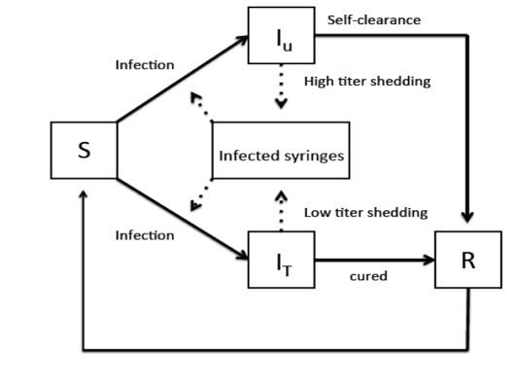
Our work is directly analogous to environmental transmission of HCV (Figure 1), where viruses “sit and wait” on drug paraphernalia, until encountering another host. This is an under-examined route of transmission in models of infectious disease.

Figure 1. Environmental or “indirect” transmission: Hepatitis C virus (HCV) transmission in an urban “patch.” An example of an environmentally-transmitted pathogen. This represents a simplified compartmental model across an ecological “patch,” which is a local injection-drug user community in the case of modern, urban HCV transmission (Oliveira et al., 2009). In the parlance of classic S-I-R model structure (Otto and Day, 2007), S corresponds susceptible hosts ; I_{u} to infected and untreated; I_{T} to infected and treated; R to recovered.

The Natural History of Bee Viruses
There are >20,000 species of bees, and nearly all collect plant pollen as a protein source, meaning that flowers are sites of shared foraging activity (Williams et al., 2014). The European honey bee (Apis mellifera) is managed for crop pollination, but wild bee species commonly forage at crop flowers, and may be of equal or greater importance to crop pollination (Garibaldi et al., 2013). A variety of RNA viruses afflict bees, and many can replicate in multiple bee species (Piot et al., 2015). There is growing evidence that many of these viruses originated with honey bees (A. mellifera and related species in Eurasia), then spread to other bees via transport of honey bees worldwide (e.g. deformed wing virus; Wilfert et al., 2016). However, the precise dynamics of transmission are poorly understood, and wild bees may act as reservoirs of disease to reinfect managed hives via ‘spillback’ (Graystock et al., 2016). Research in this area is critical, because viruses and other pathogens are implicated in widespread declines of bumble bees (Peng et al., 2011; McMahon et al., 2015), and in increased mortality of honey bee colonies (Cox-Foster et al., 2007).

In honey bees, RNA viruses may transmit vertically from queen honey bees to offspring, horizontally during mating or via contact among nest mates (Chen et al., 2006; Y. Chen and Siede, 2007; de Miranda and Fries, 2008), or may be vectored by the Varroa mite (Varroa destructor), an ectoparasite first detected in US bees in the 1980s and directly linked to high viral loads (Martin, 2001; Rosenkranz et al., 2010). Because bumble bees and other solitary bees are not known hosts of the Varroa mite, interspecific horizontal transmission most likely occurs through the shared use of floral resources (Singh et al., 2010; Graystock et al., 2015; McMahon et al., 2015). Viruses have been detected in the feces (Chen et al., 2006) and glandular secretions of worker bees (Bailey, 1969), as well as in pollen loads carried by bees (Singh et al., 2010) and pollen taken directly from flowers (Mazzei et al., 2014). Thus, viruses may be directly transmitted through salivary secretions or feces while bees are co-mingling on flowers or indirectly through infected pollen. Interestingly, viral infections differ among individual bees and the pollen loads they carry (Singh et al., 2010) suggesting a role for differences in viral ecology and/or differences in pollinator contact with contaminated pollen. Furthermore, viral loads of pollen collected directly from flowers differ among plant species (Mazzei et al., 2014) indicating that some plant species may be better at harboring disease due to differences in floral anatomy or pollinator foraging behavior. There is evidence that transmission of other bee diseases via shared flower use is a function of plant density, diversity, and identity (Adler et al., 2016), and RNA viruses may exhibit similar patterns. The resolution of this question is critical for agriculture, given that most cropping systems feature densely flowering plants, and ~70% of crops are dependent on pollinators (Klein et al., 2007).

Our Aims
In this proposal, we build upon recent theoretical examinations of indirectly transmitted pathogens by extending this theory to a highly relevant host-pathogen system of great ecological and agricultural importance, the European honey bee, Apis mellifera, and wild bumble bees (Bombus species). More broadly, we will examine how indirect routes of pathogen transmission influence infection dynamics at different scales. We believe this to be an ideal system to examine the role of indirectly transmitted pathogens because it features multiple nodes where transmission occurs (e.g., flowers, within bee colonies, etc.), which allows us to examine and model different transmission routes simultaneously, and gauge their relative contribution to dynamics.
Consequently, the project has three independent and complementary scientific Aims:
AIM 1. Using a suite of controlled experiments and landscape level analyses, we will collect data on parameters we predict to influence disease transmission dynamics at both the patch level and landscape level. These experiments are stand-alone endeavors that will address basic uncertainties about the mechanisms of bee disease transmission, and will feed the parameter space for modeling “sit-and-wait” disease transmission.
AIM 2. We will use a range of modern computational methods to create network-based, multi-scaled epidemic models of viral transmission in bee populations. Our models will be broadly applicable to similar “sit and wait” infection scenarios (for agricultural or biomedical pathogens) and will address contentious questions of broad relevance (e.g. hotspot vs. dilution models of disease transmission).
AIM 3. We will conduct two years of intensive field surveys over a range of land use, apiary management, and environmental conditions to test conclusions of the modeling, especially the risk maps. These empirical tests will allow refinement of model predictions, and will yield valuable insights on the spatial and temporal dynamics of disease transmission in bees as well as in other human and zoonotic diseases. These efforts will culminate in production of risk maps that can be used to predict sites where one would expect high prevalence and transmission of viruses among bees.

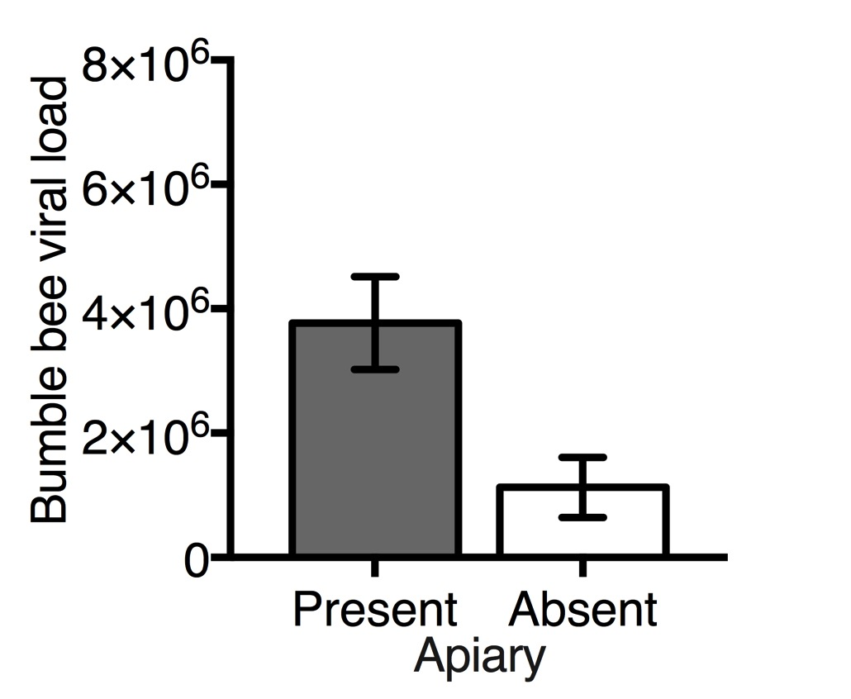
Preliminary work: In a field survey we conducted in 2015, we examined how virus prevalence in bumble bees is influenced by honey bee apiary proximity and floral diversity and density. In 2015, we made collections of bumble bees at multiple sites with and without honey bee apiaries. At each site, we collected 20 individuals of each of two bumble bee species, and made observations on floral abundance and diversity. We also made a collection of foraging honey bees (usually present regardless of apiary presence). We optimized primers for each of three RNA viruses—black queen cell virus (BQCV), deformed wing virus (DWV), and Israeli acute paralysis virus (IAPV)—and used quantitative reverse transcription polymerase chain reaction
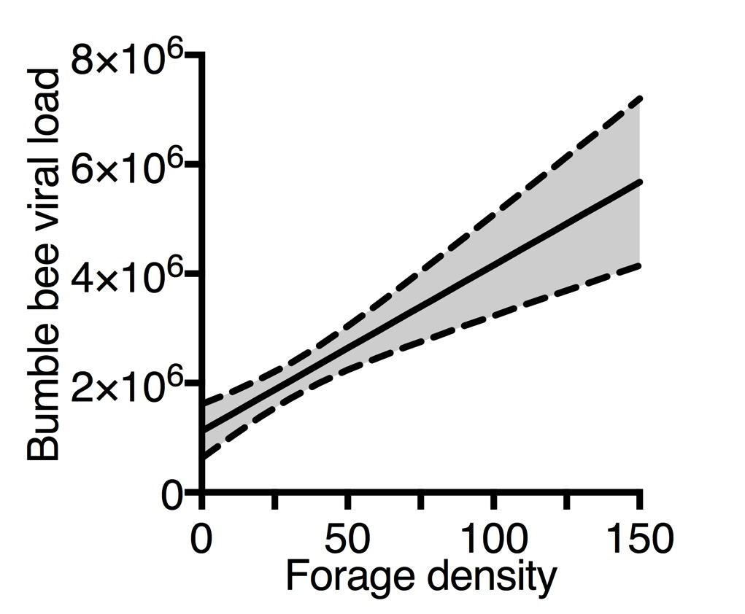
(RT-qPCR) to assess viral load for each bumble bee, and for homogenized samples of all honey bees from a site. We found that across all sites, probability of bumble bee infection was significantly higher for both BQCV (X₁² = 19.23, P < 0.0001) and DWV (X₁² = 9.33, P = 0.002) if a honey bee apiary was present at the same site. Further, bumble bee viral infection was more severe at sites with apiaries (X₁² = 6.57, P = 0.010; Fig. 2), and positively correlated with floral density (X₁² = 5.91, P = 0.015; Fig. 3) but not species richness (X₁² = 1.80, P = 0.180). Viral load (X₁² =46.48, P < 0.0001) and prevalence (X₂² = 26.85, P < 0.0001) differed among bumble bee species (B. bimaculatus and B. vagans). Finally, there was temporal variation in BQCV infection of bumble bees, with prevalence highest in June and decreasing throughout the summer (X₃² = 45.42, P < 0.0001).
Figure 3. Viral load correlated with floral forage density
Figure 2. Viral load for all viruses by presence of apiary

Based on this work, we hypothesize that viruses spread from honey bees to bumble bees, and that viral acquisition is a function of numerous interacting spatial and temporal factors, including apiary proximity, honey bee viral load, floral resource distribution, and host species identity. We therefore predict that: A) areas where wild bumble bees co-occur with managed honey bee apiaries are hotspots of viral transmission; B) transmission occurs via shared use of floral resources, and is positively correlated with floral density; C) there are temporal and spatial dynamics to bee disease transmission that can be modeled to allow better prediction of risk factors, such as land use and apiary management patterns.
Figure 4. The general approach. Here we outline the broad approach outlined in this proposal, where we aim to combine experiments, with modeling and field surveys. The work is planned to span 3 years, and would be carried out by a multidisciplinary team of researchers spanning several areas of expertise: pollination studies, ecology, epidemiology, and mathematical modeling.

AIM 1: Experiments and landscape data analysis
1.1 Patch level experiments
Here, we propose to conduct a series of experiments to determine probability of viral deposition on flowers and probability of acquisition of virus from flowers to parameterize a model that shows how, mechanistically, viruses are transmitted at a patch level.

Deposition Probability. In a controlled flight cage experiment, we will allow a colony of DWV-infected honey bees to forage on an array of flowers grown from seed in a greenhouse. Since plant species may differ in their propensity to harbor bee disease (Adler et al., 2016), we will choose and test 3-5 different plant species commonly recommended in ‘pollinator friendly’ plantings. These may include joe-pye weed (Eutrochium purpureum), showy goldenrod (Solidago speciosa), turtlehead (Chelone glabra), phacelia (Phacelia tanacetifolia), and buckwheat (Fagopyrum esculentum). We will assess number of foraging bees and will use cameras to record visitation rates to individual flowers. We will collect all visited flowers at four time intervals from 0-8 hours of exposure to infected bees. Flowers will be tested individually, with separate samples made from petals, pollen, and nectar in order to distinguish between deposition via feces (petals) and nectar/pollen (saliva). Using RT-qPCR, after the foraging period we will test all plant samples and bees for DWV. We will use results from viral assays and floral visitation rates, to measure: A) the likelihood of virus deposition, B) how much virus is deposited on flowers, and C) the relationship between deposition and infection status or viral titers in honey bees.
Acquisition Probability. The probability of acquisition of virus from a flower may be influenced by multiple factors including the amount of a virus on a flower, how long virus remains active on a flower, the number of infected flowers the forager visits, the amount of time spent foraging, and where the virus is deposited on the flower. The latter may be highly influenced by floral morphology. Although experimentally examining the role of floral morphology is outside the scope of our project, we will record it as covariate in field observations. Using a series of experiments, we will test how these factors influence the probability of viral acquisition from flowers to bumble bee hosts. Using flowering plants grown from seed in a greenhouse, we will experimentally infect different flower parts (petals, pollen, nectary) with viral isolate at a range of realistic levels, allow bumble bees to visit these flowers, and later test the bumble bees for viral infection. Results from the deposition experiment will inform our choice of plant species for the acquisition experiments. All bumble bee foragers will be individually marked and we will measure each forager’s visitation rates as well as time spent foraging on each flower. To test the infectivity and lifespan of a virus on a flower, in a separate experiment, we will infect flowers and allow bumble bees to visit the flower after 1 hour, 10 hours, 1 day, 5 days, and 8 days. All bumble bees will be collected, pollen starved for 72 hours, and tested for DWV infection using RT-qPCR. To determine virus replication in bumble bee hosts, we will conduct strand-specific RT-PCR for the presence of negative-stranded RNA of DWV, a replicative intermediate (Li et al., 2011).

1.2 Landscape-level data analyses
To identify factors involved in landscape-level transmission, we will conduct analyses of the following existing data sets and bee specimens:
Seasonality and prevalence: We will test for viruses on bee specimens collected across a range of date in 2016 field work. To further understand how virus prevalence in bumble bees changes with time, we conducted a pilot field survey in 2016. We collected bumble bees (Bombus impatiens) from 5 different sites (approx. 20 bees/site) at 4 time points. These bees are currently stored in a -80ºC freezer and will be assayed for 3 RNA viruses: black queen cell virus (BQCV), deformed wing virus (DWV) and lake sinai virus (LSV) using RT-qPCR to test how the element of time (seasonal change) might influence viral load and prevalence.
Bee abundance and diversity: Postdoctoral Fellow Leif Richardson and colleagues at Vermont Center for Ecostudies collected >10,000 bumble bee specimens during a citizen science inventory project in 2012-2014, and documented strong effects of land use and land cover on bee abundance and diversity (Richardson et al., unpublished). We will use this data to develop parameters describing effects of landscape factors on bumble bee occurrence.
Apiaries: We have obtained from the Vermont Agency of Agriculture, Food, and Markets a dataset with locations of >10,000 registered honey bee hives in >1,500 apiaries around the state. We will use these data to model how honey bee abundance, apiary management practices (e.g., migratory versus stationary operations), and other factors are correlated with bumble bee abundance, species richness, and disease prevalence. This analysis will be critical to the risk map development we describe below as a final goal in Aim 2.

AIM 2. Construct network models of transmission across multiple scales
2.1 Model bee-plant-virus transmission dynamics
From the experiments described in Aim 1, we will have developed a detailed empirical picture of several interacting factors structuring virus transmission (plant traits, bee species, virus taxon, etc.). We will not, however, have a means of integrating these different pieces of information into a coherent picture. Modeling is ideal for this purpose, as it can both synthesize conceptual pictures of complex phenomenon, and have explanatory or predictive power for phenomena taking place in the field. Using our empirical data as parameters, we will construct and compare two distinct types of network models: A) deterministic ordinary differential equations (ODE); and B) stochastic agent based models (ABM; Table 1). We choose to use these divergent modeling approaches in tandem because they are complementary, and together will allow us to use a dual modeling approach to investigate the varying and complex aspects of the plant-bee-pathogen system. Note that Aim 2.1 is not an explicitly computational or mathematical step, but an organizational step. It is, however, critical in the modeling process, and warrants explicit treatment.
Table 1. Distinguishing characteristics of the proposed types of models.
Model | Type | States modeled | State variables | Model of time | Time update | Type of prediction
ODE | analytical | population | continuous | continuous | synchronous | deterministic
ABM | simulation | individual (bee, plant, mite, virus) | discrete and/or continuous | discrete | synchronous or asynchronous | stochastic

Scales: Patch and Landscape. We will model dynamics across two ecological scales: at the level of the “patch” and the level of the “landscape.” The patch describes ecological interactions between bees, viruses, and plants that take place at restricted spatial scales, often comprising individual flowers and bee foragers in a given interaction (Fig. 5). The “landscape” describes disease dynamics at a higher level, where the interactions of multiple patches combine to create dynamics across larger units of observation. It is this level of observation that dictates epidemic spread at larger geographic scales.
2.2 Develop an ordinary differential equations (ODE) based model
Approach. Ordinary differential equations have been the workhorse for population-level modeling in biology and epidemiology, and have yielded many profound insights into the dynamics of disease transmission (Phillips, 1996; Nowak and May, 2000). Standard numerical methods will be employed to ensure that the solutions are numerically accurate (to within a specified tolerance), consistent, and stable (a particular concern if the system exhibits chaotic dynamics). The proposed ODEs will model continuous deterministic changes in continuous state variables lumped at the population or metapopulation level (e.g., the number of individuals of a given species that are infected with a given virus; Fig. 5 below). They will be developed using a novel heuristic, called “ODEs and formalized flow diagrams” (O.F.F.l) for conceptualizing and modeling complex compartmental models, that permits more careful tracking of interactions and corresponding equations (Ogbunugafor and Robinson, 2016).
On the one hand, this means that there will be relatively few variables, enabling a richer exploration of model behavior and the sensitivity of results (both in terms of solving approximations to the system of ODEs and the computation complexity of numerical simulations). However, on the other hand, modeling state variables as continuous (real-valued) population level variables changing continuously means that 1) one cannot model individually heterogeneous or adapting behaviors; 2) the interaction topology of species interactions is assumed to be panmictic (random mixing); and 3) it is impossible to simulate discrete emergentevents (e.g., extirpation of a species).
Figure 5. Hypothetical “patch dynamics” in bee viral transmission. Simplified schematic of viral transmission dynamics on a patch. We start with a basic compartmental model containing four actors: uninfected bees (B_{u}), infected bees (B_{i}), uninfected flowers (F_{u}) and carrier flowers (F_{c}). Diversity in bees, flowers, and other actors (like mite vectors) can be added to fit whatever scenario we are interested in modeling. Solid lines represent transitions—rates at which one species transforms into another species. Dashed lines represent interactions that drive the rates of transition.

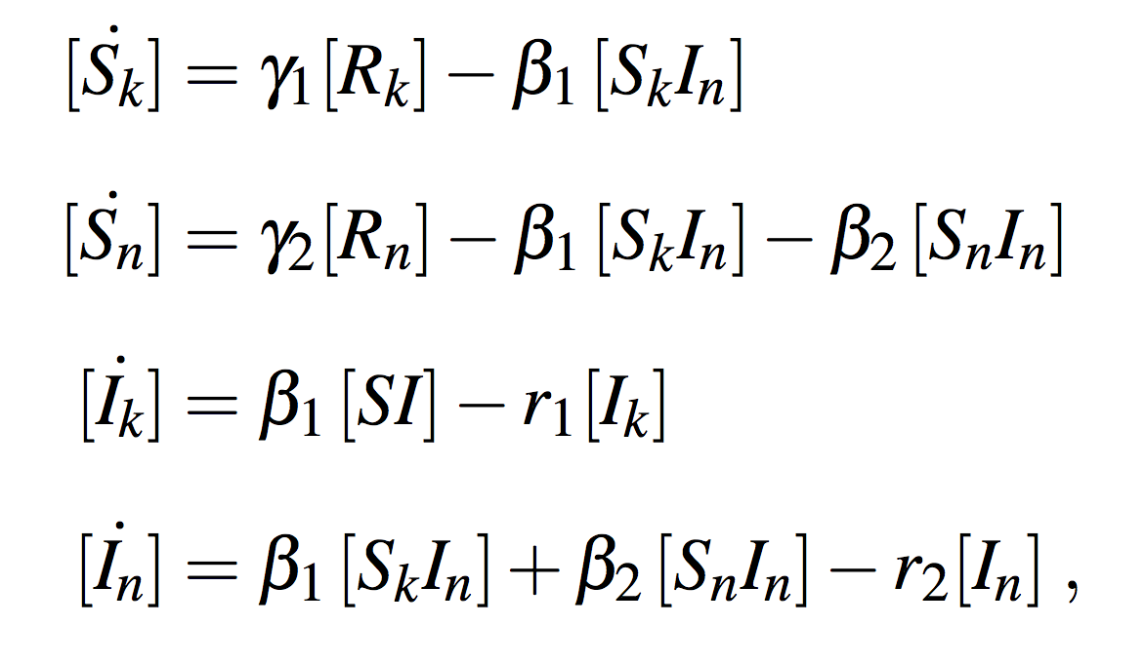
Example equations for a standard bipartite network model of disease transmission at the level of the patch. We will use a standard bipartite network model where nodes are distinguished by their state in a Susceptible-Infectious-Recovered model (Kermack and McKendrick, 1927) (variables in brackets correspond to the fraction of the population in each state) and subscripts distinguish the plants (k) from the bees (n). The epidemic is described by the following system of equations, where r₁ and r₂ are the recovery rates, beta₁ and beta₂ are the transmission rates, and gamma₁ and gamma₂ are the waning rates. The rates can vary between bee-bee contacts vs. bee-plant contacts. All variables in brackets are dynamical, and we use the dot notation to identify time derivatives and with an implicit [R_{k}] = r₁(I_{k}) and [R_{n}] = r₂(I_{n}) via the conservation condition S+I+R = 1.
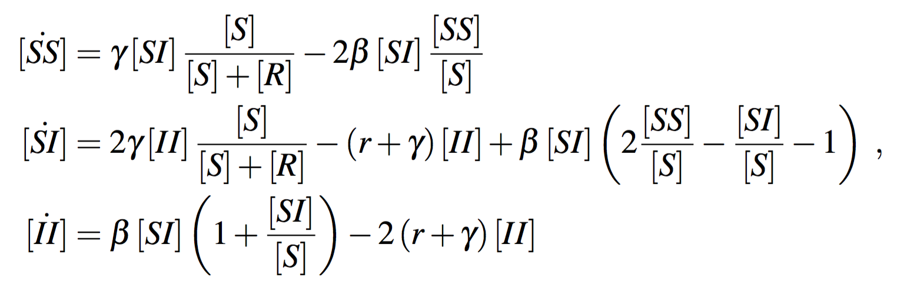

The pairs are followed by where all missing positive terms go to links involving recovered nodes (which do not need to be explicitly followed). We also dropped the subscripts for simplicity, as the full system contains seven equations.

2.3 Develop an agent based model (ABM) model
ABMs provide an intuitive, highly flexible approach to relaxing key assumptions made in the ODE models, and potentially uncover a wider range of emergent properties. As the data developed in Aim 1 will pertain to each of these actors, they can be recapitulated with regards to the individual (the “average” bee, flower, or virus taxon) and change according to simple rules (which may be deterministic or stochastic). Because of this, it is easy to model heterogeneous and/or plastic behaviors emblematic of natural systems. Furthermore, since agents can be associated with dynamically changing locations in space, one can model different types of spatially explicit interaction neighborhoods (including panmictic, nearest neighbor, distance weighted, etc.). In ABMs, time is simulated with discrete time updates (which may be synchronous or asynchronous) and attributes may be discrete and/or continuous. ABMs can thus exhibit emergence of discrete or continuous changes in system state, as well as self-organized spatial patterns. However, because attributes must be stored and updated for each individual, ABMs are much more computationally demanding (in terms of both memory and CPU time) than ODEs.
The use of multiple methods will allow us to compare them, and to ascertain which, if any, of additional complexities are important for modeling these dynamics. This approach is particularly important for systems like the bee pollinator-plant-virus system, where the particulars of the dynamics are largely unknown. In such circumstances, the use of multiple methods can reveal various features of the system. For example, we might find that the ODE model adequately captures the gross dynamics of bee to bee transmission with mites, but is inferior to the ABM on the topic of addressing questions related to the diversity and spatial distribution of floral resources.
2.4. Towards a Risk Map: Combining multi-scale models to create patch- and landscape-informed predictive models for disease spread across Vermont
Risk mapping is the use of multiple environmental variables and occurrence datasets to construct spatially explicit models of probability of some occurrence (Tong et al., 2015). Risk maps have previously been used to model prevalence and outbreak of diseases whose spread is affected by environmental factors, such as cholera (You et al., 2013) and schistosomiasis (Tong et al., 2015). The spatial aspects will utilize ArcGIS, a scalable, highly fungible GIS platform that will facilitate the integration of the models designed in Aim 2. Using this platform, we will be able to codify space with respect to the parameters that underlie the predictive models (e.g. number and distribution of apiaries).
From Aims 2 and 3, we will have two sets of network models (ODE and ABM) for two scales of dynamics (patch and landscape). The goal of the models is not simply to create multiple perspectives on the dynamics, but to organize a multi-scaled predictive model for viral transmission. By “predictive,” we mean the ability to predict different dynamics at the different scales. At the level of the patch, we want to identify factors correlated with transmission, such that we can predict those patches within a given setting where transmission is likely to be high. At the level of the landscape, we would like to identify larger-scale properties of farms and landscapes that might be predictive of large scale transmission dynamics.
Figure 6. Creating the Risk Map. The structure of the flow of information, from predictions, to parameterization, to the modeling exercises, culminating in the creation of a risk map of transmission.
Aim 3: A field survey to ground truth and test the Risk Map
To test our predictive model outputs (Aim 2), we will conduct an intensive field survey, over two years, focusing on the parameters the models identify as most influential in disease transmission at the landscape-level (Fig. 6). Using the risk map generated by the model, we will identify 20 sites across Vermont that span the range of predicted disease risk. Given our preliminary data, we expect virus prevalence in bumble bees to be influenced by one or more environmental variables, including honey bee apiary density and/or proximity, plant density and/or diversity, bee abundance and/or diversity, and seasonality. For two years, we will survey sites four times, from June to September. During each survey we will collect 20 worker caste individuals of each of three bumble bee species— Bombus bimaculatus, B. impatiens, and B. vagans—as well as honey bees (Apis mellifera). We will estimate overall bee abundance and diversity by conducting standardized net collections and by deploying pan traps for 48 hours (Droege et al., 2010). We will conduct detailed line transect surveys of flower abundance and plant species richness.

We will use a variety of spatial databases to model habitat conditions at each collection site, including the National Land Cover Database (Homer et al., 2004), Worldclim climate models (Busby, 1991), Vermont Center for Ecostudies bumble bee species diversity data (Richardson et al., unpublished), and National Honey Bee Survey data.

We will use RT-qPCR to determine prevalence of three viral diseases in each bumble bee specimen, and will also test each bee for presence of other diseases, including Nosema spp., Crithidia spp., and mites. Honey bees will be homogenized within site survey events and assayed for viruses. We will pin all other bee specimens and identify them to species level using standard taxonomic resources (e.g., Mitchell, 1960; Droege et al., 2014; Williams et al., 2014). We will calculate rarified species richness estimates for both bees and plants at each site.

We will use the resulting dataset to examine patterns of virus presence in bumble bees as a function of spatial and temporal variables, using spatial analysis, generalized linear models and repeated measures ANOVA using the R Statistical Computing Environment (R Core Team, 2016). We will then relate observed patterns of disease occurrence to modeled predictions, using statistical learning methods to evaluate model fit and value of particular model parameters in prediction. Our conclusions will allow us to refine models. We anticipate this to allow prediction of 1) what landscape and biotic factors promote disease transmission between managed and wild bees; 2) how disease risk varies across time; 3) how spatio-temporal patterns alter directionality of transmission among managed and wild bees; and 4) what factors increase and decrease the precision of our estimates of risk. Our conclusions will allow novel approaches to management of bee disease. For example, detailed risk maps will permit growers to structure land management activities to minimize disease risk to wild bee pollinators of agricultural crops. Such resources will support conservation decision making for rare, threatened, and endangered bumble bee species such as B. affinis and B. terricola, both of which are protected by law in Vermont. And, they will allow beekeepers to site apiaries to minimize pathogen spillover to wild bees as well as back-flow from wild bees to their hives. Moreover, our risk modeling of bee disease dynamics will serve as a model to increase our understanding of how environmental factors shape human and zoonotic disease outbreaks.

INTELLECTUAL MERIT
Although the 21st Century has seen a rapid increase in the scope of biological information, progress remains slow on advancing the theoretical underpinnings of infectious disease and the conversion of these ideas into actionable items to curb epidemics (in biomedical or agricultural contexts). We can begin to fill these gaps by more fully characterizing how the interactions among pathogens and their hosts leads to disease in an environmental context.
There have been recent calls for more community ecology-based perspectives on infectious diseases (Pedersen & Fenton, 2007; Joseph et al., 2013; Johnson et al., 2015). A community ecology approach would fill gaps in our understanding of many infectious disease systems, where the two-party interactions between pathogen and host have been the focus to the exclusion of broader, systems based observations. The lack of community ecology-based perspectives and methods is particularly costly in the context of diseases in agricultural systems, which are composed of multiple actors: pathogen-host dynamics, plant ecology, human farming behaviors, economics, and sociology. And while no single proposal could hope to address all of these actors and the totality of their interactions, our work aims to understand the essential dynamics of viral transmission in bee pollinators, and develop cutting-edge, scalable approaches to examining factors that influence diseases in other systems.
Our work is uniquely positioned to provide synergies and bridge the gap that exists between the practitioner and the academic. It not only addresses an important problem in agriculture, it seeks to do so using an intelligent blend of perspectives. We believe that the approach itself, and not only the knowledge of virus transmission in pollinator systems, to be a potentially groundbreaking product of this collaboration. We say that because the outlined approach—field surveys, laboratory experiments, molecular virology, computational, and mathematical biology—creates new avenues for analogous research in related systems of various kinds.
BROADER IMPACTS OF THE PROPOSED WORK
1) Training. One Post-doc and two graduate students will receive interdisciplinary training and knowledge across ecology, molecular biology, epidemiology and computer science; and 4 undergraduates/year will receive hands-on skills in field and lab work. In addition, our work will have significant broader impacts across a variety of societal sectors.
2) Agriculture. Nearly 90% of angiosperms participate in pollination mutualisms, exchanging pollen, nectar, and other floral products with animals for the service of pollen transfer between flowers (Ollerton et al., 2011). The global decline of pollinators has reduced food security and profitability for fruit and vegetable farmers who rely on pollination services. On May 19th, 2015 the White House released the "National Strategy to Promote the Health of Honey Bees and other Pollinators". Our proposal is aligned with this National Strategy to promote pollinator health for the sake of food security and ecosystem stability.
Although we know that diverse plant species surrounding croplands enhance bee species abundance and richness (Klein et al., 2007; Ricketts et al., 2008; Carvalheiro et al., 2011; Sardiñas & Kremen, 2015), virtually nothing is known of the costs/benefits of providing these resources with respect to the transfer of diseases among bees. Our work will provide direct management recommendations to farmers that, if implemented, will support delivery of the ecosystem service of pollination while minimizing risk of disease transfer. We will hold farmer and beekeeper workshops and produce and distribute a “white paper” detailing ways in which growing practices can support bee health.
3. Community engagement. We propose to engage local high school students to participate in field, greenhouse and laboratory data collection. To this end, we have identified biology teachers at 7 high schools in Chittenden and Washington Counties, VT (Burlington, South Burlington, Champlain Valley Union, Union-32, Colchester, Montpelier, and Northfield High Schools) who are interested in involving students in this research. Our collaboration with high school students will give them valuable exposure to scientific research with applied environmental value, and will help them evaluate the merits of careers in science, technology and math (STEM) fields. We believe this relationship can also improve outcomes of the research we propose here.
4. Diversity in STEM fields. This proposal outlines a research program that would launch the academic research career of C. Brandon Ogbunu, the lead investigator on this project. Though very early in his career, he has worked across multiple fields including microbial evolution, mathematical biology, computational biology, and epidemiology. He has been active and engaged in mentorship and teaching since he was in graduate school, and prioritizes student training and community participation as an essential component of his academic life. As a member of a demographic (African-Americans) that is underrepresented in the STEM fields (National Academy of Sciences 2015), he hopes to use his platform in academia as an opportunity to expose members of underrepresented groups to fields that they might be unfamiliar with, such as ecology, entomology, and computational biology. To do this, he will align his STEM diversity efforts to his many professional connections and collaborations with organizations like the Ford Foundation, the United Negro College Fund/Merck Science Initiative, and The Association of Underrepresented Minority Fellows (AUMF). He has already been involved in the recruitment of underrepresented minorities for faculty jobs at UVM. In addition, he has relationships with his alma mater, Howard University (a Historically Black College/University), in the Department of Chemistry and the College of Arts and Sciences Honors Program. He will leverage these connections to actively recruit undergraduate and graduate students to one of the member labs involved in this project (Ogbunu, Brody, or Scarpino). Lastly, Ogbunu sees this project as a means of anchoring his general effort to expose diverse communities to quantitative methods and computer science. He has been involved with Coderdojo (open-source, volunteer-led organization that hosts coding workshops targeted at young people; coderdojo.com) while he was in Cambridge, MA. He and Co-PI Scarpino are planning related activities in the Burlington and South Burlington, VT communities.
5) Educational and outreach initiatives. In 2016, Lead PI Ogbunu published several manuscripts that on pedagogical-related topics, one involving molecular evolution (Ogbunugafor and Hartl, 2016) and the other in mathematical modeling (Ogbunugafor and Robinson, 2016). In the latter case, he and a physicist colleague invented a method, called ‘Ordinary Differential Equations and Formalized Flow Diagrams” (O.F.F.l,) that aimed to improve the process of mathematical modeling of ecological systems. This is a method that we’ve directly invoked in the current proposal, and will play a role in a key broader impacts activity. Lead PI Ogbunu and Sean Robinson (of the Massachusetts Institute of Technology) have formalized the “Open Modeling Research Group” (modeling.mit.edu), where they are developing a teaching and exploration tool for mathematical modeling. In addition, Lead PI Ogbunu is using this platform to launch an outreach initiative, “Mathematical Storytelling,” where he will attempt to improve the public understanding of mathematical concepts through merging math concepts with storytelling elements (He will collaborate on this with Co-PI Scarpino) The proposed project would be an ideal launching point for the outreach project, because the O.F.F.l method is being employed in the proposed study. Therefore, it would serve as a useful example of how the same methods featured in “Mathematical Storytelling” are being used to by real-life scientists.

