# CS 255 System Design Document Template

This template lays out all the different sections that you need to complete for Project Two. Each section has guidance to prompt your thinking. You will need to continually reference the interview transcript as you work to make sure that you are addressing your client’s needs. There is no required length for the final document. Instead the goal is to complete each section based on what your client’s needs are. Remove this note when you are finished, and replace all bracketed text with the relevant information.

## UML Diagrams

### UML Use Case Diagram

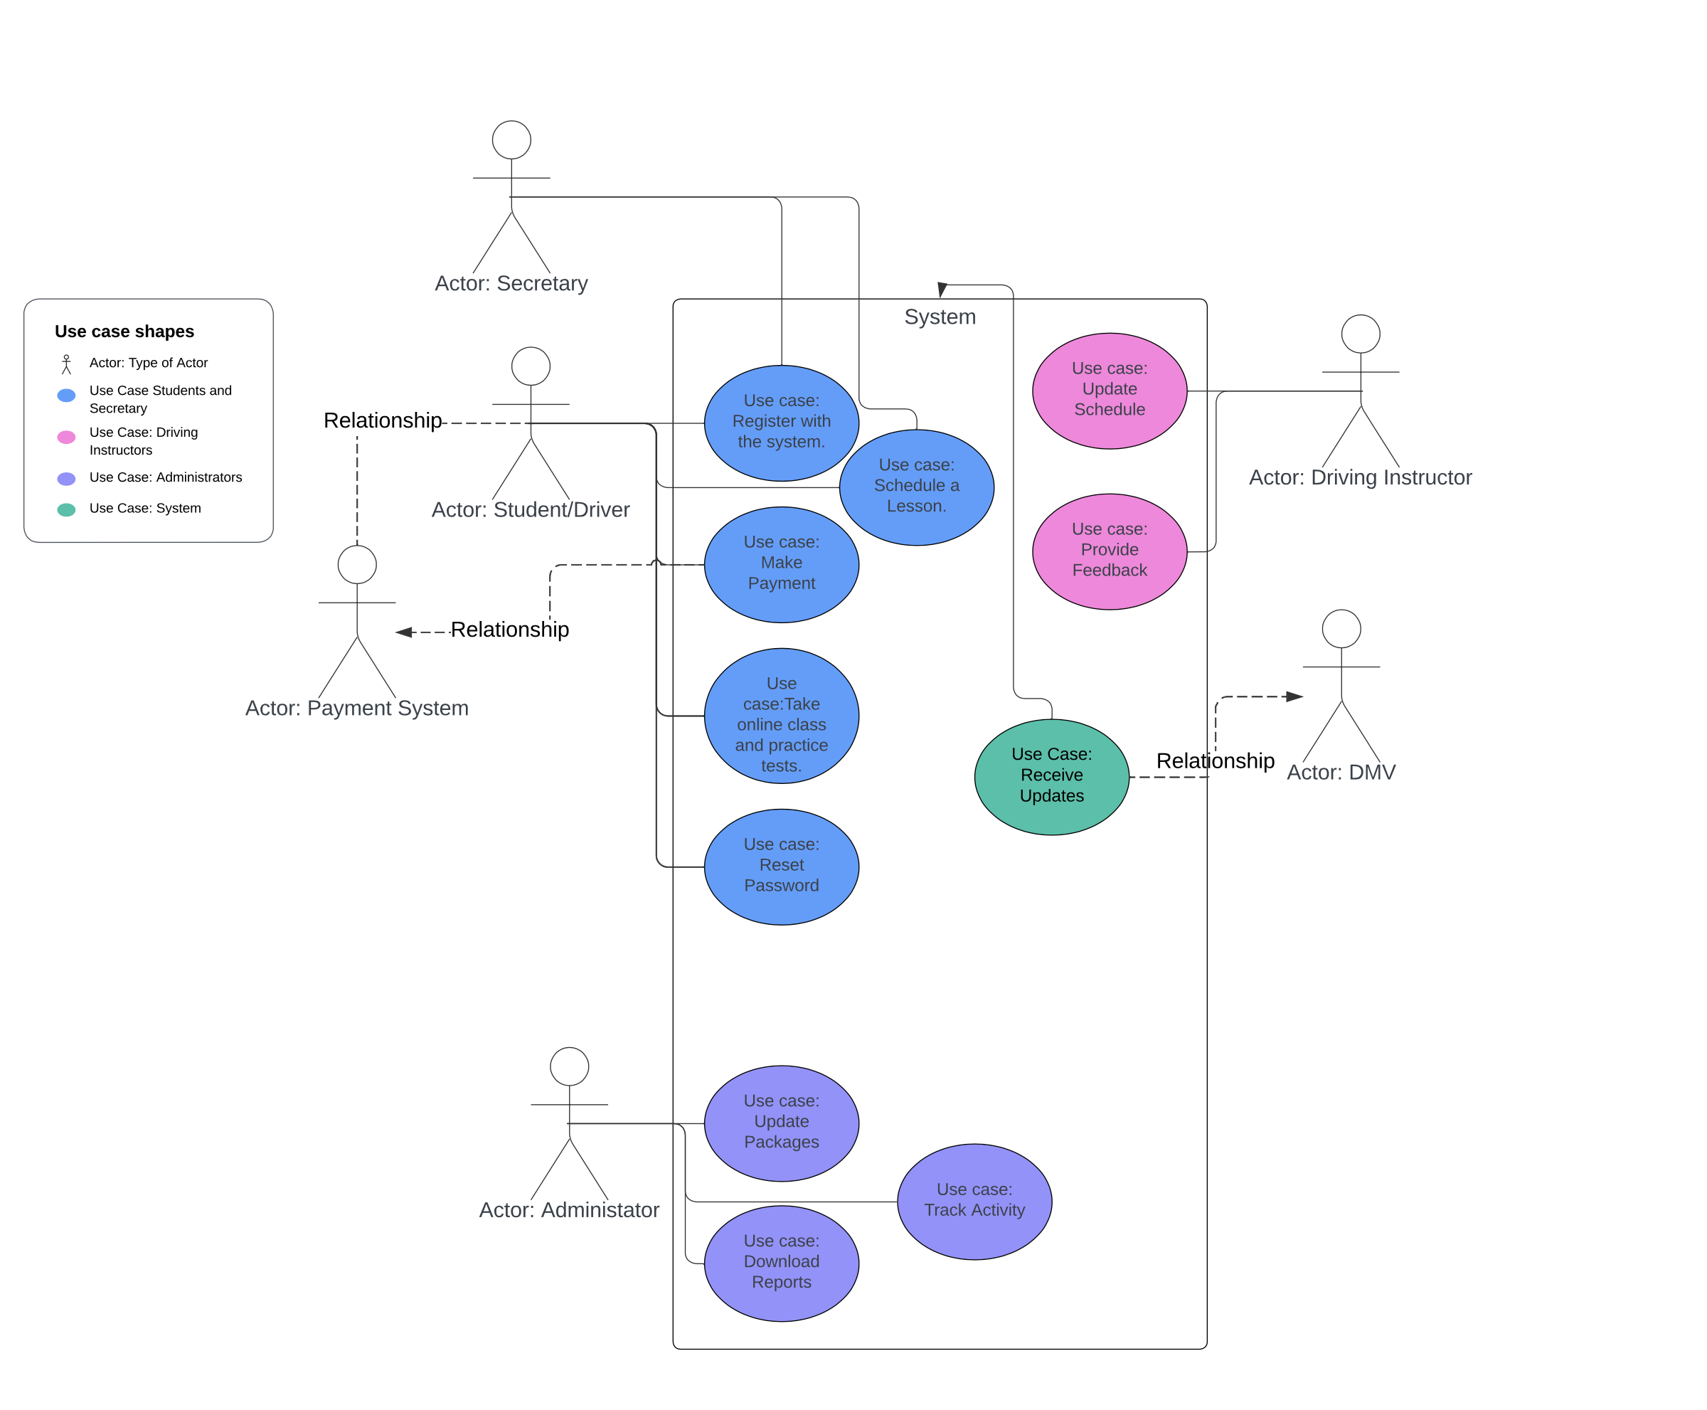

### UML Activity Diagrams

Diagram for Register with the System

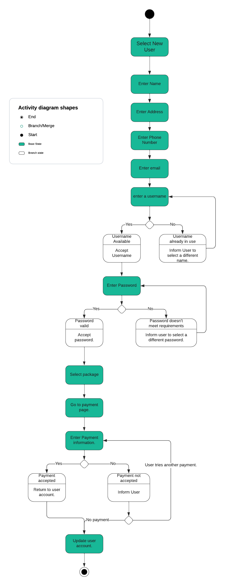

Schedule a Driving Lesson

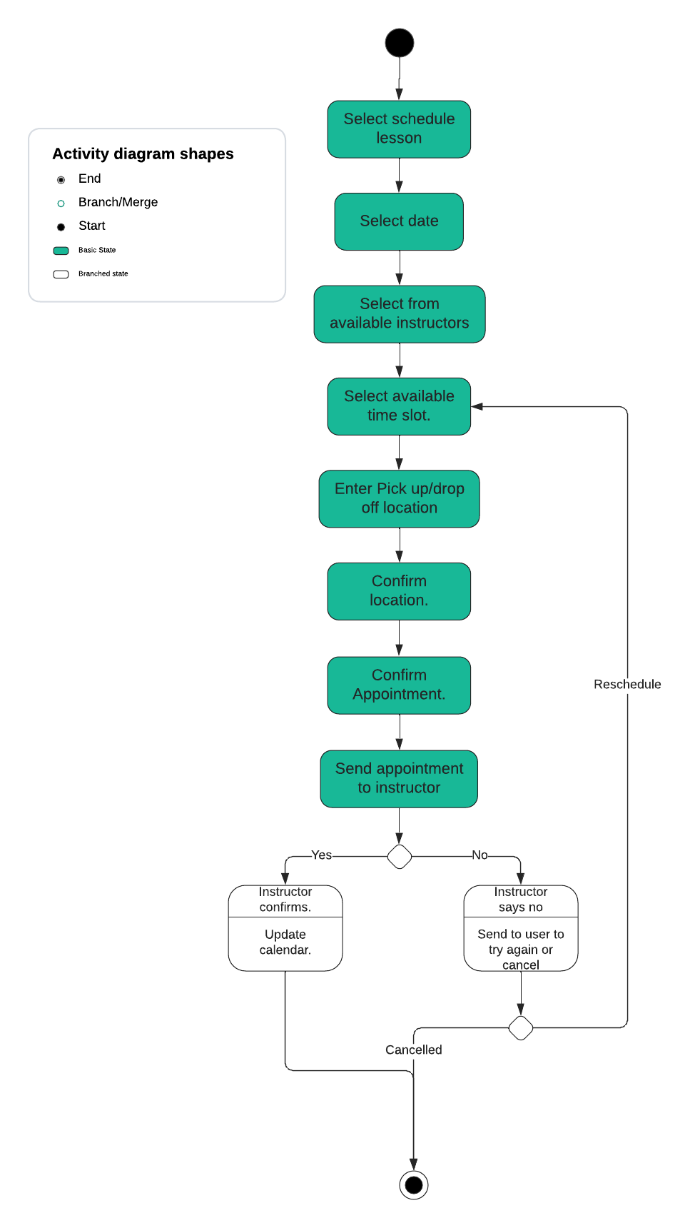

### UML Sequence Diagram

Register with System

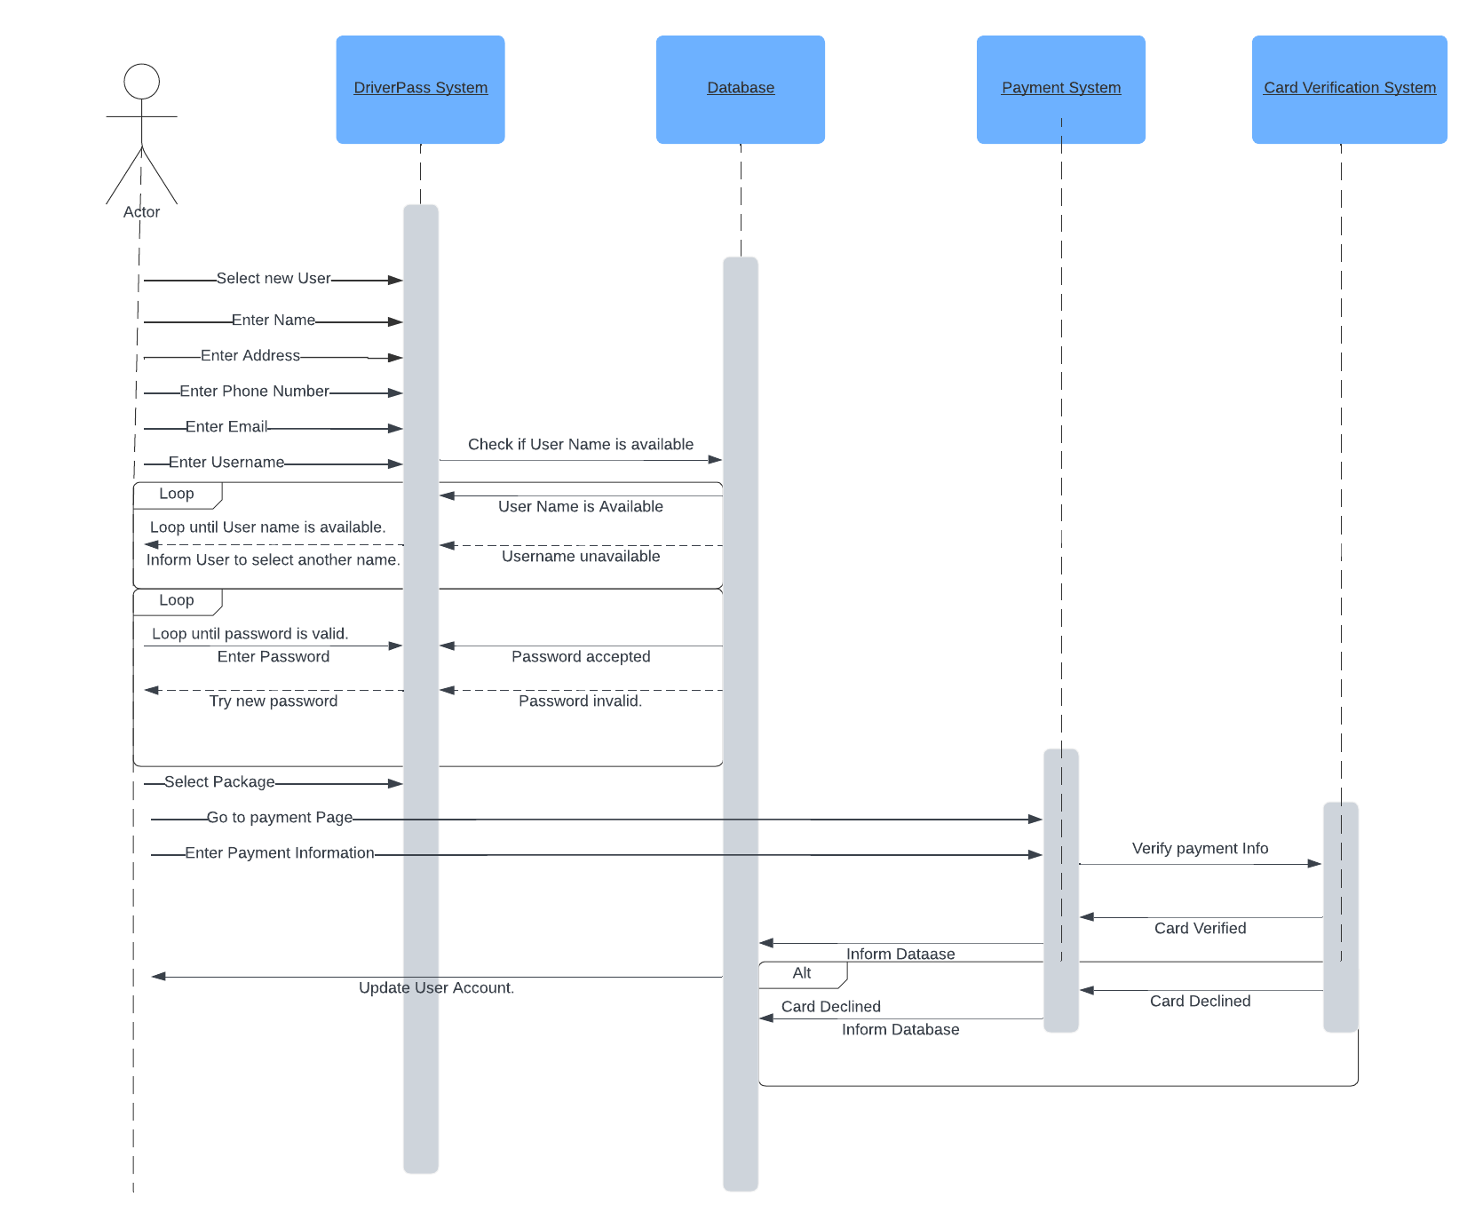

### UML Class Diagram

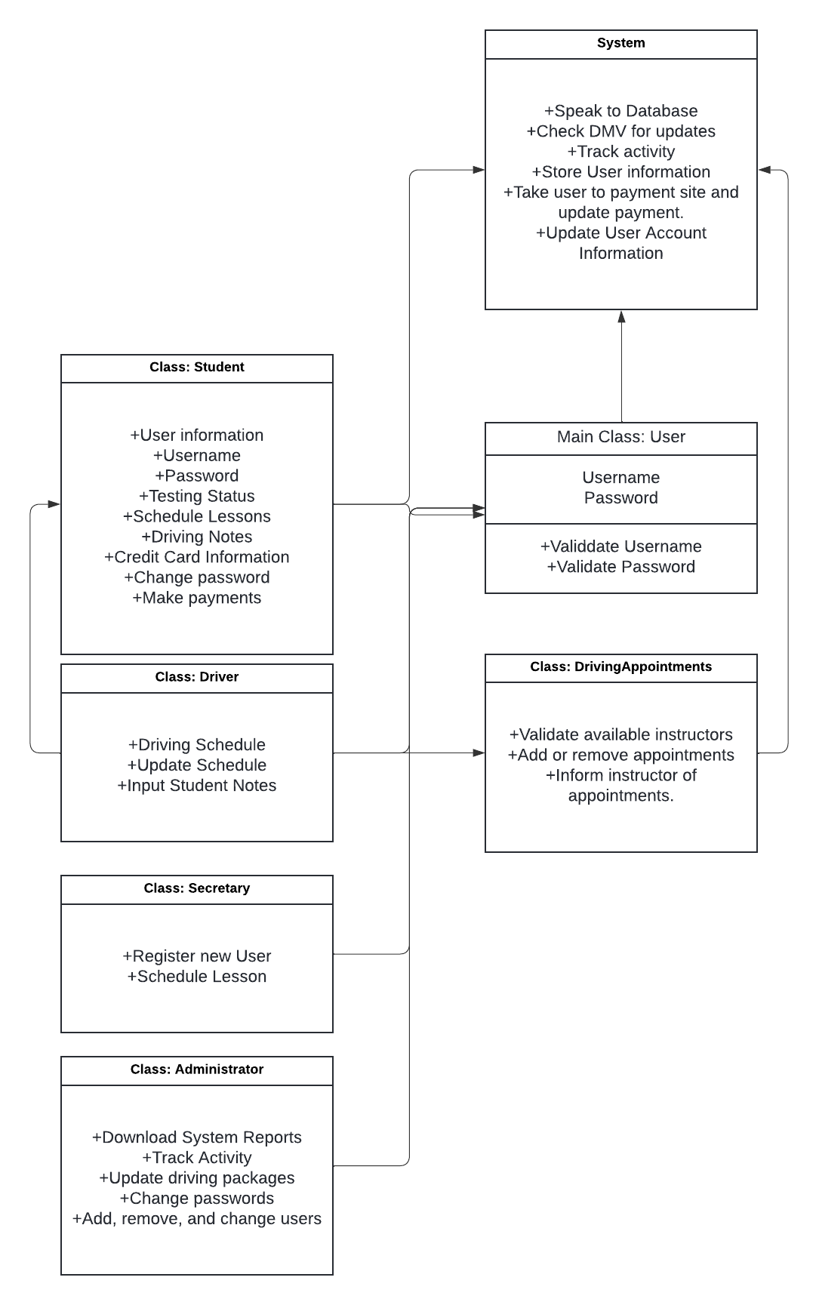

## Technical Requirements

For the technical requirements, this needs to be broken down into the hardware, software, tools, and infrastructure for the design. To begin with, we need to discuss the infrastructure.

**Infrastructure**

The infrastructure needs to be cloud and web-based in order to make the system accessible from wherever someone needs to do so. This means that the base infrastructure needs virtual machines that can be accessed via the internet. For an example, and a possible option in this, Amazon Web Services is a commonly used infrastructure that is based in the cloud. This also allows for outside management of the infrastructure and reduces downtime and risks that would normally be on the company’s hands.

The main infrastructure the company would need themselves is basic networking infrastructure. Much of this is likely handled by the cloud-based infrastructure, but a redundancy in terms of the physical side can help reduce risk as well, though the cloud will handle that reduction more easily. The hardware section will talk about the specific networking needs, but mainly it would include a single server that handles the in-house elements of routing, database, and even the active directory if necessary.

**Hardware**

The hardware needs to be broken down into user devices and networking devices. To start with, the networking devices are as follows: Physical Server running server software, Backup Database Server, Router, Modem, Wireless Router, and a Switch.

The physical server and the backup database server allow for running the company and providing base software that is important. Storing on a physical device for the backups can be difficult, but having both a backup on the cloud, and physically, allows for more control in ensuring that there’s always somewhere to find the information.

The router, modem, wireless router, and switch are all physical hardware that help employees connect to the cloud and the physical database from all devices running within the network. While the cloud can handle a lot of these capabilities, you still need a physical location set up for networking. This is because you do not want your users to insecurely store information outside of the network. Also, having a physical connection to the internet is necessary for allowing devices to access the internet. With this it is easier to keep the company’s information secure if people are running from a specific network that the company has set up.

For the user devices, this fall into the category of desktops, laptops, and mobile devices. These are the devices that the users will use to connect to the in-house network. These devices run basic software and, as long as they have networking capabilities, can connect to the network. These would allow for the employees to work where they need to.

**Software**

The next important element is the software. There is the software that runs the application, but the main software for the system runs a little differently. What needs to be considered is the following:

Database software: This software handles ensuring that users are validated, removed, added, and updated. It would also allow for downloading certain types of reports for understanding how often someone uses the system, what, if any, packages are purchased, and keep track of the information to make informed decisions. Main types of database software include NoSQL, SQL Server, and Mongo DB. These are important for reporting and ensuring that the wrong users information is input.

Operating Systems: this software is essential for running many devices. If you’re running a tablet, desktop, or laptop, those devices come with operating systems. The main thing will be to ensure that they are capable of connecting to a network. This also goes beyond those, as there does need to be a server operating system. For this, it is recommended to use a Linux based server as it will connect with the widest range of devices without blocking some out as Windows can do in terms of iOS-based devices. It is also one of the more commonly used server operating systems.

Scheduling Software: since being able to schedule driving lessons is a big part of the company’s goals, having a scheduling software that connects to everyone’s schedule is important. This can be done using programs like Microsoft Outlook where those in the network can see each other’s schedule, but this does not necessarily work for users that are trying to schedule appointments. Implementing a scheduling system that connects to the database and system itself will allow for this. A central program, likely on one of the cloud servers, would gather information and store it to be used. This would allow for the program to send out the information to the system and ensure that there are no double bookings.

Tracking/monitoring Software: tracking software is a tool for administrators and IT professionals to track activity on the system. This ties into the database and can feed in information for user activity, purchasing information, accounting information, and even web-activity used in the company. This software is also capable of producing reports that can expand upon the database reports themselves.

Office Suite: This is a pretty simple one that allows for gathering reports and accounting information in a readable format that can be used both online and offline. The main one that is currently used by most people is Office 365.

VPN Software: this is known as a virtual private network. This software allows for users from within the company to connect to the network when using an outside network. This provides a secure connection without having to leave your network open to non-employees.

**Tools**

This is more for development process. The tools that are necessary will allow for creating the program and updating it as needed. Mostly this requires development environments, which is determined by the type of coding language, and testing platforms. Tools like this can be found via the web, commonly you’ll see people use Visual Studio and JIRA for both development and testing purposes. These tools can be contained within the cloud and accessed through internet use. These tools are necessary for the development, and updating, of the system as a whole. They are focused upon the developer and tester side of things, but are necessary in ensuring the system remains up-to-date.