Module 1: Biases in Data

Samantha Durr

Computer Science, Southern New Hampshire University

CS 640: Applied AI and ML

July 6, 2026

When looking at data, especially for machine learning and artificial intelligence, it’s important to be aware what biases the data can show. In this particular assignment, we are looking at Adult Income data and searching for those potential biases. The below document is an analysis of this data.
Data Structure
The data structure can be broken down into the shape and columns. Since this data contains strings and number values, this is handled by printing the information. What is seen is that are 48,842 rows by 15 columns. The rows are the observations and the columns are the attributes. Delving further into the data, the columns are: 'age', 'workclass', 'fnlwgt', 'education', 'education-num', 'marital-status', 'occupation', 'relationship', 'race', 'sex', 'capital-gain', 'capital-loss', 'hours-per-week', 'native-country', and 'class'. This data contains numerical values through floats, but it also contains missing values. These are labelled NaN.
When looking at this data, it’s the final row of class that’s the target value. This is because there are only two possible outcomes that can be chosen <= 50K and >50K. This isn’t to say that the target variable can’t go deeper, but all other values are either NaN or they fall into the count and unique feature columns. Class only has two options that are unique and it contains all of the rows. That’s what makes it the target value.
Structural Issues
In terms of this structure, there can be a few issues within it. At this point in time, the class has some imbalances. This is seen when breaking down the data for <=50K and >50K. The majority of the data is less than or equal to that 50K value. The data itself shows that there are 37,155 rows containing that value, which is 76% of the data. There are only 11,687 rows that are greater than 50K. This is only 23% of the data. That results in this model containing a higher bias towards anyone that falls into the less than or equal to group.
From there, it’s the missing values that becomes important. Missing values are represented by NaN and, when looking at a breakdown of those missing values, provide the following information:
- Occupation: 2,809 missing and 5.75% of the total
- Workclass: 2,799 missing and 5.73% of the total
- Native-country: 857 missing and 1.75%
What this shows is that there are a total of 6,465 missing values within the data. This results in skewing the data because it’s incomplete. When incomplete, it can introduce systematic bias. This can result in the models making faulty assumptions.
Lastly, there’s the distributions. The image below shows the general distributions.
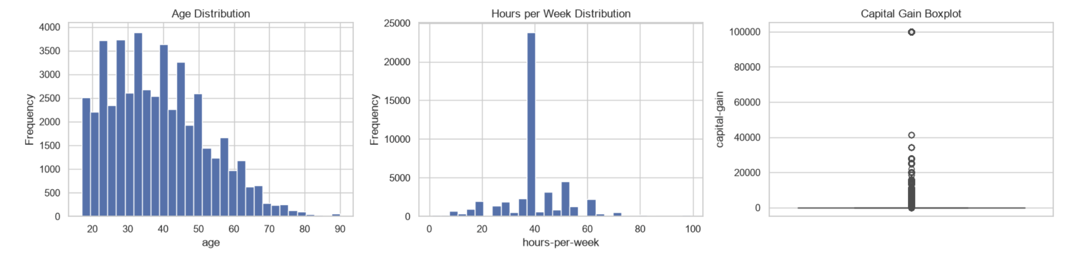
The first graph is the age distribution. This distribution shows that the age is heavily right-skewed. What this does is show that the data is peaking for individuals in their late 20’s-late 30’s. It also steadily drops as the age increases. There’s also a small number of senior citizens in the dataset, which means that any model trained on this might struggle to accurately predict the income for older populations. The next graph is the hours per week. This has a massive spike at 40 hours. This is a highly concentrated point. The data may span from 1 to 99, but it’s still clustered at the 40-hour point. This means that ‘hours-per-week’ acts less like a smooth curve and more like a massive binary indicator. The last graph is the capital gain boxplot. This has severe outliers and an artificial data cap. What this is showing is that the plot is completely squashed flat a 0. That shows that the majority of people have zero capital gains. The part that makes more interesting is that it has a vertical trail of circles that represent extreme outliers. That thick cluster of circles is sitting at the very top line of 100,000. This proves that the data was artificially censored or capped at that limit. This is a major structural anomaly.
All three of these different components show that the data is imbalanced. There are only two points that are looked at. The data is skewed in one direction no matter what type of data is being looked at and it contains enough missing values to result in the systems output being inaccurate. When it comes to going further into those patterns, it can be broken down further than just seniors not being represented. The data can go into sex, race, and the education level. Below are tables and graphs that spell out the different groups and whether the numbers are in the less than or equal to 50K or the greater than 50K classes.
Sex | <=50K | >50K
Female | 0.891 | 0.109
Male | 0.696 | 0.304

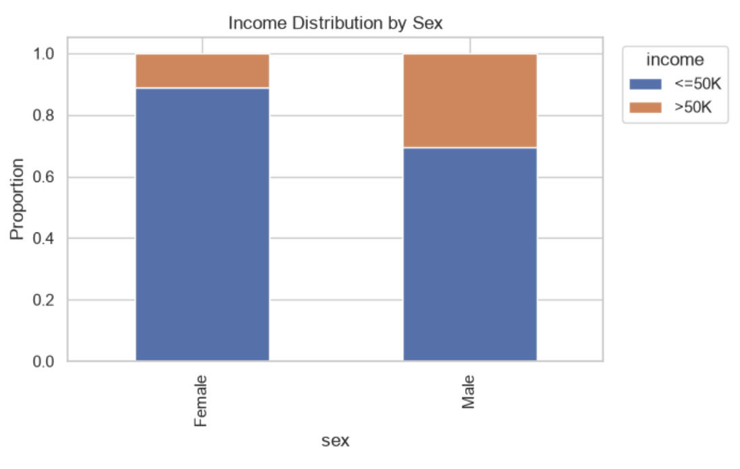
What this table, and the stacked bar chart, shows is that only about 11% of females earn more than 50K compared to over 30% of males. This results in a bias risk because the data is reflecting a heavy systemic wage gap. The model will use this sex value as a strong predictive signal. It means that the algorithm learns that if the earner is female, it needs to predict a low income. This is historical bias and penalizes females with a false predictive signal.
Race | <=50K | >50K
American-Indian-Eskimo | 0.883 | 0.117
Asian-Pacific Islander | 0.731 | 0.269
Black | 0.879 | 0.121
White | 0.746 | 0.254
Other | 0.877 | 0.123

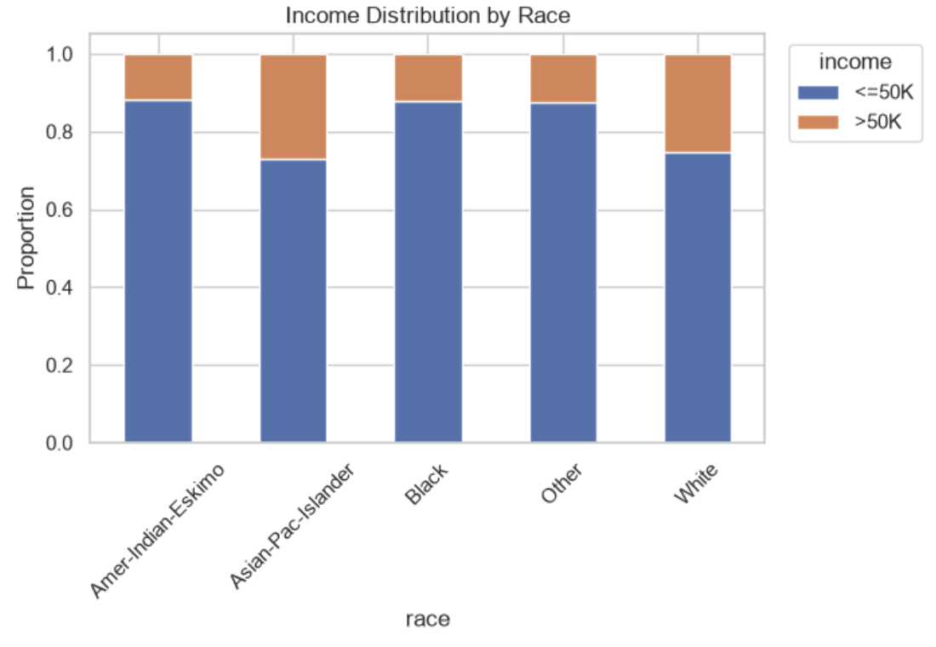
This table, and the stacked bar chart, shows that Asian-Pacific Islander and White groups have a significantly higher proportion of earning over 50K. This is around 25-27% of the total. When comparing this to the other groups, it causes a bias that leans heavily towards these groups. This is because the rest only make around 11-12% of that value. It also means that the model has an extreme shortage of data for high earners in the minority groups. What that shows is that if the algorithm attempts to maximize the overall accuracy, it optimizes its rules for the majority of the population and fails to accurately predict outcomes for minority groups. This can perpetuate systemic inequality.
Education | <=50K | >50K
Professional School | 0.260 | 0.740
Doctorate | 0.274 | 0.726
Masters | 0.451 | 0.549
Bachelors | 0.587 | 0.413
Associates—Academic | 0.742 | 0.258
Associates—Vocational | 0.747 | 0.253
Some college | 0.810 | 0.1901
High school graduate | 0.841 | 0.159
12th grade | 0.841 | 0.159
7th – 8th grade | 0.935 | 0.065

This last table shows that only 6.5% of individuals with an eighth grade education earn over 50K. On the other side, over 72.6% of doctorates and 74% of professional school grads are earning over 50K. This is a signal that shows that, unlike the other demographics, the education provides a more legitimate predictive signal for income modeling. It shows that the higher the education gained, the higher the pay, which does match a typical model.
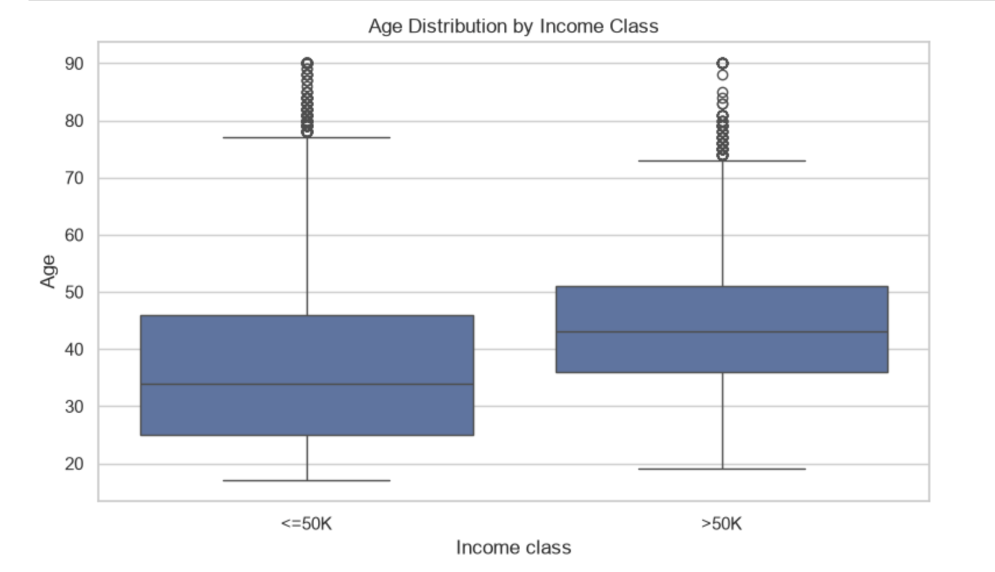
This last component, which is a box plot, shows the age gap between earning and age groups. What’s seen in this plot is that those of the approximate age of 25-45 are showing a higher earning level less than or equal to 50K, while those who are around 35-52 are earning more than 50K. The thing is, there is overlap, but this results in creating a model that will say, if you’re under the age of 35, you’re going to be earning around 50K or less. Once you get to about 35, it could go either way, but the data has a bias in the lesser direction.
What all of this points to is that the data has a tendency to lean towards natural biases in the real world because we see this actively. It means that there’s a higher chance of false predictive results based on information that’s available.
Visualization
When it comes down to going further into the bias, it’s possible to combine the share of greater than 50K between sex and by the Race. The visualizations of this are below.
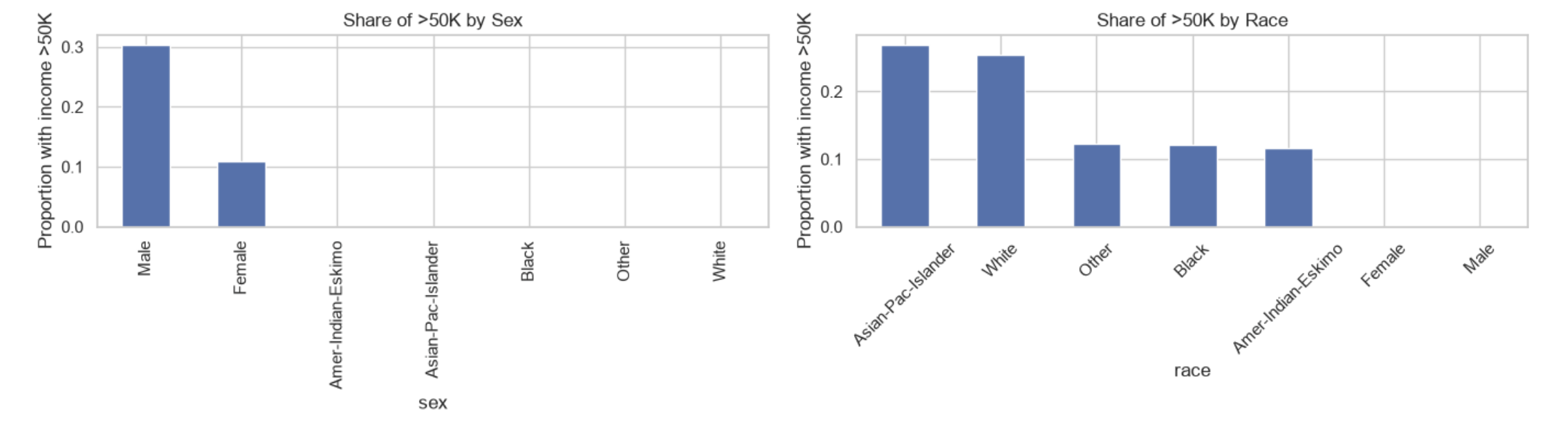
Concerns and Recommendation
What all of these tables and graphs show is that the data is going to focus, and accurately predict, result for low-income white males. Other groups will be seen as noise. That’s because that sampling is leaning towards that one group. This distorts the weights. That means that any models utilizing standard numeric optimization will have their mathematical understanding of high-net-worth individuals skewed. It’s an artificial limit that leads to flawed feature weights during the training. It can hit areas seen in the real-world, as there is a known disparity between age, sex, and race, but the data will have a problem predicting for these other groups that aren’t as represented by the data.
When it comes to taking this information and recommending appropriate preprocessing, adjustments, validation strategies, and fairness checks, it’s best to systematically mitigate the risks. The below list has the recommendations and why these were chosen.
- Preprocessing and Handling Imbalances: it’s best to implement resampling techniques such as Synthetic Minority Over-Sampling. This artificially generates synthetic examples of the minority high-income class. It can target down-sampling on the majority class records too. This addresses the other 24% the data currently ignores. This allows for treating errors in both classes with equal weight and drastically improving minority class recall and overall model generalization.
- Feature Adjustments: to accomplish this, it would be best to completely drop sensitive demographic attributes, such as sex and race from the training data. This enforces a standard of fairness by making the system ‘blind’ to these features. If the features are kept, it will continue to skew the data. By removing them, the system is forced to work with non-discriminatory features like education or occupation to map income.
- Validation Strategies: a good strategy is the Stratified K-Fold Cross-Validation method. This generates custom evaluation slices grouped by demographic categories. The idea behind this is that reduces the risk of not representing minority demographic groups. Stratifying this guarantees that every training fold preserves identical targets and feature distributions. This prevents deceptive optimization metrics.
- Fairness Checks: the way to accomplish this is to integrate post-training algorithmic fairness interventions using Disparate impact and equalized odds. With dropping the sex and or race groups, the machine model frequently reconstructs protected attributes through highly correlated proxy features. By mandating fairness checks via open-source auditable toolkits, the system can have a final safety barrier. This barrier mathematically ensures that the resulting model behaves equitably before it interacts with real-world applications.
In the end, this data is heavily biased and skewed, but if a few steps are put into place, the model can be more reliable for accurate predictions and be blind enough to support minority groups.
References
Bains, C. (2024, September 13). The legal doctrine that will be key to preventing AI discrimination. Brookings. https://www.brookings.edu/articles/the-legal-doctrine-that-will-be-key-to-preventing-ai-discrimination/
Buhl, N. (2023, August 8). How to mitigate bias in machine Learning Models. Encord. https://encord.com/blog/reducing-bias-machine-learning/
Chawla, N. V., Bowyer, K. W., Hall, L. O., & Kegelmeyer, W. P. (2002). SMOTE: Synthetic Minority Over-sampling Technique. Journal of Artificial Intelligence Research, 16, 321–357. https://doi.org/10.1613/jair.953
Common fairness metrics — Fairlearn 0.15.0.dev0 documentation. (n.d.). https://fairlearn.org/main/user_guide/assessment/common_fairness_metrics.html
GeeksforGeeks. (2025, July 15). Stratified K Fold Cross Validation. GeeksforGeeks. https://www.geeksforgeeks.org/machine-learning/stratified-k-fold-cross-validation/
Mack, O. (2023, August 31). Promoting AI Fairness: The Application of Disparate Impact Theory. Law.MIT. https://law.mit.edu/pub/promoting-ai-fairness-disparate-impact-theory/release/1
Sebastian, A. M., Peter, D., & Sebastian, R. A. (2025). An optimal imputation algorithm for reducing bias and errors in missing data handling for AI models. Decision Analytics Journal, 16, 100627. https://doi.org/10.1016/j.dajour.2025.100627
Tan, G. (2025, January 16). (Un)Objective Machines: A look at historical bias in machine learning. Towards Data Science. https://towardsdatascience.com/un-objective-machines-a-look-at-historical-bias-in-machine-learning-da5101d46169/
What is Bias (in AI)? | Stanford HAI. (n.d.). https://hai.stanford.edu/ai-definitions/what-is-bias-in-ai

