Module 7: Project 1

Samantha Durr

Computer Science, Southern New Hampshire University

CS 640: Applied AI and ML

August 17, 2026

When looking over data for clinical assessments in a medical capacity, each specialty needs a different set of data. In the case of this project, the data is focused around diabetes numbers located in a csv file. This data can be fed into a machine learning model and then analyzed to bias. From there, the model can be tuned for actual use by seeing if the data is valid.
In this particular model, the diabetes data is the base. As a part of this, there is a specific baseline that forms the shape of the model. The base structure can be seen below.
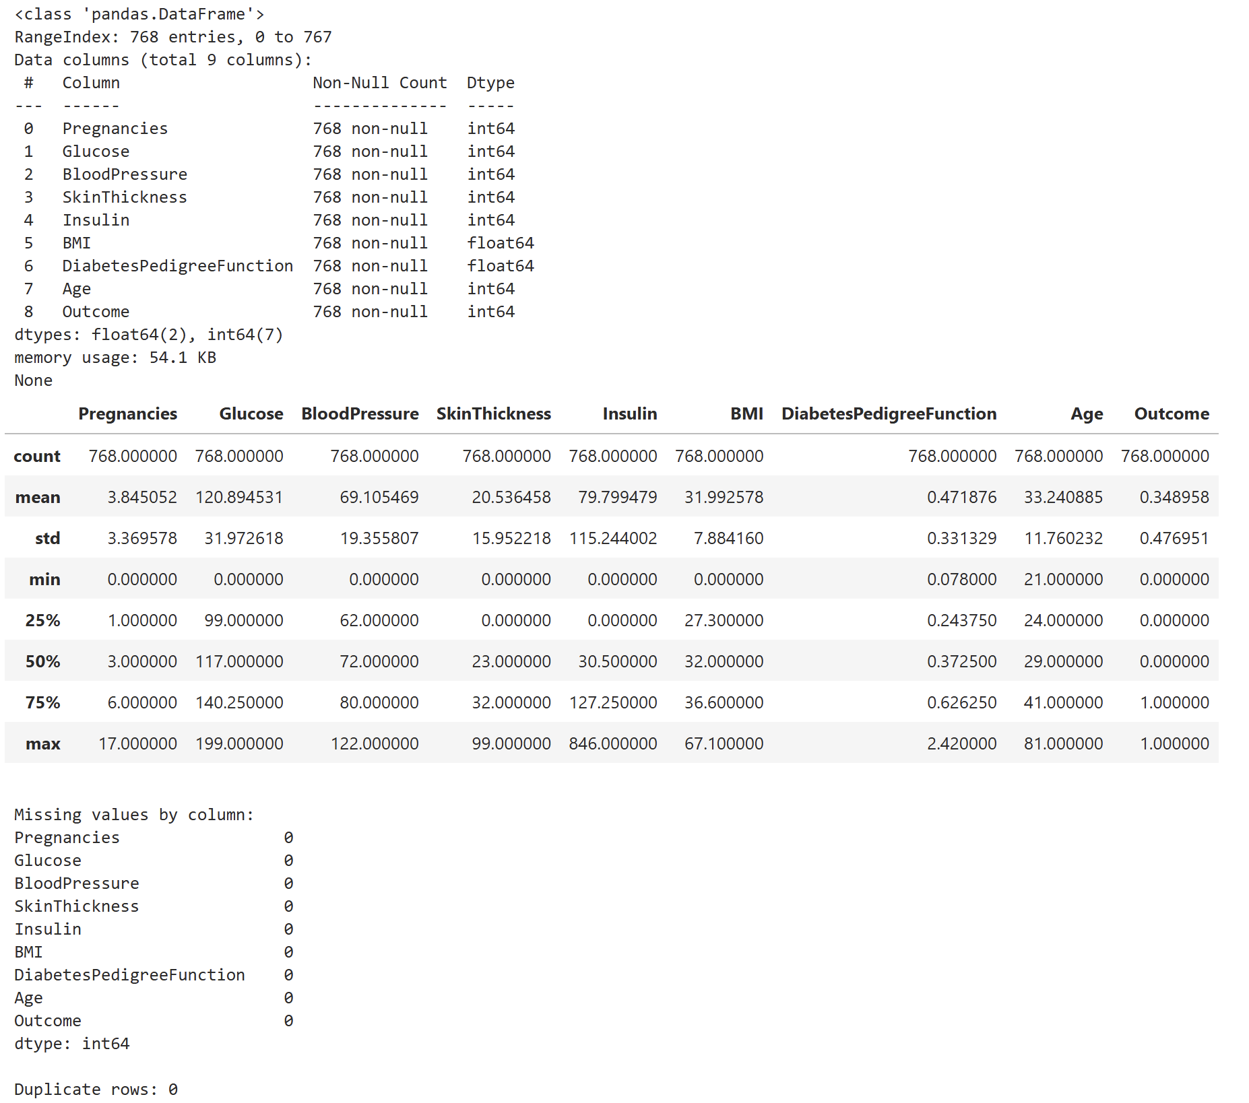
What can be seen, beyond there being a total of 768 entries with 9 columns, which is the shape, is that the data appears sound by way of always having values. What this means is that there are no empty values or null fields. That ensures that the data can be analyzed and output results with minimal preprocessing. This is where bias can enter the equation. In terms of bias in this case, this has to do with the fact that “[data] bias is an important consideration for high-stakes industries” (Rogers & Jonker, 2024). With this data being healthcare related, it’s a high stakes industry. This means thatbeing able to recognize any potential issues is important. This is why one has to recognize that there is a minimum value of 0 shown in the data. This is biologically impossible and these act as an unrecorded placeholder value. What this does is skew the data, pull features down, and mislead the multilayer perceptron during training. It’s this skewing that leads to the bias. This can be seen below in selected feature distribution.
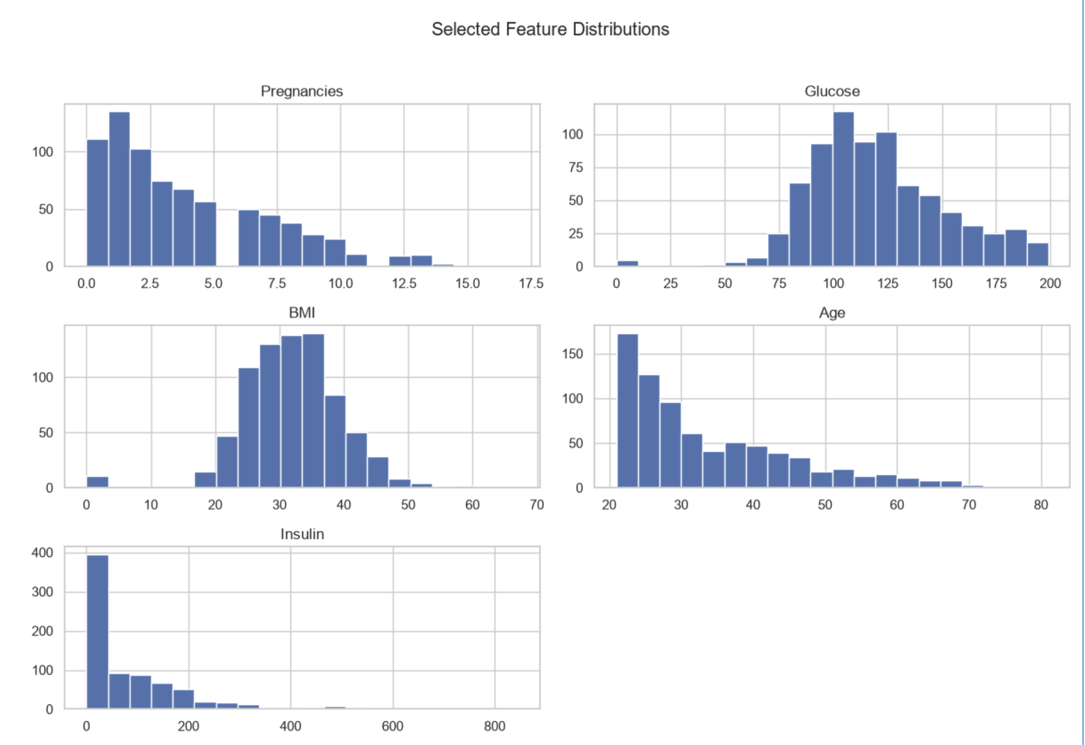
As can be seen, the only values that are more even in terms of their distribution are BMI and Glucose. In terms of what’s seen, research has backed up that there appears to be a connection between “diabetic patients [having] statistically significant higher levels of salivary glucose, average plasma glucose, and BMI” (Patel et al., 2023). Yet, the other data appears as left leaning. That applies to the class imbalance of the two classes. The values for this are shown below.
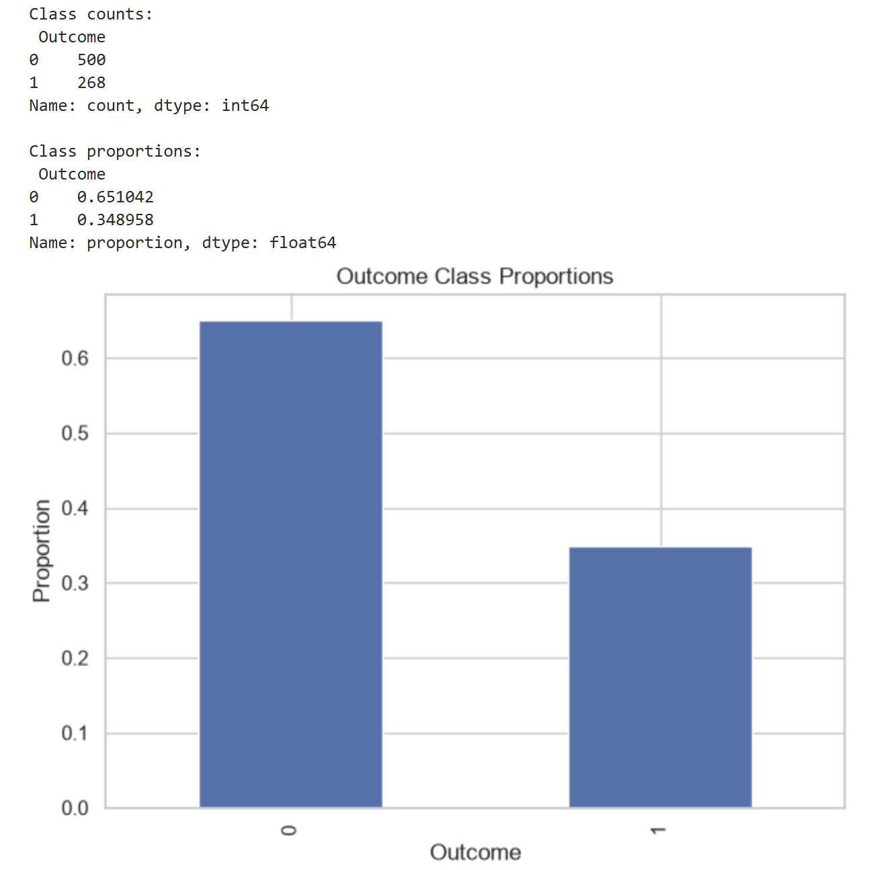
What’s seen is that the proportions are skewed towards class 0 at 500 with proportion outcome of 0.651042. This works in favor of what’s seen in the distributions. The data appears inherently favorable towards the negative class. That’s because, without proper metric evaluation, a model can exploit this imbalance and artificially inflate performance by under-predicting the minority class.
What can be seen by all of this is that the dataset reflects a specific demographic profile where other features, such as age, can act as a proxy for genetic background or historical healthcare access. The problem is that it’s a narrow demographic baseline that limits generalizability to broader, multi-ethnic, patient populations. That ends up causing a higher chance at misdiagnosing those in that group. This is why it’s best to recognize this bias in the real-world, as false negatives can delay intervention or cause death.
Model Refinement
With the initial model and the biases identified, the model needs to be refined. There are certain parts of the configuration that have to be refined. This can be seen in the following code sample.
training_method_results = []

for solver in ["adam", "sgd"]:
mlp_method = Pipeline(steps=[
("preprocess", preprocess),
("clf", MLPClassifier(
hidden_layer_sizes=(32,),
solver=solver,
alpha=1e-4,
learning_rate_init=1e-3,
max_iter=400,
early_stopping=True,
random_state=RANDOM_STATE,
)),
])
mlp_method.fit(X_train, y_train)
pred = mlp_method.predict(X_val)
prob = mlp_method.predict_proba(X_val)[:, 1]
training_method_results.append(report_metrics(y_val, pred, prob, label=f"mlp_{solver}"))

training_method_df = pd.DataFrame(training_method_results)
display(training_method_df)
Within this particular model, the MLPClassifier has specific components that can be refined. These are hidden_layer_sizes, solver, and alpha, learning_rate_init, and max_iter. The above code sample is the default that’s run to start the training before refining, but these hyperparameters are what’s needed to improve the model. However, the first part is to determine the solver. This is because the solver is what initializes the method assessment that can work for further refinement. Below is the choice made.
solver="adam"
What can be seen in this is that the model is using adam. This is the default that is written in the cell where that refinement component is located. Keeping the solver at adam means that it’s at the optimal format for the tabular data. It allows for adaptive learning rates and momentum that can handle sparse, scaled, tabular features. If the model were to use sgd, then there would be extensive manual tuning to avoid getting stuck in local minima. That makes sgd less practical for this architecture. The last optimizer, lbfgs, can perform well on small dataset, but struggles with scaling and network capacity or batch size increases. This means that it wouldn’t have worked well in this model. This causes the initial results to be shown below.
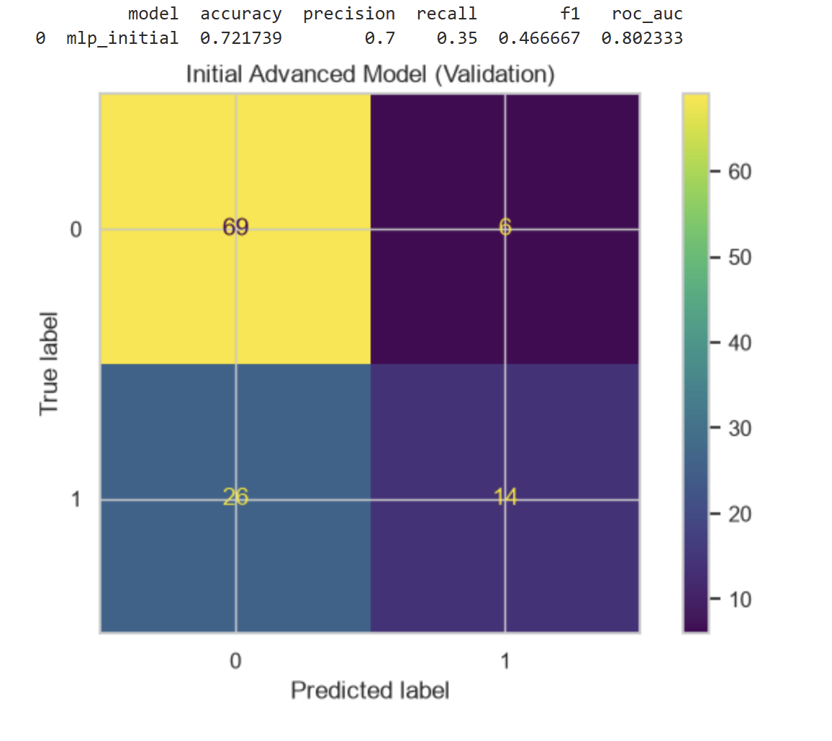
What this shows is that the initial format doesn’t show a high accuracy or precision. This is seen in the fact that these values are 0.721739 in accuracy and a precision of 0.7. At the same time, both the recall at 0.35 and the F1-Score at 0.466667 are low. This means that there are a lot of false negatives, which can be seen in the confusion matrix where there’s a value of 26. This means it’s heavy in the negative. That initial format means that the model, at this stage of refinement, isn’t the most accurate and useful it can be in.
With that in mind, the next stage is where the rest of the values that need refinement come into play. What changes were made are below.
hidden_layer_sizes=(64, 32)
alpha=1e-4
learning_rate_init=1e-3
max_iter=500
These are actually the project’s refined features already. The reason that these refinements were made, and unchanged, is that the capacity from 32 to a 64,32 is useful. This already expanded refinement allows for non-linear feature interactions that helps when dealing with clinical data. At the same time, because the layers and the solver are left at the stable configuration, this makes the alpha, learning_rate_init, and max_iter stable as they are. This means that they maintain regularization strength, can handle added capacity to avoid overfitting, and that the model can go deep enough to actually converge. It’s because this data is already in a csv file and tabular that lets the grid search identify the optimal balance between the network capacity and regularization, stabilize the convergence path via early stopping, and ensure that the performance improvements across iterations are evidence based.
What can be seen after all of these values are refined is that the model doesn’t change that much at times. The below image shows the differences between the initial, the first iteration, and the best iteration.
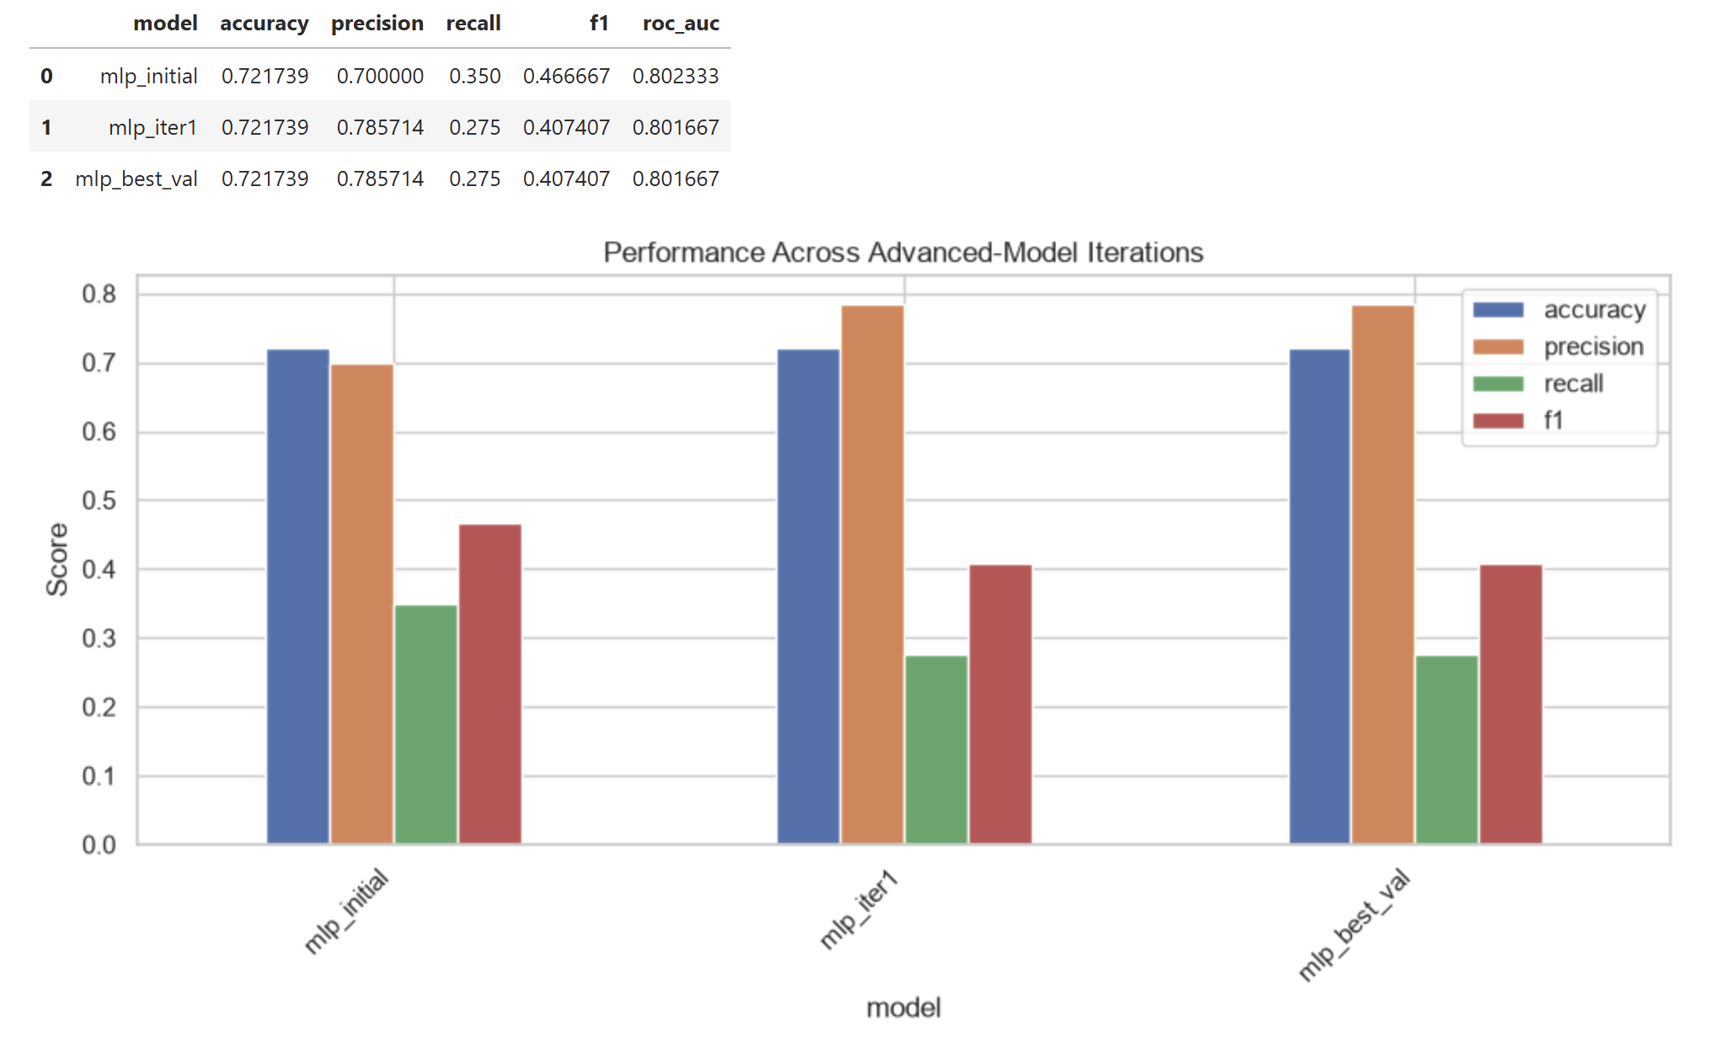
What’s seen is that accuracy doesn’t change, but precision gets better, while recall, F1-Score, and ROC-AUC get worse. If applying this data to the hold out components, that trend can be seen as well. That data is seen below.
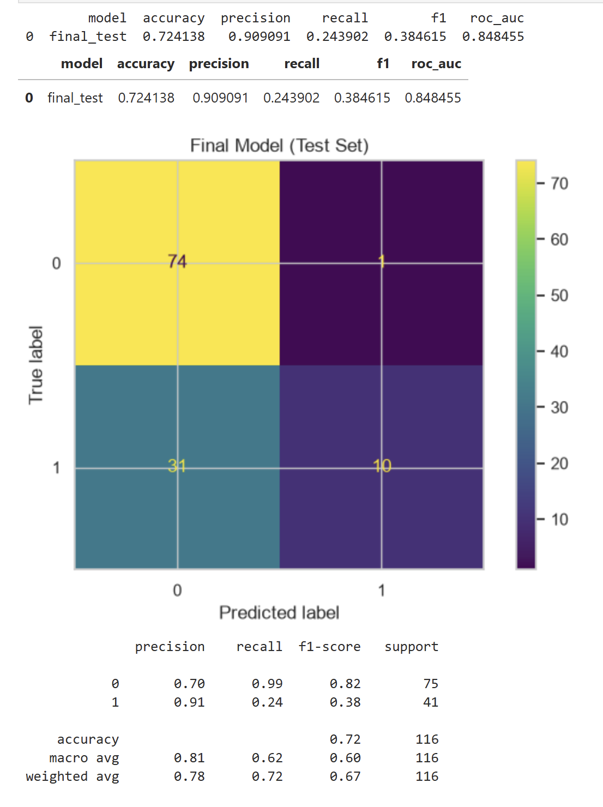
The only value that appears to improve a large amount in the hold-out data is the recall. This makes sense, but the fact is that the model converges. In a medical screening context, a focus on accuracy can be heavily misleading because of class imbalance. Right now, there is an imbalance in the data with the values of 0 as placeholders. The model needs to be effective without masking failures. The precision measures the proportion of false positives that are correct. This is critical in evaluating false positives without causing alarm. The recall measures the actual positive cases that are identified. This is important because false-negatives mean that patients don’t get properly diagnosed and can delay critical care. The F1-Score is the harmonic means of precision and recall. This is the balanced metric that judges how well the model handles the minority class. As for the ROC-AUC, it’s evaluating the model’s ability to discriminate between classes across varying probability thresholds.
This makes the model be a negative improvement. This is where the metrics flatten/drop during tuning, but that’s not a failure. The reason for this is that this data has values that are zero, which is not biologically possible for living people. That means the data can never be fully accurate or precise for this model. It’s possible to increase the accuracy, but that risks a chance of not converging. If the model doesn’t converge, it won’t be usable for long-term use that can take new data and retrain to be more accurate. That’s what makes these changes important, even with the values dropping.
References
Patel, B. J., Mehta, D. N., Vaghani, A., & Patel, K. (2023). Correlation of Body Mass Index (BMI) with Saliva and Blood Glucose Levels in Diabetic and Non-Diabetic Patients. Journal of Pharmacy and Bioallied Sciences, 15(Suppl 2), S1204–S1207. https://doi.org/10.4103/jpbs.jpbs_159_23
Rogers, J., & Jonker, A. (2024, October 4). What is Data Bias? | IBM. IBM. https://www.ibm.com/think/topics/data-bias

