Module 9: Project 2

Samantha Durr

Computer Science, Southern New Hampshire University

CS 640: Applied AI and ML

August 31, 2026

Training an AI model requires precision and finetuning. This tuning requires understanding the underlying data that’s being presented from the baseline all the way to the final tuning measures. To that end, the following analysis is focused around a project using a DistilBERT model on AG News data.
Dataset, Environment, Baseline, and Integration/Stakeholders
Before going into any finetuning and advancements in the model, it’s best to understand the integration/stakeholders, the underlying dataset, environment the model is running in, and the baseline of the initial runs. The first part is identifying the integration of the model. This model focuses around news data, which means it would be integrated into a system that handles news text streams and outputs categories that an article could be assigned to. This is similar to how websites like Forbes lists their articles as business, science, and so on. The model that’s being presented is one that analyzes an article and assigns it to a specific tag. That makes the stakeholders being users that look for specific articles, companies that are organizing their news articles, and researching trying to find information on different topics.
With the stakeholders and integration out of the way, this model has to be run in a small environment to even determine if it could be deployed. This makes the environment that the initial tests are run on important. In terms of this model, it’s being run through a Jupyter Notebook environment that’s on a Parallels Desktop virtual machine running Windows 11. This machine is located on an iMac that runs an Intel Core i5 processor with 16GB of memory. The next step is to set the seed of the data and the way it runs. The results are below.
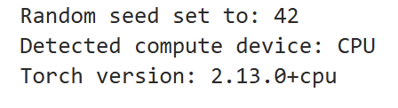
This combination of using the CPU of the device, in this case the virtual machine’s CPU, and a specific version of Torch allows for running the model. Additionally, the random seed being set to 42 is a standard that handle the AG News dataset. With that determined, it’s the dataset that needs to be looked at more intensely. This is the AG News dataset. Initializing this dataset shows what the training and testing sets are and how the data ends up labelled. The information on loading that dataset is below.
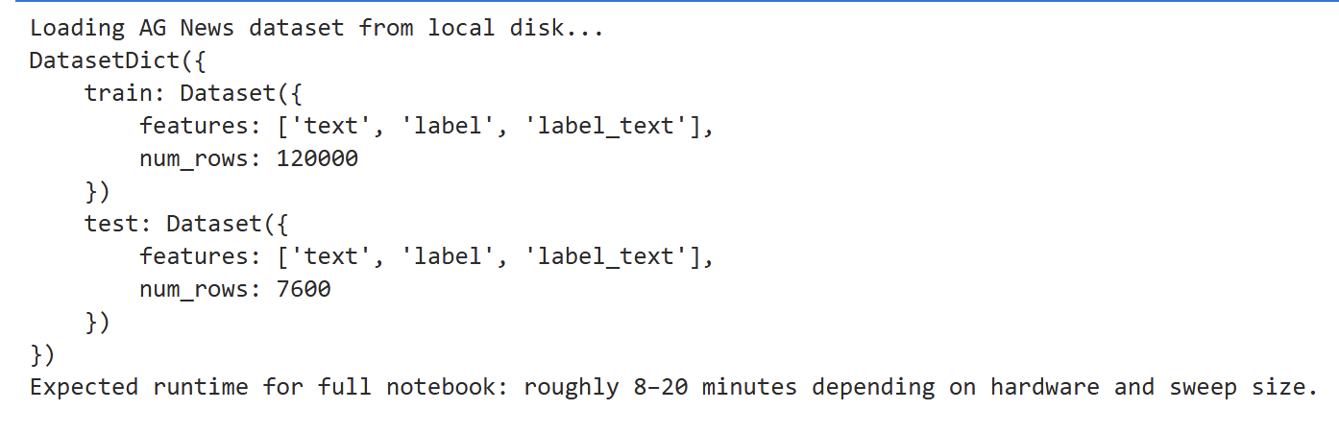
What can be seen is that the number of rows for training the model is larger than the dataset for training. This means that the testing is using a select number of rows to test how accurate the predictions are. At the same time, because this is running through a combination of a CPU and the Torch library, it can take anywhere between 8-20 minutes for the runtime. The note about the sweep size is important, especially when modifying the sweep in anyway and can make the model take a longer or shorter period of time.
With that knowledge out of the way, it’s important to know how the distribution of the dataset is formed. In terms of setting this up, because it’s on a local system, there was a modification that had to be made to the code in order for Hugging Face’s AG news to work. This is where a change to the base code was required. That change is shown below.
label_names = ["World", "Sports", "Business", "Sci/Tech"]
dataset = dataset.cast_column("label", ClassLabel(names=label_names))
num_labels = len(label_names)
This change is based on the fact that AG News uses the same 4 categories that can be looked up. Entering these into the system allows the model to easily train and test without errors. The results of this are below.
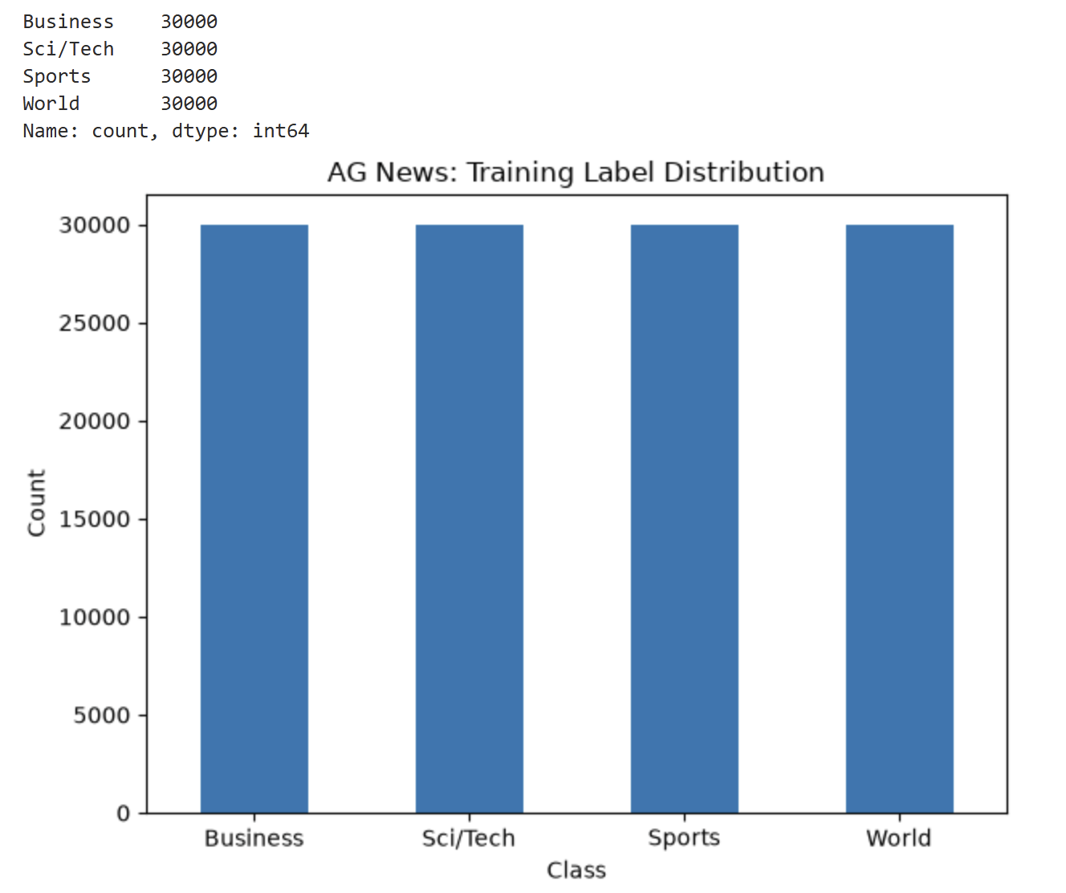
This shows an even distribution of the all the files and that they can be broken into an even balance. Yet, this even distribution is only a part of the picture as the model also look sat the length distribution for the text. Those results are below.
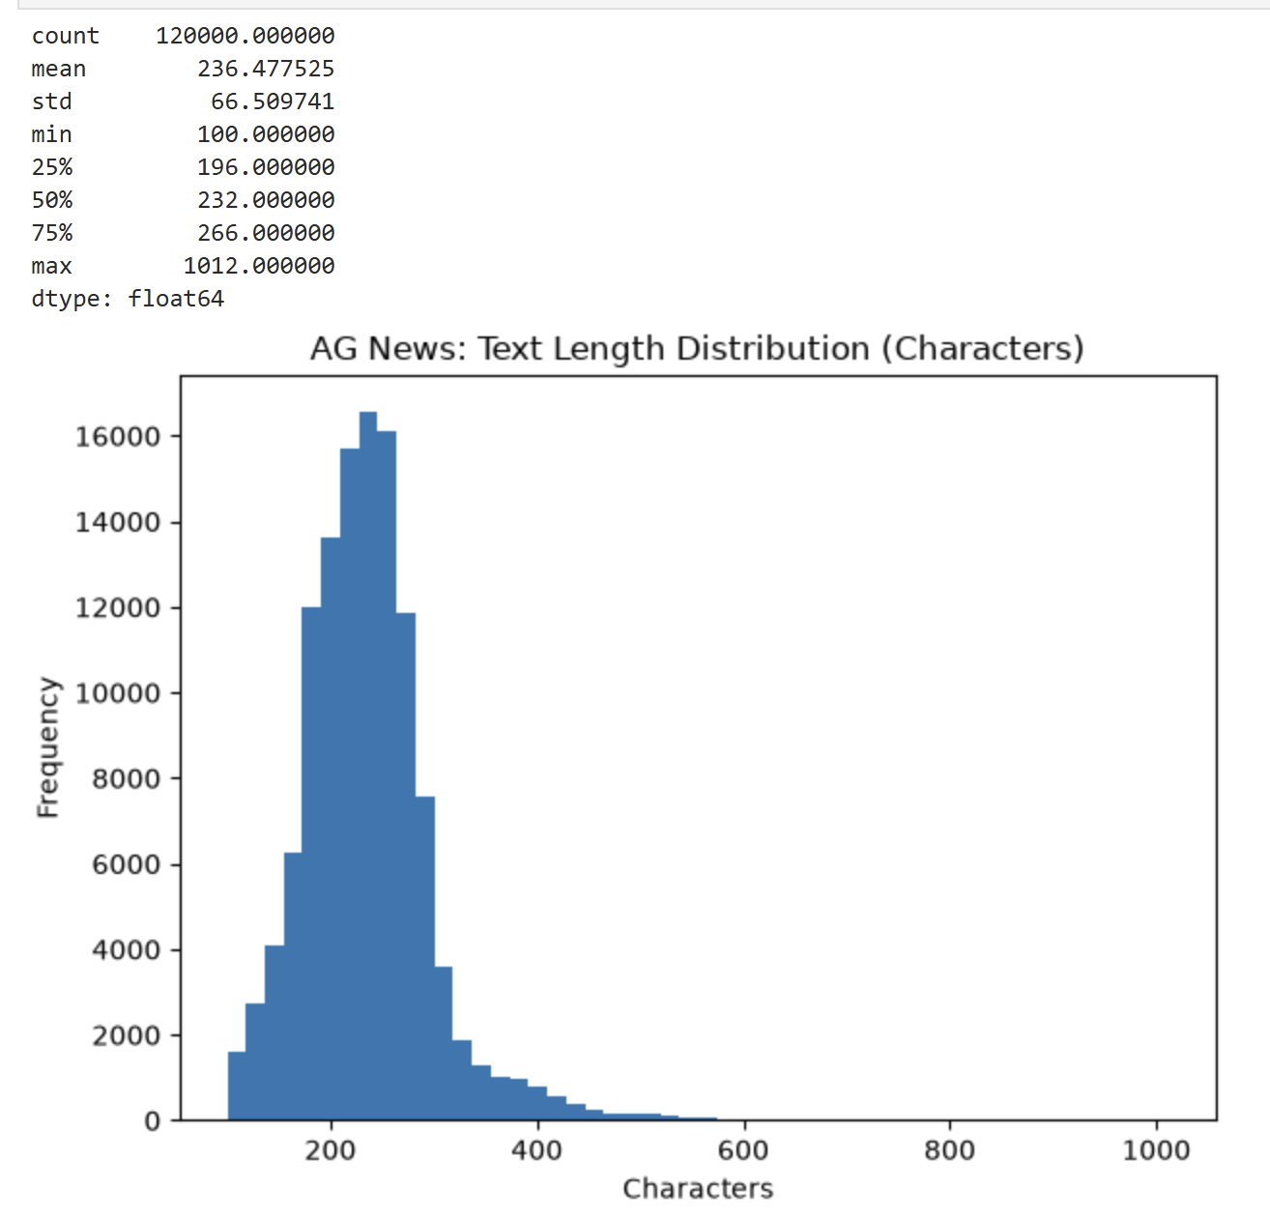
What this indicates is more peaks than expected with valid values. The reason that this baseline is important is because a single zero value can skew the data and make any refinement more difficult or less trustworthy. The fact that even the minimum lists 100 means that there is always a value for text length.
What can be seen is that the data is left-skewed and thus more biased towards characters in the range of 0-600, though more accurately based on the data the lowest value is 66. The reason that this is important is that it works through TF-IDF with logistic regression. When working with AG News, the topics use specific keywords that frequently repeat. This means that it’s good for a linear model. TF-IDF fits this because of the fact that there are only four topics to look for and they can contain a specific set of keywords that can remain distinct. An example can be the word ‘stock’ in the business articles. This can be considered as a unique word to business articles and that allows for weighting the words, which is helpful in TF-IDF. At the same time, there’s no need to focus on the word order because it’s not semantically nuanced. It’s just knowing the words to look for.
As for why the logistic regression fits, this is because it’s linear. There are four topics and they spread out enough to work in straight lines. At the same time, it can train in sections with little memory usage, which is good when using a virtual machine.
Model Design and Training Methodology
In this model, the weights and design are an important part of the baseline and eventual refining and training of the model. Before moving forward, it’s best to look at that baseline’s output of precision, recall, and F1-Score. These are below.
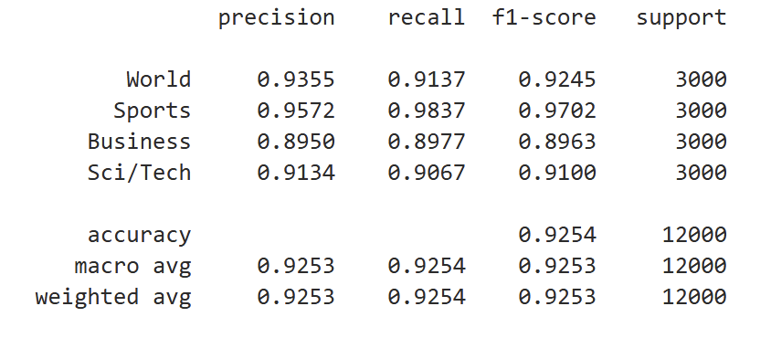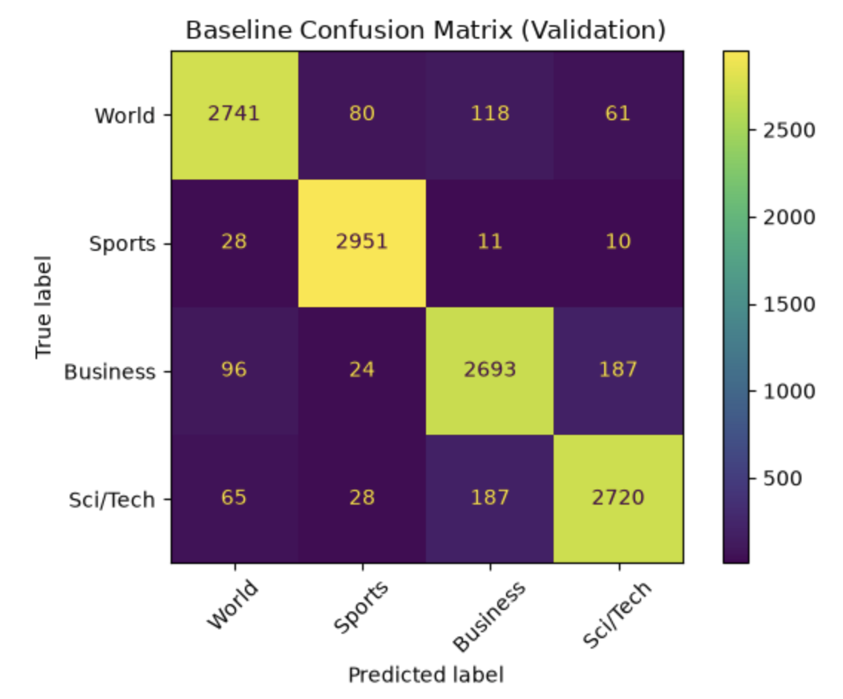
As it stands, the model itself indicates a balance that is supported by the previous breakdown of the text length as well. This means that the balance works in the favor of training the model. This makes the current model of using TF-IDF appear optimal. However, this model is using the AG News dataset. This makes a more contextual transformer helpful in improving the text classification accuracy. A transformer allows the model to capture deeper semantic meaning and word order. As the example from earlier shows, using the word ‘stock’ can work because that should only appear in Business, but that’s not the case. Stock could be used in any context. In a world context, it could mean the stock of an item. In science and technology, stock could relate to something else entirely. This makes using a contextual transformer better because it can look for the semantic meaning. In the stock example, that allows the model to find if that word is related to business or something else.
For this project, the model we’ve been presented with asks us to use DistilBERT specifically. What helps in using this particular transformer is that the dataset is multi-class. Then there’s the fact that the use of DistilBERT has been seen because “DistilBERT offers a more streamlined, quicker, and more resource-efficient alternative to BERT, providing approximately 97% of BERT’s effectiveness” (Amandeep & Suresh, 2025). The model also keeps the light-weight component seen in the TF-IDF. This makes running it on a local virtual machine or a slow Codio environment is possible.
Yet, to go beyond that, there is the finetuning of the model. In this case, the model was pre-trained when setting up the baseline. That makes it important to apply certain tuning. In the model itself, when applying the first of the advanced tuning, the model runs into specific issues. This is first seen when the initial transformer model runs into unexpected and missing values. This is shown below.
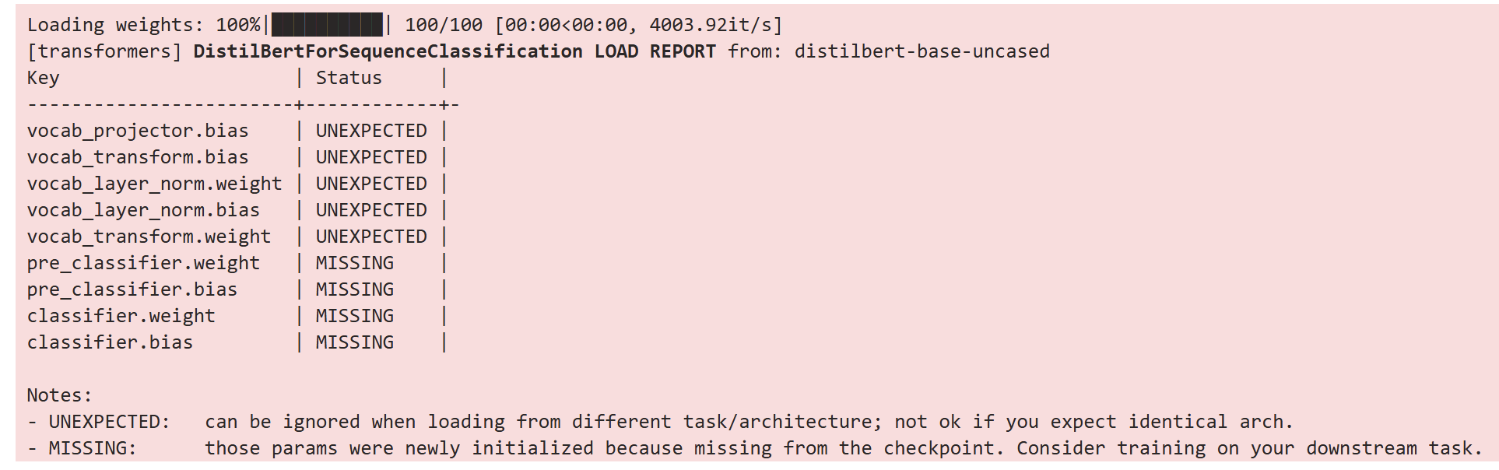
What this is showing is that there are issues that can be present later because the model currently doesn’t have enough information in the system. When adding in the actual arguments, there is improvement because it’s now paying attention to the actual system that’s running the model. That’s shown below.
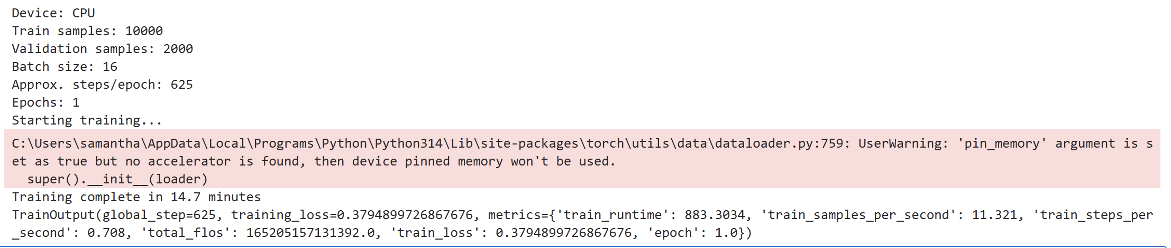
The model, now properly running, is using training and validation sets that are much smaller than what was available in the initial baseline. Instead of 120,000, there’s only 10,000 and validating the results is only using 2000. This is because the model has been tuned through the use of arguments. The tuning code is below.
training_args = TrainingArguments(
output_dir="cs640_project2_distilbert_agnews",
eval_strategy="epoch",
save_strategy="no",
learning_rate=2e-5,
per_device_train_batch_size=16,
per_device_eval_batch_size=32,
num_train_epochs=1,
weight_decay=0.01,
logging_strategy="steps",
logging_steps=20,
report_to="none",
disable_tqdm=False,
seed=SEED,
fp16=False,
)
In this model, the initial arguments are focused around quicker training and ensuring that the system can run, though the model does show to have taken 14 minutes to train. What these are doing is taking the pre-trained weights and catching more semantic nuance than the original model. The original model was more a bag-of-words setup and that can cause it to miss words or and can miss results.
It’s when looking at these trade-offs in tuning, that the model appears to take longer to train. This can be as simple as the learning rate’s aggression, large batch sizes, or even the number of epochs causing the system to slow down. But, in this initial format, the 14-minute setup fits what’s found. It also made some changes to the actual model before even delving into more finetuning. Below is are the results of the initial training of this transformer model.
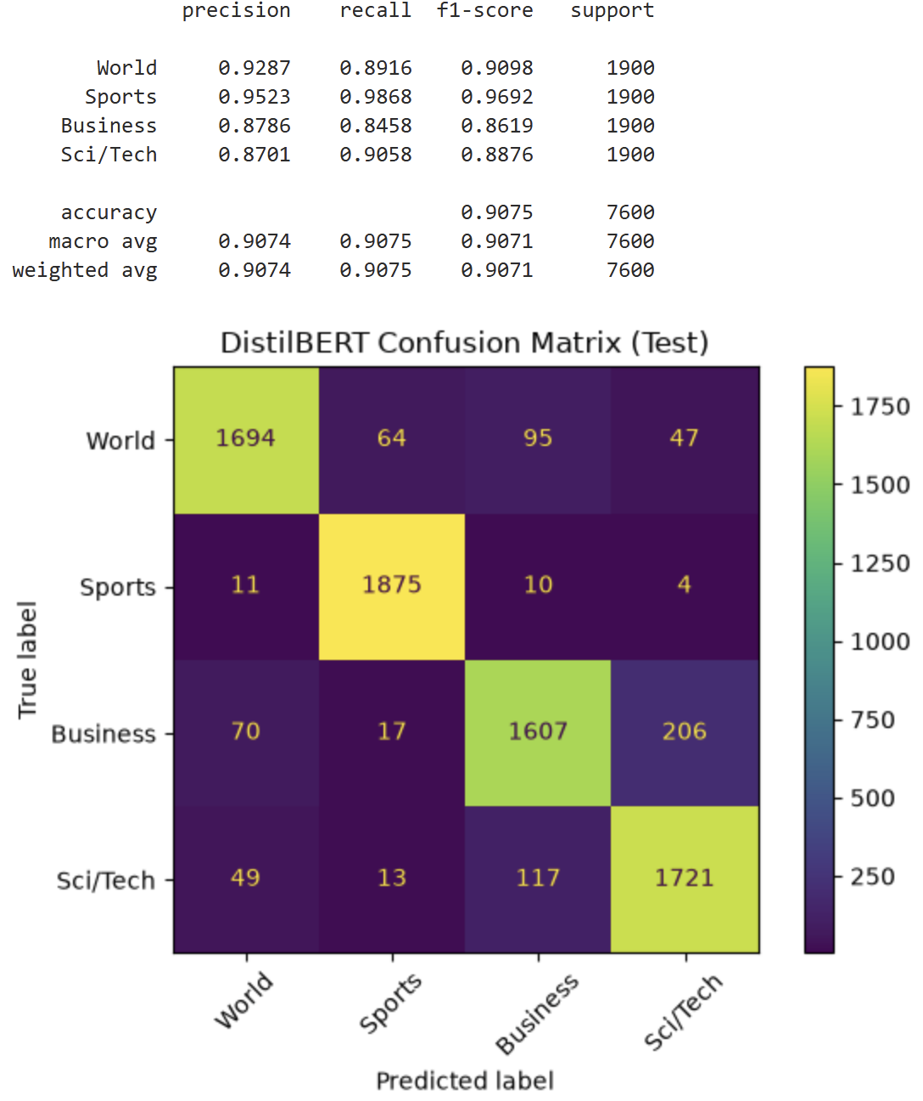
What can be seen is that there is more variation, though not too drastic. But, if it’s compared to the original model, things like precision of world being 0.9355 in the initial model and this one being 0.9287 is a reduction. This slight reduction in precision means that the model isn’t as precise as the initial. That is something to consider when further tuning the model.
However, one thing to consider is that this can also relate to the errors within the training. This is seen in the notebook with it listing a misclassification of 703 samples out of 7600. An example is below.
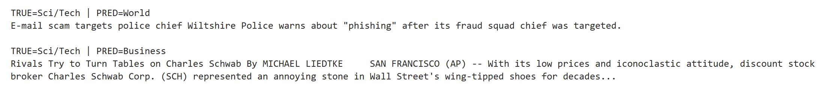
What this shows is that the predicted value doesn’t match what the article is actually selected to be. This is where a more nuanced and weighted approach can be useful. The same with the learning rate. At the moment, the model isn’t sensitive enough to properly look at an article about e-mail scams and place it in the science/technology category. The model sees it as a world article. At this point in time, this is a representation of bias towards Science/technology documents. Other examples provided by the notebook indicate this as well.
What this ends up meaning in the grand scheme of tuning this model is that it requires tuning three hyperparameters specifically. These are the learning rate, the training epochs, and the batch size is important for the training sweeps. These are also the parameters that can contribute to bias or uneven performance. This can be seen when finetuning, but a higher batch rate can cause a longer training time, or a more aggressive learning rate can cause bias against certain data. This results in an uneven performance. Yet, until the finetuning is performed, it’s unknown which parameters are going to keep the performance good and least biased.
Finetuning
With the current errors in mind, and what should be changed, the model itself is focused around 3 different sweeps with those hyperparameters. These are the parameters to be changed. Below are the parameter settings.
sweep = [
{"learning_rate": 2e-5, "num_train_epochs": 2, "per_device_train_batch_size": 32},
{"learning_rate": 3e-5, "num_train_epochs": 4, "per_device_train_batch_size": 16},
{"learning_rate": 2e-5, "num_train_epochs": 3, "per_device_train_batch_size": 16},
]
In these three runs, there are certain features that are set. The first is the adjusted baseline, which is what the first run is. This one has an increased batch size of 32 and its epochs reduced to 2. What this does is check the stability and memory scaling effects of the model. The second run has a training epoch of 4 and a batch size reduced back to 16. It also has an aggressive learning rate of 3e-5. This tests the convergence speed and monitors for potential overfitting. The last run is what the initial defaults set by the system are. This is for maintaining a standard regularization with a moderate epoch count and lower learning rate. What this does is establishes a performance control that works against the second run. Once this is run, these are the final results of each run below.
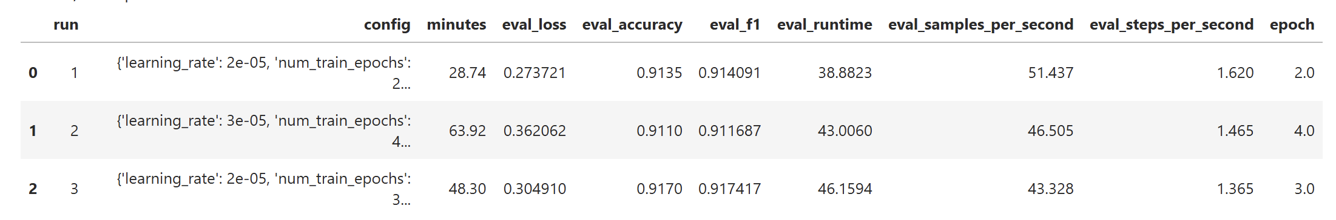
The first thing to look at is that run 2 took the longest, but also has a slightly lower accuracy and F1-Score than either runs 1 or 3. It also has the highest loss. This means that this aggressive learning rate is too large. The steps that are being taken are causing an overshoot of the optimal weights. While it can appear that having a 3e-5 learning rate could be good, and does appear to get used in models like BERT, it’s too aggressive for this particular model. In fact, even compared to the regularization, the best model would appear to be run 1 with 2 epochs, a learning rate of 2e-5, and 32 batch size. It has the least loss, but accuracy is higher in the third run.
In fact, going further into analyzing this data, there appears to be some values that aren’t good for if this was deployed. Below is that information.
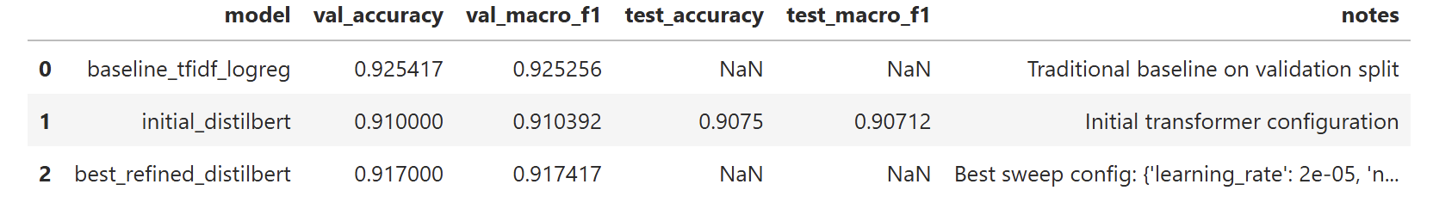
This model has missing values. The first and last don’t have any accuracy or f1 data. They are missing. The initial is the one that has these values. Yet, at the same time, the best configuration is listed as the third run. The result is to say that the traditional set up is showing the best in terms of accuracy and F1-Score. That results in a bit of a difficult determination because the best model is the baseline when chasing accuracy and F1-Score. The refinements lowered those values.
The thing is that it goes further. There is the subgrouping of data. The subgrouping can have their own value because this is a model that’s looking semantically through news articles. That data is below.
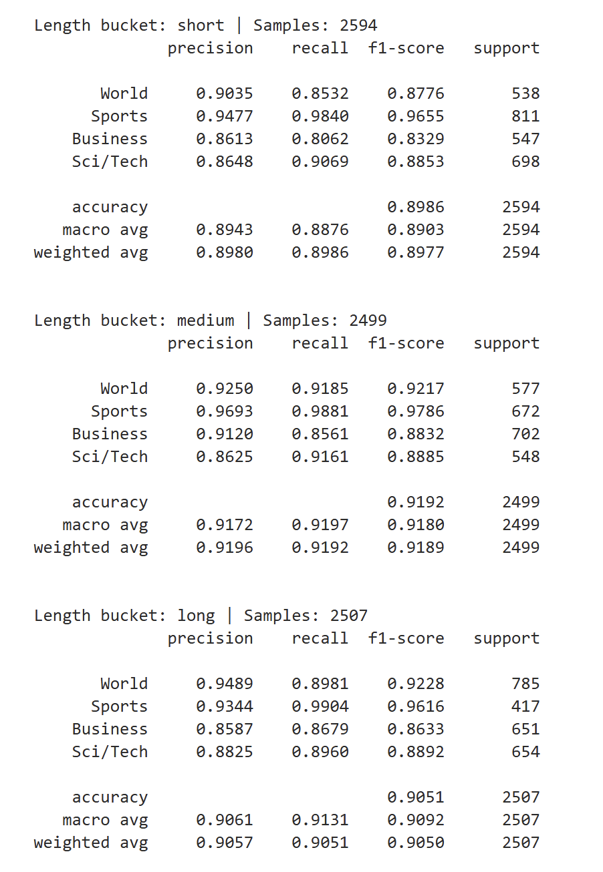
This data shows some consistency in terms of the average macro and weighted components. It’s not the same values, but they’re close enough to be considered consistent in this regard. At the same time, the precision is showing that science and business have the least precision, but otherwise the data is pretty steady among all the groups. This can be considered helpful and reliable enough in an AI workflow because there’s no way to have perfect predictions.
Ethics and Suitability
The thing is, this model can be considered suitable enough, but not fully. A part of this is the data that’s being used to train. If this was more like an AI scrape style, it could be more varied, but this is being trained on the AG News data. The biggest thing is that the current data itself hits vulnerability and ethical concerns. The biggest part is this relates to Hugging Face itself. Tests were done on Hugging Face to check over the security and, over time, “[the agents] executed code on dozens of Hugging Face servers, gained full “root” access on one such server, obtained limited private data, and gained credentials to the company messaging platform” (The Hugging Face Incident and the Road Ahead, 2026). This is a huge ethical concern in terms of privacy. If this data can be compromised by unauthorized access through the servers, then any models being trained on this AG News data are also compromised. Their data is no longer secure enough to be accurate. It means that any model using this data can be open to potential concerns that can introduce bias, steal information from users, and any human oversight being undermined.
It’s this fact that this model is using this data that reduces trust. That fact even means bringing into question the data itself when maintaining the model. The model becomes more difficult to maintain. As the data grows, the model becomes more unpredictable and, if it’s scaled up, retraining could be required. That results in the possibility of retraining from scratch if the data is considered untrustworthy.
Yet, while looking at it and saying that it’s suitable enough to deploy because the changes from the baseline weren’t massive enough to cause worry, there’s that fact that the ethical concerns towards the data remaining as unbiased as possible, secure enough to protect users, and accurate enough causes this to be not suitable.
References
Amandeep, & Suresh, S. (2025). Transforming Fake news detection: Leveraging DistilBERT models for enhanced accuracy. Procedia Computer Science, 260, 283–290. https://doi.org/10.1016/j.procs.2025.03.203
Hamza, A., Muhammad, A., Abbas, M. S., & Jan, S. U. (2026). Contextual deep learning for accurate news article categorisation with pre-trained embeddings. Scientific Reports, 16(1). https://doi.org/10.1038/s41598-026-38998-3
Ituvtu. (n.d.). GitHub - ituvtu/DistilBERT-AG-News-Classification: Fine-tuning DistilBERT for 4-class text classification on the AG News dataset. Deployed with Gradio on Hugging Face Spaces. GitHub. https://github.com/ituvtu/DistilBERT-AG-News-Classification
Jordan, J. (2023, March 5). Setting the learning rate of your neural network. Jeremy Jordan. https://www.jeremyjordan.me/nn-learning-rate/
sh0416/ag_news · Datasets at Hugging Face. (2001, February 22). https://huggingface.co/datasets/sh0416/ag_news
The Hugging Face incident and the road ahead. (2026, August 26). Open AI. https://openai.com/index/hugging-face-incident-and-the-road-ahead/

