TechPrime AI
System Overview and Role Functions
[Insert full capstone title here]

1. About the System
TechPrime AI is a web-based inventory, point-of-sale and e-commerce system for EasyPC One Oasis Branch (Rosario, Pasig City). It replaces separate, manual stock and sales records with one shared database, so every walk-in sale, online order and delivery updates stock right away.
On top of daily operations, it adds sales and demand forecasting, an AI shopping assistant (Primo) and a Build a PC tool with compatibility checks.

2. Main Functions
- Inventory Management: product catalog, barcode labels, scan-based stock-in, and low / critical / out-of-stock alerts.
- Point of Sale (POS): barcode checkout for walk-in customers (Cash, GCash, Maya, Card) with VAT-inclusive receipts.
- Online Storefront: browse, search, wishlist, cart and checkout (Lalamove delivery or store pick-up).
- Build a PC: step-by-step PC builder with compatibility checks, build score and power estimate.
- Primo AI Assistant: chatbot that answers product, order and build questions using a trained intent model.
- Forecasting and Reports: monthly sales reports and 1–3 month demand and sales forecasts, exportable to CSV / PDF.
- Security and Audit: role-based access, 15-minute idle timeout, login lockout, password rules and activity logs.
- Staff Messaging: internal chat among the Admin, Retail Officers and Inventory Custodians.

3. User Roles at a Glance
Role | Main Responsibility | Modules
Admin | Oversees users, security, forecasts and the audit trail | Dashboard, Forecast, Messages, Manage Users, Activity Logs, My Profile, Settings
Retail Officer | Monitors sales performance and forecasts | Dashboard, History, Messages, Profile
Inventory Custodian | Manages products, receiving and online orders | Dashboard, Stocks, Stock In, Orders, Activity, Messages, Profile
Cashier | Processes walk-in sales at the counter | Dashboard, POS Checkout, Receipt, Stock Alerts, Profile
Client | Shops online and plans PC builds | Home, Primo, Shop, Category, Product Details, Build a PC, Saved Builds, Wishlist, Cart, Checkout, My Account, Account Settings, Notifications, Privacy Policy

4. Admin
The Admin oversees the whole system: user accounts, security policy, forecasts and the system-wide audit trail.

4.1 Dashboard
Store-wide summary for the current month.
- Totals for orders, clients, retail officers and inventory custodians
- Monthly revenue and completed deliveries
- Restocking Alerts: products at or below the low-stock threshold
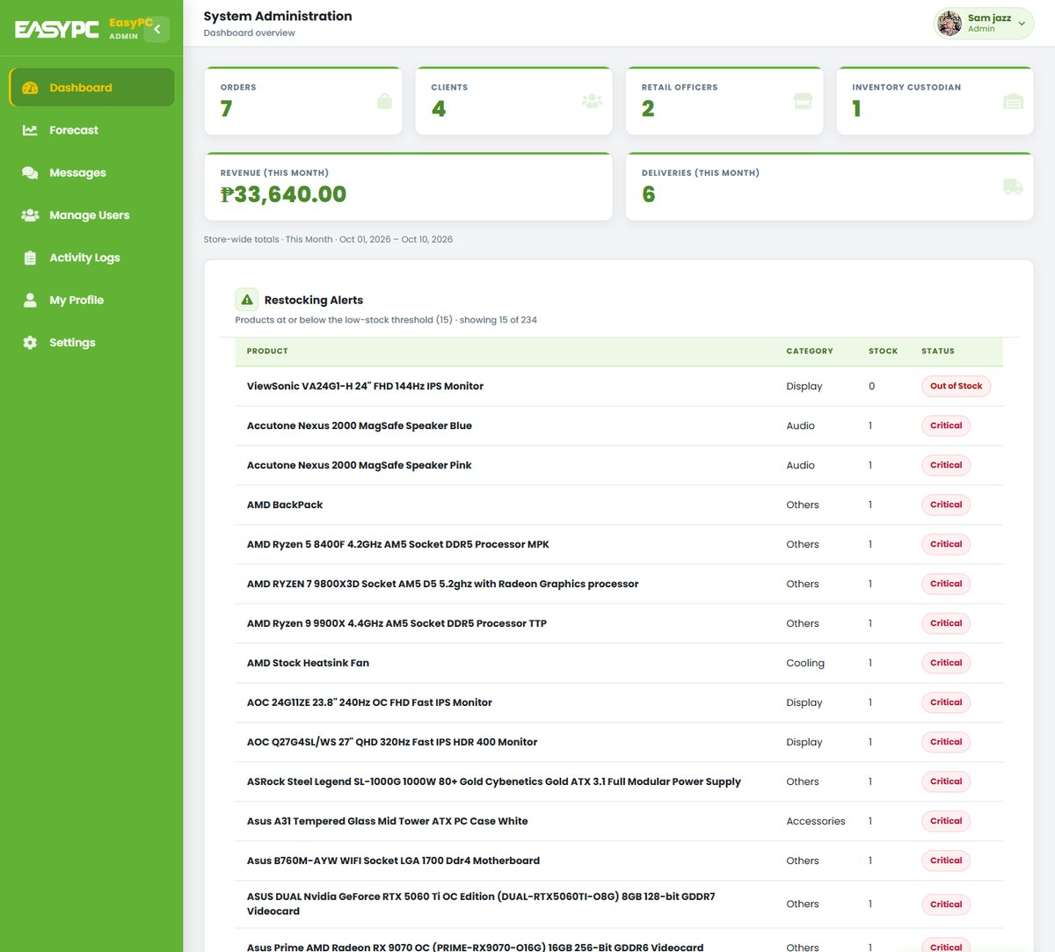
Figure 1. Admin: Dashboard

4.2 Forecast
Projects product demand and sales 1–3 months ahead.
- Product Demand Forecasting: forecast units, likely range, trend and confidence
- Sales Forecasting: expected revenue per month
- Filter by category and date range; switch between chart and table view
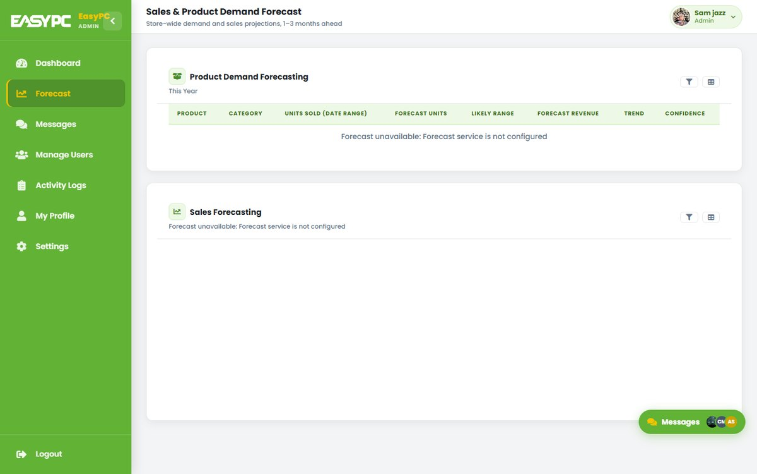
Figure 2. Admin: Forecast

4.3 Messages
Internal staff chat with Retail Officers and Inventory Custodians.
- Search staff and open a conversation
- Send messages and attachments; react, forward, pin or unsend
- Also available as a floating Messages widget on every staff page
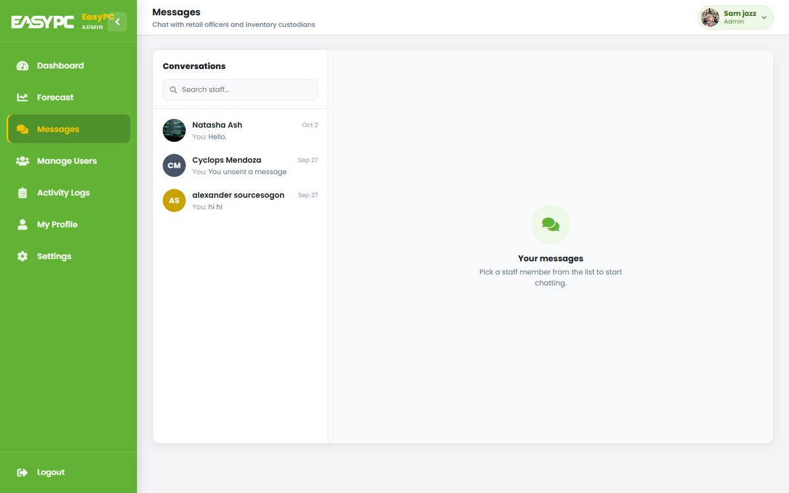
Figure 3. Admin: Messages

4.4 Manage Users
View and control every user account by role.
- Filter accounts by role; see verification and account status
- Create Staff Account for Retail Officers, Inventory Custodians and Cashiers
- Block, unblock or delete accounts
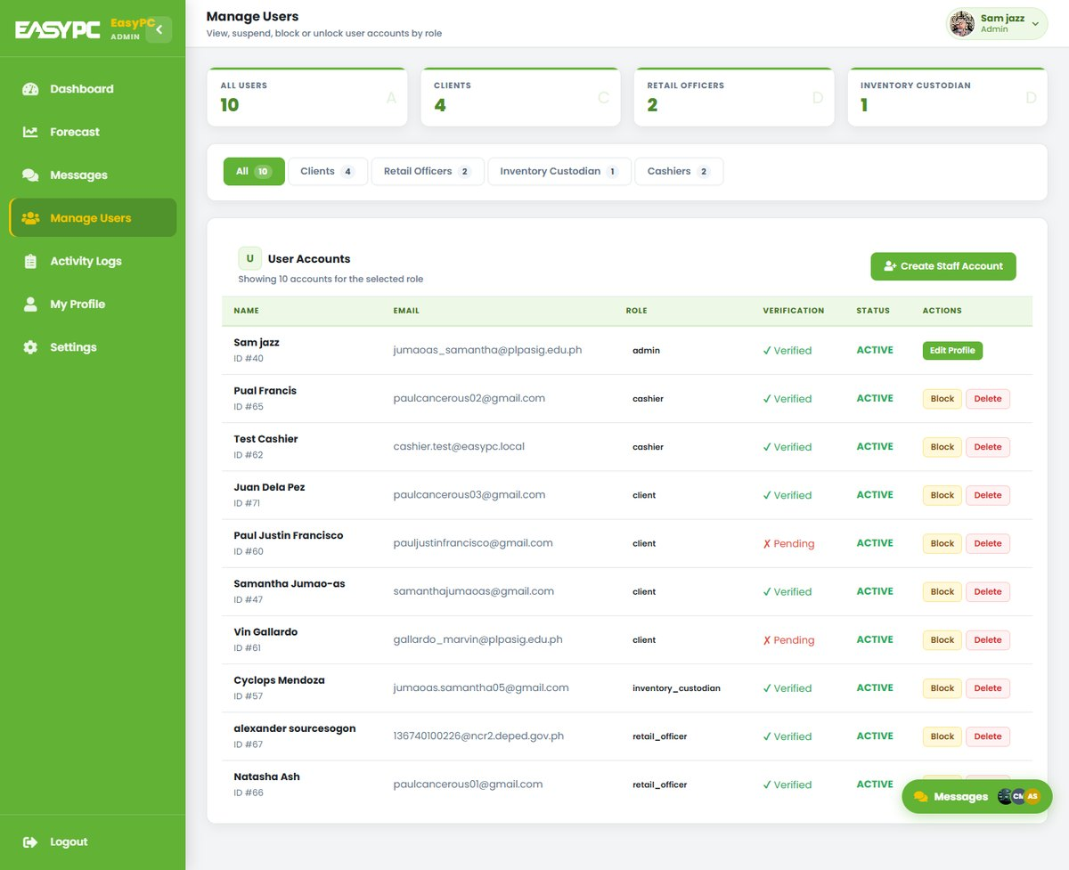
Figure 4. Admin: Manage Users

4.5 Activity Logs
System-wide audit trail of significant actions.
- Shows timestamp, user, role, action and details
- Covers logins, page views, profile changes, orders and stock updates
- Search by user, action or details
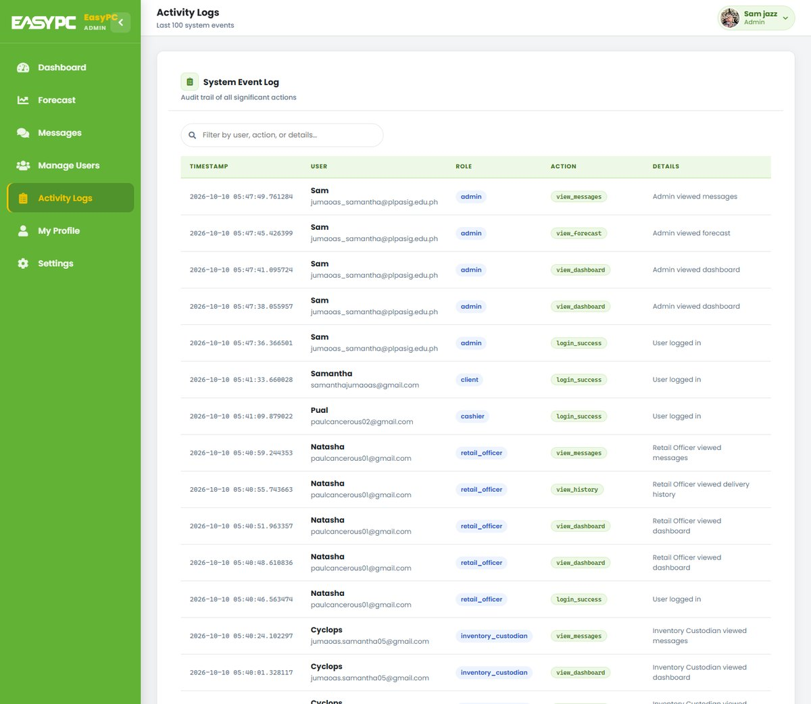
Figure 5. Admin: Activity Logs

4.6 My Profile
Lets the user update their own account details.
- Edit name, age and address; change the profile picture
- Change password with a live checklist of the password rules
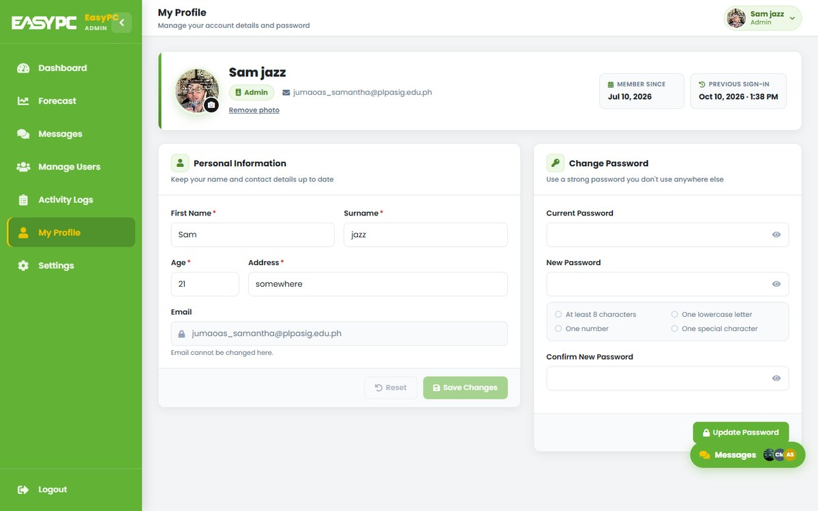
Figure 6. Admin: My Profile

4.7 Settings
Sets the login and password security policy.
- Login Security: failed attempts allowed before an account locks (1–10)
- Password Complexity: minimum length, uppercase, lowercase, number, special character
- Live Preview of the active password rules
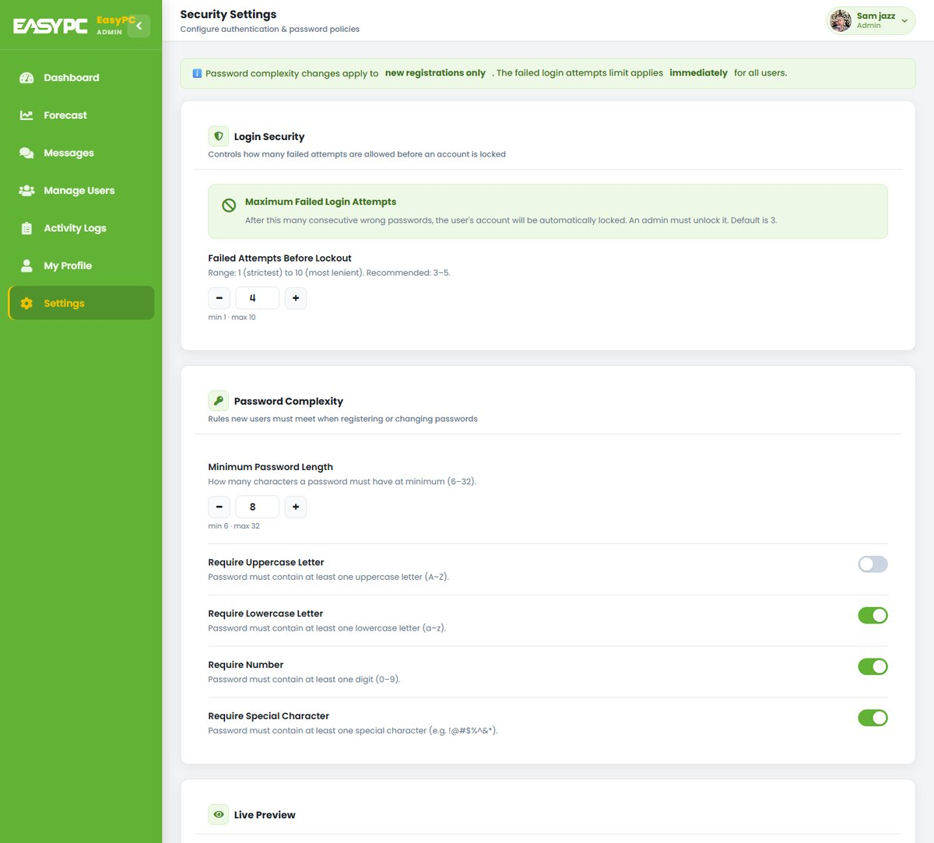
Figure 7. Admin: Settings

5. Retail Officer
The Retail Officer monitors sales performance and forecasts to guide restocking and sales decisions.

5.1 Dashboard
Sales analytics and forecasting on one page.
- This month’s total sales, transactions, units sold and average transaction
- Monthly Sales Report for the last 12 months
- Product Demand and Sales Forecasting; Print, Export CSV and Export PDF
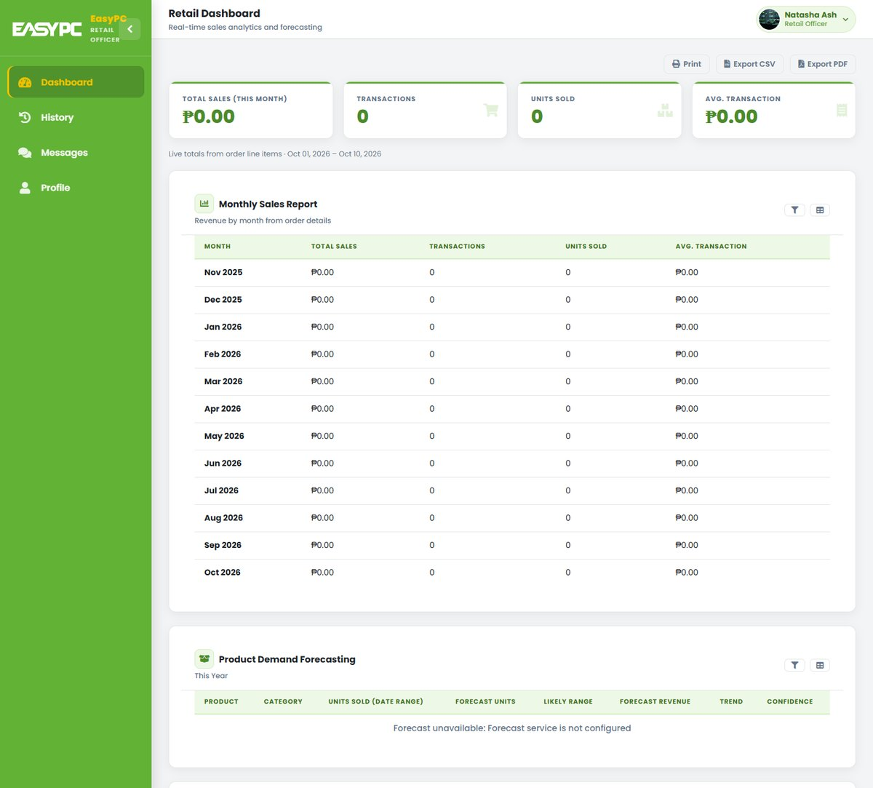
Figure 8. Retail Officer: Dashboard

5.2 History
Delivery History of completed orders.
- Filter by date range, product and customer
- Total deliveries, shipments in range, success rate and a Deliveries by Category chart
- Print or export to CSV, Excel and PDF
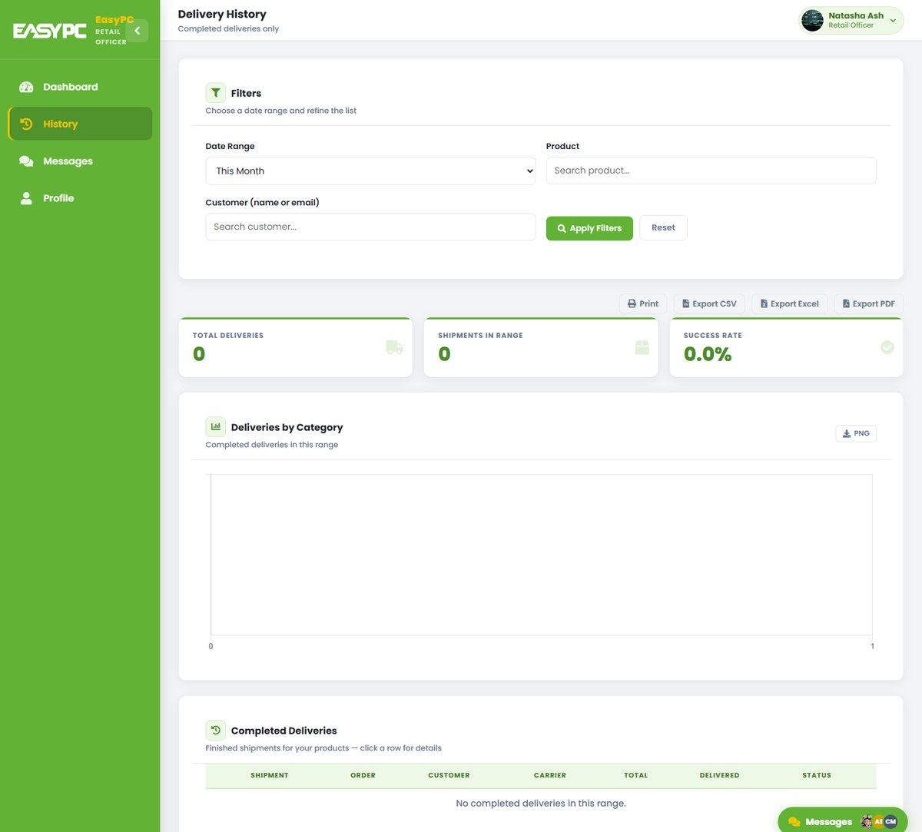
Figure 9. Retail Officer: History

5.3 Messages
Internal staff chat with the Admin and Inventory Custodians.
- Search staff and open a conversation
- Send messages and attachments; react, forward, pin or unsend
- Also available as a floating Messages widget on every staff page
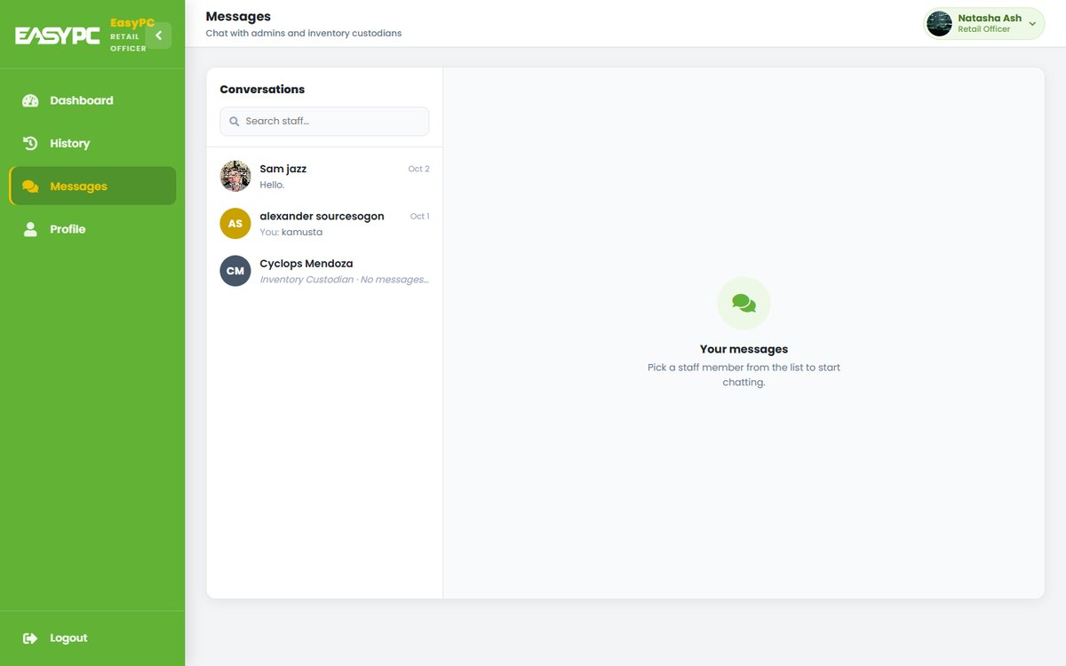
Figure 10. Retail Officer: Messages

5.4 Profile
Lets the user update their own account details.
- Edit name, age and address; change the profile picture
- Change password with a live checklist of the password rules
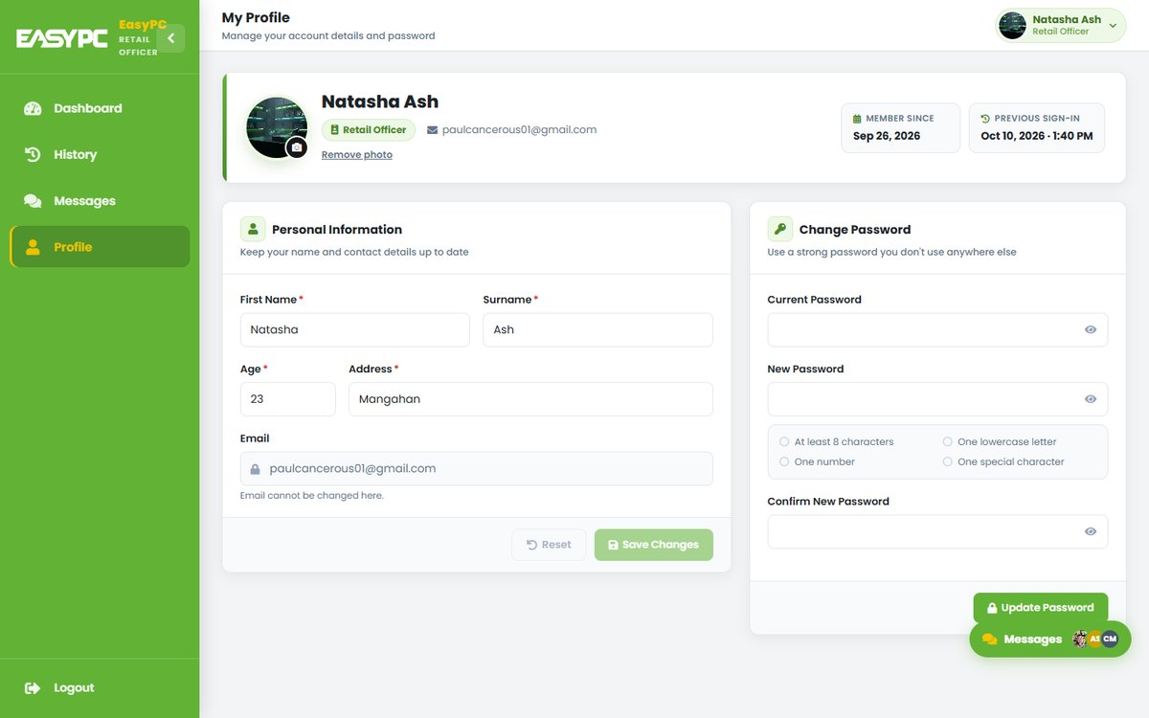
Figure 11. Retail Officer: Profile

6. Inventory Custodian
The Inventory Custodian manages the product catalog, receives deliveries and processes online orders.

6.1 Dashboard
Overview of deliveries and stock levels.
- Total and completed deliveries, pending shipments and catalog size
- Total stock units, low-stock and out-of-stock counts
- Products Stocked Per Month chart, filtered by year and category
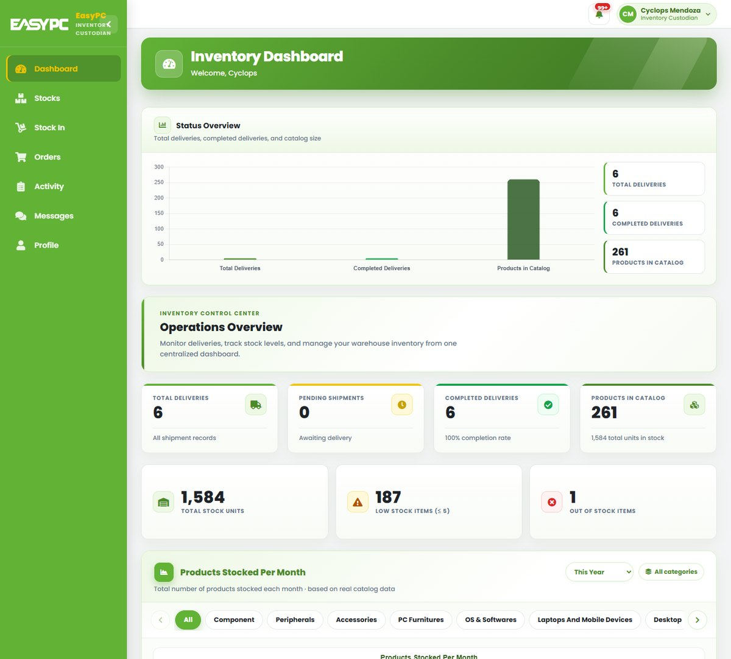
Figure 12. Inventory Custodian: Dashboard

6.2 Stocks
Master list of all products and their stock.
- Search by name, category, SKU or barcode, or scan to search; list or grid view
- Add and edit products; status badges (In Stock, Low, Critical, Out of Stock)
- Print barcode labels or Generate a barcode for items without one
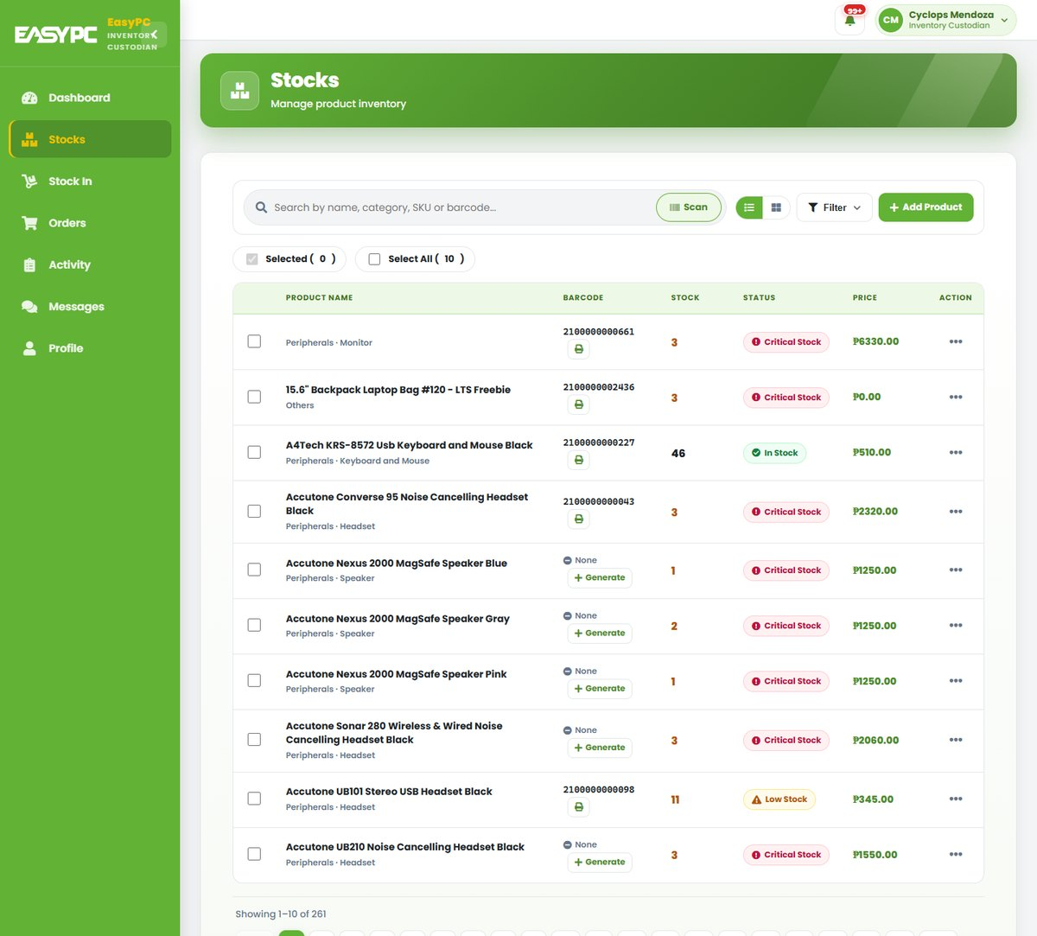
Figure 13. Inventory Custodian: Stocks

6.3 Stock In
Receives deliveries by scanning each item.
- Scan a barcode, enter quantity, choose the supplier, add a delivery reference no.
- Stock updates immediately and is recorded in the activity log
- My Recent Stock-Ins lists the last 10 receiving entries
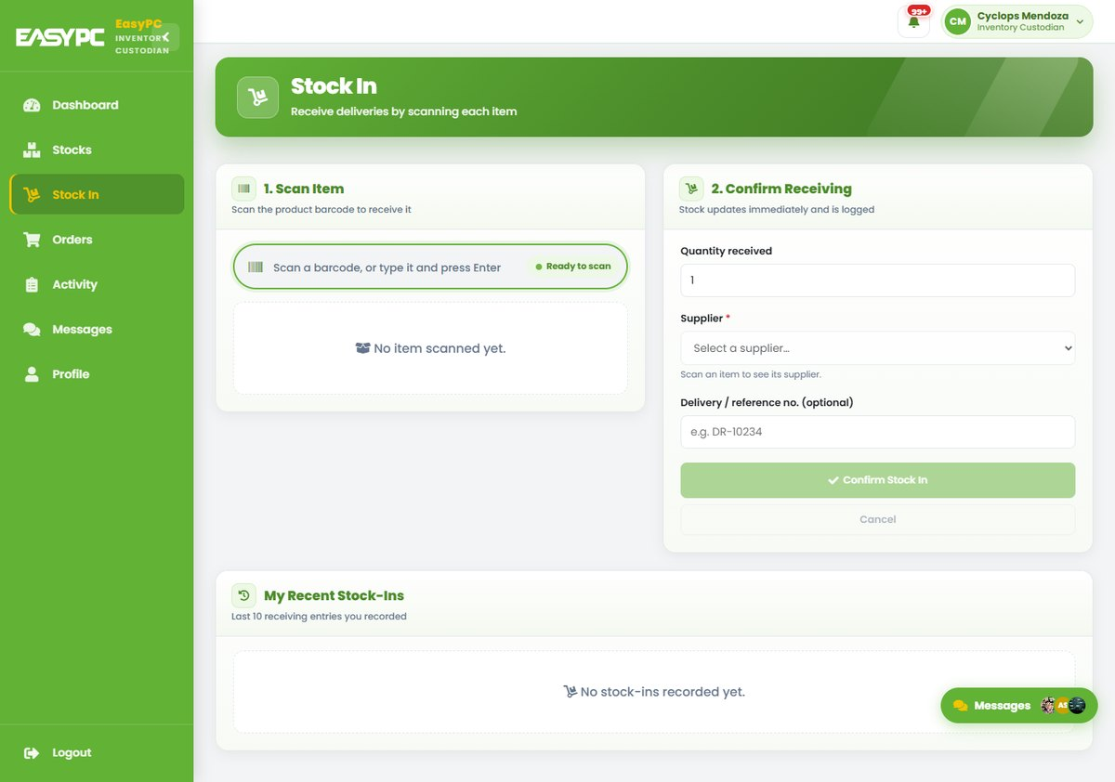
Figure 14. Inventory Custodian: Stock In

6.4 Orders
Handles customer online orders.
- Accept new orders and update their status (e.g. Completed)
- Filter by status; view customer, items, total and delivery or pick-up details
- Weekly Total Deliveries chart for the last 8 weeks
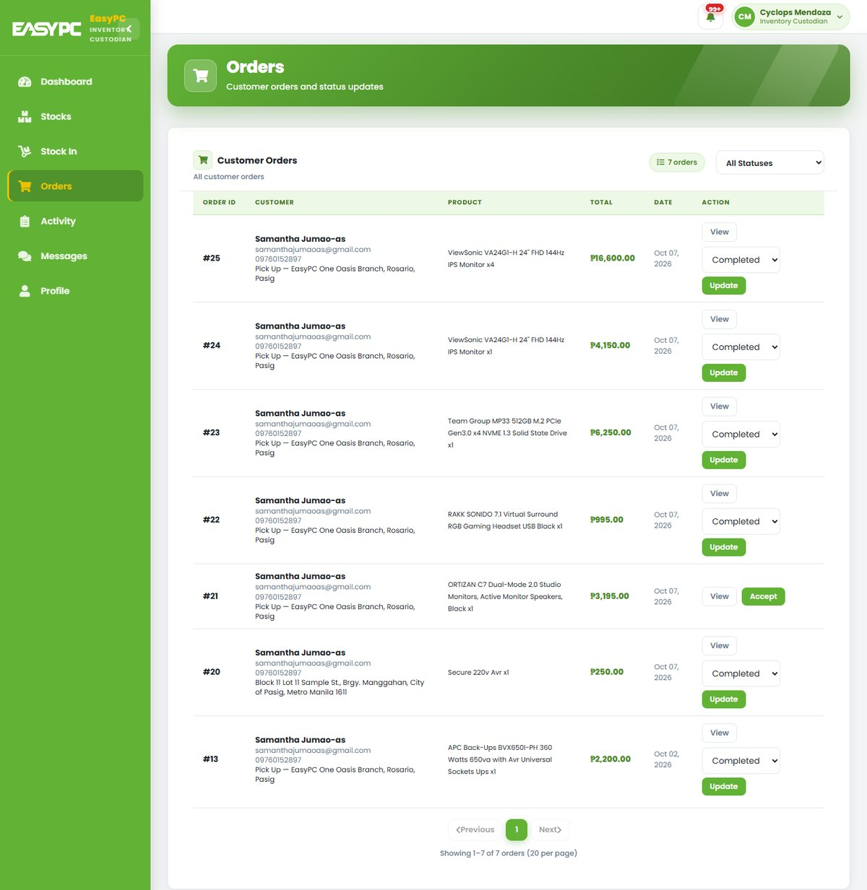
Figure 15. Inventory Custodian: Orders

6.5 Activity
History of inventory changes and custodian actions.
- Order updates, stock changes and barcode generation, with user and time
- Search by product or user; filter by activity type and period
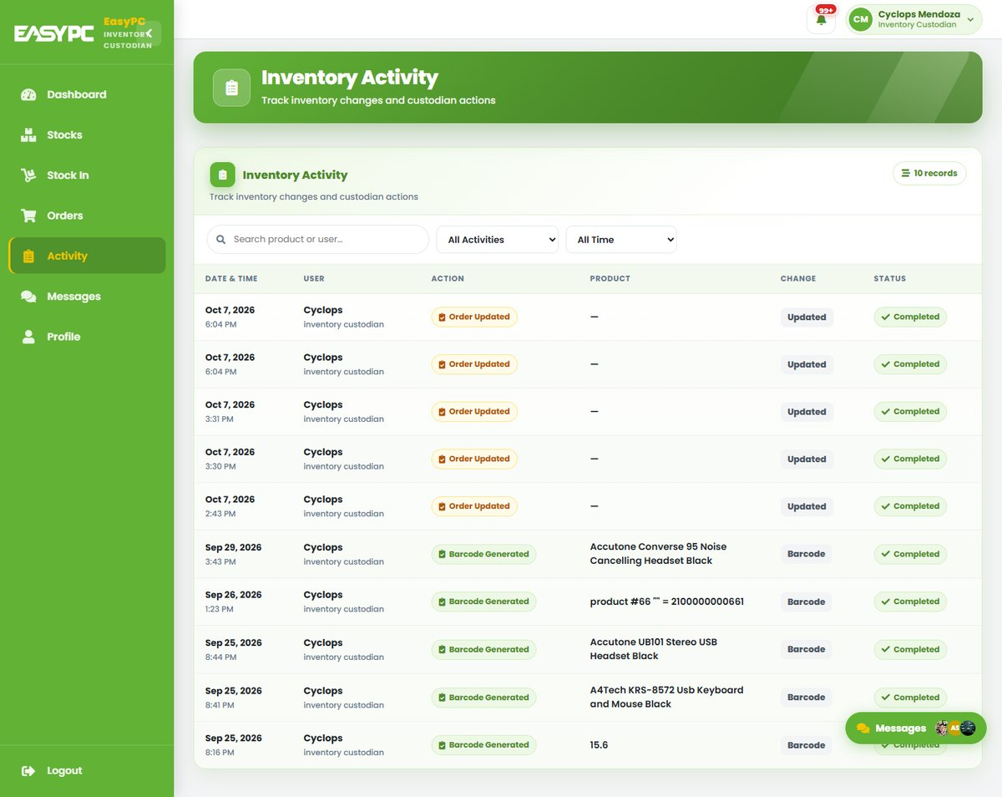
Figure 16. Inventory Custodian: Activity

6.6 Messages
Internal staff chat with the Admin and Retail Officers.
- Search staff and open a conversation
- Send messages and attachments; react, forward, pin or unsend
- Also available as a floating Messages widget on every staff page
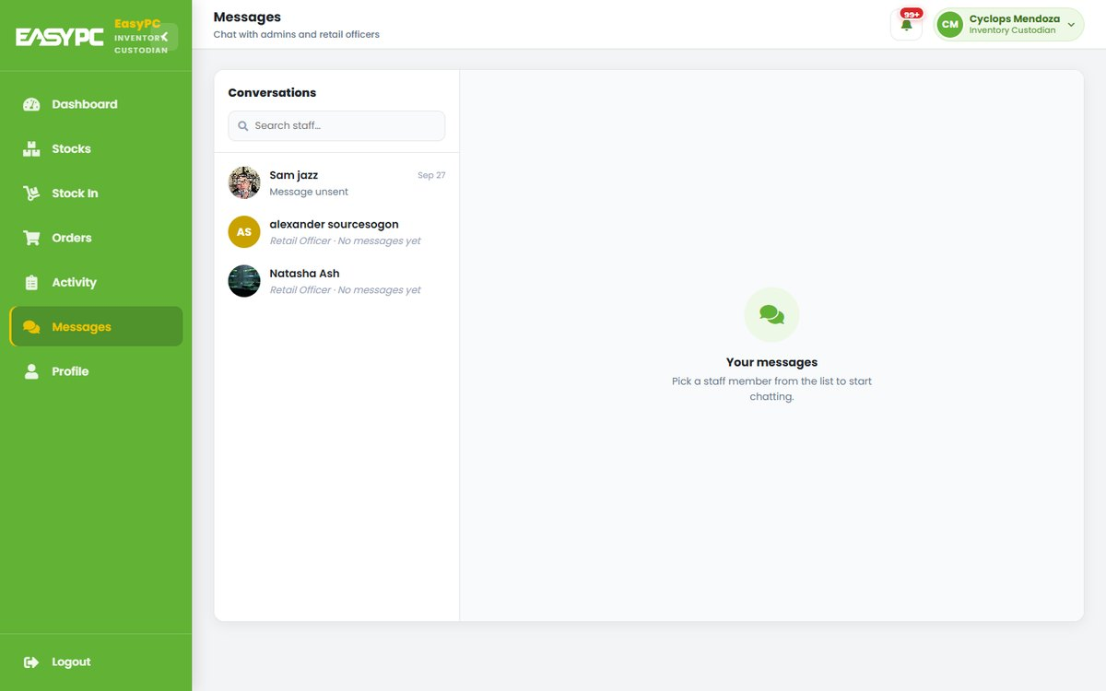
Figure 17. Inventory Custodian: Messages

6.7 Profile
Lets the user update their own account details.
- Edit name, age and address; change the profile picture
- Change password with a live checklist of the password rules
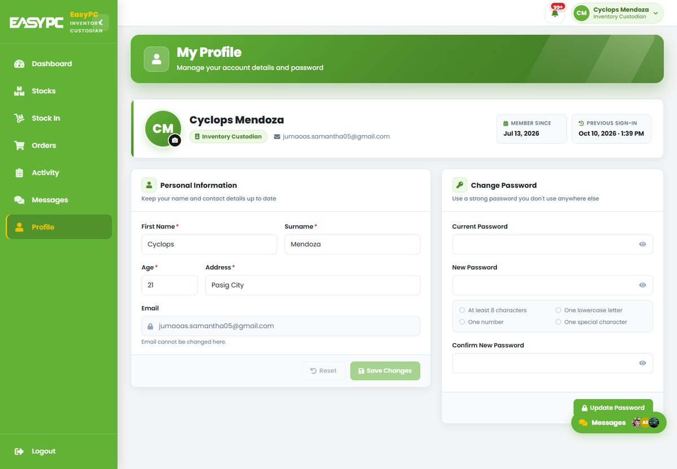
Figure 18. Inventory Custodian: Profile

7. Cashier
The Cashier processes walk-in purchases at the store counter.

7.1 Dashboard
Daily sales summary and stock warnings.
- Today’s number of sales and total amount
- Low, critical and out-of-stock counts
- My Recent Transactions with receipt reprint; live Stock Alerts panel
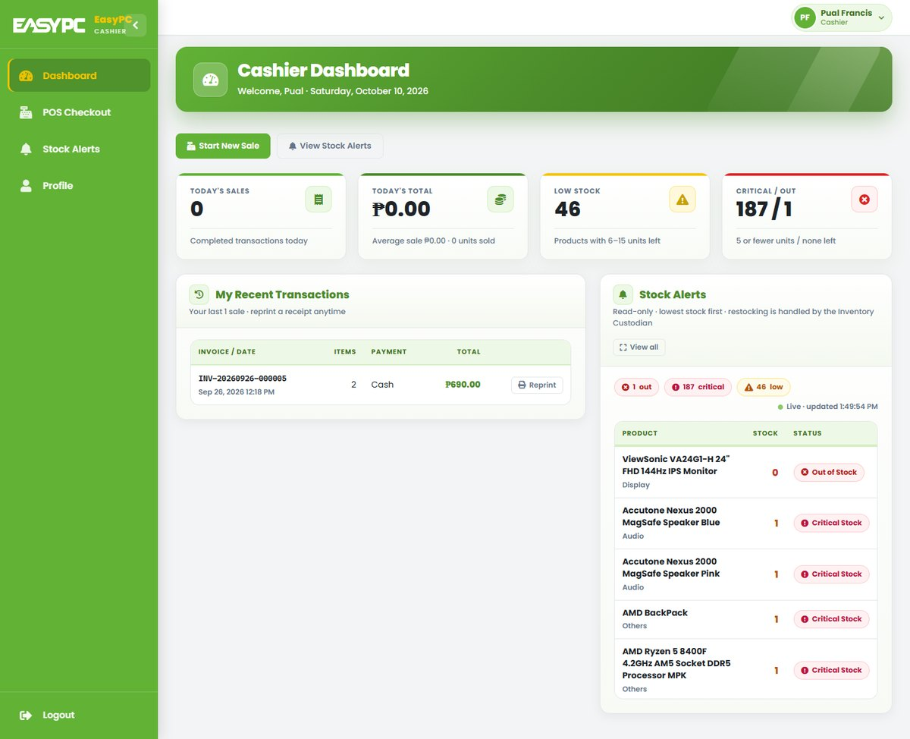
Figure 19. Cashier: Dashboard

7.2 POS Checkout
Scan items to build a sale.
- Scan or type a barcode (UPC-A, UPC-E, EAN-13, EAN-8); scanning again adds one more
- Order Summary computes VATable sales and 12% VAT (prices are VAT-inclusive)
- Pay by Cash, GCash, Maya or Card; stock is deducted automatically
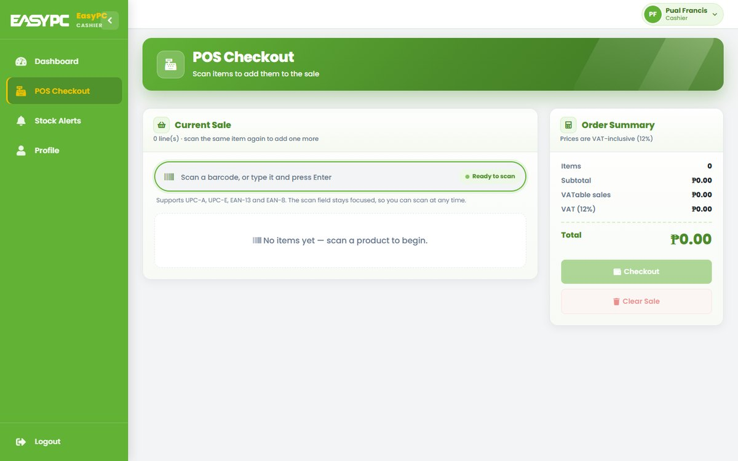
Figure 20. Cashier: POS Checkout

7.3 Receipt
Sales invoice generated after checkout.
- Invoice no., date, cashier, items, VAT breakdown, amount tendered and change
- Print Receipt, start a New Sale or return to the Dashboard
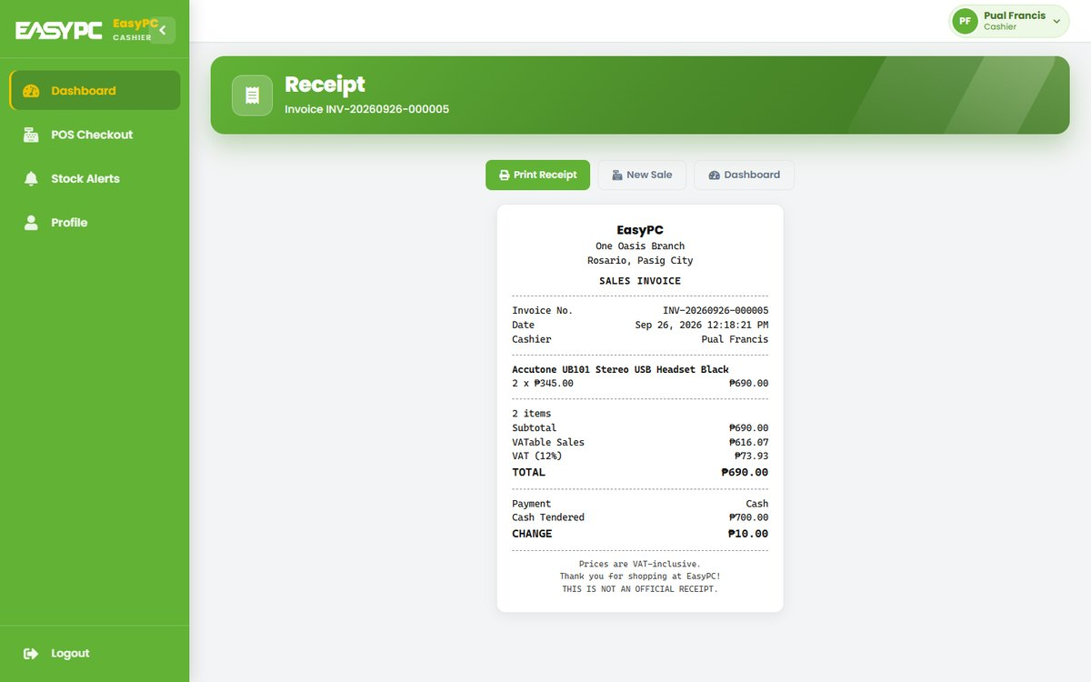
Figure 21. Cashier: Receipt

7.4 Stock Alerts
Read-only list of products that need restocking.
- Counts and list of low (6–15), critical (5 or fewer) and out-of-stock items
- Search, scan and filter; refreshes automatically
- Restocking itself is done by the Inventory Custodian
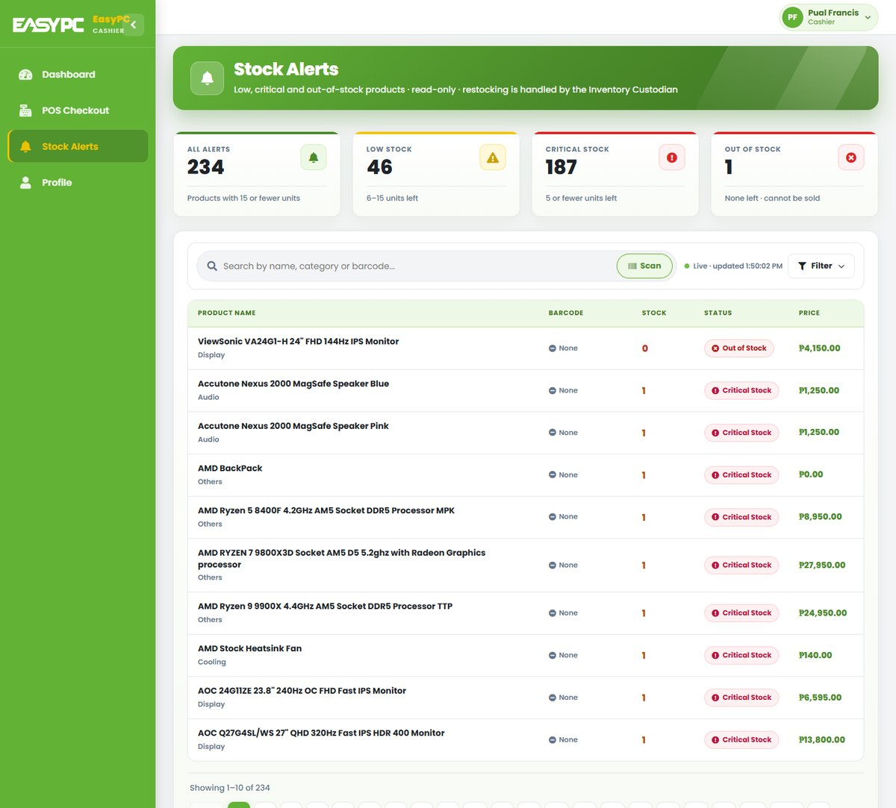
Figure 22. Cashier: Stock Alerts

7.5 Profile
Lets the user update their own account details.
- Edit name, age and address; change the profile picture
- Change password with a live checklist of the password rules
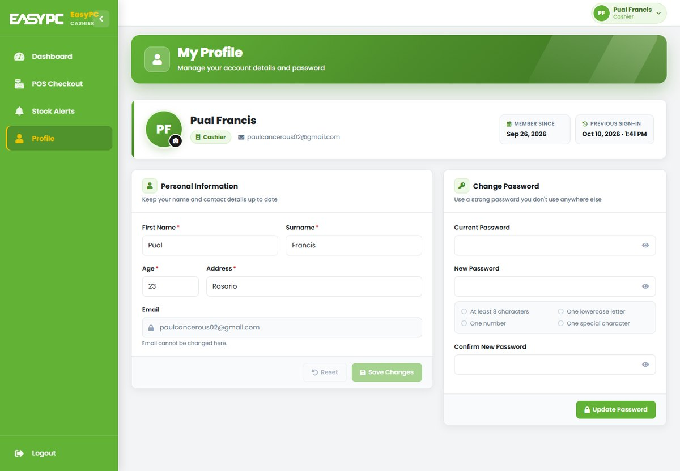
Figure 23. Cashier: Profile

8. Client
Clients browse and buy products online, plan PC builds and get help from Primo.

8.1 Home
Storefront landing page.
- Shop by Category, Featured Products and New Arrivals
- Header: product search, notifications, cart and dark-mode toggle
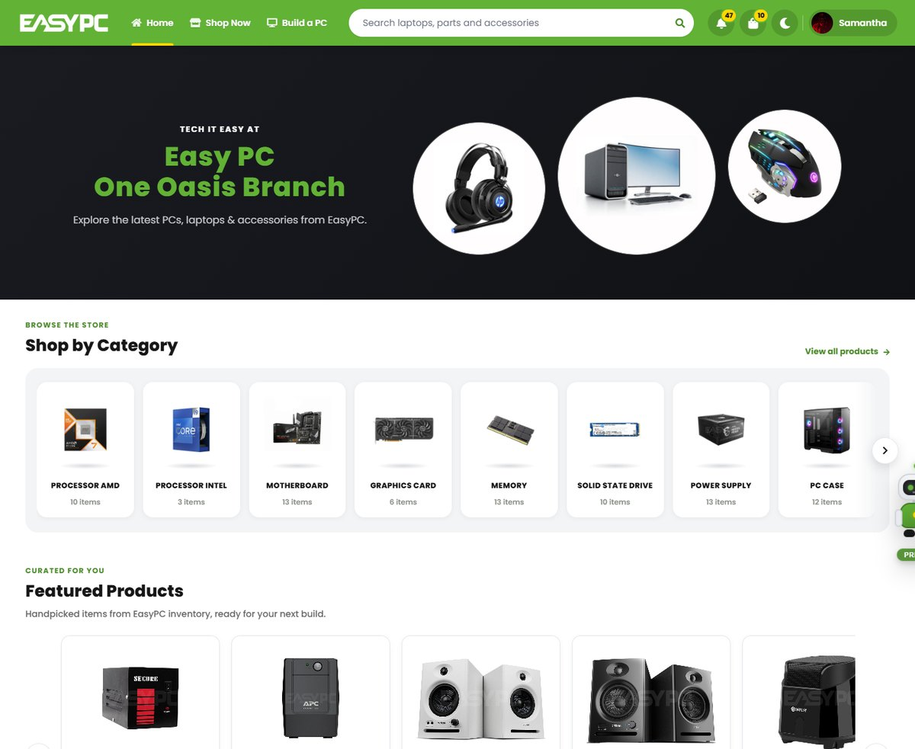
Figure 24. Client: Home

8.2 Primo AI Assistant
Chat assistant available on browsing pages.
- Quick actions: Find a laptop, Track my order, Build a PC, Returns and refunds
- Replies with product cards; past chats are saved in chat history
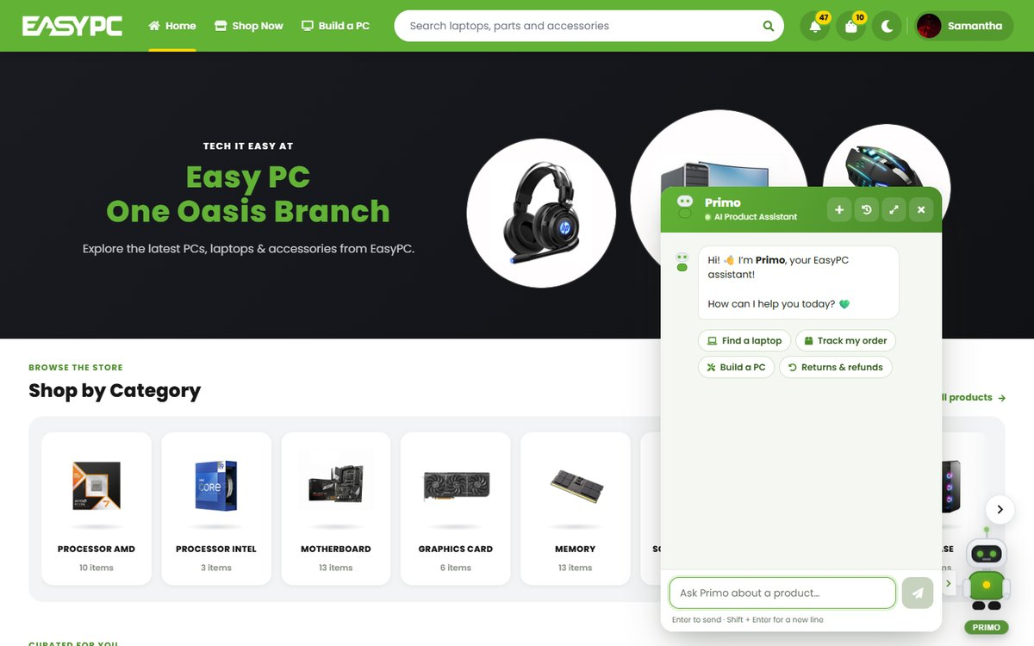
Figure 25. Client: Primo AI Assistant

8.3 Shop
All products in one place.
- Filter by category, price range and brand; quick product groups
- Add to cart, Buy Now or add to wishlist from each card
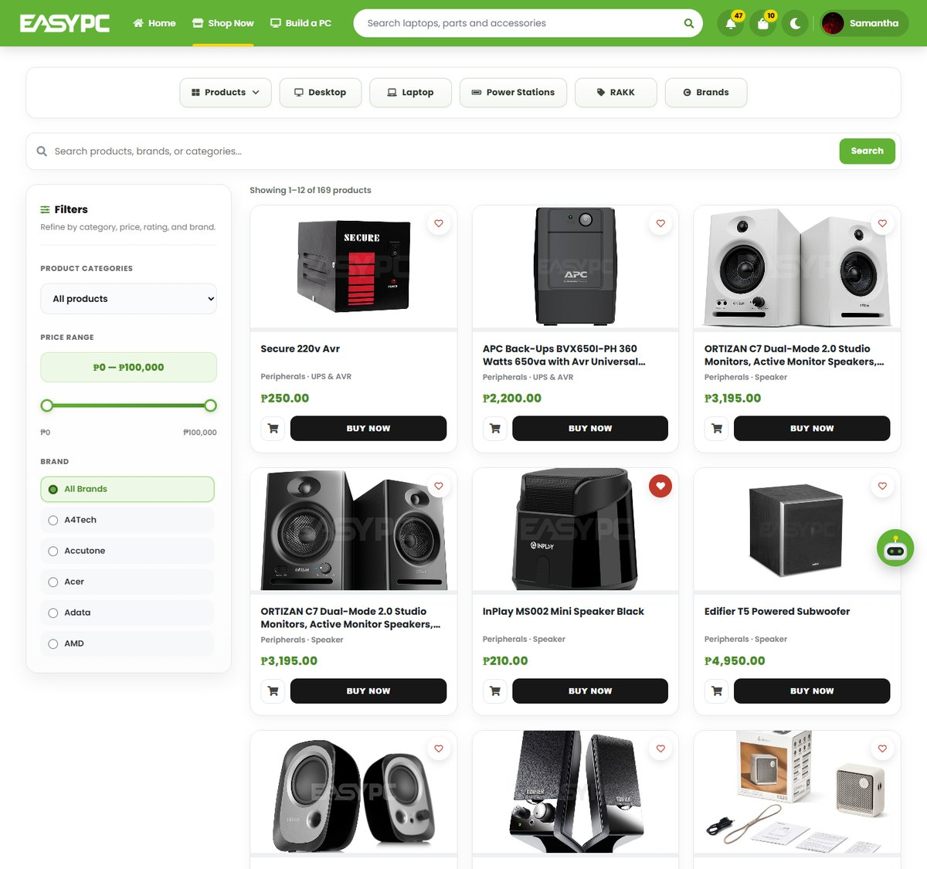
Figure 26. Client: Shop

8.4 Category
Products of one category (e.g. Laptops).
- Filter by brand, price and availability
- Sort by price (ascending / descending) or rating
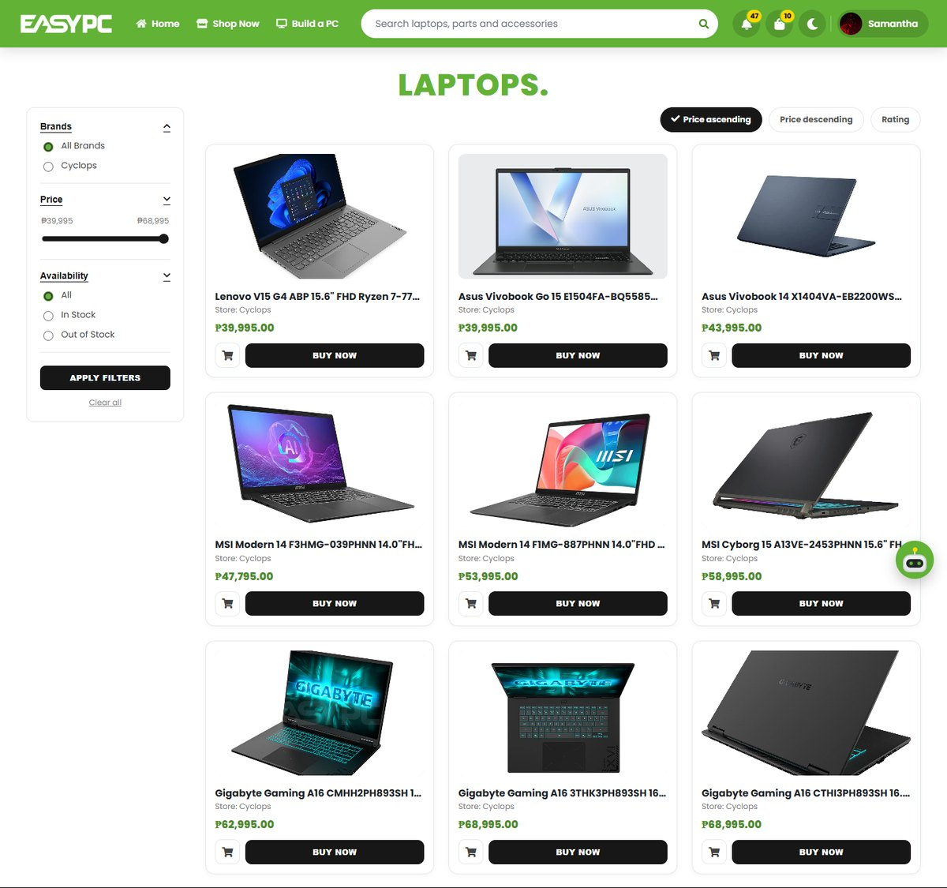
Figure 27. Client: Category

8.5 Product Details
Full information on one product.
- Image zoom, price, stock left and quantity selector
- Add to Cart, Buy Now and Add to Wishlist
- Overview, Specifications, Reviews and Related Products
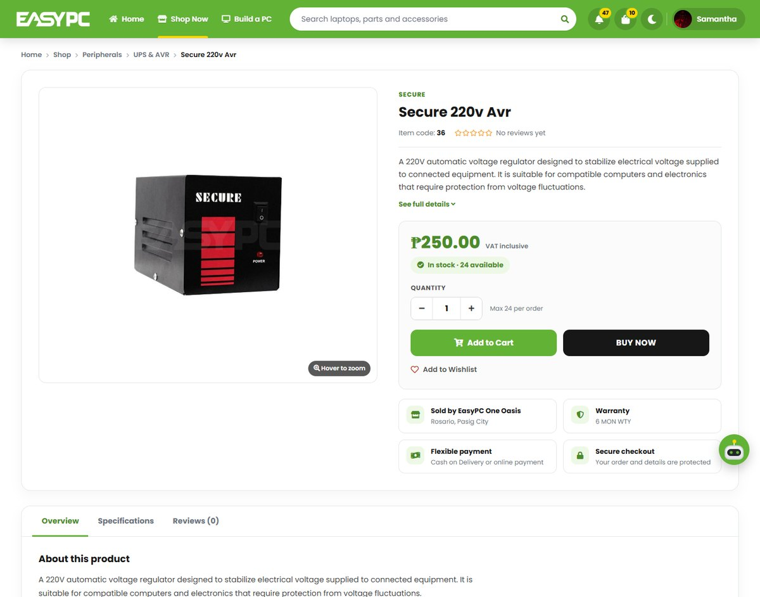
Figure 28. Client: Product Details

8.6 Build a PC
Step-by-step PC builder.
- Choose parts by step: Core, Memory, Graphics, Storage, Power, Case, Cooling
- 3D / 2D case view, build score, performance balance and power estimate
- Compatibility checks; save, share, load and compare builds
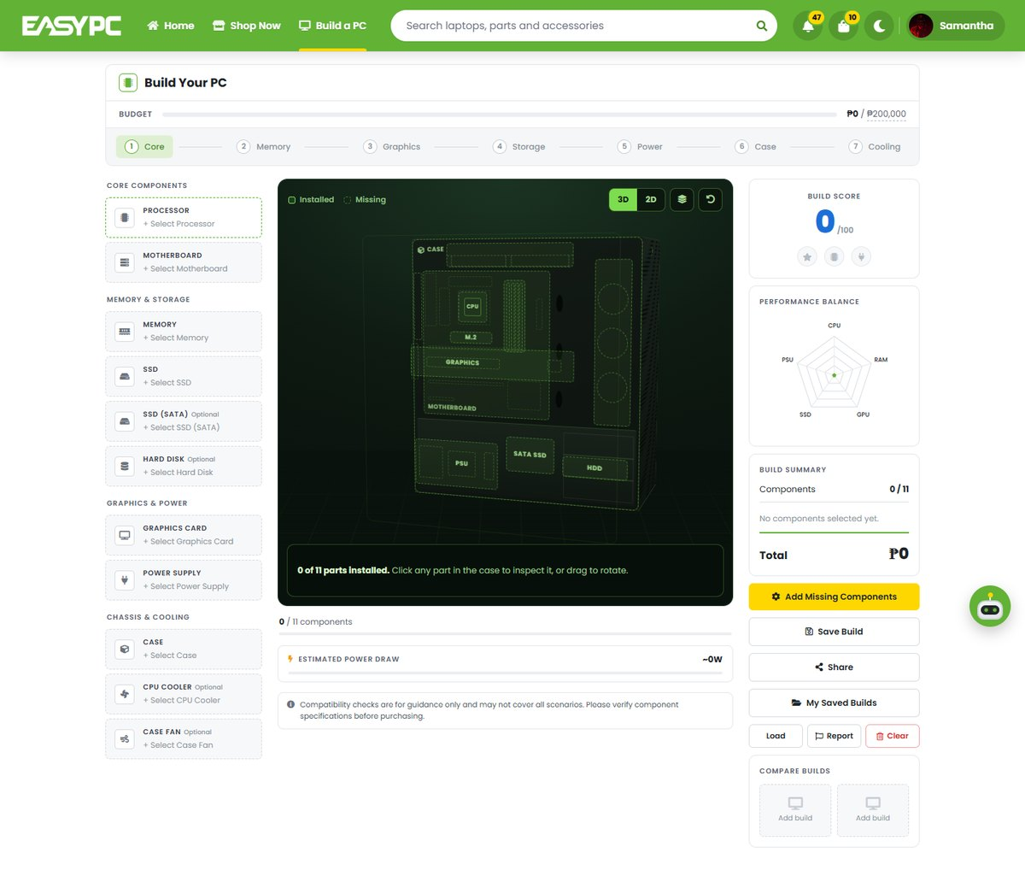
Figure 29. Client: Build a PC

8.7 Saved Builds
PC builds saved by the client.
- Shows parts, total price and whether the build is complete
- Add the whole build to cart, view, edit or delete; search and sort
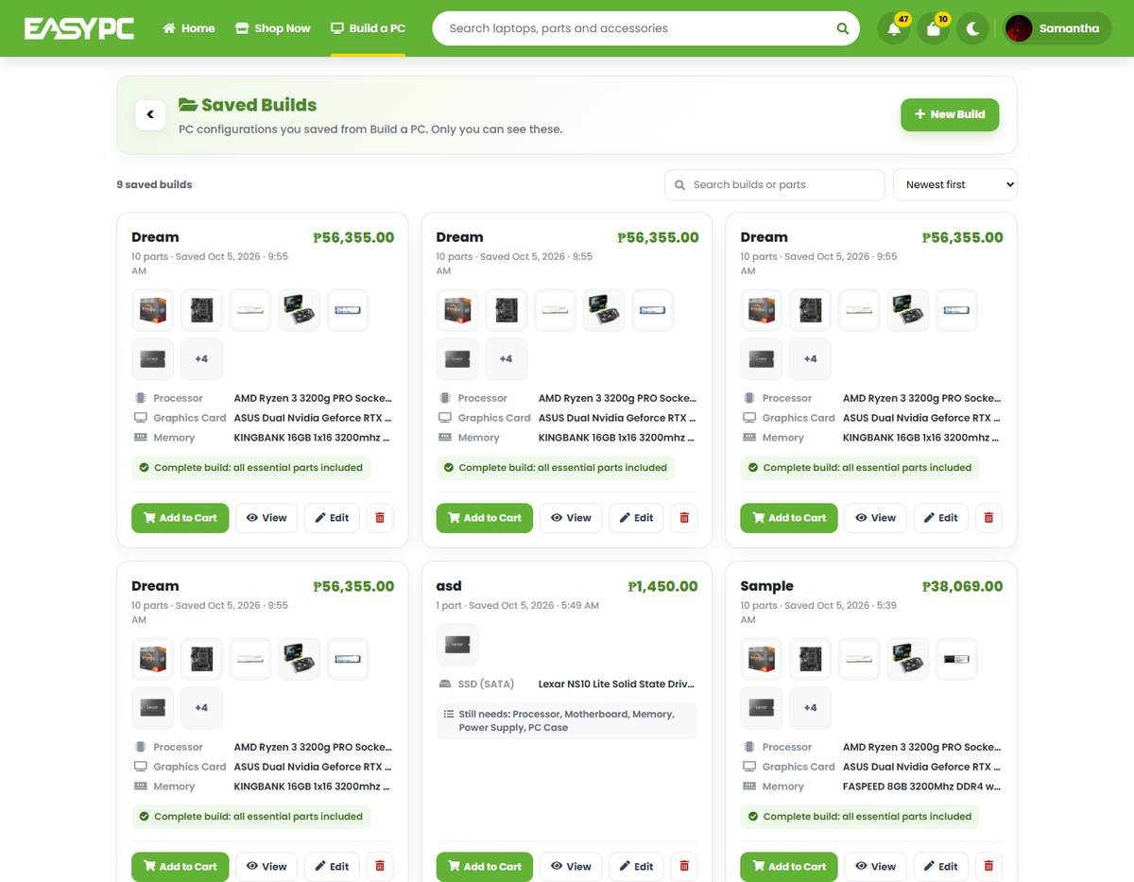
Figure 30. Client: Saved Builds

8.8 Wishlist
Products saved for later.
- Shows price and stock; Buy Now or remove from the list
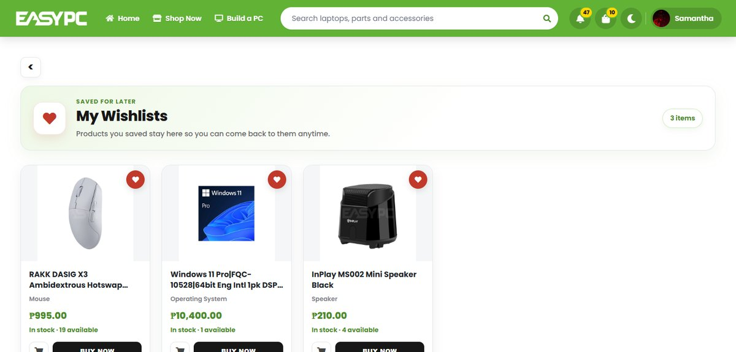
Figure 31. Client: Wishlist

8.9 Cart
Items the client plans to buy.
- Select items, change quantity or remove
- Order Summary with total, then proceed to Checkout
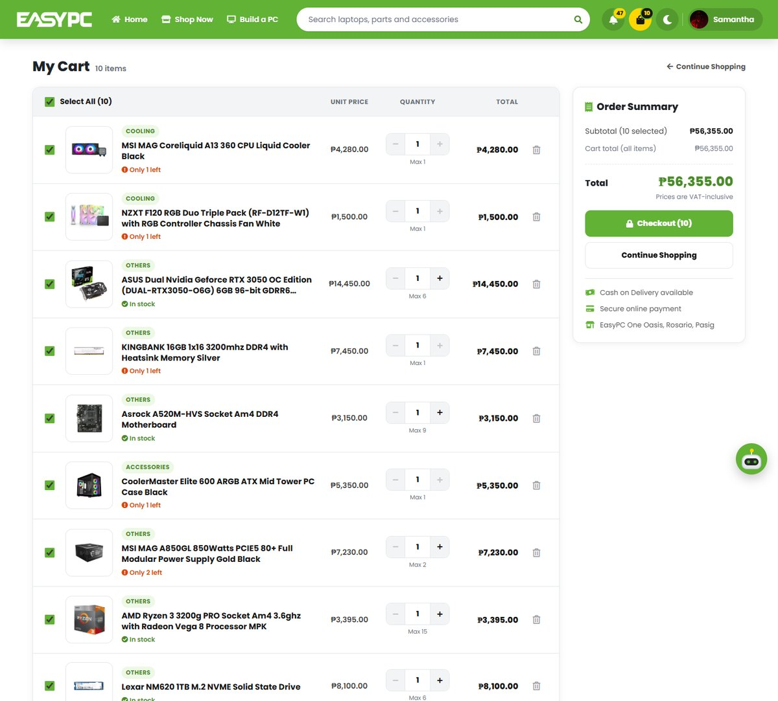
Figure 32. Client: Cart

8.10 Checkout
Confirms shipping details and places the order.
- Order method: saved address, a different address, or Pick Up at the store
- Delivery is through Lalamove; payment is made afterwards under To Pay
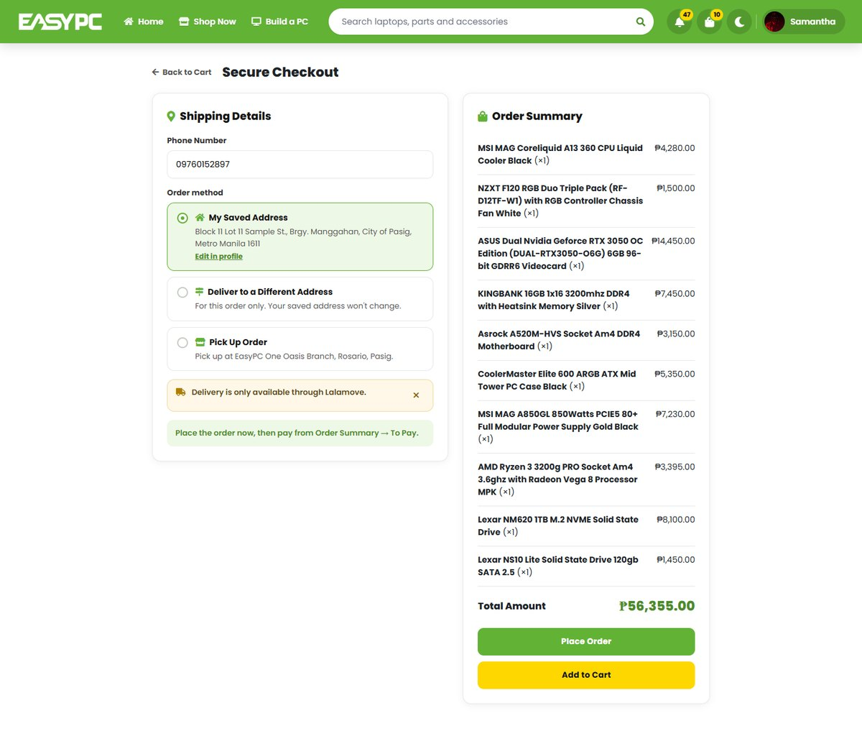
Figure 33. Client: Checkout

8.11 My Account and Orders
Client’s account hub.
- Order tabs: All, To pay, To ship, To receive; plus Order History
- Delivery address, wishlist, saved builds and notification shortcuts
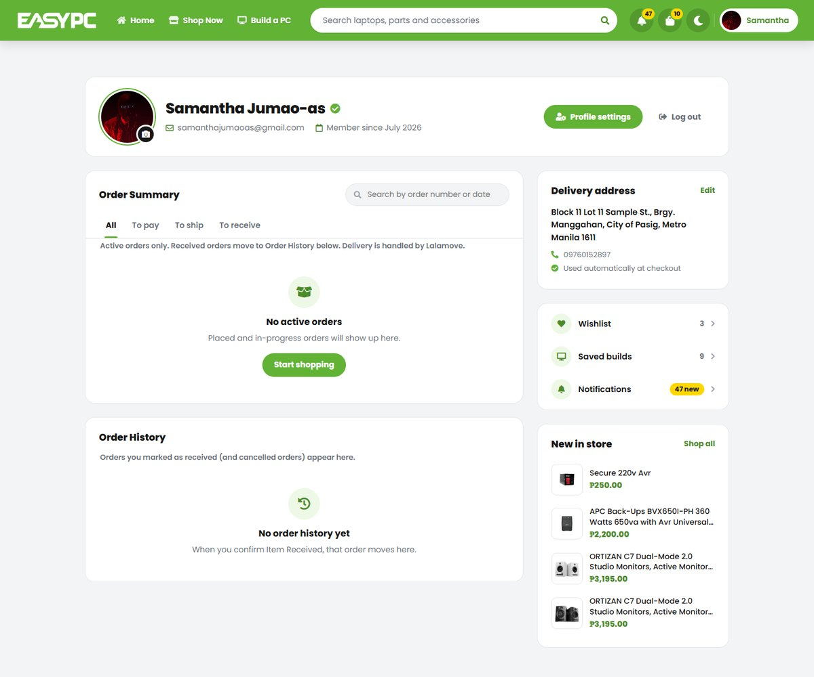
Figure 34. Client: My Account and Orders

8.12 Account Settings
Edit personal and delivery details.
- Name, age, email and phone number
- Default delivery address (province, city, barangay, ZIP) used at checkout
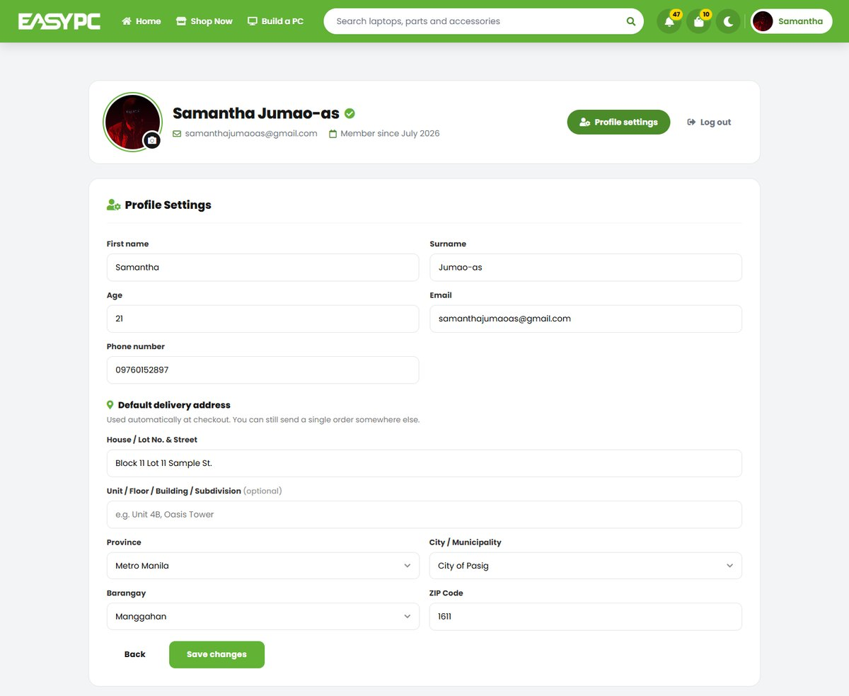
Figure 35. Client: Account Settings

8.13 Notifications
Updates about orders and payments.
- Order, payment and cancellation updates with links to the order
- Filter by type; mark all as read
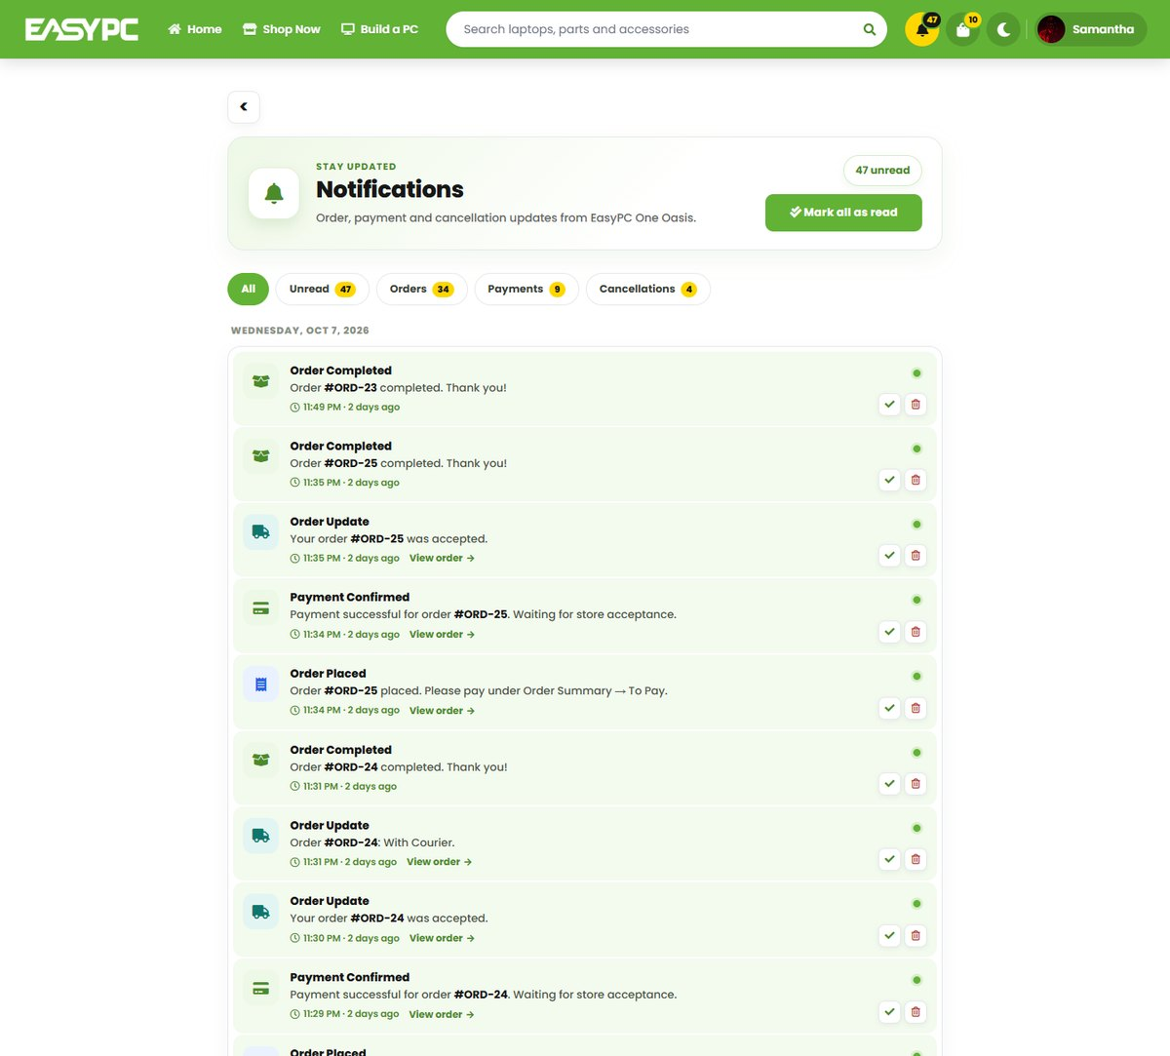
Figure 36. Client: Notifications

8.14 Privacy Policy
How the store handles customer data.
- Data collection and use, security measures, cookies and user rights
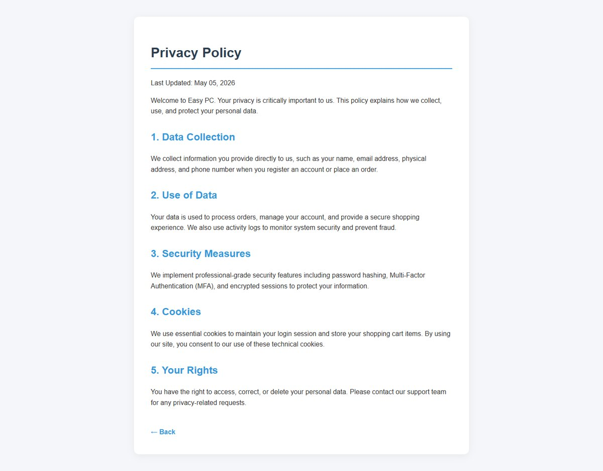
Figure 37. Client: Privacy Policy

