Thor_Rcode
2026-07-17
Project Summary: The Thor wildfire burned in July 2022 to September 2022 in the Colville National Forest, approximately 6 miles east of Metaline Falls, Washington, and was managed using limited suppression methods. The fire affected a remote landscape that had not experienced wildfire in more than a century, providing an opportunity to evaluate post-fire forest conditions following prolonged fire exclusion.Eastern Washington University and Washington Department of Natural Resources collaborated to identify the response of forest ecology to managed wildfire.As wildfire frequency and severity increase across the Inland Northwest, land managers are increasingly interested in both reducing wildfire hazard through active management and understanding when wildfire itself may function as a restoration tool. However, it remains unclear whether individual wildfire events produce beneficial or detrimental ecological outcomes, particularly in forests that have experienced extended periods of fire suppression. To assess post-fire forest ecology, 100 stratified monitoring plots were established within burned and adjacent unburned forests. Standardized forest structure and fuel measurements were collected using the 2024 Washington Department of Natural Resources Forest Health Monitoring Protocol.Differences between burned and unburned sites were evaluated using generalized linear models and nonparametric hypothesis tests while accounting for environmental covariates to isolate the effects of wildfire.
All Libraries:
library(readxl)
## Warning: package 'readxl' was built under R version 4.4.3
library(dplyr)
## Warning: package 'dplyr' was built under R version 4.4.3
##
## Attaching package: 'dplyr'
## The following objects are masked from 'package:stats':
##
## filter, lag
## The following objects are masked from 'package:base':
##
## intersect, setdiff, setequal, union
library(tidyr)
library(tidyverse)
## Warning: package 'tidyverse' was built under R version 4.4.3
## Warning: package 'ggplot2' was built under R version 4.4.3
## Warning: package 'forcats' was built under R version 4.4.2
## ── Attaching core tidyverse packages ──────────────────────── tidyverse 2.0.0 ──
## ✔ forcats 1.0.0 ✔ readr 2.1.5
## ✔ ggplot2 3.5.2 ✔ stringr 1.5.1
## ✔ lubridate 1.9.3 ✔ tibble 3.2.1
## ✔ purrr 1.0.2
## ── Conflicts ────────────────────────────────────────── tidyverse_conflicts() ──
## ✖ dplyr::filter() masks stats::filter()
## ✖ dplyr::lag() masks stats::lag()
## ℹ Use the conflicted package (<http://conflicted.r-lib.org/>) to force all conflicts to become errors
library(effects)
## Warning: package 'effects' was built under R version 4.4.2
## Loading required package: carData
## Warning: package 'carData' was built under R version 4.4.2
## lattice theme set by effectsTheme()
## See ?effectsTheme for details.
library(sf)
## Warning: package 'sf' was built under R version 4.4.3
## Linking to GEOS 3.13.0, GDAL 3.10.1, PROJ 9.5.1; sf_use_s2() is TRUE
library(emmeans)
## Warning: package 'emmeans' was built under R version 4.4.3
## Welcome to emmeans.
## Caution: You lose important information if you filter this package's results.
## See '? untidy'
library(ggplot2)
library(vegan)
## Warning: package 'vegan' was built under R version 4.4.3
## Loading required package: permute
## Warning: package 'permute' was built under R version 4.4.2
## Loading required package: lattice
library(car)
## Warning: package 'car' was built under R version 4.4.2
##
## Attaching package: 'car'
##
## The following object is masked from 'package:purrr':
##
## some
##
## The following object is masked from 'package:dplyr':
##
## recode
library(MuMIn)
## Warning: package 'MuMIn' was built under R version 4.4.2
library(glmmTMB)
## Warning: package 'glmmTMB' was built under R version 4.4.3
library(DHARMa)
## Warning: package 'DHARMa' was built under R version 4.4.3
## This is DHARMa 0.4.7. For overview type '?DHARMa'. For recent changes, type news(package = 'DHARMa')
library(ggeffects)
## Warning: package 'ggeffects' was built under R version 4.4.3
library(pscl)
## Warning: package 'pscl' was built under R version 4.4.3
## Classes and Methods for R originally developed in the
## Political Science Computational Laboratory
## Department of Political Science
## Stanford University (2002-2015),
## by and under the direction of Simon Jackman.
## hurdle and zeroinfl functions by Achim Zeileis.
library(ordinal)
## Warning: package 'ordinal' was built under R version 4.4.3
##
## Attaching package: 'ordinal'
##
## The following object is masked from 'package:dplyr':
##
## slice
library(indicspecies)
## Warning: package 'indicspecies' was built under R version 4.4.3
library("patchwork")
## Warning: package 'patchwork' was built under R version 4.4.3
library(cluster)
options(contrasts = c("contr.sum", "contr.poly"))
Data Cleaning: Data was collected using the Forest Health Monitoring datasheet V6 on Survey123 and exported as an excel file. In the first step of data cleaning I imported each excel data sheet as an individual data set. Additionally, I imported fire severity and elevation data. Elevation data were extracted from a Digital Elevation Model (USGS, n.d.) and wildfire severity values for each plot were calculated following methods of Parks et al.(2018), extracted from the WA DNR burn severity raster (WA DNR Forest Resiliency Division, 2025). Slope was measured on plot, however, slope was not recorded on two plots and for these plots the DEM was referenced and slope values were manually added to the data set. Within each data set missing data and errors were investigated through referencing photos taken at each plot and utilizing logic. The protocol says to document and record data for each individual tree within the 37.2ft radius plot. However, it was infeasible to do so for some plots that had more than 30 trees on plot. Therefore, in those high density plots we recorded trees in two diagonal quadrants.A new column was added where I noted whether or not the tree data was recorded in a split plot.
# Import each sheet into individual datasets
Monitoring <- read_excel("Thor_2025_survey_results.xlsx", sheet = "Monitoring")
Recruitment <- read_excel("Thor_2025_survey_results.xlsx", sheet = "Tree < 5in 11.8ft plot")
largetrees <- read_excel("Thor_2025_survey_results.xlsx", sheet = "Fixed radius plot")
Photoloading<- read_excel("Thor_2025_survey_results.xlsx", sheet = "Photoload_small")
logs<- read_excel("Thor_2025_survey_results.xlsx", sheet = "Photoload_large")
litterduff<- read_excel("Thor_2025_survey_results.xlsx", sheet = "litter_duff_transects")
canopy<- read_excel("Thor_2025_survey_results.xlsx", sheet = "Canopy_Cover")
FireSeverity<-read.csv("THOR_severity.csv")
Elevation<-read.csv("ElevationPlots.csv")
##standardize the column name of GlobalID
Monitoring<- Monitoring %>%
rename("ParentGlobalID" = GlobalID)
FireSeverity<-FireSeverity%>%
rename("ParentGlobalID" = globalid)
Elevation<-Elevation%>%
rename("ParentGlobalID" = globalid)
##re-format PlotID names
Monitoring <- Monitoring %>%
mutate(PlotID = PlotID %>%
str_replace_all("^Thor_", "") %>% #Remove any "THOR_" or any other
str_replace_all("[\\p{Pd}.\\s]+", "_") %>%
str_to_upper() %>% # 2. Convert to uppercase
str_replace_all("_+", "_") %>% #Remove any duplicate underscores (e.g. "__" -> "_")
str_replace_all("^_|_$", "")%>% #Trim leading/trailing underscores if any
str_replace_all("^([A-Z])(?=[A-Z])", "\\1_")) #Insert underscore after first letter if missing
Recruitment <- Recruitment %>%
mutate(PlotID = PlotID %>%
str_replace_all("^Thor_", "") %>%
str_replace_all("[\\p{Pd}.\\s]+", "_") %>%
str_to_upper() %>%
str_replace_all("_+", "_") %>%
str_replace_all("^_|_$", "")%>%
str_replace_all("^([A-Z])(?=[A-Z])", "\\1_"))
Photoloading <- Photoloading %>%
mutate(PlotID = PlotID %>%
str_replace_all("^Thor_", "") %>%
str_replace_all("[\\p{Pd}.\\s]+", "_") %>%
str_to_upper() %>%
str_replace_all("_+", "_") %>%
str_replace_all("^_|_$", "")%>%
str_replace_all("^([A-Z])(?=[A-Z])", "\\1_"))
logs <- logs %>%
mutate(PlotID = PlotID %>%
str_replace_all("^Thor_", "") %>%
str_replace_all("[\\p{Pd}.\\s]+", "_") %>%
str_to_upper() %>%
str_replace_all("_+", "_") %>%
str_replace_all("^_|_$", "")%>%
str_replace_all("^([A-Z])(?=[A-Z])", "\\1_"))
litterduff <- litterduff %>%
mutate(PlotID = PlotID %>%
str_replace_all("^Thor_", "") %>%
str_replace_all("[\\p{Pd}.\\s]+", "_") %>%
str_to_upper() %>%
str_replace_all("_+", "_") %>%
str_replace_all("^_|_$", "")%>%
str_replace_all("^([A-Z])(?=[A-Z])", "\\1_"))
largetrees <- largetrees %>%
mutate(PlotID = PlotID %>%
str_replace_all("^Thor_", "") %>%
str_replace_all("[\\p{Pd}.\\s]+", "_") %>%
str_to_upper() %>%
str_replace_all("_+", "_") %>%
str_replace_all("^_|_$", "")%>%
str_replace_all("^([A-Z])(?=[A-Z])", "\\1_"))
canopy <- canopy %>%
mutate(PlotID = PlotID %>%
str_replace_all("^Thor_", "") %>%
str_replace_all("[\\p{Pd}.\\s]+", "_") %>%
str_to_upper() %>%
str_replace_all("_+", "_") %>%
str_replace_all("^_|_$", "")%>%
str_replace_all("^([A-Z])(?=[A-Z])", "\\1_"))
##check for duplicates
table(Monitoring$PlotID)
##
## B_SC2_1 B_SC2_10 B_SC2_11 B_SC2_12 B_SC2_13 B_SC2_14 B_SC2_15 B_SC2_16
## 1 1 1 2 1 1 1 1
## B_SC2_17 B_SC2_19 B_SC2_2 B_SC2_20 B_SC2_3 B_SC2_4 B_SC2_5 B_SC2_6
## 1 1 1 1 1 2 1 1
## B_SC2_7 B_SC2_8 B_SC3_10 B_SC3_11 B_SC3_12 B_SC3_13 B_SC3_14 B_SC3_17
## 1 1 1 1 1 1 1 1
## B_SC3_18 B_SC3_19 B_SC3_2 B_SC3_21 B_SC3_22 B_SC3_23 B_SC3_24 B_SC3_25
## 1 1 1 1 1 1 1 1
## B_SC3_26 B_SC3_27 B_SC3_28 B_SC3_29 B_SC3_3 B_SC3_30 B_SC3_32 B_SC3_33
## 1 1 1 1 1 1 1 1
## B_SC3_34 B_SC3_35 B_SC3_36 B_SC3_37 B_SC3_38 B_SC3_40 B_SC3_6 B_SC3_7
## 1 2 1 1 1 1 1 1
## B_SC8_2 B_SC8_3 U_SC2_1 U_SC2_10 U_SC2_11 U_SC2_13 U_SC2_14 U_SC2_15
## 1 1 1 1 2 1 1 1
## U_SC2_16 U_SC2_17 U_SC2_18 U_SC2_19 U_SC2_4 U_SC2_5 U_SC2_8 U_SC2_9
## 1 1 1 1 1 1 1 1
## U_SC3_1 U_SC3_10 U_SC3_11 U_SC3_13 U_SC3_14 U_SC3_15 U_SC3_16 U_SC3_17
## 1 1 1 1 1 1 1 1
## U_SC3_18 U_SC3_2 U_SC3_21 U_SC3_22 U_SC3_24 U_SC3_25 U_SC3_28 U_SC3_29
## 1 1 1 1 1 1 1 1
## U_SC3_3 U_SC3_31 U_SC3_32 U_SC3_33 U_SC3_34 U_SC3_36 U_SC3_37 U_SC3_38
## 1 1 1 1 1 1 1 1
## U_SC3_4 U_SC3_40 U_SC3_5 U_SC3_6 U_SC3_7 U_SC3_8 U_SC3_9 U_SC8_1
## 1 1 1 1 1 1 1 1
## U_SC8_2 U_SC8_3 U_SC8_4
## 1 1 1
#There were two B_SC3_35 and upon investigation on the map using the X Y coordinates, I confirmed that the survey on 7/29/2025 globalID: 940b702c-e196-4476-8b2e-7a7c59d270a2 was actually a typo and this is plot U_SC3_35.I went through and changed the PlotID.
Monitoring <- Monitoring %>%
mutate(PlotID = if_else(ParentGlobalID == "940b702c-e196-4476-8b2e-7a7c59d270a2", "U_SC3_35", PlotID))
Recruitment <- Recruitment %>%
mutate(PlotID = if_else(ParentGlobalID == "940b702c-e196-4476-8b2e-7a7c59d270a2","U_SC3_35",
PlotID))
Photoloading <- Photoloading %>%
mutate(PlotID = if_else(ParentGlobalID == "940b702c-e196-4476-8b2e-7a7c59d270a2","U_SC3_35", PlotID))
logs <- logs %>%
mutate(PlotID = if_else(ParentGlobalID == "940b702c-e196-4476-8b2e-7a7c59d270a2","U_SC3_35",PlotID))
litterduff <- litterduff %>%
mutate(PlotID = if_else(ParentGlobalID == "940b702c-e196-4476-8b2e-7a7c59d270a2",
"U_SC3_35",PlotID))
largetrees <- largetrees %>%
mutate(PlotID = if_else(ParentGlobalID == "940b702c-e196-4476-8b2e-7a7c59d270a2","U_SC3_35", PlotID))
canopy <- canopy %>%
mutate(PlotID = if_else(ParentGlobalID == "940b702c-e196-4476-8b2e-7a7c59d270a2","U_SC3_35",
PlotID))
Monitoring %>%
mutate(is_duplicate = duplicated(PlotID) | duplicated(PlotID, fromLast = TRUE)) %>%
filter(is_duplicate) %>%
arrange(PlotID)
## # A tibble: 6 × 88
## ObjectID ParentGlobalID `Inventory Date` CreationDate Creator
## <dbl> <chr> <dttm> <dttm> <chr>
## 1 211 fc36ed73-becd-4237-9… 2024-08-06 00:00:00 2024-08-07 00:00:00 <NA>
## 2 1097 7b8599e4-ad89-4fdb-9… 2025-08-19 00:00:00 2025-08-26 00:00:00 skenne…
## 3 1082 c7b626d9-379b-4c09-9… 2025-08-11 00:00:00 2025-08-23 00:00:00 skenne…
## 4 1083 2d729567-36e9-4bc1-a… 2025-08-11 00:00:00 2025-08-23 00:00:00 skenne…
## 5 212 e88e548b-7864-4ffe-8… 2024-08-06 00:00:00 2024-08-08 00:00:00 <NA>
## 6 961 0127544b-963c-4b34-b… 2025-07-10 00:00:00 2025-07-13 00:00:00 skenne…
## # ℹ 83 more variables: EditDate <lgl>, Editor <lgl>, `Survey Type` <chr>,
## # Landowner <chr>, `Survey Crew Names` <chr>,
## # `Organization of inventory team` <chr>, `Sampling Event` <chr>,
## # `Month & year forest health treatment was completed` <dbl>,
## # `Project Name` <chr>, `Location Description` <lgl>,
## # `Describe Prescription` <chr>, `Site Notes` <chr>,
## # `Any other site level data` <chr>, `Forest Health Treatment ID` <lgl>, …
#Deleted all data for ID: 2d729567-36e9-4bc1-aa5f-be4d2e84c632, duplicate
#8/8/2024 U_SC2_11 global ID: e88e548b-7864-4ffe-8b01-80323e3fe502 was incomplete. Re-sampled 7/13/2025 global ID: 0127544b-963c-4b34-bdc6-1091aa53f1e4. I will remove the data for the incomplete plot e88e548b-7864-4ffe-8b01-80323e3fe502.
#Sampled the same plot in 2024 and 2025. 8/6/2024 B_SC2_12 globalID: fc36ed73-becd-4237-93c7-1aff8a47d180, 8/19/2025 B_SC2_12 globalID: 7b8599e4-ad89-4fdb-9a0c-b5d2cd1dbb3d. 2024 since the collector was different and most plots were sampled in 2025.
duplicates_to_remove <- c(
"2d729567-36e9-4bc1-aa5f-be4d2e84c632",
"e88e548b-7864-4ffe-8b01-80323e3fe502",
"fc36ed73-becd-4237-93c7-1aff8a47d180")
Monitoring <- Monitoring %>%
filter(!(ParentGlobalID %in% duplicates_to_remove))
Recruitment <- Recruitment %>%
filter(!(ParentGlobalID %in% duplicates_to_remove))
Photoloading <- Photoloading %>%
filter(!(ParentGlobalID %in% duplicates_to_remove))
logs <- logs %>%
filter(!(ParentGlobalID %in% duplicates_to_remove))
litterduff <- litterduff %>%
filter(!(ParentGlobalID %in% duplicates_to_remove))
largetrees <- largetrees %>%
filter(!(ParentGlobalID %in% duplicates_to_remove))
canopy <- canopy %>%
filter(!(ParentGlobalID %in% duplicates_to_remove))
FireSeverity <- FireSeverity %>%
filter(!(ParentGlobalID %in% duplicates_to_remove))
Elevation <- Elevation %>%
filter(!(ParentGlobalID %in% duplicates_to_remove))
#Fill in PlotID gaps by matching with the GlobalID and ensure all 100 plots are represented in each dataset
all_plots <- Monitoring %>% #create a look up table with the correct ParentGlobalID-PlotID pairs.
select(ParentGlobalID, PlotID) %>%
filter(!is.na(PlotID) & PlotID != "") %>%
distinct(ParentGlobalID, PlotID)
Recruitment <- Recruitment %>%
left_join(all_plots, by = "ParentGlobalID", suffix = c("", "_filled")) %>%
mutate(PlotID = coalesce(PlotID, PlotID_filled)) %>%
select(-PlotID_filled) %>%
right_join(all_plots, by = "PlotID")
Photoloading <- Photoloading %>%
left_join(all_plots, by = "ParentGlobalID", suffix = c("", "_filled")) %>%
mutate(PlotID = coalesce(PlotID, PlotID_filled)) %>%
select(-PlotID_filled) %>%
right_join(all_plots, by = "PlotID")
logs <- logs %>%
left_join(all_plots, by = "ParentGlobalID", suffix = c("", "_filled")) %>%
mutate(PlotID = coalesce(PlotID, PlotID_filled)) %>%
select(-PlotID_filled) %>%
right_join(all_plots, by = "PlotID")
litterduff <- litterduff %>%
left_join(all_plots, by = "ParentGlobalID", suffix = c("", "_filled")) %>%
mutate(PlotID = coalesce(PlotID, PlotID_filled)) %>%
select(-PlotID_filled) %>%
right_join(all_plots, by = "PlotID")
largetrees <- largetrees %>%
left_join(all_plots, by = "ParentGlobalID", suffix = c("", "_filled")) %>%
mutate(PlotID = coalesce(PlotID, PlotID_filled)) %>%
select(-PlotID_filled) %>%
right_join(all_plots, by = "PlotID")
canopy <- canopy %>%
left_join(all_plots, by = "ParentGlobalID", suffix = c("", "_filled")) %>%
mutate(PlotID = coalesce(PlotID, PlotID_filled)) %>%
select(-PlotID_filled) %>%
right_join(all_plots, by = "PlotID")
FireSeverity <- FireSeverity %>%
left_join(all_plots, by = "ParentGlobalID")
Elevation <- Elevation %>%
left_join(all_plots, by = "ParentGlobalID")
## Plot Information datacleaning
##Live Fuel Height was supposed to be in inches but I thought it was feet for several plots.... I changed every number less than 10 to its corresponding conversion in inches because it is more likely to be in feet than in inches since the live fuel ranged from 1-10 feet tall.
#missing slope data. With arcGISPro I used a DEM to derive slope across the survey area. I then overlayed the exact plot locations from Survey123 and determined the slope of the area that plot was in.
#missing aspect data. Looking at the map, determine which cardinal direction the slope was facing.
#missing live fuel height data for U_SC2_8 and estimated average height visually with photos
PlotInformation <- Monitoring %>%
select(
PlotID,
"Date" = "Inventory Date",
"Slope" = "Average percent of slope within plot",
"Aspect" = "Predominant aspect of the plot",
"Azimuth" = "Plot Azimuth",
"Soil Disturbance" = "Soil disturbance",
"Stand Height (ft.)" = "Stand Height",
"Live Fuel Height (in.)" = "Average Canopy Fuel Base Height",
x, y) %>%
mutate(
`Live Fuel Height (in.)` = case_when(
`Live Fuel Height (in.)` == 1 ~ 12,
`Live Fuel Height (in.)` == 2 ~ 24,
`Live Fuel Height (in.)` == 3 ~ 36,
`Live Fuel Height (in.)` == 4 ~ 48,
`Live Fuel Height (in.)` == 5 ~ 60,
`Live Fuel Height (in.)` == 6 ~ 72,
`Live Fuel Height (in.)` == 7 ~ 84,
`Live Fuel Height (in.)` == 8 ~ 96,
`Live Fuel Height (in.)` == 9 ~ 108,
TRUE ~ `Live Fuel Height (in.)`))%>%
mutate(across(c("Live Fuel Height (in.)"), as.numeric))%>%
mutate(Slope = case_when(
PlotID == "B_SC3_2" ~ 60,
PlotID == "U_SC3_17" ~ 33,
TRUE ~ Slope))%>%
mutate(
Aspect = case_when(
PlotID == "U_SC3_9" ~ "S",
PlotID %in% c("U_SC3_17","U_SC3_24") ~ "SW",
PlotID %in% c("B_SC3_21","B_SC3_12", "U_SC3_37") ~ "W",
PlotID == "U_SC2_10" ~ "NW",
TRUE ~ Aspect))%>%
mutate(`Live Fuel Height (in.)`= case_when(PlotID=="U_SC2_8"~2, TRUE ~ `Live Fuel Height (in.)`))
#vegetation plot level
vegetation <- Monitoring %>%
select(
PlotID,
"Date"="Inventory Date",
"Shrub"= "Vegetation - shrubs",
"Forb" = "Vegetation - herbaceous",
"Grass"="Vegetation - grass",
"Invasive"="Invasive Plants")
#Recruitment
#For B_SC3_6 there were a few blank rows which resembled extra data sheets added; these rows were deleted.
#ObjectID 1499 had a species (THPL) recorded but no abundance data associated with it. This is due to an error in assuming THPL seedlings would be present but none were found within the 11.8ft radius plot.
#objectID 1104 there was no data recorded which suggests no seedlings or saplings were detected in the 11.8ft radius plot.
Recruitment <- Recruitment %>%
filter(!ObjectID %in% c(1208, 1499, 1104)) %>% # Remove blank data
mutate(Species = if_else(ObjectID %in% c(1106, 1108), "unknown", Species))
#seperate recruitment into two seperate data sheets "seedlings" and "saplings"
Seedling <- Recruitment %>%
filter(`Seedling or Sapling?` == "seedling") %>%
select(
PlotID,
Species,
Abundance,
Seedling = `Seedling or Sapling?`) %>%
right_join(all_plots, by = "PlotID")
Sapling <- Recruitment %>%
filter(`Seedling or Sapling?` == "sapling") %>%
select(
PlotID,
Species,
Count,
Sapling = `Seedling or Sapling?`) %>%
right_join(all_plots, by = "PlotID")
#Large Trees (>5in.DBH) cleaning
largetrees <- largetrees %>%
mutate(`Bole Char` = as.numeric(`Bole Char`)) %>%
mutate(
`Bole Char` = if_else(
str_starts(PlotID, "U_") & is.na(`Bole Char`),
0,`Bole Char`)) %>%
mutate(Species = if_else(str_starts(Species, "Un"), "Unknown", Species)) %>%
select(PlotID, Species, DBH, "Status" = `Tree Status Code`,
`Snag class`, `Forest strata`, `Tree Height`,
`Live Crown Ratio`, `Bole Char`)
# Split Plots
split_plots <- c(
"U_SC3_7", "U_SC3_1", "U_SC3_3", "U_SC3_18", "U_SC3_4", "U_SC8_4",
"U_SC3_33", "B_SC3_6", "B_SC3_23", "B_SC3_13", "B_SC2_16", "B_SC2_13",
"B_SC2_11", "B_SC3_21", "B_SC3_17", "B_SC3_28", "B_SC3_38", "B_SC2_15",
"B_SC2_7", "U_SC3_13", "U_SC3_21", "U_SC3_25", "U_SC3_32", "U_SC3_5",
"U_SC8_2", "B_SC2_3", "U_SC2_10", "U_SC2_9", "B_SC2_8", "B_SC3_33",
"U_SC2_8", "B_SC2_17", "B_SC2_4", "U_SC2_17", "U_SC2_19", "B_SC2_5",
"U_SC3_9", "B_SC3_22")
largetrees <- largetrees %>%
mutate(treesplit = if_else(PlotID %in% split_plots, "Y", "N"))
##checking for missing data
#hist(largetrees$DBH)
#hist(largetrees$`Tree Height`)
#hist(largetrees$`Bole Char`)
#litter and duff cleaning
#hist(litterduff$`Litter depth at 0'`)
#hist(litterduff$`Duff depth at 0'`)
#hist(litterduff$`Litter depth at 25'`)
#hist(litterduff$`Duff depth at 25'`)
#hist(litterduff$`Litter depth at 50'`)
#hist(litterduff$`Litter depth at 74'`)
#hist(litterduff$`Duff depth at 74'`)
#At B_SC2_3 the litter depth at 50 was 145026.0. this is clearly a typo. Other values of litter along the transect were 0.5. Therefore, the value should be changed to 0.5.
#At U_SC3_33 the Duff depth at 0 was 33. this is clearly a typo. Other values of duff along the transect were 3.0. Therefore, the value should be changed to 3.0.
litterduff <- litterduff %>%
select(PlotID, "Litter depth at 0'","Duff depth at 0'","Litter depth at 25'","Duff depth at 25'","Litter depth at 50'","Duff depth at 50'","Litter depth at 74'","Duff depth at 74'")%>%
mutate(`Litter depth at 50'` = if_else(
PlotID == "B_SC2_3" &`Litter depth at 50'` == 145026.0,0.5,`Litter depth at 50'`))%>%
mutate(`Duff depth at 0'`= if_else(
PlotID == "U_SC3_33" &`Duff depth at 0'` == 33, 3.0,`Duff depth at 0'`))%>%
mutate(across(
where(is.numeric),
~ if_else(PlotID == "B_SC3_14", replace_na(., 0), .)))%>%
mutate(across(
where(is.numeric), ~ round(. / 0.5) * 0.5))
#Canopy
NoCanopy <- c(
"U_SC8_1", "B_SC3_12","B_SC3_26","B_SC2_6","B_SC2_14","B_SC3_2","B_SC3_24","B_SC8_3","B_SC3_13","B_SC2_16","B_SC3_18","B_SC2_13","B_SC2_11","B_SC3_17","B_SC2_13","B_SC3_19") #verified plots that were missing canopy but were marked having canopy using survey photos
canopy <- canopy %>%
filter(`Hits or Misses` != "NA")%>% #remove NA, rows that are blank were extra sheet added on survey123.
select(
PlotID,
HM = `Hits or Misses`) %>%
mutate(
HM = if_else(PlotID %in% NoCanopy, "miss", HM))
## Missing data for U_SC3_1 and there is canopy cover present on this plot
#logs cleaning
##U_SC2_10 has a missing value for "sound or rotten". This hardly effects the equation with a difference in specific gravity constant where sound = 0.4 and rotten= 0.3. This logs data should still be retained as it is important for calculating "n" number of intersections. Therefore, I will claim this log is sound for analysis but make sure to note this in the discussion.
##B_SC3_19 has one log missing the length! I will leave it as an NA because it appears that the length of the individual log is not used in calculations
## B_SC3_12 length is 260.. should be 60. Verified with largetrees data on plot, trees were around 60ft. tall so it is likely this is a typo and I meant to type 60.
##B_SC3_12 diameter is 50.6, the log length is 32.3 feet so this is a typo, it should be 5.6in
logs<-logs%>%
select(PlotID,
"Decay"='Sound or rotten',
"Diameter"= "DBH", Length)%>%
mutate(Decay = na_if(Decay, "na"))%>%
right_join(all_plots, by = "PlotID")%>%
mutate("Decay"=if_else(
PlotID == "U_SC2_10" & is.na(Decay), "sound", Decay))%>%
mutate(
across(c(Diameter, Length), as.numeric),
Decay = as.character(Decay))%>%
mutate(Length=if_else(
PlotID == "B_SC3_12" & Length ==260, 60, Length))%>%
mutate(Diameter =if_else(
PlotID == "B_SC3_12" & Diameter ==50.6, 5.6, Diameter))
#Photoloading
## Typos in values.
#U_SC8_1 forb reference height was 120.2 for one quadrat and the other quadrat was 12. Therefore I assume this is a typo and the value was meant to be 12 since 120.2 is not a true reference height. #B_SC3_11 forb observed height was 120.2 for one quadrat and the other quadrat was 12. Therefore I assume this is a typo and the value was meant to be 12 since forbs were not anywhere close to 312 inches tall.
#B_SC3_30 forb reference height was 22 for one quadrat and the other quadrat was 12. Therefore I assume this is a typo and the value was meant to be 12 since 22 is not a true reference height.
#U_SC3_34 one hour fuel load for quadrat 1= 0.32 but 2 is 45.00. This is a typo and 45.00 is not a real loading on the refernce sheet. This value was a typo and should be 0.45.
Photoloading<-Photoloading%>%
select(
PlotID,
"one" = "1-hr Dead Fuels",
"ten"= "10-hr Dead Fuels",
"hundred" = "100-hr Dead Fuels",
"shrub" = "Shrubs",
"grass" = "Grass",
"forb" = "Forb",
"DecayClass"= "100-hr Decay Class",
"shrub_height.ref" = "Reference shrub height",
"shrub_height.obs" = "Observed Shrub height",
"grass_height.ref" = "Reference grass height",
"grass_height.obs" = "Observed grass height",
"forb_height.ref" = "Reference forb height",
"forb_height.obs" = "Observed forb height") %>%
mutate(
hundred = replace_na(hundred, 0),
DecayClass = replace_na(DecayClass, "0"), # Replace NA with character "0"
shrub_height.ref = if_else(shrub_height.obs == 0, 0, shrub_height.ref),
grass_height.ref = if_else(grass_height.obs == 0, 0, grass_height.ref),
forb_height.ref = if_else(forb_height.obs == 0, 0, forb_height.ref))%>%
mutate(forb_height.ref= if_else(
PlotID == "U_SC8_1" & forb_height.ref == 120.2, 12.0,forb_height.ref))%>%
mutate(forb_height.obs=if_else(
PlotID == "B_SC3_11" & forb_height.obs == 312.0, 12.0, forb_height.obs))%>%
mutate(forb_height.ref=if_else(
PlotID == "B_SC3_30" & forb_height.ref ==22, 12, forb_height.ref))%>%
mutate(`one`=if_else(PlotID == "U_SC3_34" & `one` ==45.00, 0.45, `one`))
#final Df
Thor_data<-PlotInformation %>%
select(PlotID,Date, Slope, Aspect, "Soil Disturbance", "Stand Height (ft.)", "Live Fuel Height (in.)", x,y)%>%
mutate(
Treatment = case_when(
str_starts(PlotID, "B_") ~ "B",
str_starts(PlotID, "U_") ~ "U"))%>%
mutate("Treatment"= if_else(PlotID == "U_SC8_1" & Treatment == "U", "B",Treatment))%>%
mutate(SiteClass = str_extract(PlotID, "(?<=SC)\\d+"))
#add burned and unburned treatment column
#Change treatment from unburned to burned for U_SC8_1 because all trees were severely burned.
## Label wildfire severity and merge into final data frame
#No-severity level is considered to be outside the burn perimeter (unburned sites) an not severely burned
#U_SC8_1 (Treatment=B) is severely burned but <NULL> because it is on the edge of the burn
#B_SC2_10 and B_SC2_8 on the edge of the burn and severity level is <NULL>. marked as NA
#B_SC3_27 signs of high wildfire severity but the RASTERVALU is <NULL> likely because it is on the edge of the burn. marked as NA.
#U_SC3_24 has a RASTERVALU because there is a 100-year old wildfire that occurred within the 1km buffer. I clipped the severity raster to the 1km buffer. For my maps I did remove this area and clipped to only the Thor wildfire perimeter but for analysis I will just remove this point because it is unburned. marked as 0 because it was not burned by Thor. (and the fire was 100 years ago)
##NA's will remain for creating the final data frame but will be removed before analysis.
FireSeverity <- FireSeverity %>%
mutate(
RASTERVALU = case_when(
PlotID == "U_SC8_1" ~ NA_real_,
grepl("^U_", PlotID) ~ 0,
TRUE ~ RASTERVALU),
Severity = case_when(
RASTERVALU == 0 ~ "No",
RASTERVALU > 0 & RASTERVALU <= 1 ~ "Low",
RASTERVALU > 1 & RASTERVALU <= 2 ~ "Medium",
RASTERVALU > 2 & RASTERVALU <= 3 ~ "High",
RASTERVALU > 3 & RASTERVALU <= 4 ~ "Extreme",
TRUE ~ NA_character_))
Thor_data <- Thor_data %>%
left_join(
FireSeverity %>%
distinct(PlotID, .keep_all = TRUE) %>%
select(PlotID, Severity),
by = "PlotID")
#merge elevation to final data frame
Thor_data <- Thor_data %>%
left_join(Elevation %>%
select(PlotID, Elevation),
by = "PlotID" )
#merge vegetation to final data frame
Thor_data <- Thor_data %>%
left_join(
vegetation %>%
select(PlotID, Shrub,Forb,Grass,Invasive),
by = "PlotID" )
Thor_data <- Thor_data %>%
mutate(
Treatment = as.factor(Treatment),
SiteClass = as.factor(SiteClass),
Severity = as.factor(Severity),
Slope = as.numeric(Slope))
Thor_data <- Thor_data %>%
mutate(Treatment = factor(Treatment, levels = c("U", "B")),
Severity = factor(Severity),
SiteClass = factor(SiteClass))
Calculations and data transformation: A series of calculations were performed to gain interpretable plot-level estimates of each parameter. Firstly, I estimated 1-, 10-, and 100-hour fuels according to the methods for Photoloading outlined in Keane and Dickinson (2007) and averaged each value between the two sub-samples taken at each plot. Additionally, 100-hour fuels were assigned to decay class, because decay can alter the volume of fuels in larger fine woody debris, and these volumes were multiplied by a constant associated with each decay class. Living shrub cover and herbaceous cover also contribute to fuel load and can be estimated using similar Photoloading methods (Keane and Dickinson, 2007). Shrub, forb, and grass loads were each corrected for height by multiplying by a ratio of the observed height (i.e., an integrated average height of the material in the quadrat) to a Photoloading reference height. Next, following the Brown (1994) protocol, the volume of 1000-hour fuels was calculated from data on log diameter and decay class, incorporating slope as well.Additionally I calculated the log abundance as the total number of logs recorded along the two modified browns transects. A plot-level litter and duf depth average was taken accross the four equidistant sub-samples.Canopy cover was recorded as a series of hits or misses along the central transect. Therefore the plot-level estimate of canopy cover was calculated by counting the numbers of hits and misses in each plot and taking the proportion of hits to misses within that plot. I calculated the basal area for all mature trees (>5 in diameter at breast height, DBH) using the standard forestry equation (0.005454*DBH2). Individual tree basal areas were summed within each plot and scaled to a per-acre basis by multiplying by 10 for 1/10-acre plots and 20 for split plots. I determined tree mortality (as a proportion) by dividing the basal area of dead trees by the total basal area of the plot. Plots with no trees or those containing unidentified specimens were excluded from the analysis. Tree recruitment was estimated in a 11.8 foot sub-plot (1/100th acre; hereafter small-radius plot; Fig. 3) by quantifying seedling and sapling abundance by species within the small-radius plot. Seedlings were assigned categorical ranges (few: 0-10, moderate: 11-20, and many: > 20), and I selected the range midpoint for analysis. Recruitment abundances by species were summed together to get an overall plot-level abundance estimate. Finally, to calculate tree alpha diversity I created a tree by species matrix and calculated Shannon-based Hill numbers (q = 1), which represent the effective number of species, integrating both richness and evenness, with “q” controlling sensitivity to rare species; at q = 1, diversity reflects proportional species abundances (Roswell et al., 2021). In addition, I calculated the alpha diversity of just live trees and included new recruitment (seedlings and saplings).
# Fuel Load Calculations
## 1,10 fuel
small_load<-Photoloading%>%
select(PlotID,one,ten)%>%
group_by(PlotID)%>%
summarise(onehour=mean(one,na.rm=TRUE),
tenhour=mean(ten,na.rm=TRUE))
#merge to final data frame
Thor_data <- Thor_data %>%
left_join(
small_load %>%
select(PlotID, onehour, tenhour),
by = "PlotID" )
#100 hour fuels
# decay class 1 and 2 no need to adjust for decay, so multiply by a factor of 1?
## Adjust for degree of decay (class 3-5). 3-0.90 4-0.75 0.5
large_load <- Photoloading %>%
select(PlotID, hundred, DecayClass)%>%
mutate(
DecayFactor = case_when(
DecayClass == 0 ~ 1.00,
DecayClass == 1 ~ 1.00,
DecayClass == 2 ~ 1.00,
DecayClass == 3 ~ 0.90,
DecayClass == 4 ~ 0.75,
DecayClass == 5 ~ 0.50
),
Adjusted_hundred = hundred * DecayFactor)%>%
group_by(PlotID)%>%
summarise(hundredhour=mean(Adjusted_hundred))
#merge to final data frame
Thor_data <- Thor_data %>%
left_join(
large_load %>%
select(PlotID, hundredhour),
by = "PlotID" )
## shrub, forb, grass photoload plot level estimates
vegetation_load <- Photoloading %>%
select(PlotID, shrub, grass, forb,shrub_height.ref, shrub_height.obs,forb_height.ref, forb_height.obs,grass_height.ref, grass_height.obs) %>%
mutate(across(where(is.numeric), ~ na_if(., 0))) %>%
mutate(
shrub_height_ratio = shrub_height.obs / shrub_height.ref,
forb_height_ratio = forb_height.obs / forb_height.ref,
grass_height_ratio = grass_height.obs / grass_height.ref) %>%
mutate(across(where(is.numeric), ~ replace_na(., 0))) %>%
mutate(
shrubload = shrub * shrub_height_ratio,
forbload = forb * forb_height_ratio,
grassload = grass * grass_height_ratio)%>%
group_by(PlotID)%>%
summarise(
shrubload=mean(shrubload),
forbload=mean(forbload),
grassload=mean(grassload))
#merge to final data frame
Thor_data <- Thor_data %>%
left_join(
vegetation_load %>%
select(PlotID, shrubload,grassload,forbload),
by = "PlotID" )
#1000 hour browns transect logs
##Add constants
logs<- logs %>%
mutate(
a= 1.0,
Nl= 100,
S = case_when(
Decay == "rotten" ~ 0.30,
Decay == "sound" ~ 0.40,))
##Slope Correction Factor
Slope <- PlotInformation %>%
select(PlotID, Slope) #create temporary new data base selecting PlotID and Slope
logs <- logs %>%
left_join(Slope, by = "PlotID") #join new slope data base to Logs by matching plotID
logs <- logs %>%
mutate(c = sqrt(1 + ( (Slope / 100)^2 ))) #calculate c (slope correction factor)
#Sum diameter squared
### calculate sound and rotten seperate.
logs_rotten <- logs %>%
filter(Decay == "rotten") %>%
select(PlotID, Decay, a, S, c, Nl, Diameter)%>%
mutate(d2 = Diameter^2)%>% # square the diameter
group_by(PlotID) %>%
mutate(rotten_sumd2 = sum(d2, na.rm = TRUE)) %>%
ungroup()
logs_sound<-logs %>%
filter(Decay == "sound") %>%
select(PlotID, Decay, a, S, c, Nl, Diameter)%>%
mutate(d2 = Diameter^2)%>% # square the diameter
group_by(PlotID) %>%
mutate(sound_sumd2 = sum(d2, na.rm = TRUE)) %>% #sum of the diameter squared for each plot
ungroup()
#Logs calculation
logs_sound<- logs_sound%>%
mutate(sound_load = (11.64 * sound_sumd2 * S * a * c) / Nl)
logs_rotten<- logs_rotten%>%
mutate(rotten_load = (11.64 * rotten_sumd2 * S * a * c) / Nl)
### Combine sound and rotten load
logs_load <- logs %>%
select(PlotID) %>%
left_join(
logs_rotten %>%
select(PlotID, rotten_load),
by = "PlotID" )%>%
left_join(
logs_sound %>% select(PlotID, sound_load),
by = "PlotID" )%>%
mutate(across(where(is.numeric),
~ replace_na(as.numeric(.), 0))%>%
mutate(thousandhour=rotten_load+sound_load)) #add sound and rotten together to get total thousand
## Warning in left_join(., logs_rotten %>% select(PlotID, rotten_load), by = "PlotID"): Detected an unexpected many-to-many relationship between `x` and `y`.
## ℹ Row 1 of `x` matches multiple rows in `y`.
## ℹ Row 1 of `y` matches multiple rows in `x`.
## ℹ If a many-to-many relationship is expected, set `relationship =
## "many-to-many"` to silence this warning.
## Warning in left_join(., logs_sound %>% select(PlotID, sound_load), by = "PlotID"): Detected an unexpected many-to-many relationship between `x` and `y`.
## ℹ Row 12 of `x` matches multiple rows in `y`.
## ℹ Row 1 of `y` matches multiple rows in `x`.
## ℹ If a many-to-many relationship is expected, set `relationship =
## "many-to-many"` to silence this warning.
logs_load <- as.data.frame(logs_load)
logs_load <- logs_load %>% distinct(PlotID, .keep_all = TRUE) #remove duplicated rows
#merge to final data frame
Thor_data <- Thor_data %>%
left_join(
logs_load %>%
select(PlotID, thousandhour),
by = "PlotID" )
##logs abundance
logabundance <- logs %>%
group_by(PlotID) %>%
summarise(LogAbundance = n(), .groups = "drop")
#merge to final data frame
Thor_data <- Thor_data %>%
left_join(
logabundance %>%
select(PlotID, LogAbundance),
by = "PlotID" )
##litter and duff
#n=97
litterduff <- litterduff %>%
rowwise() %>%
mutate(
mean_litter = mean(c_across(c(2,4,6,8)), na.rm = TRUE),
mean_duff = mean(c_across(c(3,5,7,9)), na.rm = TRUE)) %>%
ungroup()
#merge to final data frame
Thor_data <- Thor_data %>%
left_join(
litterduff %>%
select(PlotID, mean_litter, mean_duff),
by = "PlotID" )
##canopy cover
canopy <- canopy %>%
group_by(PlotID, HM) %>% # group by PlotID and hit/miss
summarise(count = n(), .groups = "drop") %>% # count occurrences
pivot_wider( # reshape, hits and misses are columns with the count
names_from = HM,
values_from = count,
values_fill = 0) %>%
mutate(
total = hit + miss, # total number of observations per plot
canopycover = hit / total)%>% #proportion of hits
mutate(across(where(is.numeric),~ replace_na(as.numeric(.), 0)))
#merge to final data frame
Thor_data <- Thor_data %>%
left_join(
canopy %>%
select(PlotID, hit, miss, canopycover),
by = "PlotID" )
##Calculate mortality: dead BA/total proportion in each plot
#basal area of each tree
#for split plots divide by half the plot area
# Per-tree basal area (ft^2) from DBH; scale factor expands plot count to trees/acre
largetrees<-largetrees %>%
mutate(
basalarea=0.005454154*(DBH^2), #in ft squared
scalefactor = case_when(
treesplit == 'Y' ~ 20, #split plot was half the plot so the scale factor is double
treesplit == 'N' ~ 10)) #plot is 1/10th an acre so *10=1 acre
# Add plot-level covariates
largetrees <- largetrees %>%
left_join(
Thor_data %>%
select(PlotID, Slope, Treatment, SiteClass),
by = "PlotID")
# Per-species basal area by plot, scaled to trees/acre
SpeciesBasalArea <- largetrees %>%
group_by(PlotID, Species) %>%
summarise(
species_ba = sum(basalarea, na.rm = TRUE),
species_ba_scaled = species_ba * scalefactor) %>%
distinct(PlotID, .keep_all = TRUE) %>%
as.data.frame()
## Warning: Returning more (or less) than 1 row per `summarise()` group was deprecated in
## dplyr 1.1.0.
## ℹ Please use `reframe()` instead.
## ℹ When switching from `summarise()` to `reframe()`, remember that `reframe()`
## always returns an ungrouped data frame and adjust accordingly.
## Call `lifecycle::last_lifecycle_warnings()` to see where this warning was
## generated.
## `summarise()` has grouped output by 'PlotID', 'Species'. You can override using
## the `.groups` argument.
# Plot-level total and dead basal area, scaled, and proportion dead (mortality)
treesbasalarea <- largetrees %>%
group_by(PlotID) %>%
summarise(
plot_ba = sum(basalarea, na.rm = TRUE),
dead_ba = sum(basalarea[Status == "Dead"], na.rm = TRUE),
scaled_ba = plot_ba * scalefactor,
scaled_dead_ba = dead_ba * scalefactor,
prop.density.dead = if_else(scaled_ba == 0,0, scaled_dead_ba / scaled_ba)) %>%
distinct(PlotID, .keep_all = TRUE) %>%
as.data.frame()
## Warning: Returning more (or less) than 1 row per `summarise()` group was deprecated in
## dplyr 1.1.0.
## ℹ Please use `reframe()` instead.
## ℹ When switching from `summarise()` to `reframe()`, remember that `reframe()`
## always returns an ungrouped data frame and adjust accordingly.
## Call `lifecycle::last_lifecycle_warnings()` to see where this warning was
## generated.
## `summarise()` has grouped output by 'PlotID'. You can override using the
## `.groups` argument.
##B_SC3_40 has 0 trees so the scaled_ba is 0 and mortality is 0
# Merge mortality and basal area back into main and tree-level data frames
Thor_data <- Thor_data %>%
left_join(
treesbasalarea %>%
select(PlotID, prop.density.dead, scaled_ba),
by = "PlotID")
largetrees <- largetrees %>%
left_join(
treesbasalarea %>%
select(PlotID, prop.density.dead, scaled_ba),
by = "PlotID")
# Trees per acre
TPA <- largetrees %>%
group_by(PlotID) %>%
summarise(
TPP = n(),
deadTPP = sum(Status == "Dead", na.rm = TRUE),
TPA = TPP * scalefactor, # trees per acre
deadTPA = deadTPP * scalefactor,
.groups = "drop")
## Warning: Returning more (or less) than 1 row per `summarise()` group was deprecated in
## dplyr 1.1.0.
## ℹ Please use `reframe()` instead.
## ℹ When switching from `summarise()` to `reframe()`, remember that `reframe()`
## always returns an ungrouped data frame and adjust accordingly.
## Call `lifecycle::last_lifecycle_warnings()` to see where this warning was
## generated.
TPA <- as.data.frame(TPA)
TPA <- TPA %>% distinct(PlotID, .keep_all = TRUE) #remove duplicated rows
SPA <- largetrees %>% ##stems per acre
group_by(PlotID, Species) %>%
summarise(
stems = n(),
SPA = stems * first(scalefactor),
.groups = "drop")
#merge to final data frame
Thor_data <- Thor_data %>%
left_join(
TPA %>%
select(PlotID,TPP, deadTPA,TPA),
by = "PlotID" )
# Slope and Elevation need to be on the same scale, relativise
Thor_data <- Thor_data %>%
mutate(
SlopeZ=as.numeric(scale(Slope)),
scaled_baZ=as.numeric(scale(scaled_ba)),
ElevationZ=as.numeric(scale(Elevation)))
Thor_data$Aspect<-as.factor(Thor_data$Aspect)
#Seedling Sapling Abundance
#Sapling
Sapling_total <- Sapling %>%
group_by(PlotID) %>%
summarise(SaplingAbundance = sum(Count, na.rm = TRUE)
)
#merge to final data frame
Thor_data <- Thor_data %>%
left_join(
Sapling_total %>%
select(PlotID, SaplingAbundance),
by = "PlotID" )
##re-class seedling abundance to midpoint of range
Seedling <-Seedling%>%
mutate(
Count = case_when(
Abundance == "FE" ~ 5,
Abundance == "MO" ~ 15,
Abundance == "MA" ~ 25))
Seedling_Abundance<-Seedling%>%
mutate(
Seedling_Abundance = case_when(
Abundance == "FE" ~ 5,
Abundance == "MO" ~ 15,
Abundance == "MA" ~ 25,))%>%
group_by(PlotID)%>%
summarise(SeedlingAbundance=sum(Seedling_Abundance, na.rm = TRUE))
##add to recruitment data frame
Recruitment <- Recruitment %>%
left_join(
Seedling_Abundance %>%
select(PlotID, SeedlingAbundance),
by = "PlotID" )
#merge to final data frame
Thor_data <- Thor_data %>%
left_join(
Seedling_Abundance %>%
select(PlotID, SeedlingAbundance),
by = "PlotID" )
###Matrix of # of each species in columns and the PlotID in rows
##B_SC3_40 has 0 trees so it will be dropped from analysis
TreeMatrix <- largetrees %>%
filter(!is.na(Species), Species != "Unknown") %>%
group_by(PlotID, Species) %>%
summarise(Abundance = n(), .groups = "drop") %>%
pivot_wider(
names_from = Species,
values_from = Abundance,
values_fill = 0)
TreeMatrix <- data.frame(TreeMatrix)
# Species-by-plot matrix (no PlotID column)
TreeHillSD <- TreeMatrix[,-1]
hill <- renyi(TreeHillSD, scales = 1)
HillShannon <- as.vector(exp(hill))
TreeHillD <- data.frame(
PlotID = TreeMatrix$PlotID,
HillShannon = as.numeric(HillShannon))
#merge to final data frame
Thor_data <- Thor_data %>%
left_join(
TreeHillD %>%
select(PlotID, HillShannon),
by = "PlotID" )
###Just Live Trees Hill Number Diversity.. including seedlings and saplings
# Live large trees (exclude dead/unknown), scaled to trees/acre
LiveTrees <- largetrees %>%
filter(Status %in% c("Good", "Poor")) %>% #no dead
mutate(Species = if_else(is.na(Species), "Unknown", Species)) %>%
filter(tolower(Species) != "unknown") %>%
group_by(PlotID, Species) %>%
summarise(
Count = n(),
scalefactor = first(scalefactor),
.groups = "drop") %>%
mutate(LiveTPA = Count * scalefactor)
# Live seedlings, scaled to trees/acre (11.8 ft radius plot)
SeedlingLive <- Seedling %>%
mutate(Species = if_else(is.na(Species), "Unknown", Species)) %>%
filter(tolower(Species) != "Unknown") %>%
mutate(LiveTPA = Count * 100) # scale factor for 11.8 ft radius (1/100 acre)
# Live saplings, scaled to trees/acre
SaplingLive <- Sapling %>%
mutate(Species = if_else(is.na(Species), "Unknown", Species)) %>% # replace NA with "Unknown"
filter(tolower(Species) != "unknown") %>%
mutate(LiveTPA = Count * 100)
# Keep only PlotID/Species/LiveTPA for combining
LiveTrees0 <- LiveTrees %>%
select(PlotID, Species, LiveTPA)
SeedlingLive0 <- SeedlingLive %>%
select(PlotID, Species, LiveTPA)
SaplingLive0 <- SaplingLive %>%
select(PlotID, Species, LiveTPA)
# Combine all live size classes into one species-by-plot table
AllLiveTrees <- bind_rows(LiveTrees0, SeedlingLive0, SaplingLive0) %>%
group_by(PlotID, Species) %>%
summarise(LiveTPA = sum(LiveTPA, na.rm = TRUE), .groups = "drop")
# Species-by-plot matrix
AllLiveTrees <- AllLiveTrees %>%
select(PlotID, Species, LiveTPA) %>%
pivot_wider(
names_from = Species,
values_from = LiveTPA,
values_fill = 0)
# Convert to matrix, drop plots with no live trees
LiveTreeHill_matrix <- AllLiveTrees %>%
column_to_rownames("PlotID") %>%
as.matrix()
LiveTreeHill_matrix <- LiveTreeHill_matrix[rowSums(LiveTreeHill_matrix) > 0, ] #remove rows with no trees
# Calculation of Hill diversity (order 1, i.e. exponential of Shannon entropy)
hill_l <- renyi(LiveTreeHill_matrix, scales = 1)
HillLive <- as.vector(exp(hill_l))
LiveTreeHill_df <- data.frame(
PlotID = rownames(LiveTreeHill_matrix),
HillLive = HillLive)
#merge to final data frame
Thor_data <- Thor_data %>%
left_join(
LiveTreeHill_df %>%
select(PlotID, HillLive),
by = "PlotID" )
##Species composition "community" matrix construction
# Remove unidentified species
largetrees<-largetrees%>%
filter(Species != "Unknown") %>%
mutate(
Treatment = case_when(
str_starts(PlotID, "B_") ~ "B",
str_starts(PlotID, "U_") ~ "U"))
# Build a matrix of Treatment indexed by PlotID, for use in ordination/PERMANOVA
LT_2 <- largetrees %>%
distinct(PlotID, Treatment) %>%
column_to_rownames("PlotID")
##RE-project X Y to UTM
Thor_sf <- st_as_sf(Thor_data, coords = c("x", "y"), crs = 4326)
Thor_sf_utm <- st_transform(Thor_sf, crs = 32611) #UTM zone 11N
utm_coords <- st_coordinates(Thor_sf_utm)
Thor_data$Easting <- utm_coords[,1]
Thor_data$Northing <- utm_coords[,2]
#Restructure canopy data for hurdle model: binary indicators for complete survival/mortality, plus a subset of intermediate values for the continuous component
Thor_data_canopy <- Thor_data %>%
filter(!is.na(canopycover)) %>%
mutate(
canopy_absence = ifelse(canopycover==0,1,0),
canopy_full = ifelse(canopycover==1,1,0))
Thor_data_canopy_sev<-Thor_data_canopy%>%
filter(!is.na(Severity))%>%
mutate(
canopy_absence = ifelse(canopycover==0,1,0),
canopy_full = ifelse(canopycover==1,1,0))
Thor_data_canopy_middle <- Thor_data_canopy %>%
filter(canopy_absence == 0,
canopy_full == 0)
Thor_data_canopy_middle_sev<-Thor_data_canopy_middle%>%
filter(!is.na(Severity))
##Restructure mortality data for hurdle model: binary indicators for complete survival/mortality, plus a subset of intermediate values for the continuous component
Thor_data_mortality <- Thor_data %>%
filter(!is.na(prop.density.dead)) %>%
mutate(
AllLive = ifelse(prop.density.dead==0,1,0),
AllDead = ifelse(prop.density.dead==1,1,0))
Thor_data_mortality_middle <- Thor_data_mortality %>%
filter(AllLive == 0,
AllDead == 0)
#Reshaping fuels data
Thor_data_fuels<-Thor_data%>%
pivot_longer(
cols = c(shrubload, forbload, grassload, onehour, tenhour, hundredhour, thousandhour),
names_to = "FuelType",
values_to = "Load")
Thor_data_fuels_sev<-Thor_data_fuels%>%
filter(!is.na(Severity))
Thor_data_recruitment<-Thor_data%>%
pivot_longer(
cols = c(SeedlingAbundance, SaplingAbundance),
names_to = "Type",
values_to = "Abundance")
Thor_data_Brecruitment<-Thor_data_recruitment%>%
filter(Treatment=="B")
Thor_data_recruitment_sev<-Thor_data_recruitment%>%
filter(!is.na(Severity))
Thor_data_LD<-Thor_data%>%
filter(!is.na(mean_litter))%>%
pivot_longer(
cols = c(mean_litter, mean_duff),
names_to = "Type",
values_to = "Depth")%>%
mutate(Type=as.factor(Type))
Thor_data_LD_sev<-Thor_data_LD%>%
filter(!is.na(Severity))
Thor_data_SH<-Thor_data%>%
filter(!is.na("Stand Height (ft.)"))
Thor_data_UH <- Thor_data %>%
mutate(UH = as.numeric(`Live Fuel Height (in.)`)) %>%
filter(
!is.na(UH),
UH != 0)
Thor_data_sev<-Thor_data%>%
filter(!is.na(Severity))
Thor_data_BA <- Thor_data %>%
filter(scaled_ba != 0)%>%
mutate(log_sBA = log(scaled_ba))
Thor_data_vegcover <- Thor_data %>%
filter(!is.na(Shrub))
Thor_data_shannon<-Thor_data%>%
filter(!is.na(HillShannon))
Thor_data_Live<-Thor_data%>%
filter(!is.na(HillLive))
Thor_data_fuels$FuelType <- factor(
Thor_data_fuels$FuelType,
levels = c(
"forbload",
"shrubload",
"grassload",
"onehour",
"tenhour",
"hundredhour",
"thousandhour"))
Thor_data_Burn<-Thor_data%>%
filter(Treatment=="B")%>%
mutate(
OD_category = cut(
HillShannon,
breaks = c(0, 1, 2.5, Inf),
labels = c("1", "2", "3"),
include.lowest = TRUE))
##Forest Structure variables for ordination
FS_vars_all <- Thor_data %>%
select(
PlotID,
Treatment,
`Stand Height (ft.)`,
`Live Fuel Height (in.)`,
canopycover,
SeedlingAbundance,
SaplingAbundance,
Shrub,
Forb,
Grass,
scaled_ba,
'Mortality' = prop.density.dead) %>%
mutate(
across(c(`Stand Height (ft.)`,
`Live Fuel Height (in.)`,
SeedlingAbundance,
SaplingAbundance),
~ as.numeric(as.character(.))))%>%
mutate(
Shrub = factor(Shrub, levels = c("trace","minor","common","abundant"), ordered = TRUE),
Forb = factor(Forb, levels = c("trace","minor","common","abundant"), ordered = TRUE),
Grass = factor(Grass, levels = c("trace","minor","common","abundant"), ordered = TRUE))%>%
drop_na()%>%
mutate(Treatment = case_when(
str_starts(PlotID, "B_") ~ "B",
str_starts(PlotID, "U_") ~ "U"))
FS_vars <- FS_vars_all %>%
select(-PlotID, -Treatment)
largetrees <- largetrees %>%
filter(Species != "Unknown") %>%
mutate(
Treatment = case_when(
str_starts(PlotID, "B_") ~ "B",
str_starts(PlotID, "U_") ~ "U"))
LT_2 <- largetrees %>%
distinct(PlotID, Treatment) %>%
column_to_rownames("PlotID")
comm_SC <- largetrees %>%
group_by(PlotID, Species) %>%
summarise(SPA = n() * first(scalefactor), .groups = "drop") %>%
pivot_wider(
names_from = Species,
values_from = SPA,
values_fill = 0) %>%
column_to_rownames("PlotID")
Data Exploration: I followed the data exploration protocol outlined by Zuur et al. (2009) to identify issues that could violate model assumptions or bias results. This process included examining the distributions of response variables, detecting outliers, assessing zero inflation, evaluating collinearity among predictors, and checking for relationships between variables. These exploratory analyses guided the selection of appropriate error distributions and link functions for the generalized linear models (GLMs), ensuring that each response variable was analyzed using a model suited to its underlying data structure.
Step 1: Outliers To screen for outliers, boxplots were generated for each response variable, including the fine and coarse woody fuel load classes (1-, 10-, 100-, and 1000-hour fuels), understory vegetation loads (shrub, grass, forb), canopy cover, tree mortality (proportion of dead trees), seedling and sapling abundance, scaled basal area, and diversity of trees and just live trees including seedlings and saplings. Small fuel load classes were reshaped into long format to allow side-by-side comparison across fuel types in a single plot.
Step 2: Homogeneity of Variance in Y Homogeneity of variance was assessed by fitting a simple linear model of each response variable against Treatment, then plotting the residuals against fitted values (and, for a subset of variables, scale-location and Q-Q plots) to check for non-constant variance or patterns indicating a poor mean-variance relationship.
Step 3: Normality of Y The distribution of each response variable was visually assessed using histograms to evaluate normality and identify skewness that could inform the choice of error distribution for later GLMs. Tree diversity was log-transformed based on this inspection.
Step 4: Zero Inflation in Y The frequency of zero values in each response variable was tabulated using count() to assess the degree of zero inflation, which informed whether zero-inflated or hurdle model structures would be needed for the GLMs.
Step 5: Collinearity Among Predictors Collinearity among predictor variables (Treatment, SiteClass, Severity, Slope, and Elevation) was assessed by fitting a linear model with all predictors and calculating Variance Inflation Factors (VIF) for each. Including both Treatment and Severity in the same model produced elevated VIF values (above 3) for both predictors, so each was instead evaluated in a separate model — Treatment and Severity representing two distinct hypotheses rather than a single combined effect. With either predictor modeled on its own, all covariates had VIF values below 3. Removing canopy cover further improved VIF in the Treatment models, though not in the Severity models.
Step 6: Relationships Between Y and X, and Step 7: Interactions Response variables were reshaped into long format and plotted against each continuous predictor (Slope, Elevation) using scatterplots with linear trend lines, and against each categorical predictor (Treatment, Severity, SiteClass) using boxplots with jittered points, faceted by response variable, to visually screen for relationships and potential interaction effects. These plots suggested possible relationships between each response variable and Slope, Elevation, Treatment, and Severity; however, Treatment and Severity remained the primary predictors of interest for hypothesis testing.
To formally evaluate candidate two-way interactions identified from the hypotheses above, a linear model was fit separately for each response variable and each predictor pair and coefficient tables were compiled and displayed using flextable. Because burned plots did not occur at lower elevations, a Treatment × Elevation interaction was not included in subsequent models because the estimate would rely on extrapolation into elevation ranges outside what burned plots actually occupied and could be unreliable or fail to converge. For the same reason, Severity was not modeled as an interaction with Elevation: high and extreme severity occurred only at high elevation, and severity levels were not evenly distributed across slope either, so interactive effects involving these combinations would similarly extrapolate beyond the range of the data. Basal area, mortality, and canopy cover were also not explored as interaction terms, since these variables are themselves outcomes of the burn rather than factors that would modulate the response to it. Aspect, by contrast, was explored for potential interactive effects, given its established role in influencing post-fire vegetation growth in other studies.
These exploratory plots also revealed several patterns worth carrying into model selection. Fuel loads showed differing responses to Treatment between burned and unburned sites; stand height showed a notable interaction between Aspect and Treatment, though little evidence of a Slope × Treatment interaction; live fuel height showed a possible Treatment × Aspect interaction but not a Slope interaction; canopy cover showed an interesting Slope-dependent Treatment effect; and both seedling and sapling abundance showed evidence of Treatment effects modulated by both Aspect and Slope. Mortality also showed a notable interaction between Slope and Treatment. Such interactions of interest will be included in global models and further explored in the next section.
## Step 1: Outliers
# 1, 10, 100 hour fuels
small_load_long <- Thor_data %>%
pivot_longer(cols = c(`onehour`, `tenhour`, `hundredhour`),
names_to = "FuelType",
values_to = "Load")
ggplot(small_load_long, aes(x = FuelType, y = Load)) +
geom_boxplot() +
labs(title = "Small Fuel Loads",
x = "Fuel Type",
y = "Load")
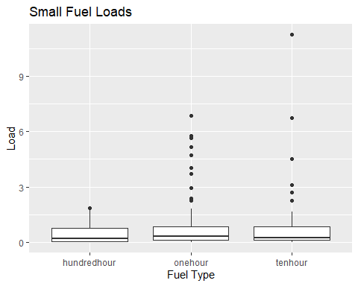
# 1000 fuels
ggplot(Thor_data, aes(x = "thousandhour", y = thousandhour)) +
geom_boxplot() +
labs(title = "Thousand Hour Fuel Outlier Check",
x = "",
y = "Fuel Load")
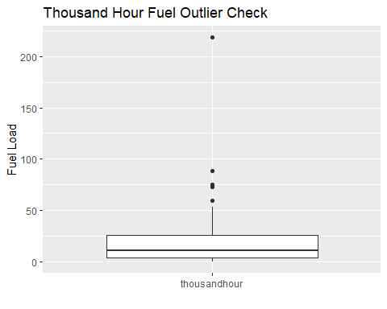
## shrub. forb, grass load
Veg_load_long <- Thor_data %>%
pivot_longer(cols = c(`shrubload`, `grassload`, `forbload`),
names_to = "FuelType",
values_to = "Load")
## Canopy
ggplot(Thor_data, aes(x = "canopycover", y = canopycover)) +
geom_boxplot() +
labs(title = "Prop. Canopy Cover Outlier Check",
x = "",
y = "proportion")
## Warning: Removed 1 row containing non-finite outside the scale range
## (`stat_boxplot()`).
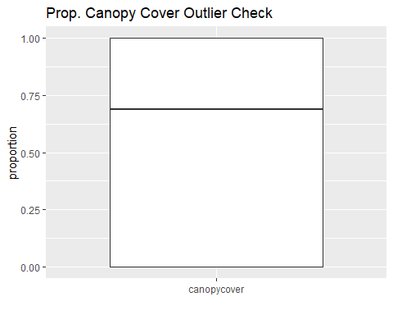
#Mortality
ggplot(Thor_data, aes(x = "Mortality", y = prop.density.dead)) +
geom_boxplot() +
labs(title = "Mortality Outlier Check",
x = "",
y = "proportion")
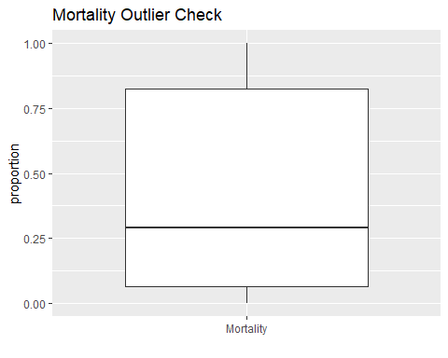
#Seedling Abundance
ggplot(Thor_data, aes(x = "Seedling Abundance", y = SeedlingAbundance)) +
geom_boxplot() +
labs(title = "Seedlings Outlier Check",
x = "",
y = "seedlings")
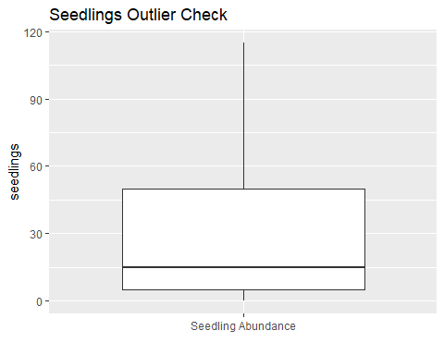
#Sapling Abundance
ggplot(Thor_data, aes(x = "Sapling Abundance", y = SaplingAbundance)) +
geom_boxplot() +
labs(title = "Sapling Outlier Check",
x = "",
y = "saplings")
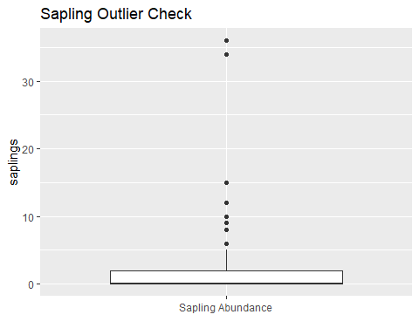
#scaled basal area trees/acre
ggplot(Thor_data, aes(x = "scaledba", y = scaled_ba)) +
geom_boxplot() +
labs(title = "trees/acre Outlier Check",
x = "",
y = "trees/acre")
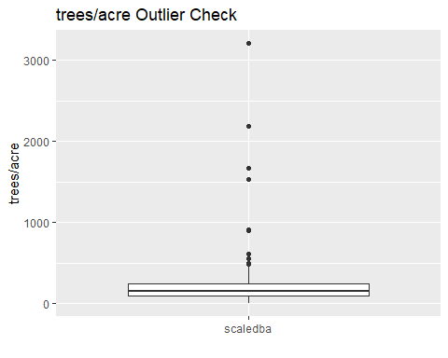
#Shannon Diversity
ggplot(Thor_data, aes(x = "Diversity", y = HillShannon)) +
geom_boxplot() +
labs(title = "Shannon Diversity Outlier Check",
x = "",
y = "Index")
## Warning: Removed 1 row containing non-finite outside the scale range
## (`stat_boxplot()`).
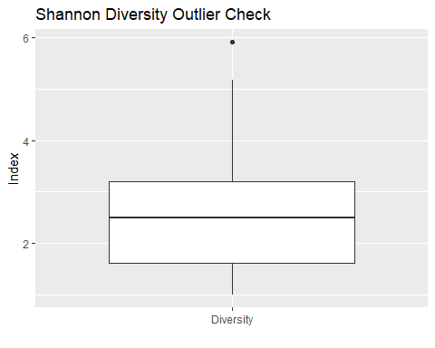
#Shannon Diversity Live
ggplot(Thor_data, aes(x = "Live Diversity", y = HillLive)) +
geom_boxplot() +
labs(title = "Live Diversity Outlier Check",
x = "",
y = "Index")
## Warning: Removed 3 rows containing non-finite outside the scale range
## (`stat_boxplot()`).
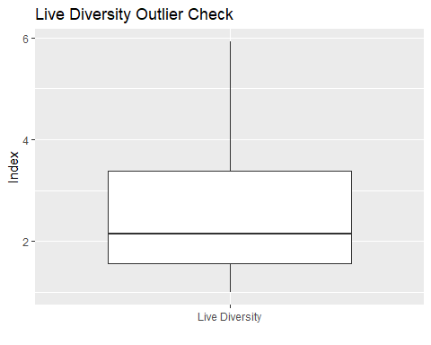
#Slope
ggplot(Thor_data, aes(x = "scaledba", y = scaled_ba)) +
geom_boxplot() +
labs(title = "trees/acre Outlier Check",
x = "",
y = "trees/acre")

## Step 2: Homogeneity in Y
model_onehour <- lm(onehour ~ Treatment, data = Thor_data)
plot(model_onehour, which = 1) # Residuals vs fitted
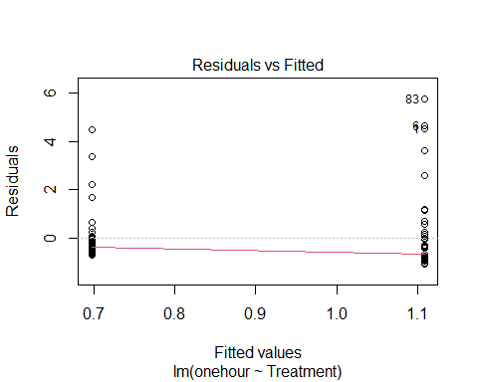
model_tenhour <- lm(tenhour ~ Treatment, data = Thor_data)
plot(model_tenhour, which = 1) # Residuals vs fitted
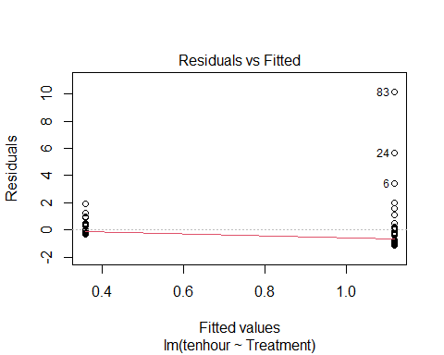
model_hundredhour <- lm(hundredhour ~ Treatment, data = Thor_data)
plot(model_hundredhour, which = 1) # Residuals vs fitted
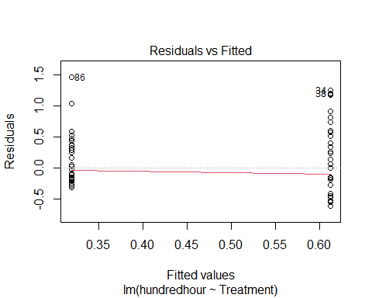
model_thousandhour <- lm(thousandhour ~ Treatment, data = Thor_data)
plot(model_thousandhour, which = 1) # Residuals vs fitted
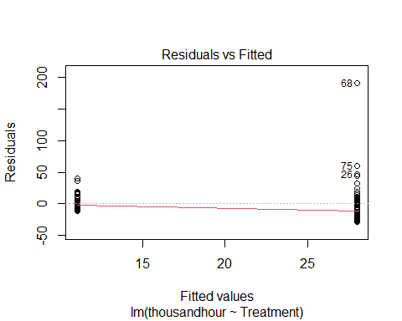
model_shrubload <- lm(shrubload ~ Treatment, data = Thor_data)
plot(model_shrubload, which = 1) # Residuals vs fitted
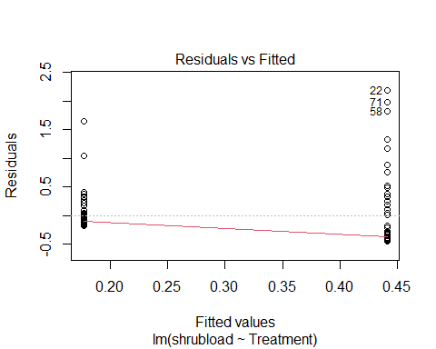
model_grassload <- lm(grassload ~ Treatment, data = Thor_data)
plot(model_grassload, which = 1) # Residuals vs fitted
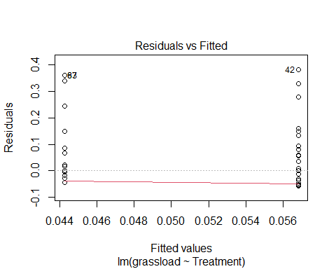
model_forbload <- lm(forbload ~ Treatment, data = Thor_data)
plot(model_forbload, which = 1) # Residuals vs fitted
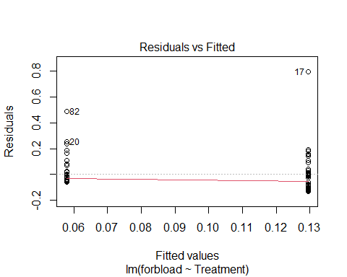
model_canopy <- lm(canopycover ~ Treatment, data = Thor_data)
plot(model_canopy, which = 1) # Residuals vs fitted
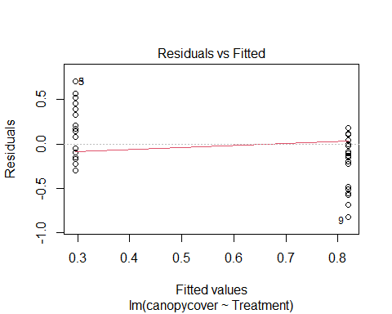
model_mortality <- lm(prop.density.dead ~ Treatment, data = Thor_data)
plot(model_mortality, which = 1) # Residuals vs fitted
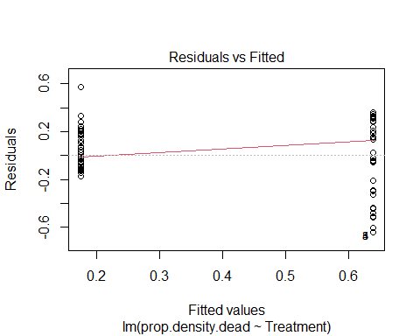
model_sap <- lm(SaplingAbundance ~ Treatment, data = Thor_data)
plot(model_sap, which = 1) # Residuals vs fitted
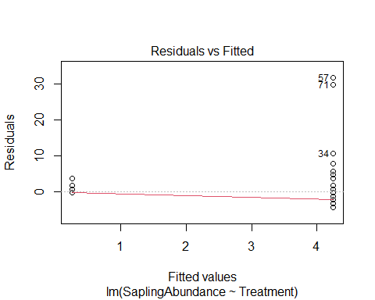
plot(model_sap, which = 3) # scale-location
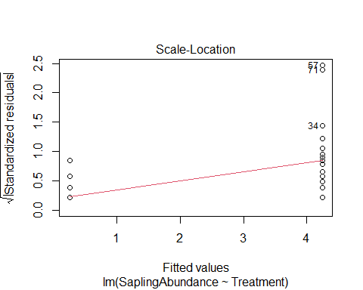
model_seed <- lm(SeedlingAbundance ~ Treatment, data = Thor_data)
plot(model_seed, which = 1) # Residuals vs fitted
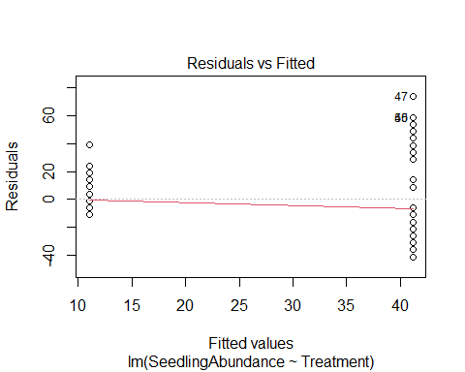
plot(model_seed, which = 3) # scale-location
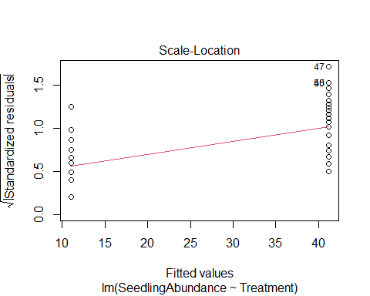
plot(model_seed, which = 2) # QQ-plot
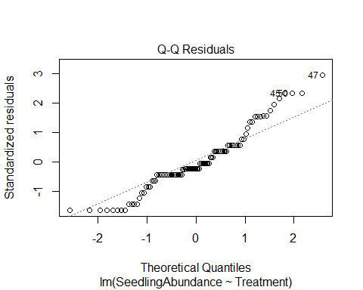
model_diversity <- lm(HillShannon ~ Treatment, data = Thor_data)
plot(model_diversity, which = 1) # Residuals vs fitted
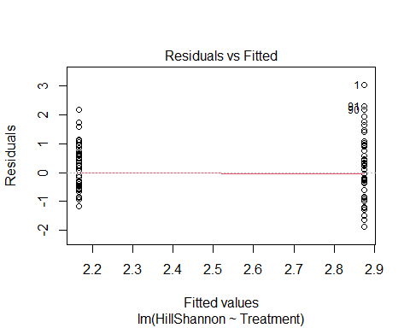
model_livediversity <- lm(HillLive ~ Treatment, data = Thor_data)
plot(model_livediversity, which = 1) # Residuals vs fitted
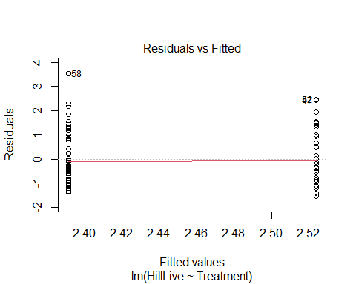
#Step 3: Normality in Y
hist(Thor_data$onehour)
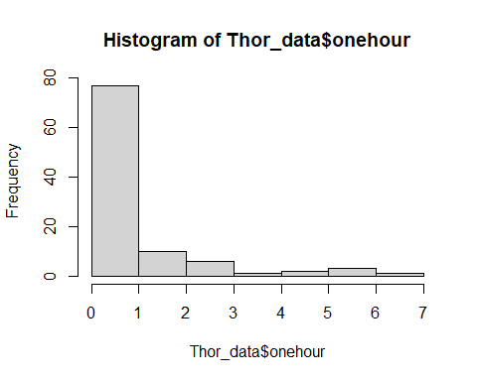
hist(Thor_data$tenhour)
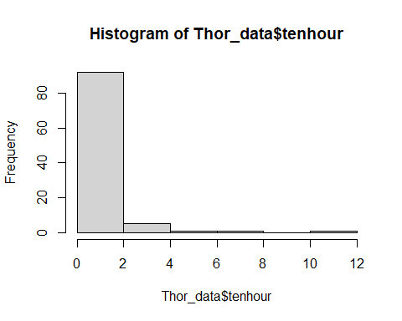
hist(Thor_data$hundredhour)
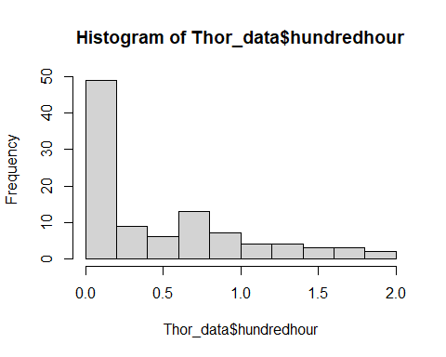
hist(Thor_data$thousandhour)
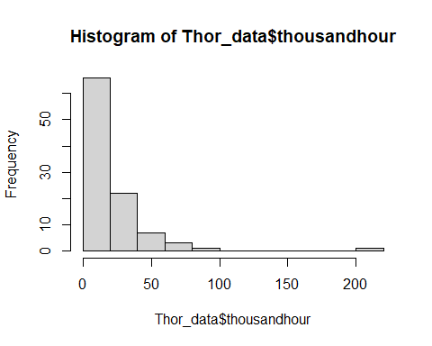
hist(Thor_data$shrubload)
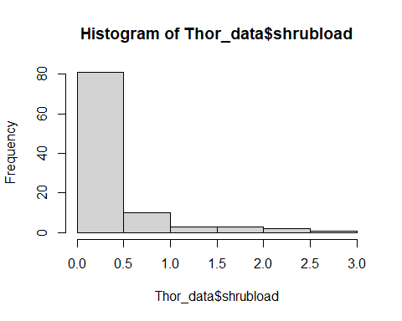
hist(Thor_data$grassload)
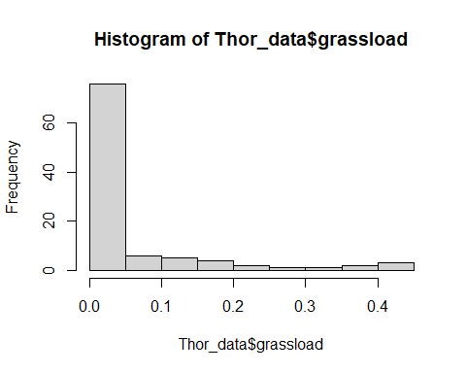
hist(Thor_data$forbload)
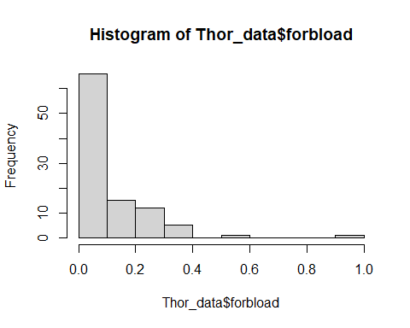
hist(Thor_data$canopycover)
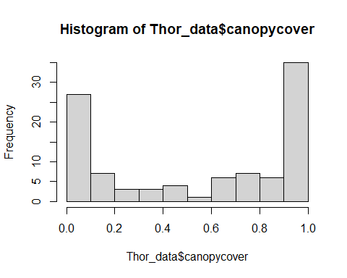
hist(Thor_data$prop.density.dead)
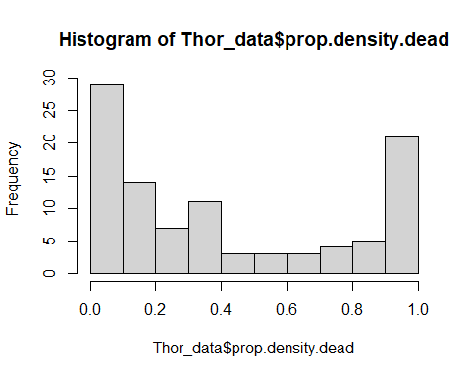
hist(Thor_data$SeedlingAbundance)
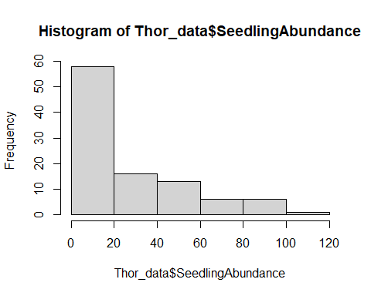
hist(litterduff$mean_litter)
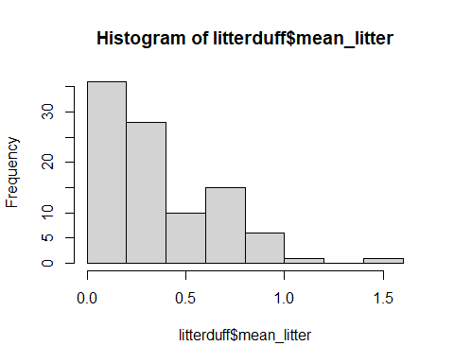
hist(Thor_data$mean_duff)
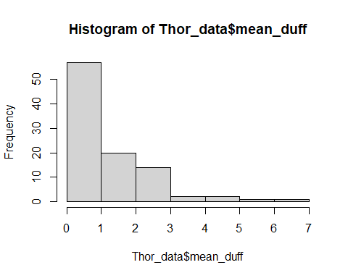
hist(Thor_data$SaplingAbundance)
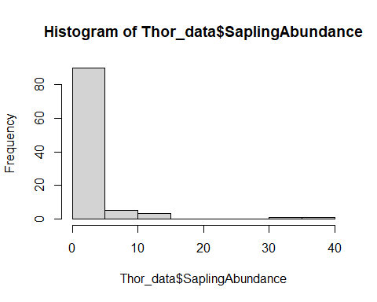
hist(Thor_data$HillShannon)
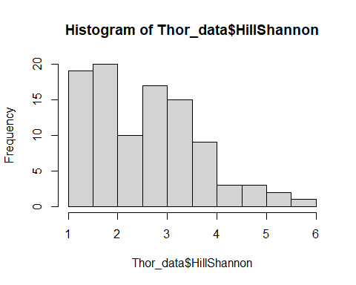
hist(Thor_data$HillLive)
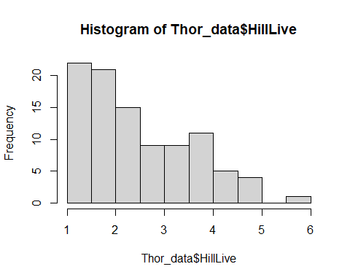
#Step 4: Zeros Y
Thor_data %>%
count(onehour)
## # A tibble: 49 × 2
## onehour n
## <dbl> <int>
## 1 0 1
## 2 0.025 2
## 3 0.05 4
## 4 0.065 4
## 5 0.09 8
## 6 0.13 5
## 7 0.14 3
## 8 0.16 1
## 9 0.18 1
## 10 0.185 3
## # ℹ 39 more rows
Thor_data %>%
count(tenhour)
## # A tibble: 46 × 2
## tenhour n
## <dbl> <int>
## 1 0 5
## 2 0.025 7
## 3 0.05 1
## 4 0.0535 1
## 5 0.065 5
## 6 0.09 5
## 7 0.115 5
## 8 0.13 3
## 9 0.14 2
## 10 0.16 1
## # ℹ 36 more rows
Thor_data %>%
count(hundredhour)
## # A tibble: 53 × 2
## hundredhour n
## <dbl> <int>
## 1 0 24
## 2 0.025 1
## 3 0.0325 1
## 4 0.05 2
## 5 0.0575 2
## 6 0.065 1
## 7 0.08 3
## 8 0.0863 1
## 9 0.112 2
## 10 0.117 1
## # ℹ 43 more rows
Thor_data %>%
count(thousandhour)
## # A tibble: 94 × 2
## thousandhour n
## <dbl> <int>
## 1 0 7
## 2 0.633 1
## 3 0.733 1
## 4 0.931 1
## 5 1.32 1
## 6 1.38 1
## 7 1.47 1
## 8 1.49 1
## 9 2.00 1
## 10 2.48 1
## # ℹ 84 more rows
Thor_data %>%
count(shrubload)
## # A tibble: 75 × 2
## shrubload n
## <dbl> <int>
## 1 0 21
## 2 0.00179 1
## 3 0.00286 1
## 4 0.00429 1
## 5 0.00536 1
## 6 0.0107 1
## 7 0.0179 2
## 8 0.025 1
## 9 0.0264 1
## 10 0.0279 2
## # ℹ 65 more rows
Thor_data %>%
count(grassload)
## # A tibble: 32 × 2
## grassload n
## <dbl> <int>
## 1 0 64
## 2 0.001 1
## 3 0.005 1
## 4 0.0085 1
## 5 0.015 1
## 6 0.0192 1
## 7 0.02 1
## 8 0.025 2
## 9 0.026 1
## 10 0.039 1
## # ℹ 22 more rows
Thor_data %>%
count(forbload)
## # A tibble: 79 × 2
## forbload n
## <dbl> <int>
## 1 0 11
## 2 0.000208 1
## 3 0.000333 1
## 4 0.000417 1
## 5 0.00167 2
## 6 0.0025 1
## 7 0.0025 3
## 8 0.00292 1
## 9 0.00333 2
## 10 0.00417 1
## # ℹ 69 more rows
Thor_data %>%
count(canopycover)
## # A tibble: 29 × 2
## canopycover n
## <dbl> <int>
## 1 0 26
## 2 0.0667 1
## 3 0.125 2
## 4 0.133 1
## 5 0.143 1
## 6 0.2 3
## 7 0.25 2
## 8 0.267 1
## 9 0.312 1
## 10 0.333 1
## # ℹ 19 more rows
Thor_data %>%
count(prop.density.dead)
## # A tibble: 71 × 2
## prop.density.dead n
## <dbl> <int>
## 1 0 17
## 2 0.0274 1
## 3 0.0297 1
## 4 0.0351 1
## 5 0.0413 1
## 6 0.0430 1
## 7 0.0500 1
## 8 0.0507 1
## 9 0.0579 1
## 10 0.0647 1
## # ℹ 61 more rows
Thor_data %>%
count(SeedlingAbundance)
## # A tibble: 18 × 2
## SeedlingAbundance n
## <dbl> <int>
## 1 0 22
## 2 5 16
## 3 10 9
## 4 15 5
## 5 20 6
## 6 25 7
## 7 30 6
## 8 35 3
## 9 50 9
## 10 55 4
## 11 70 1
## 12 75 2
## 13 80 3
## 14 85 1
## 15 90 1
## 16 95 1
## 17 100 3
## 18 115 1
Thor_data %>%
count(SaplingAbundance)
## # A tibble: 14 × 2
## SaplingAbundance n
## <dbl> <int>
## 1 0 61
## 2 1 8
## 3 2 12
## 4 3 3
## 5 4 3
## 6 5 3
## 7 6 1
## 8 8 2
## 9 9 1
## 10 10 1
## 11 12 1
## 12 15 2
## 13 34 1
## 14 36 1
Thor_data %>%
count(HillShannon)
## # A tibble: 82 × 2
## HillShannon n
## <dbl> <int>
## 1 1 13
## 2 1.22 2
## 3 1.24 1
## 4 1.28 1
## 5 1.32 1
## 6 1.38 1
## 7 1.51 3
## 8 1.57 1
## 9 1.59 1
## 10 1.60 1
## # ℹ 72 more rows
Thor_data %>%
count(HillLive)
## # A tibble: 84 × 2
## HillLive n
## <dbl> <int>
## 1 1 11
## 2 1.08 1
## 3 1.11 1
## 4 1.13 1
## 5 1.19 1
## 6 1.29 1
## 7 1.31 1
## 8 1.32 1
## 9 1.33 1
## 10 1.36 1
## # ℹ 74 more rows
#Step 5: Colinearity in X
## Topographic predictors
modelcolinearity_topo <- lm(onehour ~ Treatment + SiteClass + Slope + Elevation, data = Thor_data)
vif(modelcolinearity_topo)
## GVIF Df GVIF^(1/(2*Df))
## Treatment 1.030734 1 1.015251
## SiteClass 1.771948 2 1.153753
## Slope 1.050749 1 1.025061
## Elevation 1.734184 1 1.316884
## Severity in place of Treatment
modelcolinearity_severity <- lm(onehour ~ Severity + SiteClass + Slope + Elevation, data = Thor_data_sev)
vif(modelcolinearity_severity)
## GVIF Df GVIF^(1/(2*Df))
## Severity 1.393629 4 1.042362
## SiteClass 1.900484 2 1.174130
## Slope 1.257478 1 1.121373
## Elevation 1.692025 1 1.300779
## Adding scaled basal area (subset where basal area is defined/non-zero)
modelcolinearity_ba <- lm(onehour ~ Treatment + SiteClass + Slope + Elevation + scaled_ba, data = Thor_data_BA)
vif(modelcolinearity_ba)
## GVIF Df GVIF^(1/(2*Df))
## Treatment 1.132163 1 1.064032
## SiteClass 1.947795 2 1.181370
## Slope 1.106166 1 1.051744
## Elevation 1.753354 1 1.324143
## scaled_ba 1.283571 1 1.132948
## Adding canopy cover (subset with non-boundary canopy values, matching your Beta-regression models)
modelcolinearity_canopy <- lm(onehour ~ Treatment + SiteClass + Slope + Elevation + canopycover, data = Thor_data_canopy_middle)
vif(modelcolinearity_canopy)
## GVIF Df GVIF^(1/(2*Df))
## Treatment 1.667720 1 1.291402
## SiteClass 2.006193 2 1.190127
## Slope 1.187800 1 1.089862
## Elevation 1.611120 1 1.269299
## canopycover 1.398391 1 1.182536
## Adding mortality (subset with non-boundary mortality values, matching your Beta-regression models)
modelcolinearity_mortality <- lm(onehour ~ Treatment + SiteClass + Slope + Elevation + prop.density.dead, data = Thor_data_mortality_middle)
vif(modelcolinearity_mortality)
## GVIF Df GVIF^(1/(2*Df))
## Treatment 1.890767 1 1.375052
## SiteClass 1.604730 2 1.125513
## Slope 1.121078 1 1.058810
## Elevation 1.535495 1 1.239151
## prop.density.dead 1.796826 1 1.340458
## Checking canopy cover and mortality together (subset with both non-missing and non-boundary)
Thor_data_canopy_mortality <- Thor_data %>%
filter(!is.na(canopycover), canopycover > 0, canopycover < 1,
!is.na(prop.density.dead), prop.density.dead > 0, prop.density.dead < 1)
modelcolinearity_canopy_mortality <- lm(onehour ~ Treatment + SiteClass + Slope + Elevation + canopycover + prop.density.dead, data = Thor_data_canopy_mortality)
vif(modelcolinearity_canopy_mortality)
## GVIF Df GVIF^(1/(2*Df))
## Treatment 2.037724 1 1.427489
## SiteClass 1.911474 2 1.175823
## Slope 1.245130 1 1.115854
## Elevation 1.517065 1 1.231692
## canopycover 2.137371 1 1.461975
## prop.density.dead 1.968203 1 1.402926
#Step 6: Relationships between Y and X
response_vars <- c("onehour", "tenhour", "hundredhour", "thousandhour", "shrubload", "grassload", "forbload", "canopycover", "prop.density.dead", "SeedlingAbundance", "SaplingAbundance", "HillShannon")
# Slope
Response <- Thor_data %>%
pivot_longer(
cols = all_of(response_vars),
names_to = "response",
values_to = "response_value")
ggplot(Response, aes(x = SlopeZ, y = response_value)) +
geom_point(alpha = 0.6) +
geom_smooth(method = "lm", se = FALSE) +
facet_wrap(~ response, scales = "free_y") +
theme_minimal() +
labs( title = "Scatterplots for Slope",
x = "Slope",
y = "Response Variable")
## `geom_smooth()` using formula = 'y ~ x'
## Warning: Removed 2 rows containing non-finite outside the scale range
## (`stat_smooth()`).
## Warning: Removed 2 rows containing missing values or values outside the scale range
## (`geom_point()`).
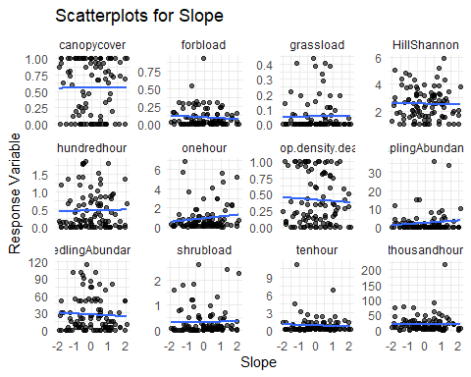
# Elevation
ggplot(Response, aes(x = ElevationZ, y = response_value)) +
geom_point(alpha = 0.6) +
geom_smooth(method = "lm", se = FALSE) +
facet_wrap(~ response, scales = "free_y") +
theme_minimal() +
labs( title = "Scatterplots for Elevation",
x = "Elevation",
y = "Response Variable")
## `geom_smooth()` using formula = 'y ~ x'
## Warning: Removed 2 rows containing non-finite outside the scale range (`stat_smooth()`).
## Removed 2 rows containing missing values or values outside the scale range
## (`geom_point()`).
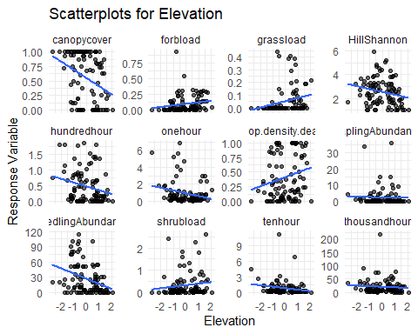
#Treatment
ggplot(Response, aes(x = Treatment, y = response_value)) +
geom_boxplot(outlier.alpha = 0.2) +
geom_jitter(width = 0.2, alpha = 0.4) +
facet_wrap(~ response, scales = "free_y") +
theme_minimal() +
labs(title = "Relationships with Treatment", x = "Treatment", y = "response")
## Warning: Removed 2 rows containing non-finite outside the scale range
## (`stat_boxplot()`).
## Removed 2 rows containing missing values or values outside the scale range
## (`geom_point()`).
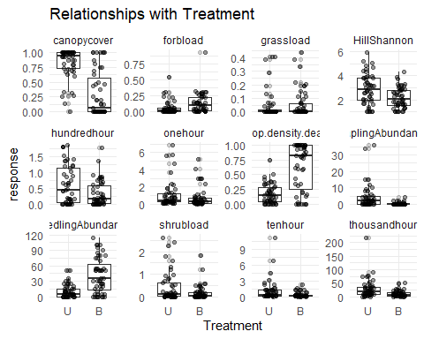
#Severity
ggplot(Response, aes(x = Severity, y = response_value)) +
geom_boxplot(outlier.alpha = 0.2) +
geom_jitter(width = 0.2, alpha = 0.4) +
facet_wrap(~ response, scales = "free_y") +
theme_minimal() +
labs(title = "Relationships with Severity", x = "Severity", y = "response")
## Warning: Removed 2 rows containing non-finite outside the scale range
## (`stat_boxplot()`).
## Removed 2 rows containing missing values or values outside the scale range
## (`geom_point()`).
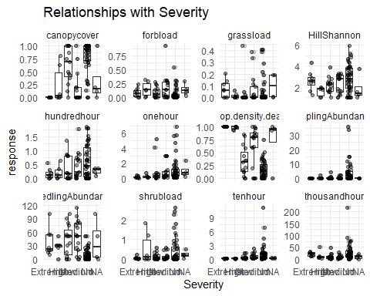
#Site Class
ggplot(Response, aes(x = SiteClass, y = response_value)) +
geom_boxplot(outlier.alpha = 0.2) +
geom_jitter(width = 0.2, alpha = 0.4) +
facet_wrap(~ response, scales = "free_y") +
theme_minimal() +
labs(title = "Relationships with Site Class", x = "SiteClass", y = "response")
## Warning: Removed 2 rows containing non-finite outside the scale range
## (`stat_boxplot()`).
## Removed 2 rows containing missing values or values outside the scale range
## (`geom_point()`).
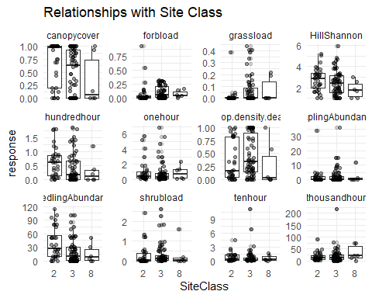
#Step 7: Interactions
#Fuels
#one hour
##Treatment*Elevation
ggplot(Thor_data, aes(x = ElevationZ, y = onehour, color = Treatment)) +
geom_point(alpha = 0.4) +
geom_smooth(method = "lm", se = TRUE) +
labs(
x = "ElevationZ",
y = "onehour",
color = "Treatment") +theme_minimal()
## `geom_smooth()` using formula = 'y ~ x'
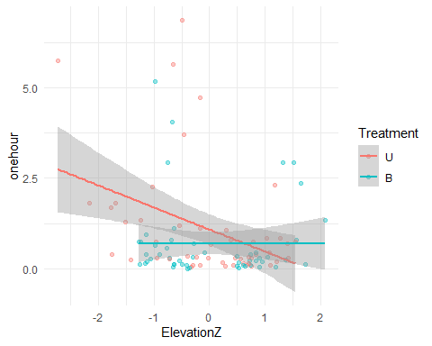
##Treatment*SlopeZ
ggplot(Thor_data, aes(x = SlopeZ, y = onehour, color = Treatment)) +
geom_point(alpha = 0.4) +
geom_smooth(method = "lm", se = TRUE) +
labs(
x = "SlopeZ",
y = "onehour",
color = "Treatment") +theme_minimal()
## `geom_smooth()` using formula = 'y ~ x'
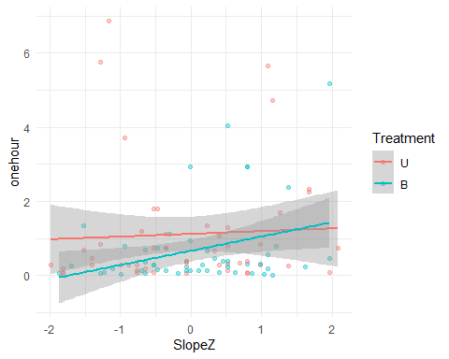
##Severity*Elevation
ggplot(Thor_data, aes(x = ElevationZ, y = onehour, color = Severity)) +
geom_point(alpha = 0.4) +
geom_smooth(method = "lm", se = TRUE) +
labs(
x = "ElevationZ",
y = "onehour",
color = "Severity") +theme_minimal()
## `geom_smooth()` using formula = 'y ~ x'
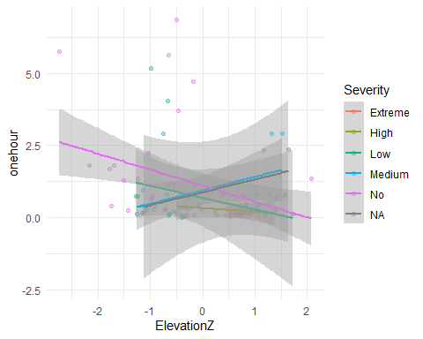
##Severity*SlopeZ
ggplot(Thor_data, aes(x = SlopeZ, y = onehour, color = Treatment)) +
geom_point(alpha = 0.4) +
geom_smooth(method = "lm", se = TRUE) +
labs(
x = "SlopeZ",
y = "onehour",
color = "Treatment") +theme_minimal()
## `geom_smooth()` using formula = 'y ~ x'

#ten hour
##Treatment*SlopeZ
ggplot(Thor_data, aes(x = SlopeZ, y = tenhour, color = Treatment)) +
geom_point(alpha = 0.4) +
geom_smooth(method = "lm", se = TRUE) +
labs(
x = "SlopeZ",
y = "tenhour",
color = "Treatment") +theme_minimal()
## `geom_smooth()` using formula = 'y ~ x'
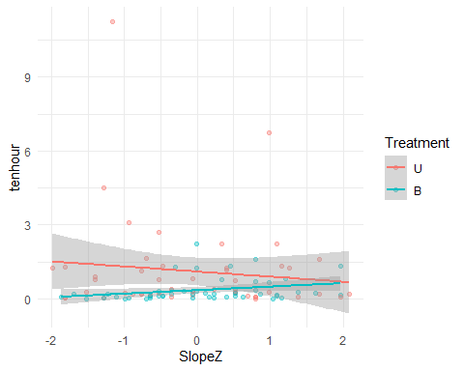
##Severity*SlopeZ
ggplot(Thor_data, aes(x = SlopeZ, y = tenhour, color = Severity)) +
geom_point(alpha = 0.4) +
geom_smooth(method = "lm", se = TRUE) +
labs(
x = "SlopeZ",
y = "tenhour",
color = "Severity") +theme_minimal()
## `geom_smooth()` using formula = 'y ~ x'
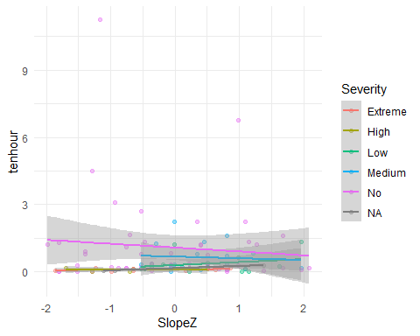
#hundred hour
##Treatment*SlopeZ
ggplot(Thor_data, aes(x = SlopeZ, y = hundredhour, color = Treatment)) +
geom_point(alpha = 0.4) +
geom_smooth(method = "lm", se = TRUE) +
labs(
x = "SlopeZ",
y = "hundredhour",
color = "Treatment") +theme_minimal()
## `geom_smooth()` using formula = 'y ~ x'
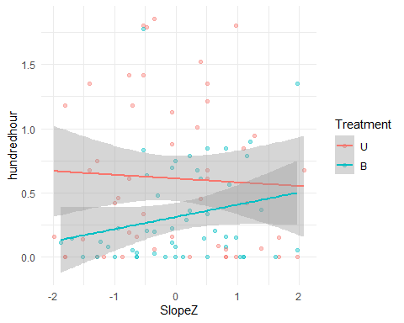
#thousand hour
##Treatment*SlopeZ
ggplot(Thor_data, aes(x = SlopeZ, y = thousandhour, color = Treatment)) +
geom_point(alpha = 0.4) +
geom_smooth(method = "lm", se = TRUE) +
labs(
x = "SlopeZ",
y = "thousandhour",
color = "Treatment") +theme_minimal()
## `geom_smooth()` using formula = 'y ~ x'
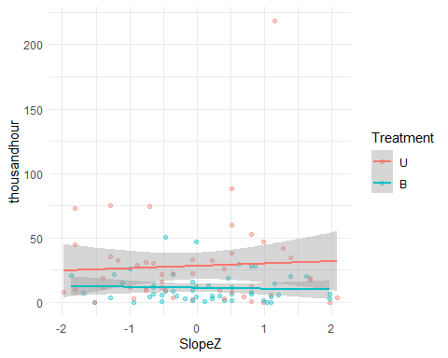
#Stand Height
##Treatment Aspect
ggplot(Thor_data, aes(x = Aspect, y = "Stand Height (ft.)", color = Treatment)) +
geom_boxplot(outlier.alpha = 0.2) +
geom_jitter(position = position_jitterdodge(jitter.width = 0.15), alpha = 0.4) +
theme_minimal() +
labs(
x = "Aspect",
y = "Stand Height (ft.)",
color = "Treatment")
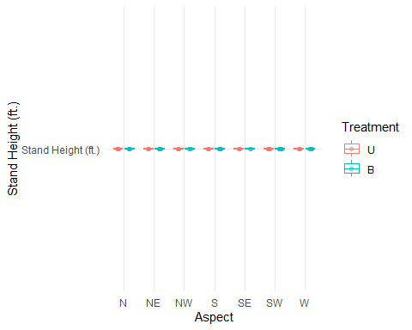
##Treatment Slope
ggplot(Thor_data, aes(x = SlopeZ, y = "Stand Height (ft.)", color = Treatment)) +
geom_boxplot(outlier.alpha = 0.2) +
geom_jitter(position = position_jitterdodge(jitter.width = 0.15), alpha = 0.4) +
theme_minimal() +
labs(
x = "SlopeZ",
y = "Stand Height (ft.)",
color = "Treatment")
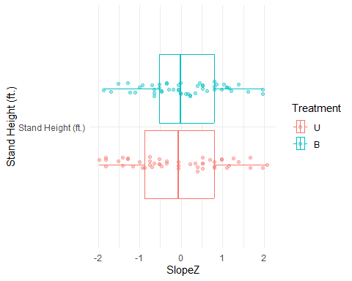
#Understory Height
##Treatment Aspect
ggplot(Thor_data, aes(x = Aspect, y = `Live Fuel Height (in.)`, color = Treatment)) +
geom_boxplot(outlier.alpha = 0.2) +
geom_jitter(position = position_jitterdodge(jitter.width = 0.15), alpha = 0.4) +
theme_minimal() +
labs(
x = "Aspect",
y = "Live Fuel Height (in.)",
color = "Treatment")
## Warning: Removed 2 rows containing non-finite outside the scale range
## (`stat_boxplot()`).
## Removed 2 rows containing missing values or values outside the scale range
## (`geom_point()`).
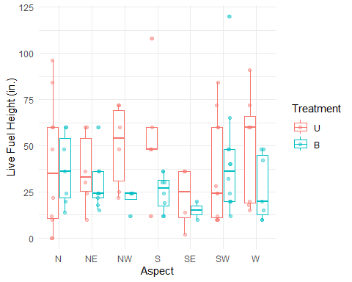
##Treatment Slope
ggplot(Thor_data, aes(x = SlopeZ, y = `Live Fuel Height (in.)`, color = Treatment)) +
geom_boxplot(outlier.alpha = 0.2) +
geom_jitter(position = position_jitterdodge(jitter.width = 0.15), alpha = 0.4) +
theme_minimal() +
labs(
x = "SlopeZ",
y = "Live Fuel Height (in.)",
color = "Treatment")
## Warning: Removed 2 rows containing non-finite outside the scale range
## (`stat_boxplot()`).
## Warning: `position_jitterdodge()` requires non-overlapping x intervals.
## Warning: Removed 2 rows containing missing values or values outside the scale range
## (`geom_point()`).
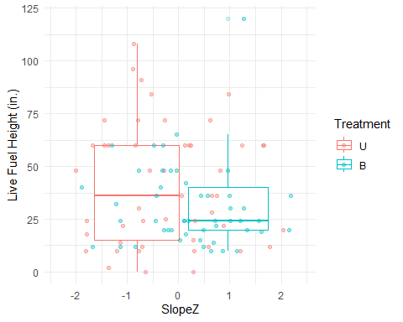
#Basal area
##Treatment Slope
ggplot(Thor_data, aes(x = SlopeZ, y = `scaled_baZ`, color = Treatment)) +
geom_boxplot(outlier.alpha = 0.2) +
geom_jitter(position = position_jitterdodge(jitter.width = 0.15), alpha = 0.4) +
theme_minimal() +
labs(
x = "Slope",
y = "Basal Area",
color = "Treatment")
## Warning: `position_jitterdodge()` requires non-overlapping x intervals.
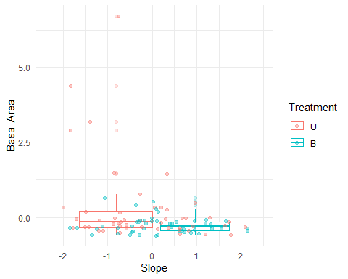
#Canopy Cover
##Treatment Slope
ggplot(Thor_data, aes(x = SlopeZ, y = canopycover, color = Treatment)) +
geom_point(alpha = 0.4) +
geom_smooth(method = "lm", se = TRUE) +
theme_minimal() +
labs(
x = "SlopeZ",
y = "Canopy Cover",
color = "Treatment")
## `geom_smooth()` using formula = 'y ~ x'
## Warning: Removed 1 row containing non-finite outside the scale range
## (`stat_smooth()`).
## Warning: Removed 1 row containing missing values or values outside the scale range
## (`geom_point()`).
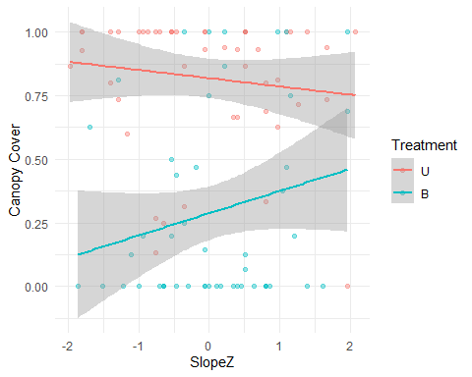
#Seedling
##Treatment Slope
ggplot(Thor_data, aes(x = SlopeZ, y = SeedlingAbundance, color = Treatment)) +
geom_point(alpha = 0.4) +
geom_smooth(method = "lm", se = TRUE) +
theme_minimal() +
labs(
x = "SlopeZ",
y = "Seedling Abundance",
color = "Treatment")
## `geom_smooth()` using formula = 'y ~ x'
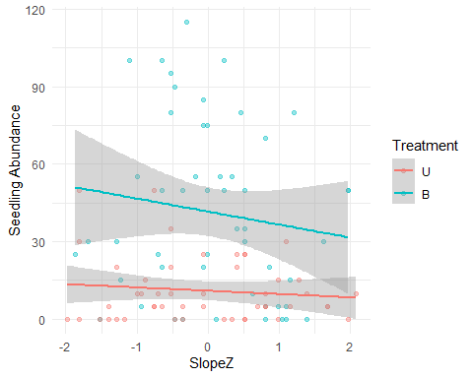
#Treatment*Aspect
ggplot(Thor_data, aes(x = Aspect, y = SeedlingAbundance, color = Treatment)) +
geom_boxplot(outlier.alpha = 0.2) +
geom_jitter(position = position_jitterdodge(jitter.width = 0.15), alpha = 0.4) +
theme_minimal() +
labs(
x = "Aspect",
y = "Seedling Abundance",
color = "Treatment")
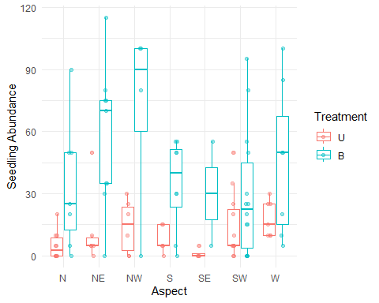
#Sapling
##Treatment Slope
ggplot(Thor_data, aes(x = SlopeZ, y = SaplingAbundance, color = Treatment)) +
geom_point(alpha = 0.4) +
geom_smooth(method = "lm", se = TRUE) +
theme_minimal() +
labs(
x = "SlopeZ",
y = "Sapling Abundance",
color = "Treatment")
## `geom_smooth()` using formula = 'y ~ x'
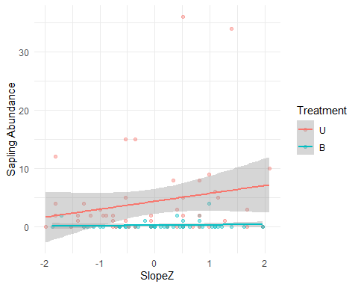
#Treatment Aspect
ggplot(Thor_data, aes(x = Aspect, y = SaplingAbundance, color = Treatment)) +
geom_boxplot(outlier.alpha = 0.2) +
geom_jitter(position = position_jitterdodge(jitter.width = 0.15), alpha = 0.4) +
theme_minimal() +
labs(
x = "Aspect",
y = "Sapling Abundance",
color = "Treatment")
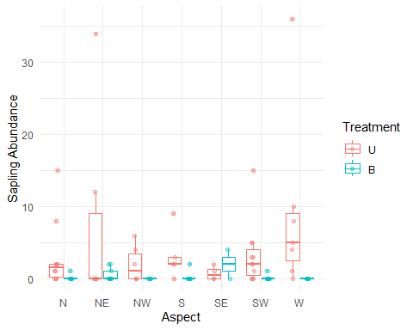
#mortality
##Treatment*Slope
ggplot(Thor_data, aes(x = SlopeZ, y = prop.density.dead, color = Treatment)) +
geom_point(alpha = 0.4) +
geom_smooth(method = "lm", se = TRUE) +
theme_minimal() +
labs(
x = "SlopeZ",
y = "Mortality Prop",
color = "Treatment")
## `geom_smooth()` using formula = 'y ~ x'
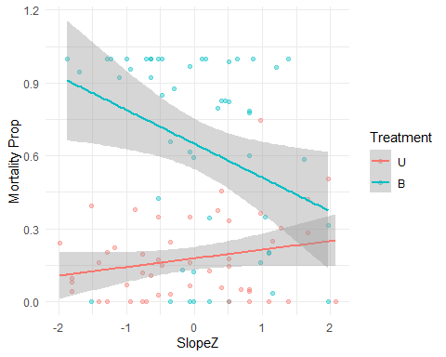
Model Exploration For each response variable, generalized linear models were built using a hypothesis-driven, manual model selection approach rather than automated stepwise or all-subsets procedures. For each response, an initial model was specified based on a priori ecological hypotheses, including Treatment or Severity, topographic covariates (Slope, Elevation, Aspect), site structural covariates (scaled basal area, canopy cover), Site Class, and their hypothesized interactions. Error distributions and link functions (e.g., Tweedie, negative binomial, beta, binomial, or Gaussian) were selected based on the distributional properties of each response variable identified during data exploration.
Starting from this global model, non-significant interaction and main-effect terms were iteratively removed to generate a candidate set of nested, simpler models for each response variable. Candidate models within a set were compared using the second-order Akaike Information Criterion (AICc), which corrects for small sample sizes, using the AICc() function. Model adequacy was additionally assessed at each stage using simulation-based residual diagnostics from the DHARMa package: scaled residuals were tested for deviations from uniformity, overdispersion (testDispersion), excess zeros (testZeroInflation), and spatial autocorrelation using plot coordinates. The final model for each response variable was selected as the model that balanced parsimony and low AICc with acceptable residual diagnostics, rather than selecting strictly on AICc alone; in several cases, a model with a marginally higher AICc was retained over a lower-AICc alternative because it produced better-behaved residuals (e.g., no significant overdispersion or spatial autocorrelation). Treatment (burned/unburned) and Severity were modeled separately for each response variable, reflecting the fact that Severity is only defined for burned plots and serves as a finer-resolution descriptor of fire effects within the Treatment framework.
##Distribution Selection
Thor_data_sc <- Thor_data %>%
mutate(
onehour_scaled = as.numeric(scale(onehour)),
tenhour_scaled = as.numeric(scale(tenhour)),
hundredhour_scaled = as.numeric(scale(hundredhour)),
thousandhour_scaled = as.numeric(scale(thousandhour)),
shrubload_scaled = as.numeric(scale(shrubload)),
grassload_scaled = as.numeric(scale(grassload)),
forbload_scaled = as.numeric(scale(forbload)),
canopycover_scaled = as.numeric(scale(canopycover)),
mortality_scaled = as.numeric(scale(prop.density.dead)),
seed_scaled = as.numeric(scale(SeedlingAbundance)),
sap_scaled = as.numeric(scale(SaplingAbundance)))
hist(Thor_data_sc$onehour)
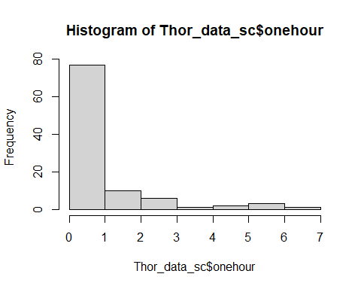
hist(Thor_data_sc$onehour_scaled)
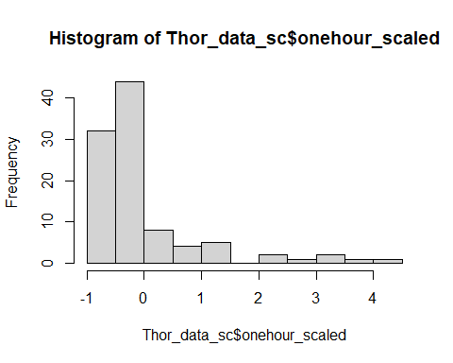
hist(Thor_data_sc$tenhour)
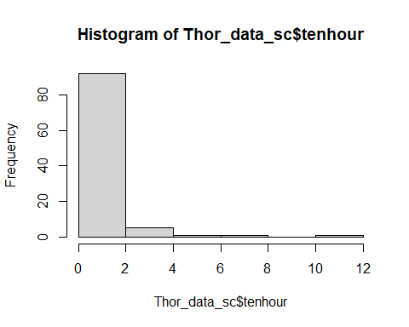
hist(Thor_data_sc$tenhour_scaled)
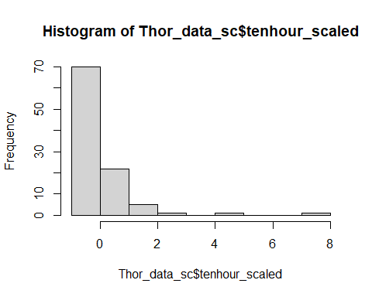
hist(Thor_data_sc$hundredhour)
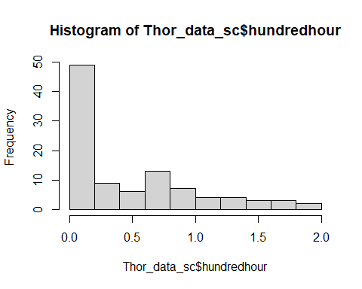
hist(Thor_data_sc$hundredhour_scaled)
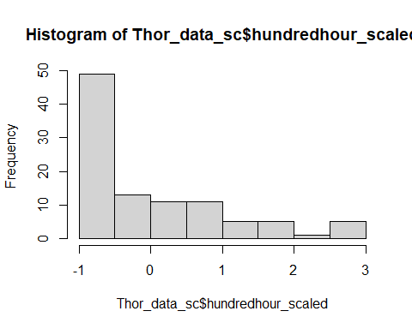
hist(Thor_data_sc$thousandhour)
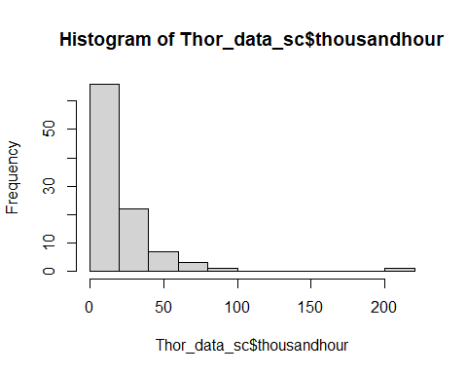
hist(Thor_data_sc$thousandhour_scaled)
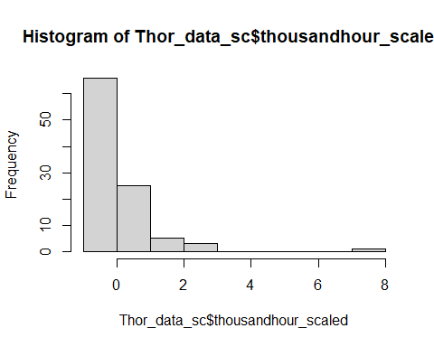
hist(Thor_data_sc$shrubload)
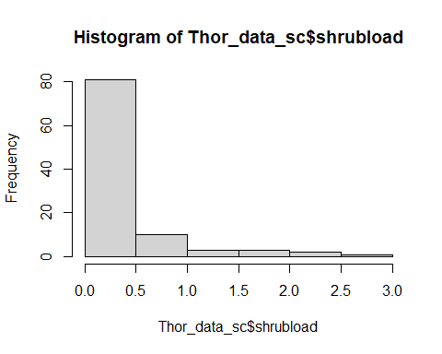
hist(Thor_data_sc$shrubload_scaled)
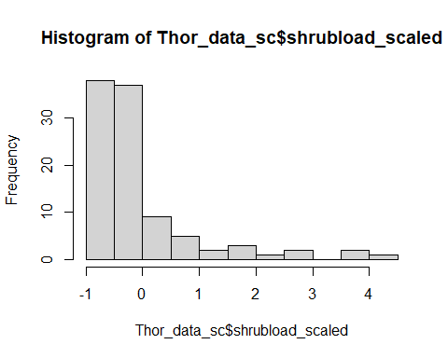
hist(Thor_data_sc$grassload)
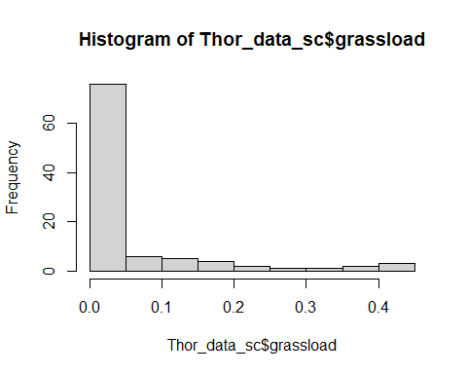
hist(Thor_data_sc$grassload_scaled)
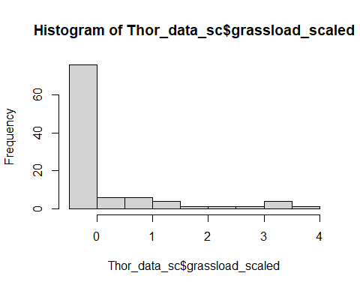
hist(Thor_data_sc$forbload)
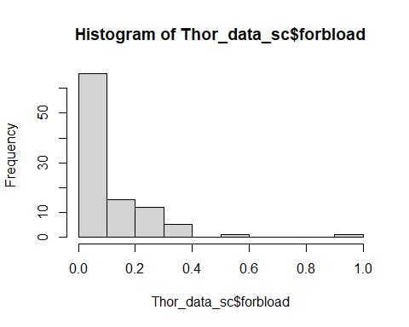
hist(Thor_data_sc$forbload_scaled)
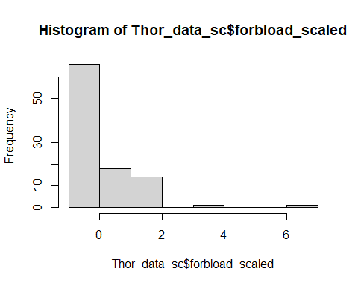
hist(Thor_data_sc$canopycover)
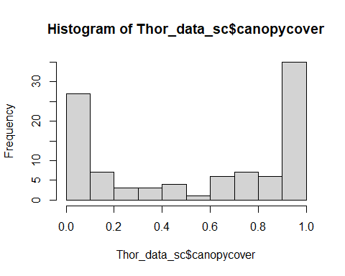
hist(Thor_data_sc$canopycover_scaled)
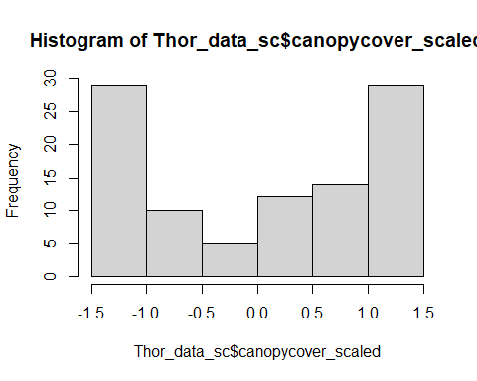
hist(Thor_data_sc$prop.density.dead)
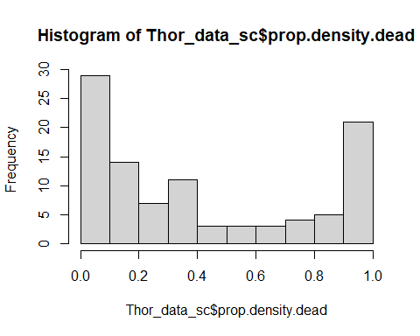
hist(Thor_data_sc$mortality_scaled)
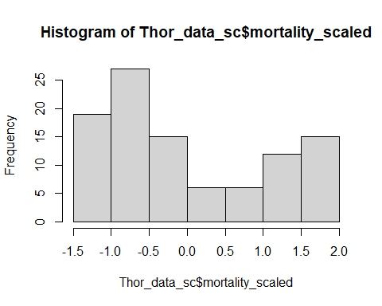
hist(Thor_data_sc$SeedlingAbundance)
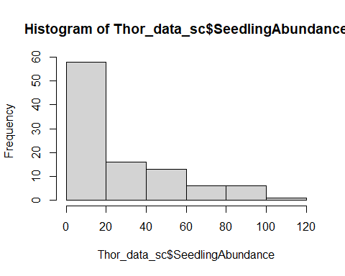
hist(Thor_data_sc$seed_scaled)
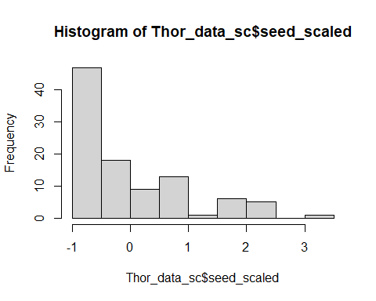
hist(Thor_data_sc$SaplingAbundance)
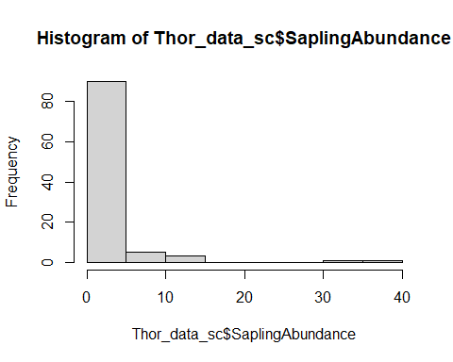
hist(Thor_data_sc$sap_scaled)
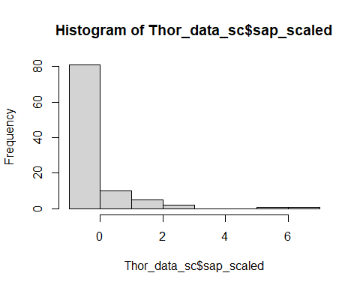
# Treatment= model 1
#Severity= model 2
#All Fuels Model
model1_fuels<- glmmTMB(Load ~ FuelType *(Treatment * SlopeZ + ElevationZ + scaled_baZ + Aspect)+SiteClass,
dispformula = ~ FuelType,
family = tweedie(link= "log"),
data=Thor_data_fuels)
Anova(model1_fuels,type=3)
## Analysis of Deviance Table (Type III Wald chisquare tests)
##
## Response: Load
## Chisq Df Pr(>Chisq)
## (Intercept) 128.8643 1 < 2.2e-16 ***
## FuelType 1282.0894 6 < 2.2e-16 ***
## Treatment 7.1190 1 0.007627 **
## SlopeZ 3.4010 1 0.065158 .
## ElevationZ 0.3493 1 0.554483
## scaled_baZ 0.1885 1 0.664197
## Aspect 19.7202 6 0.003105 **
## SiteClass 2.3768 2 0.304705
## Treatment:SlopeZ 0.4482 1 0.503185
## FuelType:Treatment 57.4976 6 1.449e-10 ***
## FuelType:SlopeZ 16.3212 6 0.012130 *
## FuelType:ElevationZ 39.5232 6 5.651e-07 ***
## FuelType:scaled_baZ 13.0713 6 0.041917 *
## FuelType:Aspect 81.8083 36 2.026e-05 ***
## FuelType:Treatment:SlopeZ 10.4780 6 0.105911
## ---
## Signif. codes: 0 '***' 0.001 '**' 0.01 '*' 0.05 '.' 0.1 ' ' 1
res_model1_fuels<-simulateResiduals(model1_fuels)
plot(res_model1_fuels)
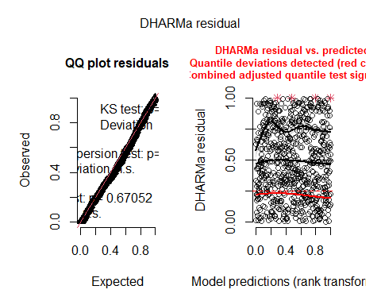
model1.1_fuels<- glmmTMB(Load ~ FuelType *(Treatment + SlopeZ + ElevationZ + scaled_baZ+ Aspect)+SiteClass,
dispformula = ~ FuelType,
family = tweedie(link= "log"),
data=Thor_data_fuels)
Anova(model1.1_fuels,type=3)
## Analysis of Deviance Table (Type III Wald chisquare tests)
##
## Response: Load
## Chisq Df Pr(>Chisq)
## (Intercept) 128.8030 1 < 2.2e-16 ***
## FuelType 1290.1112 6 < 2.2e-16 ***
## Treatment 6.4029 1 0.011393 *
## SlopeZ 2.6392 1 0.104255
## ElevationZ 0.5028 1 0.478265
## scaled_baZ 0.1510 1 0.697599
## Aspect 19.7554 6 0.003061 **
## SiteClass 1.7300 2 0.421045
## FuelType:Treatment 54.6210 6 5.529e-10 ***
## FuelType:SlopeZ 14.9342 6 0.020775 *
## FuelType:ElevationZ 41.0338 6 2.852e-07 ***
## FuelType:scaled_baZ 11.4836 6 0.074532 .
## FuelType:Aspect 84.1363 36 1.002e-05 ***
## ---
## Signif. codes: 0 '***' 0.001 '**' 0.01 '*' 0.05 '.' 0.1 ' ' 1
res_model1.1_fuels<-simulateResiduals(model1.1_fuels)
plot(res_model1.1_fuels)
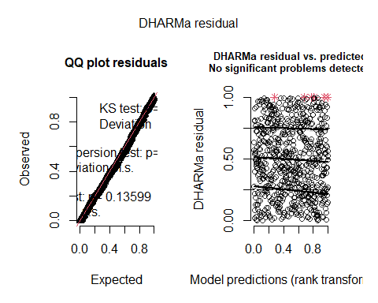
model1.2_fuels<- glmmTMB(Load ~ FuelType *(Treatment + ElevationZ + SlopeZ + Aspect)+SiteClass,
dispformula = ~ FuelType,
family = tweedie(link= "log"),
data=Thor_data_fuels)
Anova(model1.2_fuels,type=3)
## Analysis of Deviance Table (Type III Wald chisquare tests)
##
## Response: Load
## Chisq Df Pr(>Chisq)
## (Intercept) 125.9786 1 < 2.2e-16 ***
## FuelType 1263.4246 6 < 2.2e-16 ***
## Treatment 7.6278 1 0.005747 **
## ElevationZ 0.6446 1 0.422051
## SlopeZ 2.4827 1 0.115106
## Aspect 19.7469 6 0.003072 **
## SiteClass 1.1730 2 0.556281
## FuelType:Treatment 50.6295 6 3.515e-09 ***
## FuelType:ElevationZ 38.0764 6 1.085e-06 ***
## FuelType:SlopeZ 22.2464 6 0.001092 **
## FuelType:Aspect 86.9877 36 4.159e-06 ***
## ---
## Signif. codes: 0 '***' 0.001 '**' 0.01 '*' 0.05 '.' 0.1 ' ' 1
res_model1.2_fuels<-simulateResiduals(model1.2_fuels)
plot(res_model1.2_fuels)
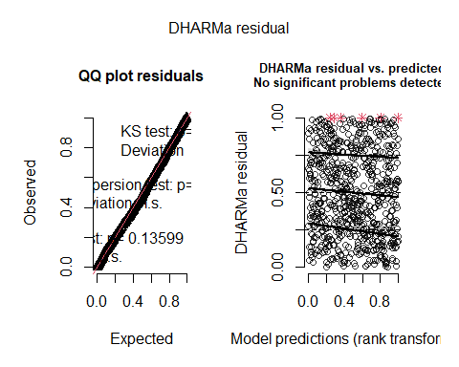
AICc(model1_fuels,model1.1_fuels,model1.2_fuels)
## df AICc
## model1_fuels 94 1378.985
## model1.1_fuels 87 1373.747
## model1.2_fuels 80 1367.807
##severity
model2_fuels<- glmmTMB(Load ~ FuelType * (Severity + scaled_baZ + SlopeZ) + SiteClass,
dispformula = ~ FuelType,
family = tweedie(link= "log"),
data=Thor_data_fuels_sev)
Anova(model2_fuels, type=3)
## Analysis of Deviance Table (Type III Wald chisquare tests)
##
## Response: Load
## Chisq Df Pr(>Chisq)
## (Intercept) 105.9427 1 < 2.2e-16 ***
## FuelType 762.5237 6 < 2.2e-16 ***
## Severity 31.1152 4 2.900e-06 ***
## scaled_baZ 0.2506 1 0.61662
## SlopeZ 0.0047 1 0.94557
## SiteClass 0.1936 2 0.90772
## FuelType:Severity 94.5439 24 2.519e-10 ***
## FuelType:scaled_baZ 11.9480 6 0.06314 .
## FuelType:SlopeZ 5.2510 6 0.51204
## ---
## Signif. codes: 0 '***' 0.001 '**' 0.01 '*' 0.05 '.' 0.1 ' ' 1
res_model2_fuels<-simulateResiduals(model2_fuels)
plot(res_model2_fuels)
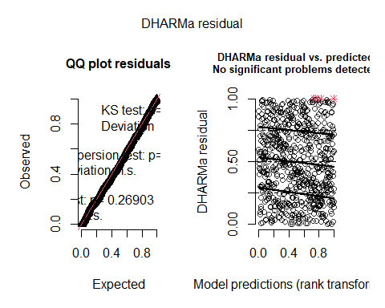
model2.1_fuels<- glmmTMB(Load ~ FuelType * (Severity + scaled_baZ) + SiteClass,
dispformula = ~ FuelType,
family = tweedie(link= "log"),
data=Thor_data_fuels_sev)
Anova(model2.1_fuels, type=3)
## Analysis of Deviance Table (Type III Wald chisquare tests)
##
## Response: Load
## Chisq Df Pr(>Chisq)
## (Intercept) 111.8250 1 < 2.2e-16 ***
## FuelType 756.7302 6 < 2.2e-16 ***
## Severity 31.4432 4 2.486e-06 ***
## scaled_baZ 0.2823 1 0.59521
## SiteClass 0.3206 2 0.85191
## FuelType:Severity 93.8581 24 3.283e-10 ***
## FuelType:scaled_baZ 13.1411 6 0.04085 *
## ---
## Signif. codes: 0 '***' 0.001 '**' 0.01 '*' 0.05 '.' 0.1 ' ' 1
res_model2.1_fuels<-simulateResiduals(model2.1_fuels)
plot(res_model2.1_fuels)
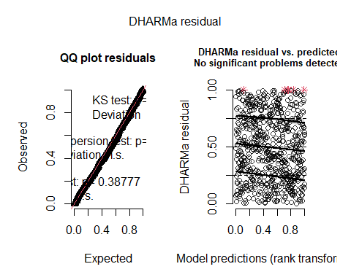
model2.2_fuels<- glmmTMB(Load ~ FuelType * Severity + SiteClass,
dispformula = ~ FuelType,
family = tweedie(link= "log"),
data=Thor_data_fuels)
Anova(model2.2_fuels, type=3)
## Analysis of Deviance Table (Type III Wald chisquare tests)
##
## Response: Load
## Chisq Df Pr(>Chisq)
## (Intercept) 108.5844 1 < 2.2e-16 ***
## FuelType 742.7029 6 < 2.2e-16 ***
## Severity 32.9451 4 1.226e-06 ***
## SiteClass 0.6278 2 0.7306
## FuelType:Severity 85.2111 24 8.809e-09 ***
## ---
## Signif. codes: 0 '***' 0.001 '**' 0.01 '*' 0.05 '.' 0.1 ' ' 1
res_model2.2_fuels<-simulateResiduals(model2.2_fuels)
plot(res_model2.2_fuels)
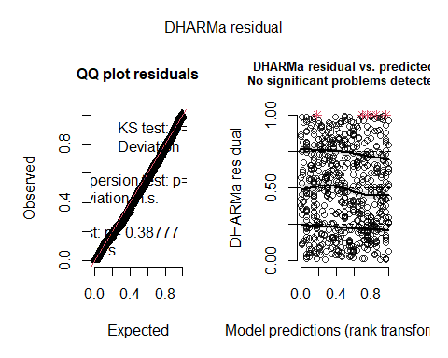
AICc(model2_fuels, model2.1_fuels, model2.2_fuels)
## df AICc
## model2_fuels 59 1366.379
## model2.1_fuels 52 1355.089
## model2.2_fuels 45 1352.824
##canopy cover n=99
#U_SC3_1 has no canopy data
model1_canopya <- glmmTMB(
canopy_absence ~ Treatment + ElevationZ + SlopeZ + SiteClass,
family = binomial(),
data = Thor_data_canopy)
Anova(model1_canopya, type=2)
## Analysis of Deviance Table (Type II Wald chisquare tests)
##
## Response: canopy_absence
## Chisq Df Pr(>Chisq)
## Treatment 13.6450 1 0.0002208 ***
## ElevationZ 1.5466 1 0.2136325
## SlopeZ 0.0015 1 0.9690681
## SiteClass 1.4873 2 0.4753855
## ---
## Signif. codes: 0 '***' 0.001 '**' 0.01 '*' 0.05 '.' 0.1 ' ' 1
res_model1_canopya<-simulateResiduals(model1_canopya)
plot(res_model1_canopya)
## Warning in newton(lsp = lsp, X = G$X, y = G$y, Eb = G$Eb, UrS = G$UrS, L = G$L,
## : Fitting terminated with step failure - check results carefully
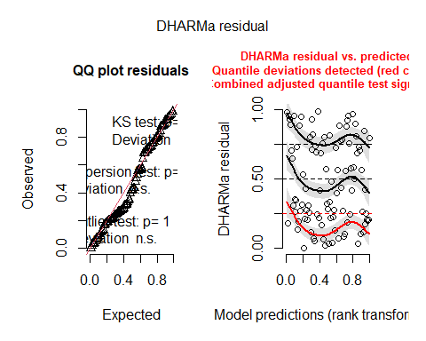
model1.1_canopya <- glmmTMB(
canopy_absence ~ Treatment + ElevationZ + SiteClass,
family = binomial(),
data = Thor_data_canopy)
Anova(model1.1_canopya, type=2)
## Analysis of Deviance Table (Type II Wald chisquare tests)
##
## Response: canopy_absence
## Chisq Df Pr(>Chisq)
## Treatment 13.6997 1 0.0002145 ***
## ElevationZ 1.5953 1 0.2065775
## SiteClass 1.4764 2 0.4779729
## ---
## Signif. codes: 0 '***' 0.001 '**' 0.01 '*' 0.05 '.' 0.1 ' ' 1
res_model1.1_canopya<-simulateResiduals(model1.1_canopya)
plot(res_model1.1_canopya)
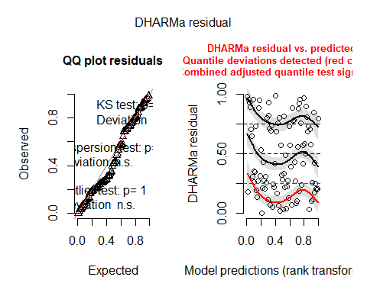
model1.2_canopya <- glmmTMB(
canopy_absence ~ Treatment + SiteClass,
family = binomial(),
data = Thor_data_canopy)
Anova(model1.2_canopya, type=2)
## Analysis of Deviance Table (Type II Wald chisquare tests)
##
## Response: canopy_absence
## Chisq Df Pr(>Chisq)
## Treatment 13.7507 1 0.0002087 ***
## SiteClass 6.3064 2 0.0427159 *
## ---
## Signif. codes: 0 '***' 0.001 '**' 0.01 '*' 0.05 '.' 0.1 ' ' 1
res_model1.2_canopya<-simulateResiduals(model1.2_canopya)
plot(res_model1.2_canopya)
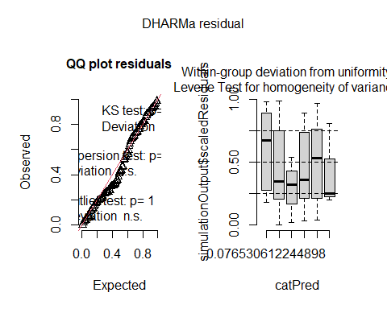
AICc(model1_canopya, model1.1_canopya, model1.2_canopya)
## df AICc
## model1_canopya 6 84.16126
## model1.1_canopya 5 81.89488
## model1.2_canopya 4 81.34089
model1_canopyp <- glmmTMB(
canopy_full ~ Treatment + SlopeZ + ElevationZ + scaled_baZ + SiteClass,
family = binomial(),
data = Thor_data_canopy)
Anova(model1_canopyp, type=2)
## Analysis of Deviance Table (Type II Wald chisquare tests)
##
## Response: canopy_full
## Chisq Df Pr(>Chisq)
## Treatment 7.4841 1 0.006225 **
## SlopeZ 1.0010 1 0.317059
## ElevationZ 2.3715 1 0.123569
## scaled_baZ 3.4607 1 0.062843 .
## SiteClass 1.7226 2 0.422603
## ---
## Signif. codes: 0 '***' 0.001 '**' 0.01 '*' 0.05 '.' 0.1 ' ' 1
res_model1_canopyp<-simulateResiduals(model1_canopyp)
plot(res_model1_canopyp)
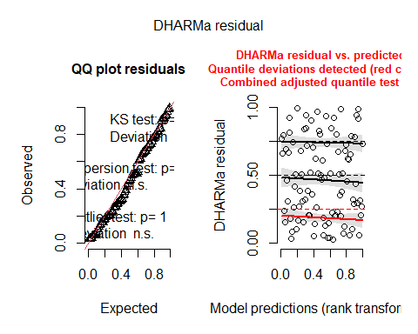
model1.1_canopyp <- glmmTMB(
canopy_full ~ Treatment + scaled_baZ + ElevationZ + SiteClass,
family = binomial(),
data = Thor_data_canopy)
Anova(model1.1_canopyp, type=2)
## Analysis of Deviance Table (Type II Wald chisquare tests)
##
## Response: canopy_full
## Chisq Df Pr(>Chisq)
## Treatment 7.4343 1 0.006399 **
## scaled_baZ 2.9941 1 0.083571 .
## ElevationZ 2.5574 1 0.109776
## SiteClass 1.6547 2 0.437204
## ---
## Signif. codes: 0 '***' 0.001 '**' 0.01 '*' 0.05 '.' 0.1 ' ' 1
res_model1.1_canopyp<-simulateResiduals(model1.1_canopyp)
plot(res_model1.1_canopyp)
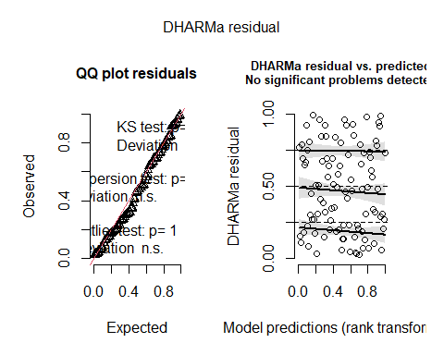
model1.2_canopyp <- glmmTMB(
canopy_full ~ Treatment + scaled_baZ + SiteClass,
family = binomial(),
data = Thor_data_canopy)
Anova(model1.2_canopyp, type=2)
## Analysis of Deviance Table (Type II Wald chisquare tests)
##
## Response: canopy_full
## Chisq Df Pr(>Chisq)
## Treatment 8.4949 1 0.003561 **
## scaled_baZ 3.2817 1 0.070057 .
## SiteClass 7.8028 2 0.020213 *
## ---
## Signif. codes: 0 '***' 0.001 '**' 0.01 '*' 0.05 '.' 0.1 ' ' 1
res_model1.2_canopyp<-simulateResiduals(model1.2_canopyp)
plot(res_model1.2_canopyp)
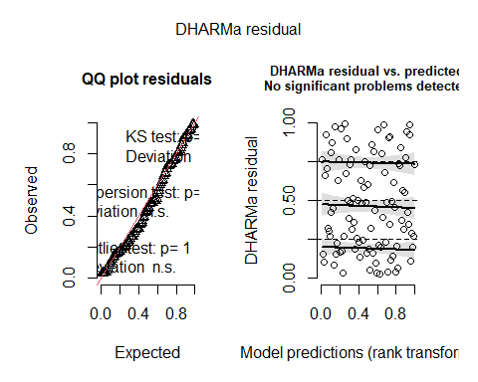
model1.3_canopyp <- glmmTMB(
canopy_full ~ Treatment + SiteClass,
family = binomial(),
data = Thor_data_canopy)
Anova(model1.3_canopyp, type=2)
## Analysis of Deviance Table (Type II Wald chisquare tests)
##
## Response: canopy_full
## Chisq Df Pr(>Chisq)
## Treatment 13.026 1 0.0003073 ***
## SiteClass 11.361 2 0.0034119 **
## ---
## Signif. codes: 0 '***' 0.001 '**' 0.01 '*' 0.05 '.' 0.1 ' ' 1
res_model1.3_canopyp<-simulateResiduals(model1.3_canopyp)
plot(res_model1.3_canopyp)
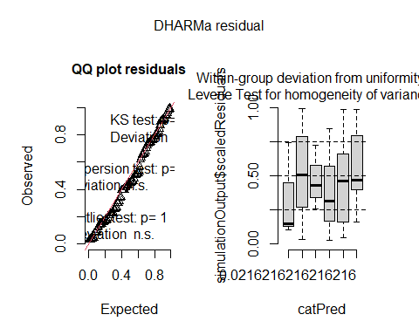
AICc(model1_canopyp,model1.1_canopyp, model1.2_canopyp, model1.3_canopyp)
## df AICc
## model1_canopyp 7 100.04795
## model1.1_canopyp 6 98.74791
## model1.2_canopyp 5 99.12346
## model1.3_canopyp 4 102.15410
model1_canopym <- glmmTMB(
canopycover ~ Treatment * (SlopeZ + scaled_baZ) + ElevationZ + SiteClass,
family = beta_family(),
data = Thor_data_canopy_middle)
Anova(model1_canopym, type=3)
## Analysis of Deviance Table (Type III Wald chisquare tests)
##
## Response: canopycover
## Chisq Df Pr(>Chisq)
## (Intercept) 1.1537 1 0.282772
## Treatment 7.4274 1 0.006424 **
## SlopeZ 0.4146 1 0.519652
## scaled_baZ 3.0398 1 0.081245 .
## ElevationZ 1.3764 1 0.240718
## SiteClass 0.7378 2 0.691510
## Treatment:SlopeZ 0.0141 1 0.905346
## Treatment:scaled_baZ 0.0027 1 0.958538
## ---
## Signif. codes: 0 '***' 0.001 '**' 0.01 '*' 0.05 '.' 0.1 ' ' 1
res_model1_canopym<-simulateResiduals(model1_canopym)
plot(res_model1_canopym)
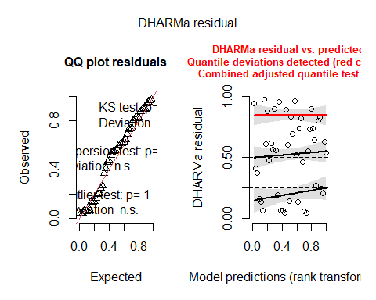
model1.1_canopym <- glmmTMB(
canopycover ~ Treatment + scaled_baZ + SlopeZ + ElevationZ + SiteClass,
family = beta_family(),
data = Thor_data_canopy_middle)
Anova(model1.1_canopym, type=2)
## Analysis of Deviance Table (Type II Wald chisquare tests)
##
## Response: canopycover
## Chisq Df Pr(>Chisq)
## Treatment 9.4840 1 0.002073 **
## scaled_baZ 3.1199 1 0.077340 .
## SlopeZ 0.4024 1 0.525843
## ElevationZ 1.5153 1 0.218331
## SiteClass 0.7522 2 0.686543
## ---
## Signif. codes: 0 '***' 0.001 '**' 0.01 '*' 0.05 '.' 0.1 ' ' 1
res_model1.1_canopym<-simulateResiduals(model1.1_canopym)
plot(res_model1.1_canopym)
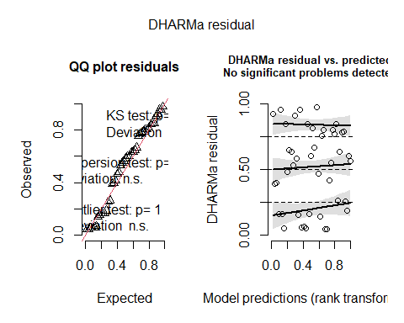
model1.2_canopym <- glmmTMB(
canopycover ~ Treatment + scaled_baZ + ElevationZ + SiteClass,
family = beta_family(),
data = Thor_data_canopy_middle)
Anova(model1.2_canopym, type=2)
## Analysis of Deviance Table (Type II Wald chisquare tests)
##
## Response: canopycover
## Chisq Df Pr(>Chisq)
## Treatment 10.4023 1 0.001259 **
## scaled_baZ 2.7129 1 0.099538 .
## ElevationZ 2.1763 1 0.140153
## SiteClass 1.0122 2 0.602849
## ---
## Signif. codes: 0 '***' 0.001 '**' 0.01 '*' 0.05 '.' 0.1 ' ' 1
res_model1.2_canopym<-simulateResiduals(model1.2_canopym)
plot(res_model1.2_canopym)
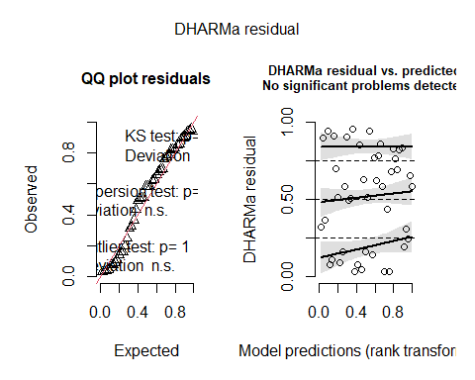
model1.3_canopym <- glmmTMB(
canopycover ~ Treatment + scaled_baZ + SiteClass,
family = beta_family(),
data = Thor_data_canopy_middle)
Anova(model1.3_canopym, type=2)
## Analysis of Deviance Table (Type II Wald chisquare tests)
##
## Response: canopycover
## Chisq Df Pr(>Chisq)
## Treatment 10.0417 1 0.00153 **
## scaled_baZ 3.3312 1 0.06798 .
## SiteClass 0.1847 2 0.91180
## ---
## Signif. codes: 0 '***' 0.001 '**' 0.01 '*' 0.05 '.' 0.1 ' ' 1
res_model1.3_canopym<-simulateResiduals(model1.3_canopym)
plot(res_model1.3_canopym)
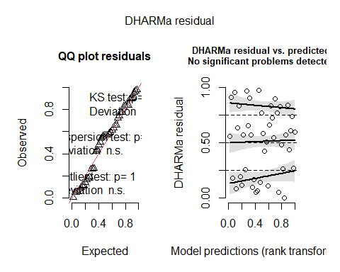
model1.4_canopym <- glmmTMB(
canopycover ~ Treatment + SiteClass,
family = beta_family(),
data = Thor_data_canopy_middle)
Anova(model1.4_canopym, type=2)
## Analysis of Deviance Table (Type II Wald chisquare tests)
##
## Response: canopycover
## Chisq Df Pr(>Chisq)
## Treatment 11.4410 1 0.0007184 ***
## SiteClass 0.6561 2 0.7203361
## ---
## Signif. codes: 0 '***' 0.001 '**' 0.01 '*' 0.05 '.' 0.1 ' ' 1
res_model1.4_canopym<-simulateResiduals(model1.4_canopym)
plot(res_model1.4_canopym)
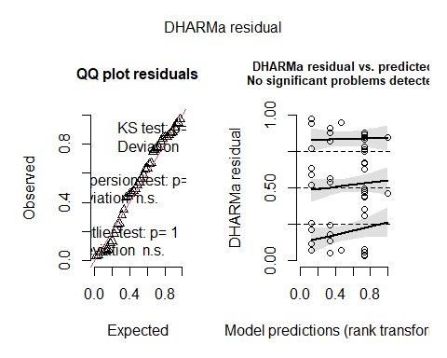
AICc(model1_canopym,model1.1_canopym, model1.2_canopym, model1.3_canopym, model1.4_canopym)
## df AICc
## model1_canopym 10 5.044966
## model1.1_canopym 8 -1.482007
## model1.2_canopym 7 -4.084671
## model1.3_canopym 6 -4.727627
## model1.4_canopym 5 -4.099782
####SEVERITY
#logistic regression for canopy absence
model2.1_canopy <- glmmTMB(
canopy_absence ~ Severity + scaled_baZ + SiteClass,
family = binomial(),
data = Thor_data_canopy_sev)
Anova(model2.1_canopy, type=2)
## Analysis of Deviance Table (Type II Wald chisquare tests)
##
## Response: canopy_absence
## Chisq Df Pr(>Chisq)
## Severity 15.8333 4 0.003251 **
## scaled_baZ 3.7774 1 0.051948 .
## SiteClass 6.0232 2 0.049212 *
## ---
## Signif. codes: 0 '***' 0.001 '**' 0.01 '*' 0.05 '.' 0.1 ' ' 1
res_model2.1_canopy<-simulateResiduals(model2.1_canopy)
plot(res_model2.1_canopy)
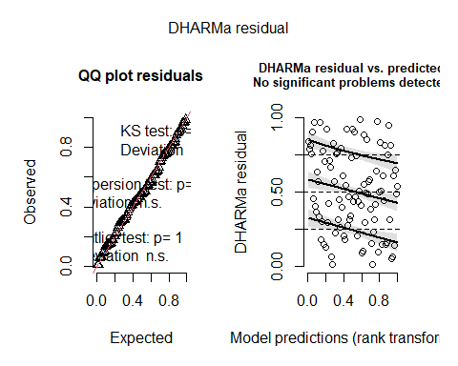
AICc(model2.1_canopy)
## [1] 57.25036
#logistic regression for full canopy
model2.2_canopy <- glmmTMB(
canopy_full ~ Severity + scaled_baZ + SiteClass,
family = binomial(),
data = Thor_data_canopy_sev)
Anova(model2.2_canopy, type=2)
## Analysis of Deviance Table (Type II Wald chisquare tests)
##
## Response: canopy_full
## Chisq Df Pr(>Chisq)
## Severity 6.0308 4 0.19686
## scaled_baZ 3.5121 1 0.06092 .
## SiteClass 4.9416 2 0.08452 .
## ---
## Signif. codes: 0 '***' 0.001 '**' 0.01 '*' 0.05 '.' 0.1 ' ' 1
res_model2.2_canopy<-simulateResiduals(model2.2_canopy)
plot(res_model2.2_canopy)
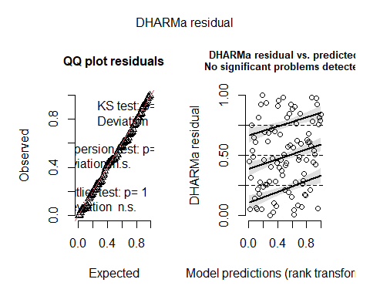
model2.2.1_canopy <- glmmTMB(
canopy_full ~ Severity + SiteClass,
family = binomial(),
data = Thor_data_canopy_sev)
Anova(model2.2.1_canopy, type=2)
## Analysis of Deviance Table (Type II Wald chisquare tests)
##
## Response: canopy_full
## Chisq Df Pr(>Chisq)
## Severity 8.371 4 0.07890 .
## SiteClass 8.300 2 0.01576 *
## ---
## Signif. codes: 0 '***' 0.001 '**' 0.01 '*' 0.05 '.' 0.1 ' ' 1
res_model2.2.1_canopy<-simulateResiduals(model2.2.1_canopy)
plot(res_model2.2.1_canopy)
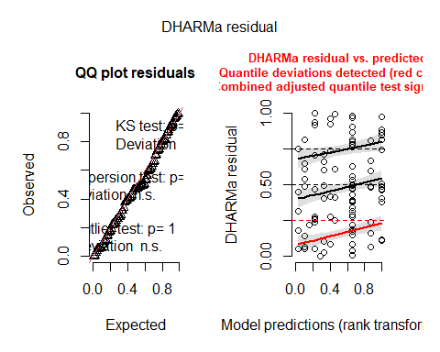
AICc(model2.2_canopy, model2.2.1_canopy)
## df AICc
## model2.2_canopy 8 96.11129
## model2.2.1_canopy 7 99.89141
#Between 0 and 1
model2.3_canopy <- glmmTMB(
canopycover ~ Severity + scaled_baZ + SlopeZ + SiteClass,
family = beta_family(),
data = Thor_data_canopy_middle_sev)
Anova(model2.3_canopy, type=2)
## Analysis of Deviance Table (Type II Wald chisquare tests)
##
## Response: canopycover
## Chisq Df Pr(>Chisq)
## Severity 10.8461 3 0.01259 *
## scaled_baZ 5.0135 1 0.02515 *
## SlopeZ 0.6880 1 0.40685
## SiteClass 0.0507 2 0.97496
## ---
## Signif. codes: 0 '***' 0.001 '**' 0.01 '*' 0.05 '.' 0.1 ' ' 1
res_model2.3_canopy<-simulateResiduals(model2.3_canopy)
plot(res_model2.3_canopy)
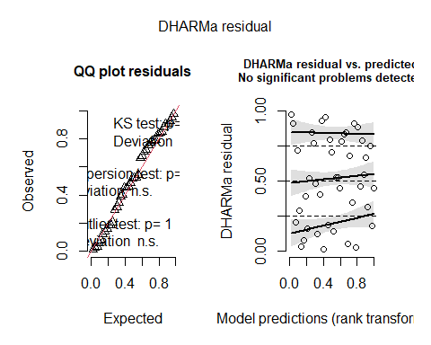
model2.3.1_canopy <- glmmTMB(
canopycover ~ Severity + scaled_baZ + SiteClass,
family = beta_family(),
data = Thor_data_canopy_middle_sev)
Anova(model2.3.1_canopy, type=2)
## Analysis of Deviance Table (Type II Wald chisquare tests)
##
## Response: canopycover
## Chisq Df Pr(>Chisq)
## Severity 11.1250 3 0.01107 *
## scaled_baZ 4.3990 1 0.03596 *
## SiteClass 0.1429 2 0.93106
## ---
## Signif. codes: 0 '***' 0.001 '**' 0.01 '*' 0.05 '.' 0.1 ' ' 1
res_model2.3.1_canopy<-simulateResiduals(model2.3.1_canopy)
plot(res_model2.3.1_canopy)
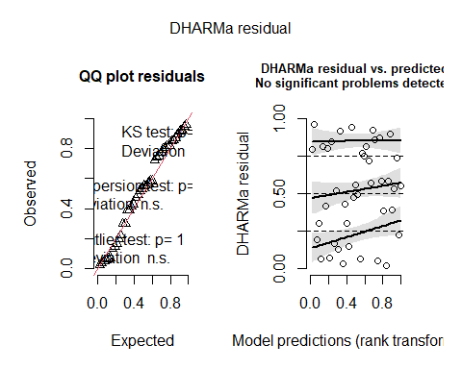
AICc(model2.3_canopy, model2.3.1_canopy)
## df AICc
## model2.3_canopy 9 2.51880435
## model2.3.1_canopy 8 -0.05860899
##treediversity
## Diversity of all large tree (overstory)
model1_TD <- glmmTMB(
HillShannon ~ Treatment * SlopeZ + prop.density.dead + SiteClass,
family = gaussian(),
data = Thor_data)
Anova(model1_TD, type=3)
## Analysis of Deviance Table (Type III Wald chisquare tests)
##
## Response: HillShannon
## Chisq Df Pr(>Chisq)
## (Intercept) 112.2222 1 < 2.2e-16 ***
## Treatment 7.0345 1 0.007996 **
## SlopeZ 0.0292 1 0.864432
## prop.density.dead 0.0140 1 0.905740
## SiteClass 5.5726 2 0.061649 .
## Treatment:SlopeZ 0.1100 1 0.740091
## ---
## Signif. codes: 0 '***' 0.001 '**' 0.01 '*' 0.05 '.' 0.1 ' ' 1
res_model1_TD<-simulateResiduals(model1_TD)
plot(res_model1_TD)
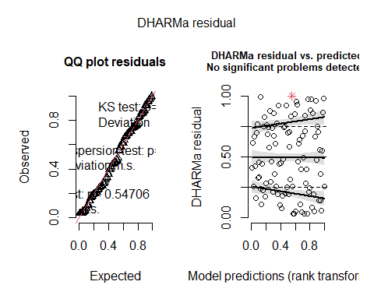
model2_TD <- glmmTMB(
HillShannon ~ Treatment + prop.density.dead + SiteClass,
family = gaussian(),
data = Thor_data)
Anova(model2_TD, type=3)
## Analysis of Deviance Table (Type III Wald chisquare tests)
##
## Response: HillShannon
## Chisq Df Pr(>Chisq)
## (Intercept) 128.0770 1 < 2.2e-16 ***
## Treatment 7.0733 1 0.007824 **
## prop.density.dead 0.0002 1 0.988553
## SiteClass 5.5055 2 0.063753 .
## ---
## Signif. codes: 0 '***' 0.001 '**' 0.01 '*' 0.05 '.' 0.1 ' ' 1
res_model2_TD<-simulateResiduals(model2_TD)
plot(res_model2_TD)
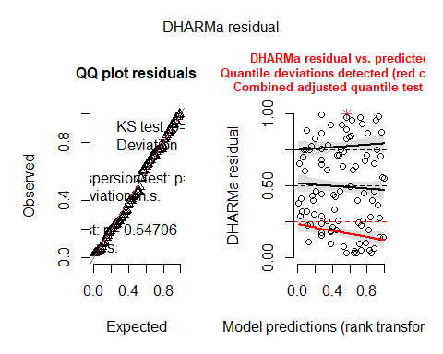
model3_TD <- glmmTMB(
HillShannon ~ Treatment + SiteClass,
family = gaussian(),
data = Thor_data)
Anova(model3_TD, type=3)
## Analysis of Deviance Table (Type III Wald chisquare tests)
##
## Response: HillShannon
## Chisq Df Pr(>Chisq)
## (Intercept) 215.6156 1 < 2.2e-16 ***
## Treatment 12.3102 1 0.0004505 ***
## SiteClass 5.5389 2 0.0626951 .
## ---
## Signif. codes: 0 '***' 0.001 '**' 0.01 '*' 0.05 '.' 0.1 ' ' 1
res_model3_TD<-simulateResiduals(model3_TD)
plot(res_model3_TD)
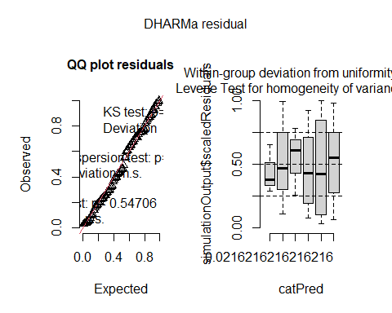
AICc(model1_TD,model2_TD, model3_TD)
## df AICc
## model1_TD 8 306.4893
## model2_TD 6 301.9257
## model3_TD 5 299.6581
#Severity
model2_OD <- glmmTMB(
HillShannon ~ Severity + prop.density.dead + SiteClass,
family = gaussian(),
data = Thor_data)
summary(model2_OD)
## Family: gaussian ( identity )
## Formula: HillShannon ~ Severity + prop.density.dead + SiteClass
## Data: Thor_data
##
## AIC BIC logLik -2*log(L) df.resid
## 292.7 315.7 -137.3 274.7 86
##
##
## Dispersion estimate for gaussian family (sigma^2): 1.06
##
## Conditional model:
## Estimate Std. Error z value Pr(>|z|)
## (Intercept) 2.35316 0.36548 6.439 1.21e-10 ***
## Severity1 0.52974 0.36831 1.438 0.1503
## Severity2 -0.56650 0.39302 -1.441 0.1495
## Severity3 -0.30709 0.29362 -1.046 0.2956
## Severity4 -0.05895 0.24527 -0.240 0.8101
## prop.density.dead -0.36777 0.50623 -0.726 0.4675
## SiteClass1 0.48427 0.20736 2.335 0.0195 *
## SiteClass2 0.08307 0.19468 0.427 0.6696
## ---
## Signif. codes: 0 '***' 0.001 '**' 0.01 '*' 0.05 '.' 0.1 ' ' 1
Anova(model2_OD, type=3)
## Analysis of Deviance Table (Type III Wald chisquare tests)
##
## Response: HillShannon
## Chisq Df Pr(>Chisq)
## (Intercept) 41.4559 1 1.206e-10 ***
## Severity 8.9875 4 0.06141 .
## prop.density.dead 0.5278 1 0.46755
## SiteClass 5.5015 2 0.06388 .
## ---
## Signif. codes: 0 '***' 0.001 '**' 0.01 '*' 0.05 '.' 0.1 ' ' 1
res_model2_OD<-simulateResiduals(model2_OD)
plot(res_model2_OD)
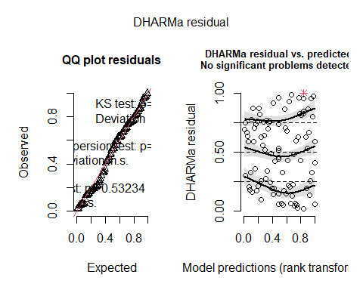
testUniformity(res_model2_OD)
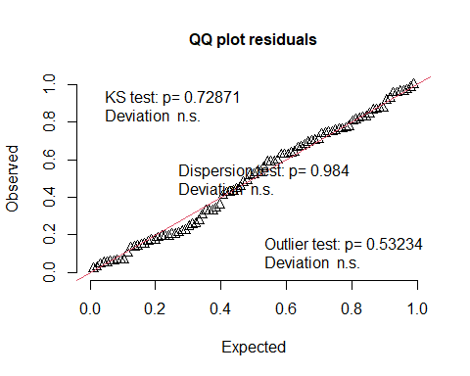
##
## Asymptotic one-sample Kolmogorov-Smirnov test
##
## data: simulationOutput$scaledResiduals
## D = 0.070737, p-value = 0.7287
## alternative hypothesis: two-sided
testDispersion(res_model2_OD)
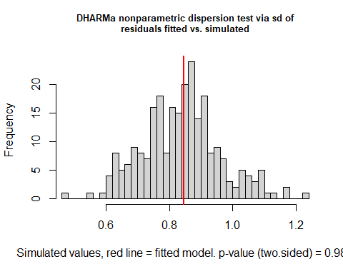
##
## DHARMa nonparametric dispersion test via sd of residuals fitted vs.
## simulated
##
## data: simulationOutput
## dispersion = 1.0103, p-value = 0.984
## alternative hypothesis: two.sided
testZeroInflation(res_model2_OD)
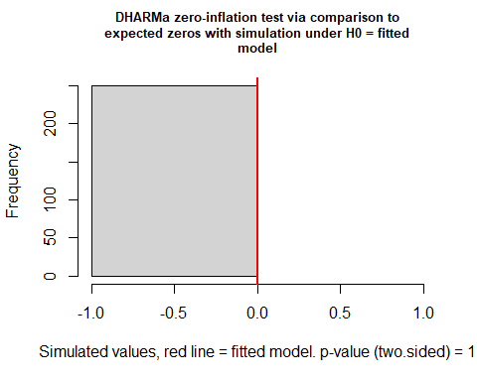
##
## DHARMa zero-inflation test via comparison to expected zeros with
## simulation under H0 = fitted model
##
## data: simulationOutput
## ratioObsSim = NaN, p-value = 1
## alternative hypothesis: two.sided
###Just diversity of live trees (trees that will persist on the landscape) n=97. 3 plots contained all dead and no recruitment
model1_LTD <- glmmTMB(
HillLive ~ Treatment * SlopeZ + SiteClass,
family = gaussian(),
data = Thor_data)
Anova(model1_LTD,type=3)
## Analysis of Deviance Table (Type III Wald chisquare tests)
##
## Response: HillLive
## Chisq Df Pr(>Chisq)
## (Intercept) 148.3772 1 <2e-16 ***
## Treatment 0.2400 1 0.6242
## SlopeZ 1.3605 1 0.2434
## SiteClass 3.4093 2 0.1818
## Treatment:SlopeZ 0.3609 1 0.5480
## ---
## Signif. codes: 0 '***' 0.001 '**' 0.01 '*' 0.05 '.' 0.1 ' ' 1
res_model1_LTD<-simulateResiduals(model1_LTD)
plot(res_model1_LTD)
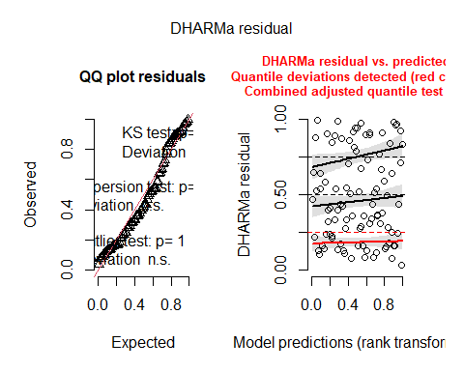
model2_LTD <- glmmTMB(
HillLive ~ Treatment + SlopeZ + SiteClass,
family = gaussian(),
data = Thor_data)
Anova(model2_LTD, type=3)
## Analysis of Deviance Table (Type III Wald chisquare tests)
##
## Response: HillLive
## Chisq Df Pr(>Chisq)
## (Intercept) 149.4166 1 <2e-16 ***
## Treatment 0.2444 1 0.6210
## SlopeZ 1.1909 1 0.2752
## SiteClass 3.3381 2 0.1884
## ---
## Signif. codes: 0 '***' 0.001 '**' 0.01 '*' 0.05 '.' 0.1 ' ' 1
res_model2_LTD<-simulateResiduals(model2_LTD)
plot(res_model2_LTD)
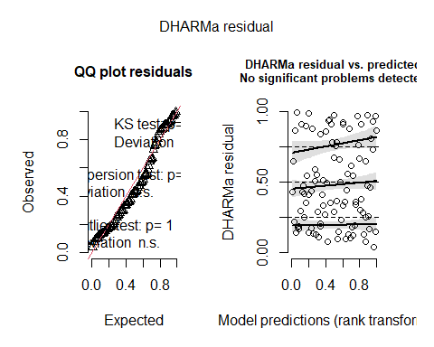
model3_LTD <- glmmTMB(
HillLive ~ Treatment + SiteClass,
family = gaussian(),
data = Thor_data)
Anova(model3_LTD, type=3)
## Analysis of Deviance Table (Type III Wald chisquare tests)
##
## Response: HillLive
## Chisq Df Pr(>Chisq)
## (Intercept) 154.0191 1 <2e-16 ***
## Treatment 0.1640 1 0.6855
## SiteClass 3.2567 2 0.1963
## ---
## Signif. codes: 0 '***' 0.001 '**' 0.01 '*' 0.05 '.' 0.1 ' ' 1
res_model3_LTD<-simulateResiduals(model3_LTD)
plot(res_model3_LTD)
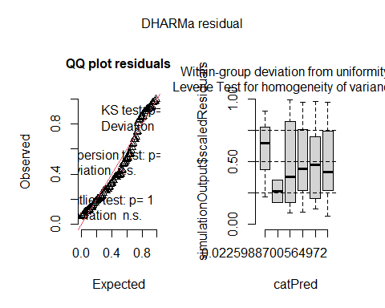
AICc(model1_LTD, model2_LTD, model3_LTD)
## df AICc
## model1_LTD 7 311.7241
## model2_LTD 6 309.7592
## model3_LTD 5 308.6689
#Severity
model2_SD <- glmmTMB(
HillLive ~ Severity + prop.density.dead + SiteClass,
family = gaussian(),
data = Thor_data)
summary(model2_SD)
## Family: gaussian ( identity )
## Formula: HillLive ~ Severity + prop.density.dead + SiteClass
## Data: Thor_data
##
## AIC BIC logLik -2*log(L) df.resid
## 295.1 318.0 -138.5 277.1 85
##
##
## Dispersion estimate for gaussian family (sigma^2): 1.12
##
## Conditional model:
## Estimate Std. Error z value Pr(>|z|)
## (Intercept) 2.06665 0.36469 5.667 1.45e-08 ***
## Severity1 0.74204 0.38297 1.938 0.0527 .
## Severity2 -1.04609 0.43213 -2.421 0.0155 *
## Severity3 -0.10637 0.29989 -0.355 0.7228
## Severity4 0.26205 0.25377 1.033 0.3018
## prop.density.dead 0.49347 0.50223 0.983 0.3258
## SiteClass1 0.38921 0.21361 1.822 0.0685 .
## SiteClass2 -0.02418 0.19968 -0.121 0.9036
## ---
## Signif. codes: 0 '***' 0.001 '**' 0.01 '*' 0.05 '.' 0.1 ' ' 1
Anova(model2_SD, type=3)
## Analysis of Deviance Table (Type III Wald chisquare tests)
##
## Response: HillLive
## Chisq Df Pr(>Chisq)
## (Intercept) 32.1140 1 1.454e-08 ***
## Severity 9.7816 4 0.04427 *
## prop.density.dead 0.9654 1 0.32582
## SiteClass 3.7347 2 0.15453
## ---
## Signif. codes: 0 '***' 0.001 '**' 0.01 '*' 0.05 '.' 0.1 ' ' 1
res_model2_SD<-simulateResiduals(model2_SD)
plot(res_model2_SD)
## Warning in newton(lsp = lsp, X = G$X, y = G$y, Eb = G$Eb, UrS = G$UrS, L = G$L,
## : Fitting terminated with step failure - check results carefully
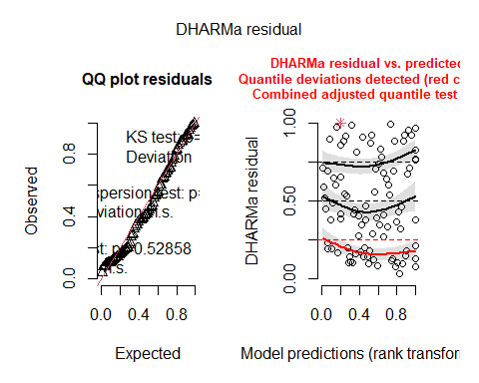
testUniformity(res_model2_SD)
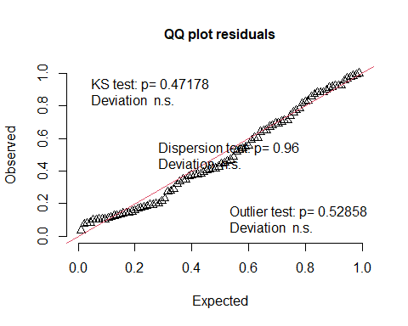
##
## Asymptotic one-sample Kolmogorov-Smirnov test
##
## data: simulationOutput$scaledResiduals
## D = 0.087234, p-value = 0.4718
## alternative hypothesis: two-sided
testDispersion(res_model2_SD)
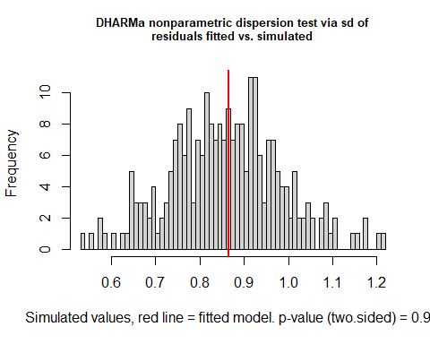
##
## DHARMa nonparametric dispersion test via sd of residuals fitted vs.
## simulated
##
## data: simulationOutput
## dispersion = 1.008, p-value = 0.96
## alternative hypothesis: two.sided
testZeroInflation(res_model2_SD)

##
## DHARMa zero-inflation test via comparison to expected zeros with
## simulation under H0 = fitted model
##
## data: simulationOutput
## ratioObsSim = NaN, p-value = 1
## alternative hypothesis: two.sided
##recruitment severity
model1_recruitment<-glmmTMB(Abundance ~ Type * (Severity + scaled_ba + SlopeZ) + SiteClass,
family=nbinom2(),
data=Thor_data_recruitment)
Anova(model1_recruitment,type=3)
## Analysis of Deviance Table (Type III Wald chisquare tests)
##
## Response: Abundance
## Chisq Df Pr(>Chisq)
## (Intercept) 0.0000 1 0.9995
## Type 0.0001 1 0.9920
## Severity 6.1405 4 0.1889
## scaled_ba 1.9511 1 0.1625
## SlopeZ 0.0231 1 0.8792
## SiteClass 0.3046 2 0.8587
## Type:Severity 62.0941 4 1.052e-12 ***
## Type:scaled_ba 0.8821 1 0.3476
## Type:SlopeZ 2.1869 1 0.1392
## ---
## Signif. codes: 0 '***' 0.001 '**' 0.01 '*' 0.05 '.' 0.1 ' ' 1
res_model1_recruitment<-simulateResiduals(model1_recruitment)
plot(res_model1_recruitment)
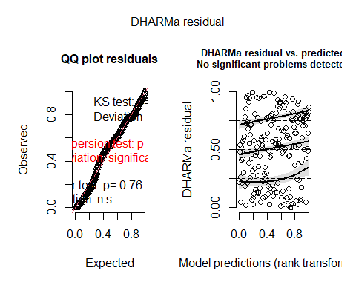
model1.2_recruitment<-glmmTMB(Abundance ~ Type * (Severity + scaled_ba) + SiteClass,
family=nbinom2(),
data=Thor_data_recruitment_sev)
Anova(model1.2_recruitment,type=3)
## Analysis of Deviance Table (Type III Wald chisquare tests)
##
## Response: Abundance
## Chisq Df Pr(>Chisq)
## (Intercept) 0.0000 1 0.99955
## Type 0.0001 1 0.99414
## Severity 6.4106 4 0.17051
## scaled_ba 3.0306 1 0.08171 .
## SiteClass 0.4570 2 0.79571
## Type:Severity 60.1710 4 2.67e-12 ***
## Type:scaled_ba 2.8042 1 0.09402 .
## ---
## Signif. codes: 0 '***' 0.001 '**' 0.01 '*' 0.05 '.' 0.1 ' ' 1
res_model1.2_recruitment<-simulateResiduals(model1.2_recruitment)
plot(res_model1.2_recruitment)
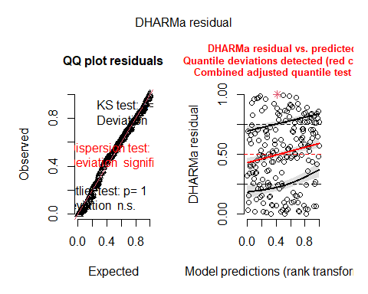
model1.3_recruitment<-glmmTMB(Abundance ~ Type * Severity + SiteClass,
family=nbinom2(),
ziformula = ~ Severity,
data=Thor_data_recruitment_sev)
Anova(model1.3_recruitment,type=3)
## Analysis of Deviance Table (Type III Wald chisquare tests)
##
## Response: Abundance
## Chisq Df Pr(>Chisq)
## (Intercept) 0.0000 1 0.99970
## Type 0.0000 1 0.99502
## Severity 11.3897 4 0.02252 *
## SiteClass 0.0828 2 0.95946
## Type:Severity 83.2726 4 < 2e-16 ***
## ---
## Signif. codes: 0 '***' 0.001 '**' 0.01 '*' 0.05 '.' 0.1 ' ' 1
res_model1.3_recruitment<-simulateResiduals(model1.3_recruitment)
plot(res_model1.3_recruitment)
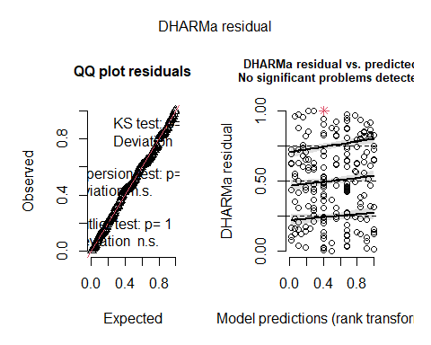
AICc(model1_recruitment, model1.2_recruitment, model1.3_recruitment)
## df AICc
## model1_recruitment 17 1099.243
## model1.2_recruitment 15 1096.652
## model1.3_recruitment 18 1076.149
##seedling abundance
mean_count <- mean(Thor_data$SeedlingAbundance)
var_count <- var(Thor_data$SeedlingAbundance)
overdispersion_ratio <- var_count / mean_count
hist(Thor_data$SeedlingAbundance)

model1.0_seedling <- glmmTMB(
SeedlingAbundance ~ Treatment * (Aspect + SlopeZ) + ElevationZ + SiteClass,
family = nbinom2,
ziformula = ~Treatment,
data = Thor_data)
Anova(model1.0_seedling, type=3)
## Analysis of Deviance Table (Type III Wald chisquare tests)
##
## Response: SeedlingAbundance
## Chisq Df Pr(>Chisq)
## (Intercept) 458.4310 1 < 2.2e-16 ***
## Treatment 56.2822 1 6.278e-14 ***
## Aspect 13.6662 6 0.03360 *
## SlopeZ 4.8057 1 0.02837 *
## ElevationZ 17.7959 1 2.459e-05 ***
## SiteClass 5.4033 2 0.06709 .
## Treatment:Aspect 14.4452 6 0.02504 *
## Treatment:SlopeZ 0.0029 1 0.95695
## ---
## Signif. codes: 0 '***' 0.001 '**' 0.01 '*' 0.05 '.' 0.1 ' ' 1
res_model1.0_seedling<-simulateResiduals(model1.0_seedling)
plot(res_model1.0_seedling)
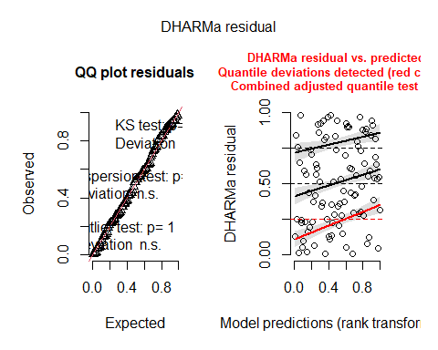
model1.1_seedling <- glmmTMB(
SeedlingAbundance ~ Treatment * Aspect + ElevationZ + SlopeZ + SiteClass,
family = nbinom2,
ziformula = ~Treatment,
data = Thor_data)
Anova(model1.1_seedling, type=3)
## Analysis of Deviance Table (Type III Wald chisquare tests)
##
## Response: SeedlingAbundance
## Chisq Df Pr(>Chisq)
## (Intercept) 472.2160 1 < 2.2e-16 ***
## Treatment 58.5557 1 1.976e-14 ***
## Aspect 13.6811 6 0.03341 *
## ElevationZ 18.4821 1 1.715e-05 ***
## SlopeZ 4.9022 1 0.02682 *
## SiteClass 5.4602 2 0.06521 .
## Treatment:Aspect 15.0499 6 0.01987 *
## ---
## Signif. codes: 0 '***' 0.001 '**' 0.01 '*' 0.05 '.' 0.1 ' ' 1
res_model1.1_seedling<-simulateResiduals(model1.1_seedling)
plot(res_model1.1_seedling)
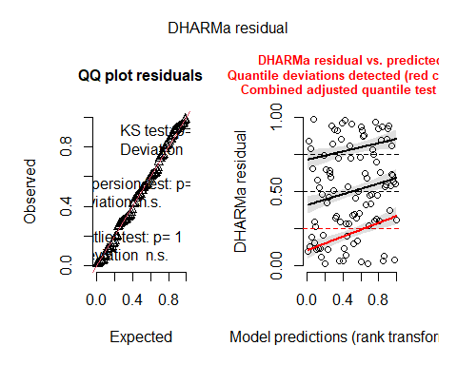
AICc(model1.0_seedling, model1.1_seedling)
## df AICc
## model1.0_seedling 22 787.2710
## model1.1_seedling 21 783.9772
#Severity
model2_seedling <- glmmTMB(
SeedlingAbundance ~ Severity * scaled_ba + SiteClass,
family = nbinom2,
ziformula = ~Treatment,
data = Thor_data)
summary(model2_seedling)
## Family: nbinom2 ( log )
## Formula: SeedlingAbundance ~ Severity * scaled_ba + SiteClass
## Zero inflation: ~Treatment
## Data: Thor_data
##
## AIC BIC logLik -2*log(L) df.resid
## 755.7 794.2 -362.9 725.7 81
##
##
## Dispersion parameter for nbinom2 family (): 2.37
##
## Conditional model:
## Estimate Std. Error z value Pr(>|z|)
## (Intercept) 3.4265388 0.1902836 18.008 <2e-16 ***
## Severity1 0.0137495 0.3357598 0.041 0.967
## Severity2 0.1766739 0.3443078 0.513 0.608
## Severity3 0.2850894 0.3248915 0.877 0.380
## Severity4 0.1657024 0.3065307 0.541 0.589
## scaled_ba 0.0011807 0.0007459 1.583 0.113
## SiteClass1 -0.0165200 0.1643405 -0.101 0.920
## SiteClass2 -0.0949784 0.1494597 -0.635 0.525
## Severity1:scaled_ba 0.0009659 0.0020457 0.472 0.637
## Severity2:scaled_ba -0.0013355 0.0014270 -0.936 0.349
## Severity3:scaled_ba 0.0003598 0.0015259 0.236 0.814
## Severity4:scaled_ba 0.0012120 0.0014188 0.854 0.393
## ---
## Signif. codes: 0 '***' 0.001 '**' 0.01 '*' 0.05 '.' 0.1 ' ' 1
##
## Zero-inflation model:
## Estimate Std. Error z value Pr(>|z|)
## (Intercept) -1.3515 0.2630 -5.139 2.76e-07 ***
## Treatment1 0.4033 0.2627 1.535 0.125
## ---
## Signif. codes: 0 '***' 0.001 '**' 0.01 '*' 0.05 '.' 0.1 ' ' 1
Anova(model2_seedling, type=3)
## Analysis of Deviance Table (Type III Wald chisquare tests)
##
## Response: SeedlingAbundance
## Chisq Df Pr(>Chisq)
## (Intercept) 324.2714 1 < 2e-16 ***
## Severity 11.7790 4 0.01907 *
## scaled_ba 2.5054 1 0.11346
## SiteClass 0.4045 2 0.81688
## Severity:scaled_ba 3.8947 4 0.42044
## ---
## Signif. codes: 0 '***' 0.001 '**' 0.01 '*' 0.05 '.' 0.1 ' ' 1
res_model2_seedling<-simulateResiduals(model2_seedling)
plot(res_model2_seedling)
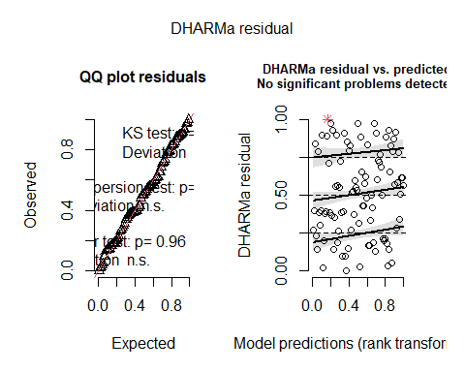
model2.1_seedling <- glmmTMB(
SeedlingAbundance ~ Severity + scaled_ba * SiteClass,
family = nbinom2,
ziformula = ~Treatment,
data = Thor_data)
summary(model2.1_seedling)
## Family: nbinom2 ( log )
## Formula: SeedlingAbundance ~ Severity + scaled_ba * SiteClass
## Zero inflation: ~Treatment
## Data: Thor_data
##
## AIC BIC logLik -2*log(L) df.resid
## 754.6 787.9 -364.3 728.6 83
##
##
## Dispersion parameter for nbinom2 family (): 2.28
##
## Conditional model:
## Estimate Std. Error z value Pr(>|z|)
## (Intercept) 3.681e+00 1.926e-01 19.108 <2e-16 ***
## Severity1 1.193e-01 2.236e-01 0.533 0.5938
## Severity2 -5.005e-02 2.598e-01 -0.193 0.8472
## Severity3 3.591e-01 1.950e-01 1.841 0.0656 .
## Severity4 4.394e-01 1.730e-01 2.540 0.0111 *
## scaled_ba -6.665e-05 4.919e-04 -0.136 0.8922
## SiteClass1 -6.619e-02 2.164e-01 -0.306 0.7597
## SiteClass2 -2.635e-01 2.228e-01 -1.183 0.2369
## scaled_ba:SiteClass1 1.353e-04 5.069e-04 0.267 0.7895
## scaled_ba:SiteClass2 7.045e-04 7.570e-04 0.931 0.3520
## ---
## Signif. codes: 0 '***' 0.001 '**' 0.01 '*' 0.05 '.' 0.1 ' ' 1
##
## Zero-inflation model:
## Estimate Std. Error z value Pr(>|z|)
## (Intercept) -1.3516 0.2629 -5.141 2.74e-07 ***
## Treatment1 0.4019 0.2627 1.530 0.126
## ---
## Signif. codes: 0 '***' 0.001 '**' 0.01 '*' 0.05 '.' 0.1 ' ' 1
Anova(model2.1_seedling, type=3)
## Analysis of Deviance Table (Type III Wald chisquare tests)
##
## Response: SeedlingAbundance
## Chisq Df Pr(>Chisq)
## (Intercept) 365.1218 1 < 2.2e-16 ***
## Severity 45.9940 4 2.47e-09 ***
## scaled_ba 0.0184 1 0.8922
## SiteClass 1.4091 2 0.4943
## scaled_ba:SiteClass 1.1681 2 0.5576
## ---
## Signif. codes: 0 '***' 0.001 '**' 0.01 '*' 0.05 '.' 0.1 ' ' 1
res_model2.1_seedling<-simulateResiduals(model2.1_seedling)
plot(res_model2.1_seedling)
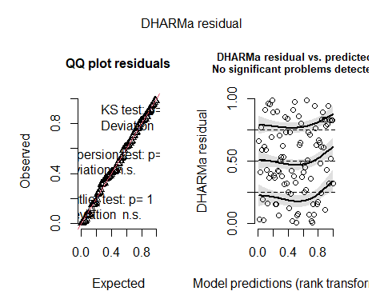
#Best residual plots and best AICc sig dif.
model2.2_seedling <- glmmTMB(
SeedlingAbundance ~ Severity + scaled_ba + SiteClass,
family = nbinom2,
ziformula = ~Treatment,
data = Thor_data)
summary(model2.2_seedling)
## Family: nbinom2 ( log )
## Formula: SeedlingAbundance ~ Severity + scaled_ba + SiteClass
## Zero inflation: ~Treatment
## Data: Thor_data
##
## AIC BIC logLik -2*log(L) df.resid
## 751.7 779.9 -364.8 729.7 85
##
##
## Dispersion parameter for nbinom2 family (): 2.23
##
## Conditional model:
## Estimate Std. Error z value Pr(>|z|)
## (Intercept) 3.624e+00 1.585e-01 22.857 <2e-16 ***
## Severity1 9.927e-02 2.226e-01 0.446 0.6557
## Severity2 -4.664e-02 2.619e-01 -0.178 0.8587
## Severity3 3.623e-01 1.967e-01 1.841 0.0656 .
## Severity4 4.479e-01 1.734e-01 2.583 0.0098 **
## scaled_ba 6.052e-05 2.152e-04 0.281 0.7785
## SiteClass1 -1.153e-02 1.685e-01 -0.068 0.9454
## SiteClass2 -1.073e-01 1.531e-01 -0.701 0.4833
## ---
## Signif. codes: 0 '***' 0.001 '**' 0.01 '*' 0.05 '.' 0.1 ' ' 1
##
## Zero-inflation model:
## Estimate Std. Error z value Pr(>|z|)
## (Intercept) -1.3549 0.2637 -5.139 2.76e-07 ***
## Treatment1 0.4013 0.2633 1.524 0.128
## ---
## Signif. codes: 0 '***' 0.001 '**' 0.01 '*' 0.05 '.' 0.1 ' ' 1
Anova(model2.2_seedling, type=3)
## Analysis of Deviance Table (Type III Wald chisquare tests)
##
## Response: SeedlingAbundance
## Chisq Df Pr(>Chisq)
## (Intercept) 522.4650 1 < 2.2e-16 ***
## Severity 45.1650 4 3.674e-09 ***
## scaled_ba 0.0791 1 0.7785
## SiteClass 0.4971 2 0.7799
## ---
## Signif. codes: 0 '***' 0.001 '**' 0.01 '*' 0.05 '.' 0.1 ' ' 1
res_model2.2_seedling<-simulateResiduals(model2.2_seedling)
plot(res_model2.2_seedling)
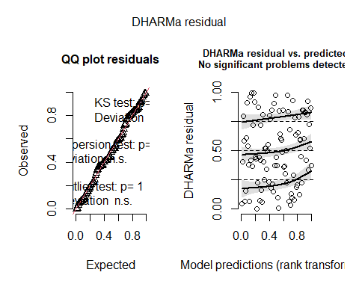
testUniformity(res_model2.2_seedling)
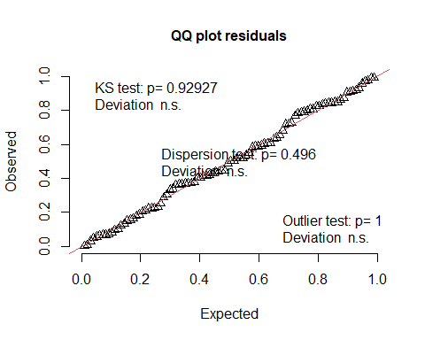
##
## Exact one-sample Kolmogorov-Smirnov test
##
## data: simulationOutput$scaledResiduals
## D = 0.053852, p-value = 0.9293
## alternative hypothesis: two-sided
testDispersion(res_model2.2_seedling)
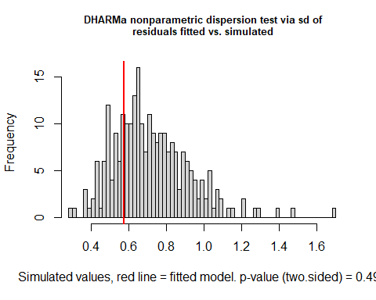
##
## DHARMa nonparametric dispersion test via sd of residuals fitted vs.
## simulated
##
## data: simulationOutput
## dispersion = 0.80065, p-value = 0.496
## alternative hypothesis: two.sided
testZeroInflation(res_model2.2_seedling)
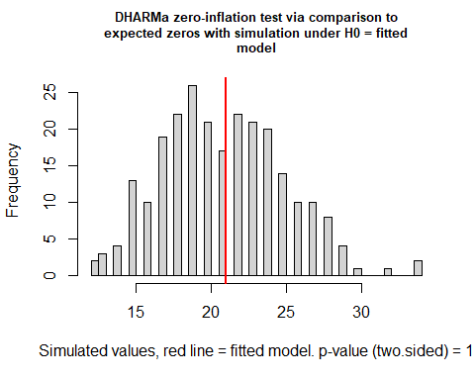
##
## DHARMa zero-inflation test via comparison to expected zeros with
## simulation under H0 = fitted model
##
## data: simulationOutput
## ratioObsSim = 0.99791, p-value = 1
## alternative hypothesis: two.sided
AICc(model2_seedling, model2.1_seedling, model2.2_seedling)
## df AICc
## model2_seedling 15 761.7314
## model2.1_seedling 13 759.0345
## model2.2_seedling 11 754.8153
##Sapling Abundance
hist(Thor_data$SaplingAbundance)

##over dispersed
mean_count <- mean(Thor_data$SaplingAbundance)
var_count <- var(Thor_data$SaplingAbundance)
overdispersion_ratio <- var_count / mean_count
model1.0_sapling <- glmmTMB(
SaplingAbundance ~ Treatment * (Aspect + SlopeZ + scaled_baZ) + ElevationZ + SiteClass,
family = nbinom2(),
ziformula = ~Treatment,
data = Thor_data)
Anova(model1.0_sapling, type=3)
## Analysis of Deviance Table (Type III Wald chisquare tests)
##
## Response: SaplingAbundance
## Chisq Df Pr(>Chisq)
## (Intercept) 0.0000 1 0.998322
## Treatment 0.0000 1 0.997808
## Aspect 17.0119 6 0.009239 **
## SlopeZ 0.4817 1 0.487652
## scaled_baZ 2.3621 1 0.124316
## ElevationZ 4.5334 1 0.033240 *
## SiteClass 7.5040 2 0.023471 *
## Treatment:Aspect 15.2418 6 0.018457 *
## Treatment:SlopeZ 0.0347 1 0.852156
## Treatment:scaled_baZ 1.8690 1 0.171584
## ---
## Signif. codes: 0 '***' 0.001 '**' 0.01 '*' 0.05 '.' 0.1 ' ' 1
res_model1.0_sapling<-simulateResiduals(model1.0_sapling)
plot(res_model1.0_sapling)
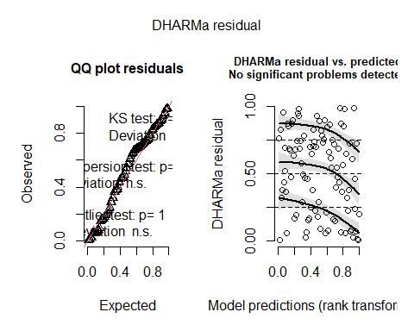
model1.1_sapling <- glmmTMB(
SaplingAbundance ~ Treatment * Aspect + ElevationZ + scaled_baZ + SiteClass,
family = nbinom2(),
ziformula = ~Treatment,
data = Thor_data)
Anova(model1.1_sapling, type=3)
## Analysis of Deviance Table (Type III Wald chisquare tests)
##
## Response: SaplingAbundance
## Chisq Df Pr(>Chisq)
## (Intercept) 0.0000 1 0.999288
## Treatment 0.0000 1 0.998987
## Aspect 17.8163 6 0.006708 **
## ElevationZ 4.2687 1 0.038821 *
## scaled_baZ 1.6785 1 0.195130
## SiteClass 7.5935 2 0.022443 *
## Treatment:Aspect 12.7446 6 0.047276 *
## ---
## Signif. codes: 0 '***' 0.001 '**' 0.01 '*' 0.05 '.' 0.1 ' ' 1
res_model1.1_sapling<-simulateResiduals(model1.1_sapling)
plot(res_model1.1_sapling)
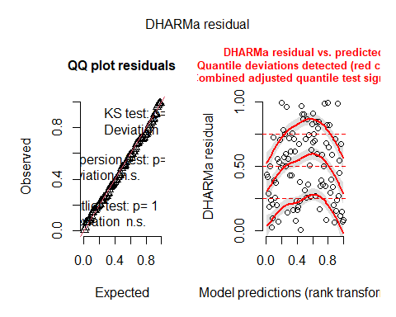
model1.2_sapling <- glmmTMB(
SaplingAbundance ~ Treatment * Aspect + ElevationZ + SiteClass,
family = nbinom2(),
ziformula = ~Treatment,
data = Thor_data)
Anova(model1.2_sapling, type=3)
## Analysis of Deviance Table (Type III Wald chisquare tests)
##
## Response: SaplingAbundance
## Chisq Df Pr(>Chisq)
## (Intercept) 0.0000 1 0.998956
## Treatment 0.0000 1 0.998562
## Aspect 20.3180 6 0.002431 **
## ElevationZ 2.7555 1 0.096922 .
## SiteClass 9.2488 2 0.009810 **
## Treatment:Aspect 15.3100 6 0.017978 *
## ---
## Signif. codes: 0 '***' 0.001 '**' 0.01 '*' 0.05 '.' 0.1 ' ' 1
res_model1.2_sapling<-simulateResiduals(model1.2_sapling)
plot(res_model1.2_sapling)
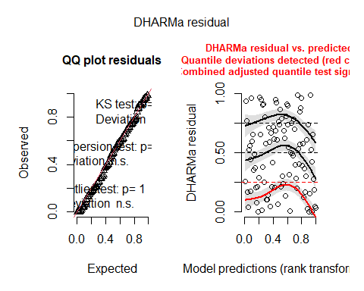
model1.3_sapling <- glmmTMB(
SaplingAbundance ~ Treatment * Aspect + SiteClass,
family = nbinom2(),
ziformula = ~Treatment,
data = Thor_data)
Anova(model1.3_sapling, type=3)
## Analysis of Deviance Table (Type III Wald chisquare tests)
##
## Response: SaplingAbundance
## Chisq Df Pr(>Chisq)
## (Intercept) 0.000 1 0.998328
## Treatment 0.000 1 0.997783
## Aspect 16.839 6 0.009892 **
## SiteClass 11.526 2 0.003142 **
## Treatment:Aspect 14.360 6 0.025864 *
## ---
## Signif. codes: 0 '***' 0.001 '**' 0.01 '*' 0.05 '.' 0.1 ' ' 1
res_model1.3_sapling<-simulateResiduals(model1.3_sapling)
plot(res_model1.3_sapling)
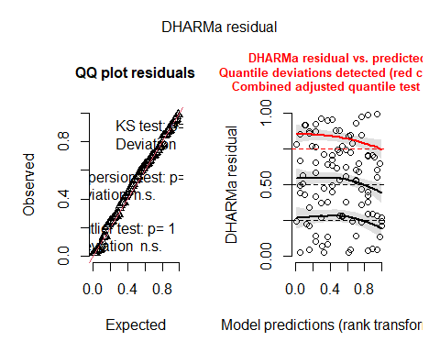
AICc(model1.0_sapling, model1.1_sapling,model1.2_sapling, model1.3_sapling)
## df AICc
## model1.0_sapling 24 322.3998
## model1.1_sapling 21 315.8235
## model1.2_sapling 20 314.3502
## model1.3_sapling 19 313.4924
##severity
model2_sapling <- glmmTMB(
SaplingAbundance ~ Severity + scaled_ba + SiteClass,
family = nbinom2,
data = Thor_data)
summary(model2_sapling)
## Family: nbinom2 ( log )
## Formula: SaplingAbundance ~ Severity + scaled_ba + SiteClass
## Data: Thor_data
##
## AIC BIC logLik -2*log(L) df.resid
## 310.1 333.1 -146.0 292.1 87
##
##
## Dispersion parameter for nbinom2 family (): 0.433
##
## Conditional model:
## Estimate Std. Error z value Pr(>|z|)
## (Intercept) -4.425e+00 1.681e+03 -0.003 0.9979
## Severity1 -1.582e+01 6.723e+03 -0.002 0.9981
## Severity2 3.245e+00 1.681e+03 0.002 0.9985
## Severity3 3.483e+00 1.681e+03 0.002 0.9983
## Severity4 3.157e+00 1.681e+03 0.002 0.9985
## scaled_ba -8.236e-04 4.854e-04 -1.697 0.0898 .
## SiteClass1 1.288e-01 3.729e-01 0.345 0.7299
## SiteClass2 1.924e-01 3.303e-01 0.582 0.5603
## ---
## Signif. codes: 0 '***' 0.001 '**' 0.01 '*' 0.05 '.' 0.1 ' ' 1
Anova(model2_sapling, type=3)
## Analysis of Deviance Table (Type III Wald chisquare tests)
##
## Response: SaplingAbundance
## Chisq Df Pr(>Chisq)
## (Intercept) 0.0000 1 0.99790
## Severity 34.3996 4 6.17e-07 ***
## scaled_ba 2.8787 1 0.08976 .
## SiteClass 0.4066 2 0.81603
## ---
## Signif. codes: 0 '***' 0.001 '**' 0.01 '*' 0.05 '.' 0.1 ' ' 1
res_model2_sapling<-simulateResiduals(model2_sapling)
plot(res_model2_sapling)
## Warning in newton(lsp = lsp, X = G$X, y = G$y, Eb = G$Eb, UrS = G$UrS, L = G$L,
## : Fitting terminated with step failure - check results carefully
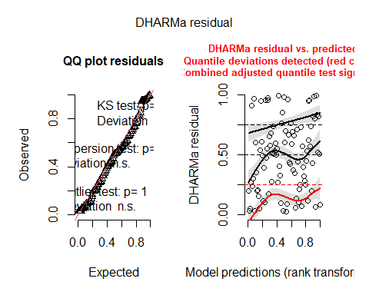
testUniformity(res_model2_sapling)
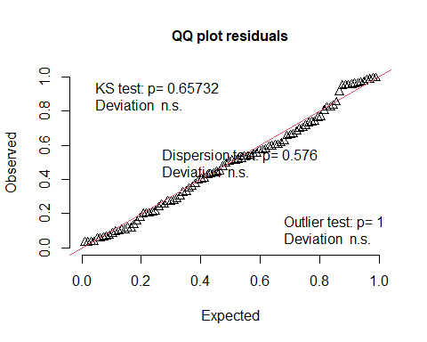
##
## Exact one-sample Kolmogorov-Smirnov test
##
## data: simulationOutput$scaledResiduals
## D = 0.073065, p-value = 0.6573
## alternative hypothesis: two-sided
testDispersion(res_model2_sapling)
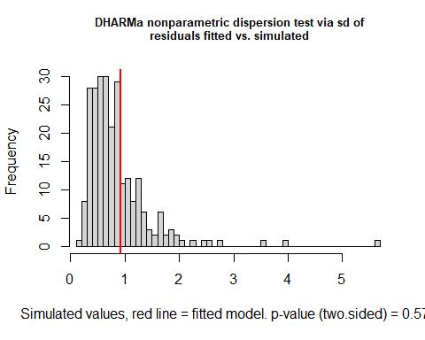
##
## DHARMa nonparametric dispersion test via sd of residuals fitted vs.
## simulated
##
## data: simulationOutput
## dispersion = 1.0846, p-value = 0.576
## alternative hypothesis: two.sided
testZeroInflation(res_model2_sapling)
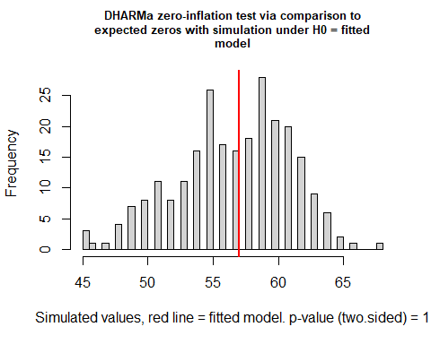
##
## DHARMa zero-inflation test via comparison to expected zeros with
## simulation under H0 = fitted model
##
## data: simulationOutput
## ratioObsSim = 1.0034, p-value = 1
## alternative hypothesis: two.sided
##Detritus (Litter and duff)
model1_LD<-glmmTMB(Depth~ Type*(Treatment * SlopeZ+ scaled_baZ)+ SiteClass,
family=tweedie(link = "log"),
data=Thor_data_LD)
res_model1_LD<-simulateResiduals(model1_LD)
plot(res_model1_LD)
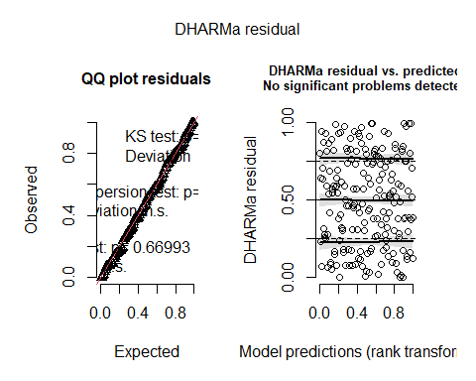
Anova(model1_LD,type=3)
## Analysis of Deviance Table (Type III Wald chisquare tests)
##
## Response: Depth
## Chisq Df Pr(>Chisq)
## (Intercept) 29.5937 1 5.328e-08 ***
## Type 60.2995 1 8.147e-15 ***
## Treatment 36.5492 1 1.489e-09 ***
## SlopeZ 0.0584 1 0.809121
## scaled_baZ 1.0518 1 0.305091
## SiteClass 11.6060 2 0.003019 **
## Treatment:SlopeZ 0.9745 1 0.323570
## Type:Treatment 22.0995 1 2.589e-06 ***
## Type:SlopeZ 0.0000 1 0.999471
## Type:scaled_baZ 0.3314 1 0.564824
## Type:Treatment:SlopeZ 0.1532 1 0.695449
## ---
## Signif. codes: 0 '***' 0.001 '**' 0.01 '*' 0.05 '.' 0.1 ' ' 1
model1.1_LD<-glmmTMB(Depth~ Type*(Treatment * scaled_baZ)+ SiteClass,
family=tweedie(link = "log"),
data=Thor_data_LD)
res_model1.1_LD<-simulateResiduals(model1.1_LD)
plot(res_model1.1_LD)
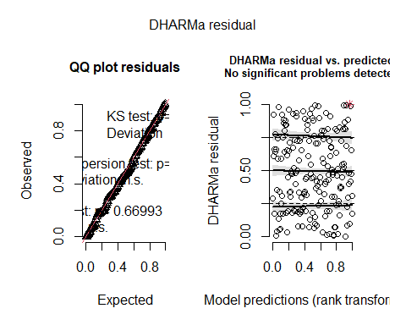
Anova(model1.1_LD,type=3)
## Analysis of Deviance Table (Type III Wald chisquare tests)
##
## Response: Depth
## Chisq Df Pr(>Chisq)
## (Intercept) 22.0731 1 2.625e-06 ***
## Type 39.1177 1 3.990e-10 ***
## Treatment 23.8976 1 1.016e-06 ***
## scaled_baZ 1.6057 1 0.205099
## SiteClass 10.3158 2 0.005754 **
## Treatment:scaled_baZ 1.2217 1 0.269036
## Type:Treatment 20.0289 1 7.628e-06 ***
## Type:scaled_baZ 0.2250 1 0.635263
## Type:Treatment:scaled_baZ 0.5823 1 0.445423
## ---
## Signif. codes: 0 '***' 0.001 '**' 0.01 '*' 0.05 '.' 0.1 ' ' 1
model1.2_LD<-glmmTMB(Depth~ Type * Treatment + SiteClass,
family=tweedie(link = "log"),
data=Thor_data_LD)
res_model1.2_LD<-simulateResiduals(model1.1_LD)
plot(res_model1.2_LD)
Anova(model1.2_LD,type=3)
## Analysis of Deviance Table (Type III Wald chisquare tests)
##
## Response: Depth
## Chisq Df Pr(>Chisq)
## (Intercept) 30.411 1 3.496e-08 ***
## Type 61.098 1 5.431e-15 ***
## Treatment 44.005 1 3.276e-11 ***
## SiteClass 16.223 2 3e-04 ***
## Type:Treatment 25.250 1 5.035e-07 ***
## ---
## Signif. codes: 0 '***' 0.001 '**' 0.01 '*' 0.05 '.' 0.1 ' ' 1
AICc(model1_LD, model1.1_LD,model1.2_LD)
## df AICc
## model1_LD 14 372.5780
## model1.1_LD 12 367.6757
## model1.2_LD 8 363.0125
##Detritus (Litter and duff)
model2_LD<-glmmTMB(Depth~ Type*(Severity + SlopeZ+ scaled_baZ) + SiteClass,
family=tweedie(link = "log"),
data=Thor_data_LD_sev)
Anova(model2_LD,type=3)
## Analysis of Deviance Table (Type III Wald chisquare tests)
##
## Response: Depth
## Chisq Df Pr(>Chisq)
## (Intercept) 45.8581 1 1.271e-11 ***
## Type 4.9714 1 0.02577 *
## Severity 40.3620 4 3.643e-08 ***
## SlopeZ 0.3774 1 0.53898
## scaled_baZ 1.1323 1 0.28728
## SiteClass 8.3604 2 0.01530 *
## Type:Severity 24.2963 4 6.966e-05 ***
## Type:SlopeZ 0.0086 1 0.92614
## Type:scaled_baZ 0.5765 1 0.44770
## ---
## Signif. codes: 0 '***' 0.001 '**' 0.01 '*' 0.05 '.' 0.1 ' ' 1
res_model2_LD<-simulateResiduals(model2_LD)
plot(res_model2_LD)
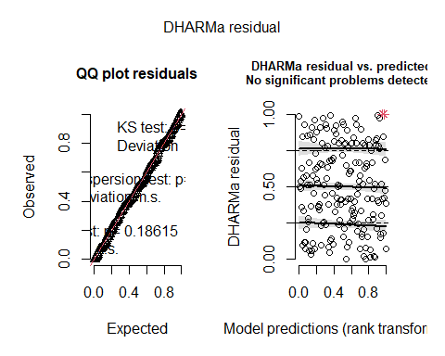
model2.1_LD<-glmmTMB(Depth~ Type*(Severity + scaled_baZ) + SiteClass,
family=tweedie(link = "log"),
data=Thor_data_LD_sev)
Anova(model2.1_LD,type=3)
## Analysis of Deviance Table (Type III Wald chisquare tests)
##
## Response: Depth
## Chisq Df Pr(>Chisq)
## (Intercept) 48.3880 1 3.497e-12 ***
## Type 4.8781 1 0.02720 *
## Severity 39.9669 4 4.397e-08 ***
## scaled_baZ 0.8783 1 0.34868
## SiteClass 7.8148 2 0.02009 *
## Type:Severity 24.1865 4 7.329e-05 ***
## Type:scaled_baZ 0.6020 1 0.43782
## ---
## Signif. codes: 0 '***' 0.001 '**' 0.01 '*' 0.05 '.' 0.1 ' ' 1
res_model2.1_LD<-simulateResiduals(model2.1_LD)
plot(res_model2.1_LD)
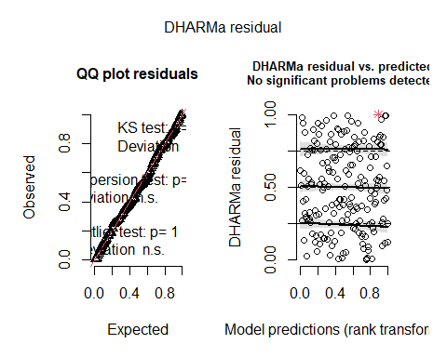
model2.2_LD<-glmmTMB(Depth~ Type*Severity + SiteClass,
family=tweedie(link = "log"),
data=Thor_data_LD_sev)
Anova(model2.2_LD,type=3)
## Analysis of Deviance Table (Type III Wald chisquare tests)
##
## Response: Depth
## Chisq Df Pr(>Chisq)
## (Intercept) 47.718 1 4.920e-12 ***
## Type 4.680 1 0.030515 *
## Severity 45.020 4 3.938e-09 ***
## SiteClass 13.220 2 0.001347 **
## Type:Severity 27.422 4 1.633e-05 ***
## ---
## Signif. codes: 0 '***' 0.001 '**' 0.01 '*' 0.05 '.' 0.1 ' ' 1
res_model2.2_LD<-simulateResiduals(model2.2_LD)
plot(res_model2.2_LD)
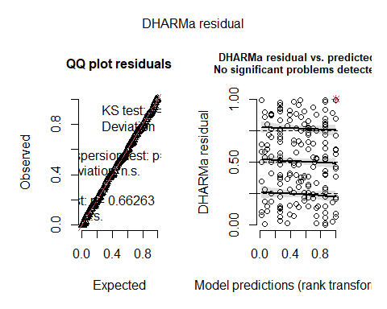
AICc(model2_LD, model2.1_LD, model2.2_LD)
## df AICc
## model2_LD 18 361.2706
## model2.1_LD 16 356.9699
## model2.2_LD 14 355.7624
##mortality
#logistic regression for 0% mortality
model1_mortalitya <- glmmTMB(
AllLive ~ Treatment * (SlopeZ + scaled_ba) + SiteClass,
family = binomial(),
data = Thor_data_mortality)
Anova(model1_mortalitya, type=2)
## Analysis of Deviance Table (Type II Wald chisquare tests)
##
## Response: AllLive
## Chisq Df Pr(>Chisq)
## Treatment 2.2611 1 0.13266
## SlopeZ 0.2882 1 0.59140
## scaled_ba 2.1326 1 0.14420
## SiteClass 7.5333 2 0.02313 *
## Treatment:SlopeZ 0.4263 1 0.51382
## Treatment:scaled_ba 0.5478 1 0.45921
## ---
## Signif. codes: 0 '***' 0.001 '**' 0.01 '*' 0.05 '.' 0.1 ' ' 1
res_model1_mortalitya<-simulateResiduals(model1_mortalitya)
plot(res_model1_mortalitya)
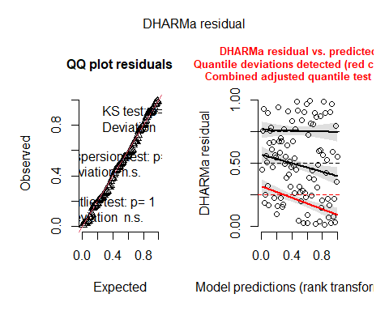
testUniformity(res_model1_mortalitya)
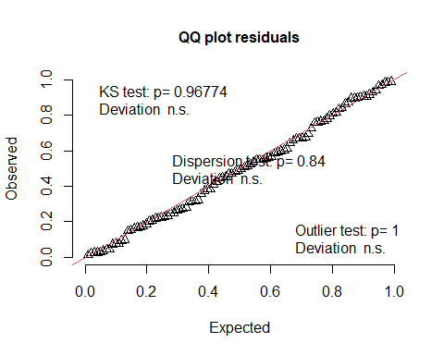
##
## Asymptotic one-sample Kolmogorov-Smirnov test
##
## data: simulationOutput$scaledResiduals
## D = 0.049385, p-value = 0.9677
## alternative hypothesis: two-sided
testDispersion(res_model1_mortalitya)
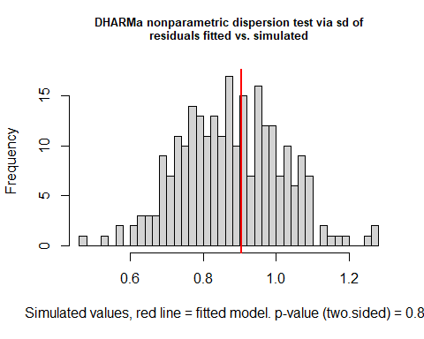
##
## DHARMa nonparametric dispersion test via sd of residuals fitted vs.
## simulated
##
## data: simulationOutput
## dispersion = 1.0341, p-value = 0.84
## alternative hypothesis: two.sided
model1.1_mortalitya <- glmmTMB(
AllLive ~ Treatment + SlopeZ + scaled_ba + SiteClass,
family = binomial(),
data = Thor_data_mortality)
Anova(model1.1_mortalitya, type=2)
## Analysis of Deviance Table (Type II Wald chisquare tests)
##
## Response: AllLive
## Chisq Df Pr(>Chisq)
## Treatment 2.5581 1 0.10973
## SlopeZ 0.2212 1 0.63811
## scaled_ba 2.1150 1 0.14586
## SiteClass 7.2924 2 0.02609 *
## ---
## Signif. codes: 0 '***' 0.001 '**' 0.01 '*' 0.05 '.' 0.1 ' ' 1
res_model1.1_mortalitya<-simulateResiduals(model1.1_mortalitya)
plot(res_model1.1_mortalitya)
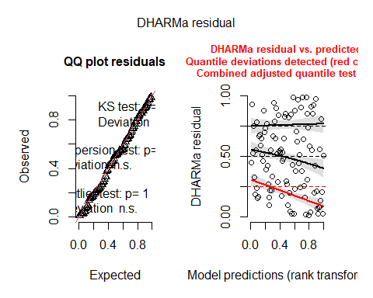
model1.2_mortalitya <- glmmTMB(
AllLive ~ Treatment + scaled_ba + SiteClass,
family = binomial(),
data = Thor_data_mortality)
Anova(model1.2_mortalitya, type=2)
## Analysis of Deviance Table (Type II Wald chisquare tests)
##
## Response: AllLive
## Chisq Df Pr(>Chisq)
## Treatment 2.4756 1 0.11562
## scaled_ba 2.3730 1 0.12345
## SiteClass 7.0899 2 0.02887 *
## ---
## Signif. codes: 0 '***' 0.001 '**' 0.01 '*' 0.05 '.' 0.1 ' ' 1
res_model1.2_mortalitya<-simulateResiduals(model1.2_mortalitya)
plot(res_model1.2_mortalitya)
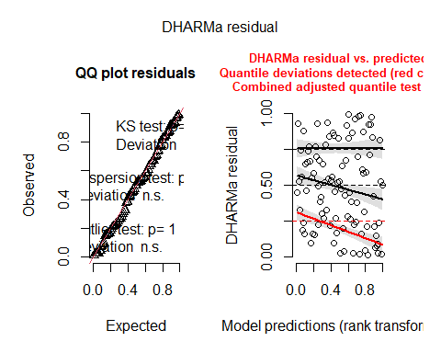
model1.3_mortalitya <- glmmTMB(
AllLive ~ Treatment + SiteClass,
family = binomial(),
data = Thor_data_mortality)
Anova(model1.3_mortalitya, type=2)
## Analysis of Deviance Table (Type II Wald chisquare tests)
##
## Response: AllLive
## Chisq Df Pr(>Chisq)
## Treatment 1.0029 1 0.31662
## SiteClass 5.7866 2 0.05539 .
## ---
## Signif. codes: 0 '***' 0.001 '**' 0.01 '*' 0.05 '.' 0.1 ' ' 1
res_model1.3_mortalitya<-simulateResiduals(model1.3_mortalitya)
plot(res_model1.3_mortalitya)
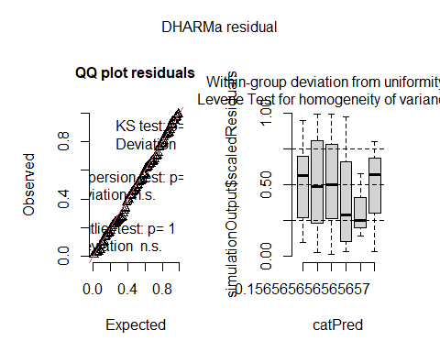
AICc(model1_mortalitya,model1.1_mortalitya, model1.2_mortalitya, model1.3_mortalitya)
## df AICc
## model1_mortalitya 8 97.07028
## model1.1_mortalitya 6 93.41196
## model1.2_mortalitya 5 91.36903
## model1.3_mortalitya 4 93.05293
#logistic regression for 100% mortality
model1_mortalityp <- glmmTMB(
AllDead ~ Treatment + SlopeZ + scaled_ba + SiteClass,
family = binomial(),
data = Thor_data_mortality)
Anova(model1_mortalityp, type=2)
## Analysis of Deviance Table (Type II Wald chisquare tests)
##
## Response: AllDead
## Chisq Df Pr(>Chisq)
## Treatment 0.0000 1 0.99889
## SlopeZ 4.1425 1 0.04182 *
## scaled_ba 0.0031 1 0.95559
## SiteClass 3.0406 2 0.21864
## ---
## Signif. codes: 0 '***' 0.001 '**' 0.01 '*' 0.05 '.' 0.1 ' ' 1
res_model1_mortalityp<-simulateResiduals(model1_mortalityp)
plot(res_model1_mortalityp)
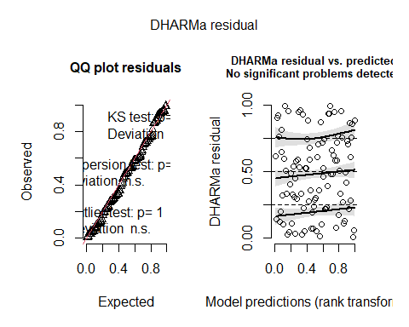
model1.1_mortalityp <- glmmTMB(
AllDead ~ Treatment + SlopeZ + SiteClass,
family = binomial(),
data = Thor_data_mortality)
Anova(model1.1_mortalityp, type=2)
## Analysis of Deviance Table (Type II Wald chisquare tests)
##
## Response: AllDead
## Chisq Df Pr(>Chisq)
## Treatment 0.0000 1 0.99911
## SlopeZ 4.1460 1 0.04173 *
## SiteClass 3.1281 2 0.20929
## ---
## Signif. codes: 0 '***' 0.001 '**' 0.01 '*' 0.05 '.' 0.1 ' ' 1
res_model1.1_mortalityp<-simulateResiduals(model1.1_mortalityp)
plot(res_model1.1_mortalityp)
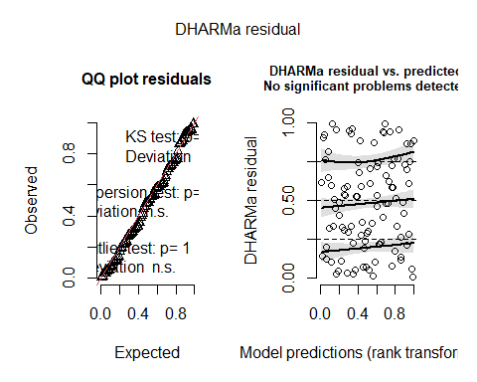
AICc(model1_mortalityp,model1.1_mortalityp)
## df AICc
## model1_mortalityp 6 63.95991
## model1.1_mortalityp 5 61.69811
#Between 0 and 1
model1_mortalitym <- glmmTMB(
prop.density.dead ~ Treatment * (SlopeZ + scaled_ba) + SiteClass,
family = beta_family(),
data = Thor_data_mortality_middle)
Anova(model1_mortalitym, type=3)
## Analysis of Deviance Table (Type III Wald chisquare tests)
##
## Response: prop.density.dead
## Chisq Df Pr(>Chisq)
## (Intercept) 0.0681 1 0.794109
## Treatment 20.8477 1 4.973e-06 ***
## SlopeZ 2.6388 1 0.104280
## scaled_ba 0.3222 1 0.570287
## SiteClass 0.2209 2 0.895415
## Treatment:SlopeZ 8.2044 1 0.004179 **
## Treatment:scaled_ba 0.3620 1 0.547394
## ---
## Signif. codes: 0 '***' 0.001 '**' 0.01 '*' 0.05 '.' 0.1 ' ' 1
res_model1_mortalitym<-simulateResiduals(model1_mortalitym)
plot(res_model1_mortalitym)
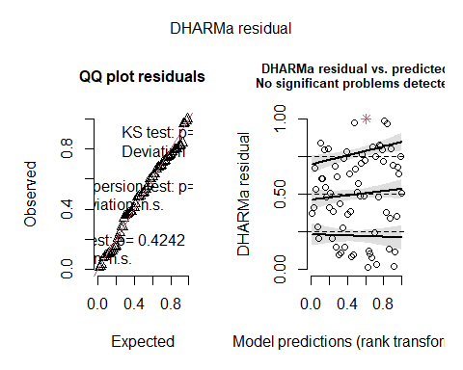
model1.1_mortalitym <- glmmTMB(
prop.density.dead ~ Treatment * SlopeZ + SiteClass,
family = beta_family(),
data = Thor_data_mortality_middle)
Anova(model1.1_mortalitym, type=3)
## Analysis of Deviance Table (Type III Wald chisquare tests)
##
## Response: prop.density.dead
## Chisq Df Pr(>Chisq)
## (Intercept) 0.5381 1 0.463220
## Treatment 47.6471 1 5.103e-12 ***
## SlopeZ 2.7094 1 0.099757 .
## SiteClass 0.2046 2 0.902752
## Treatment:SlopeZ 8.3489 1 0.003859 **
## ---
## Signif. codes: 0 '***' 0.001 '**' 0.01 '*' 0.05 '.' 0.1 ' ' 1
res_model1.1_mortalitym<-simulateResiduals(model1.1_mortalitym)
plot(res_model1.1_mortalitym)
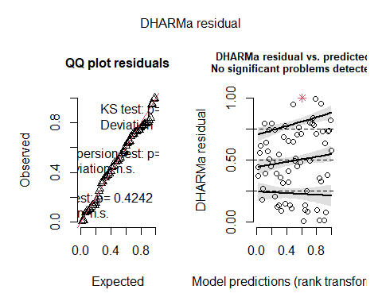
AICc(model1_mortalitym,model1.1_mortalitym)
## df AICc
## model1_mortalitym 9 -27.66761
## model1.1_mortalitym 7 -32.51732
#Severity
model2_mortality<-glmmTMB(
prop.density.dead ~ Treatment + SlopeZ + SiteClass,
family = binomial,
data = Thor_data)
## Warning in eval(family$initialize): non-integer #successes in a binomial glm!
Anova(model2_mortality, type=3)
## Analysis of Deviance Table (Type III Wald chisquare tests)
##
## Response: prop.density.dead
## Chisq Df Pr(>Chisq)
## (Intercept) 4.5306 1 0.03329 *
## Treatment 20.9304 1 4.763e-06 ***
## SlopeZ 1.0522 1 0.30500
## SiteClass 3.0038 2 0.22270
## ---
## Signif. codes: 0 '***' 0.001 '**' 0.01 '*' 0.05 '.' 0.1 ' ' 1
summary(model2_mortality)
## Family: binomial ( logit )
## Formula: prop.density.dead ~ Treatment + SlopeZ + SiteClass
## Data: Thor_data
##
## AIC BIC logLik -2*log(L) df.resid
## 118.1 131.1 -54.0 108.1 95
##
##
## Conditional model:
## Estimate Std. Error z value Pr(>|z|)
## (Intercept) -0.8182 0.3844 -2.129 0.0333 *
## Treatment1 -1.1518 0.2518 -4.575 4.76e-06 ***
## SlopeZ -0.2529 0.2466 -1.026 0.3050
## SiteClass1 -0.1734 0.4463 -0.388 0.6977
## SiteClass2 0.6370 0.4191 1.520 0.1285
## ---
## Signif. codes: 0 '***' 0.001 '**' 0.01 '*' 0.05 '.' 0.1 ' ' 1
res_model2_mortality<-simulateResiduals(model2_mortality)
plot(res_model2_mortality)
## qu = 0.5, log(sigma) = -3.676884 : outer Newton did not converge fully.
## qu = 0.75, log(sigma) = -2.492841 : outer Newton did not converge fully.
## Warning in newton(lsp = lsp, X = G$X, y = G$y, Eb = G$Eb, UrS = G$UrS, L = G$L,
## : Fitting terminated with step failure - check results carefully
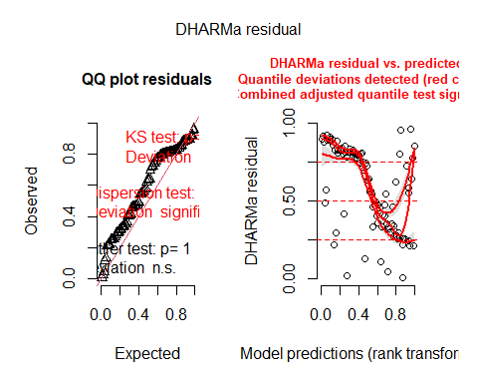
##Stand Height
model1.0_standheight<-glmmTMB(
`Stand Height (ft.)` ~ Treatment * (Aspect + scaled_baZ) + ElevationZ + SiteClass,
family = gaussian,
data = Thor_data_SH)
Anova(model1.0_standheight, type=3)
## Analysis of Deviance Table (Type III Wald chisquare tests)
##
## Response: Stand Height (ft.)
## Chisq Df Pr(>Chisq)
## (Intercept) 583.9004 1 < 2.2e-16 ***
## Treatment 1.0057 1 0.315945
## Aspect 7.0398 6 0.317184
## scaled_baZ 23.4181 1 1.303e-06 ***
## ElevationZ 5.4975 1 0.019044 *
## SiteClass 6.1909 2 0.045255 *
## Treatment:Aspect 19.4169 6 0.003515 **
## Treatment:scaled_baZ 5.8764 1 0.015345 *
## ---
## Signif. codes: 0 '***' 0.001 '**' 0.01 '*' 0.05 '.' 0.1 ' ' 1
res_model1.0_standheight<-simulateResiduals(model1.0_standheight)
plot(res_model1.0_standheight)
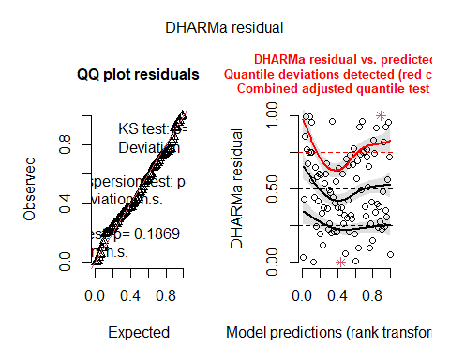
model1.1_standheight<-glmmTMB(
`Stand Height (ft.)` ~ Treatment * (Aspect + scaled_baZ) +SiteClass,
family = gaussian,
data = Thor_data_SH)
Anova(model1.1_standheight, type=3)
## Analysis of Deviance Table (Type III Wald chisquare tests)
##
## Response: Stand Height (ft.)
## Chisq Df Pr(>Chisq)
## (Intercept) 554.3131 1 < 2.2e-16 ***
## Treatment 0.4240 1 0.514933
## Aspect 8.5091 6 0.203123
## scaled_baZ 21.2524 1 4.026e-06 ***
## SiteClass 5.6343 2 0.059776 .
## Treatment:Aspect 21.4552 6 0.001519 **
## Treatment:scaled_baZ 5.8798 1 0.015316 *
## ---
## Signif. codes: 0 '***' 0.001 '**' 0.01 '*' 0.05 '.' 0.1 ' ' 1
res_model1.1_standheight<-simulateResiduals(model1.1_standheight)
plot(res_model1.1_standheight)
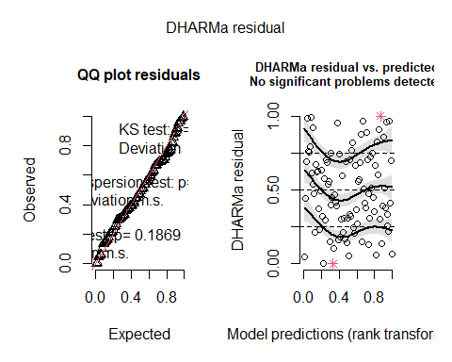
AICc(model1.0_standheight, model1.1_standheight)
## df AICc
## model1.0_standheight 20 862.8723
## model1.1_standheight 19 865.0734
model2_standheight<-glmmTMB(
`Stand Height (ft.)` ~ Severity + scaled_baZ + SlopeZ + SiteClass,
family = gaussian,
data = Thor_data_sev)
Anova(model2_standheight, type=2)
## Analysis of Deviance Table (Type II Wald chisquare tests)
##
## Response: Stand Height (ft.)
## Chisq Df Pr(>Chisq)
## Severity 6.2113 4 0.1839
## scaled_baZ 27.2997 1 1.742e-07 ***
## SlopeZ 0.5733 1 0.4489
## SiteClass 7.7079 2 0.0212 *
## ---
## Signif. codes: 0 '***' 0.001 '**' 0.01 '*' 0.05 '.' 0.1 ' ' 1
res_model2_standheight<-simulateResiduals(model2_standheight)
plot(res_model2_standheight)
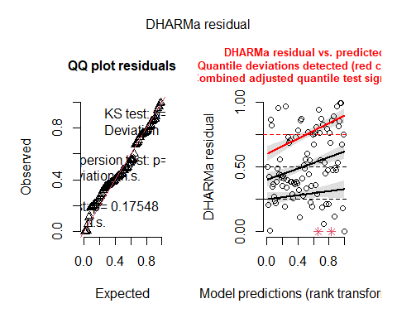
model2.1_standheight<-glmmTMB(
`Stand Height (ft.)` ~ Severity + scaled_baZ + SiteClass,
family = gaussian,
data = Thor_data)
Anova(model2.1_standheight, type=2)
## Analysis of Deviance Table (Type II Wald chisquare tests)
##
## Response: Stand Height (ft.)
## Chisq Df Pr(>Chisq)
## Severity 5.6112 4 0.23013
## scaled_baZ 26.8323 1 2.219e-07 ***
## SiteClass 7.1025 2 0.02869 *
## ---
## Signif. codes: 0 '***' 0.001 '**' 0.01 '*' 0.05 '.' 0.1 ' ' 1
res_model2.1_standheight<-simulateResiduals(model2.1_standheight)
plot(res_model2.1_standheight)
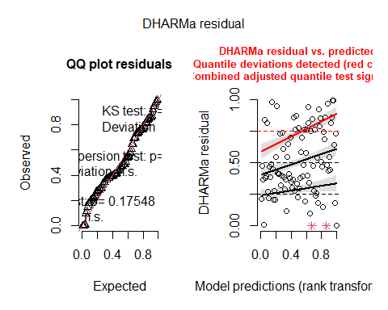
AICc(model2_standheight, model2.1_standheight)
## df AICc
## model2_standheight 10 834.5522
## model2.1_standheight 9 832.6223
##Understory Height
model1.0_underheight<-glmmTMB(
UH ~ Treatment * (Aspect + scaled_baZ + SlopeZ) + ElevationZ + SiteClass,
family = Gamma(link="log"),
data = Thor_data_UH)
Anova(model1.0_underheight, type=3)
## Analysis of Deviance Table (Type III Wald chisquare tests)
##
## Response: UH
## Chisq Df Pr(>Chisq)
## (Intercept) 930.1635 1 < 2e-16 ***
## Treatment 4.8225 1 0.02809 *
## Aspect 10.3035 6 0.11244
## scaled_baZ 0.1664 1 0.68333
## SlopeZ 0.3339 1 0.56339
## ElevationZ 3.0117 1 0.08266 .
## SiteClass 4.0264 2 0.13356
## Treatment:Aspect 7.8763 6 0.24731
## Treatment:scaled_baZ 0.0018 1 0.96588
## Treatment:SlopeZ 0.0059 1 0.93869
## ---
## Signif. codes: 0 '***' 0.001 '**' 0.01 '*' 0.05 '.' 0.1 ' ' 1
res_model1.0_underheight<-simulateResiduals(model1.0_underheight)
plot(res_model1.0_underheight)
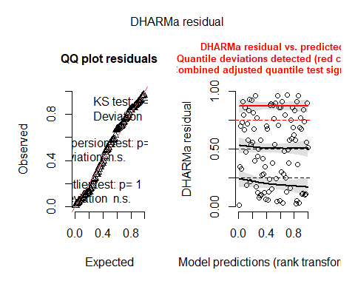
model1.1_underheight<-glmmTMB(
UH ~ Treatment + Aspect + scaled_baZ + SlopeZ + ElevationZ + SiteClass,
family = Gamma(link="log"),
data = Thor_data_UH)
Anova(model1.1_underheight, type=3)
## Analysis of Deviance Table (Type III Wald chisquare tests)
##
## Response: UH
## Chisq Df Pr(>Chisq)
## (Intercept) 1165.8107 1 < 2e-16 ***
## Treatment 5.3608 1 0.02059 *
## Aspect 10.6555 6 0.09962 .
## scaled_baZ 1.4602 1 0.22690
## SlopeZ 0.6784 1 0.41015
## ElevationZ 3.4919 1 0.06167 .
## SiteClass 3.3430 2 0.18796
## ---
## Signif. codes: 0 '***' 0.001 '**' 0.01 '*' 0.05 '.' 0.1 ' ' 1
res_model1.1_underheight<-simulateResiduals(model1.1_underheight)
plot(res_model1.1_underheight)
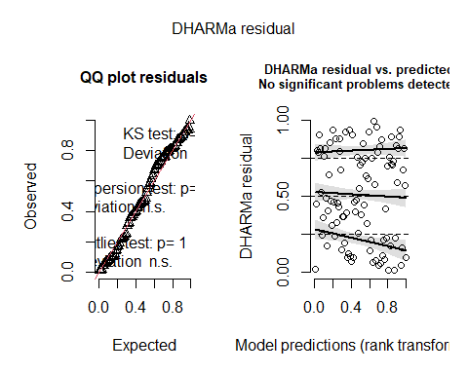
model1.2_underheight<-glmmTMB(
UH ~ Treatment + Aspect + scaled_baZ + ElevationZ + SiteClass,
family = Gamma(link="log"),
data = Thor_data_UH)
Anova(model1.2_underheight, type=3)
## Analysis of Deviance Table (Type III Wald chisquare tests)
##
## Response: UH
## Chisq Df Pr(>Chisq)
## (Intercept) 1159.5170 1 < 2e-16 ***
## Treatment 5.6288 1 0.01767 *
## Aspect 11.2531 6 0.08086 .
## scaled_baZ 1.1249 1 0.28887
## ElevationZ 2.9742 1 0.08460 .
## SiteClass 2.8623 2 0.23903
## ---
## Signif. codes: 0 '***' 0.001 '**' 0.01 '*' 0.05 '.' 0.1 ' ' 1
res_model1.2_underheight<-simulateResiduals(model1.2_underheight)
plot(res_model1.2_underheight)
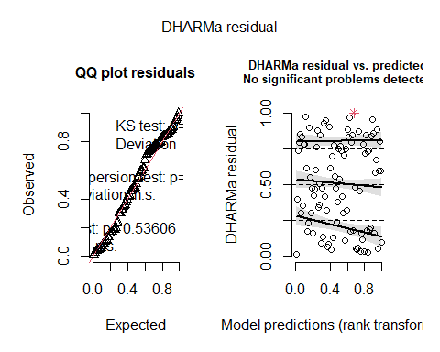
model1.3_underheight<-glmmTMB(
UH ~ Treatment + Aspect + ElevationZ + SiteClass,
family = Gamma(link="log"),
data = Thor_data_UH)
Anova(model1.3_underheight, type=3)
## Analysis of Deviance Table (Type III Wald chisquare tests)
##
## Response: UH
## Chisq Df Pr(>Chisq)
## (Intercept) 1158.4043 1 < 2e-16 ***
## Treatment 4.6159 1 0.03168 *
## Aspect 11.7551 6 0.06766 .
## ElevationZ 3.0378 1 0.08135 .
## SiteClass 4.0140 2 0.13439
## ---
## Signif. codes: 0 '***' 0.001 '**' 0.01 '*' 0.05 '.' 0.1 ' ' 1
res_model1.3_underheight<-simulateResiduals(model1.3_underheight)
plot(res_model1.3_underheight)
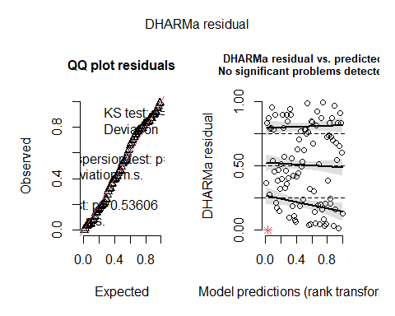
model1.4_underheight<-glmmTMB(
UH ~ Treatment + Aspect + SiteClass,
family = Gamma(link="log"),
data = Thor_data_UH)
Anova(model1.4_underheight, type=3)
## Analysis of Deviance Table (Type III Wald chisquare tests)
##
## Response: UH
## Chisq Df Pr(>Chisq)
## (Intercept) 1132.1008 1 < 2e-16 ***
## Treatment 5.7142 1 0.01683 *
## Aspect 9.9565 6 0.12649
## SiteClass 1.4585 2 0.48228
## ---
## Signif. codes: 0 '***' 0.001 '**' 0.01 '*' 0.05 '.' 0.1 ' ' 1
res_model1.4_underheight<-simulateResiduals(model1.4_underheight)
plot(res_model1.4_underheight)
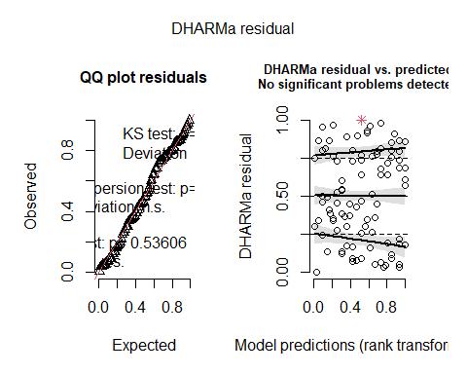
model1.5_underheight<-glmmTMB(
UH ~ Treatment + SiteClass,
family = Gamma(link="log"),
data = Thor_data_UH)
Anova(model1.5_underheight, type=3)
## Analysis of Deviance Table (Type III Wald chisquare tests)
##
## Response: UH
## Chisq Df Pr(>Chisq)
## (Intercept) 1322.6439 1 < 2e-16 ***
## Treatment 5.0579 1 0.02451 *
## SiteClass 1.0373 2 0.59533
## ---
## Signif. codes: 0 '***' 0.001 '**' 0.01 '*' 0.05 '.' 0.1 ' ' 1
res_model1.5_underheight<-simulateResiduals(model1.5_underheight)
plot(res_model1.5_underheight)
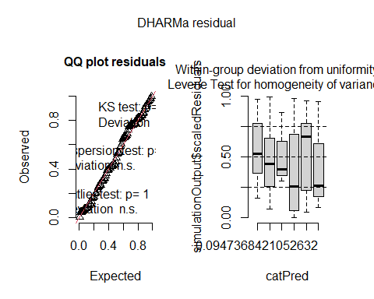
AICc(model1.0_underheight,model1.1_underheight,model1.2_underheight, model1.3_underheight, model1.4_underheight, model1.5_underheight)
## df AICc
## model1.0_underheight 22 882.8493
## model1.1_underheight 14 865.6447
## model1.2_underheight 13 863.5774
## model1.3_underheight 12 861.9277
## model1.4_underheight 11 862.3474
## model1.5_underheight 5 856.0130
##basal area
model1_BA<-glmmTMB(
log_sBA ~ Treatment * (Aspect + SlopeZ) + ElevationZ+ SiteClass,
family = gaussian,
data = Thor_data_BA)
Anova(model1_BA, type=3)
## Analysis of Deviance Table (Type III Wald chisquare tests)
##
## Response: log_sBA
## Chisq Df Pr(>Chisq)
## (Intercept) 897.6271 1 < 2.2e-16 ***
## Treatment 9.9584 1 0.001601 **
## Aspect 11.7052 6 0.068879 .
## SlopeZ 4.7843 1 0.028720 *
## ElevationZ 0.0348 1 0.852081
## SiteClass 4.3056 2 0.116159
## Treatment:Aspect 7.4128 6 0.284350
## Treatment:SlopeZ 1.7987 1 0.179871
## ---
## Signif. codes: 0 '***' 0.001 '**' 0.01 '*' 0.05 '.' 0.1 ' ' 1
res_model1_BA<-simulateResiduals(model1_BA)
plot(res_model1_BA)
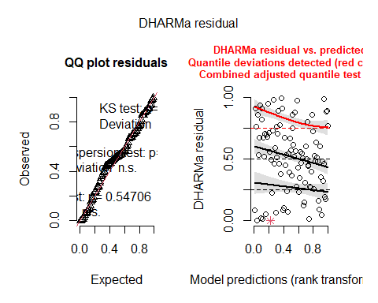
model1.1_BA<-glmmTMB(
log_sBA ~ Treatment + Aspect + SlopeZ + SiteClass,
family = gaussian,
data = Thor_data_BA)
Anova(model1.1_BA, type=3)
## Analysis of Deviance Table (Type III Wald chisquare tests)
##
## Response: log_sBA
## Chisq Df Pr(>Chisq)
## (Intercept) 921.2186 1 < 2.2e-16 ***
## Treatment 10.7466 1 0.001045 **
## Aspect 10.2034 6 0.116343
## SlopeZ 4.9580 1 0.025970 *
## SiteClass 7.5257 2 0.023217 *
## ---
## Signif. codes: 0 '***' 0.001 '**' 0.01 '*' 0.05 '.' 0.1 ' ' 1
res_model1.1_BA<-simulateResiduals(model1.1_BA)
plot(res_model1.1_BA)
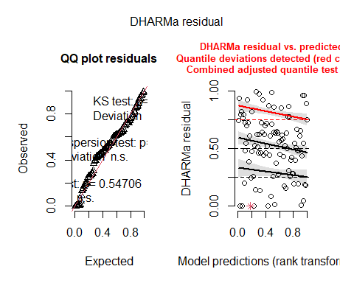
model1.2_BA<-glmmTMB(
log_sBA ~ Treatment + SlopeZ + SiteClass,
family = gaussian,
data = Thor_data_BA)
Anova(model1.2_BA, type=3)
## Analysis of Deviance Table (Type III Wald chisquare tests)
##
## Response: log_sBA
## Chisq Df Pr(>Chisq)
## (Intercept) 922.0113 1 < 2.2e-16 ***
## Treatment 9.5704 1 0.001977 **
## SlopeZ 2.4986 1 0.113949
## SiteClass 6.4108 2 0.040543 *
## ---
## Signif. codes: 0 '***' 0.001 '**' 0.01 '*' 0.05 '.' 0.1 ' ' 1
res_model1.2_BA<-simulateResiduals(model1.2_BA)
plot(res_model1.2_BA)
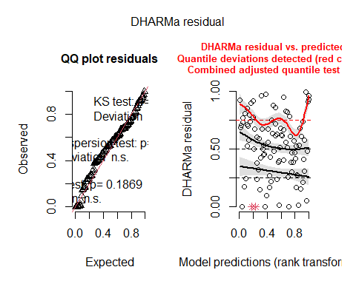
model1.3_BA<-glmmTMB(
log_sBA ~ Treatment + SiteClass,
family = gaussian,
data = Thor_data_BA)
Anova(model1.3_BA, type=3)
## Analysis of Deviance Table (Type III Wald chisquare tests)
##
## Response: log_sBA
## Chisq Df Pr(>Chisq)
## (Intercept) 911.6294 1 < 2.2e-16 ***
## Treatment 10.3521 1 0.001293 **
## SiteClass 6.8152 2 0.033120 *
## ---
## Signif. codes: 0 '***' 0.001 '**' 0.01 '*' 0.05 '.' 0.1 ' ' 1
res_model1.3_BA<-simulateResiduals(model1.3_BA)
plot(res_model1.3_BA)
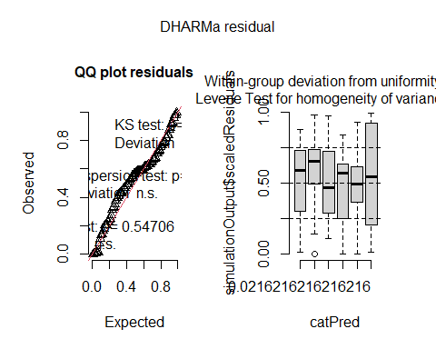
AICc(model1_BA, model1.1_BA,model1.2_BA, model1.3_BA)
## df AICc
## model1_BA 20 317.1723
## model1.1_BA 12 306.2133
## model1.2_BA 6 301.2097
## model1.3_BA 5 301.4093
Final Models: Best-fit models identified through the model selection process above were used to address each study objective and generate corresponding visualizations. For each response variable, the selected model was used to calculate estimated marginal means (via emmeans) and/or predicted values (via ggpredict) for Treatment (Objectives 1–3) or Severity (Objective 4), along with pairwise contrasts and percent effect sizes calculated from back-transformed model estimates. Individual response-variable plots were standardized in appearance and later combined into multi-panel summary figures using the patchwork package.
Objective 1: Assess baseline differences in forest structure between control and impact sites
Multivariate forest structure differences between burned and unburned sites were tested with PERMANOVA (adonis2) on Gower dissimilarities, with the homogeneity-of-dispersion assumption checked via betadisper, and visualized with NMDS ordinations (95% confidence ellipses by Treatment).Associations between Treatment and categorical shrub, forb, and grass cover classes were tested with chi-square and Fisher’s exact tests on contingency tables, and visualized as grouped bar charts combined into a three-panel figure. For each remaining response variable, the selected model (see Model Selection) was used to calculate estimated marginal means for Treatment, pairwise contrasts, and percent effect size from back-transformed estimates, plotted with 95% confidence intervals.
Color Pallete
##Color Palletes
Treatmentcol<-c("B" = "#E09F3E", "U" = "#74586E")
Slope_cols<-c("-1"= "#F4A4AC", "0"= "#7F8023", "1"="#3B7D91")
cols_sev <- c("No" = "#585123", "Low" = "#EEC170", "Medium"="#F2A65A", "High"="#F58549", "Extreme"= "#8B0000")
Forest Structure Differences
##habitat Structure
##PERMAONVA GOWER
gower_dist <- daisy(FS_vars, metric = "gower") ##calculate gower distances
set.seed(123)
adonis2(gower_dist ~ Treatment, data = FS_vars_all, permutations = 999) #PERMANOVA
## Permutation test for adonis under reduced model
## Permutation: free
## Number of permutations: 999
##
## adonis2(formula = gower_dist ~ Treatment, data = FS_vars_all, permutations = 999)
## Df SumOfSqs R2 F Pr(>F)
## Model 1 0.59482 0.19702 14.967 0.001 ***
## Residual 61 2.42422 0.80298
## Total 62 3.01904 1.00000
## ---
## Signif. codes: 0 '***' 0.001 '**' 0.01 '*' 0.05 '.' 0.1 ' ' 1
#assumption check for PERMANOVA
set.seed(123)
disp_FS <- betadisper(gower_dist, FS_vars_all$Treatment)
anova(disp_FS)
## Analysis of Variance Table
##
## Response: Distances
## Df Sum Sq Mean Sq F value Pr(>F)
## Groups 1 0.006739 0.0067389 1.7773 0.1874
## Residuals 61 0.231287 0.0037916
#NMDS
FS_nmds_structure <- metaMDS(gower_dist,k = 2,trymax = 100)
## Run 0 stress 0.1952482
## Run 1 stress 0.2157586
## Run 2 stress 0.1976697
## Run 3 stress 0.1976303
## Run 4 stress 0.1952483
## ... Procrustes: rmse 0.0001281811 max resid 0.0006583433
## ... Similar to previous best
## Run 5 stress 0.1979751
## Run 6 stress 0.2014799
## Run 7 stress 0.2140726
## Run 8 stress 0.2004021
## Run 9 stress 0.2148635
## Run 10 stress 0.1976303
## Run 11 stress 0.1952482
## ... Procrustes: rmse 7.157002e-05 max resid 0.0003581172
## ... Similar to previous best
## Run 12 stress 0.2006818
## Run 13 stress 0.2047502
## Run 14 stress 0.2134329
## Run 15 stress 0.1952484
## ... Procrustes: rmse 0.0001281716 max resid 0.0006520219
## ... Similar to previous best
## Run 16 stress 0.2244799
## Run 17 stress 0.1952482
## ... New best solution
## ... Procrustes: rmse 5.073499e-06 max resid 2.593357e-05
## ... Similar to previous best
## Run 18 stress 0.197975
## Run 19 stress 0.2133193
## Run 20 stress 0.2230407
## *** Best solution repeated 1 times
FS_nmds_structure$stress
## [1] 0.1952482
FS_nmds_scores <- as.data.frame(FS_nmds_structure$points)
FS_nmds_scores <- cbind(FS_nmds_scores,FS_vars_all[, c("Treatment", "PlotID")])
ggplot(FS_nmds_scores, aes(MDS1, MDS2, color = Treatment, fill = Treatment)) +
stat_ellipse(geom = "polygon",
level = 0.95,
alpha = 0.15) +
geom_point(size = 3) +
theme_minimal() +
scale_color_manual(values = Treatmentcol) +
scale_fill_manual(values = Treatmentcol) +
labs(
x = "NMDS1",
y = "NMDS2",
color = "Burn Status",
fill = "Burn Status")
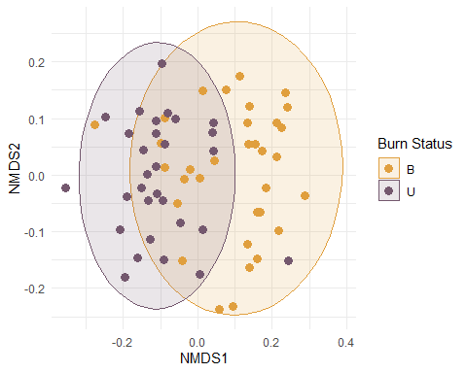
Vegetation Cover
## contingency table shrub, forb, grass
Shrubtable<-table(Thor_data_vegcover$Shrub, Thor_data_vegcover$Treatment)
chisq.test(Shrubtable)
## Warning in chisq.test(Shrubtable): Chi-squared approximation may be incorrect
##
## Pearson's Chi-squared test
##
## data: Shrubtable
## X-squared = 5.9761, df = 4, p-value = 0.2009
fisher.test(Shrubtable)
##
## Fisher's Exact Test for Count Data
##
## data: Shrubtable
## p-value = 0.2115
## alternative hypothesis: two.sided
Thor_data_vegcover$Shrub<-factor(Thor_data_vegcover$Shrub,levels=c("absent","trace","minor","common","abundant"))
vegcols=c("absent"= "#ec6d18", "trace" = "#ffe9a3", "minor" = "#ffb933", "common"= "#f6de4b", "abundant"= "#ffa213")
shrubc<-ggplot(Thor_data_vegcover, aes(x=Treatment, fill=Shrub))+
geom_bar(position="dodge")+
scale_fill_manual(values = vegcols)+
theme_minimal()
Forbtable<-table(Thor_data_vegcover$Forb, Thor_data_vegcover$Treatment)
chisq.test(Forbtable)
## Warning in chisq.test(Forbtable): Chi-squared approximation may be incorrect
##
## Pearson's Chi-squared test
##
## data: Forbtable
## X-squared = 20.826, df = 4, p-value = 0.0003428
fisher.test(Forbtable)
##
## Fisher's Exact Test for Count Data
##
## data: Forbtable
## p-value = 0.0001733
## alternative hypothesis: two.sided
Thor_data_vegcover$Forb<-factor(Thor_data_vegcover$Forb,levels=c("absent","trace","minor","common","abundant"))
forbc<-ggplot(Thor_data_vegcover, aes(x=Treatment, fill=Forb))+ geom_bar(position="dodge")+
scale_fill_manual(values = vegcols)+
theme_minimal()
Grasstable<-table(Thor_data_vegcover$Grass, Thor_data_vegcover$Treatment)
chisq.test(Grasstable)
##
## Pearson's Chi-squared test
##
## data: Grasstable
## X-squared = 2.4755, df = 4, p-value = 0.649
fisher.test(Grasstable)
##
## Fisher's Exact Test for Count Data
##
## data: Grasstable
## p-value = 0.6508
## alternative hypothesis: two.sided
Thor_data_vegcover$Grass<-factor(Thor_data_vegcover$Grass,levels=c("absent","trace","minor","common","abundant"))
grassc<-ggplot(Thor_data_vegcover, aes(x=Treatment, fill=Grass))+ geom_bar(position="dodge")+
scale_fill_manual(values = vegcols)+
theme_minimal()
shrubc<-shrubc + ggtitle("A. Shrub Cover")+theme(legend.title = element_blank())
forbc<-forbc + ggtitle("B. Forb Cover")+theme(legend.title = element_blank())
grassc<-grassc + ggtitle("C. Grass Cover")+theme(legend.title = element_blank())
vegcover <- (shrubc | forbc | grassc) +
plot_layout(guides = "collect") +
theme(plot.margin = margin(0, 0, 0, 0))
vegcover
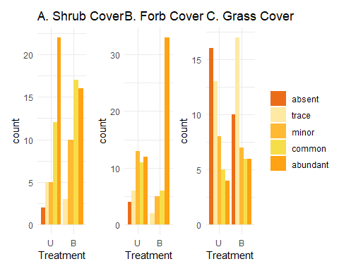
Stand Height modeled with a Treatment × Aspect and basal area × Aspect interaction, plus Elevation and Site Class; additional contrasts examined how the Treatment effect varied by Aspect and how the basal area relationship varied by Aspect.
model1_standheight<-glmmTMB(
`Stand Height (ft.)` ~ Treatment * Aspect + scaled_baZ:Aspect + scaled_baZ + ElevationZ + SiteClass,
family = gaussian,
data = Thor_data_SH)
Anova(model1_standheight, type=3)
## Analysis of Deviance Table (Type III Wald chisquare tests)
##
## Response: Stand Height (ft.)
## Chisq Df Pr(>Chisq)
## (Intercept) 733.4624 1 < 2.2e-16 ***
## Treatment 0.0623 1 0.8028994
## Aspect 11.3589 6 0.0778977 .
## scaled_baZ 50.3169 1 1.308e-12 ***
## ElevationZ 4.2335 1 0.0396338 *
## SiteClass 4.8113 2 0.0902071 .
## Treatment:Aspect 20.5084 6 0.0022474 **
## Aspect:scaled_baZ 24.3636 6 0.0004476 ***
## ---
## Signif. codes: 0 '***' 0.001 '**' 0.01 '*' 0.05 '.' 0.1 ' ' 1
res_model1_standheight<-simulateResiduals(model1_standheight)
plot(res_model1_standheight)
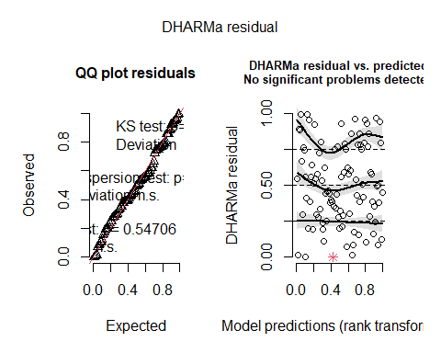
SHemmeans=emmeans(model1_standheight, ~ Treatment)
## NOTE: Results may be misleading due to involvement in interactions
summary(SHemmeans, type = "response")
## Treatment emmean SE df lower.CL upper.CL
## U 65.1 2.92 74 59.2 70.9
## B 65.9 2.96 74 60.0 71.8
##
## Results are averaged over the levels of: Aspect, SiteClass
## Confidence level used: 0.95
emmeans(model1_standheight, ~ Treatment) %>%
contrast("revpairwise")# no need to transform because it is Gaussian
## NOTE: Results may be misleading due to involvement in interactions
## contrast estimate SE df t.ratio p.value
## B - U 0.84 3.37 74 0.250 0.8036
##
## Results are averaged over the levels of: Aspect, SiteClass
((65.9-65.1)/65.1)*100 #percent effect size
## [1] 1.228879
standheight <- ggpredict(model1_standheight, terms = "Treatment")
## Warning: Looks like you are using syntactically invalid variable names, quoted in
## backticks: `Stand Height (ft.)`. This may result in unexpected
## behaviour. Please rename your variables (e.g., `Stand.Height..ft..`
## instead of `Stand Height (ft.)`) and fit the model again.
Pstandheight <- ggplot(standheight, aes(x = x, y = predicted)) +
geom_point(size = 3, color = "#87251D") +
geom_errorbar(
aes(ymin = conf.low, ymax = conf.high),
width = 0.15,
color = "#87251D") +
geom_text(
aes(label = round(predicted, 1)),
vjust = -0.01,
hjust = 1.3,
size = 4) +
annotate(
"text",
x = Inf,
y = Inf,
label = "A",
hjust = 1.5,
vjust = 1.5,
size = 6,
fontface = "bold") +
labs(
x = "Treatment",
y = "Predicted Stand Height (ft.)") +
theme(
aspect.ratio = 1)+
theme_minimal()
Pstandheight
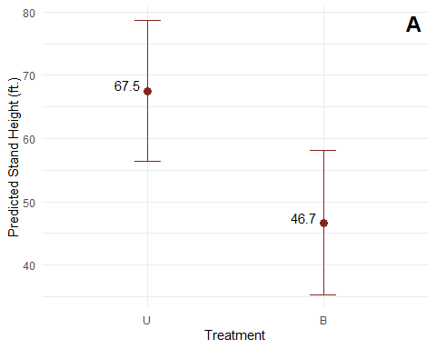
SHA <- emmeans(model1_standheight, ~ Treatment | Aspect)
pairs(SHA)
## Aspect = N:
## contrast estimate SE df t.ratio p.value
## U - B 20.86 7.77 74 2.684 0.0090
##
## Aspect = NE:
## contrast estimate SE df t.ratio p.value
## U - B -14.12 7.64 74 -1.848 0.0687
##
## Aspect = NW:
## contrast estimate SE df t.ratio p.value
## U - B -24.31 9.71 74 -2.505 0.0144
##
## Aspect = S:
## contrast estimate SE df t.ratio p.value
## U - B -5.75 7.99 74 -0.720 0.4737
##
## Aspect = SE:
## contrast estimate SE df t.ratio p.value
## U - B 5.28 13.20 74 0.401 0.6899
##
## Aspect = SW:
## contrast estimate SE df t.ratio p.value
## U - B 9.80 5.57 74 1.760 0.0826
##
## Aspect = W:
## contrast estimate SE df t.ratio p.value
## U - B 2.36 7.45 74 0.316 0.7526
##
## Results are averaged over the levels of: SiteClass
SHA <- ggpredict(model1_standheight,
terms = c("Aspect","Treatment"))
## Warning: Looks like you are using syntactically invalid variable names, quoted in
## backticks: `Stand Height (ft.)`. This may result in unexpected
## behaviour. Please rename your variables (e.g., `Stand.Height..ft..`
## instead of `Stand Height (ft.)`) and fit the model again.
ggplot(SHA, aes(x = x, y = predicted, color = group)) +
geom_point(size = 3, position = position_dodge(width = 0.3)) +
geom_errorbar(aes(ymin = conf.low, ymax = conf.high),
width = 0.2,
position = position_dodge(width = 0.3)) +
scale_color_manual(values = Treatmentcol,labels = c("Unburned", "Burned")) +
scale_fill_manual(values = Treatmentcol) +
labs(
x = "Aspect",
y = "Predicted Stand Height",
color = "Burn Status") +
theme_classic()
## Warning: No shared levels found between `names(values)` of the manual scale and the
## data's fill values.
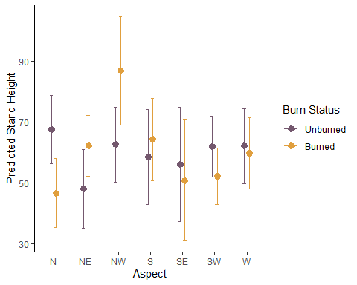
SHBAA <- emtrends(model1_standheight, ~ Aspect, var = "scaled_baZ", infer = c(TRUE, TRUE))
SHBAA
## Aspect scaled_baZ.trend SE df lower.CL upper.CL t.ratio p.value
## N 17.28 4.42 74 8.48 26.1 3.913 0.0002
## NE 6.68 2.15 74 2.39 11.0 3.104 0.0027
## NW 52.76 13.40 74 26.05 79.5 3.936 0.0002
## S 44.72 15.30 74 14.16 75.3 2.916 0.0047
## SE 7.94 5.22 74 -2.47 18.3 1.520 0.1327
## SW 20.15 6.03 74 8.14 32.2 3.343 0.0013
## W 12.98 3.19 74 6.61 19.3 4.062 0.0001
##
## Results are averaged over the levels of: Treatment, SiteClass
## Confidence level used: 0.95
SHBA<- ggpredict(model1_standheight,
terms = c("scaled_baZ", "Aspect"))
## Warning: Looks like you are using syntactically invalid variable names, quoted in
## backticks: `Stand Height (ft.)`. This may result in unexpected
## behaviour. Please rename your variables (e.g., `Stand.Height..ft..`
## instead of `Stand Height (ft.)`) and fit the model again.
ggplot(SHBA, aes(x = x, y = predicted, color = group)) +
geom_line(linewidth = 1.2) +
geom_ribbon(aes(ymin = conf.low, ymax = conf.high, fill = group),
alpha = 0.15, color = NA) +
labs(
x = "Basal Area (standardized)",
y = "Predicted Stand Height",
color = "Aspect",
fill = "Aspect"
) +
theme_classic()
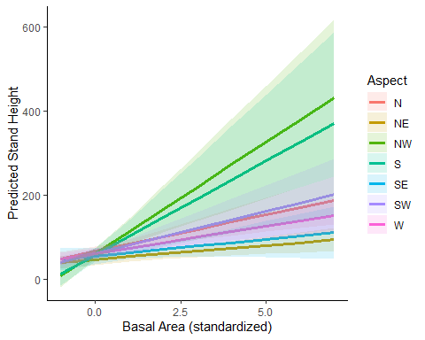
Understory Height Gamma model (log link) on Treatment and Site Class Basal area (log-transformed): modeled with a Treatment × Slope interaction and Site Class; the interaction was visualized against observed data, and slope effects within each Treatment level estimated with emtrends
model1_underheight<-glmmTMB(
UH ~ Treatment + SiteClass,
family = Gamma(link="log"),
data = Thor_data_UH)
Anova(model1_underheight, type=2)
## Analysis of Deviance Table (Type II Wald chisquare tests)
##
## Response: UH
## Chisq Df Pr(>Chisq)
## Treatment 5.0579 1 0.02451 *
## SiteClass 1.0373 2 0.59533
## ---
## Signif. codes: 0 '***' 0.001 '**' 0.01 '*' 0.05 '.' 0.1 ' ' 1
summary(model1_underheight)
## Family: Gamma ( log )
## Formula: UH ~ Treatment + SiteClass
## Data: Thor_data_UH
##
## AIC BIC logLik -2*log(L) df.resid
## 855.3 868.2 -422.7 845.3 91
##
##
## Dispersion estimate for Gamma family (sigma^2): 0.402
##
## Conditional model:
## Estimate Std. Error z value Pr(>|z|)
## (Intercept) 3.59132 0.09875 36.37 <2e-16 ***
## Treatment1 0.14845 0.06601 2.25 0.0245 *
## SiteClass1 -0.10283 0.12080 -0.85 0.3946
## SiteClass2 0.04112 0.10994 0.37 0.7084
## ---
## Signif. codes: 0 '***' 0.001 '**' 0.01 '*' 0.05 '.' 0.1 ' ' 1
res_model1_underheight<-simulateResiduals(model1_underheight)
plot(res_model1_underheight)

UHemmean=emmeans(model1_underheight, ~ Treatment)
pairs(UHemmean, reverse = TRUE)
## contrast estimate SE df z.ratio p.value
## B - U -0.297 0.132 Inf -2.249 0.0245
##
## Results are averaged over the levels of: SiteClass
## Results are given on the log (not the response) scale.
summary(UHemmean,type = "response",infer = TRUE)
## Treatment response SE df asymp.LCL asymp.UCL null z.ratio p.value
## U 42.1 5.11 Inf 33.2 53.4 1 30.783 <.0001
## B 31.3 3.63 Inf 24.9 39.3 1 29.679 <.0001
##
## Results are averaged over the levels of: SiteClass
## Confidence level used: 0.95
## Intervals are back-transformed from the log scale
## Tests are performed on the log scale
((26.1-38.3)/38.3)*100
## [1] -31.85379
understoryheight <- ggpredict(model1_underheight, terms = "Treatment")
Punderstoryheight<-ggplot(understoryheight, aes(x = x, y = predicted)) +
geom_point(size = 3, color = "#87251D") +
geom_errorbar(aes(ymin = conf.low, ymax = conf.high), width = 0.15, color= "#87251D") +
geom_text(
aes(label = round(predicted, 1)),
vjust = -0.01,
hjust = 1.3,
size = 4) +
annotate(
"text",
x = Inf,
y = Inf,
label = "B",
hjust = 1.5,
vjust = 1.5,
size = 6,
fontface = "bold") +
labs(
x = "Treatment",
y = "Predicted Understory Height (in.)") +
theme(
aspect.ratio = 1)+
theme_minimal()
print(Punderstoryheight)
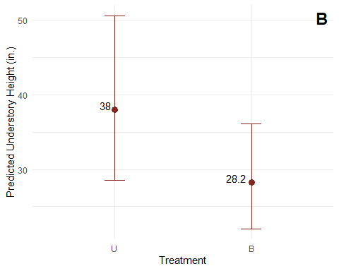
Basal Area
model1_BA<-glmmTMB(
log_sBA ~ Treatment + SiteClass,
family = gaussian,
data = Thor_data_BA)
Anova(model1_BA, type=2)
## Analysis of Deviance Table (Type II Wald chisquare tests)
##
## Response: log_sBA
## Chisq Df Pr(>Chisq)
## Treatment 10.3521 1 0.001293 **
## SiteClass 6.8152 2 0.033120 *
## ---
## Signif. codes: 0 '***' 0.001 '**' 0.01 '*' 0.05 '.' 0.1 ' ' 1
res_model1_BA<-simulateResiduals(model1_BA)
plot(res_model1_BA)

baemmean=emmeans(model1_BA, ~ Treatment)
pairs(baemmean, reverse = TRUE)
## contrast estimate SE df t.ratio p.value
## B - U -0.682 0.212 94 -3.217 0.0018
##
## Results are averaged over the levels of: SiteClass
summary(baemmean,type = "response",infer = TRUE)
## Treatment emmean SE df lower.CL upper.CL t.ratio p.value
## U 5.24 0.195 94 4.85 5.63 26.834 <.0001
## B 4.56 0.192 94 4.17 4.94 23.697 <.0001
##
## Results are averaged over the levels of: SiteClass
## Confidence level used: 0.95
((4.46-5.24)/5.24)*100
## [1] -14.8855
baemm_df <- as.data.frame(baemmean)
burnedba <- baemm_df$emmean[baemm_df$Treatment == "B"]
unburnedba <- baemm_df$emmean[baemm_df$Treatment == "U"]
bapercent_effect <- ((burnedba - unburnedba) / unburnedba) * 100
bapercent_effect
## [1] -13.01826
basalarea <- ggpredict(model1_BA, terms = "Treatment")
Pbasalarea<-ggplot(basalarea, aes(x = x, y = predicted)) +
geom_point(size = 3, color = "#87251D") +
geom_errorbar(aes(ymin = conf.low, ymax = conf.high), width = 0.15, color= "#87251D") +
geom_text(
aes(label = round(predicted, 1)),
vjust = -0.01,
hjust = 1.3,
size = 4) +
annotate(
"text",
x = Inf,
y = Inf,
label = "C",
hjust = 1.5,
vjust = 1.5,
size = 6,
fontface = "bold"
) +
labs(
x = "Treatment",
y = "Predicted Basal Area (acre)") +
theme(
aspect.ratio = 1)+
theme_minimal()
print(Pbasalarea)
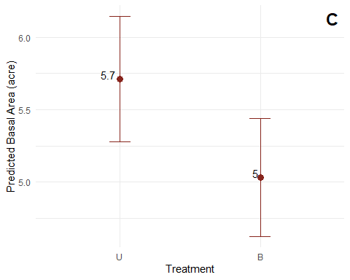
Canopy Cover n=99 modeled in three parts due to boundary values — logistic regression for complete absence, logistic regression for complete presence, and Beta regression for intermediate proportions.
#logistic regression for canopy absence
model1.1_canopy<- glmmTMB(
canopy_absence ~ Treatment + SiteClass,
family = binomial(),
data = Thor_data_canopy)
Anova(model1.1_canopy, type=2)
## Analysis of Deviance Table (Type II Wald chisquare tests)
##
## Response: canopy_absence
## Chisq Df Pr(>Chisq)
## Treatment 13.7507 1 0.0002087 ***
## SiteClass 6.3064 2 0.0427159 *
## ---
## Signif. codes: 0 '***' 0.001 '**' 0.01 '*' 0.05 '.' 0.1 ' ' 1
res_model1.1_canopy<-simulateResiduals(model1.1_canopy)
plot(res_model1.1_canopy)

canopya_treatment <- emmeans(model1.1_canopy,~ Treatment)
pairs(canopya_treatment, reverse = TRUE)
## contrast estimate SE df z.ratio p.value
## B - U 4.24 1.14 Inf 3.708 0.0002
##
## Results are averaged over the levels of: SiteClass
## Results are given on the log odds ratio (not the response) scale.
summary(canopya_treatment,type = "response",infer = TRUE)
## Treatment prob SE df asymp.LCL asymp.UCL null z.ratio p.value
## U 0.0229 0.0233 Inf 0.00305 0.152 0.5 -3.613 0.0003
## B 0.6199 0.1270 Inf 0.36215 0.824 0.5 0.908 0.3637
##
## Results are averaged over the levels of: SiteClass
## Confidence level used: 0.95
## Intervals are back-transformed from the logit scale
## Tests are performed on the logit scale
(0.6199-0.0229)*100 # percent point increase
## [1] 59.7
contrast(canopya_treatment, method = "pairwise", transform = "response")
## contrast estimate SE df z.ratio p.value
## U - B -4.24 1.14 Inf -3.708 0.0002
##
## Results are averaged over the levels of: SiteClass
## Results are given on the log odds ratio (not the response) scale.
canopya <- ggpredict(model1.1_canopy, terms = "Treatment")
Pcanopya<-ggplot(canopya, aes(x = x, y = predicted)) +
geom_point(size = 3, color = "#87251D") +
geom_errorbar(aes(ymin = conf.low, ymax = conf.high), width = 0.15, color= "#87251D") +
geom_text(aes(label = round(predicted, 1)),
vjust = -0.01,
hjust = 1.3,
size = 4) +
annotate(
"text",
x = Inf,
y = Inf,
label = "D",
hjust = 1.5,
vjust = 1.5,
size = 6,
fontface = "bold"
) +
labs(
x = "Treatment",
y = "Predicted Canopy Absence Probability") +
theme(
aspect.ratio = 1)+
theme_minimal()
print(Pcanopya)
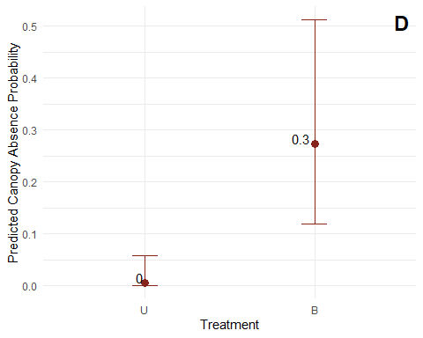
#logistic regression for full canopy
model1.2_canopy <- glmmTMB(
canopy_full ~ Treatment + scaled_baZ + SiteClass,
family = binomial(),
data = Thor_data_canopy)
Anova(model1.2_canopy, type=2)
## Analysis of Deviance Table (Type II Wald chisquare tests)
##
## Response: canopy_full
## Chisq Df Pr(>Chisq)
## Treatment 8.4949 1 0.003561 **
## scaled_baZ 3.2817 1 0.070057 .
## SiteClass 7.8028 2 0.020213 *
## ---
## Signif. codes: 0 '***' 0.001 '**' 0.01 '*' 0.05 '.' 0.1 ' ' 1
res_model1.2_canopy<-simulateResiduals(model1.2_canopy)
plot(res_model1.2_canopy)

canopyf_treatment <- emmeans(model1.2_canopy,~ Treatment, type = "link")
pairs(canopyf_treatment, reverse = TRUE)
## contrast estimate SE df z.ratio p.value
## B - U -1.76 0.604 Inf -2.915 0.0036
##
## Results are averaged over the levels of: SiteClass
## Results are given on the log odds ratio (not the response) scale.
summary(canopyf_treatment,type = "response",infer = TRUE)
## Treatment prob SE df asymp.LCL asymp.UCL null z.ratio p.value
## U 0.428 0.1270 Inf 0.2134 0.674 0.5 -0.559 0.5764
## B 0.114 0.0627 Inf 0.0367 0.303 0.5 -3.305 0.0009
##
## Results are averaged over the levels of: SiteClass
## Confidence level used: 0.95
## Intervals are back-transformed from the logit scale
## Tests are performed on the logit scale
(0.114-0.428)*100 # percent point increase
## [1] -31.4
canopyp <- ggpredict(model1.2_canopy, terms = "Treatment")
Pcanopyp<-ggplot(canopyp, aes(x = x, y = predicted)) +
geom_point(size = 3, color = "#87251D") +
geom_errorbar(aes(ymin = conf.low, ymax = conf.high), width = 0.15, color= "#87251D") +
geom_text(
aes(label = round(predicted, 1)),
vjust = -0.01,
hjust = 1.3,
size = 4) +
annotate(
"text",
x = Inf,
y = Inf,
label = "E",
hjust = 1.5,
vjust = 1.5,
size = 6,
fontface = "bold"
) +
labs(
x = "Treatment",
y = "Predicted Canopy Presence Probability") +
theme(
aspect.ratio = 1)+
theme_minimal()
print(Pcanopyp)
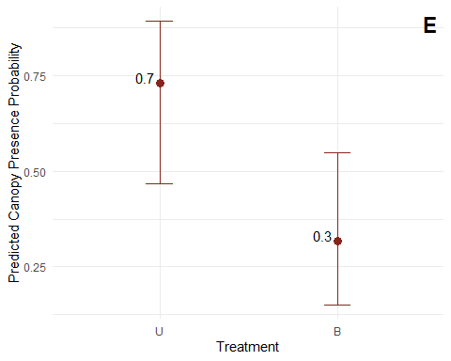
#Between 0 and 1
model1.3_canopy <- glmmTMB(
canopycover ~ Treatment + scaled_baZ + SiteClass,
family = beta_family(),
data = Thor_data_canopy_middle)
Anova(model1.3_canopy, type=2)
## Analysis of Deviance Table (Type II Wald chisquare tests)
##
## Response: canopycover
## Chisq Df Pr(>Chisq)
## Treatment 10.0417 1 0.00153 **
## scaled_baZ 3.3312 1 0.06798 .
## SiteClass 0.1847 2 0.91180
## ---
## Signif. codes: 0 '***' 0.001 '**' 0.01 '*' 0.05 '.' 0.1 ' ' 1
res_model1.3_canopy<-simulateResiduals(model1.3_canopy)
plot(res_model1.3_canopy)

canopy_treatment <- emmeans(model1.3_canopy,~ Treatment, type = "link")
pairs(canopy_treatment, reverse = TRUE)
## contrast estimate SE df z.ratio p.value
## B - U -1.04 0.327 Inf -3.169 0.0015
##
## Results are averaged over the levels of: SiteClass
## Results are given on the log odds ratio (not the response) scale.
summary(canopy_treatment,type = "response",infer = TRUE)
## Treatment response SE df asymp.LCL asymp.UCL null z.ratio p.value
## U 0.659 0.0606 Inf 0.533 0.766 0.5 2.443 0.0146
## B 0.407 0.0758 Inf 0.270 0.559 0.5 -1.203 0.2290
##
## Results are averaged over the levels of: SiteClass
## Confidence level used: 0.95
## Intervals are back-transformed from the logit scale
## Tests are performed on the logit scale
(0.407-0.659)*100 # percent point increase
## [1] -25.2
canopy <- ggpredict(model1.3_canopy, terms = "Treatment")
Pcanopy<-ggplot(canopy, aes(x = x, y = predicted)) +
geom_point(size = 3, color = "#87251D") +
geom_errorbar(aes(ymin = conf.low, ymax = conf.high), width = 0.15, color= "#87251D") +
geom_text(
aes(label = round(predicted, 1)),
vjust = -0.01,
hjust = 1.3,
size = 4) +
annotate(
"text",
x = Inf,
y = Inf,
label = "F",
hjust = 1.5,
vjust = 1.5,
size = 6,
fontface = "bold") +
labs(
x = "Treatment",
y = "Predicted Canopy") +
theme(
aspect.ratio = 1)+
theme_minimal()
print(Pcanopy)
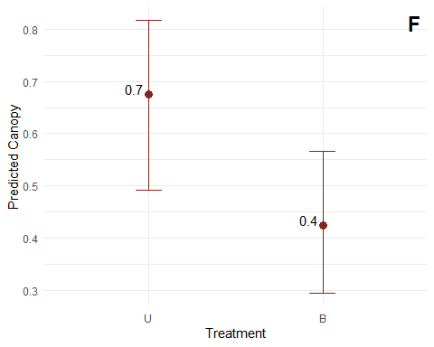
Seedling Abundance negative binomial model with a Treatment-based zero-inflation term, including Treatment × Aspect and Treatment × Elevation interactions and Slope; additional analyses examined how the Slope relationship and Treatment effect varied across Aspect and Elevation.
model1_seedling <- glmmTMB(
SeedlingAbundance ~ Treatment * Aspect + ElevationZ + SlopeZ + SiteClass,
family = nbinom2,
ziformula = ~Treatment,
data = Thor_data)
Anova(model1_seedling, type=3)
## Analysis of Deviance Table (Type III Wald chisquare tests)
##
## Response: SeedlingAbundance
## Chisq Df Pr(>Chisq)
## (Intercept) 472.2160 1 < 2.2e-16 ***
## Treatment 58.5557 1 1.976e-14 ***
## Aspect 13.6811 6 0.03341 *
## ElevationZ 18.4821 1 1.715e-05 ***
## SlopeZ 4.9022 1 0.02682 *
## SiteClass 5.4602 2 0.06521 .
## Treatment:Aspect 15.0499 6 0.01987 *
## ---
## Signif. codes: 0 '***' 0.001 '**' 0.01 '*' 0.05 '.' 0.1 ' ' 1
res_model1_seedling<-simulateResiduals(model1_seedling)
plot(res_model1_seedling)
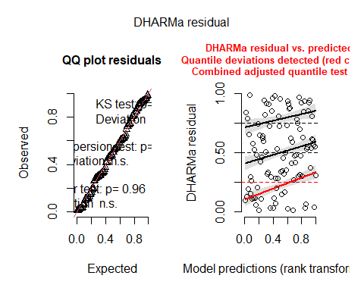
seedemmean=emmeans(model1_seedling, ~ Treatment, component = "cond", infer = c(TRUE, TRUE))
## NOTE: Results may be misleading due to involvement in interactions
pairs(seedemmean, reverse = TRUE)
## contrast estimate SE df z.ratio p.value
## B - U 1.54 0.201 Inf 7.652 <.0001
##
## Results are averaged over the levels of: Aspect, SiteClass
## Results are given on the log (not the response) scale.
summary(seedemmean,type = "response",infer = TRUE)
## Treatment response SE df asymp.LCL asymp.UCL null z.ratio p.value
## U 10.3 2.00 Inf 7.0 15.0 1 11.944 <.0001
## B 48.0 7.27 Inf 35.6 64.5 1 25.527 <.0001
##
## Results are averaged over the levels of: Aspect, SiteClass
## Confidence level used: 0.95
## Intervals are back-transformed from the log scale
## Tests are performed on the log scale
((48.0-10.3)/10.3)*100
## [1] 366.0194
seedemm_df <- as.data.frame(seedemmean)
burnedseed <- seedemm_df$emmean[seedemm_df$Treatment == "B"]
unburnedseed <- seedemm_df$emmean[seedemm_df$Treatment == "U"]
seedpercent_effect <- ((burnedseed - unburnedseed) / unburnedseed) * 100
seedpercent_effect
## [1] 66.2234
seed <- ggpredict(model1_seedling, terms = "Treatment")
Pseedling<-ggplot(seed, aes(x = x, y = predicted)) +
geom_point(size = 3, color = "#87251D") +
geom_errorbar(aes(ymin = conf.low, ymax = conf.high), width = 0.15, color= "#87251D") +
geom_text(
aes(label = round(predicted, 1)),
vjust = -0.01,
hjust = 1.3,
size = 4) +
annotate(
"text",
x = Inf,
y = Inf,
label = "G",
hjust = 1.5,
vjust = 1.5,
size = 6,
fontface = "bold"
) +
labs(
x = "Treatment",
y = "Predicted Seedling Abundance") +
theme(
aspect.ratio = 1)+
theme_minimal()
print(Pseedling)
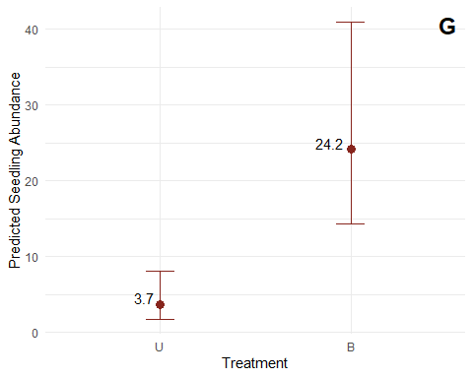
seedslopeeff<-emtrends(model1_seedling, ~ SlopeZ, var = "SlopeZ", infer = c(TRUE, TRUE))
seedslopeeff
## SlopeZ SlopeZ.trend SE df asymp.LCL asymp.UCL z.ratio p.value
## 8.48e-17 -0.177 0.08 Inf -0.334 -0.0203 -2.214 0.0268
##
## Results are averaged over the levels of: Treatment, Aspect, SiteClass
## Confidence level used: 0.95
seedsl <- ggpredict(model1_seedling, terms = "SlopeZ")
ggplot(seedsl, aes(x = x, y = predicted)) +
geom_line(linewidth = 1, color = "#6a2e35") +
geom_ribbon(aes(ymin = conf.low, ymax = conf.high),
alpha = 0.2, fill = "#6a2e35") +
geom_point(data = Thor_data,
aes(x = SlopeZ, y = SeedlingAbundance),
inherit.aes = FALSE,
alpha = 0.5, color = "black") +
labs(
x = "Slope (standardized)",
y = "Predicted Abundance") +
theme_classic()
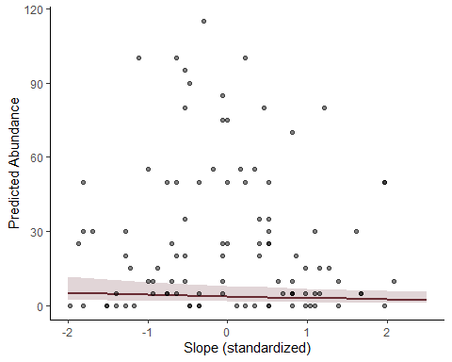
stamean=emmeans(model1_seedling, ~ Treatment|Aspect, infer = c(TRUE, TRUE))
pairs(stamean)
## Aspect = N:
## contrast estimate SE df z.ratio p.value
## U - B -1.878 0.406 Inf -4.625 <.0001
##
## Aspect = NE:
## contrast estimate SE df z.ratio p.value
## U - B -1.644 0.385 Inf -4.264 <.0001
##
## Aspect = NW:
## contrast estimate SE df z.ratio p.value
## U - B -1.830 0.459 Inf -3.989 0.0001
##
## Aspect = S:
## contrast estimate SE df z.ratio p.value
## U - B -1.477 0.403 Inf -3.665 0.0002
##
## Aspect = SE:
## contrast estimate SE df z.ratio p.value
## U - B -2.743 1.010 Inf -2.709 0.0068
##
## Aspect = SW:
## contrast estimate SE df z.ratio p.value
## U - B -0.600 0.285 Inf -2.102 0.0356
##
## Aspect = W:
## contrast estimate SE df z.ratio p.value
## U - B -0.621 0.323 Inf -1.921 0.0547
##
## Results are averaged over the levels of: SiteClass
## Results are given on the log (not the response) scale.
STA <- ggpredict(model1_seedling,
terms = c("Aspect","Treatment"))
ggplot(STA, aes(x = x, y = predicted, color = group)) +
geom_point(size = 3, position = position_dodge(width = 0.3)) +
geom_errorbar(aes(ymin = conf.low, ymax = conf.high),
width = 0.2,
position = position_dodge(width = 0.3)) +
scale_color_manual(values = Treatmentcol, labels = c("Unburned", "Burned")) +
scale_fill_manual(values = Treatmentcol) +
labs(
x = "Aspect",
y = "Predicted Seedling Abundance",
color = "Burn Status") +
theme_classic()
## Warning: No shared levels found between `names(values)` of the manual scale and the
## data's fill values.
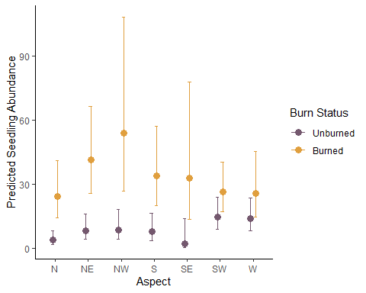
Sapling Abundance negative binomial model on Treatment, aspect, and Site Class
model1_sapling <- glmmTMB(
SaplingAbundance ~ Treatment * Aspect + SiteClass,
family = nbinom2(),
ziformula = ~ Treatment,
data = Thor_data)
Anova(model1_sapling, type=3)
## Analysis of Deviance Table (Type III Wald chisquare tests)
##
## Response: SaplingAbundance
## Chisq Df Pr(>Chisq)
## (Intercept) 0.000 1 0.998328
## Treatment 0.000 1 0.997783
## Aspect 16.839 6 0.009892 **
## SiteClass 11.526 2 0.003142 **
## Treatment:Aspect 14.360 6 0.025864 *
## ---
## Signif. codes: 0 '***' 0.001 '**' 0.01 '*' 0.05 '.' 0.1 ' ' 1
res_model1_sapling<-simulateResiduals(model1_sapling)
plot(res_model1_sapling)

sapemmean <- emmeans(model1_sapling,~ Treatment, type = "response")
## NOTE: Results may be misleading due to involvement in interactions
pairs(sapemmean, reverse = TRUE)
## contrast ratio SE df null z.ratio p.value
## B / U 0.000394 1.11 Inf 1 -0.003 0.9978
##
## Results are averaged over the levels of: Aspect, SiteClass
## Tests are performed on the log scale
summary(sapemmean,type = "response",infer = TRUE)
## Treatment response SE df asymp.LCL asymp.UCL null z.ratio p.value
## U 2.61984 0.695 Inf 1.56 4 1 3.631 0.0003
## B 0.00103 2.910 Inf 0.00 Inf 1 -0.002 0.9981
##
## Results are averaged over the levels of: Aspect, SiteClass
## Confidence level used: 0.95
## Intervals are back-transformed from the log scale
## Tests are performed on the log scale
((0.00103-2.61984)/2.61984)*100
## [1] -99.96068
sapemm_df <- as.data.frame(sapemmean)
burnedsap <- sapemm_df$emmean[sapemm_df$Treatment == "B"]
unburnedsap <- sapemm_df$emmean[sapemm_df$Treatment == "U"]
sappercent_effect <- ((burnedsap - unburnedsap) / unburnedsap) * 100
sappercent_effect
## numeric(0)
sap <- ggpredict(model1_sapling, terms = "Treatment")
PSapling<-ggplot(sap, aes(x = x, y = predicted)) +
geom_point(size = 3, color = "#87251D") +
geom_errorbar(aes(ymin = conf.low, ymax = conf.high), width = 0.15, color= "#87251D") +
geom_text(
aes(label = round(predicted, 1)),
vjust = -0.01,
hjust = 1.3,
size = 4) +
annotate(
"text",
x = Inf,
y = Inf,
label = "H",
hjust = 1.5,
vjust = 1.5,
size = 6,
fontface = "bold"
) +
labs(
x = "Treatment",
y = "Predicted Sapling Abundance") +
theme(
aspect.ratio = 1)+
theme_minimal()
print(PSapling)
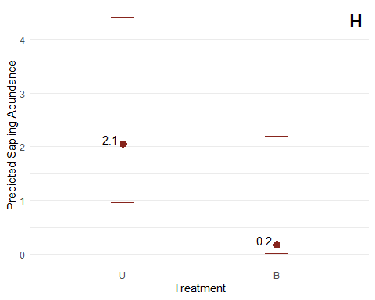
saptamean=emmeans(model1_sapling, ~ Treatment|Aspect, infer = c(TRUE, TRUE))
pairs(saptamean)
## Aspect = N:
## contrast estimate SE df z.ratio p.value
## U - B 2.443 1.31e+00 Inf 1.869 0.0616
##
## Aspect = NE:
## contrast estimate SE df z.ratio p.value
## U - B 4.203 8.93e-01 Inf 4.705 <.0001
##
## Aspect = NW:
## contrast estimate SE df z.ratio p.value
## U - B 20.483 9.10e+03 Inf 0.002 0.9982
##
## Aspect = S:
## contrast estimate SE df z.ratio p.value
## U - B 1.925 1.06e+00 Inf 1.815 0.0695
##
## Aspect = SE:
## contrast estimate SE df z.ratio p.value
## U - B -0.968 1.15e+00 Inf -0.839 0.4013
##
## Aspect = SW:
## contrast estimate SE df z.ratio p.value
## U - B 3.462 1.17e+00 Inf 2.950 0.0032
##
## Aspect = W:
## contrast estimate SE df z.ratio p.value
## U - B 23.327 1.75e+04 Inf 0.001 0.9989
##
## Results are averaged over the levels of: SiteClass
## Results are given on the log (not the response) scale.
SapTA <- ggpredict(model1_sapling,
terms = c("Aspect","Treatment"))
ggplot(SapTA, aes(x = x, y = predicted, color = group)) +
geom_point(size = 3, position = position_dodge(width = 0.3)) +
geom_errorbar(aes(ymin = conf.low, ymax = conf.high),
width = 0.2,
position = position_dodge(width = 0.3)) +
scale_color_manual(values = Treatmentcol, labels = c("Unburned", "Burned")) +
scale_fill_manual(values = Treatmentcol) +
labs(
x = "Aspect",
y = "Predicted Sapling Abundance",
color = "Burn Status") +
theme_classic()
## Warning: No shared levels found between `names(values)` of the manual scale and the
## data's fill values.
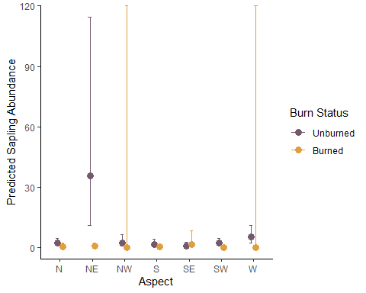
Tree Mortality modeled in three parts, mirroring canopy cover (complete survival, complete mortality, and Beta regression for intermediate proportions)
#logistic regression for 0% mortality
model1.1_mortality <- glmmTMB(
AllLive ~ Treatment + scaled_ba + SiteClass,
family = binomial(),
data = Thor_data_mortality)
Anova(model1.1_mortality, type=2)
## Analysis of Deviance Table (Type II Wald chisquare tests)
##
## Response: AllLive
## Chisq Df Pr(>Chisq)
## Treatment 2.4756 1 0.11562
## scaled_ba 2.3730 1 0.12345
## SiteClass 7.0899 2 0.02887 *
## ---
## Signif. codes: 0 '***' 0.001 '**' 0.01 '*' 0.05 '.' 0.1 ' ' 1
res_model1.1_mortality<-simulateResiduals(model1.1_mortality)
plot(res_model1.1_mortality)

testUniformity(res_model1.1_mortality)
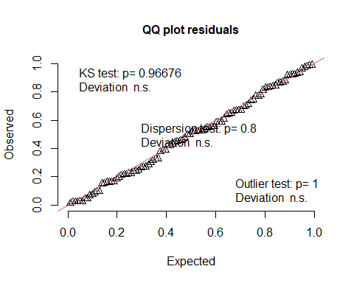
##
## Asymptotic one-sample Kolmogorov-Smirnov test
##
## data: simulationOutput$scaledResiduals
## D = 0.049548, p-value = 0.9668
## alternative hypothesis: two-sided
testDispersion(res_model1.1_mortality)
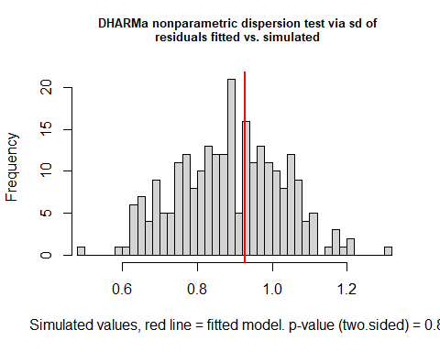
##
## DHARMa nonparametric dispersion test via sd of residuals fitted vs.
## simulated
##
## data: simulationOutput
## dispersion = 1.0475, p-value = 0.8
## alternative hypothesis: two.sided
mortalitya_treatment <- emmeans(model1.1_mortality,~ Treatment, type = "link")
pairs(mortalitya_treatment, reverse = TRUE)
## contrast estimate SE df z.ratio p.value
## B - U -0.945 0.601 Inf -1.573 0.1156
##
## Results are averaged over the levels of: SiteClass
## Results are given on the log odds ratio (not the response) scale.
summary(mortalitya_treatment,type = "response",infer = TRUE)
## Treatment prob SE df asymp.LCL asymp.UCL null z.ratio p.value
## U 0.324 0.0980 Inf 0.1663 0.535 0.5 -1.642 0.1005
## B 0.157 0.0659 Inf 0.0656 0.331 0.5 -3.374 0.0007
##
## Results are averaged over the levels of: SiteClass
## Confidence level used: 0.95
## Intervals are back-transformed from the logit scale
## Tests are performed on the logit scale
(0.157-0.324)*100 # percent point increase
## [1] -16.7
mortalitya <- ggpredict(model1.1_mortality, terms = "Treatment")
Pmortalitya<-ggplot(mortalitya, aes(x = x, y = predicted)) +
geom_point(size = 3, color = "#87251D") +
geom_errorbar(aes(ymin = conf.low, ymax = conf.high), width = 0.15, color= "#87251D") +
geom_text(
aes(label = round(predicted, 1)),
vjust = -0.01,
hjust = 1.3,
size = 4) +
annotate(
"text",
x = Inf,
y = Inf,
label = "I",
hjust = 1.5,
vjust = 1.5,
size = 6,
fontface = "bold"
) +
theme(
aspect.ratio = 1)+
labs(
x = "Treatment",
y = "Predicted Mortality Absence") +
theme_minimal()
print(Pmortalitya)
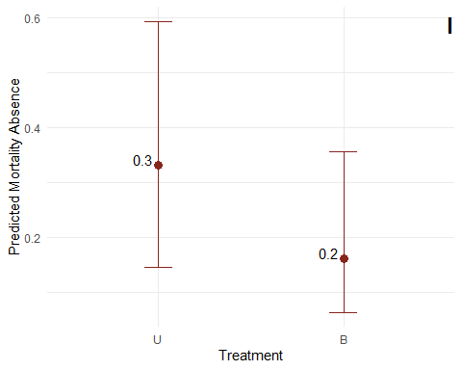
#logistic regression for 100% mortality
model1.2_mortality <- glmmTMB(
AllDead ~ Treatment + SlopeZ + SiteClass,
family = binomial(),
data = Thor_data_mortality)
Anova(model1.2_mortality, type=2)
## Analysis of Deviance Table (Type II Wald chisquare tests)
##
## Response: AllDead
## Chisq Df Pr(>Chisq)
## Treatment 0.0000 1 0.99911
## SlopeZ 4.1460 1 0.04173 *
## SiteClass 3.1281 2 0.20929
## ---
## Signif. codes: 0 '***' 0.001 '**' 0.01 '*' 0.05 '.' 0.1 ' ' 1
res_model1.2_mortality<-simulateResiduals(model1.2_mortality)
plot(res_model1.2_mortality)

testUniformity(res_model1.2_mortality)
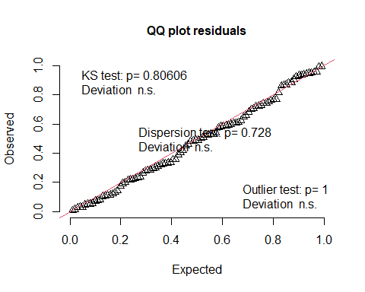
##
## Asymptotic one-sample Kolmogorov-Smirnov test
##
## data: simulationOutput$scaledResiduals
## D = 0.064084, p-value = 0.8061
## alternative hypothesis: two-sided
testDispersion(res_model1.2_mortality)
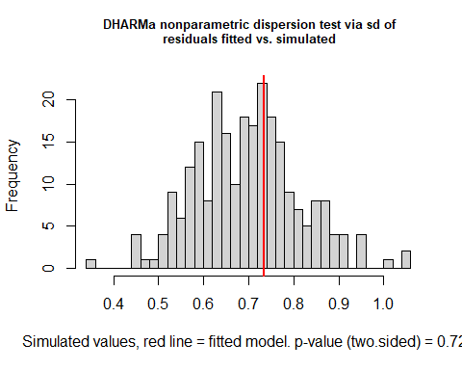
##
## DHARMa nonparametric dispersion test via sd of residuals fitted vs.
## simulated
##
## data: simulationOutput
## dispersion = 1.0513, p-value = 0.728
## alternative hypothesis: two.sided
mortalityp_treatment <- emmeans(model1.2_mortality,~ Treatment, type = "link")
pairs(mortalityp_treatment, reverse = TRUE)
## contrast estimate SE df z.ratio p.value
## B - U 23.3 20900 Inf 0.001 0.9991
##
## Results are averaged over the levels of: SiteClass
## Results are given on the log odds ratio (not the response) scale.
summary(mortalityp_treatment,type = "response",infer = TRUE)
## Treatment prob SE df asymp.LCL asymp.UCL null z.ratio p.value
## U 0.000 5.50e-07 Inf 0.000 1.000 0.5 -0.001 0.9991
## B 0.258 1.07e-01 Inf 0.104 0.511 0.5 -1.881 0.0599
##
## Results are averaged over the levels of: SiteClass
## Confidence level used: 0.95
## Intervals are back-transformed from the logit scale
## Tests are performed on the logit scale
(0.258-0.000)*100 # percent point increase
## [1] 25.8
mortalityp <- ggpredict(model1.2_mortality, terms = "Treatment")
Pmortalityp<-ggplot(mortalityp, aes(x = x, y = predicted)) +
geom_point(size = 3, color = "#87251D") +
geom_errorbar(aes(ymin = conf.low, ymax = conf.high), width = 0.15, color= "#87251D") +
geom_text(
aes(label = round(predicted, 1)),
vjust = -0.01,
hjust = 1.3,
size = 4) +
annotate(
"text",
x = Inf,
y = Inf,
label = "J",
hjust = 1.5,
vjust = 1.5,
size = 6,
fontface = "bold"
) +
labs(
x = "Treatment",
y = "Predicted Mortality Presence") +
theme(
aspect.ratio = 1)+
theme_minimal()
print(Pmortalityp)
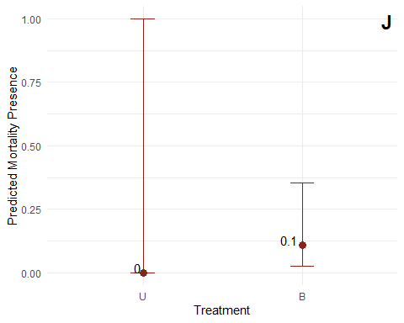
#Between 0 and 1
model1.3_mortality <- glmmTMB(
prop.density.dead ~ Treatment * SlopeZ + SiteClass,
family = beta_family(),
data = Thor_data_mortality_middle)
Anova(model1.3_mortality, type=2)
## Analysis of Deviance Table (Type II Wald chisquare tests)
##
## Response: prop.density.dead
## Chisq Df Pr(>Chisq)
## Treatment 41.5408 1 1.154e-10 ***
## SlopeZ 0.8378 1 0.360015
## SiteClass 0.2046 2 0.902752
## Treatment:SlopeZ 8.3489 1 0.003859 **
## ---
## Signif. codes: 0 '***' 0.001 '**' 0.01 '*' 0.05 '.' 0.1 ' ' 1
res_model1.3_mortality<-simulateResiduals(model1.3_mortality)
plot(res_model1.3_mortality)

testUniformity(res_model1.3_mortality)
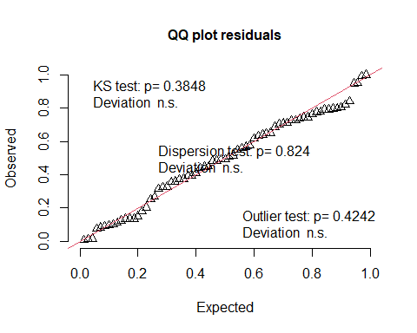
##
## Asymptotic one-sample Kolmogorov-Smirnov test
##
## data: simulationOutput$scaledResiduals
## D = 0.10904, p-value = 0.3848
## alternative hypothesis: two-sided
testDispersion(res_model1.3_mortality)
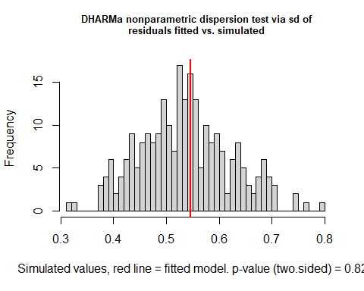
##
## DHARMa nonparametric dispersion test via sd of residuals fitted vs.
## simulated
##
## data: simulationOutput
## dispersion = 1.0202, p-value = 0.824
## alternative hypothesis: two.sided
mortality_treatment <- emmeans(model1.3_mortality,~ Treatment, type = "link")
## NOTE: Results may be misleading due to involvement in interactions
pairs(mortality_treatment, reverse = TRUE)
## contrast estimate SE df z.ratio p.value
## B - U 1.73 0.255 Inf 6.805 <.0001
##
## Results are averaged over the levels of: SiteClass
## Results are given on the log odds ratio (not the response) scale.
summary(mortality_treatment,type = "response",infer = TRUE)
## Treatment response SE df asymp.LCL asymp.UCL null z.ratio p.value
## U 0.257 0.0520 Inf 0.169 0.371 0.5 -3.898 0.0001
## B 0.662 0.0637 Inf 0.529 0.774 0.5 2.361 0.0182
##
## Results are averaged over the levels of: SiteClass
## Confidence level used: 0.95
## Intervals are back-transformed from the logit scale
## Tests are performed on the logit scale
(0.662-0.257)*100 # percent point increase
## [1] 40.5
mortality <- ggpredict(model1.3_mortality, terms = "Treatment")
Pmortality<-ggplot(mortality, aes(x = x, y = predicted)) +
geom_point(size = 3, color = "#87251D") +
geom_errorbar(aes(ymin = conf.low, ymax = conf.high), width = 0.15, color= "#87251D") +
geom_text(
aes(label = round(predicted, 1)),
vjust = -0.01,
hjust = 1.3,
size = 4) +
annotate(
"text",
x = Inf,
y = Inf,
label = "K",
hjust = 1.5,
vjust = 1.5,
size = 6,
fontface = "bold") +
labs(
x = "Treatment",
y = "Predicted Mortality") +
theme(
aspect.ratio = 1)+
theme_minimal()
print(Pmortality)
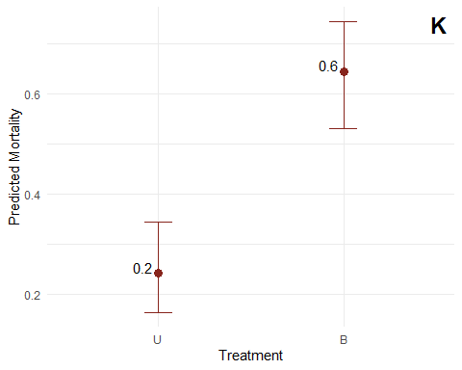
[Objective 2: Assess baseline differences in fuels between control and impact sites] Fuel models (woody fuels and litter/duff depth) regressed fuel load or litter/ duff depth on the interaction of Fuel Type with Treatment, Elevation, Slope, and Aspect, plus Site Class, using a Tweedie distribution with fuel-type-specific dispersion. Estimated marginal means and pairwise contrasts were calculated for the Treatment × Fuel Type interaction, and percent effect sizes were calculated by hand for each fuel type. Predicted fuel loads by Treatment and Fuel Type were plotted on a log scale, and the Slope and Elevation relationships within each fuel type were visualized using emtrends and predicted-value line plots.
Fuels
model1_fuels<- glmmTMB(Load ~ FuelType *(Treatment + ElevationZ + SlopeZ + Aspect)+SiteClass,
dispformula = ~ FuelType,
family = tweedie(link= "log"),
data=Thor_data_fuels)
Anova(model1_fuels,type=3)
## Analysis of Deviance Table (Type III Wald chisquare tests)
##
## Response: Load
## Chisq Df Pr(>Chisq)
## (Intercept) 125.9786 1 < 2.2e-16 ***
## FuelType 1263.4246 6 < 2.2e-16 ***
## Treatment 7.6278 1 0.005747 **
## ElevationZ 0.6446 1 0.422051
## SlopeZ 2.4827 1 0.115106
## Aspect 19.7469 6 0.003072 **
## SiteClass 1.1730 2 0.556281
## FuelType:Treatment 50.6295 6 3.515e-09 ***
## FuelType:ElevationZ 38.0764 6 1.085e-06 ***
## FuelType:SlopeZ 22.2464 6 0.001092 **
## FuelType:Aspect 86.9877 36 4.159e-06 ***
## ---
## Signif. codes: 0 '***' 0.001 '**' 0.01 '*' 0.05 '.' 0.1 ' ' 1
res_model1_fuels<-simulateResiduals(model1_fuels)
plot(res_model1_fuels)

Fuels_treatment <- emmeans(model1_fuels,~ Treatment|FuelType, type = "link")
pairs(Fuels_treatment, reverse = TRUE)
## FuelType = forbload:
## contrast estimate SE df z.ratio p.value
## B - U 0.960 0.248 Inf 3.876 0.0001
##
## FuelType = shrubload:
## contrast estimate SE df z.ratio p.value
## B - U -0.800 0.285 Inf -2.810 0.0050
##
## FuelType = grassload:
## contrast estimate SE df z.ratio p.value
## B - U 0.480 0.519 Inf 0.924 0.3557
##
## FuelType = onehour:
## contrast estimate SE df z.ratio p.value
## B - U -0.256 0.210 Inf -1.219 0.2228
##
## FuelType = tenhour:
## contrast estimate SE df z.ratio p.value
## B - U -1.036 0.224 Inf -4.624 <.0001
##
## FuelType = hundredhour:
## contrast estimate SE df z.ratio p.value
## B - U -0.626 0.277 Inf -2.261 0.0237
##
## FuelType = thousandhour:
## contrast estimate SE df z.ratio p.value
## B - U -0.932 0.208 Inf -4.474 <.0001
##
## Results are averaged over the levels of: Aspect, SiteClass
## Results are given on the log (not the response) scale.
summary(Fuels_treatment,type = "response",infer = TRUE)
## FuelType = forbload:
## Treatment response SE df asymp.LCL asymp.UCL null z.ratio p.value
## U 0.0491 0.00981 Inf 0.03319 0.0726 1 -15.089 <.0001
## B 0.1283 0.02250 Inf 0.09094 0.1809 1 -11.703 <.0001
##
## FuelType = shrubload:
## Treatment response SE df asymp.LCL asymp.UCL null z.ratio p.value
## U 0.3069 0.06420 Inf 0.20371 0.4625 1 -5.647 <.0001
## B 0.1380 0.03290 Inf 0.08651 0.2201 1 -8.316 <.0001
##
## FuelType = grassload:
## Treatment response SE df asymp.LCL asymp.UCL null z.ratio p.value
## U 0.0162 0.00726 Inf 0.00674 0.0390 1 -9.209 <.0001
## B 0.0262 0.01100 Inf 0.01149 0.0597 1 -8.658 <.0001
##
## FuelType = onehour:
## Treatment response SE df asymp.LCL asymp.UCL null z.ratio p.value
## U 0.9441 0.14400 Inf 0.69957 1.2741 1 -0.376 0.7068
## B 0.7310 0.11700 Inf 0.53462 0.9996 1 -1.962 0.0497
##
## FuelType = tenhour:
## Treatment response SE df asymp.LCL asymp.UCL null z.ratio p.value
## U 1.0289 0.15800 Inf 0.76183 1.3896 1 0.186 0.8526
## B 0.3652 0.06610 Inf 0.25606 0.5208 1 -5.562 <.0001
##
## FuelType = hundredhour:
## Treatment response SE df asymp.LCL asymp.UCL null z.ratio p.value
## U 0.4767 0.09640 Inf 0.32077 0.7085 1 -3.665 0.0002
## B 0.2549 0.05570 Inf 0.16609 0.3911 1 -6.258 <.0001
##
## FuelType = thousandhour:
## Treatment response SE df asymp.LCL asymp.UCL null z.ratio p.value
## U 25.8432 3.87000 Inf 19.27517 34.6494 1 21.737 <.0001
## B 10.1716 1.76000 Inf 7.24585 14.2786 1 13.404 <.0001
##
## Results are averaged over the levels of: Aspect, SiteClass
## Confidence level used: 0.95
## Intervals are back-transformed from the log scale
## Tests are performed on the log scale
#Forb
((0.1283-0.0491)/0.0491)*100
## [1] 161.3035
#shrub
((0.1380-0.3069)/0.3069)*100
## [1] -55.03421
#grass
((0.0262-0.0162)/0.0162)*100
## [1] 61.7284
#1-hour
((0.7310-0.9441)/0.9441)*100
## [1] -22.57176
#10-hour
((0.3652-1.0289)/1.0289)*100
## [1] -64.50578
#100-hour
((0.2549-0.4767)/0.4767)*100
## [1] -46.52821
#1000-hour
((10.1716-25.8432)/25.8432)*100
## [1] -60.6411
pred_FT_Treat <- ggpredict(model1_fuels, terms = c("Treatment", "FuelType"))
ggplot(pred_FT_Treat, aes(x = x, y = predicted, color = x)) +
geom_point(size = 3, position = position_dodge(width = 0.3)) +
geom_errorbar(aes(ymin = conf.low, ymax = conf.high),
width = 0.2,
position = position_dodge(width = 0.3)) +
scale_y_log10() +
facet_wrap(~ group, scales = "free_y") +
labs(
x = "Burn Status",
y = "Predicted Fuel Load (log scale)",
color = "Burn Status"
) +
scale_color_manual(values = Treatmentcol) +
theme_classic()
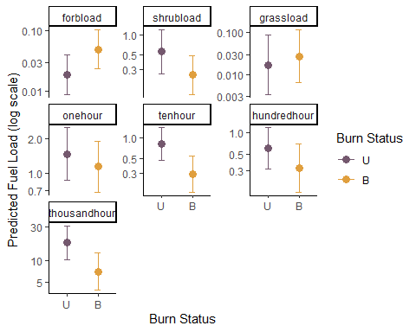
Fuels_slope <- emtrends(model1_fuels, ~ FuelType | SlopeZ,
var = "SlopeZ", type = "link",inf=TRUE)
Fuels_slope
## SlopeZ = 8.53e-17:
## FuelType SlopeZ.trend SE df asymp.LCL asymp.UCL z.ratio p.value
## forbload -0.2810 0.130 Inf -0.5366 -0.0254 -2.155 0.0312
## shrubload 0.2376 0.151 Inf -0.0587 0.5340 1.572 0.1160
## grassload 0.1607 0.313 Inf -0.4530 0.7744 0.513 0.6078
## onehour 0.4509 0.104 Inf 0.2464 0.6554 4.322 <.0001
## tenhour 0.0635 0.111 Inf -0.1548 0.2818 0.570 0.5685
## hundredhour 0.0881 0.150 Inf -0.2065 0.3826 0.586 0.5578
## thousandhour -0.0208 0.106 Inf -0.2279 0.1863 -0.197 0.8440
##
## Results are averaged over the levels of: Treatment, Aspect, SiteClass
## Confidence level used: 0.95
FS <- ggpredict(model1_fuels,
terms = c("SlopeZ","FuelType"))
ggplot(FS, aes(x = x, y = predicted)) +
geom_line(linewidth = 1.5, color = "#274001") +
geom_ribbon(aes(ymin = conf.low, ymax = conf.high),
alpha = 0.2, fill = "#274001") +
scale_y_log10() +
facet_wrap(~ group) +
labs(
x = "SlopeZ",
y = "Predicted Fuel Load (log scale)"
) +
theme_classic()
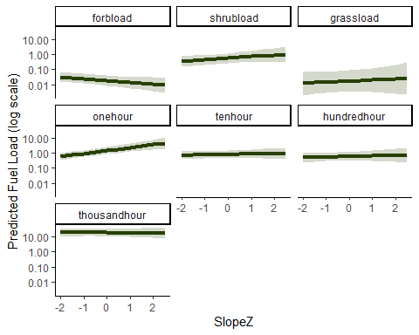
Fuels_aspect <- emmeans(model1_fuels,~ FuelType|Aspect, type = "link")
contrast(Fuels_aspect, method = "pairwise", transform = "response")
## Aspect = N:
## contrast estimate SE df z.ratio p.value
## forbload - shrubload -2.5220 0.472 Inf -5.339 <.0001
## forbload - grassload 0.3326 0.805 Inf 0.413 0.9996
## forbload - onehour -3.7520 0.413 Inf -9.083 <.0001
## forbload - tenhour -2.7747 0.436 Inf -6.360 <.0001
## forbload - hundredhour -2.6852 0.475 Inf -5.650 <.0001
## forbload - thousandhour -5.9218 0.437 Inf -13.563 <.0001
## shrubload - grassload 2.8546 0.796 Inf 3.585 0.0062
## shrubload - onehour -1.2300 0.393 Inf -3.129 0.0291
## shrubload - tenhour -0.2526 0.418 Inf -0.605 0.9967
## shrubload - hundredhour -0.1632 0.458 Inf -0.356 0.9998
## shrubload - thousandhour -3.3998 0.418 Inf -8.132 <.0001
## grassload - onehour -4.0846 0.762 Inf -5.361 <.0001
## grassload - tenhour -3.1073 0.774 Inf -4.012 0.0012
## grassload - hundredhour -3.0178 0.797 Inf -3.786 0.0029
## grassload - thousandhour -6.2544 0.775 Inf -8.075 <.0001
## onehour - tenhour 0.9773 0.348 Inf 2.807 0.0742
## onehour - hundredhour 1.0668 0.396 Inf 2.695 0.0995
## onehour - thousandhour -2.1698 0.347 Inf -6.248 <.0001
## tenhour - hundredhour 0.0894 0.420 Inf 0.213 1.0000
## tenhour - thousandhour -3.1471 0.376 Inf -8.378 <.0001
## hundredhour - thousandhour -3.2366 0.420 Inf -7.703 <.0001
##
## Aspect = NE:
## contrast estimate SE df z.ratio p.value
## forbload - shrubload -1.4102 0.410 Inf -3.439 0.0105
## forbload - grassload 2.6249 0.847 Inf 3.098 0.0320
## forbload - onehour -1.3447 0.383 Inf -3.507 0.0082
## forbload - tenhour -1.9394 0.371 Inf -5.225 <.0001
## forbload - hundredhour -1.1225 0.433 Inf -2.593 0.1280
## forbload - thousandhour -5.0617 0.369 Inf -13.712 <.0001
## shrubload - grassload 4.0351 0.859 Inf 4.697 0.0001
## shrubload - onehour 0.0655 0.409 Inf 0.160 1.0000
## shrubload - tenhour -0.5292 0.397 Inf -1.334 0.8363
## shrubload - hundredhour 0.2876 0.455 Inf 0.632 0.9958
## shrubload - thousandhour -3.6515 0.394 Inf -9.263 <.0001
## grassload - onehour -3.9696 0.846 Inf -4.693 0.0001
## grassload - tenhour -4.5643 0.841 Inf -5.430 <.0001
## grassload - hundredhour -3.7474 0.870 Inf -4.308 0.0003
## grassload - thousandhour -7.6866 0.840 Inf -9.153 <.0001
## onehour - tenhour -0.5947 0.369 Inf -1.614 0.6733
## onehour - hundredhour 0.2222 0.431 Inf 0.516 0.9986
## onehour - thousandhour -3.7170 0.367 Inf -10.126 <.0001
## tenhour - hundredhour 0.8169 0.420 Inf 1.945 0.4503
## tenhour - thousandhour -3.1222 0.354 Inf -8.815 <.0001
## hundredhour - thousandhour -3.9391 0.419 Inf -9.411 <.0001
##
## Aspect = NW:
## contrast estimate SE df z.ratio p.value
## forbload - shrubload -1.7548 0.588 Inf -2.982 0.0453
## forbload - grassload 4.1764 1.640 Inf 2.551 0.1414
## forbload - onehour -3.0449 0.501 Inf -6.078 <.0001
## forbload - tenhour -2.1561 0.527 Inf -4.089 0.0009
## forbload - hundredhour -1.3946 0.612 Inf -2.280 0.2536
## forbload - thousandhour -5.7475 0.507 Inf -11.329 <.0001
## shrubload - grassload 5.9311 1.640 Inf 3.608 0.0057
## shrubload - onehour -1.2902 0.524 Inf -2.461 0.1737
## shrubload - tenhour -0.4013 0.549 Inf -0.731 0.9907
## shrubload - hundredhour 0.3602 0.630 Inf 0.572 0.9976
## shrubload - thousandhour -3.9927 0.529 Inf -7.543 <.0001
## grassload - onehour -7.2213 1.620 Inf -4.471 0.0002
## grassload - tenhour -6.3324 1.620 Inf -3.901 0.0019
## grassload - hundredhour -5.5709 1.650 Inf -3.371 0.0132
## grassload - thousandhour -9.9238 1.620 Inf -6.137 <.0001
## onehour - tenhour 0.8889 0.454 Inf 1.956 0.4429
## onehour - hundredhour 1.6504 0.550 Inf 3.001 0.0429
## onehour - thousandhour -2.7026 0.431 Inf -6.270 <.0001
## tenhour - hundredhour 0.7615 0.574 Inf 1.328 0.8392
## tenhour - thousandhour -3.5914 0.461 Inf -7.791 <.0001
## hundredhour - thousandhour -4.3529 0.555 Inf -7.841 <.0001
##
## Aspect = S:
## contrast estimate SE df z.ratio p.value
## forbload - shrubload 0.3120 0.571 Inf 0.546 0.9981
## forbload - grassload 1.4324 0.777 Inf 1.843 0.5185
## forbload - onehour -1.3794 0.440 Inf -3.138 0.0283
## forbload - tenhour -1.3142 0.457 Inf -2.877 0.0612
## forbload - hundredhour -0.2411 0.559 Inf -0.431 0.9995
## forbload - thousandhour -4.9273 0.437 Inf -11.267 <.0001
## shrubload - grassload 1.1204 0.853 Inf 1.314 0.8458
## shrubload - onehour -1.6914 0.563 Inf -3.004 0.0426
## shrubload - tenhour -1.6262 0.577 Inf -2.820 0.0715
## shrubload - hundredhour -0.5531 0.661 Inf -0.837 0.9812
## shrubload - thousandhour -5.2393 0.561 Inf -9.340 <.0001
## grassload - onehour -2.8118 0.771 Inf -3.646 0.0050
## grassload - tenhour -2.7466 0.781 Inf -3.516 0.0080
## grassload - hundredhour -1.6735 0.845 Inf -1.980 0.4277
## grassload - thousandhour -6.3597 0.770 Inf -8.258 <.0001
## onehour - tenhour 0.0652 0.447 Inf 0.146 1.0000
## onehour - hundredhour 1.1383 0.551 Inf 2.065 0.3740
## onehour - thousandhour -3.5479 0.427 Inf -8.310 <.0001
## tenhour - hundredhour 1.0731 0.565 Inf 1.899 0.4811
## tenhour - thousandhour -3.6131 0.444 Inf -8.129 <.0001
## hundredhour - thousandhour -4.6862 0.550 Inf -8.523 <.0001
##
## Aspect = SE:
## contrast estimate SE df z.ratio p.value
## forbload - shrubload 0.5508 0.837 Inf 0.658 0.9947
## forbload - grassload -0.3302 0.908 Inf -0.364 0.9998
## forbload - onehour -2.8414 0.580 Inf -4.901 <.0001
## forbload - tenhour -2.7825 0.577 Inf -4.825 <.0001
## forbload - hundredhour -1.0695 0.714 Inf -1.497 0.7468
## forbload - thousandhour -4.6078 0.636 Inf -7.248 <.0001
## shrubload - grassload -0.8810 1.050 Inf -0.841 0.9806
## shrubload - onehour -3.3922 0.780 Inf -4.347 0.0003
## shrubload - tenhour -3.3333 0.778 Inf -4.285 0.0004
## shrubload - hundredhour -1.6203 0.885 Inf -1.831 0.5270
## shrubload - thousandhour -5.1586 0.823 Inf -6.270 <.0001
## grassload - onehour -2.5113 0.856 Inf -2.934 0.0521
## grassload - tenhour -2.4524 0.854 Inf -2.872 0.0620
## grassload - hundredhour -0.7393 0.952 Inf -0.776 0.9872
## grassload - thousandhour -4.2776 0.895 Inf -4.780 <.0001
## onehour - tenhour 0.0589 0.491 Inf 0.120 1.0000
## onehour - hundredhour 1.7720 0.647 Inf 2.738 0.0890
## onehour - thousandhour -1.7664 0.559 Inf -3.159 0.0265
## tenhour - hundredhour 1.7131 0.644 Inf 2.659 0.1088
## tenhour - thousandhour -1.8253 0.556 Inf -3.285 0.0177
## hundredhour - thousandhour -3.5383 0.698 Inf -5.073 <.0001
##
## Aspect = SW:
## contrast estimate SE df z.ratio p.value
## forbload - shrubload -1.0878 0.376 Inf -2.896 0.0580
## forbload - grassload -0.1796 0.475 Inf -0.378 0.9998
## forbload - onehour -2.1929 0.325 Inf -6.751 <.0001
## forbload - tenhour -1.8742 0.333 Inf -5.622 <.0001
## forbload - hundredhour -2.3350 0.344 Inf -6.792 <.0001
## forbload - thousandhour -5.9182 0.313 Inf -18.927 <.0001
## shrubload - grassload 0.9082 0.497 Inf 1.826 0.5302
## shrubload - onehour -1.1051 0.357 Inf -3.097 0.0322
## shrubload - tenhour -0.7865 0.365 Inf -2.156 0.3196
## shrubload - hundredhour -1.2473 0.374 Inf -3.334 0.0150
## shrubload - thousandhour -4.8305 0.346 Inf -13.953 <.0001
## grassload - onehour -2.0133 0.460 Inf -4.375 0.0002
## grassload - tenhour -1.6946 0.466 Inf -3.636 0.0051
## grassload - hundredhour -2.1554 0.474 Inf -4.551 0.0001
## grassload - thousandhour -5.7386 0.451 Inf -12.729 <.0001
## onehour - tenhour 0.3187 0.312 Inf 1.022 0.9491
## onehour - hundredhour -0.1422 0.323 Inf -0.440 0.9995
## onehour - thousandhour -3.7253 0.290 Inf -12.844 <.0001
## tenhour - hundredhour -0.4608 0.332 Inf -1.389 0.8082
## tenhour - thousandhour -4.0440 0.299 Inf -13.513 <.0001
## hundredhour - thousandhour -3.5832 0.311 Inf -11.518 <.0001
##
## Aspect = W:
## contrast estimate SE df z.ratio p.value
## forbload - shrubload -0.7584 0.493 Inf -1.538 0.7218
## forbload - grassload 1.3804 0.738 Inf 1.870 0.5003
## forbload - onehour -1.8835 0.400 Inf -4.707 0.0001
## forbload - tenhour -1.4696 0.419 Inf -3.512 0.0081
## forbload - hundredhour -1.5111 0.456 Inf -3.315 0.0160
## forbload - thousandhour -5.0533 0.408 Inf -12.398 <.0001
## shrubload - grassload 2.1388 0.772 Inf 2.770 0.0818
## shrubload - onehour -1.1251 0.463 Inf -2.432 0.1850
## shrubload - tenhour -0.7111 0.479 Inf -1.486 0.7536
## shrubload - hundredhour -0.7526 0.510 Inf -1.475 0.7599
## shrubload - thousandhour -4.2948 0.468 Inf -9.178 <.0001
## grassload - onehour -3.2639 0.718 Inf -4.546 0.0001
## grassload - tenhour -2.8500 0.728 Inf -3.912 0.0018
## grassload - hundredhour -2.8915 0.749 Inf -3.858 0.0022
## grassload - thousandhour -6.4337 0.721 Inf -8.919 <.0001
## onehour - tenhour 0.4140 0.382 Inf 1.083 0.9331
## onehour - hundredhour 0.3725 0.422 Inf 0.882 0.9754
## onehour - thousandhour -3.1697 0.370 Inf -8.570 <.0001
## tenhour - hundredhour -0.0415 0.440 Inf -0.094 1.0000
## tenhour - thousandhour -3.5837 0.390 Inf -9.195 <.0001
## hundredhour - thousandhour -3.5422 0.429 Inf -8.264 <.0001
##
## Results are averaged over the levels of: Treatment, SiteClass
## Results are given on the log (not the response) scale.
## P value adjustment: tukey method for comparing a family of 7 estimates
Fuels_e <- emtrends(model1_fuels, ~ FuelType | ElevationZ,
var = "ElevationZ", type = "link",inf=TRUE)
Fuels_e
## ElevationZ = -5.16e-16:
## FuelType ElevationZ.trend SE df asymp.LCL asymp.UCL z.ratio p.value
## forbload 0.346 0.1370 Inf 0.0780 0.6144 2.530 0.0114
## shrubload 0.335 0.1540 Inf 0.0341 0.6358 2.182 0.0291
## grassload 0.783 0.3260 Inf 0.1431 1.4226 2.398 0.0165
## onehour -0.232 0.0992 Inf -0.4265 -0.0377 -2.340 0.0193
## tenhour -0.376 0.1180 Inf -0.6070 -0.1452 -3.193 0.0014
## hundredhour -0.318 0.1470 Inf -0.6059 -0.0296 -2.161 0.0307
## thousandhour -0.122 0.1150 Inf -0.3474 0.1031 -1.063 0.2879
##
## Results are averaged over the levels of: Treatment, Aspect, SiteClass
## Confidence level used: 0.95
Fe <- ggpredict(model1_fuels,
terms = c("ElevationZ","FuelType"))
ggplot(Fe, aes(x = x, y = predicted)) +
geom_line(linewidth = 1.5, color = "#274001") +
geom_ribbon(aes(ymin = conf.low, ymax = conf.high),
alpha = 0.2, fill = "#274001") +
scale_y_log10() +
facet_wrap(~ group) +
labs(
x = "ElevationZ",
y = "Predicted Fuel Load (log scale)"
) +
theme_classic()
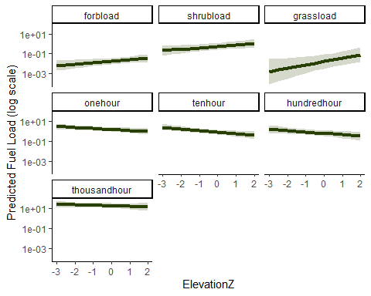
Fuels_elev_treat <- emtrends(model1_fuels, ~ Treatment | FuelType,var = "ElevationZ",infer = c(TRUE, TRUE))
Fuels_elev_treat
## FuelType = forbload:
## Treatment ElevationZ.trend SE df asymp.LCL asymp.UCL z.ratio p.value
## U 0.346 0.1370 Inf 0.0780 0.6144 2.530 0.0114
## B 0.346 0.1370 Inf 0.0780 0.6144 2.530 0.0114
##
## FuelType = shrubload:
## Treatment ElevationZ.trend SE df asymp.LCL asymp.UCL z.ratio p.value
## U 0.335 0.1540 Inf 0.0341 0.6358 2.182 0.0291
## B 0.335 0.1540 Inf 0.0341 0.6358 2.182 0.0291
##
## FuelType = grassload:
## Treatment ElevationZ.trend SE df asymp.LCL asymp.UCL z.ratio p.value
## U 0.783 0.3260 Inf 0.1431 1.4226 2.398 0.0165
## B 0.783 0.3260 Inf 0.1431 1.4226 2.398 0.0165
##
## FuelType = onehour:
## Treatment ElevationZ.trend SE df asymp.LCL asymp.UCL z.ratio p.value
## U -0.232 0.0992 Inf -0.4265 -0.0377 -2.340 0.0193
## B -0.232 0.0992 Inf -0.4265 -0.0377 -2.340 0.0193
##
## FuelType = tenhour:
## Treatment ElevationZ.trend SE df asymp.LCL asymp.UCL z.ratio p.value
## U -0.376 0.1180 Inf -0.6070 -0.1452 -3.193 0.0014
## B -0.376 0.1180 Inf -0.6070 -0.1452 -3.193 0.0014
##
## FuelType = hundredhour:
## Treatment ElevationZ.trend SE df asymp.LCL asymp.UCL z.ratio p.value
## U -0.318 0.1470 Inf -0.6059 -0.0296 -2.161 0.0307
## B -0.318 0.1470 Inf -0.6059 -0.0296 -2.161 0.0307
##
## FuelType = thousandhour:
## Treatment ElevationZ.trend SE df asymp.LCL asymp.UCL z.ratio p.value
## U -0.122 0.1150 Inf -0.3474 0.1031 -1.063 0.2879
## B -0.122 0.1150 Inf -0.3474 0.1031 -1.063 0.2879
##
## Results are averaged over the levels of: Aspect, SiteClass
## Confidence level used: 0.95
FE <- ggpredict(
model1_fuels,
terms = c("ElevationZ", "FuelType", "Treatment"))
FE
## # Predicted values of Load
##
## FuelType: forbload
## Treatment: U
##
## ElevationZ | Predicted | 95% CI
## ------------------------------------
## -3.00 | 0.01 | 0.00, 0.02
## -1.50 | 0.01 | 0.00, 0.03
## -0.50 | 0.02 | 0.01, 0.03
## 2.00 | 0.04 | 0.02, 0.09
##
## FuelType: forbload
## Treatment: B
##
## ElevationZ | Predicted | 95% CI
## ------------------------------------
## -3.00 | 0.02 | 0.01, 0.05
## -1.50 | 0.03 | 0.01, 0.07
## -0.50 | 0.04 | 0.02, 0.09
## 2.00 | 0.10 | 0.04, 0.24
##
## FuelType: shrubload
## Treatment: U
##
## ElevationZ | Predicted | 95% CI
## ------------------------------------
## -3.00 | 0.21 | 0.07, 0.64
## -1.50 | 0.34 | 0.15, 0.79
## -0.50 | 0.47 | 0.22, 1.01
## 2.00 | 1.10 | 0.41, 2.95
##
## FuelType: shrubload
## Treatment: B
##
## ElevationZ | Predicted | 95% CI
## ------------------------------------
## -3.00 | 0.09 | 0.03, 0.26
## -1.50 | 0.15 | 0.07, 0.32
## -0.50 | 0.21 | 0.11, 0.42
## 2.00 | 0.49 | 0.19, 1.30
##
## FuelType: grassload
## Treatment: U
##
## ElevationZ | Predicted | 95% CI
## ------------------------------------
## -3.00 | 0.00 | 0.00, 0.03
## -1.50 | 0.01 | 0.00, 0.04
## -0.50 | 0.01 | 0.00, 0.07
## 2.00 | 0.08 | 0.02, 0.44
##
## FuelType: grassload
## Treatment: B
##
## ElevationZ | Predicted | 95% CI
## ------------------------------------
## -3.00 | 0.00 | 0.00, 0.04
## -1.50 | 0.01 | 0.00, 0.06
## -0.50 | 0.02 | 0.00, 0.09
## 2.00 | 0.13 | 0.03, 0.61
##
## FuelType: onehour
## Treatment: U
##
## ElevationZ | Predicted | 95% CI
## ------------------------------------
## -3.00 | 2.93 | 1.51, 5.71
## -1.50 | 2.07 | 1.23, 3.49
## -0.50 | 1.64 | 0.99, 2.72
## 2.00 | 0.92 | 0.44, 1.91
##
## FuelType: onehour
## Treatment: B
##
## ElevationZ | Predicted | 95% CI
## ------------------------------------
## -3.00 | 2.27 | 1.11, 4.67
## -1.50 | 1.60 | 0.92, 2.79
## -0.50 | 1.27 | 0.76, 2.12
## 2.00 | 0.71 | 0.36, 1.42
##
## FuelType: tenhour
## Treatment: U
##
## ElevationZ | Predicted | 95% CI
## ------------------------------------
## -3.00 | 2.51 | 1.19, 5.30
## -1.50 | 1.43 | 0.82, 2.51
## -0.50 | 0.98 | 0.57, 1.68
## 2.00 | 0.38 | 0.17, 0.88
##
## FuelType: tenhour
## Treatment: B
##
## ElevationZ | Predicted | 95% CI
## ------------------------------------
## -3.00 | 0.89 | 0.40, 2.01
## -1.50 | 0.51 | 0.27, 0.96
## -0.50 | 0.35 | 0.19, 0.64
## 2.00 | 0.14 | 0.06, 0.32
##
## FuelType: hundredhour
## Treatment: U
##
## ElevationZ | Predicted | 95% CI
## ------------------------------------
## -3.00 | 1.57 | 0.62, 3.99
## -1.50 | 0.98 | 0.49, 1.93
## -0.50 | 0.71 | 0.38, 1.34
## 2.00 | 0.32 | 0.12, 0.86
##
## FuelType: hundredhour
## Treatment: B
##
## ElevationZ | Predicted | 95% CI
## ------------------------------------
## -3.00 | 0.84 | 0.31, 2.27
## -1.50 | 0.52 | 0.24, 1.13
## -0.50 | 0.38 | 0.18, 0.80
## 2.00 | 0.17 | 0.06, 0.50
##
## FuelType: thousandhour
## Treatment: U
##
## ElevationZ | Predicted | 95% CI
## -------------------------------------
## -3.00 | 25.92 | 12.71, 52.84
## -1.50 | 21.58 | 12.55, 37.09
## -0.50 | 19.10 | 11.27, 32.35
## 2.00 | 14.07 | 6.16, 32.14
##
## FuelType: thousandhour
## Treatment: B
##
## ElevationZ | Predicted | 95% CI
## ------------------------------------
## -3.00 | 10.20 | 4.59, 22.68
## -1.50 | 8.49 | 4.55, 15.85
## -0.50 | 7.52 | 4.16, 13.58
## 2.00 | 5.54 | 2.41, 12.75
##
## Adjusted for:
## * SlopeZ = 0.00
## * Aspect = N
## * SiteClass = 2
##
## Not all rows are shown in the output. Use `print(..., n = Inf)` to show
## all rows.
Litter and Duff
model1_LD<-glmmTMB(Depth~ Type * Treatment + SiteClass,
family=tweedie(link = "log"),
data=Thor_data_LD)
Anova(model1_LD,type=3)
## Analysis of Deviance Table (Type III Wald chisquare tests)
##
## Response: Depth
## Chisq Df Pr(>Chisq)
## (Intercept) 30.411 1 3.496e-08 ***
## Type 61.098 1 5.431e-15 ***
## Treatment 44.005 1 3.276e-11 ***
## SiteClass 16.223 2 3e-04 ***
## Type:Treatment 25.250 1 5.035e-07 ***
## ---
## Signif. codes: 0 '***' 0.001 '**' 0.01 '*' 0.05 '.' 0.1 ' ' 1
res_model1_LD<-simulateResiduals(model1_LD)
plot(res_model1_LD)
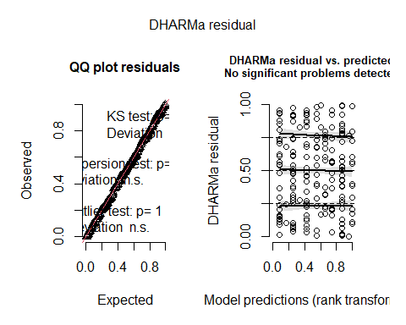
LD_treatment <- emmeans(model1_LD,~ Treatment|Type, type = "fixed")
pairs(LD_treatment, reverse = TRUE)
## Type = mean_duff:
## contrast estimate SE df z.ratio p.value
## B - U -1.536 0.154 Inf -9.965 <.0001
##
## Type = mean_litter:
## contrast estimate SE df z.ratio p.value
## B - U -0.214 0.214 Inf -1.001 0.3166
##
## Results are averaged over the levels of: SiteClass
## Results are given on the log (not the response) scale.
summary(LD_treatment,type = "response",infer = TRUE)
## Type = mean_duff:
## Treatment response SE df asymp.LCL asymp.UCL null z.ratio p.value
## U 2.067 0.2280 Inf 1.664 2.567 1 6.569 <.0001
## B 0.445 0.0672 Inf 0.331 0.598 1 -5.361 <.0001
##
## Type = mean_litter:
## Treatment response SE df asymp.LCL asymp.UCL null z.ratio p.value
## U 0.382 0.0640 Inf 0.275 0.530 1 -5.743 <.0001
## B 0.308 0.0529 Inf 0.220 0.431 1 -6.853 <.0001
##
## Results are averaged over the levels of: SiteClass
## Confidence level used: 0.95
## Intervals are back-transformed from the log scale
## Tests are performed on the log scale
#Duff
((0.445-2.067)/2.067)*100
## [1] -78.47121
#litter
((0.308-0.382)/0.382)*100
## [1] -19.37173
pred_LD_Treat <- ggpredict(model1_LD,
terms = c("Type", "Treatment"))
ggplot(pred_LD_Treat, aes(x = x, y = predicted, fill = group)) +
geom_col(position = position_dodge(width = 0.9)) +
geom_errorbar(aes(ymin = conf.low, ymax = conf.high),
position = position_dodge(width = 0.9),
width = 0.2) +
scale_x_discrete(labels = c(
"mean_litter" = "Litter",
"mean_duff" = "Duff"))+
labs(
x = "Burn Status",
y = "Predicted Mean Depth",
fill = "Burn Status"
) +
scale_fill_manual(values = Treatmentcol) +
theme_classic()
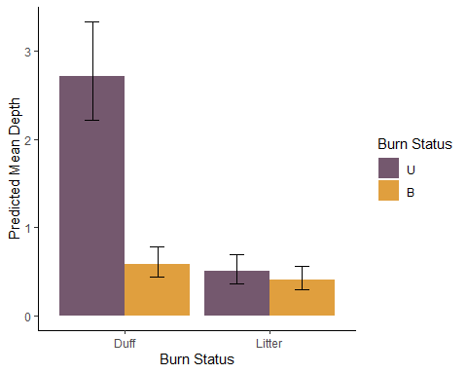
[Objective 3: Assess baseline differences in forest community between control and impact sites] Differences in mature tree species composition between Treatments were tested with a PERMANOVA (adonis2) on Bray-Curtis dissimilarities, with the dispersion assumption checked using betadisper. Composition patterns were visualized with an NMDS ordination with 95% confidence ellipses by Treatment, and indicator species associated with each Treatment were identified using the indicspecies package (multipatt).Separate Gaussian models regressed Hill-Shannon diversity — calculated once for all mature trees and once restricted to surviving (live) trees — on Treatment and Site Class. For each model, estimated marginal means, pairwise contrasts, and percent effect size were calculated for the Treatment effect.
Mature Tree Species Composition with NMDS
bray_dist <- vegdist(comm_SC, method = "bray")
##Is multivariate species composition different between treatments?
set.seed(123)
adonis2(bray_dist ~ Treatment, data = LT_2)
## Permutation test for adonis under reduced model
## Permutation: free
## Number of permutations: 999
##
## adonis2(formula = bray_dist ~ Treatment, data = LT_2)
## Df SumOfSqs R2 F Pr(>F)
## Model 1 0.681 0.02132 2.1134 0.059 .
## Residual 97 31.240 0.97868
## Total 98 31.920 1.00000
## ---
## Signif. codes: 0 '***' 0.001 '**' 0.01 '*' 0.05 '.' 0.1 ' ' 1
#assumption check for PERMANOVA
set.seed(123)
disp <- betadisper(bray_dist, LT_2$Treatment)
anova(disp)
## Analysis of Variance Table
##
## Response: Distances
## Df Sum Sq Mean Sq F value Pr(>F)
## Groups 1 0.03636 0.036363 2.9703 0.08799 .
## Residuals 97 1.18750 0.012242
## ---
## Signif. codes: 0 '***' 0.001 '**' 0.01 '*' 0.05 '.' 0.1 ' ' 1
nmds_SC <- metaMDS(comm_SC, k = 2, trymax = 50)
## Square root transformation
## Wisconsin double standardization
## Run 0 stress 0.1830396
## Run 1 stress 0.1883914
## Run 2 stress 0.1896893
## Run 3 stress 0.1844771
## Run 4 stress 0.1844767
## Run 5 stress 0.1818542
## ... New best solution
## ... Procrustes: rmse 0.01277938 max resid 0.1135868
## Run 6 stress 0.1821375
## ... Procrustes: rmse 0.03725415 max resid 0.1882346
## Run 7 stress 0.1830396
## Run 8 stress 0.1811848
## ... New best solution
## ... Procrustes: rmse 0.03499029 max resid 0.1893199
## Run 9 stress 0.1807909
## ... New best solution
## ... Procrustes: rmse 0.03044048 max resid 0.1792907
## Run 10 stress 0.1818542
## Run 11 stress 0.1811357
## ... Procrustes: rmse 0.03036821 max resid 0.1785602
## Run 12 stress 0.1961404
## Run 13 stress 0.182137
## Run 14 stress 0.1824085
## Run 15 stress 0.201828
## Run 16 stress 0.1796181
## ... New best solution
## ... Procrustes: rmse 0.01187949 max resid 0.1134409
## Run 17 stress 0.1887275
## Run 18 stress 0.1807632
## Run 19 stress 0.1974892
## Run 20 stress 0.179618
## ... New best solution
## ... Procrustes: rmse 3.164611e-05 max resid 0.0002467814
## ... Similar to previous best
## *** Best solution repeated 1 times
nmds_SC <- as.data.frame(nmds_SC$points)
nmds_SC <- cbind(nmds_SC,LT_2["Treatment"])
ggplot(nmds_SC, aes(MDS1, MDS2, color = Treatment, fill = Treatment)) +
stat_ellipse(geom = "polygon",
level = 0.95,
alpha = 0.15) +
geom_point(size = 3) +
theme_minimal() +
scale_color_manual(values = Treatmentcol) +
scale_fill_manual(values = Treatmentcol) +
labs(
x = "NMDS1",
y = "NMDS2",
color = "Burn Status",
fill = "Burn Status")
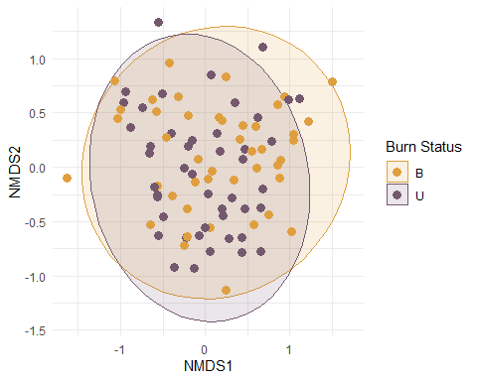
##indicator Species
#citation("indicspecies")
isa <- multipatt(comm_SC, LT_2$Treatment,
func = "IndVal.g",
control = how(nperm = 999))
summary(isa)
##
## Multilevel pattern analysis
## ---------------------------
##
## Association function: IndVal.g
## Significance level (alpha): 0.05
##
## Total number of species: 18
## Selected number of species: 0
## Number of species associated to 1 group: 0
##
## List of species associated to each combination:
## ---
## Signif. codes: 0 '***' 0.001 '**' 0.01 '*' 0.05 '.' 0.1 ' ' 1
Mature Tree Diversity n=99
model1_TD <- glmmTMB(
HillShannon ~ Treatment + SiteClass,
family = gaussian(),
data = Thor_data)
Anova(model1_TD, type=3)
## Analysis of Deviance Table (Type III Wald chisquare tests)
##
## Response: HillShannon
## Chisq Df Pr(>Chisq)
## (Intercept) 215.6156 1 < 2.2e-16 ***
## Treatment 12.3102 1 0.0004505 ***
## SiteClass 5.5389 2 0.0626951 .
## ---
## Signif. codes: 0 '***' 0.001 '**' 0.01 '*' 0.05 '.' 0.1 ' ' 1
res_model1_TD<-simulateResiduals(model1_TD)
plot(res_model1_TD)

TD_fire<-emmeans(model1_TD, "Treatment")
pairs(TD_fire, reverse = TRUE)
## contrast estimate SE df t.ratio p.value
## B - U -0.737 0.21 94 -3.509 0.0007
##
## Results are averaged over the levels of: SiteClass
summary(TD_fire,type = "response",infer = TRUE)
## Treatment emmean SE df lower.CL upper.CL t.ratio p.value
## U 2.73 0.193 94 2.34 3.11 14.106 <.0001
## B 1.99 0.191 94 1.61 2.37 10.453 <.0001
##
## Results are averaged over the levels of: SiteClass
## Confidence level used: 0.95
((1.99-2.73)/2.73)*100
## [1] -27.10623
Live Tree Survivors Diversity n=97
model1_LTD <- glmmTMB(
HillLive ~ Treatment + SiteClass,
family = gaussian(),
data = Thor_data)
Anova(model1_LTD, type=3)
## Analysis of Deviance Table (Type III Wald chisquare tests)
##
## Response: HillLive
## Chisq Df Pr(>Chisq)
## (Intercept) 154.0191 1 <2e-16 ***
## Treatment 0.1640 1 0.6855
## SiteClass 3.2567 2 0.1963
## ---
## Signif. codes: 0 '***' 0.001 '**' 0.01 '*' 0.05 '.' 0.1 ' ' 1
res_model1_LTD<-simulateResiduals(model1_LTD)
plot(res_model1_LTD)

LTD_fire<-emmeans(model1_LTD, "Treatment")
pairs(LTD_fire, reverse = TRUE)
## contrast estimate SE df t.ratio p.value
## B - U 0.0929 0.229 92 0.405 0.6864
##
## Results are averaged over the levels of: SiteClass
summary(LTD_fire,type = "response",infer = TRUE)
## Treatment emmean SE df lower.CL upper.CL t.ratio p.value
## U 2.27 0.216 92 1.84 2.7 10.498 <.0001
## B 2.36 0.222 92 1.92 2.8 10.648 <.0001
##
## Results are averaged over the levels of: SiteClass
## Confidence level used: 0.95
((2.36-2.27)/2.27)*100
## [1] 3.964758
Objective 4: Determine effects of severity in burned sites For each response variable examined under Objective 1–3 (fuels, recruitment/seedling and sapling abundance, litter/duff depth, canopy cover, and stand height), an analogous model was refit using Severity in place of Treatment as the primary predictor, restricted to burned plots. Estimated marginal means were calculated for Severity (or the Severity × Type / Severity × Fuel Type interaction where relevant), with polynomial contrasts used to test for a linear or higher-order trend across ordered severity levels and pairwise contrasts used to compare adjacent severity classes. Percent change between adjacent severity levels was calculated by hand from the back-transformed estimates for each response variable and level. Predicted values were visualized as bar charts (scaled where necessary for comparability across fuel types) or line plots across severity levels, with consistent color scales (cols_sev) applied across figures.
Fuels
model2_fuels<- glmmTMB(Load ~ FuelType * Severity + SiteClass,
dispformula = ~ FuelType,
family = tweedie(link= "log"),
data=Thor_data_fuels_sev)
Anova(model2_fuels, type=3)
## Analysis of Deviance Table (Type III Wald chisquare tests)
##
## Response: Load
## Chisq Df Pr(>Chisq)
## (Intercept) 108.5844 1 < 2.2e-16 ***
## FuelType 742.7029 6 < 2.2e-16 ***
## Severity 32.9451 4 1.226e-06 ***
## SiteClass 0.6278 2 0.7306
## FuelType:Severity 85.2111 24 8.809e-09 ***
## ---
## Signif. codes: 0 '***' 0.001 '**' 0.01 '*' 0.05 '.' 0.1 ' ' 1
res_model2_fuels<-simulateResiduals(model2_fuels)
plot(res_model2_fuels)

FuelSInteraction=emmeans(model2_fuels, ~ Severity|FuelType, infer = c(TRUE, TRUE))
contrast(FuelSInteraction,method = "poly",type="response")
## FuelType = forbload:
## contrast ratio SE df null z.ratio p.value
## linear 0.5082 0.559 Inf 1 -0.616 0.5380
## quadratic 0.1275 0.162 Inf 1 -1.621 0.1050
## cubic 0.4638 0.544 Inf 1 -0.655 0.5127
## quartic 0.0045 0.013 Inf 1 -1.854 0.0637
##
## FuelType = grassload:
## contrast ratio SE df null z.ratio p.value
## linear 2.0567 4.950 Inf 1 0.300 0.7643
## quadratic 11.8618 33.300 Inf 1 0.881 0.3786
## cubic 0.0293 0.090 Inf 1 -1.149 0.2504
## quartic 6.8860 50.600 Inf 1 0.263 0.7928
##
## FuelType = hundredhour:
## contrast ratio SE df null z.ratio p.value
## linear 29.0624 41.300 Inf 1 2.370 0.0178
## quadratic 0.9928 1.600 Inf 1 -0.004 0.9964
## cubic 0.7355 1.160 Inf 1 -0.194 0.8461
## quartic 3.1330 11.700 Inf 1 0.305 0.7601
##
## FuelType = onehour:
## contrast ratio SE df null z.ratio p.value
## linear 253.2283 295.000 Inf 1 4.745 <.0001
## quadratic 0.1353 0.174 Inf 1 -1.553 0.1203
## cubic 0.7625 0.942 Inf 1 -0.219 0.8263
## quartic 24.0911 67.800 Inf 1 1.131 0.2579
##
## FuelType = shrubload:
## contrast ratio SE df null z.ratio p.value
## linear 16.1385 24.700 Inf 1 1.815 0.0696
## quadratic 0.3733 0.650 Inf 1 -0.566 0.5717
## cubic 138.3923 206.000 Inf 1 3.319 0.0009
## quartic 0.0093 0.034 Inf 1 -1.274 0.2025
##
## FuelType = tenhour:
## contrast ratio SE df null z.ratio p.value
## linear 891.6229 1150.000 Inf 1 5.289 <.0001
## quadratic 1.5170 2.170 Inf 1 0.291 0.7707
## cubic 0.2476 0.357 Inf 1 -0.968 0.3330
## quartic 17.6026 58.200 Inf 1 0.868 0.3857
##
## FuelType = thousandhour:
## contrast ratio SE df null z.ratio p.value
## linear 1.0021 0.921 Inf 1 0.002 0.9982
## quadratic 33.8800 36.900 Inf 1 3.235 0.0012
## cubic 4.2949 4.720 Inf 1 1.326 0.1848
## quartic 3.0730 8.440 Inf 1 0.409 0.6825
##
## Results are averaged over the levels of: SiteClass
## Tests are performed on the log scale
#post-hoc pairwise
contrast(FuelSInteraction,method = "pairwise",type="response")
## FuelType = forbload:
## contrast ratio SE df null z.ratio p.value
## Extreme / High 0.5887 0.3760 Inf 1 -0.830 0.9214
## Extreme / Low 1.0103 0.5510 Inf 1 0.019 1.0000
## Extreme / Medium 0.4957 0.2560 Inf 1 -1.361 0.6530
## Extreme / No 1.5287 0.7310 Inf 1 0.887 0.9017
## High / Low 1.7160 0.9700 Inf 1 0.956 0.8749
## High / Medium 0.8420 0.4520 Inf 1 -0.320 0.9977
## High / No 2.5965 1.3000 Inf 1 1.903 0.3155
## Low / Medium 0.4907 0.2050 Inf 1 -1.707 0.4298
## Low / No 1.5131 0.5620 Inf 1 1.115 0.7988
## Medium / No 3.0838 1.0100 Inf 1 3.434 0.0054
##
## FuelType = grassload:
## contrast ratio SE df null z.ratio p.value
## Extreme / High 5.2310 8.3200 Inf 1 1.041 0.8365
## Extreme / Low 2.1762 2.4800 Inf 1 0.682 0.9604
## Extreme / Medium 1.1035 1.1800 Inf 1 0.092 1.0000
## Extreme / No 1.5181 1.4500 Inf 1 0.437 0.9925
## High / Low 0.4160 0.6290 Inf 1 -0.580 0.9780
## High / Medium 0.2110 0.3080 Inf 1 -1.066 0.8238
## High / No 0.2902 0.4000 Inf 1 -0.898 0.8978
## Low / Medium 0.5071 0.4810 Inf 1 -0.716 0.9529
## Low / No 0.6976 0.5700 Inf 1 -0.440 0.9922
## Medium / No 1.3757 0.9870 Inf 1 0.445 0.9919
##
## FuelType = hundredhour:
## contrast ratio SE df null z.ratio p.value
## Extreme / High 0.8481 0.7360 Inf 1 -0.190 0.9997
## Extreme / Low 0.4835 0.3350 Inf 1 -1.050 0.8319
## Extreme / Medium 0.3823 0.2570 Inf 1 -1.433 0.6065
## Extreme / No 0.2763 0.1680 Inf 1 -2.116 0.2129
## High / Low 0.5700 0.4280 Inf 1 -0.748 0.9450
## High / Medium 0.4508 0.3300 Inf 1 -1.088 0.8128
## High / No 0.3258 0.2200 Inf 1 -1.662 0.4578
## Low / Medium 0.7908 0.3980 Inf 1 -0.466 0.9903
## Low / No 0.5715 0.2400 Inf 1 -1.332 0.6712
## Medium / No 0.7227 0.2800 Inf 1 -0.840 0.9183
##
## FuelType = onehour:
## contrast ratio SE df null z.ratio p.value
## Extreme / High 0.5100 0.3590 Inf 1 -0.957 0.8744
## Extreme / Low 0.1528 0.0860 Inf 1 -3.340 0.0075
## Extreme / Medium 0.1513 0.0832 Inf 1 -3.434 0.0054
## Extreme / No 0.1154 0.0588 Inf 1 -4.239 0.0002
## High / Low 0.2997 0.1720 Inf 1 -2.096 0.2219
## High / Medium 0.2966 0.1670 Inf 1 -2.156 0.1967
## High / No 0.2263 0.1190 Inf 1 -2.832 0.0373
## Low / Medium 0.9898 0.3590 Inf 1 -0.028 1.0000
## Low / No 0.7550 0.2280 Inf 1 -0.930 0.8855
## Medium / No 0.7628 0.2160 Inf 1 -0.957 0.8744
##
## FuelType = shrubload:
## contrast ratio SE df null z.ratio p.value
## Extreme / High 0.1000 0.0848 Inf 1 -2.715 0.0518
## Extreme / Low 0.3692 0.2890 Inf 1 -1.273 0.7079
## Extreme / Medium 0.4119 0.3190 Inf 1 -1.144 0.7828
## Extreme / No 0.1226 0.0848 Inf 1 -3.036 0.0203
## High / Low 3.6923 2.4700 Inf 1 1.954 0.2890
## High / Medium 4.1198 2.7100 Inf 1 2.151 0.1988
## High / No 1.2265 0.6870 Inf 1 0.365 0.9962
## Low / Medium 1.1158 0.6350 Inf 1 0.192 0.9997
## Low / No 0.3322 0.1510 Inf 1 -2.432 0.1068
## Medium / No 0.2977 0.1310 Inf 1 -2.764 0.0452
##
## FuelType = tenhour:
## contrast ratio SE df null z.ratio p.value
## Extreme / High 1.0343 0.8350 Inf 1 0.042 1.0000
## Extreme / Low 0.2712 0.1670 Inf 1 -2.116 0.2129
## Extreme / Medium 0.1521 0.0902 Inf 1 -3.175 0.0130
## Extreme / No 0.0873 0.0478 Inf 1 -4.459 0.0001
## High / Low 0.2622 0.1810 Inf 1 -1.942 0.2949
## High / Medium 0.1470 0.0983 Inf 1 -2.868 0.0336
## High / No 0.0844 0.0530 Inf 1 -3.936 0.0008
## Low / Medium 0.5607 0.2290 Inf 1 -1.415 0.6183
## Low / No 0.3220 0.1110 Inf 1 -3.291 0.0088
## Medium / No 0.5743 0.1740 Inf 1 -1.833 0.3545
##
## FuelType = thousandhour:
## contrast ratio SE df null z.ratio p.value
## Extreme / High 1.4883 0.8290 Inf 1 0.714 0.9534
## Extreme / Low 2.1818 1.0100 Inf 1 1.688 0.4415
## Extreme / Medium 2.6650 1.2100 Inf 1 2.166 0.1927
## Extreme / No 0.7465 0.2820 Inf 1 -0.773 0.9385
## High / Low 1.4660 0.7700 Inf 1 0.728 0.9500
## High / Medium 1.7906 0.9260 Inf 1 1.127 0.7925
## High / No 0.5016 0.2280 Inf 1 -1.520 0.5491
## Low / Medium 1.2214 0.4970 Inf 1 0.492 0.9881
## Low / No 0.3422 0.1100 Inf 1 -3.330 0.0077
## Medium / No 0.2801 0.0877 Inf 1 -4.065 0.0005
##
## Results are averaged over the levels of: SiteClass
## P value adjustment: tukey method for comparing a family of 5 estimates
## Tests are performed on the log scale
summary(FuelSInteraction,type = "response",infer = TRUE)
## FuelType = forbload:
## Severity response SE df asymp.LCL asymp.UCL null z.ratio p.value
## Extreme 0.0855 0.0382 Inf 3.56e-02 0.2053 1 -5.500 <.0001
## High 0.1451 0.0684 Inf 5.76e-02 0.3657 1 -4.093 <.0001
## Low 0.0846 0.0276 Inf 4.47e-02 0.1602 1 -7.582 <.0001
## Medium 0.1724 0.0478 Inf 1.00e-01 0.2969 1 -6.339 <.0001
## No 0.0559 0.0110 Inf 3.80e-02 0.0822 1 -14.683 <.0001
##
## FuelType = grassload:
## Severity response SE df asymp.LCL asymp.UCL null z.ratio p.value
## Extreme 0.0705 0.0622 Inf 1.25e-02 0.3975 1 -3.005 0.0027
## High 0.0135 0.0179 Inf 9.97e-04 0.1819 1 -3.243 0.0012
## Low 0.0324 0.0236 Inf 7.75e-03 0.1353 1 -4.702 <.0001
## Medium 0.0639 0.0393 Inf 1.91e-02 0.2134 1 -4.469 <.0001
## No 0.0464 0.0177 Inf 2.20e-02 0.0978 1 -8.072 <.0001
##
## FuelType = hundredhour:
## Severity response SE df asymp.LCL asymp.UCL null z.ratio p.value
## Extreme 0.1597 0.0932 Inf 5.09e-02 0.5013 1 -3.143 0.0017
## High 0.1883 0.1230 Inf 5.24e-02 0.6774 1 -2.556 0.0106
## Low 0.3304 0.1260 Inf 1.57e-01 0.6972 1 -2.907 0.0037
## Medium 0.4178 0.1440 Inf 2.12e-01 0.8223 1 -2.526 0.0115
## No 0.5781 0.1140 Inf 3.93e-01 0.8504 1 -2.783 0.0054
##
## FuelType = onehour:
## Severity response SE df asymp.LCL asymp.UCL null z.ratio p.value
## Extreme 0.1243 0.0618 Inf 4.69e-02 0.3294 1 -4.193 <.0001
## High 0.2438 0.1250 Inf 8.93e-02 0.6655 1 -2.755 0.0059
## Low 0.8134 0.2220 Inf 4.76e-01 1.3903 1 -0.755 0.4502
## Medium 0.8218 0.2110 Inf 4.97e-01 1.3595 1 -0.764 0.4448
## No 1.0774 0.1630 Inf 8.01e-01 1.4493 1 0.493 0.6223
##
## FuelType = shrubload:
## Severity response SE df asymp.LCL asymp.UCL null z.ratio p.value
## Extreme 0.0514 0.0344 Inf 1.38e-02 0.1911 1 -4.431 <.0001
## High 0.5142 0.2740 Inf 1.81e-01 1.4587 1 -1.250 0.2112
## Low 0.1393 0.0580 Inf 6.16e-02 0.3150 1 -4.735 <.0001
## Medium 0.1248 0.0500 Inf 5.69e-02 0.2736 1 -5.197 <.0001
## No 0.4192 0.0829 Inf 2.85e-01 0.6176 1 -4.397 <.0001
##
## FuelType = tenhour:
## Severity response SE df asymp.LCL asymp.UCL null z.ratio p.value
## Extreme 0.0926 0.0495 Inf 3.25e-02 0.2639 1 -4.453 <.0001
## High 0.0895 0.0552 Inf 2.67e-02 0.3000 1 -3.911 0.0001
## Low 0.3414 0.1080 Inf 1.83e-01 0.6361 1 -3.385 0.0007
## Medium 0.6089 0.1680 Inf 3.55e-01 1.0447 1 -1.801 0.0717
## No 1.0603 0.1640 Inf 7.83e-01 1.4363 1 0.378 0.7056
##
## FuelType = thousandhour:
## Severity response SE df asymp.LCL asymp.UCL null z.ratio p.value
## Extreme 19.9059 7.2100 Inf 9.79e+00 40.4906 1 8.256 <.0001
## High 13.3748 5.8900 Inf 5.64e+00 31.6925 1 5.892 <.0001
## Low 9.1234 2.6900 Inf 5.12e+00 16.2582 1 7.500 <.0001
## Medium 7.4695 2.1700 Inf 4.22e+00 13.2154 1 6.908 <.0001
## No 26.6648 3.8300 Inf 2.01e+01 35.3235 1 22.885 <.0001
##
## Results are averaged over the levels of: SiteClass
## Confidence level used: 0.95
## Intervals are back-transformed from the log scale
## Tests are performed on the log scale
#forb
#low-no
((0.0846-0.0559)/0.0559)*100
## [1] 51.34168
#med-low
((0.1724-0.0846)/0.0846)*100
## [1] 103.7825
#high-med
((0.1451 -0.1724)/0.1724)*100
## [1] -15.83527
#extreme-high
((0.0855-0.1451)/0.1451)*100
## [1] -41.07512
#Shrub
#low-no
((0.1393-0.4192)/0.4192)*100
## [1] -66.77004
#med-low
(( 0.1248 -0.1393)/0.1393)*100
## [1] -10.40919
#high-med
((0.5142-0.1248)/0.1248)*100
## [1] 312.0192
#extreme-high
((0.0514- 0.5142)/ 0.5142)*100
## [1] -90.00389
#Grass
#low-no
((0.0324- 0.0464)/ 0.0464)*100
## [1] -30.17241
#med-low
((0.0639-0.0324)/0.0324)*100
## [1] 97.22222
#high-med
((0.0135- 0.0639)/ 0.0639)*100
## [1] -78.87324
#extreme-high
((0.0705-0.0135)/0.0135)*100
## [1] 422.2222
#1-hour
#low-no
((0.8135- 1.0774)/ 1.0774)*100
## [1] -24.49415
#med-low
(( 0.8218- 0.8135)/ 0.8135)*100
## [1] 1.020283
#high-med
((0.2438- 0.8218)/ 0.8218)*100
## [1] -70.33341
#extreme-high
((0.1243-0.2438)/0.2438)*100
## [1] -49.01559
#10-hour
#low-no
((0.3414-1.0603)/1.0603)*100
## [1] -67.80157
#med-low
((0.6089- 0.3414)/ 0.3414)*100
## [1] 78.35384
#high-med
((0.0895-0.6089)/0.6089)*100
## [1] -85.30136
#extreme-high
((0.0926- 0.0895)/ 0.0895)*100
## [1] 3.463687
#100-hour
#low-no
((0.3304-0.5781)/0.5781)*100
## [1] -42.84726
#med-low
((0.4178-0.3304)/0.3304)*100
## [1] 26.45278
#high-med
(( 0.1883- 0.4178)/ 0.4178)*100
## [1] -54.93059
#extreme-high
(( 0.4178-0.1883 )/0.1883)*100
## [1] 121.88
#1000-houe
#low-no
(( 9.1234- 26.6647)/ 26.6647)*100
## [1] -65.78473
#med-low
(( 7.4694- 9.1234)/ 9.1234)*100
## [1] -18.12921
#high-med
((13.3748-7.4694)/7.4694)*100
## [1] 79.06124
#extreme-high
((19.9060- 13.3748 )/ 13.3748 )*100
## [1] 48.83213
plot(FuelSInteraction)
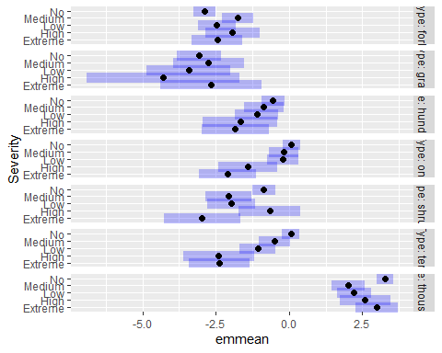
pred_FuelS <- ggpredict(model2_fuels, terms = c("FuelType", "Severity"))
## Some of the focal terms are of type `character`. This may lead to
## unexpected results. It is recommended to convert these variables to
## factors before fitting the model.
## The following variables are of type character: `FuelType`
pred_FuelS <- pred_FuelS %>%
group_by(x) %>%
mutate(pred_scaled = predicted / max(predicted),
conf.low_scaled = conf.low / max(predicted),
conf.high_scaled = conf.high / max(predicted)) %>%
ungroup() %>%
mutate(group = factor(group,
levels = c("No", "Low", "Medium", "High", "Extreme")))%>%
mutate(conf.high_scaled = ifelse(conf.high_scaled > 2.5, 2.5, conf.high_scaled))
ggplot(pred_FuelS,
aes(x = group, y = pred_scaled, fill = group)) +
geom_col() +
geom_errorbar(aes(ymin = conf.low_scaled, ymax = conf.high_scaled),
width = 0.2) +
facet_wrap(~ x, ncol = 4) +
labs(x = "Severity",
y = "Predicted Fuel Load (scaled)",
fill = "Severity") +
scale_fill_manual(values = cols_sev) +
theme_classic() +
theme(
axis.text.x = element_blank(),
axis.ticks.x = element_blank(),
axis.title.x = element_text(size = 14, face = "bold"),
axis.title.y = element_text(size = 14, face = "bold"),
axis.text.y = element_text(size = 12, face = "bold"),
legend.title = element_text(size = 13, face = "bold"),
legend.text = element_text(size = 12))
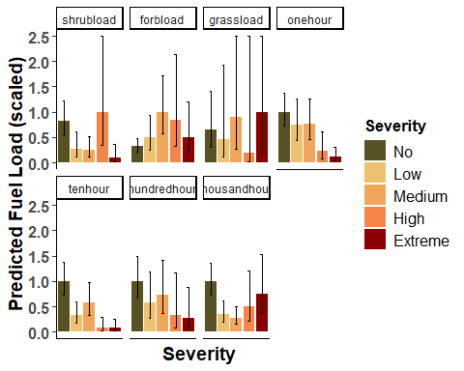
Recruitment
##Recruitment
Thor_data_recruitment$Type<-as.factor(Thor_data_recruitment$Type)
model2_recruitment<-glmmTMB(Abundance ~ Type * Severity + SiteClass,
family=nbinom2(),
ziformula = ~ Treatment,
data=Thor_data_recruitment_sev)
Anova(model2_recruitment,type=3)
## Analysis of Deviance Table (Type III Wald chisquare tests)
##
## Response: Abundance
## Chisq Df Pr(>Chisq)
## (Intercept) 0.0000 1 0.99972
## Type 0.0001 1 0.99241
## Severity 11.2445 4 0.02395 *
## SiteClass 0.0559 2 0.97242
## Type:Severity 83.4846 4 < 2e-16 ***
## ---
## Signif. codes: 0 '***' 0.001 '**' 0.01 '*' 0.05 '.' 0.1 ' ' 1
res_model2_recruitment<-simulateResiduals(model2_recruitment)
plot(res_model2_recruitment)
## Warning in newton(lsp = lsp, X = G$X, y = G$y, Eb = G$Eb, UrS = G$UrS, L = G$L,
## : Fitting terminated with step failure - check results carefully
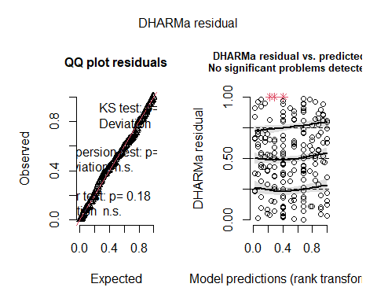
recruitment_severity <- emmeans(model2_recruitment,~ Severity|Type, type = "response")
contrast(recruitment_severity,method = "poly",type="response")
## Type = SaplingAbundance:
## contrast ratio SE df null z.ratio p.value
## linear 3.14e+17 2.45e+21 Inf 1 0.005 0.9959
## quadratic 0.00e+00 0.00e+00 Inf 1 -0.004 0.9969
## cubic 7.67e+08 2.99e+12 Inf 1 0.005 0.9958
## quartic 0.00e+00 0.00e+00 Inf 1 -0.003 0.9973
##
## Type = SeedlingAbundance:
## contrast ratio SE df null z.ratio p.value
## linear 0.00e+00 0.00e+00 Inf 1 -1.586 0.1127
## quadratic 0.00e+00 0.00e+00 Inf 1 -2.985 0.0028
## cubic 0.00e+00 0.00e+00 Inf 1 -2.212 0.0270
## quartic 1.00e+00 2.00e+00 Inf 1 0.035 0.9717
##
## Results are averaged over the levels of: SiteClass
## Tests are performed on the log scale
contrast(recruitment_severity,method = "pairwise", type="response")
## Type = SaplingAbundance:
## contrast ratio SE df null z.ratio p.value
## Extreme / High 0.0000 9.35e-05 Inf 1 -0.004 1.0000
## Extreme / Low 0.0000 7.71e-05 Inf 1 -0.005 1.0000
## Extreme / Medium 0.0000 1.06e-04 Inf 1 -0.004 1.0000
## Extreme / No 0.0000 6.50e-06 Inf 1 -0.005 1.0000
## High / Low 0.8251 7.87e-01 Inf 1 -0.201 0.9996
## High / Medium 1.1342 1.10e+00 Inf 1 0.130 0.9999
## High / No 0.0699 5.87e-02 Inf 1 -3.168 0.0133
## Low / Medium 1.3746 9.67e-01 Inf 1 0.452 0.9914
## Low / No 0.0848 4.39e-02 Inf 1 -4.768 <.0001
## Medium / No 0.0617 3.33e-02 Inf 1 -5.161 <.0001
##
## Type = SeedlingAbundance:
## contrast ratio SE df null z.ratio p.value
## Extreme / High 1.1393 5.35e-01 Inf 1 0.278 0.9987
## Extreme / Low 0.6972 2.77e-01 Inf 1 -0.908 0.8939
## Extreme / Medium 0.6549 2.44e-01 Inf 1 -1.134 0.7886
## Extreme / No 2.4897 8.24e-01 Inf 1 2.756 0.0463
## High / Low 0.6120 2.75e-01 Inf 1 -1.092 0.8108
## High / Medium 0.5748 2.48e-01 Inf 1 -1.285 0.7003
## High / No 2.1853 8.70e-01 Inf 1 1.964 0.2839
## Low / Medium 0.9393 2.98e-01 Inf 1 -0.197 0.9997
## Low / No 3.5709 1.03e+00 Inf 1 4.434 0.0001
## Medium / No 3.8017 9.97e-01 Inf 1 5.094 <.0001
##
## Results are averaged over the levels of: SiteClass
## P value adjustment: tukey method for comparing a family of 5 estimates
## Tests are performed on the log scale
summary(recruitment_severity,type = "response",infer = TRUE)
## Type = SaplingAbundance:
## Severity response SE df asymp.LCL asymp.UCL null z.ratio p.value
## Extreme 0.000 3.90e-05 Inf 0.0000 Inf 1 -0.005 0.9962
## High 0.414 3.46e-01 Inf 0.0806 2 1 -1.056 0.2908
## Low 0.502 2.53e-01 Inf 0.1871 1 1 -1.370 0.1707
## Medium 0.365 1.93e-01 Inf 0.1293 1 1 -1.904 0.0570
## No 5.920 1.14e+00 Inf 4.0577 9 1 9.229 <.0001
##
## Type = SeedlingAbundance:
## Severity response SE df asymp.LCL asymp.UCL null z.ratio p.value
## Extreme 37.643 1.22e+01 Inf 19.9440 71 1 11.195 <.0001
## High 33.041 1.29e+01 Inf 15.3635 71 1 8.953 <.0001
## Low 53.989 1.41e+01 Inf 32.3171 90 1 15.234 <.0001
## Medium 57.479 1.39e+01 Inf 35.7305 92 1 16.702 <.0001
## No 15.119 2.51e+00 Inf 10.9194 21 1 16.358 <.0001
##
## Results are averaged over the levels of: SiteClass
## Confidence level used: 0.95
## Intervals are back-transformed from the log scale
## Tests are performed on the log scale
#seedling
#low-no
((53.989 - 15.119)/15.119)*100
## [1] 257.0937
#med-low
((57.479-53.989)/53.989)*100
## [1] 6.46428
#high-med
((33.041- 57.479)/ 57.479)*100
## [1] -42.5164
#extreme-high
((37.643-33.041 )/33.041 )*100
## [1] 13.92815
#sapling
#low-no
((0.502- 5.920)/ 5.920)*100
## [1] -91.52027
##med-low
((0.365 - 0.502)/ 0.502)*100
## [1] -27.29084
#high-med
((0.414-0.365)/0.365)*100
## [1] 13.42466
#extreme-high
((0-0.414)/0.414)*100
## [1] -100
pairs(recruitment_severity)
## Type = SaplingAbundance:
## contrast ratio SE df null z.ratio p.value
## Extreme / High 0.0000 9.35e-05 Inf 1 -0.004 1.0000
## Extreme / Low 0.0000 7.71e-05 Inf 1 -0.005 1.0000
## Extreme / Medium 0.0000 1.06e-04 Inf 1 -0.004 1.0000
## Extreme / No 0.0000 6.50e-06 Inf 1 -0.005 1.0000
## High / Low 0.8251 7.87e-01 Inf 1 -0.201 0.9996
## High / Medium 1.1342 1.10e+00 Inf 1 0.130 0.9999
## High / No 0.0699 5.87e-02 Inf 1 -3.168 0.0133
## Low / Medium 1.3746 9.67e-01 Inf 1 0.452 0.9914
## Low / No 0.0848 4.39e-02 Inf 1 -4.768 <.0001
## Medium / No 0.0617 3.33e-02 Inf 1 -5.161 <.0001
##
## Type = SeedlingAbundance:
## contrast ratio SE df null z.ratio p.value
## Extreme / High 1.1393 5.35e-01 Inf 1 0.278 0.9987
## Extreme / Low 0.6972 2.77e-01 Inf 1 -0.908 0.8939
## Extreme / Medium 0.6549 2.44e-01 Inf 1 -1.134 0.7886
## Extreme / No 2.4897 8.24e-01 Inf 1 2.756 0.0463
## High / Low 0.6120 2.75e-01 Inf 1 -1.092 0.8108
## High / Medium 0.5748 2.48e-01 Inf 1 -1.285 0.7003
## High / No 2.1853 8.70e-01 Inf 1 1.964 0.2839
## Low / Medium 0.9393 2.98e-01 Inf 1 -0.197 0.9997
## Low / No 3.5709 1.03e+00 Inf 1 4.434 0.0001
## Medium / No 3.8017 9.97e-01 Inf 1 5.094 <.0001
##
## Results are averaged over the levels of: SiteClass
## P value adjustment: tukey method for comparing a family of 5 estimates
## Tests are performed on the log scale
plot(recruitment_severity)
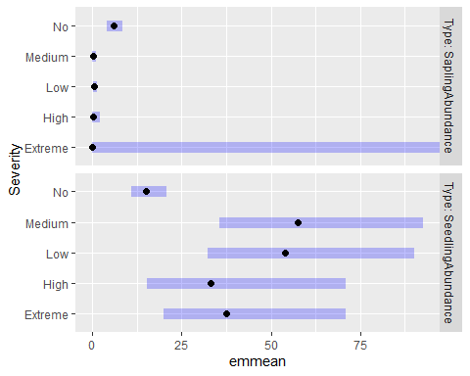
pred_recruitment <- ggpredict(model2_recruitment, terms = c("Type", "Severity"))
## Some of the focal terms are of type `character`. This may lead to
## unexpected results. It is recommended to convert these variables to
## factors before fitting the model.
## The following variables are of type character: `Type`
pred_recruitment <- pred_recruitment %>%
group_by(x) %>%
mutate(pred_scaled = predicted / max(predicted),
conf.low_scaled = conf.low / max(predicted),
conf.high_scaled = conf.high / max(predicted)) %>%
ungroup() %>%
mutate(group = factor(group,
levels = c("No", "Low", "Medium", "High", "Extreme")))
ggplot(pred_recruitment,
aes(x = group, y = predicted, fill = group)) +
geom_col() +
geom_errorbar(
aes(ymin = conf.low, ymax = conf.high),
width = 0.2) +
facet_wrap( ~ x, scales = "free_y",
labeller = as_labeller(c(
"SaplingAbundance" = "Sapling",
"SeedlingAbundance" = "Seedling"))) +
labs(
x = "Severity",
y = "Predicted Abundance",
fill = "Severity") +
scale_fill_manual(values = cols_sev) +
theme_classic() +
theme(
axis.text.x = element_blank(),
axis.ticks.x = element_blank(),
axis.title.x = element_text(size = 14, face = "bold"),
axis.title.y = element_text(size = 14, face = "bold"),
axis.text.y = element_text(size = 12, face = "bold"),
legend.title = element_text(size = 13, face = "bold"),
legend.text = element_text(size = 12),
strip.text = element_text(size = 13, face = "bold"))
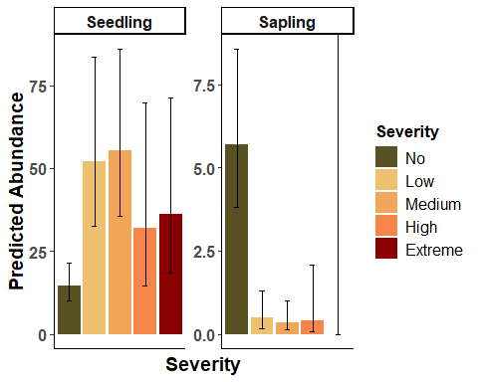
Detritus
model2_LD<-glmmTMB(Depth~ Type * Severity + SiteClass,
family=tweedie(link = "log"),
data=Thor_data_LD_sev)
Anova(model2_LD,type=3)
## Analysis of Deviance Table (Type III Wald chisquare tests)
##
## Response: Depth
## Chisq Df Pr(>Chisq)
## (Intercept) 47.718 1 4.920e-12 ***
## Type 4.680 1 0.030515 *
## Severity 45.020 4 3.938e-09 ***
## SiteClass 13.220 2 0.001347 **
## Type:Severity 27.422 4 1.633e-05 ***
## ---
## Signif. codes: 0 '***' 0.001 '**' 0.01 '*' 0.05 '.' 0.1 ' ' 1
res_model2_LD<-simulateResiduals(model2_LD)
plot(res_model2_LD)

LD_severity <- emmeans(model2_LD,~ Severity|Type, type = "response")
contrast(LD_severity,method = "poly", type="response")
## Type = mean_duff:
## contrast ratio SE df null z.ratio p.value
## linear 320.8915 447.000 Inf 1 4.147 <.0001
## quadratic 0.7102 1.040 Inf 1 -0.234 0.8146
## cubic 25.1449 27.100 Inf 1 2.991 0.0028
## quartic 1.0785 2.440 Inf 1 0.033 0.9734
##
## Type = mean_litter:
## contrast ratio SE df null z.ratio p.value
## linear 8.5644 12.200 Inf 1 1.513 0.1303
## quadratic 0.0916 0.139 Inf 1 -1.574 0.1155
## cubic 7.2708 8.140 Inf 1 1.773 0.0763
## quartic 0.0405 0.101 Inf 1 -1.281 0.2004
##
## Results are averaged over the levels of: SiteClass
## Tests are performed on the log scale
contrast(LD_severity,method = "pairwise", type= "response")
## Type = mean_duff:
## contrast ratio SE df null z.ratio p.value
## Extreme / High 0.1994 0.1500 Inf 1 -2.149 0.1993
## Extreme / Low 0.2060 0.1430 Inf 1 -2.273 0.1536
## Extreme / Medium 0.2284 0.1580 Inf 1 -2.131 0.2068
## Extreme / No 0.0522 0.0345 Inf 1 -4.470 0.0001
## High / Low 1.0331 0.4450 Inf 1 0.076 1.0000
## High / Medium 1.1453 0.4900 Inf 1 0.317 0.9978
## High / No 0.2616 0.0980 Inf 1 -3.580 0.0032
## Low / Medium 1.1086 0.3460 Inf 1 0.331 0.9974
## Low / No 0.2532 0.0593 Inf 1 -5.867 <.0001
## Medium / No 0.2284 0.0531 Inf 1 -6.350 <.0001
##
## Type = mean_litter:
## contrast ratio SE df null z.ratio p.value
## Extreme / High 0.2120 0.1600 Inf 1 -2.055 0.2398
## Extreme / Low 0.3390 0.2410 Inf 1 -1.520 0.5492
## Extreme / Medium 0.3051 0.2140 Inf 1 -1.692 0.4386
## Extreme / No 0.2848 0.1920 Inf 1 -1.868 0.3348
## High / Low 1.5990 0.7410 Inf 1 1.013 0.8494
## High / Medium 1.4391 0.6460 Inf 1 0.811 0.9273
## High / No 1.3435 0.5410 Inf 1 0.734 0.9487
## Low / Medium 0.9000 0.3270 Inf 1 -0.290 0.9985
## Low / No 0.8402 0.2570 Inf 1 -0.570 0.9794
## Medium / No 0.9336 0.2670 Inf 1 -0.240 0.9993
##
## Results are averaged over the levels of: SiteClass
## P value adjustment: tukey method for comparing a family of 5 estimates
## Tests are performed on the log scale
summary(LD_severity,type = "response",infer = TRUE)
## Type = mean_duff:
## Severity response SE df asymp.LCL asymp.UCL null z.ratio p.value
## Extreme 0.103 0.0684 Inf 0.0281 0.379 1 -3.424 0.0006
## High 0.517 0.1960 Inf 0.2465 1.086 1 -1.741 0.0816
## Low 0.501 0.1150 Inf 0.3192 0.786 1 -3.008 0.0026
## Medium 0.452 0.1070 Inf 0.2839 0.719 1 -3.352 0.0008
## No 1.978 0.2120 Inf 1.6031 2.440 1 6.363 <.0001
##
## Type = mean_litter:
## Severity response SE df asymp.LCL asymp.UCL null z.ratio p.value
## Extreme 0.103 0.0684 Inf 0.0281 0.379 1 -3.424 0.0006
## High 0.487 0.1880 Inf 0.2282 1.038 1 -1.863 0.0624
## Low 0.304 0.0845 Inf 0.1766 0.524 1 -4.285 <.0001
## Medium 0.338 0.0884 Inf 0.2026 0.565 1 -4.146 <.0001
## No 0.362 0.0594 Inf 0.2626 0.500 1 -6.190 <.0001
##
## Results are averaged over the levels of: SiteClass
## Confidence level used: 0.95
## Intervals are back-transformed from the log scale
## Tests are performed on the log scale
#duff
#low-no
((0.517 - 0.103)/ 0.103)*100
## [1] 401.9417
#med-low
((0.501-0.517)/0.517)*100
## [1] -3.094778
#high-med
((0.452-0.501)/0.501)*100
## [1] -9.780439
#extreme-high
((1.978- 0.452)/ 0.452)*100
## [1] 337.6106
#litter
#low-no
((0.487 -0.103)/0.103)*100
## [1] 372.8155
#med-low
((0.304- 0.487)/ 0.487)*100
## [1] -37.577
#high-med
(( 0.338-0.304)/0.304)*100
## [1] 11.18421
#extreme-high
((0.362-0.338)/0.338)*100
## [1] 7.100592
pred_LD <- ggpredict(model2_LD, terms = c("Type", "Severity"))
ggplot(pred_LD,
aes(x = group, y = predicted, fill = group)) +
geom_col() +
geom_errorbar(
aes(ymin = conf.low, ymax = conf.high),
width = 0.2) +
facet_wrap(
~ x,
labeller = as_labeller(c(
"mean_duff" = "Duff",
"mean_litter" = "Litter"))) +
labs(
x = "Severity",
y = "Predicted Mean Depth",
fill = "Severity") +
scale_fill_manual(values = cols_sev) +
theme_classic() +
theme(
axis.text.x = element_blank(),
axis.ticks.x = element_blank(),
axis.title.x = element_text(size = 14, face = "bold"),
axis.title.y = element_text(size = 14, face = "bold"),
axis.text.y = element_text(size = 12, face = "bold"),
legend.title = element_text(size = 13, face = "bold"),
legend.text = element_text(size = 12),
strip.text = element_text(size = 13, face = "bold"))
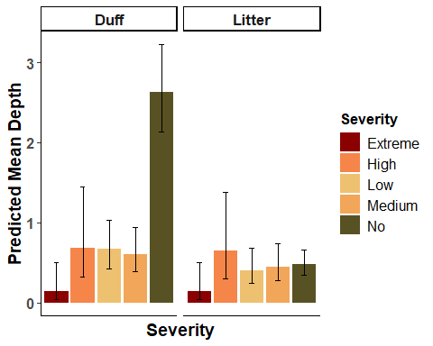
Canopy Cover
#logistic regression for canopy absence
model2.1_canopy <- glmmTMB(
canopy_absence ~ Severity + scaled_baZ + SiteClass,
family = binomial(),
data = Thor_data_canopy_sev)
Anova(model2.1_canopy, type=2)
## Analysis of Deviance Table (Type II Wald chisquare tests)
##
## Response: canopy_absence
## Chisq Df Pr(>Chisq)
## Severity 15.8333 4 0.003251 **
## scaled_baZ 3.7774 1 0.051948 .
## SiteClass 6.0232 2 0.049212 *
## ---
## Signif. codes: 0 '***' 0.001 '**' 0.01 '*' 0.05 '.' 0.1 ' ' 1
res_model2.1_canopy<-simulateResiduals(model2.1_canopy)
plot(res_model2.1_canopy)

canopyabs_severity <- emmeans(model2.1_canopy,~ Severity, type = "response")
pairs(canopyabs_severity)
## contrast odds.ratio SE df null z.ratio p.value
## Extreme / High 8.85e+09 2.05e+14 Inf 1 0.001 1.0000
## Extreme / Low 1.61e+11 3.74e+15 Inf 1 0.001 1.0000
## Extreme / Medium 2.00e+09 4.64e+13 Inf 1 0.001 1.0000
## Extreme / No 5.11e+11 1.18e+16 Inf 1 0.001 1.0000
## High / Low 1.80e+01 2.90e+01 Inf 1 1.824 0.3597
## High / Medium 0.00e+00 0.00e+00 Inf 1 -1.173 0.7667
## High / No 5.80e+01 9.40e+01 Inf 1 2.504 0.0897
## Low / Medium 0.00e+00 0.00e+00 Inf 1 -3.158 0.0138
## Low / No 3.00e+00 5.00e+00 Inf 1 0.730 0.9495
## Medium / No 2.55e+02 4.01e+02 Inf 1 3.527 0.0038
##
## Results are averaged over the levels of: SiteClass
## P value adjustment: tukey method for comparing a family of 5 estimates
## Tests are performed on the log odds ratio scale
plot(ggpredict(model2.1_canopy, "Severity"))
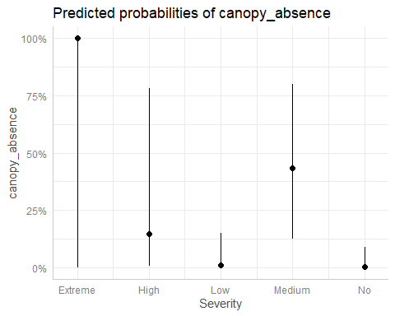
#logistic regression for full canopy
model2.2_canopy <- glmmTMB(
canopy_full ~ Severity + scaled_baZ + SiteClass,
family = binomial(),
data = Thor_data_canopy_sev)
Anova(model2.2_canopy, type=2)
## Analysis of Deviance Table (Type II Wald chisquare tests)
##
## Response: canopy_full
## Chisq Df Pr(>Chisq)
## Severity 6.0308 4 0.19686
## scaled_baZ 3.5121 1 0.06092 .
## SiteClass 4.9416 2 0.08452 .
## ---
## Signif. codes: 0 '***' 0.001 '**' 0.01 '*' 0.05 '.' 0.1 ' ' 1
res_model2.2_canopy<-simulateResiduals(model2.2_canopy)
plot(res_model2.2_canopy)

canopypres_severity <- emmeans(model2.2_canopy,~ Severity, type = "response")
pairs(canopypres_severity)
## contrast odds.ratio SE df null z.ratio p.value
## Extreme / High 1.5901 57100.00 Inf 1 0.000 1.0000
## Extreme / Low 0.0000 0.00 Inf 1 -0.001 1.0000
## Extreme / Medium 0.0000 0.00 Inf 1 -0.001 1.0000
## Extreme / No 0.0000 0.00 Inf 1 -0.001 1.0000
## High / Low 0.0000 0.00 Inf 1 -0.001 1.0000
## High / Medium 0.0000 0.00 Inf 1 -0.001 1.0000
## High / No 0.0000 0.00 Inf 1 -0.001 1.0000
## Low / Medium 9.0834 11.00 Inf 1 1.826 0.3585
## Low / No 0.5600 0.41 Inf 1 -0.792 0.9330
## Medium / No 0.0616 0.07 Inf 1 -2.443 0.1040
##
## Results are averaged over the levels of: SiteClass
## P value adjustment: tukey method for comparing a family of 5 estimates
## Tests are performed on the log odds ratio scale
#Between 0 and 1
model2.3_canopy <- glmmTMB(
canopycover ~ Severity + scaled_baZ + SiteClass,
family = beta_family(),
data = Thor_data_canopy_middle_sev)
Anova(model2.3_canopy, type=2)
## Analysis of Deviance Table (Type II Wald chisquare tests)
##
## Response: canopycover
## Chisq Df Pr(>Chisq)
## Severity 11.1250 3 0.01107 *
## scaled_baZ 4.3990 1 0.03596 *
## SiteClass 0.1429 2 0.93106
## ---
## Signif. codes: 0 '***' 0.001 '**' 0.01 '*' 0.05 '.' 0.1 ' ' 1
res_model2.3_canopy<-simulateResiduals(model2.3_canopy)
plot(res_model2.3_canopy)

testUniformity(res_model2.3_canopy)
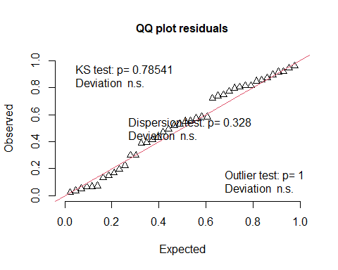
##
## Asymptotic one-sample Kolmogorov-Smirnov test
##
## data: simulationOutput$scaledResiduals
## D = 0.10095, p-value = 0.7854
## alternative hypothesis: two-sided
testDispersion(res_model2.3_canopy)
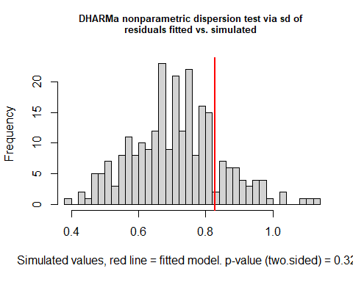
##
## DHARMa nonparametric dispersion test via sd of residuals fitted vs.
## simulated
##
## data: simulationOutput
## dispersion = 1.1635, p-value = 0.328
## alternative hypothesis: two.sided
canopy_severity <- emmeans(model2.3_canopy,~ Severity, type = "response")
contrast(canopy_severity,method = "poly", type="response")
## contrast odds.ratio SE df null z.ratio p.value
## linear 11.2 19.00 Inf 1 1.425 0.1543
## quadratic 2.7 2.35 Inf 1 1.140 0.2543
## cubic 40.4 70.30 Inf 1 2.123 0.0338
##
## Results are averaged over the levels of: SiteClass
## Tests are performed on the log odds ratio scale
contrast(canopy_severity,method = "pairwise", type="response")
## contrast odds.ratio SE df null z.ratio p.value
## High / Low 0.616 0.403 Inf 1 -0.741 0.8804
## High / Medium 1.467 1.020 Inf 1 0.552 0.9462
## High / No 0.335 0.182 Inf 1 -2.009 0.1844
## Low / Medium 2.382 1.290 Inf 1 1.599 0.3789
## Low / No 0.543 0.229 Inf 1 -1.447 0.4702
## Medium / No 0.228 0.117 Inf 1 -2.883 0.0205
##
## Results are averaged over the levels of: SiteClass
## P value adjustment: tukey method for comparing a family of 4 estimates
## Tests are performed on the log odds ratio scale
summary(canopy_severity,type = "response",infer = TRUE)
## Severity response SE df asymp.LCL asymp.UCL null z.ratio p.value
## High 0.400 0.1360 Inf 0.180 0.669 0.5 -0.717 0.4734
## Low 0.520 0.0999 Inf 0.331 0.703 0.5 0.198 0.8427
## Medium 0.313 0.1040 Inf 0.150 0.539 0.5 -1.633 0.1025
## No 0.666 0.0597 Inf 0.541 0.771 0.5 2.568 0.0102
##
## Results are averaged over the levels of: SiteClass
## Confidence level used: 0.95
## Intervals are back-transformed from the logit scale
## Tests are performed on the logit scale
#low/no
(0.520- 0.666)*100
## [1] -14.6
#medium/low
( 0.313 -0.520)*100
## [1] -20.7
#high/medium
( 0.400-0.313 )*100
## [1] 8.7
plot(ggpredict(model2.3_canopy,terms=c("Severity","SiteClass")))
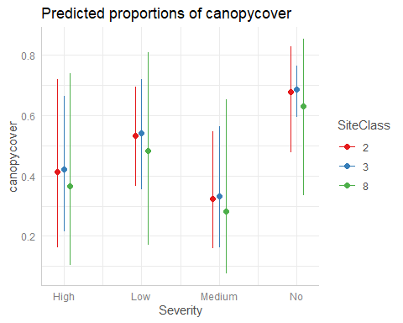
canopy_severity <- as.data.frame(canopy_severity)
ggplot(canopy_severity,
aes(x = Severity, y = response, fill = Severity)) +
geom_col() +
geom_errorbar(aes(ymin = asymp.LCL,
ymax = asymp.UCL),
width = 0.2) +
labs(
x = "Severity",
y = "Predicted Canopy Cover (%)",
fill = "Severity"
) +
scale_fill_manual(values = cols_sev) +
theme_classic() +
theme(
axis.text.x = element_blank(),
axis.ticks.x = element_blank(),
axis.title.x = element_text(size = 20, face = "bold"),
axis.title.y = element_text(size = 20, face = "bold"),
axis.text.y = element_text(size = 20, face = "bold"),
legend.title = element_text(size = 20, face = "bold"),
legend.text = element_text(size = 15))
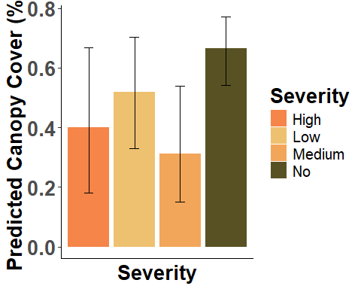
Stand Height
model2_standheight<-glmmTMB(
`Stand Height (ft.)` ~ Severity + scaled_baZ + SiteClass,
family = gaussian,
data = Thor_data_sev)
Anova(model2_standheight, type=2)
## Analysis of Deviance Table (Type II Wald chisquare tests)
##
## Response: Stand Height (ft.)
## Chisq Df Pr(>Chisq)
## Severity 5.6112 4 0.23013
## scaled_baZ 26.8323 1 2.219e-07 ***
## SiteClass 7.1025 2 0.02869 *
## ---
## Signif. codes: 0 '***' 0.001 '**' 0.01 '*' 0.05 '.' 0.1 ' ' 1
res_model2_standheight<-simulateResiduals(model2_standheight)
plot(res_model2_standheight)

SH_severity <- emmeans(model2_standheight,~ Severity, type = "link")
contrast(SH_severity,method = "poly", type= "response")
## contrast estimate SE df t.ratio p.value
## linear -23.71 16.8 86 -1.413 0.1613
## quadratic 44.01 19.4 86 2.269 0.0258
## cubic -8.68 18.0 86 -0.481 0.6316
## quartic -7.06 43.8 86 -0.161 0.8723
##
## Results are averaged over the levels of: SiteClass
contrast(SH_severity,method = "pairwise", type="response")
## contrast estimate SE df t.ratio p.value
## Extreme - High 13.90 9.72 86 1.431 0.6098
## Extreme - Low 18.69 8.33 86 2.243 0.1740
## Extreme - Medium 15.17 8.01 86 1.894 0.3282
## Extreme - No 11.22 7.20 86 1.558 0.5284
## High - Low 4.79 8.59 86 0.557 0.9807
## High - Medium 1.27 8.33 86 0.153 0.9999
## High - No -2.68 7.63 86 -0.352 0.9967
## Low - Medium -3.52 6.23 86 -0.565 0.9798
## Low - No -7.47 5.39 86 -1.387 0.6378
## Medium - No -3.95 5.06 86 -0.781 0.9354
##
## Results are averaged over the levels of: SiteClass
## P value adjustment: tukey method for comparing a family of 5 estimates
summary(SH_severity,type = "response",infer = TRUE)
## Severity emmean SE df lower.CL upper.CL t.ratio p.value
## Extreme 76.6 7.35 86 62.0 91.2 10.419 <.0001
## High 62.7 7.70 86 47.4 78.0 8.143 <.0001
## Low 57.9 5.06 86 47.9 68.0 11.444 <.0001
## Medium 61.4 5.04 86 51.4 71.5 12.188 <.0001
## No 65.4 3.31 86 58.8 72.0 19.770 <.0001
##
## Results are averaged over the levels of: SiteClass
## Confidence level used: 0.95
#low-no
((57.9-65.4)/65.4)*100
## [1] -11.46789
#med-low
((61.4-57.9)/57.9)*100
## [1] 6.044905
#high-med
(( 62.7-61.4)/61.4)*100
## [1] 2.117264
#extreme-high
((76.6-62.7)/62.7)*100
## [1] 22.16906
pred_SH <- ggpredict(model2_standheight, terms = "Severity")
## Warning: Looks like you are using syntactically invalid variable names, quoted in
## backticks: `Stand Height (ft.)`. This may result in unexpected
## behaviour. Please rename your variables (e.g., `Stand.Height..ft..`
## instead of `Stand Height (ft.)`) and fit the model again.
ggplot(pred_SH,
aes(x =x, y = predicted, fill = x)) +
geom_col() +
geom_errorbar(aes(ymin = conf.low, ymax = conf.high),
width = 0.2) +
labs(x = "Severity",
y = "Predicted Stand Height",
fill = "Severity") +
scale_fill_manual(values = cols_sev) +
theme_classic() +
theme(
axis.text.x = element_blank(),
axis.ticks.x = element_blank(),
axis.title.x = element_text(size = 20, face = "bold"),
axis.title.y = element_text(size = 20, face = "bold"),
axis.text.y = element_text(size = 20, face = "bold"),
legend.title = element_text(size = 20, face = "bold"),
legend.text = element_text(size = 15))
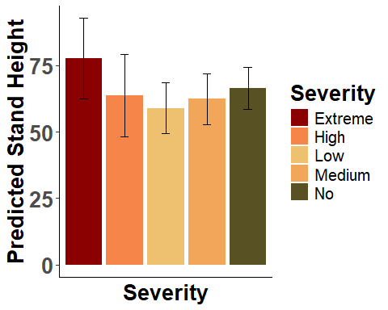
Individual prediction plots generated for each forest structure response variable (stand height, understory height, basal area, canopy presence/absence/percent, seedling and sapling abundance, and mortality presence/absence/percent) were relabeled with shared titles and formatting, then assembled into a single multi-panel figure using patchwork. Shared x- and y-axis labels were added as separate blank ggplot panels and combined with the response-variable panels using plot_layout() to produce one composite figure with a single external axis label rather than repeated labels on each subplot.
#Forest Structure
Pstandheight = Pstandheight +
labs(x = NULL, y = NULL, title = "Stand Height (ft.)") +
theme(plot.title = element_text(face = "bold"))
Punderstoryheight = Punderstoryheight +
labs(x = NULL, y = NULL, title = "Understory Height (in.)") +
theme(plot.title = element_text(face = "bold"))
Pbasalarea = Pbasalarea +
labs(x = NULL, y = NULL, title = "Basal Area (acre)") +
theme(plot.title = element_text(face = "bold"))
Pcanopya = Pcanopya +
labs(x = NULL, y = NULL, title = "Canopy (A)") +
theme(plot.title = element_text(face = "bold"))
Pcanopyp = Pcanopyp +
labs(x = NULL, y = NULL, title = "Canopy (P)") +
theme(plot.title = element_text(face = "bold"))
Pcanopy = Pcanopy +
labs(x = NULL, y = NULL, title = "Canopy%") +
theme(plot.title = element_text(face = "bold"))
Pseedling = Pseedling +
labs(x = NULL, y = NULL, title = "#Seedling") +
theme(plot.title = element_text(face = "bold"))
PSapling = PSapling +
labs(x = NULL, y = NULL, title = "#Sapling") +
theme(plot.title = element_text(face = "bold"))
Pmortalitya = Pmortalitya +
labs(x = NULL, y = NULL, title = "Mortality (A)") +
theme(plot.title = element_text(face = "bold"))
Pmortalityp = Pmortalityp +
labs(x = NULL, y = NULL, title = "Mortality (P)") +
theme(plot.title = element_text(face = "bold"))
Pmortality = Pmortality +
labs(x = NULL, y = NULL, title = "Mortality%") +
theme(plot.title = element_text(face = "bold"))
# Y-axis panel
y_axis_plot <- ggplot() +
geom_blank() +
labs(y = "Predicted Marginal Mean") +
theme_void() +
theme(
axis.title.y = element_text(angle = 90, size = 14, vjust = 0.5),
plot.margin = margin(0, 0, 0, 0),
plot.title = element_text(face= "bold"))
blank <- ggplot() + theme_void()
# Forest structure panels
forest_panels <- (Pstandheight | Punderstoryheight | Pbasalarea) /
(Pcanopya | Pcanopyp | Pcanopy) /
(Pseedling | PSapling | Pmortalitya)/
(Pmortalityp | Pmortality | blank)
# X-axis label panel
x_axis_plot <- ggplot() +
annotate("text", x = 1, y = 1, label = "Burn Status", size = 5) +
theme_void() +
theme(
plot.margin = margin(0, 0, 0, 0),
plot.title = element_text(face = "bold"))
# Combine
ForestStructure_plot <- (y_axis_plot | (forest_panels / x_axis_plot)) +
plot_layout(widths = c(0.05, 1), heights = c(1, 0.02),
guides = "collect")+
theme(plot.margin = margin(0, -5, 0, 0))
ForestStructure_plot
