**Samantha Mellin**

**Dec 8 2016**

Noise Reduction Analysis

# Abstract

After working to reduce the noise generated while taking data for a highly sensitive probe we must determine whether the noise reduction implemented has resulted in data collection with appropriate levels of noise. Already costly equipment and man-hours have been put into this system, so whether or not to continue to work to reduce noise, and the impact of those noise reduction techniques are of vital importance. Current methods to determine the effect of the noise on the system rely on highly convoluted data-manipulation techniques. A Bayesian approach to noise-distribution will determine the true level and distribution of noise from which further conclusions can be drawn. After implementing a Bayesian analysis on the signal distribution across a number of sample conditions, it is seen that even when there appear to be some non-uniform distribution to the noise, all the noise generated is uniform, and that variance in noise using further noise reduction techniques is inconsistent and thus likely insignificant.

# Introduction

Noise is one of the most difficult problems to diagnose. Continuing effort is committed to improving the signal to noise ratio of a prototype emittance scanner in the hopes of finding an effective way to measure the emittance and thus brightness of a plasma ion-source currently used in electron microscopy. This is a first necessary step to redesigning the extractor geometry in order to improve ion-source performance; if there is not an analytical way to tell if one beam is performing better than another then you cannot analyze the impact of geometry on the beam.

The inspiration for this study into the distribution of noise came on the tail of a signal to noise characterization test using distinct speed settings on the Keithley 6487 picoammeter.[1] The study was designed to determine the most efficient rate at which to measure the current accounting for speed and signal clarity. The results of the test however we inconclusive, as the behavior of the noise did not follow the expected relationship based on the instrument manual. Further observation shows the region around the maximum does not have statistically significant variance, making it difficult to determine with confidence the true area of maximum current. This in itself is not detrimental to the end design as we are looking to find a reliable user-facing tool to find the maximum current, not the region of maximum current. However, we cannot currently move forward on an automated method for aligning our probe in which to take the current until we have an accurate enough measurement device. It is from this data that a Bayesian analytical technique will be applied.

The noise detected in the measurements can arise from several different origins, currently we are attempting to control for vibrations from the surroundings, from the type and length of cable used to connect the source to the picoammeter and the picoammeter resolution itself. All easily implemented noise reduction techniques have been employed in the system, now we must look at the data to confirm if any further noise-reduction is necessary, and check if current ‘advanced’ techniques actually improve the quality of the collection.

Previous noise analysis focused on end-stage results in the full-width 50, a standard measurement used in emittance collection. The full-width 50’s was generated with a modified boot-strap sampler on the raw data of each collected sample. The variance in the full-width was determined to be the result of noise in the system. This analysis results in a many-times removed look at the raw data, possibly distorting the effects and importance of the noise in the data. Bootstrapping is commonly used when Bayesian analytical techniques are either unavailable or unknown.[2] A baysian approach will show us if the noise is order-dependent, or if it is uniformly distributed over samples.

# Noise in Emitter Measurements:

As part of an ongoing project to optimize a new type of emittance scanner for a Plasma Ion Source the rate of sampling was characterized to ensure optimal sampling rate was chosen to ensure minimum time spend during data collection without effecting sample reliability.

The data we will be using comes from 5 different levels of sampling rate starting at 2 powerline cycles (2PLC) which runs for 33.34msec up to 6PLC or 100.2msec (.1second), and a rerunning of 2PLC for a total of 3 2PLC emittance collections. Although increasing PLC results in a longer integration time by the Keithly, there was no difference in data collection times across the samples.

A quick look at the spread of currents across the data showed that there was an odd trend in PLC4 [figure 3], so it was omitted from the analysis, and there were no immediately apparent trends in the noise correlated with the time the sample was taken. Running an algorithm that checks different types of probability distributions showed that all of the noise is most likely uniformly generated, without a large spread in probability distributions. The power line cycle had little effect on the probability distribution [figure 4], which is reasonable looking at the spread of data when looking at a single area across PLC values [figure 5].

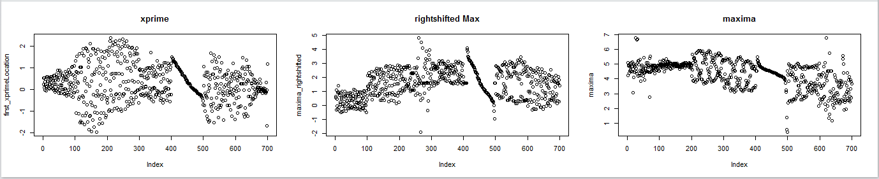

Figure 3: Data Distribution with each 100 index increment a new data collection condition

|  |  |
| --- | --- |
| **Power Line Cycles** | **Uniform Probability Distribution**  Figure 4: table of PDF values found with Baysian analysis program. All data was found to follow uniform distribution |
| 2PLC | PDF = 57.26% |
| 3PLC | PDF = 72.49% |
| 4PLC | PDF = 62.36% |
| 5PLC | PDF = 59.20% |

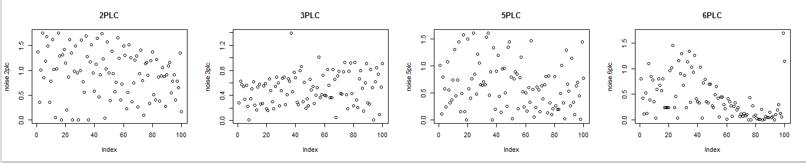

Figure 5: Looking at the difference between samples around the first point of collection(~ 75 um from maxima location)

Even regions that seemed to have some alternative type of data distribution were shown to follow a uniform distribution like the visually sinusoidal data around the maxima of PLC 2 & PLC3 albeit with a very small PDF of 35.5%.

# Conclusions

While there appeared to be a pattern to the noise data, Bayesian analysis of varied probability distributions indicated that the noise was consistently uniform. There did not seem to be any great effect of PLC value on the data which is congruent with our observation that PLC value did not affect the time to complete data collection, and the small returns found by increasing the PLC from 1 to 10. The uniform data all fell within 57-72% of the probability density function.

Future work would include replacing the apertures on the instrument to see how beam spread effects the noise distribution, however inconsistencies across samples indicates that taking similar samples across different conditions does not behave consistently.

Current noise reduction techniques are sufficient at this time moving forward. After improving the data collection to reduce errors across steps and the aperture manufacture methods it may be reasonable to revisit the noise in the data distributions. However, given current conditions, noise reduction efforts are unlikely to result in improved data collection given the small impact of PLC on performance. Any further conceived efforts are not likely to improve the collection beyond that of the PLC rate.

1. Internal FEI memo Melanie Pierce to FEI Plasma Emitters Group; *Characterization of Keithley Rates for Uncertainty in FW50 values*
2. http://www.sumsar.net/blog/2015/04/the-non-parametric-bootstrap-as-a-bayesian-model/