Databases Final Project

Samantha Siow (415)

Daniel Jalova (315)

We created a database of startups, founders and investors.

This database allows users to query for startups or people within a given market type or location, and to find their success rates.

**Changes to our initial vision:**

We had to do away including the amount and type of funding that startups have received because that information was not readily available on the API we were using.

We changed the format of our database such that investors are grouped together with startup founders and employees, and investing companies are group together with startups. This removed the need for an investorID and simplified our database.

**Specialized Data Extraction:**

Because we used the AngelList API[1], we found that a lot of the data we needed was in JSON format. There were several stages to extracting the data that we need. Using AngelList’s RESTful interface, we created a Python script[2] to send http queries for startups and people, and then saved these as lists of JSON Objects. We then created a Java program that parsed the JSON into Startup and Person classes, and converted each object into a .csv file. Each .csv file represented a table in our database, resulting in tables for StartupMarkets, StartupListings, UserRoles, StartupLocations and StartupTypes. This made it much easier to load onto the MySQL database using the inbuilt LOAD LOCAL DATA INFILE method.

The Python script and Java program can be found in the PythonScripts folder and the AngelListJSONtoCSVParser folder respectively.

**User Guide:**

The user can run the code through their browser.

**Major areas of Specialization:**

* Complex extraction of real data from online sources: This was achieved through the complex parsing of data in JSON format from the AngelList API into MySQL.
* Specialized view or forms-based interface with sophisticated report generation: This was achieved through a CSS/HTML browser interface that would allow the user to view all information on a startup, the related people, and what their roles are within the startup. The user can also filter all the startups by location or market type, and a generated reported on any startup in the database.

**System Limitations and Suggested Possibilities for Improvement**

* We are limited by the size of memory of our ugrad database. One way we could improve this was to move the database onto a different server, should we have needed more memory.
* We are also limited by the AngelList API, which only allowed us to pull 1000 queries per hour. Because of limited time and the large volume of data, we were only able to pull approximately 8,000 queries which might not be a good approximation of the full extent of all the Startups and related people in the world. One way we could have improved this was by utilizing different APIs, such as Crunchbase, in order to pull more information, but that would have involved more complex parsing methods because the format would be very different.
* Additionally, the AngelList API did not have some of the data we needed in order to make more complex queries and relations, such as the type and amount of funding startups had. In order to improve this, we could, as said above, have utilized a different API that would have provided this information.

**Sample Output**

Home screen:

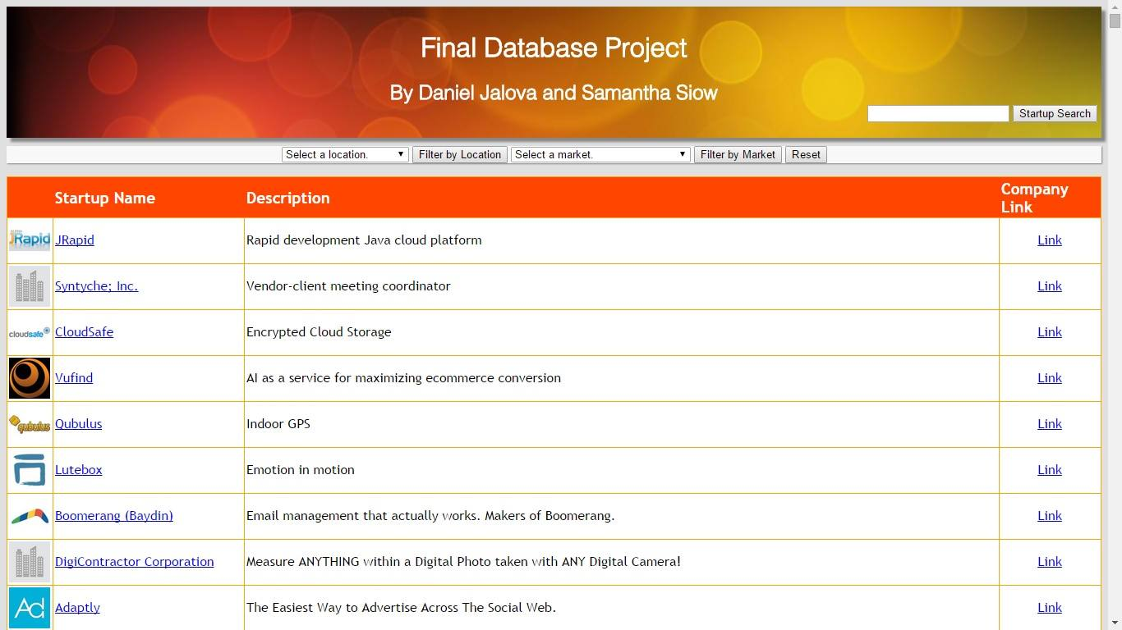

Filter by drop down boxes:

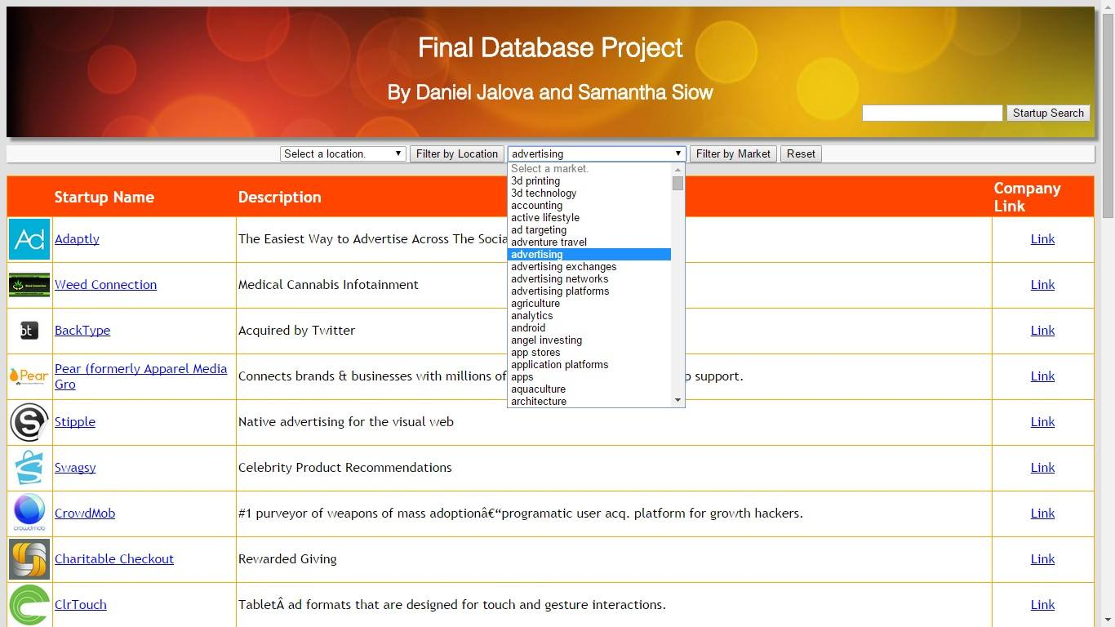

Resulting report generated for a startup:

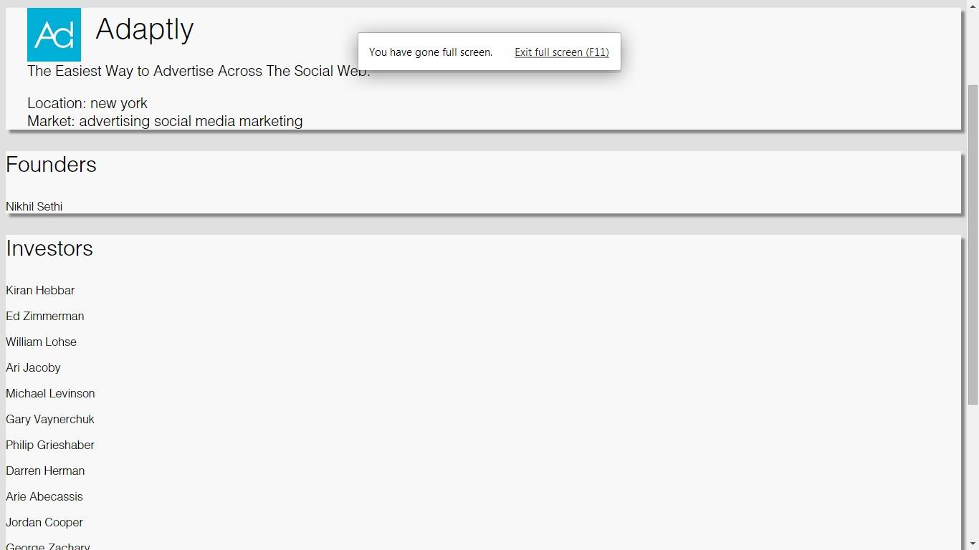

**Relational Table Specification [4]**

DROP TABLE IF EXISTS StartupListing; # Startup data

CREATE TABLE StartupListing

(id INT NOT NULL PRIMARY KEY, # id = 123

startupName VARCHAR(32) NOT NULL, # startupName = 'AngelList'

quality int NOT NULL, # quality = 10, based on AngelList rankings

highConcept VARCHAR(140), # highConcept = 'A platform for startups'

companyUrl VARCHAR(140), # companyUrl = 'http://angel.co'

companySize VARCHAR(12), # companySize = '1-10'

thumbUrl VARCHAR(200)); # thumbUrl = 'http://....jpg' thumbnail image

DROP TABLE IF EXISTS StartupLocation; # Location data for each startup

CREATE TABLE StartupLocation

(id INT NOT NULL, # id for the startup, e.g. 123

location VARCHAR(32) NOT NULL, # location of a startup’s office, e.g. San Francisco

FOREIGN KEY (id) REFERENCES StartupListing(id));

DROP TABLE IF EXISTS StartupMarkets; # Markets for the startup's products

CREATE TABLE StartupMarkets

(id INT NOT NULL, # id for the startup, e.g. 123

market VARCHAR(32) NOT NULL, # market for the startup's product, e.g. mobile

FOREIGN KEY (id) REFERENCES StartupListing(id)); # links to the startup listing

DROP TABLE IF EXISTS StartupTypes; # Type of startup = vc, incubator, closed, acquired

CREATE TABLE StartupTypes

(id INT NOT NULL PRIMARY KEY, # id for the startup, e.g. 123

type VARCHAR(32) NOT NULL, # type of startup, e.g. acquired

FOREIGN KEY (id) REFERENCES StartupListing(id));

DROP TABLE IF EXISTS StartupRoles; # People and their roles in startups

CREATE TABLE StartupRoles

(id INT NOT NULL PRIMARY KEY, # id of the user, e.g. 345

name VARCHAR(32) NOT NULL, # name of the person, e.g. John Smith

roleID INT NOT NULL, # the id of their role

role VARCHAR(32) NOT NULL, # their role in the startup, e.g. founder, past_investor

startupID INT NOT NULL, # id of the startup that they are related to, e.g. 123

FOREIGN KEY (id) REFERENCES StartupListing(id));

**MySQL Code**

LoadTables.SQL

# Loads the database with startup entries from the .csv files.

DROP TABLE IF EXISTS StartupListing; # Startup data

CREATE TABLE StartupListing

(id INT NOT NULL PRIMARY KEY, # id = 123

startupName VARCHAR(32) NOT NULL, # startupName = 'AngelList'

quality int NOT NULL, # quality = 10, based on AngelList rankings

highConcept VARCHAR(140), # highConcept = 'A platform for startups'

companyUrl VARCHAR(140), # companyUrl = 'http://angel.co'

companySize VARCHAR(12), # companySize = '1-10'

thumbUrl VARCHAR(200)); # thumbUrl = 'http://....jpg' thumbnail image

LOAD DATA LOCAL INFILE '/Users/samanthasiow/Documents/Fall 2014/Databases/FinalProject/SQLScripts/AllStartupListings.csv' INTO TABLE StartupListing

FIELDS TERMINATED BY ','

LINES TERMINATED BY '\n';

SELECT * FROM StartupListing;

#Load database with startup locations from csv files

DROP TABLE IF EXISTS StartupLocation; # Location data for each startup

CREATE TABLE StartupLocation

(id INT NOT NULL, # id for the startup, e.g. 123

location VARCHAR(32) NOT NULL, # location of a startup’s office, e.g. San Francisco

FOREIGN KEY (id) REFERENCES StartupListing(id));

LOAD DATA LOCAL INFILE '/Users/samanthasiow/Documents/Fall 2014/Databases/FinalProject/SQLScripts/AllStartupLocations.csv' INTO TABLE StartupLocation

FIELDS TERMINATED BY ','

LINES TERMINATED BY '\n';

SELECT * FROM StartupLocation;

# Load database with startup markets from the csv files

DROP TABLE IF EXISTS StartupMarkets; # Markets for the startup's products

CREATE TABLE StartupMarkets

(id INT NOT NULL, # id for the startup, e.g. 123

market VARCHAR(32) NOT NULL, # market for the startup's product, e.g. mobile

FOREIGN KEY (id) REFERENCES StartupListing(id)); # links to the startup listing

LOAD DATA LOCAL INFILE '/Users/samanthasiow/Documents/Fall 2014/Databases/FinalProject/SQLScripts/AllStartupMarkets.csv' INTO TABLE StartupMarkets

FIELDS TERMINATED BY ','

LINES TERMINATED BY '\n';

SELECT * FROM StartupMarkets;

# Load database with startup types from the csv files

DROP TABLE IF EXISTS StartupTypes; # Type of startup = vc, incubator, closed, acquired

CREATE TABLE StartupTypes

(id INT NOT NULL PRIMARY KEY, # id for the startup, e.g. 123

type VARCHAR(32) NOT NULL, # type of startup, e.g. acquired

FOREIGN KEY (id) REFERENCES StartupListing(id));

LOAD DATA LOCAL INFILE '/Users/samanthasiow/Documents/Fall 2014/Databases/FinalProject/SQLScripts/AllStartupTypes.csv' INTO TABLE StartupTypes

FIELDS TERMINATED BY ','

LINES TERMINATED BY '\n';

SELECT * FROM StartupTypes;

# Load database with people and their roles in startups.

DROP TABLE IF EXISTS StartupRoles; # People and their roles in startups

CREATE TABLE StartupRoles

(id INT NOT NULL PRIMARY KEY, # id of the user, e.g. 345

name VARCHAR(32) NOT NULL, # name of the person, e.g. John Smith

roleID INT NOT NULL, # the id of their role

role VARCHAR(32) NOT NULL, # their role in the startup, e.g. founder, past_investor

startupID INT NOT NULL, # id of the startup that they are related to, e.g. 123

FOREIGN KEY (id) REFERENCES StartupListing(id));

LOAD DATA LOCAL INFILE '/Users/samanthasiow/Documents/Fall 2014/Databases/FinalProject/SQLScripts/AllUserRoles.csv' INTO TABLE StartupRoles

FIELDS TERMINATED BY ','

LINES TERMINATED BY '\n';

SELECT * FROM StartupRoles;

ShowAcquiredStartups.sql

/* Display all acquired startups */

DELIMITER $$

DROP PROCEDURE IF EXISTS ShowAcquiredStartups $$

CREATE PROCEDURE ShowAcquiredStartups()

BEGIN

SELECT startupName as StartupName, highConcept as HighConcept, companyUrl as URL

FROM StartupListing as S, StartupTypes as T

WHERE S.id = T.id and T.type = 'acquired';

END

$$

ShowLargestMarketPerLocation.sql

/* Display the most popular startup market by location */

DELIMITER $$

DROP PROCEDURE IF EXISTS ShowLargestMarketPerLocation $$

CREATE PROCEDURE ShowLargestMarketPerLocation(IN locationName VARCHAR(255))

BEGIN

CREATE OR REPLACE VIEW NumStartupsPerLocation AS

SELECT *

FROM (SELECT M.market as Market, count(market) as NumStartups

FROM StartupLocation as L, StartupMarkets as M

WHERE L.id = M.id and L.location = locationName

GROUP BY market

ORDER BY NumStartups DESC) as M

WHERE M.NumStartups >= ALL (SELECT count(market) as NumStartups

FROM StartupLocation as L, StartupMarkets as M

WHERE L.id = M.id and L.location = locationName

GROUP BY market

ORDER BY NumStartups DESC);

END;

$$

ShowNumStartupsAtLocation.sql

/* Takes a location param, and displays the number of startups at that location */

DELIMITER $$

DROP PROCEDURE IF EXISTS ShowNumStartupsAtLocation $$

CREATE PROCEDURE ShowNumStartupsAtLocation(IN locationName VARCHAR(255))

BEGIN

SELECT L.location, count(L.location) as NumStartups

FROM StartupLocation as L, StartupListing as S

WHERE L.id = S.id and L.location = locationName;

END;

$$

ShowNumStartupsPerLocation.sql

/* Display the number of startups per location */

DELIMITER $$

DROP PROCEDURE IF EXISTS ShowNumStartupsPerLocation $$

CREATE PROCEDURE ShowNumStartupsPerLocation()

BEGIN

SELECT L.location, count(L.location) as NumStartups

FROM StartupLocation as L, StartupListing as S

WHERE L.id = S.id

GROUP BY location

ORDER BY NumStartups DESC;

END;

$$

ShowPercentageAcquiredPerLocation.sql

/* Display an ordered list of the percentage startups acquired by location */

DELIMITER $$

DROP PROCEDURE IF EXISTS ShowPercentageAcquiredPerLocation $$

CREATE PROCEDURE ShowPercentageAcquiredPerLocation()

BEGIN

CREATE OR REPLACE VIEW NumStartupsPerLocation AS

SELECT DISTINCT L.location, count(L.location) as numPerCity

FROM StartupMarkets as M, StartupLocation as L

WHERE M.id = L.id

GROUP BY L.location;

SELECT DISTINCT A.location, (A.numAcquired/N.numPerCity)*100 as PercentageAcquired

FROM NumStartupsPerLocation as N,

(SELECT DISTINCT L.location, count(location) as numAcquired

FROM StartupTypes as T, StartupLocation as L

WHERE T.id = L.id and T.type = 'acquired'

GROUP BY L.Location) as A

WHERE A.location = N.location

ORDER BY PercentageAcquired DESC;

END;

$$

ShowPercentageMarketPerLocation.sql

/* Given a market type, display the % of startups of that market in all locations */

DELIMITER $$

DROP PROCEDURE IF EXISTS ShowPercentageMarketPerLocation $$

CREATE PROCEDURE ShowPercentageMarketPerLocation(IN marketType VARCHAR(255))

BEGIN

CREATE OR REPLACE VIEW NumStartupsPerLocation AS

SELECT DISTINCT L.location, count(L.location) as numPerCity

FROM StartupMarkets as M, StartupListing as S, StartupLocation as L

WHERE M.id = S.id and S.id = L.id

GROUP BY L.location;

SELECT DISTINCT M.location, (M.numPerCity/N.numPerCity)*100 as PercentageMobile

FROM NumStartupsPerLocation as N,

(SELECT DISTINCT L.id, L.location, count(L.location) as numPerCity

FROM StartupMarkets as M, StartupListing as S, StartupLocation as L

WHERE M.id = S.id and S.id = L.id and M.market = marketType

GROUP BY L.location) as M

WHERE M.location = N.location

ORDER BY PercentageMobile DESC;

END;

$$

ShowPersonsByStartup.sql

/* Show all the people related to the startup and what their relation is */

DELIMITER $$

DROP PROCEDURE IF EXISTS ShowPersonsByStartup $$

CREATE PROCEDURE ShowPersonsByStartup(IN startupID INT)

BEGIN

IF EXISTS (SELECT * FROM StartupListing as SL WHERE SL.id = startupID)

THEN

SELECT name as Name, role as Role, startupName as StartupName

FROM StartupListing as S, StartupRoles as R

WHERE R.startupID = S.id and S.id = startupID;

ELSE

SELECT 'No people found for that startup.' AS 'Error Message';

END IF;

END

$$

ShowRolesByStartupID.sql

/* Display all people with a given role, given the startup id*/

DELIMITER $$

DROP PROCEDURE IF EXISTS ShowRolesByStartupID $$

CREATE PROCEDURE ShowRolesByStartupID(IN startupID INT, IN queryBy VARCHAR(255))

BEGIN

IF EXISTS (SELECT * FROM StartupListing as SL WHERE SL.id = startupID)

THEN

SELECT name as Name, role as Role, startupName as StartupName

FROM StartupListing as S, StartupRoles as R

WHERE R.startupID = S.id and S.id = startupID and R.role = queryBy;

ELSE

SELECT 'No people found for that role for that startup.' AS 'Error Message';

END IF;

END;

$$

ShowStartupByLocation.sql

/* Display all startups at a given location */

DELIMITER $$

DROP PROCEDURE IF EXISTS ShowStartupByLocation $$

CREATE PROCEDURE ShowStartupByLocation(IN locationName VARCHAR(255))

BEGIN

IF EXISTS (SELECT location FROM StartupLocation WHERE location = locationName)

THEN

SELECT startupName as StartupName, highConcept as HighConcept, companyUrl as URL

FROM StartupListing as S, StartupLocation as L

WHERE S.id = L.id and L.location = locationName;

ELSE

SELECT 'No Startups Located.' AS 'Error Message';

END IF;

END

$$

ShowStartupByMarket.sql

/* Display all startups in a given market */

DELIMITER $$

DROP PROCEDURE IF EXISTS ShowStartupByMarket $$

CREATE PROCEDURE ShowStartupByMarket(IN marketName VARCHAR(255))

BEGIN

IF EXISTS (SELECT market FROM StartupMarkets WHERE marketName = market)

THEN

SELECT startupName as StartupName, highConcept as HighConcept, companyUrl as URL

FROM StartupListing as S, StartupMarkets as M

WHERE S.id = M.id and M.market = marketName;

ELSE

SELECT 'No Startups found in that Market.' AS 'Error Message';

END IF;

END

$$

ShowStartupIDByName.sql

/* Given a startup id, return the name of the startup */

DELIMITER $$

DROP PROCEDURE IF EXISTS ShowStartupIDByName $$

CREATE PROCEDURE ShowStartupIDByName(IN startupName VARCHAR(255))

BEGIN

IF EXISTS (SELECT * FROM StartupListing as SL WHERE SL.startupName = startupName)

THEN

SELECT id as id

FROM StartupListing as S

WHERE S.startupName = startupName;

ELSE

SELECT 'No startups found for that ID.' AS 'Error Message';

END IF;

END

$$

ShowPersonRoles.sql

/* Show all roles a person has, given their name */

DELIMITER $$

DROP PROCEDURE IF EXISTS ShowPersonRoles $$

CREATE PROCEDURE ShowPersonRoles(IN personName VARCHAR(255))

BEGIN

IF EXISTS (SELECT * FROM StartupRoles WHERE personName = name)

THEN

SELECT name as Name, role as Role, startupName as StartupName

FROM StartupListing as S, StartupRoles as R

WHERE R.startupID = S.id and R.name = personName;

ELSE

SELECT 'No Startups found in that Market.' AS 'Error Message';

END IF;

END

$$

**Python Scripts for Retrieving Data on the AngelList RESTful Interface**

pullStartups.py

import os,sys

import urllib

import json

from angellist import AngelList

def main(argv):

if len(sys.argv) != 3 or not argv[1].isdigit() or not argv[2].isdigit():

print "Usage is python read.py <start ID> <end ID>"

exit()

if ( int(argv[1]) > int(argv[2]) ):

print "Invalid range"

exit()

filename = "Startups_" + argv[1] + "-" + argv[2]

if not os.path.isfile(filename):

angel = AngelList("6093fd1f428b52cd5e5f039e63b4870ce3b3c5884ff35e32")

# angelapi.search({'method':'GET', 'query':'search-string'})

f = open(filename, 'w')

# Enter range of IDs here

for x in range( int(argv[1]), int(argv[2]) ):

try:

f.write(json.dumps( angel.startups({'method':'GET', 'id':str(x)}) ) )

f.write('\n')

except Exception:

pass

if __name__ == "__main__":

main(sys.argv)

pullStartupRoles.py

import sys, os

import json

import urllib2

from angellist import AngelList

def main(argv):

if len(sys.argv) != 3 or not argv[1].isdigit() or not argv[2].isdigit():

print "Usage is python pullStartupRoles.py <start ID> <end ID>"

exit()

startID = int(argv[1])

endID = int(argv[2])

if ( startID >= endID ):

print "Invalid Range"

try:

roles = open( "roles", 'r')

except IOError:

"File does not exist"

filename = "Roles_" + argv[1] + "-" + argv[2]

if not os.path.isfile(filename):

angel = AngelList("6093fd1f428b52cd5e5f039e63b4870ce3b3c5884ff35e32")

ANGELLIST_ROLES_URL = "https://api.angel.co/1/startup_roles?startup_id="

f = open(filename, 'w')

# Enter range of IDs here

for startupID in roles:

try:

if ( int(startupID) >= startID and int(startupID) <= endID ):

result = json.dumps(json.loads(urllib2.urlopen(ANGELLIST_ROLES_URL + startupID).read()))

f.write( '{"startupID":' + startupID.rstrip('\n') + ', ' + result[1:])

f.write('\n')

except Exception:

pass

if __name__ == "__main__":

main(sys.argv)

**Java Program for parsing JSON to .csv files**

StartupListing.java

**package** StartupData;

/* Holds all the data for a startup */

**public** **class** StartupListing {

**private** String id;

**private** String name;

**private** String quality;

**private** String highConcept;

**private** String companyUrl;

**private** String companySize;

**private** String thumbUrl;

**public** StartupListing(String id,String name, String quality,

String highConcept, String companyUrl, String companySize, String thumbUrl) {

**super**();

**this**.id = id;

**this**.name = name;

**this**.quality = quality;

**this**.highConcept = highConcept;

**this**.companyUrl = companyUrl;

**this**.companySize = companySize;

**this**.thumbUrl = thumbUrl;

}

@Override

**public** String toString() {

**return** id.replace(",", ";")

+ "," + name.replace(",", ";")

+ "," + quality.replace(",", ";")

+ "," + highConcept.replace(",", ";") + "," + companyUrl.replace(",", ";")

+ "," + companySize.replace(",", ";") + "," + thumbUrl;

}

}

AngelListStartupJSONtoCSV.java

**package** StartupData;

**import** java.io.BufferedReader;

**import** java.io.FileNotFoundException;

**import** java.io.FileReader;

**import** java.io.PrintWriter;

**import** java.io.UnsupportedEncodingException;

**import** java.util.ArrayList;

**import** org.json.JSONArray;

**import** org.json.JSONException;

**import** org.json.JSONObject;

**public** **class** AngelListStartupJSONtoCSV {

**private** **static** ArrayList<StartupListing> *allStartupListings*; // all startups

**private** **static** ArrayList<String> *allStartupLocations*; // relation for startup to locations

**private** **static** ArrayList<String> *allStartupMarkets*; // relation for startup to markets

**private** **static** ArrayList<String> *allStartupTypes*; // relation for startup to types

**private** **static** String[] *StartupFiles*; // files to read

**public** **static** **void** main(String[] args) **throws** Exception {

*setupArrays*();

**for** (**int** i=0 ; i < *StartupFiles*.length; i++) {

*readFromFile*("Startups_" + *StartupFiles*[i]);

}

*printToFile*(*allStartupListings*, "StartupListings");

*printToFile*(*allStartupLocations*, "StartupLocations");

*printToFile*(*allStartupMarkets*, "StartupMarkets");

*printToFile*(*allStartupTypes*, "StartupTypes");

}

// Used an open source JSON parser

// Run with the .jar from http://mvnrepository.com/artifact/org.json/json

/**

* Parse the JSON string into a startupData object,

* and add it to the appropriate list.

* **@param** startupObject json formatted string

*/

**private** **static** **void** parseJSONtoList(String startupObject) **throws** Exception {

String id, name, quality, highConcept, companyUrl, companySize, thumbUrl;

StartupListing startupData;

**try** {

JSONObject startup = **new** JSONObject(startupObject);

id = startup.get("id") + "";

System.***out***.println(id);

// if not hidden, get all the data

**if** (!startup.getBoolean("hidden")) {

name = startup.get("name") + "";

quality = startup.get("quality") + "";

highConcept = startup.get("high_concept") + "";

companyUrl = startup.get("company_url") + "";

thumbUrl = startup.get("thumb_url") + "";

// for each market type the startup is listed as,

// add to the markets list.

JSONArray market = startup.getJSONArray("markets");

**for** (**int** k = 0; k < market.length(); k++) {

JSONObject marketTag = market.getJSONObject(k);

*allStartupMarkets*.add(id + "," + marketTag.getString("name"));

}

// for each location the startup is listed as,

// add to the location list.

JSONArray location = startup.getJSONArray("locations");

**for** (**int** k = 0; k < location.length(); k++) {

JSONObject locationTag = location.getJSONObject(k);

*allStartupLocations*.add( id + "," + locationTag.getString("name"));

}

companySize = startup.get("company_size") + "";

// for each company type the startup is listed as,

// add to the type list.

JSONArray type = startup.getJSONArray("company_type");

**for** (**int** k = 0; k < type.length(); k++) {

JSONObject companyType = type.getJSONObject(k);

*allStartupTypes*.add(id + "," + companyType.getString("name"));

}

// crate a startupData object to hold all the information

startupData = **new** StartupListing(id,

name, quality, highConcept, companyUrl, companySize, thumbUrl);

*allStartupListings*.add(startupData);

}

} **catch** (JSONException e) {

e.printStackTrace();

}

}

/**

* Read from the file and parse line by line.

* **@param** path path to file

* **@throws** Exception file not found

*/

**private** **static** **void** readFromFile(String path) **throws** Exception {

FileReader fr = **new** FileReader(path);

BufferedReader reader = **new** BufferedReader(fr);

String next;

**while** ((next = reader.readLine()) != **null**) {

*parseJSONtoList*(next);

}

}

/**

* Print the contents of the array list into a file

* **@param** listToPrint the list to print

* **@param** fileName the name of the file to print to

*/

**private** **static** **void** printToFile(ArrayList listToPrint, String fileName) {

PrintWriter writer;

**try** {

writer = **new** PrintWriter("all" + fileName + ".csv", "UTF-8");

**for**(**int** i = 0; i < listToPrint.size(); i++) {

writer.println(listToPrint.get(i).toString());

}

writer.close();

} **catch** (FileNotFoundException e) {

e.printStackTrace();

} **catch** (UnsupportedEncodingException e) {

e.printStackTrace();

}

}

**private** **static** **void** setupArrays() {

*allStartupListings* = **new** ArrayList<>();

*allStartupLocations* = **new** ArrayList<>();

*allStartupMarkets* = **new** ArrayList<>();

*allStartupTypes* = **new** ArrayList<>();

*StartupFiles* = **new** String[6];

*StartupFiles*[0] = "1-1000";

*StartupFiles*[1] = "1001-2000";

*StartupFiles*[2] = "2001-3000";

*StartupFiles*[3] = "3001-3500";

*StartupFiles*[4] = "6001-7000";

*StartupFiles*[5] = "7001-8000";

}

}

StartupRole.java

**package** StartupRoles;

/* Holds all the data for an individual and their role in a startup */

**public** **class** StartupRole {

String role;

String name;;

String userID;

String roleID;

String startupID;

**public** StartupRole(String userID, String name, String role, String roleID, String startupID) {

**this**.userID = userID;

**this**.name = name.replace(',', ';');

**this**.role = role.replace(',', ';');

**this**.roleID = roleID;

**this**.startupID = startupID;

}

**public** String toString() {

**return** userID + "," + name + "," + roleID + "," + role + "," + startupID;

}

}

AngelListRoleJSONtoCSV.java

**package** StartupRoles;

**import** java.io.BufferedReader;

**import** java.io.FileNotFoundException;

**import** java.io.FileReader;

**import** java.io.PrintWriter;

**import** java.io.UnsupportedEncodingException;

**import** java.util.ArrayList;

**import** java.util.HashMap;

**import** org.json.JSONArray;

**import** org.json.JSONObject;

/*Convert a JSON formatted string into an entry on a csv */

**public** **class** AngelListRoleJSONtoCSV {

**private** **static** ArrayList<StartupRole> *allUserRoles*;

**public** **static** **void** main(String[] args) **throws** Exception {

*allUserRoles* = **new** ArrayList<>();

String path = "Roles_1-2000";

*readFromFile*(path);

*printToFile*(*allUserRoles*, "UserRoles");

}

/**

* Parse the JSON string into a startupRole object,

* and add it to the allUserRoles list.

* **@param** startupRoles json formatted string

*/

**private** **static** **void** parseJSONToList(String startupRoles) {

StartupRole user;

String userID, startupID, userName, userRole, roleID;

JSONObject object = **new** JSONObject(startupRoles);

startupID = object.get("startupID") + "";

JSONArray roles = object.getJSONArray("startup_roles");

// for each role the startup has, create a user with that role

// that is attached to the startup

**for** (**int** i = 0; i < roles.length(); i++) {

JSONObject role = roles.getJSONObject(i);

roleID = role.get("id") + "";

userRole = role.get("role") + "";

JSONObject userInfo = role.getJSONObject("user");

userName = userInfo.get("name") + "";

userID = userInfo.get("id") + "";

user = **new** StartupRole(userID, userName, userRole, roleID, startupID);

*allUserRoles*.add(user);

}

}

/**

* Read from the file and parse line by line.

* **@param** path path to file

* **@throws** Exception file not found

*/

@SuppressWarnings("resource")

**private** **static** **void** readFromFile(String path) **throws** Exception {

FileReader fr = **new** FileReader(path);

BufferedReader reader = **new** BufferedReader(fr);

String next;

next = reader.readLine();

*parseJSONToList*(next);

**while** ((next = reader.readLine()) != **null**) {

*parseJSONToList*(next);

}

}

/**

* Print the contents of the array list into a file

* **@param** listToPrint the list to print

* **@param** fileName the name of the file to print to

*/

**private** **static** **void** printToFile(ArrayList listToPrint, String fileName) {

PrintWriter writer;

**try** {

writer = **new** PrintWriter("all" + fileName + ".csv", "UTF-8");

**for**(**int** i = 0; i < listToPrint.size(); i++) {

writer.println(listToPrint.get(i).toString());

}

writer.close();

} **catch** (FileNotFoundException e) {

e.printStackTrace();

} **catch** (UnsupportedEncodingException e) {

e.printStackTrace();

}

}

}