**Final Project Documentation**: MAIA Beauty

Samantha Totayou, Sahar Dirani and Mostapha Fatayari

Lebanese American University

Spring 2023

Presented on May 12, 2023

MAIA: Design Rationale

# Why MAIA?

MAIA is a name with a rich history and mythology. In Greek mythology, Maia is the goddess of spring growth and new beginnings, and she is also associated with beauty and fertility. Naming a beauty website after Maia signifies the desire to promote growth and renewal, as well as to inspire and help people enhance their beauty. Additionally, Maia is a unique and memorable name that can help the website stand out in a crowded market.   
We promote natural beauty, and our products are organic. Maia as stated previously is associated with spring growth, the awakening of nature and blossoming of flowers further supports our values.

# The Brand

## Vision

Our vision is to provide people with a motherly touch to boost their charm and confidence in their own skin.

### Mission

We provide people around the world with safe and effective solutions and products at competitive prices. We strive to offer high-quality natural products to make a positive difference in people’s beauty and wellbeing.

# The Homepage Rationale

The menu bar on the far left is placed in the beginning so the user can directly choose what he/she wants to surf. We did not add the full logo of the brand because we wanted to preserve the minimalism of the website. Moreover, we were inspired by Caudalie's website as they also did not add their grape icon to the name. The header of the website is simple, minimalistic, and user-friendly. It includes whatever the user needs to quickly access. The link to the social platforms of the brand allows users to check our posts to make them further motivated to purchase. The cart icon and profile icon are the user's related information and saved history on the website. The search icon at the far right allows users to search for certain keywords.   
The model's image is perfect as her face is makeup-free and that is evident from the appearance of her freckles. This stresses on the fact that there is no need to wear makeup when our skincare products are being used. Her blue eyes also complement the website's green color. The Rock Rose image (Image by Beverly Buckley from Pixabay) is our skincare product's main ingredient. Its pink color also contrasts the green shade which is our brand’s primary color.   
"Where skin meets nurture" is our slogan. People often confuse nurture with nature as they sound the same. This is interesting as our products are natural and help care for the skin.

Sahar:explain her part

# Sign Up and Login Pages

We designed our signup and login pages to be as user-friendly as possible. The information that the user must enter to signup is not huge which makes the user demotivated to continue, and it is not too concise which makes it sufficient to collect the necessary data.   
In the login form, there is also an option to signup if the user does not have an account already.   
The background of these pages was designed on Canva. The brand’s name MAIA is found on the top left of the page with the word “beauty” under it to further emphasize our niche. The color used is #3e5136, a shade of green that defines our brand’s color. However, different transparencies of this color were used. “100% organic” reiterates what our brand values most.  
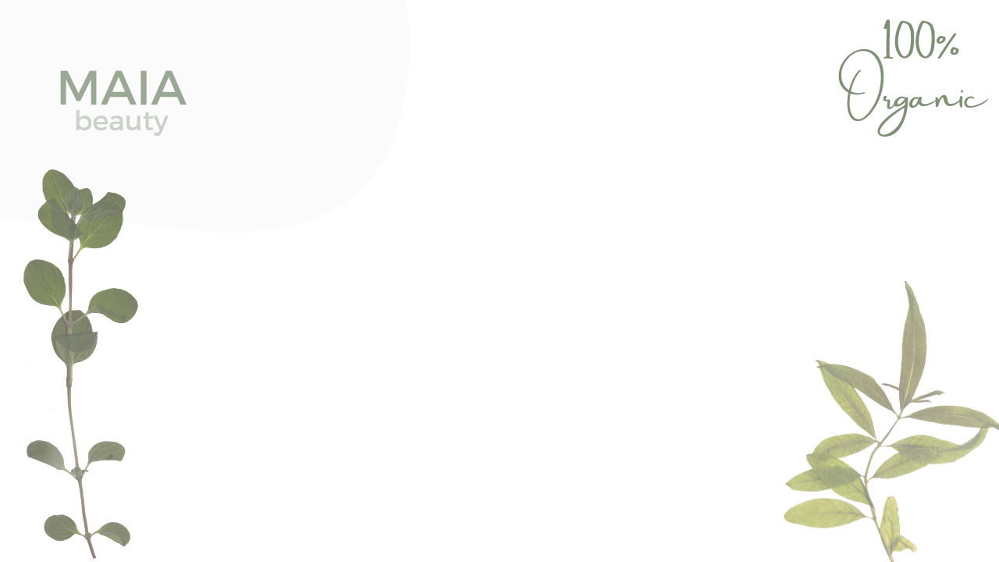

# Products Page

Sahar

# Booking Page

The banner displayed on the top of the page greets the users and wishes them an enjoyable experience when using our services. In the middle, our brand name MAIA is placed to show that our brand is the core of all the experience. The banner was also designed on Canva.

Three divs of border-radius 30px are placed below the banner which include the main categories of the services we offer. The divs are linked to the booking forms of each category. Once the user clicks on the desired category, the booking form appears below (That is why we used the command: onclick="document.getElementById('makeup-app').style.display='block'" ). Next to each booking form, we specified the category “Book Your ….. Appointment!”.  
The booking form also contains personal data like Name and email address in case the user wishes to book an appointment for another person or by using a different naming than his/her personal account.

# Cart

### Design

The products in the cart are connected to the database. Once a user selects a product from the products page, it is automatically added to the cart, or My Bag page. A user can play with the quantity selected by the plus and – signs. The price of 1 unit item is also shown next to the total price to make it easier for the user to make his calculations.   
When the user hovers of the product image, a “remove product” button appears which allows the user to instantly remove the product from his cart.  
The page’s footer includes the subtotal of the products along with the taxes and shipping fees.  
Our transaction system is based on Cash On Delivery at the moment to avoid any issues with the banks and online paying systems in Lebanon due to the unstable dollar rate and economic crisis.

JavaScript  
The JavaScript script associated with the page defines several functions to handle the changes made to the shopping cart. The first function, `changeVal`, takes an element as an argument and updates the full price of the product in the cart based on the quantity and price values stored in its parent element. The second function, `changeTotal`, updates the total price of the cart by calculating the sum of all the individual product prices, adding the tax and shipping costs, and displaying the result on the webpage. The `$(document).ready()` function is called when the document is loaded and sets up event listeners for several buttons on the page. When the "remove" button is clicked, it removes the corresponding product from the cart and updates the total price. When the "qt-plus" or "qt-minus" buttons are clicked, they respectively increase or decrease the quantity of the product in the cart and update its full price. Finally, when the "btn" button is clicked, it sets the `check` variable to true, which indicates that the shopping cart is being emptied due to a completed purchase.