A Time-Frequency Based Suspicious Activity Detection for Anti-Money Laundering
Now-a-days due to online transactions it’s become easier for criminal to transfer money to one and other to complete criminal task and this money transfer is called as Money-Laundering. To detect such transaction many Anti-Money Laundering technique was used where FINANACIAL BANK UNITS will form suspicious transaction to Financial Intelligence Unit (FIU) and FIU will forward this details to Law Enforcement Agencies (LEA) for further investigation and if transaction found suspicious then they will inform to police who will recover transaction money for public use.
This existing manual transaction investigation success ratio is 5% and failed ratio is 95% and to automate such process many machine learning algorithms was used but they were dependent on transaction data and its accuracy is not up to the mark so author of this paper using Random Forest algorithm and then experiment with Transaction data and Time Frequency data. Random Forest Training with Time Frequency data is giving high FSCORE and HIGH True Positive Rate compare to normal transaction data.
Time Frequency data can be obtained from transaction dataset by applying Fourier Transform called FFT. FFT will return 11 features such as Mean, Variance, Skewness, Kurtosis etc.
To train random forest algorithm we have used TRANSACTION data which contain 11 features and below is the dataset screen shot
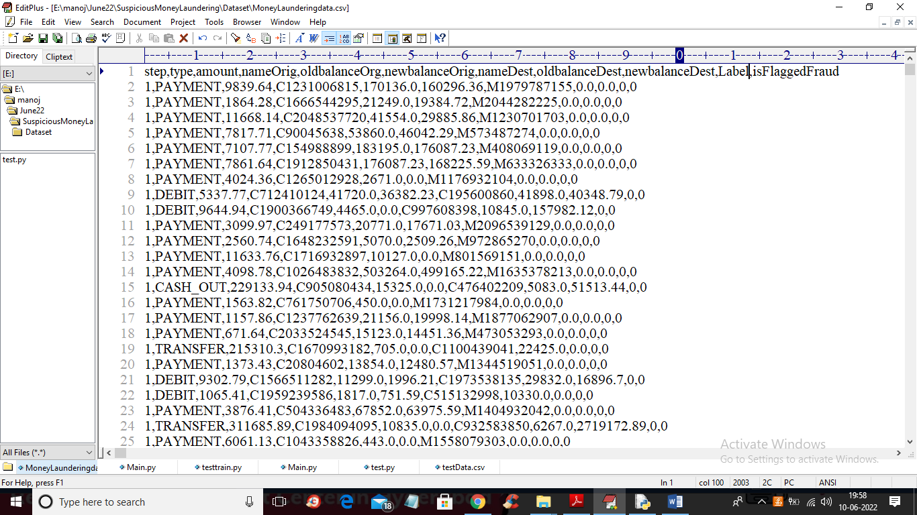
In above dataset first row contains dataset column names and remaining rows contains dataset values
Modules Information
To implement this project we have designed following modules
- Upload Anti-Money Laundering Dataset: using this module we will upload dataset to application and then plot graph with normal and money laundering transaction count
- Preprocess Dataset: dataset contains missing and non-numeric data so Random Forest will accept only numeric data so by applying Label Encoder class we are converting non-numeric data into numeric data. Label encoder assign unique ID to each non-numeric data
- Run Random Forest with Transaction: processed data will be split into train and test where application will used 80% dataset to train Random Forest on transaction data and then this trained model will be applied on 20% test data to calculate FSCORE, True Positive and Negative Rate.
- Run With Transaction & Time Frequency: using this module we will convert transaction data into Time Frequency by applying FFT algorithm and then this Time Frequency transaction data get trained with Random Forest to get FSCORE, TPR and FPR values
- Comparison Graph: using this module we will plot FSCORE Random Forest graph between Transaction data and Time Frequency FFT data
- Predict Money Laundering from Test Data: using this module we will upload test data and then apply Random Forest model to predict weather test data contains normal transaction features or Money-Laundering features.
SCREEN SHOTS
To run project double click on ‘run.bat’ file to get below screen
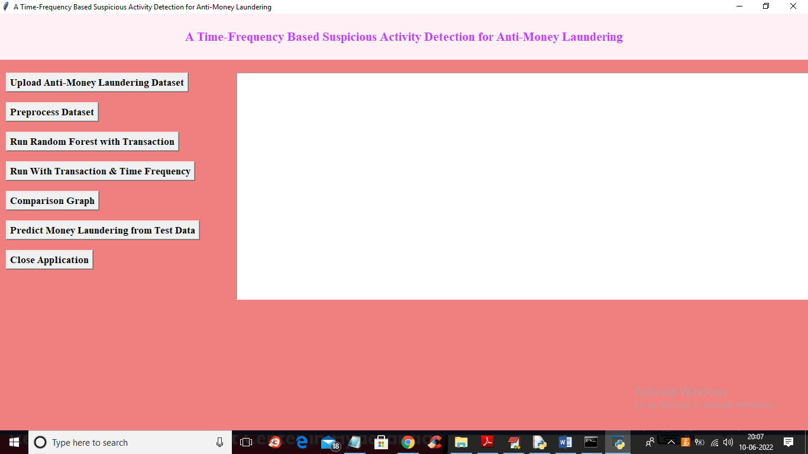
In above screen click on ‘Upload Anti-Money Laundering Dataset’ button to upload dataset and get below output
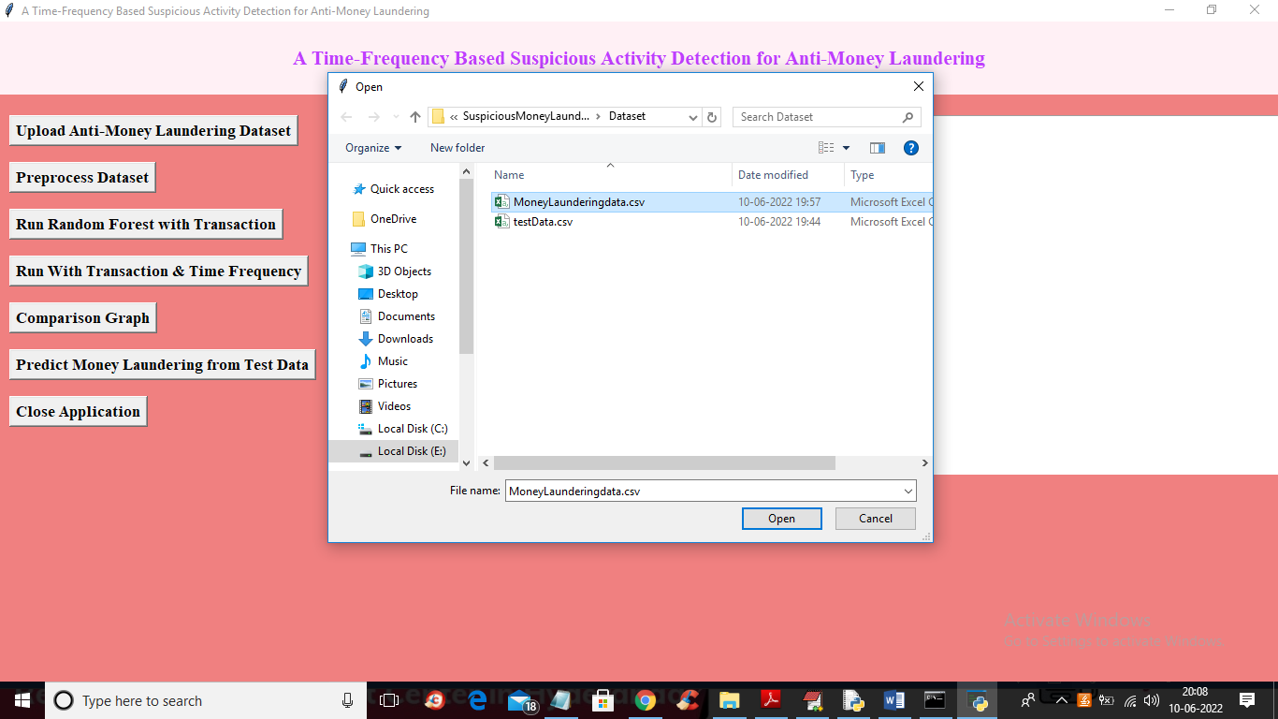
In above screen selecting and uploading ‘Money Laundering’ dataset and then click on ‘Open’ button to upload dataset and get below output
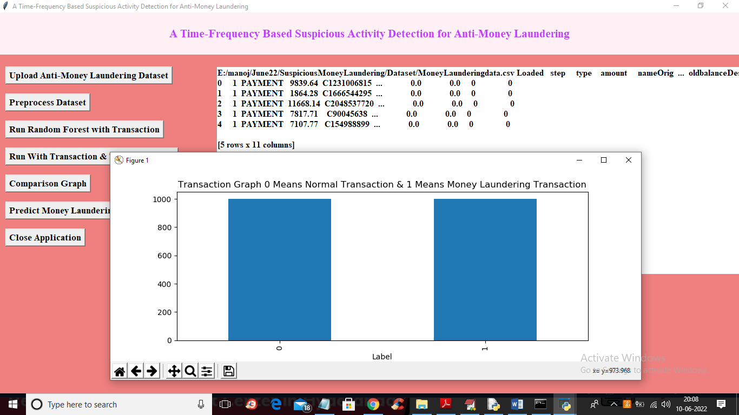
In above screen we can see dataset loaded and dataset contains some numeric and non-numeric data so we need to Preprocess data to convert into numeric and in above graph x-axis represents labels where 0 means Normal transaction and 1 means Money-Laundering transaction and y-axis represents counts. Now close above graph and then click on ‘Preprocess Dataset’ button to clean dataset and get below output
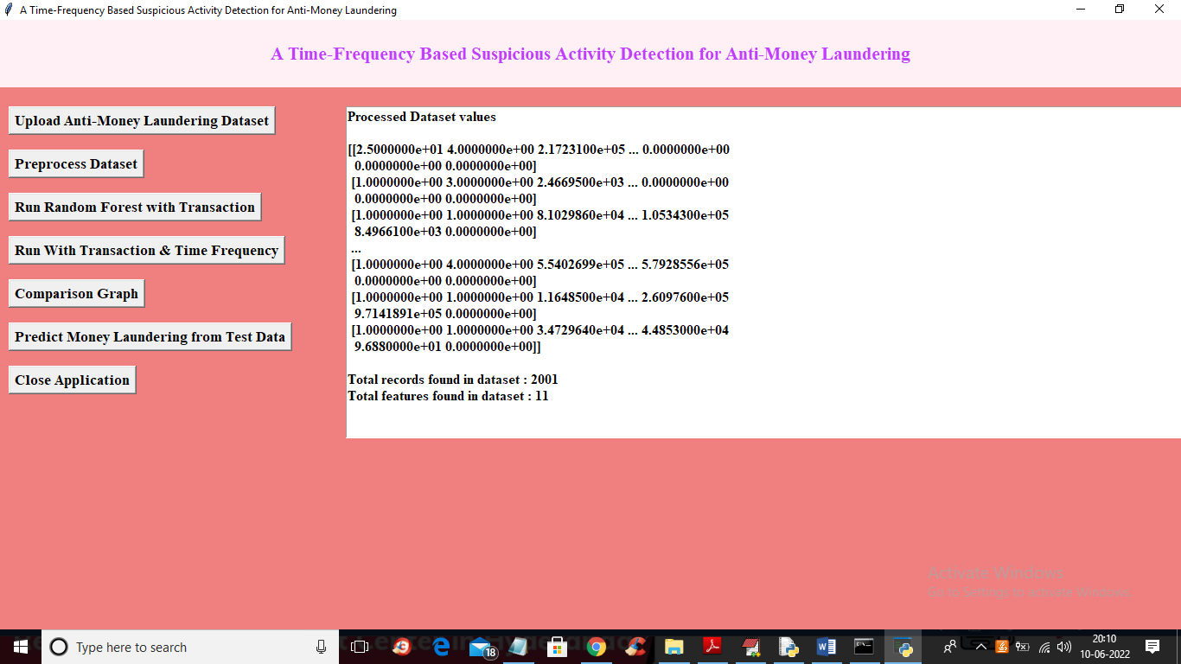
In above screen we can see entire dataset converted to numeric format and in last two lines we can see dataset contains 2001 records and each record contains 11 features and now dataset is ready and now click on ‘Run Random Forest with Transaction’ button to train Random Forest on transaction dataset and get beloww output
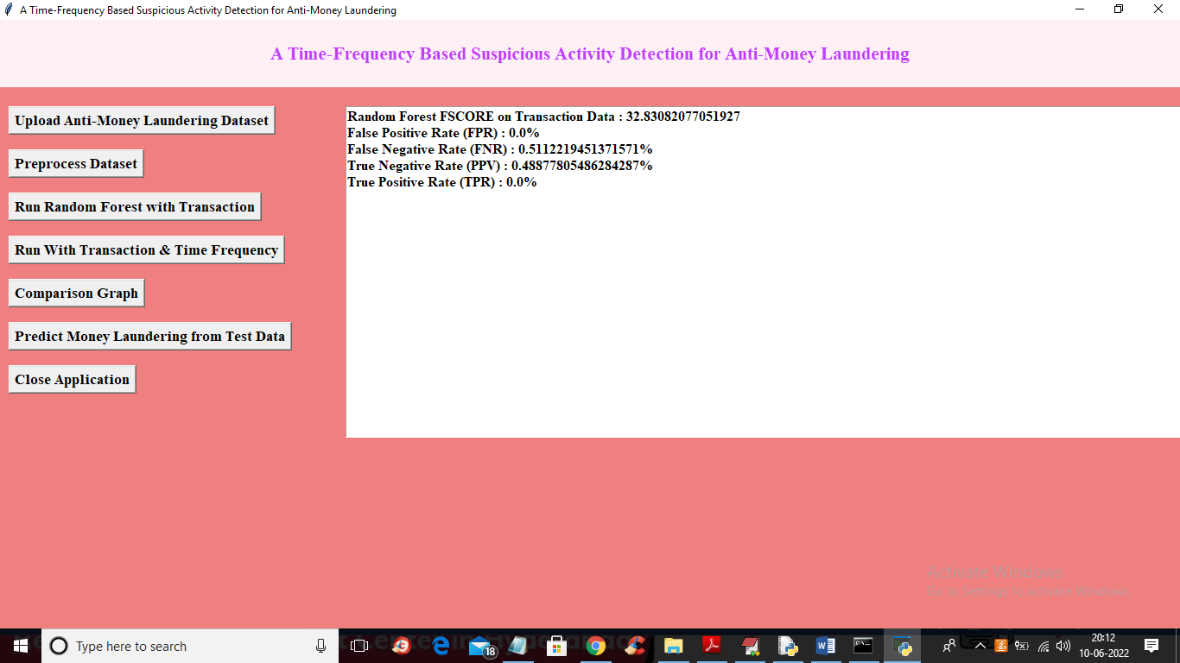
In above screen with Random Forest on transaction data we got FSCORE as 32% and True Positive Rate (TPR) as 0. So transaction data features will not allow Random Forest to train perfectly and now click on ‘Run With Transaction & Time Frequency’ button to convert Transaction data into Time Frequency and then retrain Random Forest to get below output
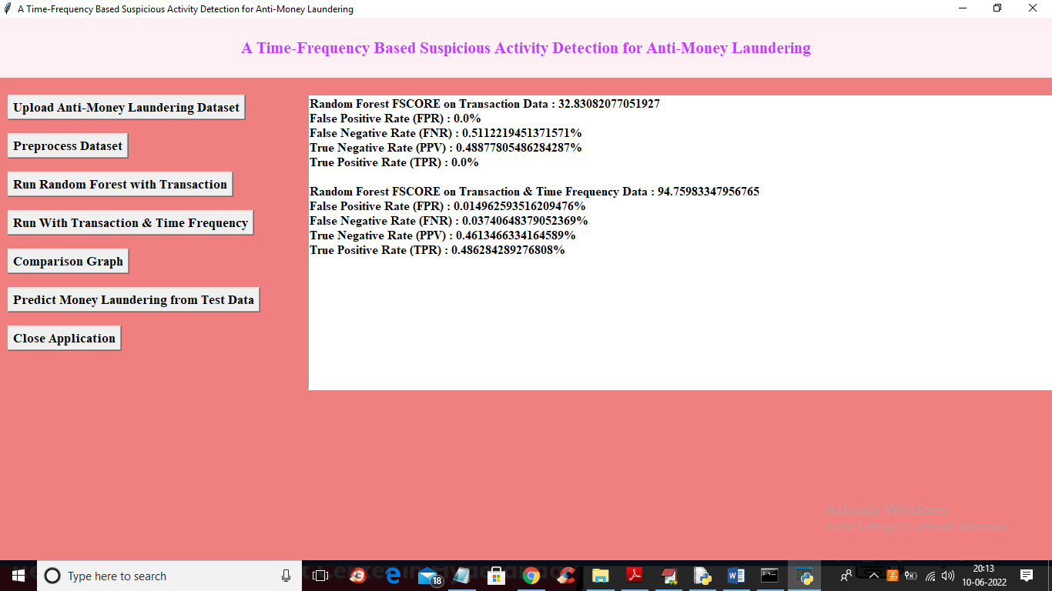
In above screen Random Forest with Time Frequency Transaction data got 94% FSCORE and TPR as 45% so by converting transaction data into time frequency we can build accurate prediction model. Now click on ‘Comparison Graph’ button to get below graph
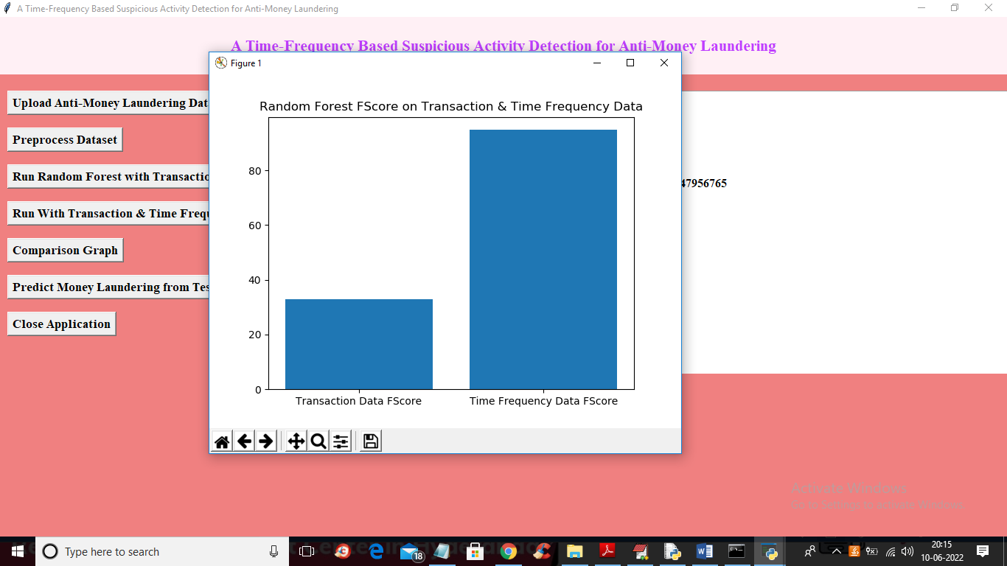
In above graph x-axis represents technique name and y-axis represents FSCORE and in both techniques Time Frequency got high FSCORE and now close above graph and then click on ‘Predict Money Laundering from Test Data’ button to upload test data and get prediction output
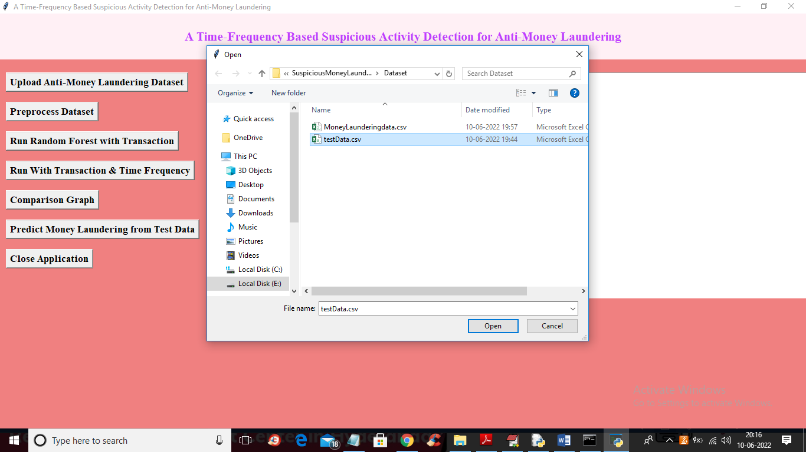
In above screen selecting and uploading ‘testData.csv’ file and then click on ‘Open’ button to get below output
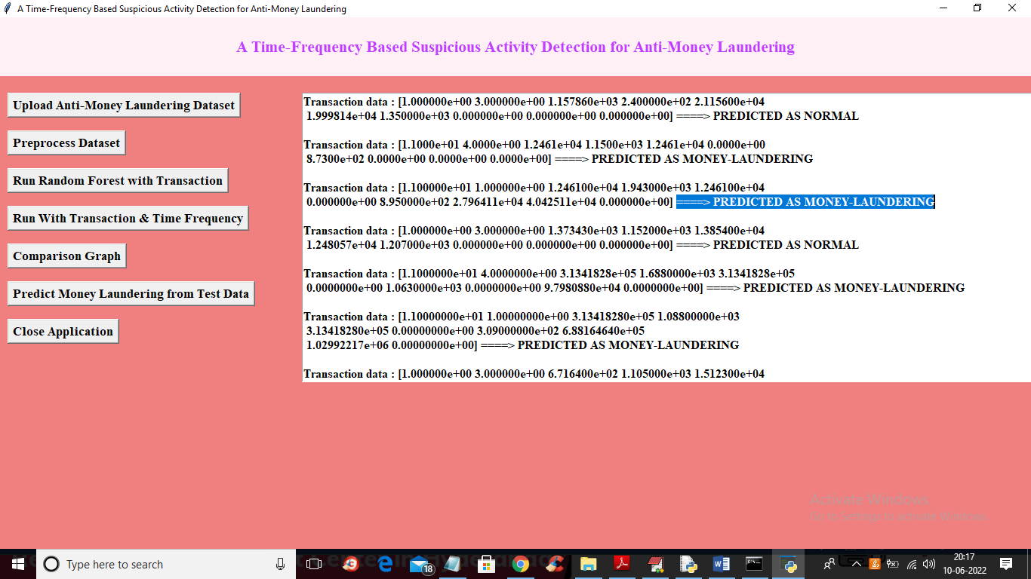
In above screen in square bracket we can see transaction test data and after arrow symbol =we got prediction output as ‘Normal or Money Laundering’

