# Problem Statement

You are working for the data analysis team and wish to analyse the data in hand for various demographic parameters. The analysis at hand involves basic data preparation, processing and understanding. Further, you also wish to forecast the effects of certain information on the overall Aadhaar number generation. The metadata/dictionary is provided below:

Metadata/Data Dictionary

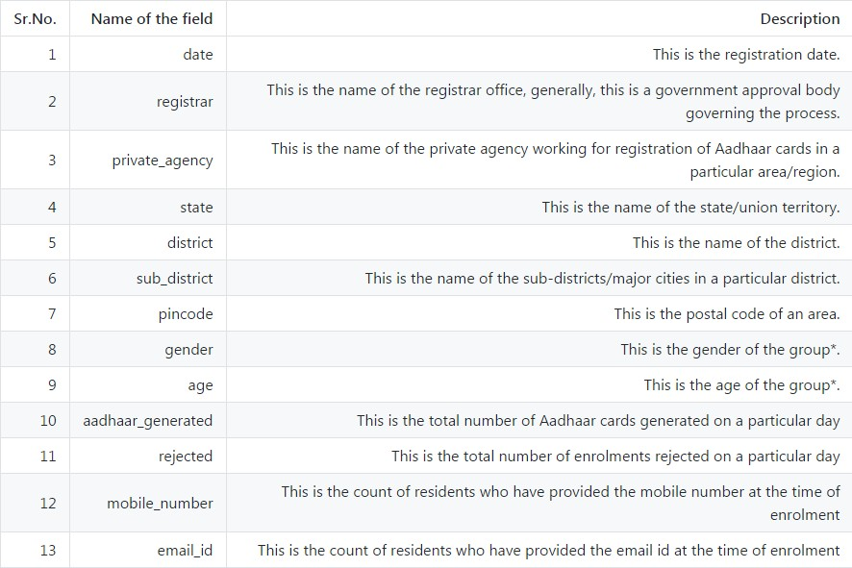

(*: explained in the example below).

Note: The dataset does not contain the headers. You should use the header names in the order as mentioned above.

You can understand the data dictionary better by the following example: A row with data - 20150420, Allahabad Bank, A-Onerealtors Pvt Ltd, Uttar Pradesh, Ambedkar Nagar, Akbarpur, 224155, F, 15, 5, 0, 0, 4 indicates that

* On 20 Apr 2014 (date), for A-Onerealtors Pvt Ltd (private_agency) registered with Allahabad Bank (registrar) at PIN code 224155, Akbarpur (sub_district), Ambedkar Nagar (district), Uttar Pradesh (state)
* Among the group of women aged 15
* There were 5 Aadhar numbers generated and 0 were rejected
* Out of the 5 that applied, none had an email ID and 4 had mobile numbers

# Checkpoints

## Checkpoint 1

Load the data into HDFS, Hive Managed table, Hive External table and Spark DataFrame.

1. Commit the screenshot of the view/result of the top 25 rows from each individual store (HDFS, Hive – Managed/External and Spark DataFrame).

***[cloudera@quickstart ~]$ hdfs dfs –ls***

***[cloudera@quickstart ~]$ hdfs dfs -put aadhar.csv /user/cloudera***

***hive> drop database if exists aadhar_db;***

***OK***

***Time taken: 0.364 seconds***

***hive> create database if not exists aadhar_db;***

***OK***

***Time taken: 3.404 seconds***

***hive> create table if not exists aadhar(registrar varchar(100), private_agency varchar(100), state varchar(50), district varchar(50), sub_district varchar(50), pin_code int, gender char(2), age int, aadhar_generated int, enrollment_rejected int, email_id int, mobile_no int) row format delimited fields terminated by ',' stored as textfile;***

***OK***

***Time taken: 0.5 seconds***

***hive> describe formatted aadhar;***

***OK***

***# col_name data_type comment***

***registrar varchar(100)***

***private_agency varchar(100)***

***state varchar(50)***

***district varchar(50)***

***sub_district varchar(50)***

***pin_code int***

***gender char(2)***

***age int***

***aadhar_generated int***

***enrollment_rejected int***

***email_id int***

***mobile_no int***

***# Detailed Table Information***

***Database: default***

***Owner: cloudera***

***CreateTime: Thu Aug 08 21:28:52 PDT 2019***

***LastAccessTime: UNKNOWN***

***Protect Mode: None***

***Retention: 0***

***Location: hdfs://quickstart.cloudera:8020/user/hive/warehouse/aadhar***

***Table Type: MANAGED_TABLE***

***Table Parameters:***

***transient_lastDdlTime 1565324932***

***# Storage Information***

***SerDe Library: org.apache.hadoop.hive.serde2.lazy.LazySimpleSerDe***

***InputFormat: org.apache.hadoop.mapred.TextInputFormat***

***OutputFormat: org.apache.hadoop.hive.ql.io.HiveIgnoreKeyTextOutputFormat***

***Compressed: No***

***Num Buckets: -1***

***Bucket Columns: []***

***Sort Columns: []***

***Storage Desc Params:***

***field.delim ,***

***serialization.format ,***

***Time taken: 0.235 seconds, Fetched: 38 row(s)***

***hive> load data inpath '/user/cloudera/aadhar.csv' into table aadhar;***

***Loading data to table default.aadhar***

***Table default.aadhar stats: [numFiles=1, totalSize=46483335]***

***OK***

***Time taken: 0.53 seconds***

***hive> create external table if not exists aadhar1(registrar varchar(100), private_agency varchar(100), state varchar(50), district varchar(50), sub_district varchar(50), pin_code int, gender char(2), age int, aadhar_generated int, enrollment_rejected int, email_id int, mobile_no int) row format delimited fields terminated by ',' stored as textfile location '/user/cloudera/aadhar.csv';***

***OK***

***Time taken: 0.076 seconds***

***hive> describe formatted aadhar1;***

***OK***

***# col_name data_type comment***

***registrar varchar(100)***

***private_agency varchar(100)***

***state varchar(50)***

***district varchar(50)***

***sub_district varchar(50)***

***pin_code int***

***gender char(2)***

***age int***

***aadhar_generated int***

***enrollment_rejected int***

***email_id int***

***mobile_no int***

***# Detailed Table Information***

***Database: default***

***Owner: cloudera***

***CreateTime: Thu Aug 08 21:35:35 PDT 2019***

***LastAccessTime: UNKNOWN***

***Protect Mode: None***

***Retention: 0***

***Location: hdfs://quickstart.cloudera:8020/user/cloudera/aadhar.csv***

***Table Type: EXTERNAL_TABLE***

***Table Parameters:***

***EXTERNAL TRUE***

***transient_lastDdlTime 1565325335***

***# Storage Information***

***SerDe Library: org.apache.hadoop.hive.serde2.lazy.LazySimpleSerDe***

***InputFormat: org.apache.hadoop.mapred.TextInputFormat***

***OutputFormat: org.apache.hadoop.hive.ql.io.HiveIgnoreKeyTextOutputFormat***

***Compressed: No***

***Num Buckets: -1***

***Bucket Columns: []***

***Sort Columns: []***

***Storage Desc Params:***

***field.delim ,***

***serialization.format ,***

***Time taken: 0.089 seconds, Fetched: 39 row(s)***

***scala> import org.apache.spark.sql.hive.HiveContext***

***scala> val hc = new org.apache.spark.sql.hive.HiveContext(sc)***

***scala> val aadhardf = hc.sql("select * from aadhar")***

***aadhardf: org.apache.spark.sql.DataFrame = [registrar: string, private_agency: string, state: string, district: string, sub_district: string, pin_code: int, gender: string, age: int, aadhar_generated: int, enrollment_rejected: int, email_id: int, mobile_no: int]***

***scala> val RDD=sc.textFile("/user/cloudera/aadhar.csv")***

***scala> val first=RDD.first()***

***scala> val filterRDD = RDD.filter(w=>w!=first)***

***scala> val Aadhar=filterRDD.map(x=>(x.split(",")(0),x.split(",")(1),x.split(",")(2),x.split(",")(3),x.split(",")(4),x.split(",")(5),x.split(",")(6),x.split(",")(7).toInt,x.split(",")(8).toInt,x.split(",")(9).toInt,x.split(",")(10).toInt,x.split(",")(11).toInt))***

***scala> val aadhardf = Aadhar.toDF("registrar","private_agency","state","district","sub_district","pin_code","gender","age","aadhar_generated","rejected","mobile_no","email_id");***

## Checkpoint 2

1. Describe the schema.

***hive> describe aadhar;***

***OK***

***registrar varchar(100)***

***private_agency varchar(100)***

***state varchar(50)***

***district varchar(50)***

***sub_district varchar(50)***

***pin_code int***

***gender char(2)***

***age int***

***aadhar_generated int***

***enrollment_rejected int***

***email_id int***

***mobile_no int***

1. Find the count and names of registrars in the table.

***hive> insert overwrite local directory '/home/cloudera/hive/aadhar' row format delimited fields terminated by ',' stored as textfile select registrar, count(registrar) from aadhar group by registrar;***

1. Find the number of states, districts in each state and sub-districts in each district.

***hive> select state, count(state), district, count(district), sub_district count(sub_district) over (partition by state,district) from aadhar group by state, district,sub_district;***

1. Find the number of males and females in each state from the table and display a suitable plot.

***Hive> insert overwrite local directory '/home/cloudera/hive/aadhar' row format delimited fields terminated by ',' stored as textfile select state,gender, count(gender) from aadhar group by state,gender;***

1. Find out the names of private agencies for each state.

***hive> insert overwrite local directory '/home/cloudera/hive/aadhar' row format delimited fields terminated by ',' stored as textfile select state,private_agency, count(private_agency) from aadhar group by state,private_agency;***

1. Plot the number of private agencies for each state.

## Checkpoint 3

1. Find top 3 states generating most number of Aadhaar cards?

***hive> create table aadhar_generated as select state,sum(aadhar_generated) as sum_generation from aadhar group by state;***

***Hive> insert overwrite local directory '/home/cloudera/hive/aadhar' row format delimited fields terminated by ',' stored as textfile select * from aadhar_generated order by sum_generation desc limit 3;***

1. Find top 3 private agencies generating the most number of Aadhar cards?

***hive> create table aadhar_generated_pr as select private_agency,sum(aadhar_generated) as sum_generation from aadhar group by private_agency;***

***hive> insert overwrite local directory '/home/cloudera/hive/aadhar' row format delimited fields terminated by ',' stored as textfile select * from aadhar_generated_pr order by sum_generation desc limit 3;***

1. Find the number of residents providing email, mobile number? (Hint: consider non-zero values.)

***hive> insert overwrite local directory '/home/cloudera/hive/aadhar' row format delimited fields terminated by ',' stored as textfile select count(email_id) from aadhar where email_id is NOT NULL and mobile_no is NOT NULL;***

1. Find top 3 districts where enrolment numbers are maximum?

***hive> create table aadhar_generated_district as select district,sum(aadhar_generated) as sum_generation from aadhar group by district;***

***hive> insert overwrite local directory '/home/cloudera/hive/aadhar' row format delimited fields terminated by ',' stored as textfile select * from aadhar_generated_district order by sum_generation desc limit 3;***

1. Find the no. of Aadhaar cards generated in each state?

***hive> insert overwrite local directory '/home/cloudera/hive/aadhar' row format delimited fields terminated by ',' stored as textfile select state, sum(aadhar_generated) as aadhar_generated_by_state from aadhar group by state;***

## Checkpoint 4

1. Create a data frame using the file and provide its summary.

***scala> aadhardf.describe().show()***

***+-------+------------------+------------------+-------------------+-------------------+------------------+***

***|summary| age| aadhar_generated| rejected| mobile_no| email_id|***

***+-------+------------------+------------------+-------------------+-------------------+------------------+***

***| count| 440818| 440818| 440818| 440818| 440818|***

***| mean|19.704367788974135|1.6014296149431284|0.08751003815633662|0.04415427682172688|1.0544964134858377|***

***| stddev|18.686811059770278| 3.391819119747009|0.40708726865347666| 0.2372120691047531|1.5477642589293523|***

***| min| 0| 0| 0| 0| 0|***

***| max| 118| 391| 40| 15| 93|***

***+-------+------------------+------------------+-------------------+-------------------+------------------+***

1. Write a command to see the correlation between “age” and “mobile_number”? (Hint: Consider the percentage of people who have provided the mobile number out of the total applicants)

***hive> insert overwrite local directory '/home/cloudera/hive/aadhar' row format delimited fields terminated by ',' stored as textfile select corr(age, mobile_no) from aadhar;***

1. Find the number of unique pincodes in the data?

***hive> insert overwrite local directory '/home/cloudera/hive/aadhar' row format delimited fields terminated by ',' stored as textfile select distinct(pin_code) from aadhar;***

1. Find the number of Aadhaar registrations rejected in Uttar Pradesh and Maharashtra?

***Hive> insert overwrite local directory '/home/cloudera/hive/aadhar' row format delimited fields terminated by ',' stored as textfile select state, sum(enrollment_rejected) from aadhar where state like "%Uttar P%" or state like "%Mahar%" group by state;***

## Checkpoint 5

On the given dataset, perform EDA and find:

1. The top 3 states where the percentage of Aadhaar cards being generated for males is the highest.

***hive> create table male_percent as select state, round((sum(aadhar_generated)/sum(aadhar_generated+enrollment_rejected))*100,2) as percentage from aadhar where gender = 'M' group by state;***

***hive> select * from male_percent order by percentage desc limit 3;***

1. In each of these 3 states, identify the top 3 districts where the percentage of Aadhaar cards being rejected for females is the highest.

***hive> create table female_top_district as select district, round((sum(enrollment_rejected)/sum(aadhar_generated+enrollment_rejected))*100,2) as percentage from aadhar where gender = 'F' and state in ("Andaman and Nicobar Islands", "Others", "Lakshadweep") group by district;***

***hive> insert overwrite local directory "/home/cloudera/hive/aadhar" row format delimited fields terminated by ',' stored as textfile select * from female_top_district order by percentage desc limit 3;***

1. The top 3 states where the percentage of Aadhaar cards being generated for females is the highest.

***hive> create table female_top_state as select state, round((sum(aadhar_generated)/sum(aadhar_generated+enrollment_rejected))*100,2) as percentage from aadhar where gender = 'F' group by state;***

***hive> insert overwrite local directory "/home/cloudera/hive/aadhar" row format delimited fields terminated by ',' stored as textfile select * from female_top_state order by percentage desc limit 3;***

1. In each of these 3 states, identify the top 3 districts where the percentage of Aadhaar cards being rejected for males is the highest.

***hive> create table male_top as select district, round((sum(enrollment_rejected)/sum(aadhar_generated+enrollment_rejected))*100,2) as percentage from aadhar where gender = 'M' and state in ("Dadra and Nagar Haveli", "Others", "Sikkim") group by district;***

***hive> insert overwrite local directory "/home/cloudera/hive/aadhar" row format delimited fields terminated by ',' stored as textfile select * from male_top order by percentage desc limit 3;***

1. The summary of the acceptance percentage of all the Aadhaar cards applications by bucketing the age group into 10 buckets.

***Hive>create table aadhar_bucket(registrar string,private_agency string,state string,district string,sub_district string,pincode string,gender string, age int,aadhar_generated int,rejected int,email_id int,moblie_number int) clustered by (age) into 10 buckets row format delimited fields terminated by ',' stored as textfile TBLPROPERTIES('serialization.null.format'='','skip.header.line.count'='1');***

***hive> insert overwrite local directory '/home/cloudera/hive/aadhar' row format delimited fields terminated by ',' stored as textfile select round((sum(rejected)/sum(aadhar_generated+rejected))*100,2) from aadhar_bucket;***